Terraform Agent
Agentic Infrastructure Assistant — Project Documentation
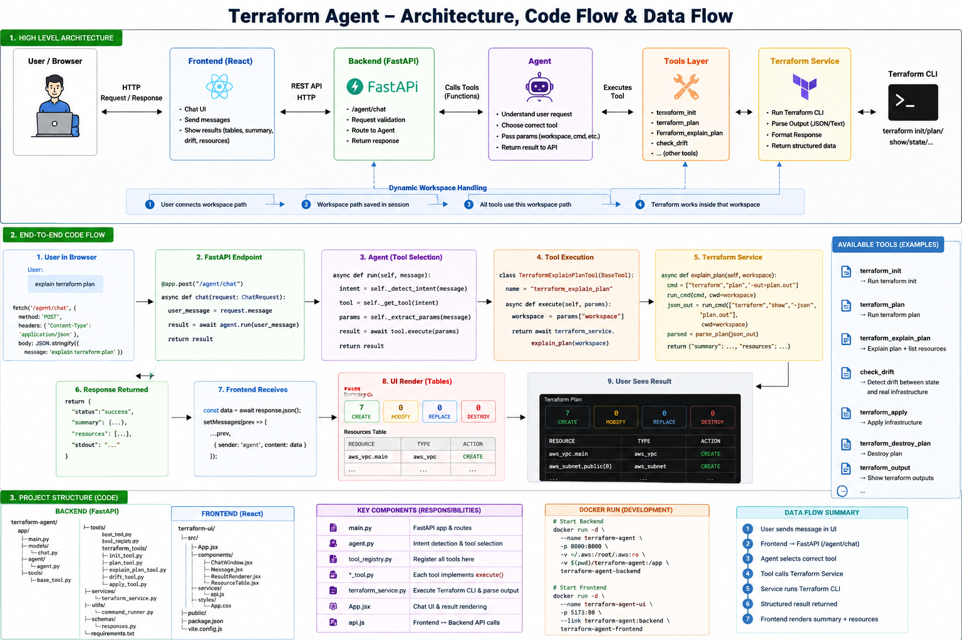
Architecture, code flow and data flow overview
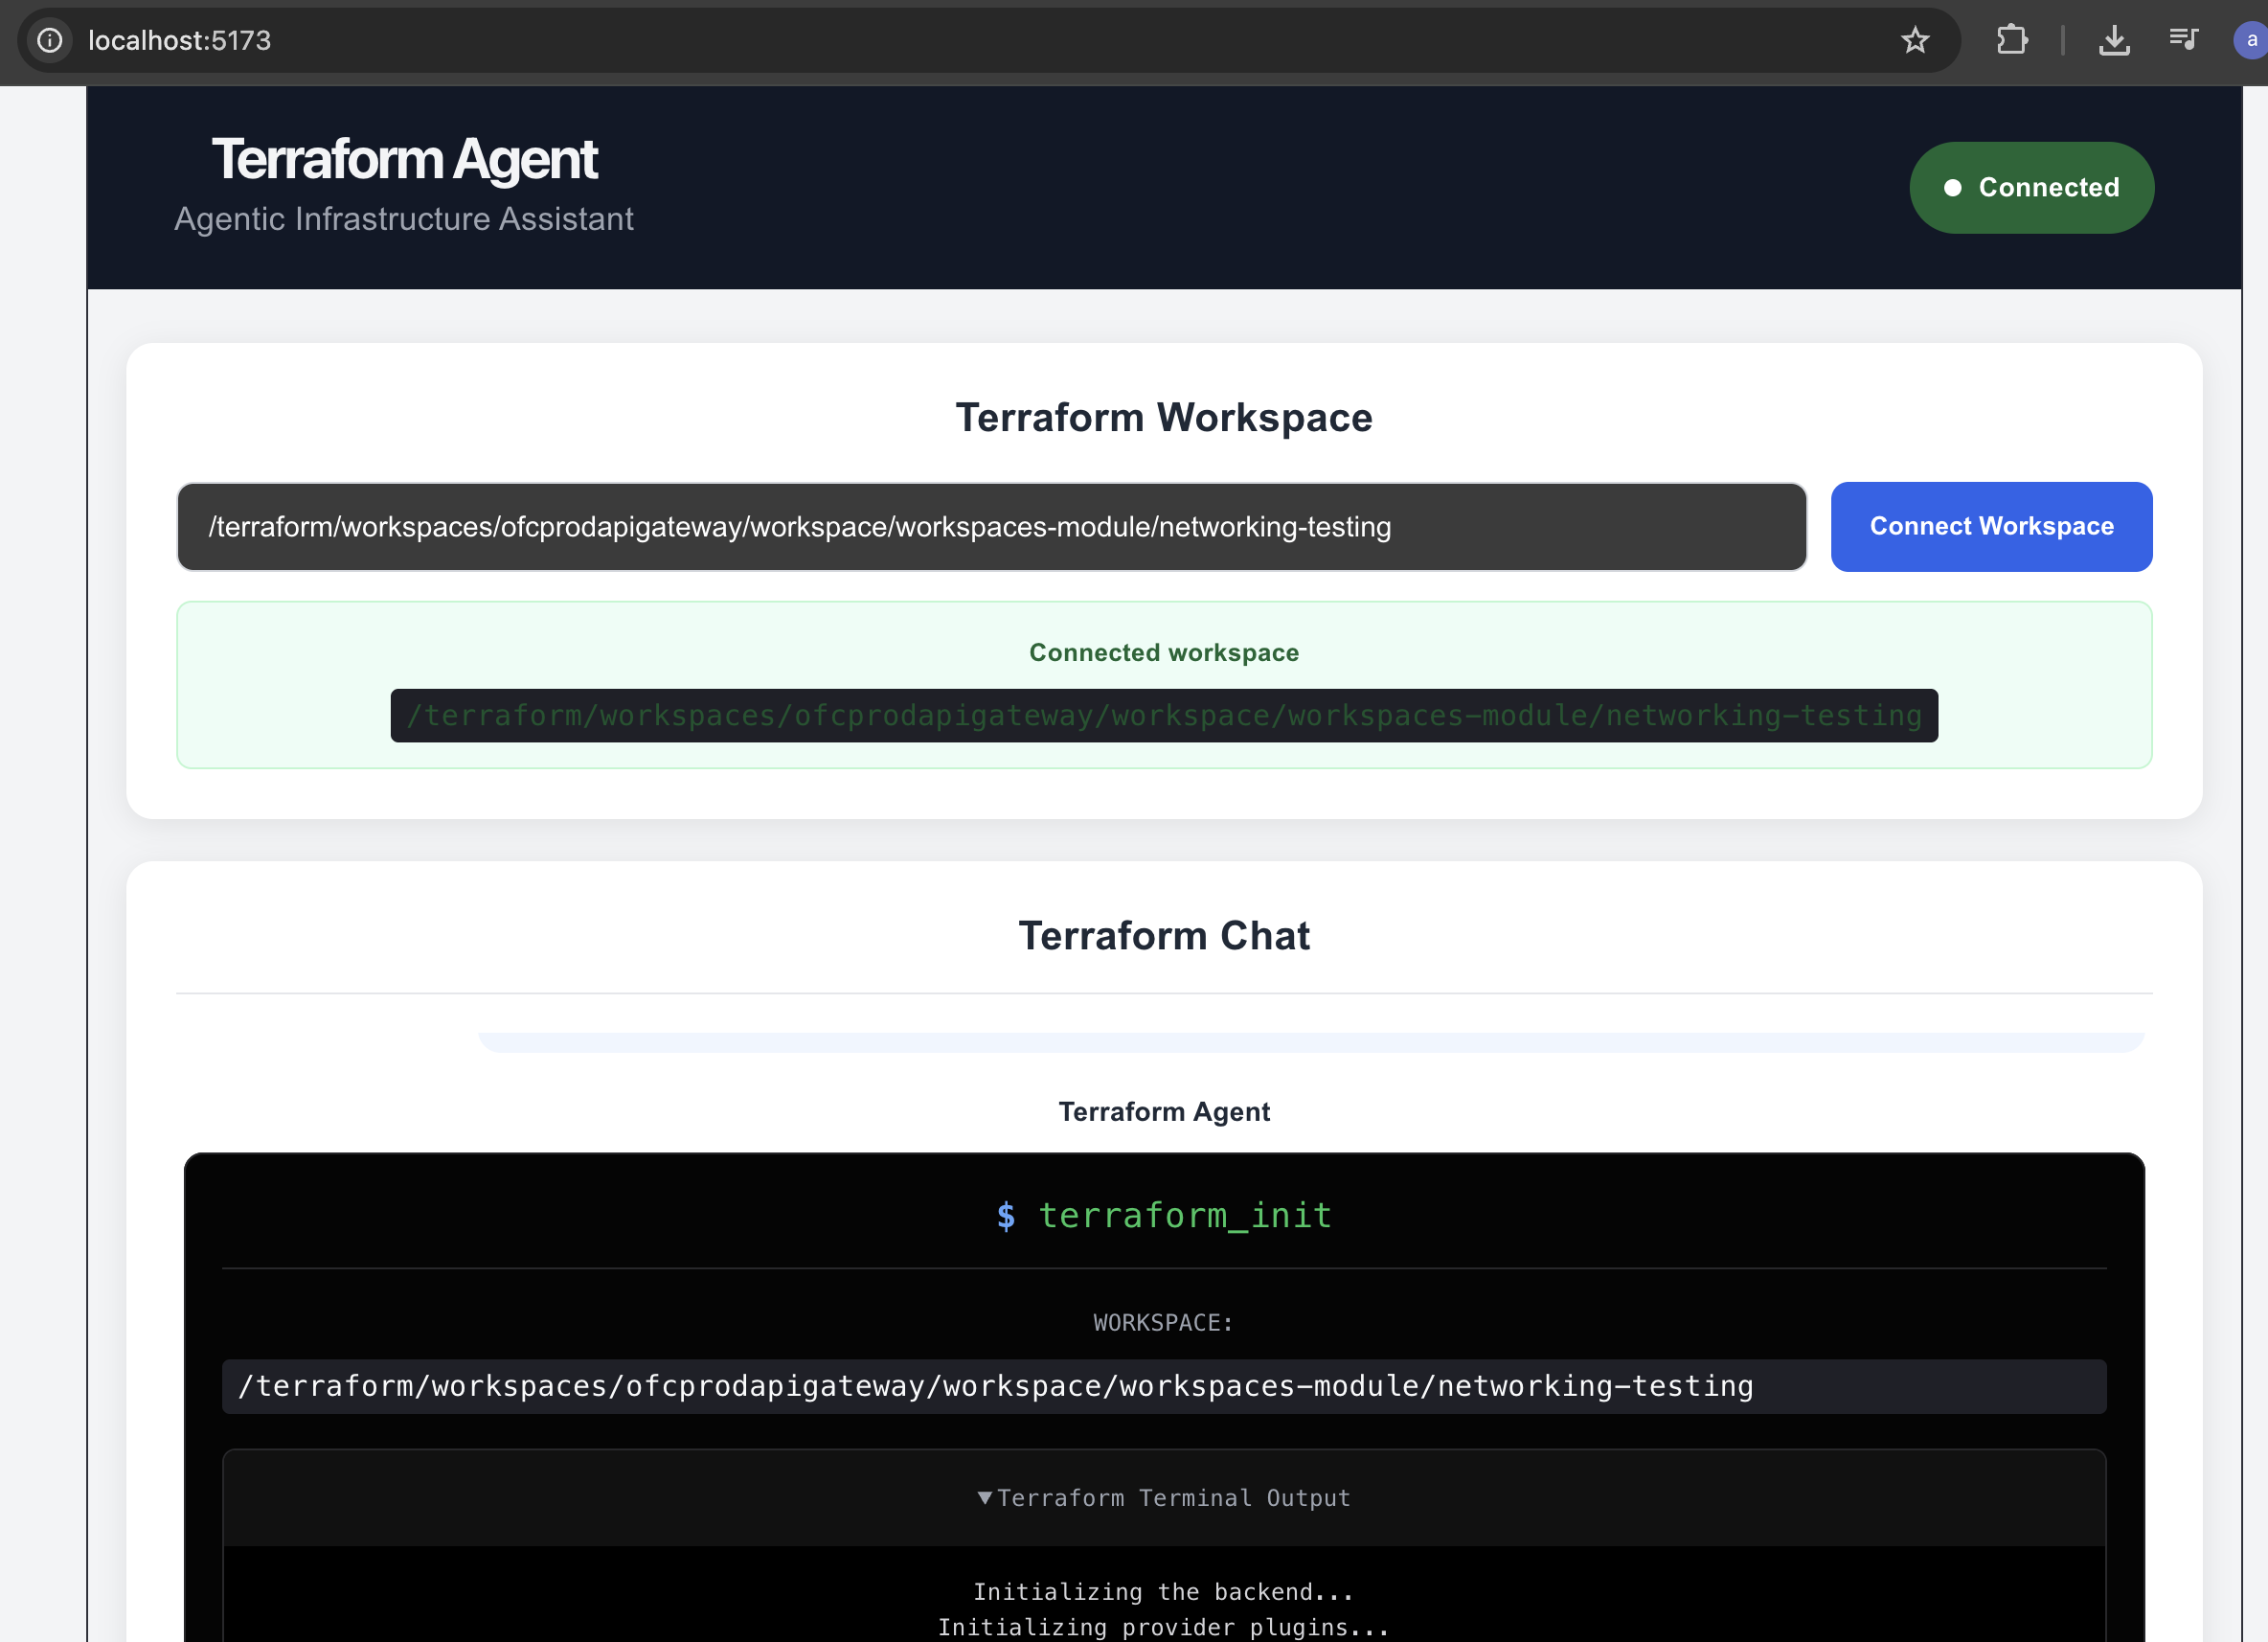
Terraform Agent UI — workspace connected and ready for chat
This document describes the Terraform Agent: a chat-based assistant that lets a developer run and understand Terraform operations through natural language instead of typing raw CLI commands. It combines a React frontend, a FastAPI backend, a local Ollama LLM for intent detection, and a set of Terraform tools that wrap the Terraform CLI.
Repository: github.com/ArpitChouksey/PersonalProject/tree/P10-AgenticAi/TerraformAgentWork/CompleteTerraformCode

1. Project Overview
The Terraform Agent is an agentic infrastructure assistant that allows a user to interact with Terraform through a web-based chat interface, instead of manually running commands such as:
terraform init
terraform validate
terraform plan
terraform show -json
Instead, the user can simply type natural-language requests such as:
- “initialize terraform”
- “do terraform plan”
- “explain plan”
- “is there any drift?”
The agent understands the user's intent, picks the right Terraform tool, runs it against the connected Terraform workspace, and returns a structured, easy-to-read response to the UI — instead of a wall of raw terminal text.
The project is built around a tool-based architecture (Agent → Tool Registry → Tool → Terraform Service → Terraform CLI), which keeps it easy to add new Terraform capabilities, and eventually Docker and Kubernetes tools, behind the same chat interface.

2. Objectives
- Provide a simple chat UI for interacting with Terraform.
- Let the user connect a Terraform workspace from the UI instead of hardcoding a path.
- Support natural-language requests instead of raw Terraform commands.
- Convert raw Terraform CLI output into structured, readable information.
- Clearly show which resources will be created, modified, replaced, or destroyed.
- Detect drift between Terraform state/configuration and real infrastructure.
- Keep every Terraform operation as an independent, reusable tool.
- Keep the architecture extensible for future tools (Docker, Kubernetes, MCP).
- Containerize both the frontend and backend with Docker.

3. Architecture
At a high level, a request flows through five layers:
Browser (React UI, localhost:5173)
| HTTP POST /agent/chat
v
FastAPI Backend (localhost:8000)
|
v
TerraformAgent -- Ollama (llama3.2) for intent + tool selection
|
v
Tool Registry -> terraform_init / validate / plan / explain_plan / state / drift
|
v
TerraformService -> subprocess -> Terraform CLI -> AWS
The important design decision is that the React UI and the FastAPI API layer never talk to Terraform directly. All Terraform execution goes through the Agent → Tool → Service chain, which keeps the presentation, orchestration, and execution concerns separated.

4. Technology Stack
Layer | Technology
Frontend | React 19 + Vite
Frontend server | Nginx (production build)
Backend | Python + FastAPI
Agent / intent detection | Ollama (local LLM, default model llama3.2) via function calling
Infrastructure tool | Terraform CLI
Cloud provider | AWS
Containerization | Docker
API communication | REST / HTTP (JSON)
Future extension | MCP (Model Context Protocol)

5. Project Structure
The project has two independent applications: a FastAPI backend (terraform-agent) and a React frontend (terraform-ui).

Backend — terraform-agent/
terraform-agent/
├── app/
│ ├── main.py # FastAPI app, CORS, /agent/chat route
│ ├── config.py # OLLAMA_HOST, OLLAMA_MODEL, TERRAFORM_DIR
│ ├── agent/
│ │ ├── agent.py # TerraformAgent: session + intent + tool call
│ │ └── prompts.py # System prompt used by the LLM
│ ├── models/
│ │ ├── request.py # ChatRequest schema
│ │ └── response.py # AgentResponse schema
│ ├── session/
│ │ └── manager.py # In-memory session -> workspace path mapping
│ ├── tools/
│ │ ├── registry.py # TOOL_EXECUTORS + Ollama tool definitions
│ │ ├── terraform_state.py
│ │ ├── terraform_drift.py
│ │ └── terraform/
│ │ ├── init.py
│ │ ├── validate.py
│ │ ├── plan.py
│ │ └── explain_plan.py
│ └── services/
│ └── terraform_service.py # subprocess execution, JSON parsing
├── requirements.txt
├── Dockerfile
└── .env

Frontend — terraform-ui/
terraform-ui/
├── src/
│ ├── main.jsx
│ ├── App.jsx # Workspace connect UI + chat UI + result rendering
│ ├── App.css
│ └── assets/
├── public/
├── package.json
├── vite.config.js
├── Dockerfile
└── nginx.conf
Note: the frontend currently lives in a single App.jsx file rather than separate components (ChatWindow, ResourceTable, etc.). Splitting it into components is a reasonable next refactor as the UI grows, but is not required for the app to work.

6. Responsibility of Each Component

6.1 React Frontend
- Lets the user enter and connect a Terraform workspace path.
- Sends chat messages to the backend.
- Renders chat messages, plan summaries, and resource tables.
- Never executes Terraform itself — it only talks to the backend over HTTP.

6.2 FastAPI Backend (main.py)
- Exposes / (health check), /health, and POST /agent/chat.
- Validates the incoming request and forwards the message to TerraformAgent.chat().
- Returns the agent's structured response as JSON.

6.3 Agent (agent/agent.py)
- Resolves the current session and its connected workspace path.
- Detects when a message is actually a workspace path and stores it in the session.
- Otherwise sends the message to Ollama with the registered tool definitions and lets the model choose a tool via function calling.
- Calls execute_tool() with the chosen tool name, arguments, and workspace path.

6.4 Tool Registry (tools/registry.py)
- Declares the six available tools and their Ollama function-calling schema.
- Maps each tool name to its Python executor function.
- execute_tool() looks up and runs the right executor, with graceful fallback across a few call signatures.

6.5 Terraform Service (services/terraform_service.py)
- Runs the underlying terraform subprocess commands (init, validate, plan, show -json, state).
- Captures stdout/stderr/return code and parses JSON output where relevant.
- Shared by every tool, so no tool re-implements subprocess handling.

7. Workspace Handling
A key design goal was avoiding a hardcoded Terraform workspace path. Early versions mounted a fixed host path into the container:
-v /Users/<name>/.../networking-testing:/terraform/workspace
This does not scale, since every new workspace would need a new container run command.
Instead, the workspace is set at runtime through the chat itself. The React UI's “Connect Workspace” field sends the path as a message; the agent's extract_path() recognizes it (an absolute path, or one prefixed with “path:”) and stores it against the current session via the SessionManager, instead of asking for it on every question.
User enters workspace path
|
v
React UI -> "Connect Workspace"
|
v
FastAPI /agent/chat
|
v
TerraformAgent.extract_path() + SessionManager.set_terraform_path()
|
v
All later tool calls in this session reuse the stored path
The current implementation keeps one default session per backend process (SessionManager auto-creates it on startup) — it is structured so that per-user/per-browser sessions can be added later without changing the tool layer.

8. Available Tools
Six Terraform tools are implemented and registered today:
User request (example) | Tool | What it does
“initialize terraform” | terraform_init | Runs terraform init in the workspace.
“validate my config” | terraform_validate | Runs terraform validate.
“do terraform plan” | terraform_plan | Runs terraform plan and returns the raw plan output.
“what resources will be created?” / “explain plan” | terraform_explain_plan | Runs terraform show -json on the plan and returns a create/modify/replace/destroy summary plus a resource list.
“show state” | terraform_state | Reads the current Terraform state (terraform state / show -json) for resources Terraform manages.
“is there any drift?” | terraform_drift | Compares configuration/state with actual infrastructure and reports drifted, missing, and extra resources.

terraform_apply, terraform_destroy_plan, and terraform_output are useful next tools and are already documented as an extension pattern (see Section 12), but they are not wired into the registry yet — today the agent is intentionally read-only/plan-only, which is also a safer default.

9. Agent Decision Layer
Intent detection is not a hand-written keyword matcher. TerraformAgent sends the user's message, a system prompt, and the tool definitions to a local Ollama model (default llama3.2, configurable via OLLAMA_MODEL / OLLAMA_HOST in .env) using Ollama's function-calling API. The model itself decides which tool, if any, to call.
response = ollama_client.chat(
model=OLLAMA_MODEL,
messages=[system_prompt, user_message],
tools=get_tools(),
)
if no tool_call:
return the model's plain text reply
else:
execute_tool(tool_name, arguments, terraform_path)
The system prompt (agent/prompts.py) explicitly restricts the model to read-only/plan-time capabilities today and instructs it not to run infrastructure-changing operations unless a tool for that is explicitly available.

10. Explaining a Plan and Detecting Drift
Raw Terraform output like the line below tells you how many changes exist, but not what they are:
Plan: 7 to add, 0 to change, 0 to destroy.
terraform_explain_plan parses terraform show -json and returns both a summary and the resource list, e.g.:
CREATE | MODIFY | REPLACE | DESTROY | TOTAL
7 | 0 | 0 | 0 | 7

followed by a resource-level table, for example:
Resource | Type | Action
aws_vpc.main | aws_vpc | CREATE
aws_subnet.public[0] | aws_subnet | CREATE
aws_internet_gateway.this | aws_internet_gateway | CREATE
aws_route_table.workspaces | aws_route_table | CREATE

terraform_drift is a related but different check: it compares the Terraform configuration/state against the actual infrastructure and reports drifted, missing, and extra resources — for example, resources that exist in configuration but are not yet recorded in state, each shown with a short description and a suggested action.

11. End-to-End Request Lifecycle
Example: the user asks “what resources will be created?”
Step | Layer | What happens
1 | React | POST /agent/chat with { "message": "what resources will be created?" }
2 | FastAPI | main.py receives and forwards the message to TerraformAgent.chat().
3 | Agent | Looks up the session's workspace path; sends the message + tools to Ollama.
4 | Ollama | Model selects terraform_explain_plan as the tool to call.
5 | Tool Registry | execute_tool() runs the explain_plan tool against the workspace.
6 | Terraform Service | Runs terraform show -json on the plan and parses the JSON.
7 | Response | Structured JSON (status, tool, summary, resources) is returned to FastAPI.
8 | React | Renders the CREATE/MODIFY/REPLACE/DESTROY summary and the resource table.

12. Extending the Agent — Adding a New Tool
A new capability is added as a tool and registered in the tool registry — Terraform logic should never be placed directly in the API layer or the UI. The project's README_Add_New_Tool.md walks through this using terraform_output as the worked example:

Step 1 — Add a service method
In services/terraform_service.py, add a method (e.g. output()) that runs the Terraform command with cwd=terraform_path and returns a status/data or status/error dictionary.

Step 2 — Create the tool file
Create tools/terraform/output.py with a thin execute(terraform_path) wrapper that calls the new service method — the tool layer should stay small.

Step 3 — Register the tool
Import the tool in tools/registry.py, add it to TOOL_EXECUTORS, and add its Ollama function-calling schema to TOOLS.

Step 4 — Teach the agent when to use it
Update the system prompt in agent/prompts.py so the model knows which phrases (“show terraform outputs”, “what are the output values”, etc.) map to the new tool.

Step 5 — Test in order
- Import the service method directly and confirm it runs against a real workspace.
- Import and run the tool's execute() function.
- Call get_available_tools() / execute_tool() from the registry.
- Hit POST /agent/chat with a message that should trigger the new tool.
- Rebuild and re-test inside Docker.
Because the API uses one generic endpoint (POST /agent/chat), a new Terraform tool normally needs no new route and no frontend change — only a custom UI component if the tool's response needs special visualization.

13. Running the Project with Docker

Backend
cd terraform-agent
docker build -t terraform-agent .
docker run -d \\
--name terraform-agent \\
-p 8000:8000 \\
--add-host=host.docker.internal:host-gateway \\
-v ~/.aws:/root/.aws:ro \\
-v "/YOUR/HOST/TERRAFORM_WORKSPACE:/terraform/workspace" \\
terraform-agent

Frontend
cd terraform-ui
docker build -t terraform-agent-ui .
docker run -d \\
--name terraform-agent-ui \\
-p 5173:80 \\
terraform-agent-ui
# open http://localhost:5173

Verifying
docker ps
docker logs -f terraform-agent
docker logs -f terraform-agent-ui
docker exec -it terraform-agent ls -la /terraform/workspace
docker exec -it terraform-agent aws sts get-caller-identity
Rebuild after any code change by stopping/removing the affected container, rebuilding the image, then running it again with the same command.

14. Recommended Testing Flow
Level | Check
Terraform | cd <workspace> && terraform init && terraform plan
Backend | curl http://localhost:8000 and http://localhost:8000/health
API | curl -X POST http://localhost:8000/agent/chat -d '{"message":"terraform plan"}'
Frontend | Open http://localhost:5173, connect a workspace, and run through init → plan → explain plan → drift

15. Common Problems

Frontend says “Failed to fetch”
Confirm the backend container is running (docker ps), check docker logs terraform-agent, and confirm curl http://localhost:8000 responds.

Container name already in use
docker rm -f terraform-agent-ui

Terraform path does not exist inside the container
Check docker exec -it terraform-agent ls -la /terraform/workspace and verify the -v mount matches the intended host path. Terraform always operates on the container-visible path, not the original host path.

16. Security Considerations
Because the agent can execute infrastructure commands, a production version should treat these carefully:
- Any future terraform apply / terraform destroy tools — read-only tools (plan, state, drift, output) are safer by default.
- Authentication and authorization on the API.
- Restricting which workspaces a session is allowed to connect to.
- A command allow-list, with explicit approval before any destructive action.
- Audit logging of every tool execution.
- Secret management, and least-privilege AWS IAM permissions for the credentials the container uses.

17. Core Design Principle
The most important rule in this codebase:
The Agent decides what to do; the Tool performs the operation; the Service runs Terraform; the API communicates; React presents the result.
Agent = Decision
Tool = Action
Service = Terraform execution
API = Communication
React = Presentation

18. Future Roadmap
The Terraform Agent is one part of a larger agentic infrastructure idea, alongside a Docker Agent and the already-built Kubernetes Agent, eventually unified through a common MCP layer:
Agentic Infrastructure Assistant
|
+--------------------+--------------------+
| | |
v v v
Docker Agent Terraform Agent Kubernetes Agent
| | |
+--------------------+--------------------+
|
v
MCP Layer
- terraform_output, terraform_apply, and terraform_destroy_plan as the next tools, following the exact extension pattern in Section 12.
- Multi-session support in SessionManager for concurrent users.
- Splitting App.jsx into components (Chat, PlanSummary, ResourceTable) as the UI grows.
- Exposing today's tools as MCP-callable capabilities so Terraform, Docker, and Kubernetes agents share one interface.

19. Summary
The Terraform Agent lets a user run and understand Terraform through natural language: React → FastAPI → Agent (Ollama function-calling) → Tool → Terraform Service → Terraform CLI → structured JSON → React. Six tools are implemented today — init, validate, plan, explain_plan, state, and drift — covering initialization, validation, planning, human-readable plan explanation, and drift detection. The workspace is connected once per session instead of being retyped with every question, and the tool-registry pattern makes it straightforward to add apply/destroy/output next, and eventually Docker and Kubernetes tools behind the same MCP-ready architecture.
User → React → FastAPI → Agent → Tool → Terraform Service → Terraform CLI → Structured Response → React

20. Screenshots — Demo Walkthrough
The workspace-connect screenshot is on the cover page. The screenshots below continue that same session, in the order they would appear to a user.
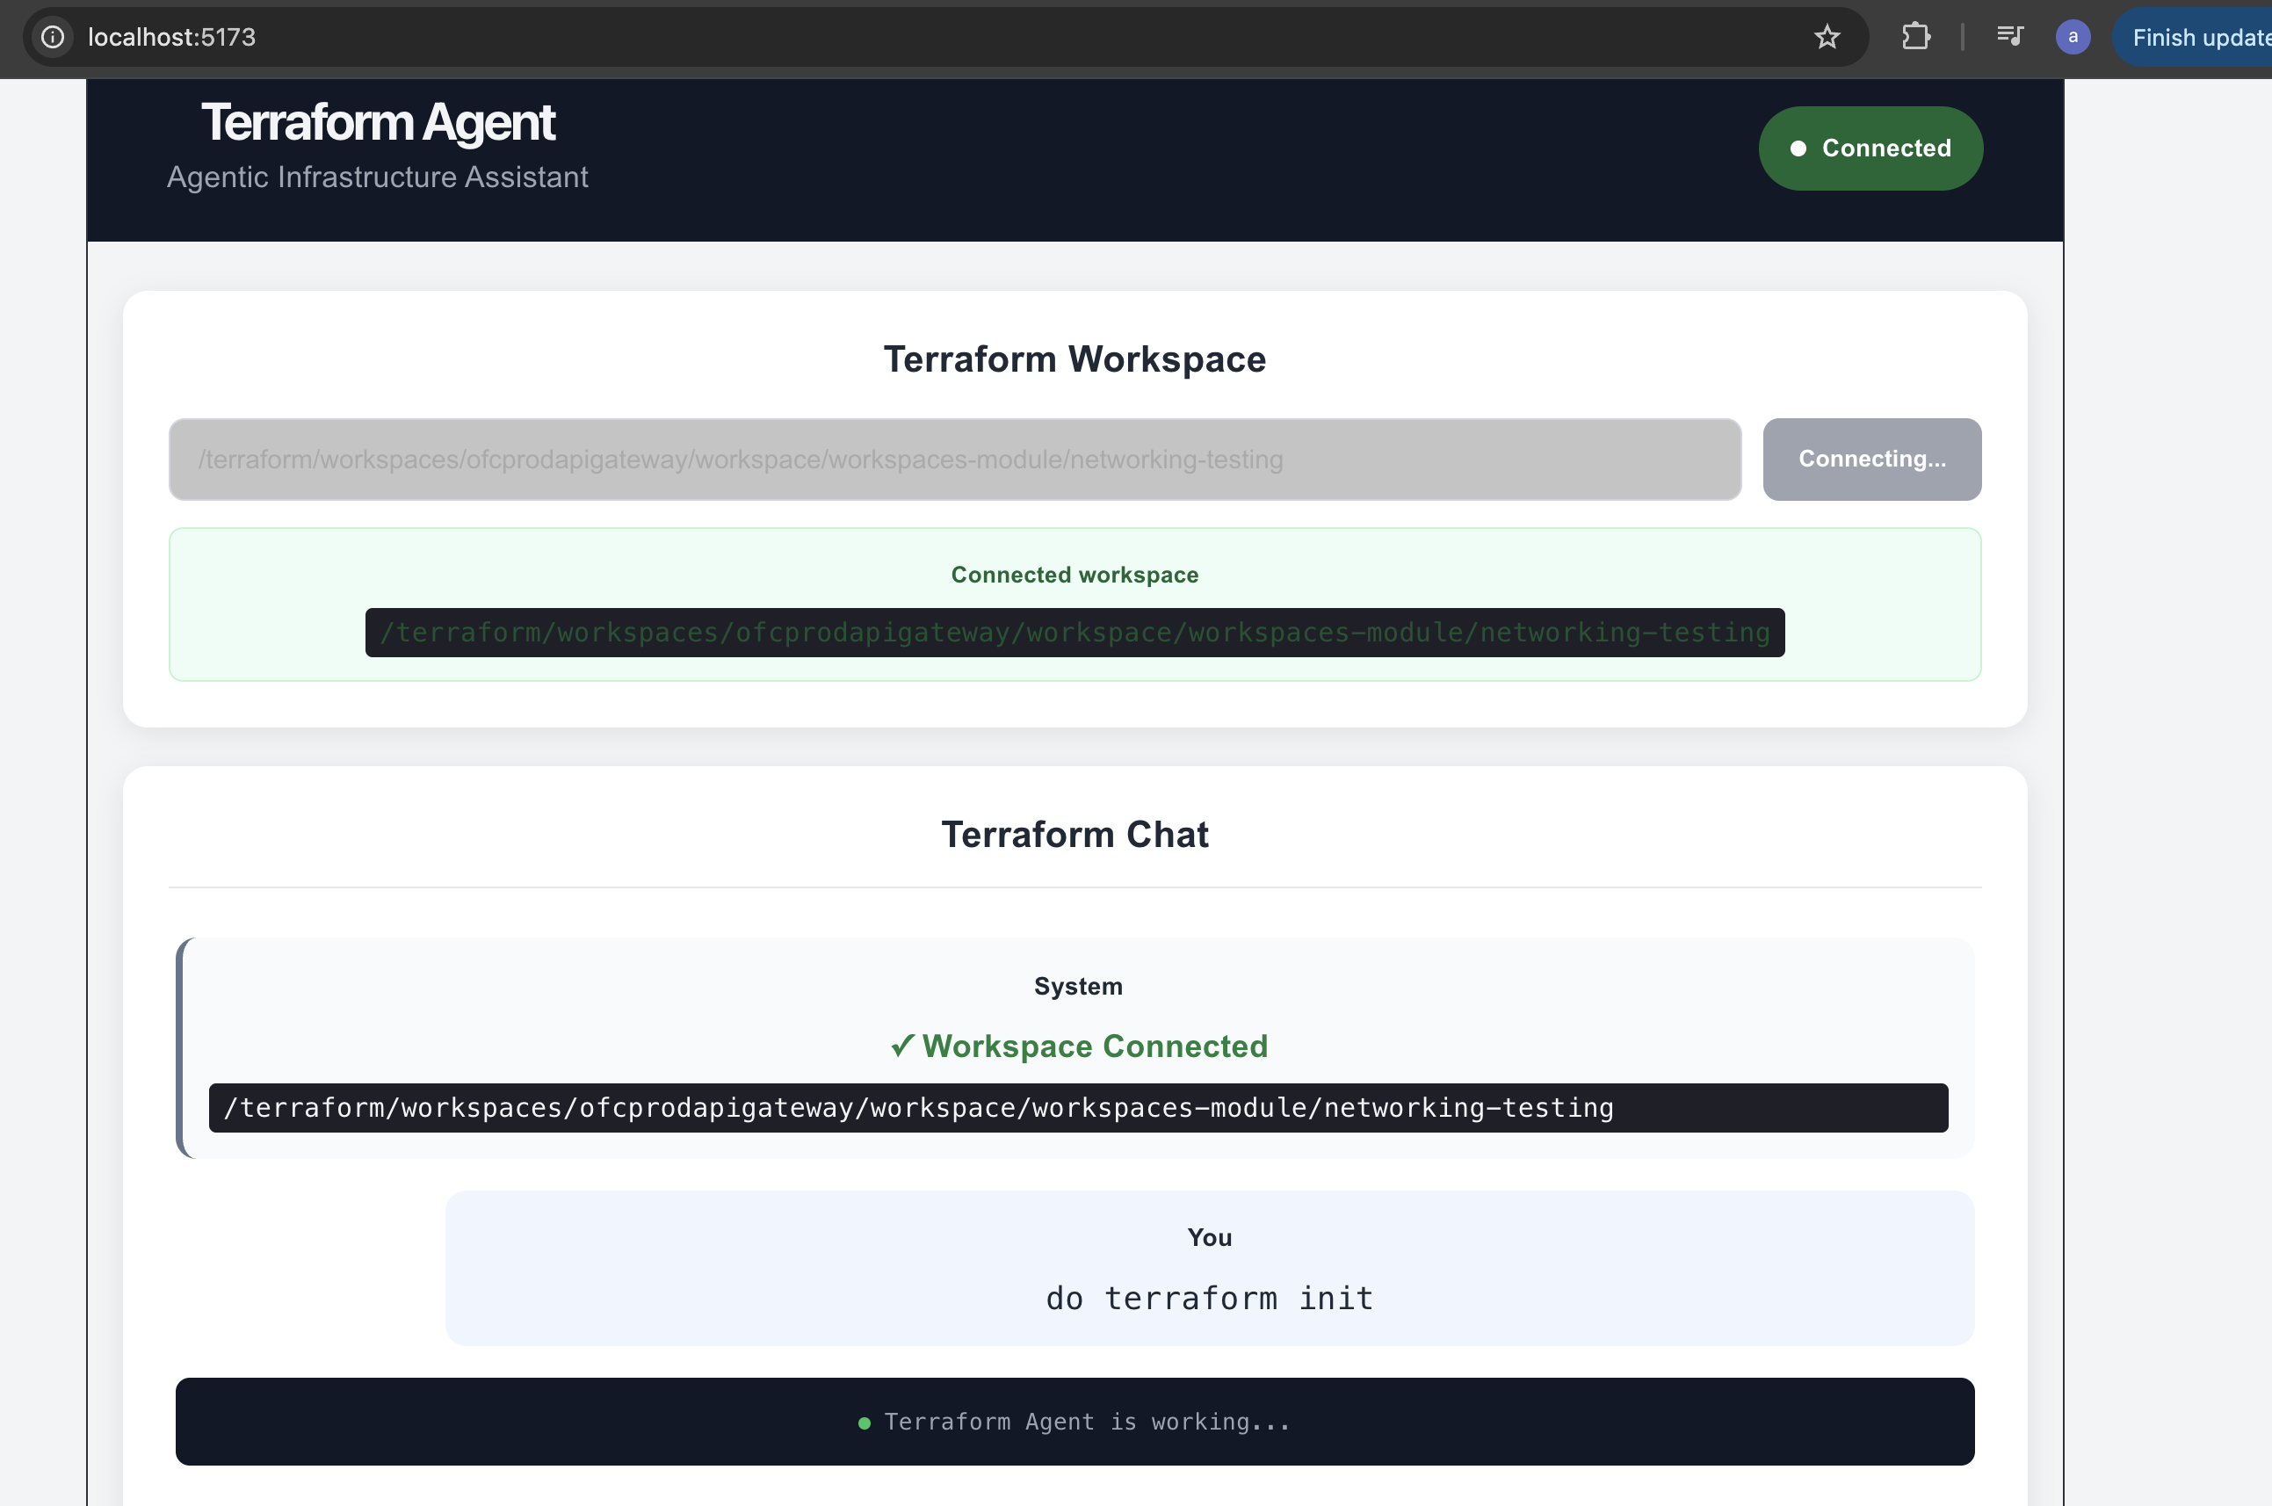
1. Workspace connected; user asks the agent to run terraform init.
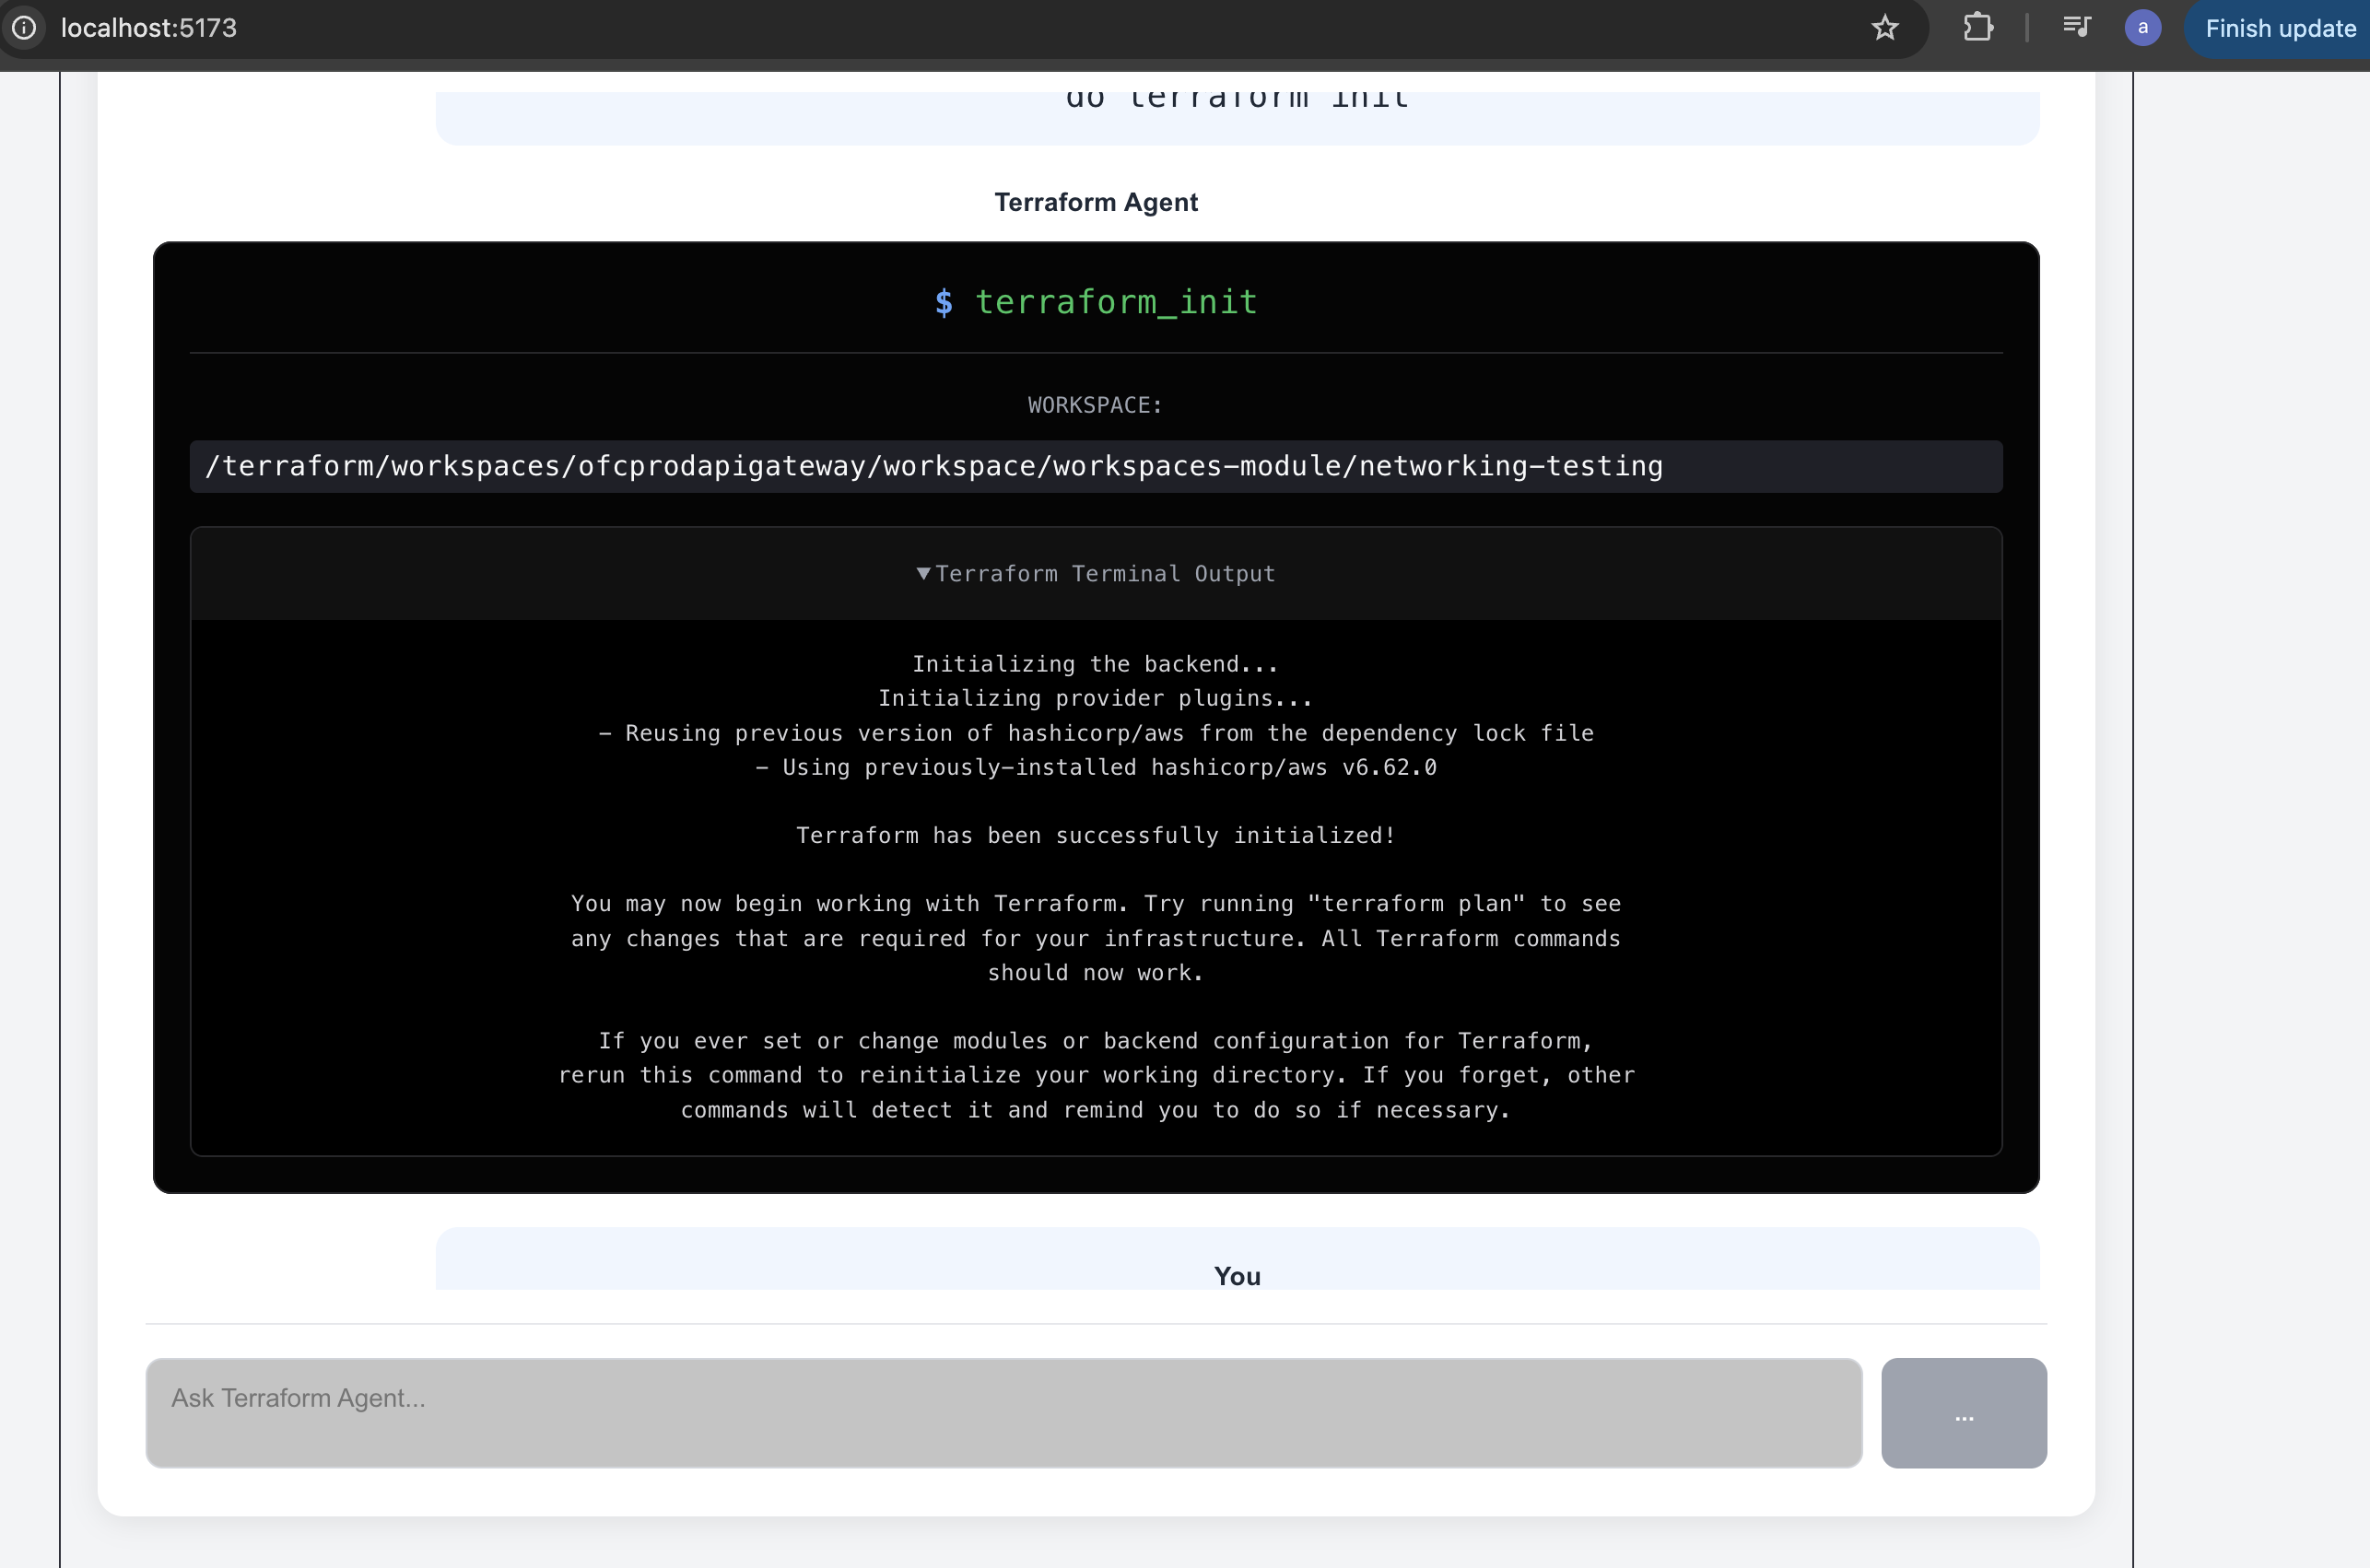
2. terraform_init output streamed back into the chat.
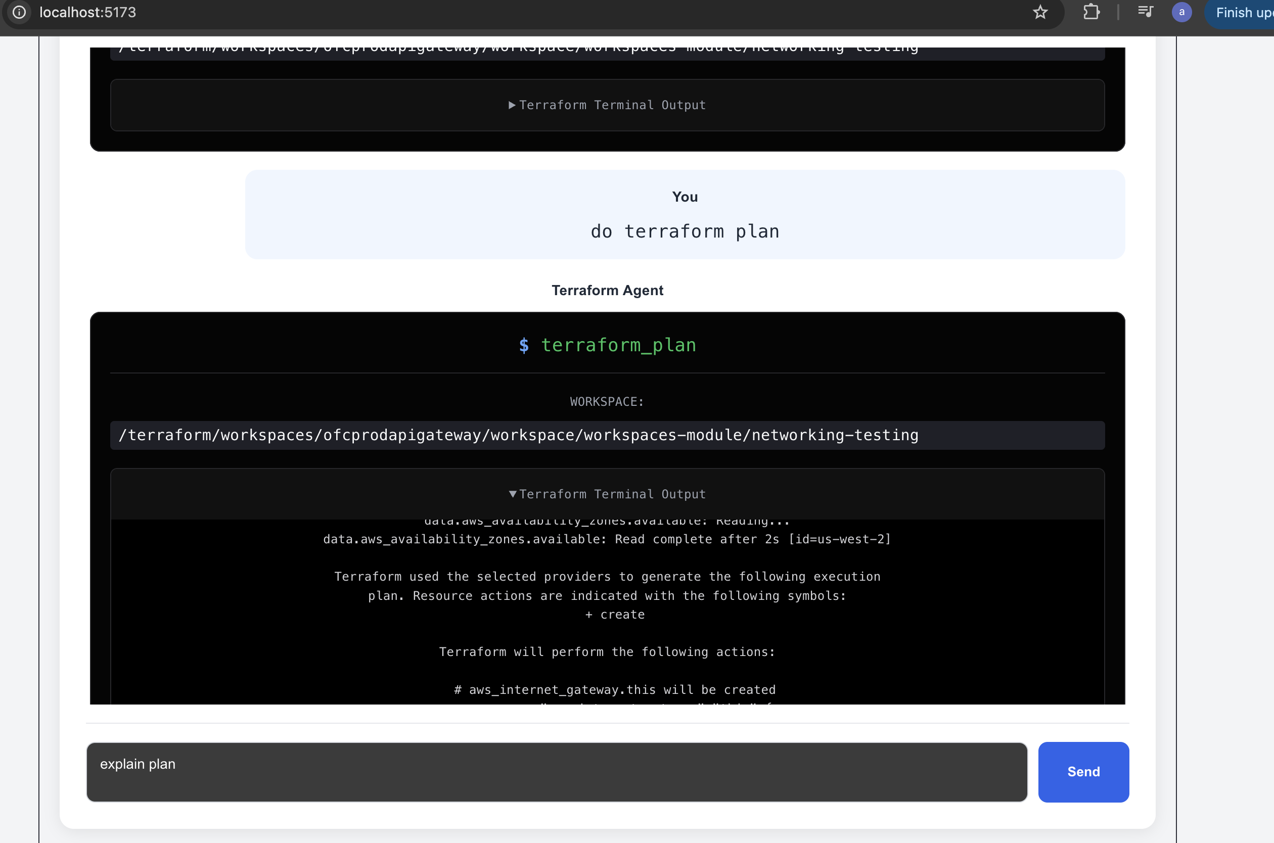
3. Running terraform plan, then asking the agent to explain the plan.
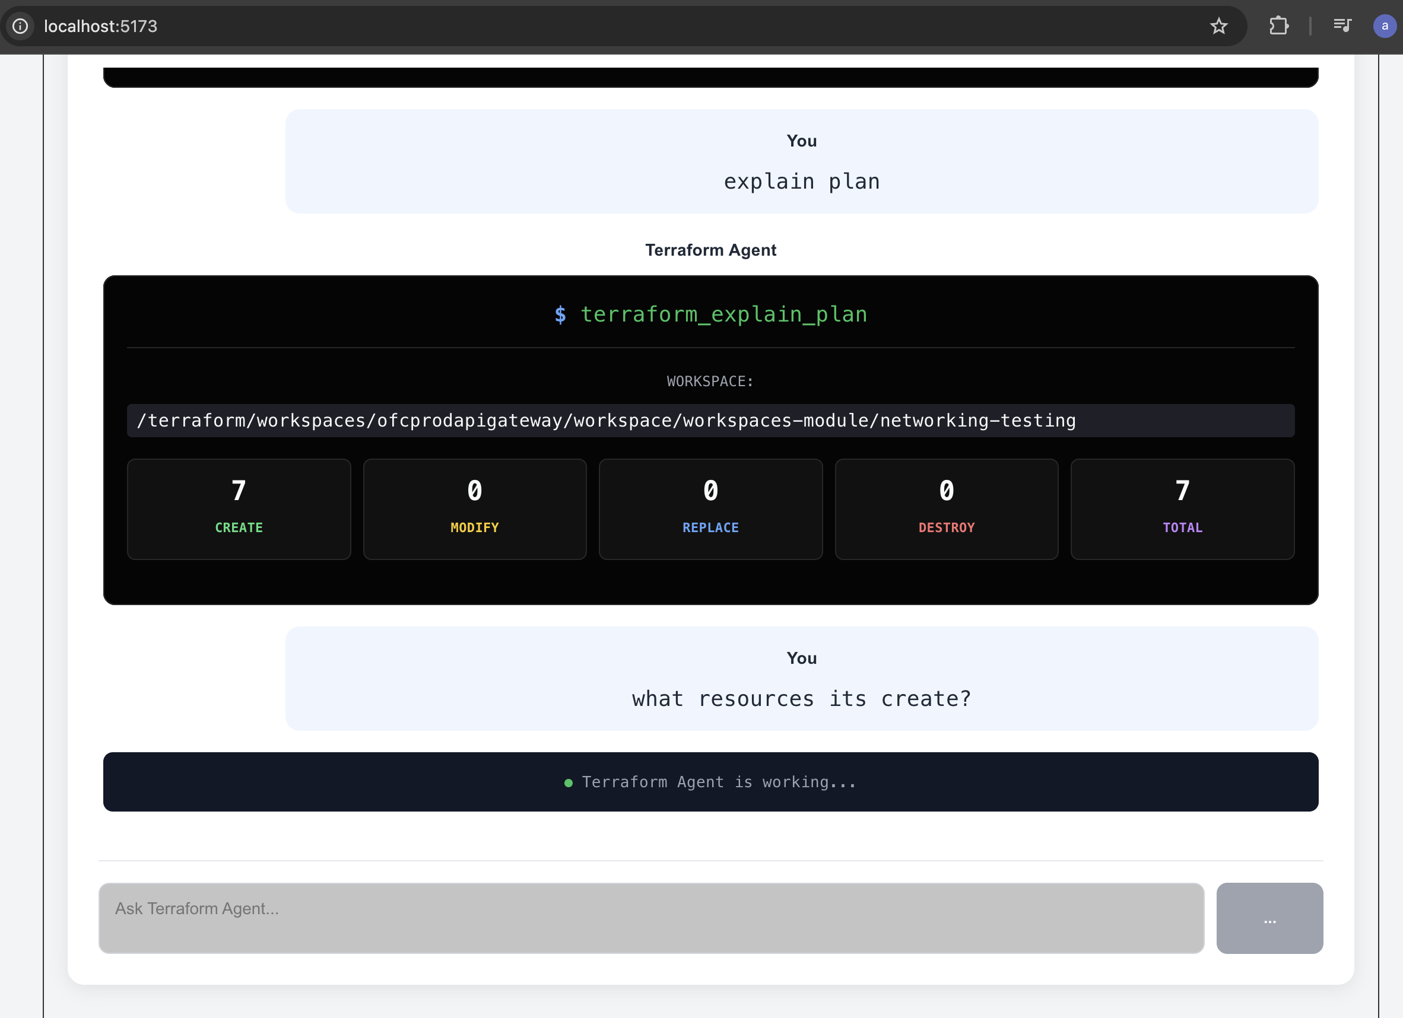
4. terraform_explain_plan summary: 7 create / 0 modify / 0 replace / 0 destroy.
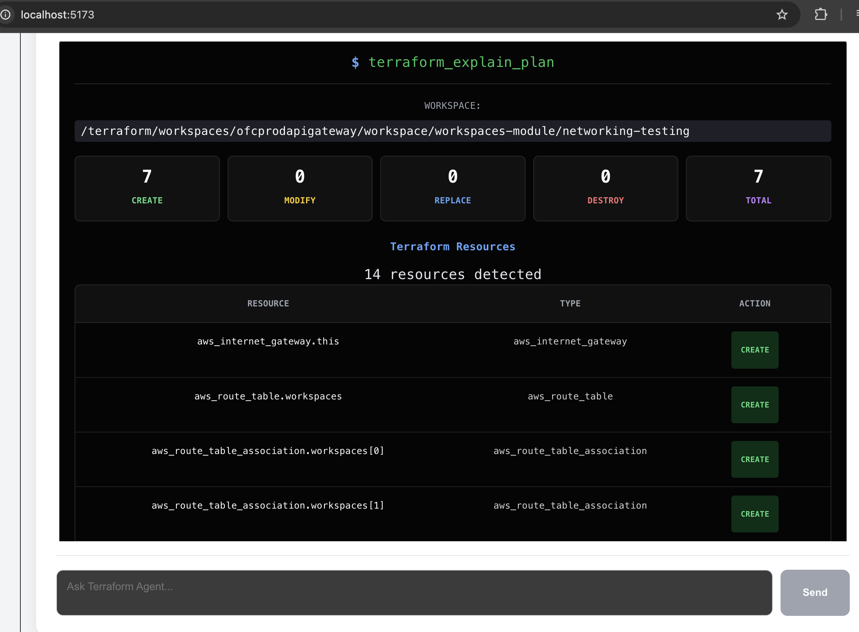
5. Resource-level detail from terraform_explain_plan (14 resources detected).
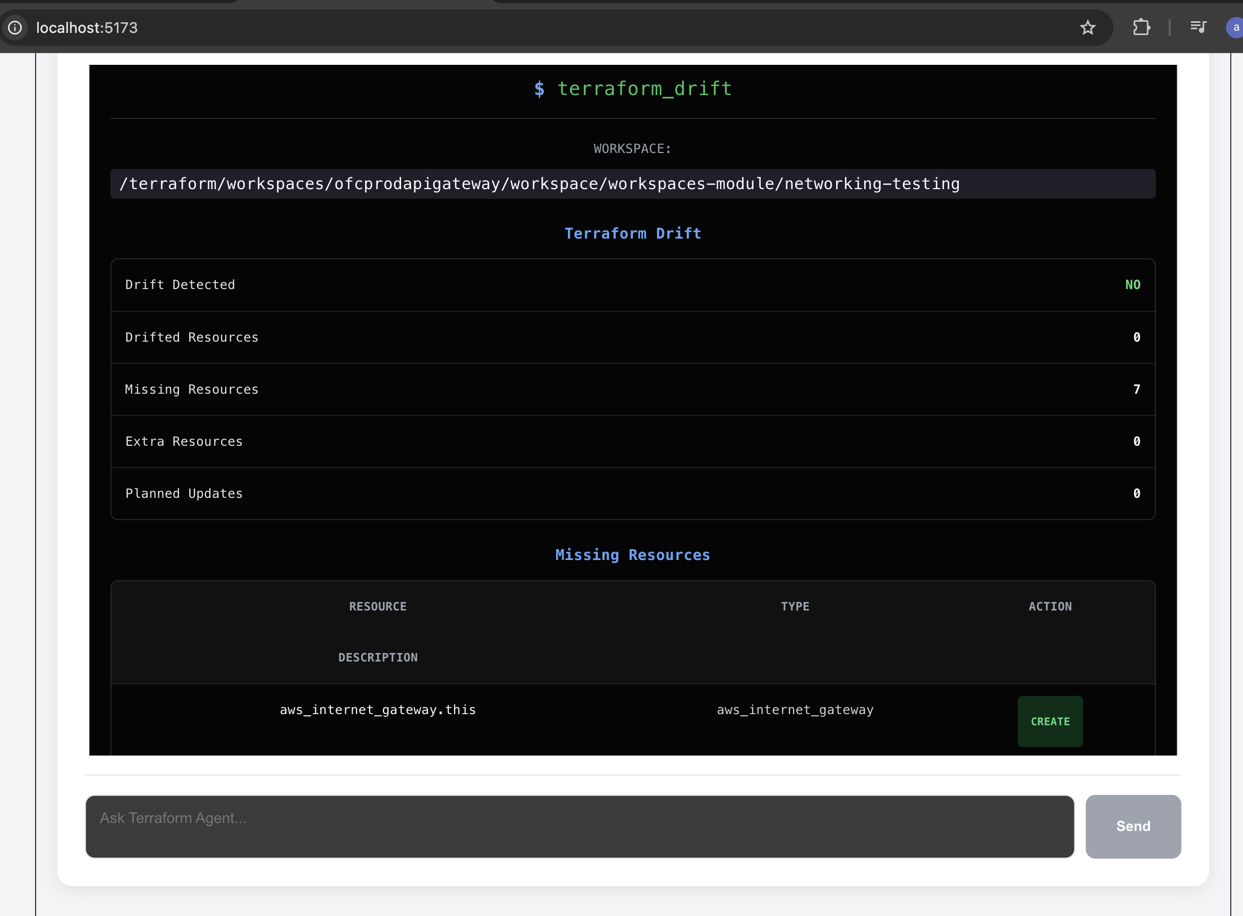
6. terraform_drift output — no drift, 7 resources missing from state.
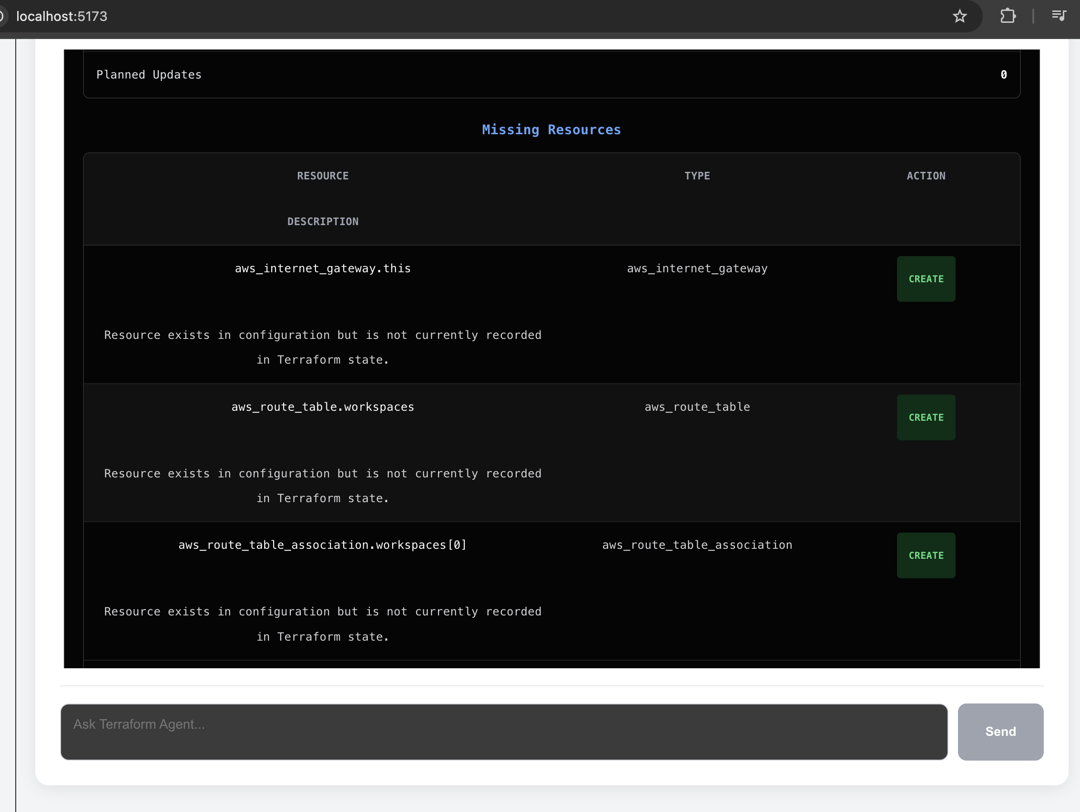
7. Missing-resources detail with a suggested CREATE action per resource.

21. LinkedIn Post
Ready-to-post copy for sharing this project:
🚀 Built a Terraform Agent — an agentic infrastructure assistant.
Instead of typing “terraform init / plan / show” by hand, I built a chat-based assistant that understands natural language and runs the right Terraform operation for you.
🧠 How it works:
React chat UI → FastAPI → an Agent backed by a local Ollama LLM (function calling) → a registry of Terraform tools → the Terraform CLI → a structured JSON response rendered back as plan summaries and resource tables.
✅ What it can do today:
• Initialize and validate a Terraform workspace
• Run terraform plan and explain it in plain English (create/modify/replace/destroy, resource by resource)
• Read Terraform state
• Detect drift between configuration/state and real infrastructure
🔌 One workspace connection, many questions — no need to repeat the path on every message.
🐳 Fully Dockerized — React/Nginx frontend + FastAPI backend, each in their own container.
🧩 Built as a tool-based architecture on purpose — the same pattern will plug into a Docker Agent and my existing Kubernetes Agent behind a shared MCP layer.
This is part of a bigger exploration into agentic infrastructure tooling — letting AI safely understand and operate infrastructure through well-defined, auditable tools instead of free-form shell access.
🔗 Code: https://github.com/ArpitChouksey/PersonalProject/tree/P10-AgenticAi/TerraformAgentWork/CompleteTerraformCode
#Terraform #DevOps #AI #AgenticAI #InfrastructureAsCode #AWS #FastAPI #React #Docker #Ollama #CloudEngineering
Tip: swap in a short screen-recording GIF of the chat (connect workspace → explain plan → drift check) as the post's cover — that combination gets the idea across in a few seconds.

