P9-MCP-CUSTOM-SERVER
Adding an MCP Server, an AI/RAG Client and a Chat UI to the Project9-Messaging Microservices
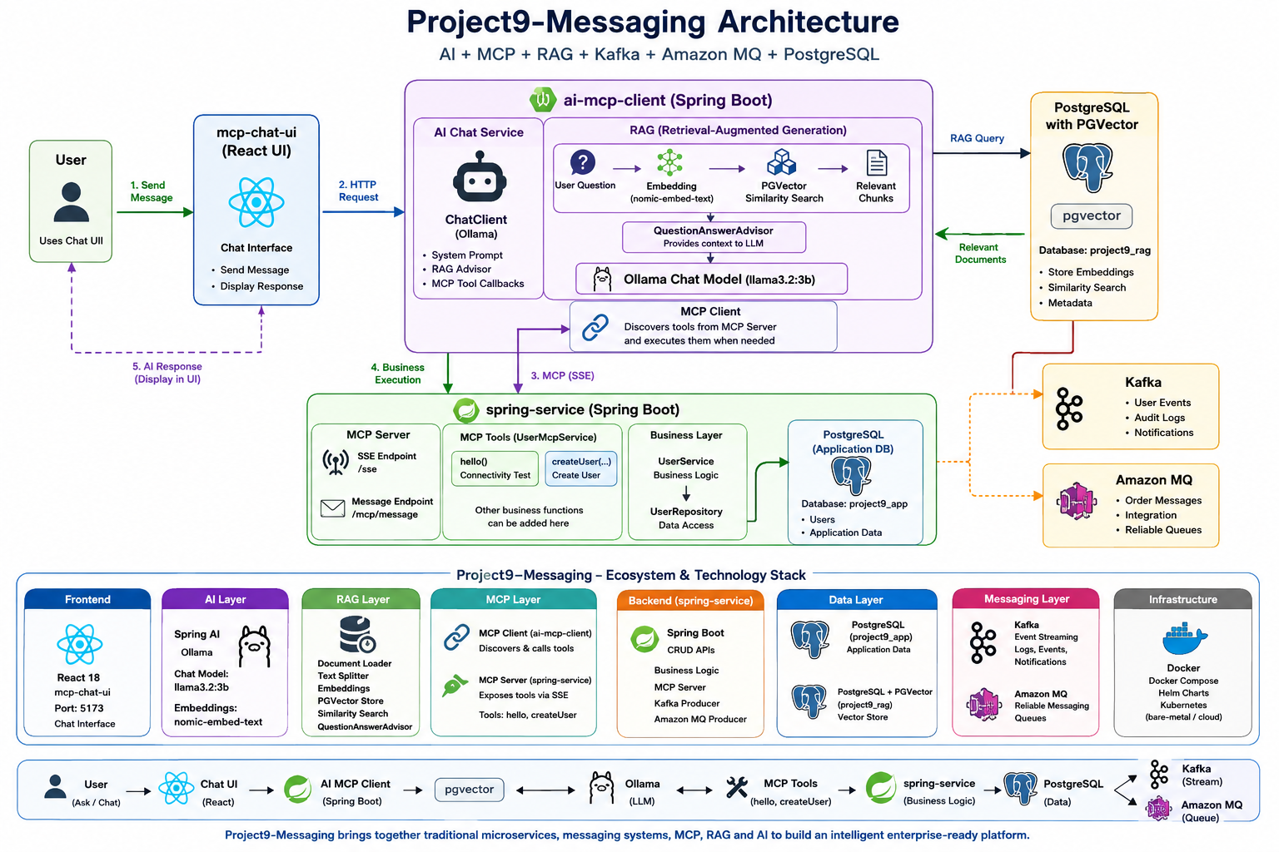

This guide documents how MCP (Model Context Protocol), an AI chat layer, RAG and a React UI were added on top of the existing spring-service CRUD microservice, and how to run every part of the stack. All commands are copied exactly as they are meant to be run — copy/paste them as-is into your terminal.

1. Project Overview
P9-MCP-CUSTOM-SERVER (Project9-Messaging) is an enterprise-style learning platform that brings together traditional Spring Boot microservices, AI, MCP, RAG, a local LLM, vector search, and messaging systems into a single end-to-end architecture.
The platform is made up of three applications:
- spring-service — the Spring Boot CRUD microservice. It owns the business logic, PostgreSQL persistence, the MCP Server, and the MCP tools.
- ai-mcp-client — the Spring AI application. It handles AI chat, the Ollama integration, RAG, PGVector, and the MCP Client.
- mcp-chat-ui — the React web interface used to talk to the AI assistant.

1.1 Core Architecture
React Chat UI
|
v
AI MCP Client
|
+---------------------+
| |
v v
RAG Ollama
| |
v v
PostgreSQL LLM
+ PGVector
|
v
MCP Client
|
v
Spring Service
|
+-------------+-------------+
| | |
v v v
PostgreSQL Kafka Amazon MQ

1.2 Key Capabilities

AI & RAG
- Local LLM inference using Ollama
- llama3.2 for chat generation
- nomic-embed-text for embeddings
- PostgreSQL + PGVector for vector storage
- Document chunking and similarity search
- QuestionAnswerAdvisor for retrieval-augmented generation

MCP
- MCP Server hosted inside spring-service
- MCP Client hosted inside ai-mcp-client
- Current tools: hello, createUser
- MCP lets the AI assistant call real application functionality instead of only generating text

Messaging
- Kafka for event streaming and application events
- Amazon MQ for reliable queue-based messaging
- A provider-based design lets the messaging implementation be selected through configuration

Deployment
- Local / bare-metal execution
- Docker
- Kubernetes
- Helm
- Environment-variable based configuration so the same build works in every environment

1.3 End-to-End Request Flow
A typical request travels through:
User → React UI → AI MCP Client → RAG / Ollama → MCP Client → Spring Service → PostgreSQL / Kafka / Amazon MQ
This is the same idea used by a Claude Desktop / MCP host style client:
USER
|
v
Claude Desktop (or any MCP host, e.g. Cursor)
|
v
MCP Host
|
v
MCP Client
==================================
MCP Protocol
==================================
|
v
Spring Boot MCP Server
|
+----------+----------+
| | |
v v v
User Tool Audit Tool Messaging Tool
|
v
UserService / AuditService / MessagingService
|
+----------+----------+
| | |
v v v
PostgreSQL Kafka AmazonMQ

1.4 Current vs. Target Architecture
Current architecture: Target architecture:

REST REST MCP
| | |
v v v
Controller Controller MCP Tools
| | |
v +-----+-----+
Service |
| v
v Service Layer
Repository |
v
Repository

2. Part 1 — Building the MCP Server (Module 9.1)

Step 1 — Create the MCP Package Structure
Before writing any tool, create the package layout that will hold the MCP code inside spring-service. This is exactly the same layout convention already used for REST — packages such as tools, dto, model, exception and util play the same role as controller, dto, entity and exception do for REST.
Current project layout (spring-service):
spring-service
├── Dockerfile
├── HELP.md
├── mvnw
├── mvnw.cmd
├── pom.xml
├── src
│ ├── main
│ │ ├── java/com/company/spring_service
│ │ │ ├── config/RestTemplateConfig.java
│ │ │ ├── controller/UserController.java
│ │ │ ├── dto/ApiResponse.java, UserRequest.java
│ │ │ ├── entity/AuditLog.java, User.java
│ │ │ ├── event/BaseEvent.java, EventType.java,
│ │ │ │ UserCreatedEvent.java, ...
│ │ │ ├── exception/GlobalExceptionHandler.java, ServiceException.java
│ │ │ ├── messaging/
│ │ │ │ ├── amazonmq/{config,consumer,producer,provider}
│ │ │ │ ├── kafka/{config,consumer,producer,provider}
│ │ │ │ ├── broker/MessagingProvider.java
│ │ │ │ ├── config/MessagingConfiguration.java
│ │ │ │ ├── exception/MessagingProviderNotFoundException.java
│ │ │ │ ├── factory/MessagingProviderFactory.java
│ │ │ │ ├── properties/MessagingProperties.java
│ │ │ │ └── service/MessagingService.java
│ │ │ ├── repository/AuditLogRepository.java, UserRepository.java
│ │ │ ├── service/AuditService.java, PythonClientService.java,
│ │ │ │ UserService.java
│ │ │ └── SpringServiceApplication.java
│ │ └── resources/application.properties, log4j2.xml
│ └── test/java/com/company/spring_service/SpringServiceApplicationTests.java
└── target/ ...
Create the new mcp package and its sub-packages inside spring-service (commands run from src/main/java/com/company/spring_service):
mkdir mcp
cd mcp
mkdir config
mkdir -p tools dto model exception util
Note: On macOS/BSD, mkdir does not support -r. Use -p to create nested/multiple directories in one call, as shown above.

What each new package is for
tools — contains the MCP tools: UserTool, AuditTool, MessagingTool, HealthTool. Think of these as the MCP equivalent of REST Controllers.
dto — tool request/response objects — exactly like REST DTOs.
model — will hold tool metadata, MCP models and shared classes.
exception — custom MCP exceptions.
util — helper utilities.

Step 2 — Understand What Happens Internally
Understanding the startup sequence matters more than copying dependencies. Before MCP is added, Spring Boot starts like this:
SpringApplication.run()
|
v
Component Scan
|
v
@RestController
|
v
DispatcherServlet
|
v
Application Ready
After MCP is added, Spring Boot brings up a second, independent pipeline alongside REST:
SpringApplication.run()
|
v
Component Scan
|
v
@RestController
|
v
MCP Tool Scan
|
v
Tool Registry
|
v
MCP Server
|
v
Application Ready
Note: Spring Boot now starts two independent infrastructures — REST and MCP — and both run side by side.

Step 3 — The First Tool: hello()
The first tool to build is deliberately not UserTool or MessagingTool — it is a plain hello() tool, because it teaches the entire request lifecycle without the extra moving parts of a database, Kafka, or PostgreSQL.
Tool Registration
|
v
Discovery
|
v
Invocation
|
v
Response
Internal flow, for example when an MCP client such as Cursor calls hello:
Cursor
|
v
MCP Client
|
v
Spring MCP Server
|
v
HelloTool
|
v
String Response
|
v
Cursor
This mirrors the familiar REST request lifecycle:
Browser
|
v
DispatcherServlet
|
v
Controller
|
v
Response

Step 4 — Project Milestones
The MCP layer was implemented in this order:
- Milestone 1 — MCP Server starts, with no tools registered yet (just startup).
- Milestone 2 — Hello Tool.
- Milestone 3 — Health Tool.
- Milestone 4 — User Tool, reusing the existing UserService.
- Milestone 5 — Messaging Tool, reusing the existing MessagingService.
- Milestone 6 — Audit Tool, reusing the existing AuditService.

3. Part 2 — Add Spring AI MCP to the Project (Module 9.2)
Goal for this module: the application should compile, start successfully, and have the MCP infrastructure auto-configured. No tools are wired up yet — that comes next. This is the same pattern used earlier in the project when the Kafka dependency was added before writing a producer.

Step 1 — Why the WebMVC Starter
spring-service already depends on spring-boot-starter-web, which means it runs on Spring MVC. Because of that, the project uses the WebMVC MCP starter rather than WebFlux — this is also what the Spring AI documentation recommends when spring-boot-starter-web is already present.

Step 2 — Add the Spring AI BOM
Inside pom.xml, add the Spring AI BOM to <dependencyManagement>:
<!-- ========================================================== -->
<!-- Dependency Management -->
<!-- ========================================================== -->
<dependencyManagement>
<dependencies>
<!-- Spring AI BOM -->
<dependency>
<groupId>org.springframework.ai</groupId>
<artifactId>spring-ai-bom</artifactId>
<version>2.0.0</version>
<type>pom</type>
<scope>import</scope>
</dependency>
</dependencies>
</dependencyManagement>
<!-- ========================================================== -->
<!-- Dependencies -->
<!-- ========================================================== -->

Step 3 — Add the MCP Server Starter
Add the MCP server starter dependency:
<dependency>
<groupId>org.springframework.ai</groupId>
<artifactId>spring-ai-starter-mcp-server-webmvc</artifactId>
</dependency>
This starter provides:
- MCP Server
- Tool registry
- JSON-RPC handling
- Tool discovery
- Streamable HTTP support
- Spring Boot auto-configuration

Step 4 — What This Dependency Actually Adds
Adding this single dependency conceptually brings in an entire subsystem, not just one JAR:
Spring AI MCP
|
+-- MCP Server
+-- JSON-RPC Engine
+-- Tool Registry
+-- Tool Dispatcher
+-- Schema Generator
+-- Transport Layer
+-- Auto Configuration

Step 5 — Startup Sequence, Before and After
Before MCP:
SpringApplication
|
v
Auto Configuration
|
v
DispatcherServlet
|
v
@RestController
|
v
Application Started
After MCP:
SpringApplication
|
v
Auto Configuration
|
v
DispatcherServlet
|
v
MCP Auto Configuration
|
v
Tool Registry
|
v
Transport Provider
|
v
Application Started
Note: None of these classes are instantiated manually — Spring Boot creates and wires all of them automatically.

Step 6 — MCP Server Configuration (application.properties)
# ==========================================================
# MCP SERVER
# ==========================================================
spring.ai.mcp.server.enabled=true

# Server identity
spring.ai.mcp.server.name=spring-service-mcp
spring.ai.mcp.server.version=1.0.0

# Transport
spring.ai.mcp.server.protocol=STREAMABLE

# Server type
spring.ai.mcp.server.type=SYNC

# Description shown to MCP clients
spring.ai.mcp.server.instructions=Enterprise Spring Boot MCP Server exposing User, Messaging, Audit and Health tools.

# Enable MCP capabilities
spring.ai.mcp.server.capabilities.tool=true
spring.ai.mcp.server.capabilities.resource=true
spring.ai.mcp.server.capabilities.prompt=true
spring.ai.mcp.server.capabilities.completion=true

# Automatically scan @Tool annotations
spring.ai.mcp.server.annotation-scanner.enabled=true

# MCP endpoint
spring.ai.mcp.server.streamable-http.mcp-endpoint=/mcp

# Request timeout
spring.ai.mcp.server.request-timeout=20s

Architecture After This Step
Spring Boot
|
+-- REST Controllers
|
+-- MCP Infrastructure
| +-- JSON-RPC
| +-- Tool Registry
| +-- Transport
| +-- Dispatcher
|
+-- Services

4. Fixing Common Startup Issues
These are real issues hit while bringing MCP up for the first time, kept here so the next person does not have to re-diagnose them.

4.1 log4j / SLF4J conflict on test run
Running the test suite failed with:
java.lang.ExceptionInInitializerError
Caused by: org.apache.logging.log4j.LoggingException:
log4j-slf4j2-impl cannot be present with log4j-to-slf4j
The cause was visible in the dependency tree:
mvn dependency:tree | grep log

[INFO] +- org.springframework.boot:spring-boot-starter-log4j2:jar:4.0.0:compile
[INFO] | +- org.apache.logging.log4j:log4j-slf4j2-impl:jar:2.25.2:compile
[INFO] | +- org.apache.logging.log4j:log4j-core:jar:2.25.2:compile
[INFO] | \- org.apache.logging.log4j:log4j-jul:jar:2.25.2:compile
[INFO] +- org.apache.logging.log4j:log4j-layout-template-json:jar:2.25.2:compile
[INFO] | +- org.springframework.boot:spring-boot-starter-logging:jar:4.0.0:compile
[INFO] | | +- ch.qos.logback:logback-classic:jar:1.5.21:compile
[INFO] | | \- org.apache.logging.log4j:log4j-to-slf4j:jar:2.25.2:compile
Both log4j-slf4j2-impl (from spring-boot-starter-log4j2) and log4j-to-slf4j (pulled in transitively through spring-boot-starter-logging) ended up on the classpath at the same time, which Log4j2 refuses to allow. When you hit this, exclude the conflicting transitive dependency from whichever starter is pulling it in, so only one SLF4J binding remains on the classpath.

4.2 Wrong package name
An early version of HelloTool.java used the wrong package for this project and did not get picked up by component scanning:
package com.company.springservice.mcp.tools; // incorrect — no underscore
package com.company.spring_service.mcp.tools; // correct — matches the module's base package
Note: Always match the base package used by SpringServiceApplication.java exactly (spring_service, with an underscore) so component scanning finds the class.

4.3 /mcp and /mcp/sse return 500 / "No static resource"
Hitting /mcp or /mcp/sse directly with a plain GET returns errors such as:
org.springframework.web.servlet.resource.NoResourceFoundException: No static resource mcp.
org.springframework.web.servlet.resource.NoResourceFoundException: No static resource mcp/sse.
This is expected — those routes are not simple REST endpoints. The real transport endpoints created by the Spring AI MCP Server WebMVC starter are:
GET /sse -> opens the SSE (Server-Sent Events) stream and returns a sessionId
POST /mcp/message -> where the client sends JSON-RPC requests, using that sessionId
This can be confirmed from the startup log:
grep -i "McpServerAutoConfiguration" startup.log

INFO org.springframework.ai.mcp.server.autoconfigure.McpServerAutoConfiguration :
Enable tools capabilities, notification: true
Enable resources capabilities, notification: true
Enable prompts capabilities, notification: true
Enable completions capabilities
The flow, once the dependency and configuration above are in place:
pom.xml
| spring-ai-starter-mcp-server-webmvc
v
Spring AI MCP Server Auto Configuration
|
v
WebMvcSseServerTransportProvider
|
+-- GET /sse
+-- POST /mcp/message

MCP Server
|
+----------------+----------------+
| |
Transport MCP Features
| |
/sse Tools
/mcp/message Resources
Prompts

5. Testing the MCP Server End to End
Sanity-check the Actuator endpoint first, then walk through the raw JSON-RPC handshake with curl before relying on the AI client.

5.1 Confirm the application is up
curl -kv http://localhost:8080/actuator
Expected response includes a HAL links document listing health, info, prometheus and metrics.

5.2 Open the SSE stream and capture the session id
curl -N http://localhost:8080/sse

id:ed27035a-4a4c-48c4-91fc-66a8b558a6d2
event:endpoint
data:/mcp/message?sessionId=ed27035a-4a4c-48c4-91fc-66a8b558a6d2
Keep this terminal open — the connection must stay alive for the session to remain valid. Use the sessionId from the data: line for every following request.

5.3 Send the MCP handshake (initialize)
curl -X POST \
"http://localhost:8080/mcp/message?sessionId=NEW_SESSION_ID" \
-H "Content-Type: application/json" \
-d '{
"jsonrpc": "2.0",
"id": 1,
"method": "initialize",
"params": {
"protocolVersion": "2024-11-05",
"capabilities": {},
"clientInfo": {
"name": "curl-client",
"version": "1.0.0"
}
}
}'

5.4 Confirm the client is initialized
curl -X POST \
"http://localhost:8080/mcp/message?sessionId=NEW_SESSION_ID" \
-H "Content-Type: application/json" \
-d '{
"jsonrpc": "2.0",
"method": "notifications/initialized"
}'

5.5 List the available tools
curl -X POST \
"http://localhost:8080/mcp/message?sessionId=NEW_SESSION_ID" \
-H "Content-Type: application/json" \
-d '{
"jsonrpc": "2.0",
"id": 2,
"method": "tools/list",
"params": {}
}'
The result is delivered on the open SSE stream from step 5.2, not on the POST response itself. The POST simply returns 200 with an empty body — watch the curl -N http://localhost:8080/sse terminal for the actual JSON-RPC result.

5.6 Call the hello tool
curl -X POST \
"http://localhost:8080/mcp/message?sessionId=NEW_SESSION_ID" \
-H "Content-Type: application/json" \
-d '{
"jsonrpc": "2.0",
"id": 2,
"method": "tools/call",
"params": {
"name": "hello",
"arguments": {}
}
}'
Expected result, delivered on the SSE stream:
data:{"jsonrpc":"2.0","id":2,"result":{"content":[{"type":"text","text":"\"hello. MCP Custom Curd application server is working\""}],"isError":false}}

5.7 Proof — Actual spring-service Startup Log
This is the real terminal output captured on my machine the first time spring-service came up cleanly with MCP enabled — kept here as evidence the server actually started and MCP auto-configuration actually ran, not just that the steps above look correct on paper.
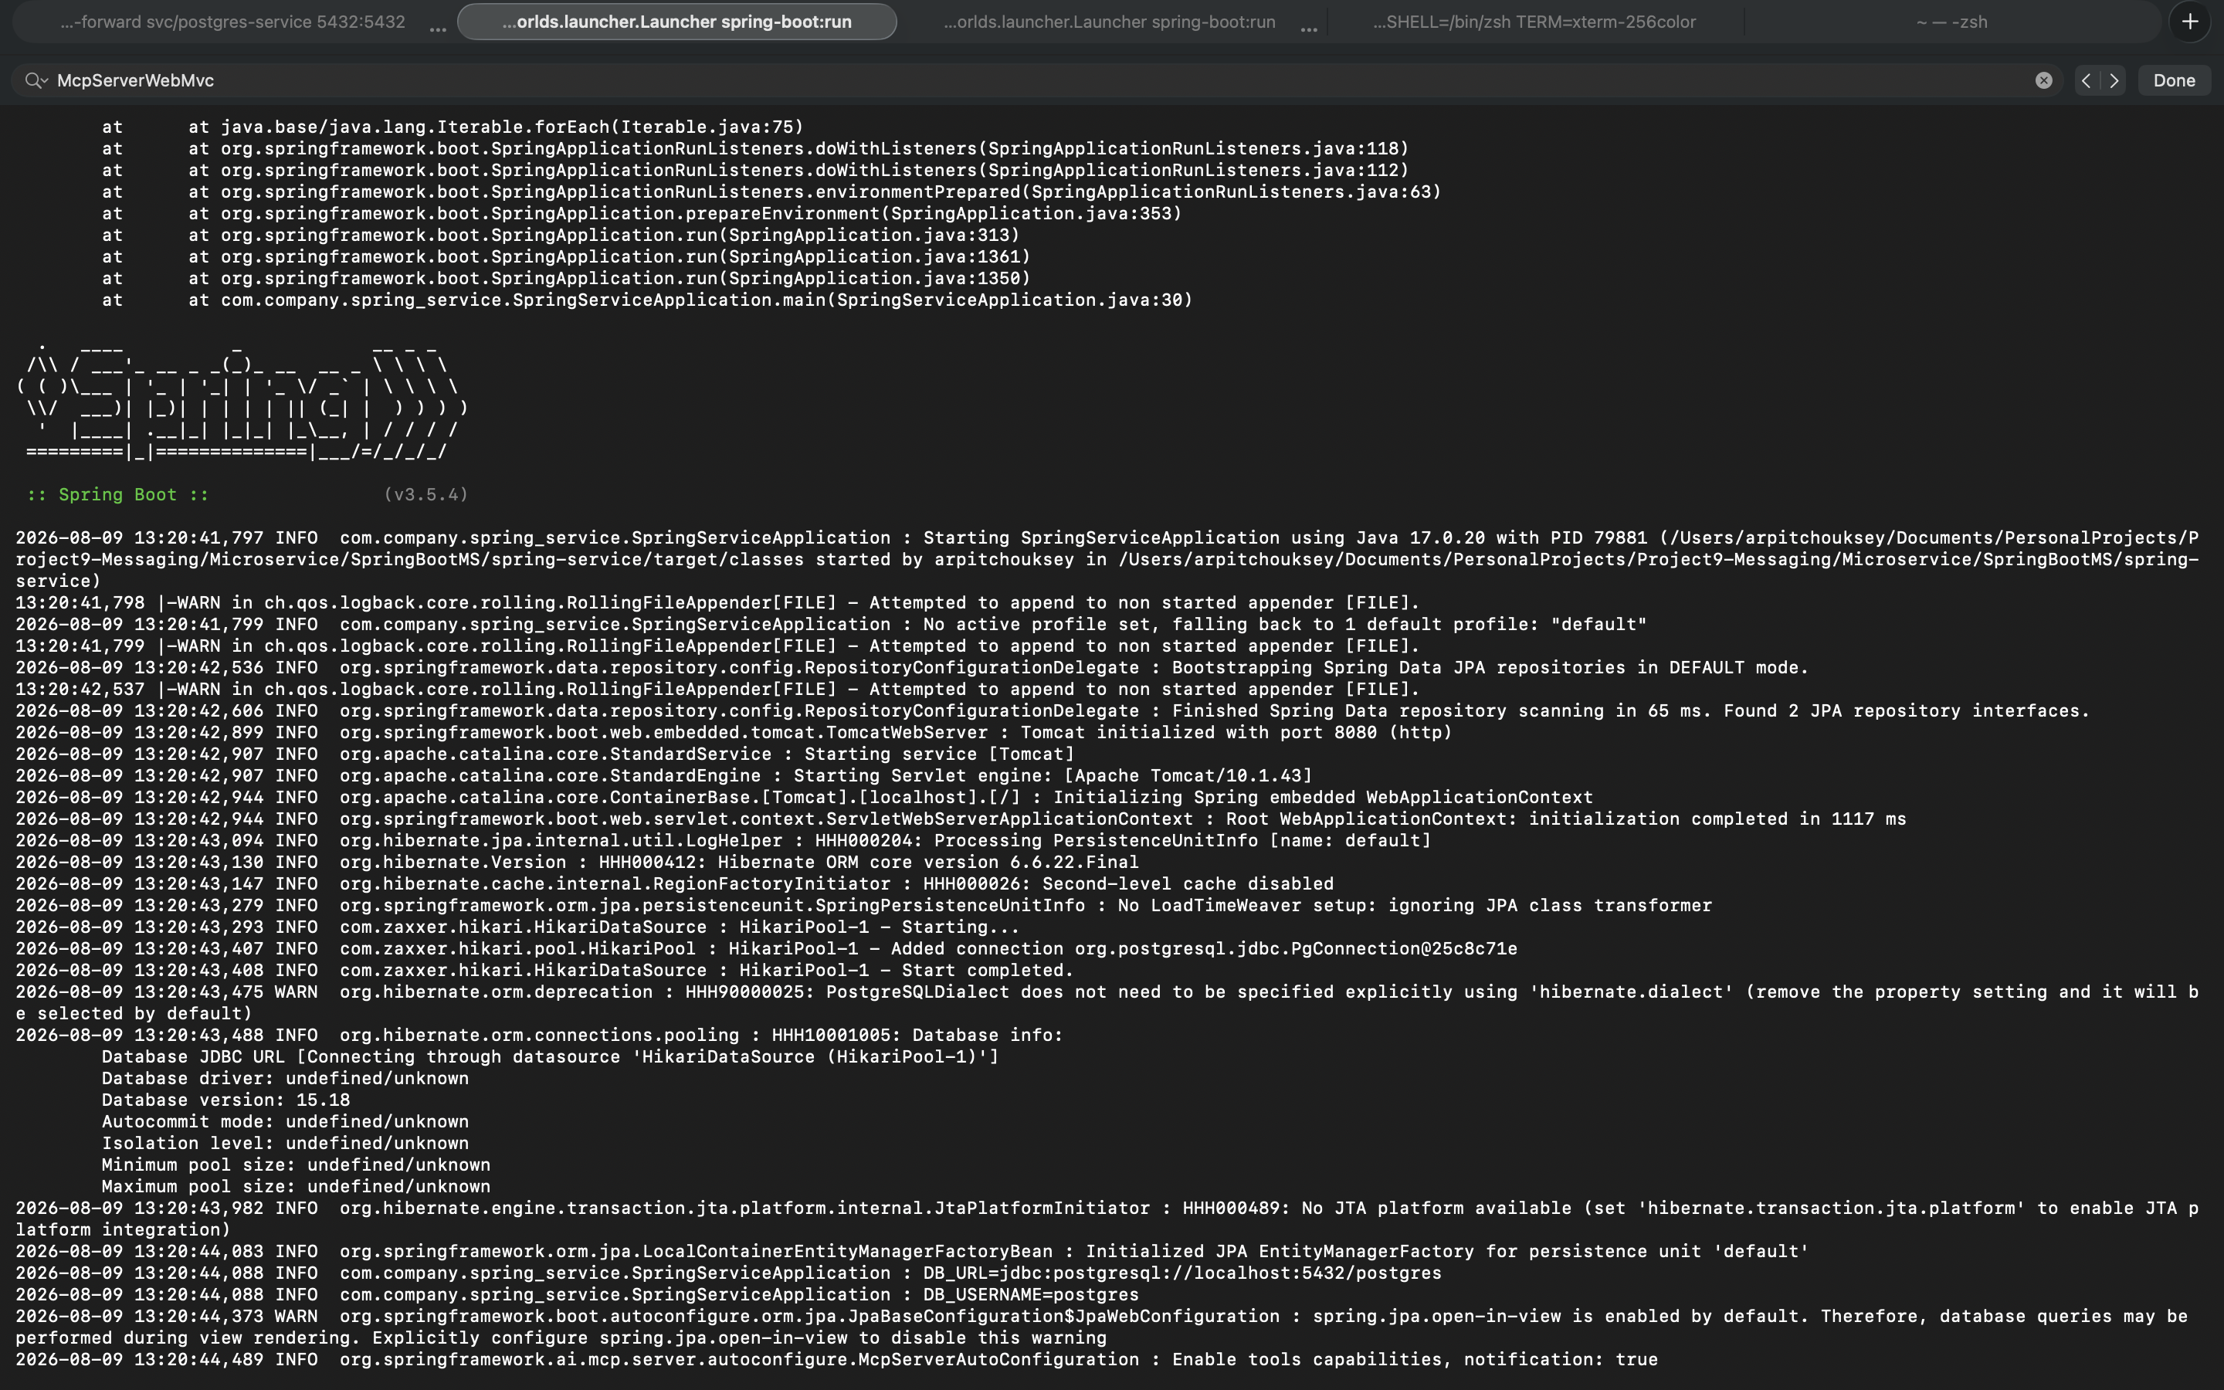
Screenshot — spring-service startup log: Spring Boot banner, Tomcat on port 8080, Hibernate/Postgres connection, and org.springframework.ai.mcp.server.autoconfigure.McpServerAutoConfiguration enabling tool capabilities.

6. Building the createUser Tool
Location: spring-service/src/main/java/com/company/spring_service/mcp/service/UserMcpService.java
@Tool(
name = "createUser",
description = "Creates a new user with name and email"
)
public String createUser(String name, String email) {
UserRequest request = new UserRequest(name, email);
userService.createUser(request);
return "User created successfully";
}
Call flow:
MCP Client / curl
|
| tools/call
v
MCP Server
|
v
UserMcpService.createUser()
|
v
UserService.createUser()
|
v
UserRepository
|
v
PostgreSQL
Together, the two tools cover:
- hello — verifies the MCP server is reachable and responding.
- createUser — calls straight into the existing application service and creates a real user row in PostgreSQL.

6.1 Proof — Users Actually Persisted in PostgreSQL
To confirm createUser was not just returning a success message but genuinely writing to the database, I connected straight into the Postgres pod running in Kubernetes and queried the users table directly:
kubectl get po
kubectl exec -it postgres-5dbcf46c4c-mn6vp -- psql -U postgres

\dt
SELECT * FROM users;
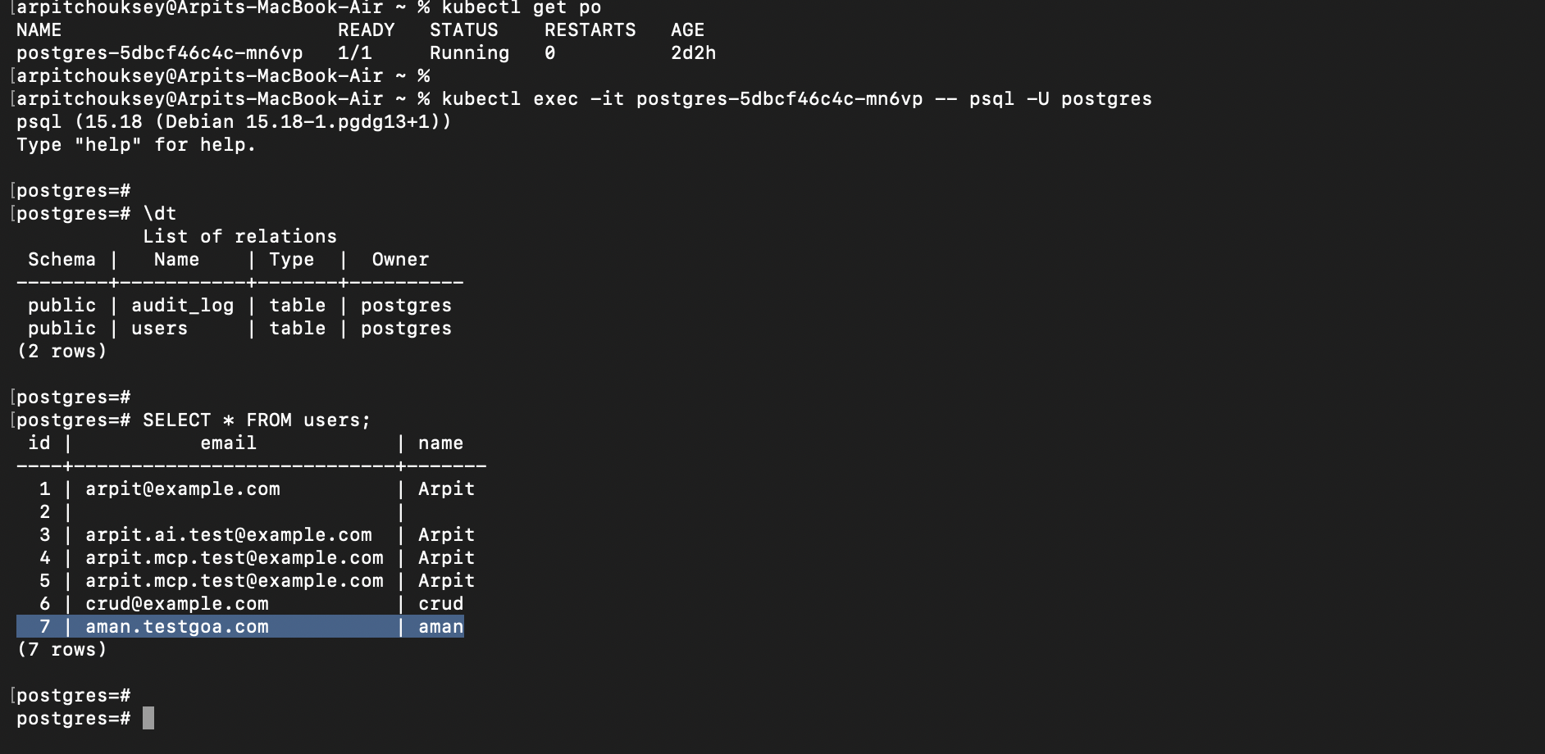
Screenshot — kubectl exec into the Postgres pod, listing tables (audit_log, users) and querying SELECT * FROM users, showing the rows created earlier through the MCP createUser tool (including the 'aman' user created via the chat UI).

7. Adding the LLM Layer (Ollama)

7.1 Install Ollama and pull a chat model
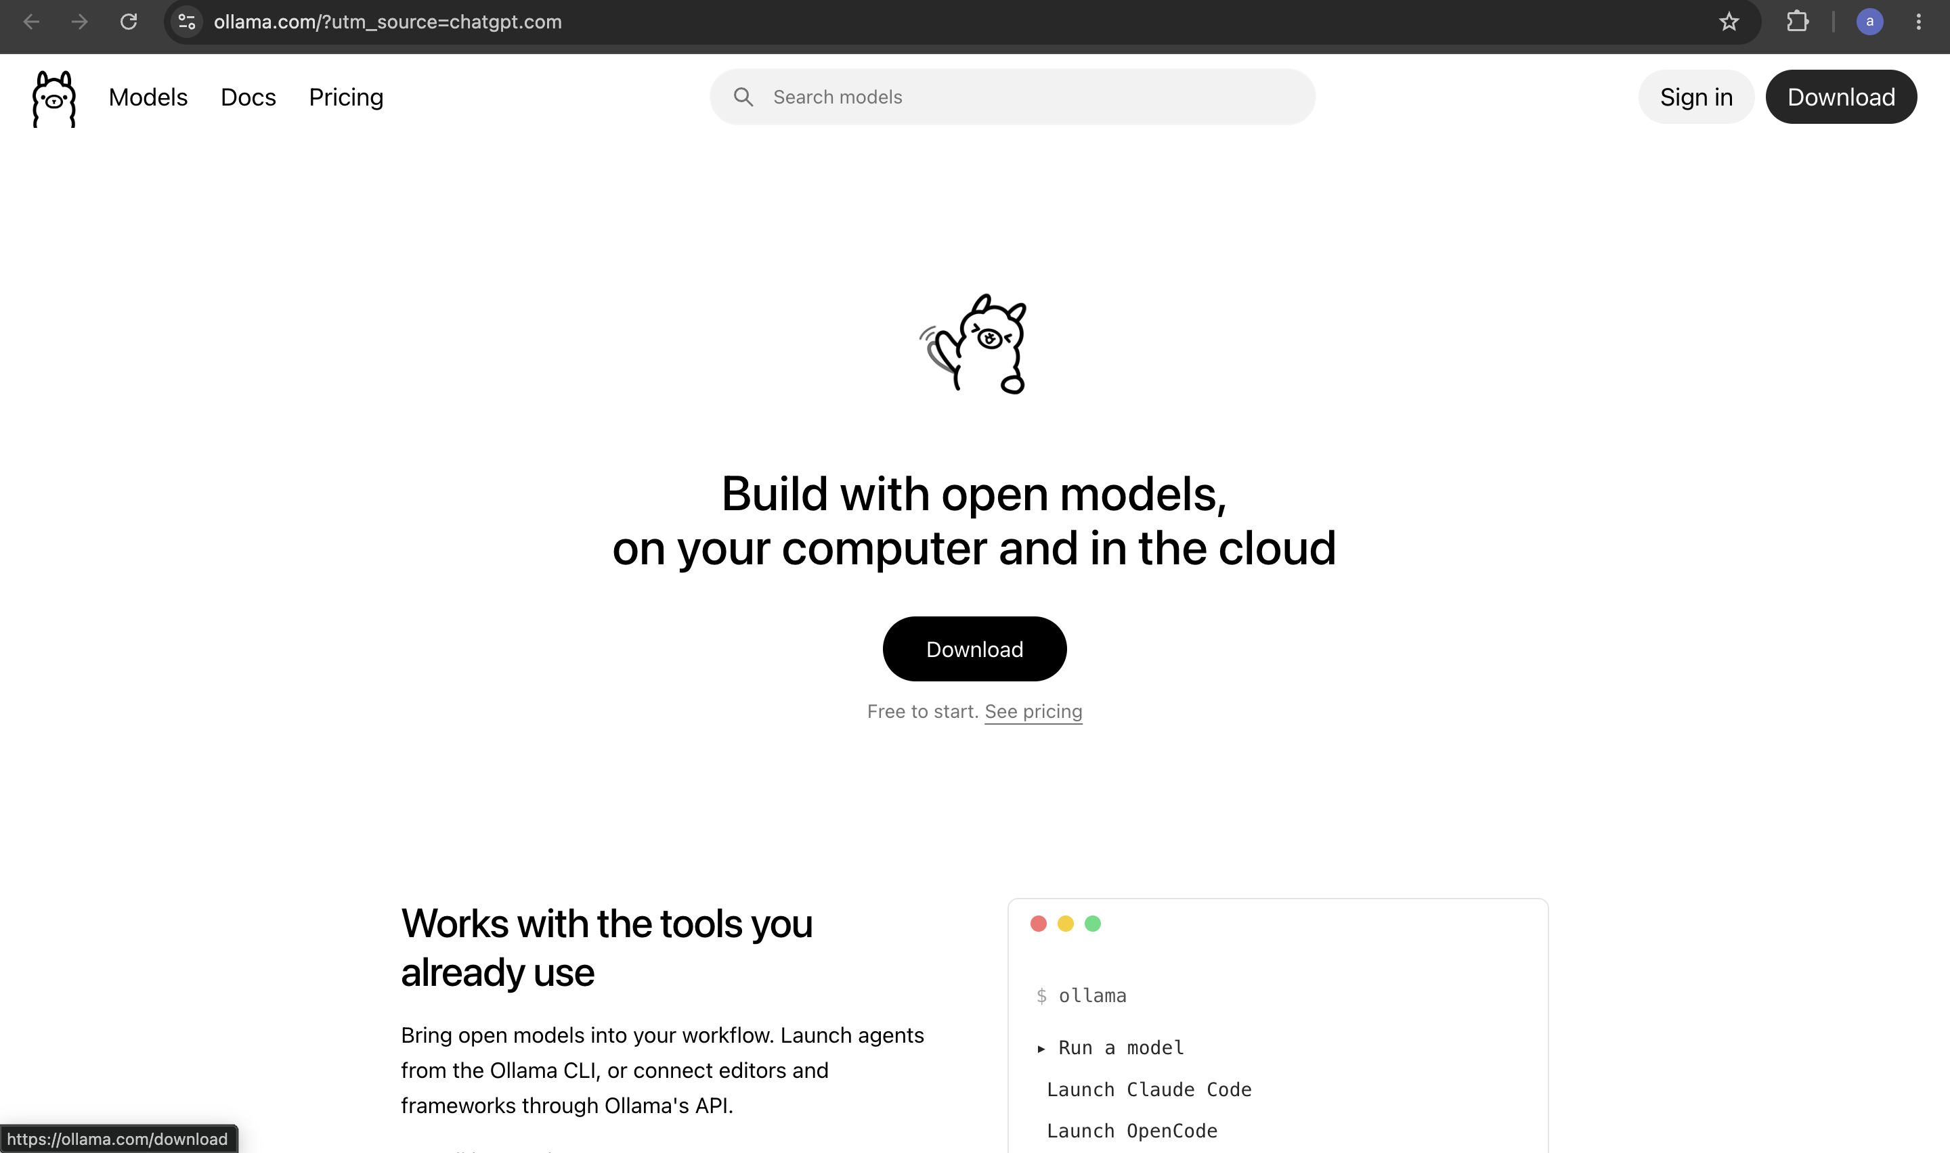
Screenshot — ollama.com, where the Ollama CLI is downloaded from.
curl -fsSL https://ollama.com/install.sh | sh
ollama pull llama3.2:3b
Run it once to confirm it responds:
ollama run llama3.2:3b
>>> Hello, are you working?

7.2 Add the Ollama dependency
<!-- ========================= -->
<!-- OLLAMA -->
<!-- ========================= -->
<dependency>
<groupId>org.springframework.ai</groupId>
<artifactId>spring-ai-starter-model-ollama</artifactId>
</dependency>

7.3 Configure Ollama
# ==========================================================
# LLM / OLLAMA
# ==========================================================
spring.ai.ollama.base-url=http://localhost:11434
spring.ai.ollama.chat.options.model=llama3.2:3b

7.4 Create the chat controller and service
AIChatController.java:
@RestController
public class AIChatController {

private final AIChatService aiChatService;

public AIChatController(AIChatService aiChatService) {
this.aiChatService = aiChatService;
}

@GetMapping("/ai/chat")
public String chat(@RequestParam String message) {
return aiChatService.chat(message);
}
}
AIChatService.java:
@Service
public class AIChatService {

private final ChatClient chatClient;

public AIChatService(ChatClient.Builder chatClientBuilder) {
this.chatClient = chatClientBuilder.build();
}

public String chat(String message) {
return chatClient
.prompt()
.user(message)
.call()
.content();
}
}
Request flow:
curl
|
v
GET /ai/chat
|
v
AIChatController
|
v
AIChatService
|
v
Spring AI ChatClient
|
v
Ollama
|
v
llama3.2:3b
|
v
Response

7.5 Test the chat endpoint
curl --get \
--data-urlencode "message=Use the hello tool and tell me its result" \
http://localhost:8080/ai/chat
At this point the two independent pieces are both working:
- LLM side: Spring Boot → Spring AI → Ollama → LLM
- MCP side: MCP → createUser → UserService → PostgreSQL
The next step connects them together, so that the model itself can decide to call createUser.

8. Connecting the MCP Client to the MCP Server

8.1 Tool calling vs. real MCP client/server communication
When the ChatClient is wired up directly with .toolCallbacks(userMcpTools), the model can already call createUser, but the call path is:
AI
|
v
ChatClient
|
v
Ollama
|
v
ToolCallback
|
v
UserMcpService
That is tool calling through a Java callback, not MCP-client-to-MCP-server communication over the wire. The target architecture instead routes the call through a real MCP Client talking MCP protocol to the MCP Server exposed by spring-service:
AI
|
v
MCP Client
|
v
MCP Protocol
|
v
MCP Server
|
v
UserMcpService

8.2 Two-service architecture
User
|
v
+-------------------+
| ai-mcp-client |
| :8081 |
| |
| /ai/chat |
| | |
| v |
| ChatClient |
| | |
| v |
| Ollama |
| | |
| v |
| MCP Client |
+---------+-----------+
|
MCP/SSE
|
v
+-------------------+
| spring-service |
| :8080 |
| |
| MCP Server |
| | |
| v |
| UserMcpService |
| | |
| v |
| UserService |
| | |
| v |
| PostgreSQL |
+-------------------+

8.3 Configure the MCP connection
File: ai-mcp-client/src/main/resources/application.properties
spring.ai.mcp.client.sse.connections.spring-service.url=http://localhost:8080
spring.ai.mcp.client.sse.connections.spring-service.sse-endpoint=/sse
These two lines tell ai-mcp-client: "My MCP server is at localhost:8080, and its SSE endpoint is /sse."

8.4 Proof — Actual ai-mcp-client Startup Log
This is the real startup log from ai-mcp-client, captured the moment the MCP Client successfully completed its handshake with spring-service-mcp — the i.m.client.McpAsyncClient line shows the negotiated protocol version, the server capabilities (tools, prompts, resources), and the server name spring-service-mcp, followed by Tomcat starting on port 8081.
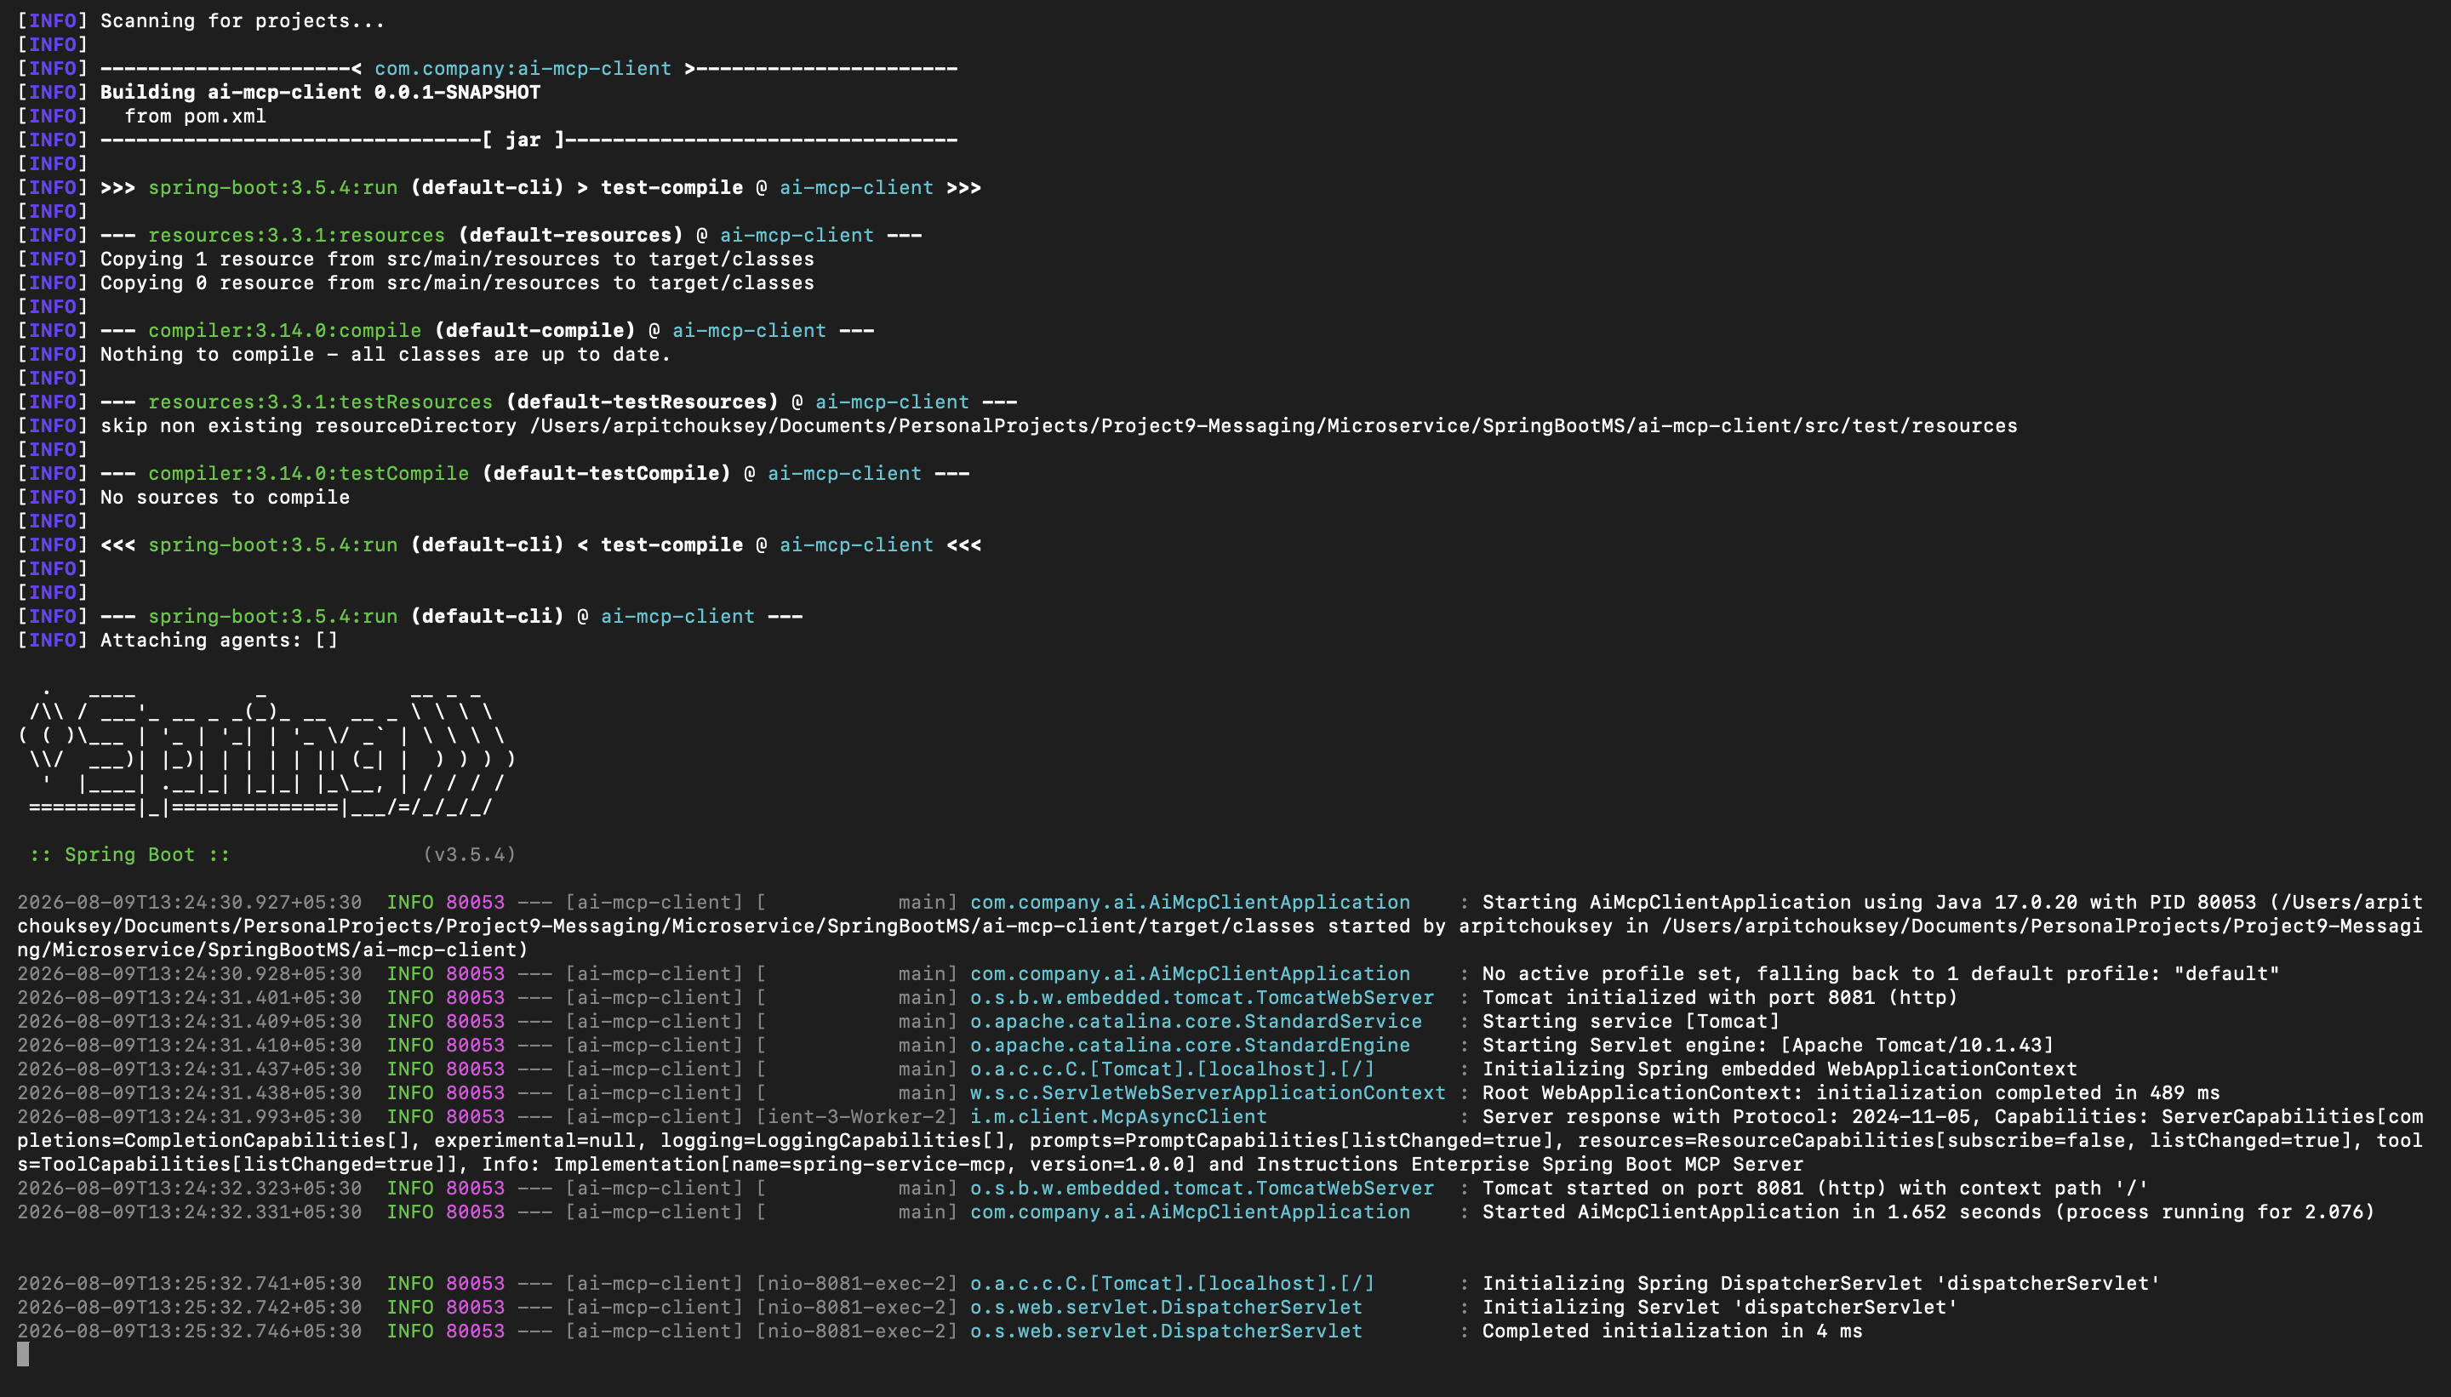
Screenshot — ai-mcp-client startup log: Spring Boot banner, then McpAsyncClient reporting 'Server response with Protocol: 2024-11-05 ... Info: Implementation[name=spring-service-mcp, version=1.0.0]', followed by Tomcat starting on port 8081.

8.5 List the tools discovered through the MCP Client
curl http://localhost:8081/mcp/tools
Expected result:
["ai_mcp_client_spring_service_createUser","ai_mcp_client_spring_service_hello"]

8.6 Drive it through natural language
curl --get \
--data-urlencode "message=Use the hello tool and tell me its result" \
http://localhost:8081/ai/chat
curl --get \
--data-urlencode "message=Create a user named Arpit with email arpit.mcp.test@example.com" \
http://localhost:8081/ai/chat
Full round trip once this works:
User: "Create a user named Arpit with email arpit@example.com"
|
v
ai-mcp-client :8081
|
v
ChatClient -> Ollama / LLM -> decides to call "createUser"
|
v
MCP Client
|
| MCP protocol
v
spring-service :8080 -> MCP Server -> createUser tool
|
v
UserMcpService -> UserService -> UserRepository -> PostgreSQL
|
v
Result flows back: PostgreSQL -> UserService -> MCP Server ->
MCP Client -> ChatClient -> Ollama -> /ai/chat -> curl

8.7 What exists at this point
- MCP Server — yes. Implemented by UserMcpService.java and McpToolConfig.java, exposed by Spring AI on /sse and /mcp/message.
- AI application — yes. Implemented by AIChatController.java and AIChatService.java, exposed on /ai/chat, calling ChatClient -> Ollama.
- MCP Client — yes, once the spring.ai.mcp.client.sse.connections.* properties above are set. This is what lets the LLM reach the MCP Server over the real MCP protocol instead of a local Java callback.

9. Building the React Chat UI (mcp-chat-ui)

9.1 Scaffold the project
npm create vite@latest mcp-chat-ui -- --template react
When prompted:
- Linter: Oxlint
- Install with npm and start now: Yes
This creates mcp-chat-ui/ with a working Vite dev server on port 5173 by default.
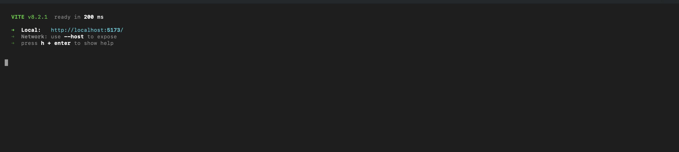
Screenshot — Vite dev server output confirming it is ready and serving on http://localhost:5173/.
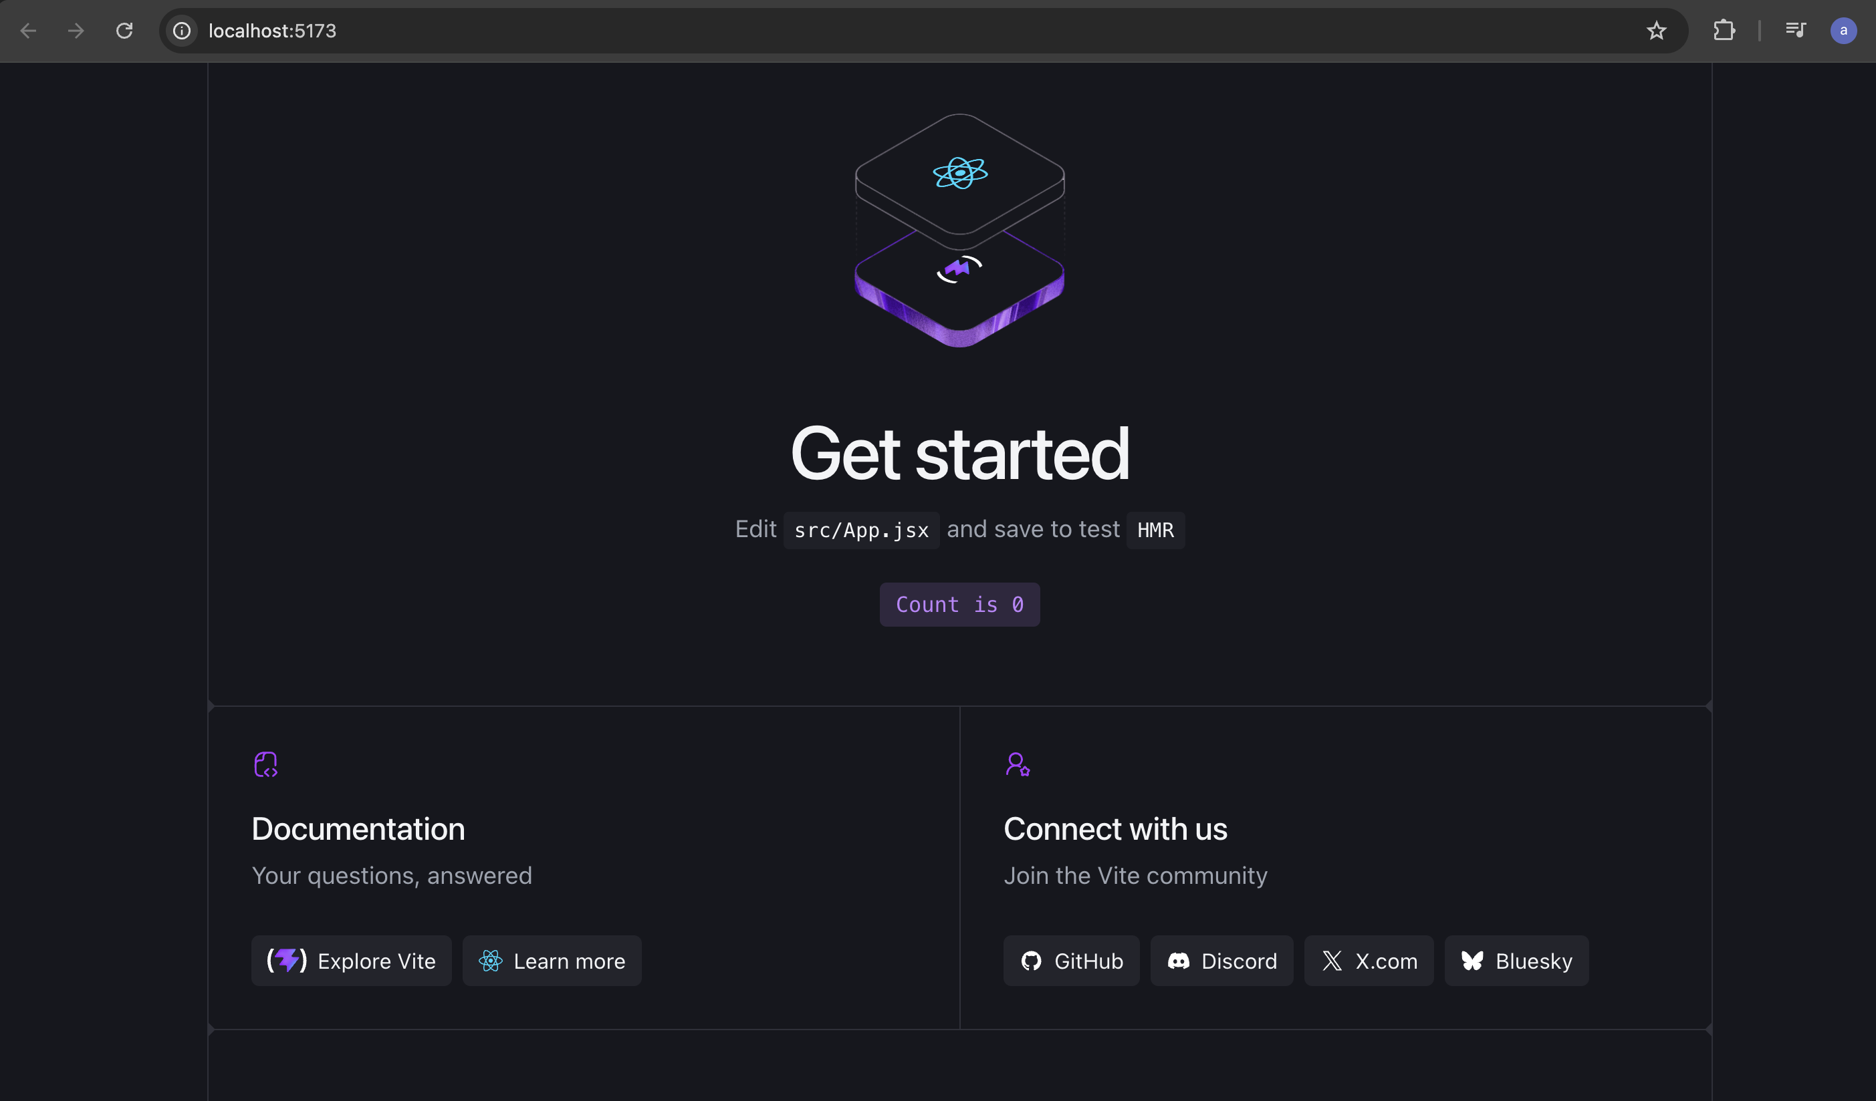
Screenshot — the default Vite + React scaffold loading in the browser at localhost:5173, confirming the project was created correctly before any custom chat UI code was added.

9.2 Project structure
Kept intentionally simple:
mcp-chat-ui/
├── package.json
├── index.html
├── src/
│ ├── App.jsx
│ ├── App.css
│ ├── main.jsx
│ └── services/
│ └── chatService.js
└── ...
cd src
mkdir services

9.3 chatService.js
This file is the only place that knows how to reach the backend:
const AI_API_URL = "http://localhost:8081/ai/chat";

export async function sendMessage(message) {
const response = await fetch(
`${AI_API_URL}?message=${encodeURIComponent(message)}`
);

if (!response.ok) {
throw new Error(`Request failed: ${response.status}`);
}

return await response.text();
}

9.4 What the UI looks like
+--------------------------------------------------------+
| MCP Custom CRUD Assistant |
+--------------------------------------------------------+
| |
| You |
| +----------------------------------------------------+ |
| | Create a user named Arpit with email arpit@x.com | |
| +----------------------------------------------------+ |
| |
| Assistant |
| +----------------------------------------+ |
| | User Arpit has been created successfully.| |
| +----------------------------------------+ |
| |
+----------------------------------------------------------+
| Type your message... [ Send ] |
+----------------------------------------------------------+
Data path: React Chatbot → HTTP → ai-mcp-client :8081 (/ai/chat) → Spring AI → Ollama → MCP Client → MCP/SSE → spring-service :8080 → MCP Server → MCP Tools → UserService → DB.

9.5 Proof — the Real UI, Live and Working
The mock-up above is what was sketched out before building the UI. This is the actual mcp-chat-ui application running in the browser, holding a real conversation that calls the hello tool and then the createUser tool through the full MCP path described in this guide.
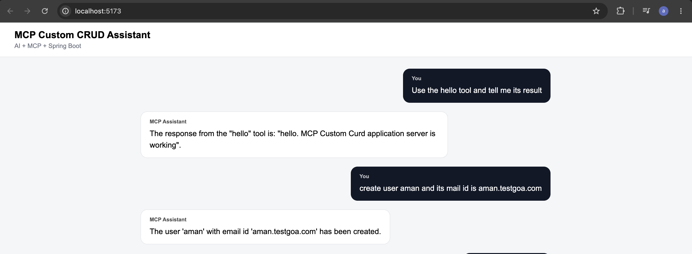
Screenshot — MCP Custom CRUD Assistant running live at localhost:5173. 'Use the hello tool and tell me its result' returns the real hello tool response, and 'create user aman and its mail id is aman.testgoa.com' results in the assistant confirming the user was created — proof the AI, MCP Client, MCP Server and UserService chain all worked together end to end.

10. Adding RAG (Retrieval-Augmented Generation)

10.1 Why
Without RAG, the model only knows what is in its training data plus whatever tools it calls. RAG lets it also answer from this project's own documentation.
Before:
React
|
v
AI MCP Client
|
v
Ollama
|
v
MCP Client
|
v
MCP Server
|
v
Tools
After adding RAG:
React
|
v
AI MCP Client
|
+----------------+----------------+
| |
v v
RAG Retrieval MCP Client
| |
v v
Vector Store MCP Server
| |
v v
Documents CRUD Tools
| |
+----------------+----------------+
|
v
Ollama
|
v
Answer
Query types after this step:
- "What is our messaging architecture?" -> handled by RAG
- "Create user Arpit" -> handled by MCP
- "Explain our user creation process and then create Arpit" -> handled by RAG + MCP together

10.2 Add dependencies to ai-mcp-client/pom.xml
<!-- PGVector -->
<dependency>
<groupId>org.springframework.ai</groupId>
<artifactId>spring-ai-starter-vector-store-pgvector</artifactId>
</dependency>

<!-- RAG Advisor -->
<dependency>
<groupId>org.springframework.ai</groupId>
<artifactId>spring-ai-vector-store-advisor</artifactId>
</dependency>

<!-- PostgreSQL -->
<dependency>
<groupId>org.postgresql</groupId>
<artifactId>postgresql</artifactId>
<scope>runtime</scope>
</dependency>
Note: spring-ai-starter-model-ollama is already a dependency from Part 7 — Spring AI reuses it for embeddings too, no extra starter needed.

10.3 Pull the embedding model
ollama pull nomic-embed-text
Confirm both models are present:
ollama list

NAME ID SIZE MODIFIED
nomic-embed-text:latest 0a109f422b47 274 MB ...
llama3.2:3b a80c4f17acd5 2.0 GB ...

10.4 Load and query the knowledge base
Load the project documentation into PGVector:
curl -X POST http://localhost:8081/rag/load
Expected response:
Project knowledge loaded successfully. Chunks created: 8
Ask a question that can only be answered from the loaded documentation:
curl --get \
--data-urlencode "message=Which port does ai-mcp-client run on?" \
http://localhost:8081/ai/chat
Result flow for RAG + MCP together:
User
|
v
ChatClient
|
+--------+--------+
| |
v v
RAG MCP
| |
v v
PGVector MCP Client
| |
v v
Project Context MCP Server
| |
| v
| Tools
+--------+--------+
|
v
Ollama
|
v
Response
Note: For the current, fully accurate list of RAG endpoints, environment variables, and test prompts, see the project README.md in SpringBootMS/ — this guide focuses on the reasoning behind each step, and the README is kept as the up-to-date operational reference.

11. Deployment Notes (Docker / Kubernetes / Helm)
Once all three applications work locally, the same environment-variable-driven configuration lets them run unchanged in containers and in Kubernetes.

11.1 Confirming the cluster is up
kubectl get po

NAME READY STATUS RESTARTS AGE
ai-mcp-client-5fd547b4f-xkwx2 1/1 Running 0 2m33s
kafka-5c6c58bc87-vqzxb 1/1 Running 0 14h
mcp-chat-ui-6d998c58fc-dsmdb 1/1 Running 0 2m33s
postgres-cb5bd7bfd-bw8mm 1/1 Running 0 14h
spring-service-85f575557d-jj95m 1/1 Running 0 5m21s

11.2 Exercising the API and MCP endpoint through the service
curl -i -X POST http://localhost:8080/api/users \
-H "Content-Type: application/json" \
-d '{
"name": "Arpit",
"email": "arpit@example.com"
}'
curl -i http://localhost:8080/sse

HTTP/1.1 200
Cache-Control: no-cache
Content-Type: text/event-stream
Transfer-Encoding: chunked

id:24850508-de61-4eff-b763-44413c6fc2e1
event:endpoint
data:/mcp/message?sessionId=24850508-de61-4eff-b763-44413c6fc2e1

11.3 Testing service-to-service connectivity from inside a pod
kubectl exec -it ai-mcp-client-5fd547b4f-xkwx2 -- sh

$ wget -S -O - http://spring-service:8080/sse
This confirms the ai-mcp-client pod can reach the spring-service MCP endpoint using the Kubernetes service DNS name (spring-service), the same way spring.ai.mcp.client.sse.connections.spring-service.url is configured for the cluster.

11.4 Installing Ollama via Helm
helm install ollama .

NAME: ollama
LAST DEPLOYED: ...
NAMESPACE: default
STATUS: deployed
REVISION: 1
DESCRIPTION: Install complete
kubectl get svc

NAME TYPE CLUSTER-IP EXTERNAL-IP PORT(S) AGE
ai-mcp-client ClusterIP 10.103.254.161 <none> 8081/TCP 4h19m
kafka-service ClusterIP 10.96.161.123 <none> 9092/TCP,9093/TCP 14h
mcp-chat-ui ClusterIP 10.105.20.191 <none> 80/TCP 4h12m
ollama-service ClusterIP 10.110.135.230 <none> 11434/TCP 6s
postgres-service ClusterIP 10.96.73.11 <none> 5432/TCP 14h
spring-service ClusterIP 10.106.1.218 <none> 8080/TCP 31m
kubectl exec deployment/ollama -- ollama pull llama3.2
kubectl exec deployment/ollama -- ollama ps

NAME ID SIZE PROCESSOR CONTEXT UNTIL
nomic-embed-text:latest 0a109f422b47 376 MB 100% CPU 2048 3 minutes from now
llama3.2:latest a80c4f17acd5 2.9 GB 100% CPU 4096 3 minutes from now
Note: Running the LLM inside Kubernetes on CPU-only nodes is noticeably slower to pull and load models than running Ollama on bare metal, and can fail outright on resource-constrained clusters. If you hit this, either give the Ollama pod more CPU/memory, or run Ollama on the host and point OLLAMA_BASE_URL at it instead.

12. How to Run the Full Project
This is the practical "which service starts first" checklist. It mirrors, and should be read together with, the detailed setup steps in SpringBootMS/README.md.

12.1 Prerequisites
- Java 17 — check with java -version
- Maven (or the bundled ./mvnw wrapper in each Spring Boot project)
- Node.js 22+ and npm — check with node -v and npm -v
- PostgreSQL with the pgvector extension available
- Ollama — check with ollama --version

12.2 Start-up order
Start infrastructure before application code, and start spring-service before ai-mcp-client, because ai-mcp-client's MCP Client connects out to spring-service's MCP Server on startup.
- PostgreSQL — with the project9_app and project9_rag databases created, and the vector extension enabled on project9_rag.
- Ollama — ollama serve, then confirm the chat and embedding models are pulled.
- Kafka — reachable on localhost:9092 (or use the bundled docker-compose.yml, see 12.3 below).
- spring-service — the MCP Server and the REST API; must be up before ai-mcp-client connects to it.
- ai-mcp-client — the AI chat + RAG + MCP Client; loads RAG knowledge once it is running.
- mcp-chat-ui — the React front end, last, since it only talks to ai-mcp-client.

12.3 Kafka via Docker Compose
A ready-made Kafka broker is provided in docker-compose.yml at the project root:
docker compose up -d kafka
This starts a single-node Kafka broker (KRaft mode, no Zookeeper) reachable at localhost:9092, matching the default KAFKA_BOOTSTRAP_SERVERS used by spring-service.

12.4 Terminal-by-terminal local startup
Terminal 1 — PostgreSQL: start it, and make sure project9_app and project9_rag exist.
Terminal 2 — Ollama:
ollama serve
Terminal 3 — Kafka: start it and confirm localhost:9092 is reachable (docker compose up -d kafka, or a local install).
Terminal 4 — spring-service:
cd spring-service

export DB_URL=jdbc:postgresql://localhost:5432/project9_app
export DB_USERNAME=postgres
export DB_PASSWORD=postgres
export KAFKA_BOOTSTRAP_SERVERS=localhost:9092
export MESSAGING_PROVIDER=kafka

./mvnw spring-boot:run
Terminal 5 — ai-mcp-client:
cd ai-mcp-client

export OLLAMA_BASE_URL=http://localhost:11434
export OLLAMA_CHAT_MODEL=llama3.2:latest
export OLLAMA_EMBEDDING_MODEL=nomic-embed-text:latest

export MCP_SERVER_URL=http://localhost:8080
export MCP_SSE_ENDPOINT=/sse

export DB_URL=jdbc:postgresql://localhost:5432/project9_rag
export DB_USERNAME=postgres
export DB_PASSWORD=postgres

./mvnw spring-boot:run
Terminal 6 — load the RAG knowledge base once ai-mcp-client is up:
curl -X POST http://localhost:8081/rag/load
Terminal 7 — React UI:
cd mcp-chat-ui

npm ci
npm run dev
Open http://localhost:5173 in a browser.

12.5 Quick verification, in order
- curl http://localhost:8080/actuator/health — spring-service is up.
- curl -N http://localhost:8080/sse — the MCP endpoint opens an SSE session.
- curl http://localhost:11434/ — Ollama responds.
- ollama list — llama3.2 and nomic-embed-text are both installed.
- curl http://localhost:8081/mcp/tools — ai-mcp-client has discovered hello and createUser through MCP.
- curl -X POST http://localhost:8081/rag/load — RAG knowledge base loads without error.
- curl --get --data-urlencode "message=Use the hello MCP tool and tell me its response." http://localhost:8081/ai/chat — MCP call through the AI works end to end.
- curl --get --data-urlencode "message=Create a user named Arpit Final Test with email arpit.final.test@example.com using the appropriate MCP tool." http://localhost:8081/ai/chat — the model creates a real row through MCP.
Note: Full endpoint reference, environment variables, Docker build/run commands, and the complete Helm/Kubernetes install order are kept in SpringBootMS/README.md — treat this document as the narrative build guide and README.md as the operational reference.

13. Final Proof of Testing — Live End-to-End Run
These are the exact, unedited screenshots from the final live test session of the full stack — React UI, ai-mcp-client, Ollama, MCP protocol, spring-service, and RAG — all working together in one continuous conversation. Kept as-is for future reference as proof this was built and verified working, not just documented.

13.1 createUser through the live UI
Asking the assistant to create a user by name and email, and having it actually call the createUser MCP tool:
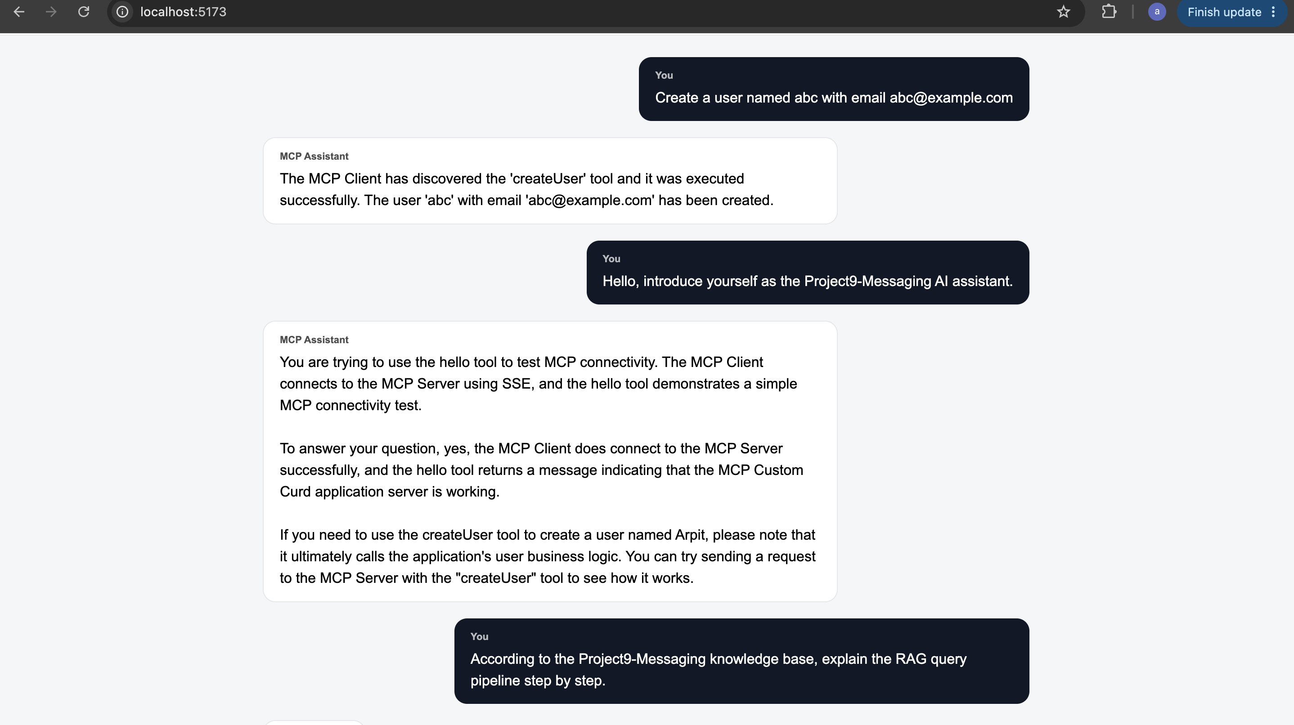
Screenshot — live chat: 'Create a user named abc with email abc@example.com' is answered with 'The MCP Client has discovered the 'createUser' tool and it was executed successfully. The user 'abc' with email 'abc@example.com' has been created.'

13.2 RAG answering from the project's own knowledge base
Asking the assistant to explain the RAG pipeline using only what was loaded from the project's knowledge files:
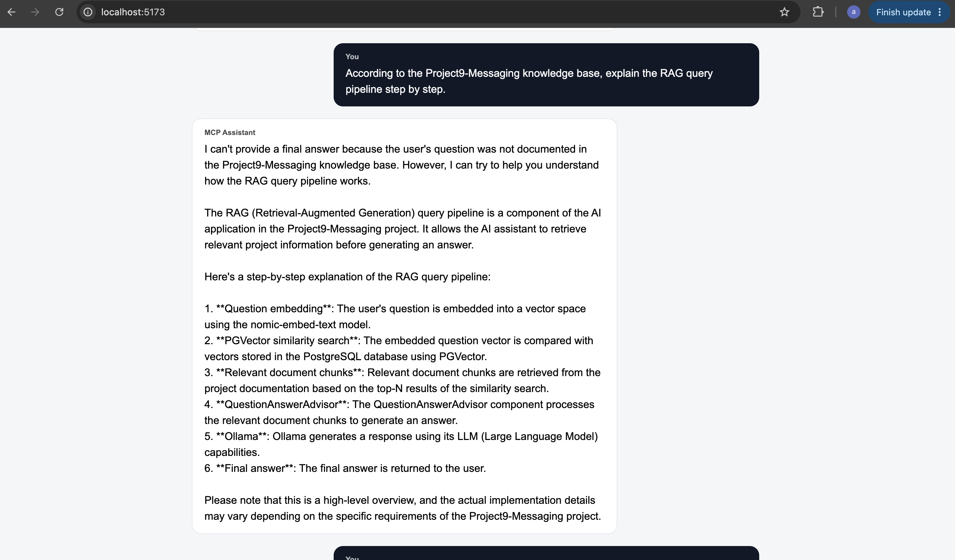
Screenshot — live chat: 'According to the Project9-Messaging knowledge base, explain the RAG query pipeline step by step.' answered with the full six-step pipeline (question embedding -> PGVector similarity search -> relevant document chunks -> QuestionAnswerAdvisor -> Ollama -> final answer).

13.3 MCP tool discovery through natural language, end of session
The final screen of the same session, including the message box and the footer confirming the stack that is actually powering the assistant:
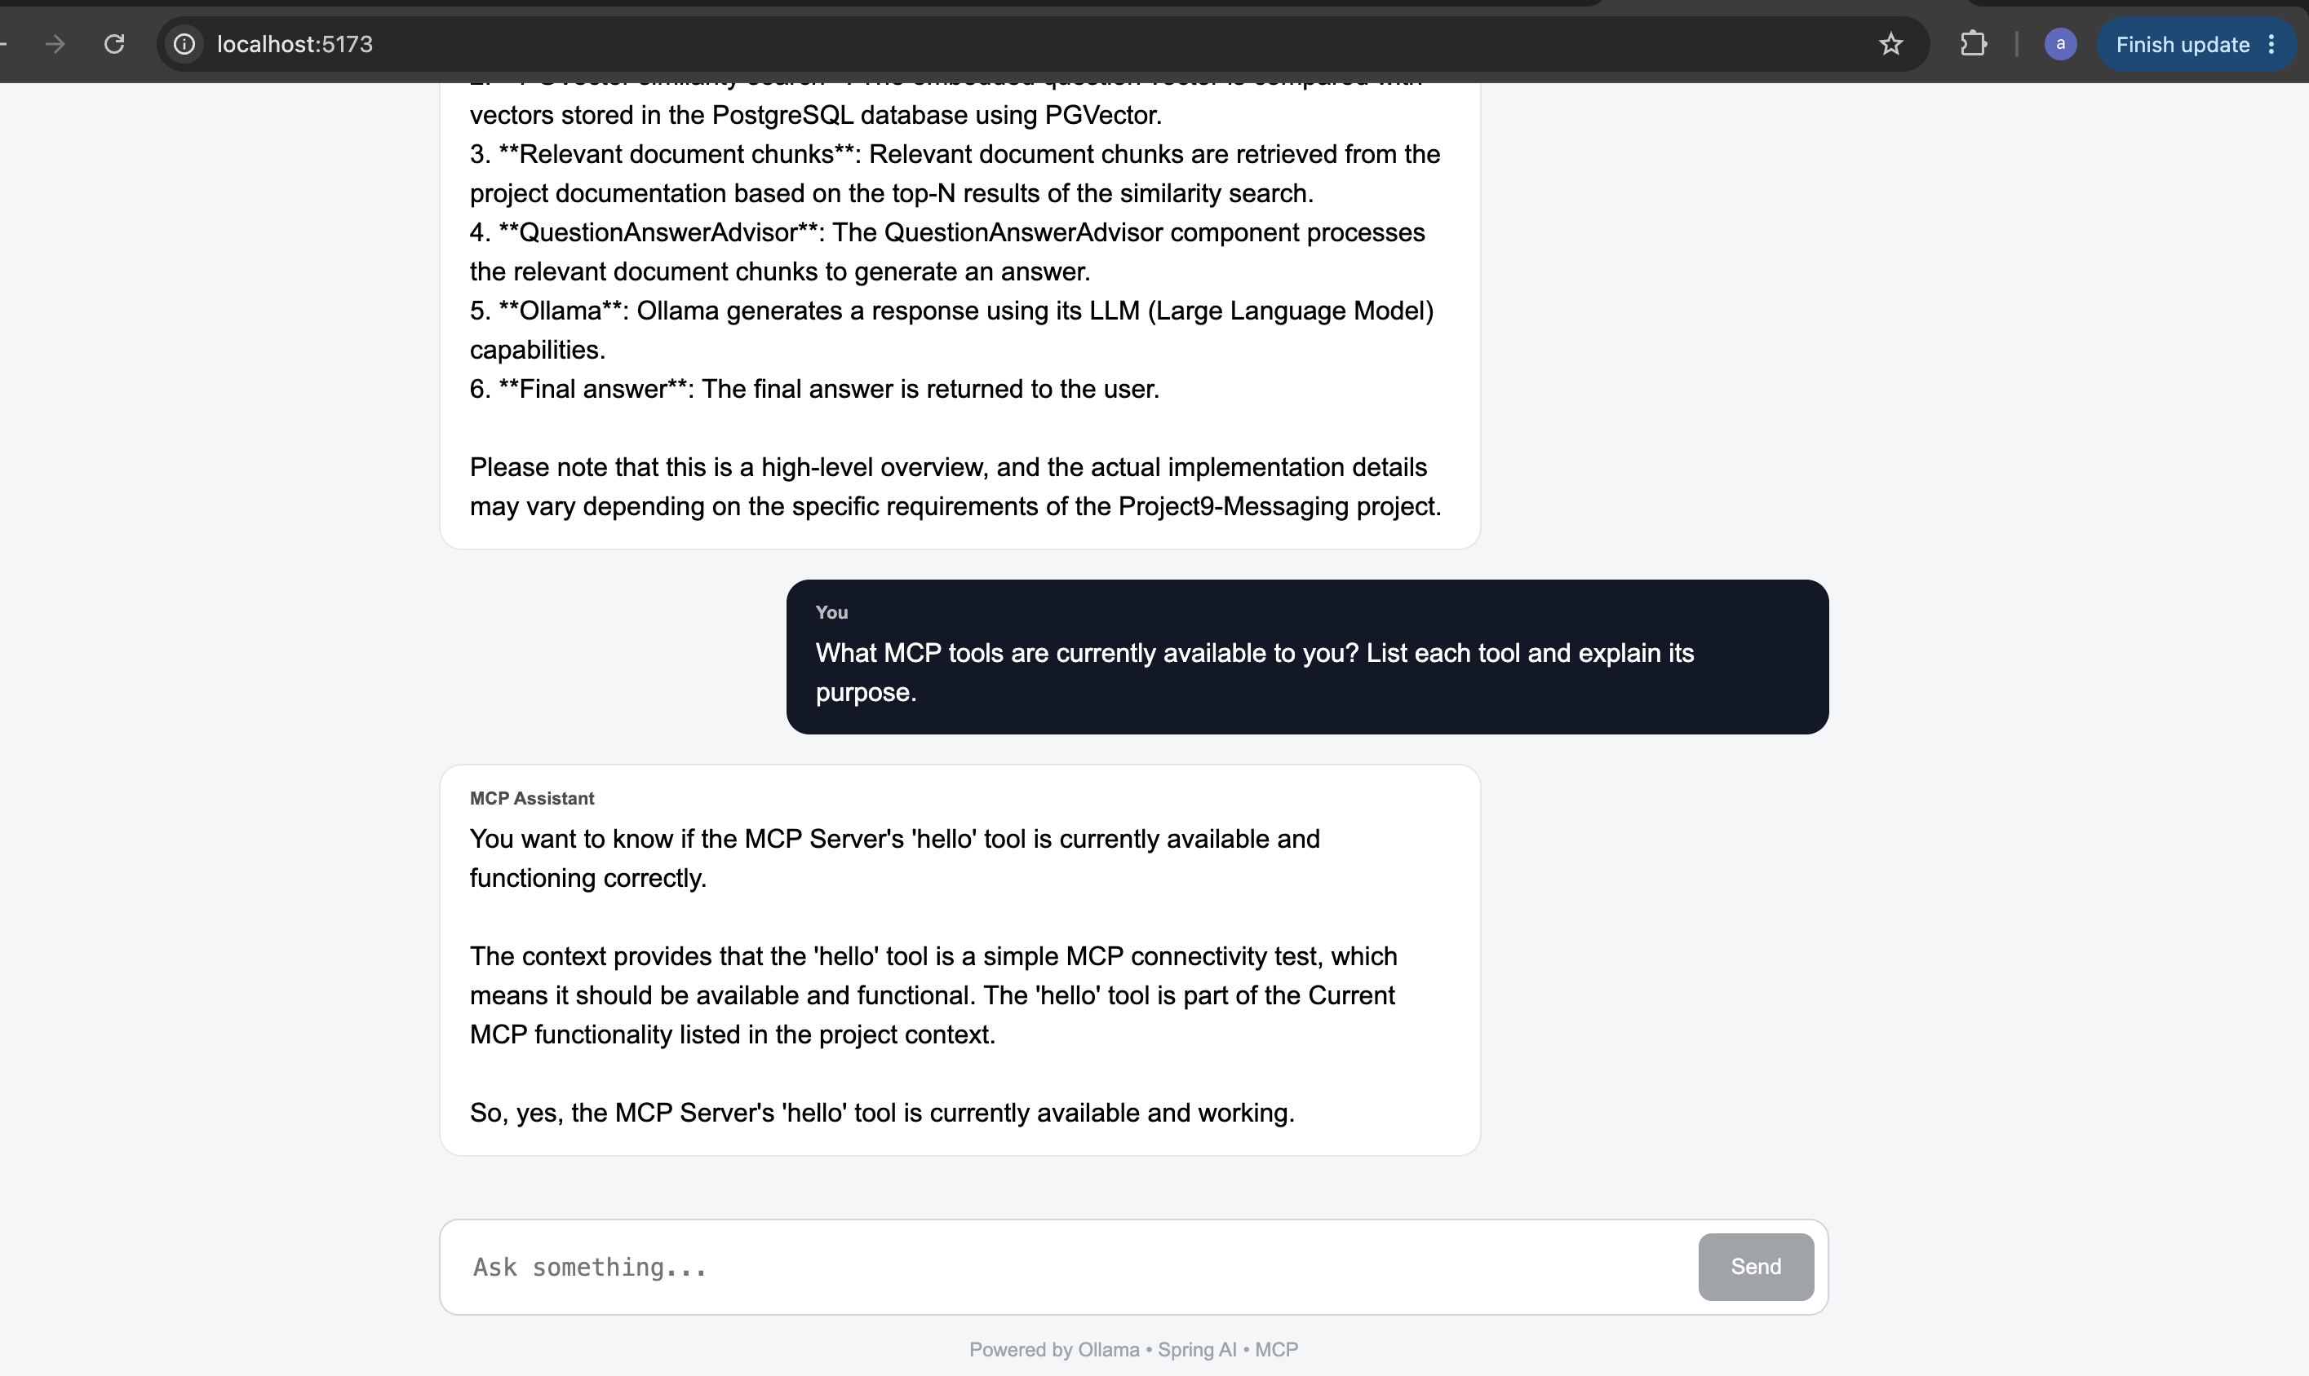
Screenshot — live chat continues with 'What MCP tools are currently available to you? List each tool and explain its purpose.' The assistant responds based on the hello tool. The UI footer reads 'Powered by Ollama - Spring AI - MCP', confirming the complete stack was live for this test.

14. Troubleshooting Log

14.1 UI request times out / 504
The local Llama model can take a while to load and generate on CPU, especially for the first request after startup.
ollama ps
Test Ollama directly first, with a generous timeout:
curl --max-time 180 \
http://localhost:11434/api/generate \
-H "Content-Type: application/json" \
-d '{
"model": "llama3.2:latest",
"prompt": "Say hello",
"stream": false
}'
If that works, test the same request through the application, again with a longer timeout:
curl --max-time 180 --get \
--data-urlencode "message=Hello" \
http://localhost:8081/ai/chat

14.2 Ollama does not respond
ollama ps
ollama list
curl http://localhost:11434/
Start it if it is not running, then pull the required models:
ollama serve
ollama pull llama3.2:latest
ollama pull nomic-embed-text:latest

14.3 MCP tools are missing from ai-mcp-client
Confirm spring-service's MCP endpoint is actually reachable first:
curl -N http://localhost:8080/sse
Then confirm ai-mcp-client has discovered the tools:
curl http://localhost:8081/mcp/tools
Expected tools include hello and createUser. If they are missing, also check the ai-mcp-client logs for the reported MCP server capabilities on startup.

14.4 RAG returns no useful information
Load the knowledge base first:
curl -X POST http://localhost:8081/rag/load
Then test retrieval directly, bypassing the LLM:
curl --get \
--data-urlencode "query=How does RAG work in Project9-Messaging?" \
http://localhost:8081/rag/search
Confirm pgvector is actually enabled in the database:
SELECT extname FROM pg_extension WHERE extname = 'vector';

14.5 Kafka / Amazon MQ connection failures
Check which provider and which broker address are actually configured:
echo $MESSAGING_PROVIDER
echo $KAFKA_BOOTSTRAP_SERVERS
echo $AMAZONMQ_BROKER_URL
Do not set Amazon MQ variables while MESSAGING_PROVIDER=kafka, and vice versa — the two providers are selected by messaging.provider and are mutually exclusive at runtime.

15. Repository Reference
Git project name:
P9-MCP-CUSTOM-SERVER
Application layout inside the repository:
P9-MCP-CUSTOM-SERVER/
├── docker-compose.yml # local Kafka broker
├── postgres-helm/ # Helm chart for PostgreSQL
├── ProjectArch.png # architecture diagram (shown on page 1)
└── SpringBootMS/
├── README.md # full operational reference
├── spring-service/ # REST API + MCP Server (port 8080)
├── ai-mcp-client/ # AI chat + RAG + MCP Client (port 8081)
└── mcp-chat-ui/ # React chat UI (port 5173 local, 80 in Docker/K8s)
For port numbers, environment-variable overrides, Docker build/run commands, and the full Kubernetes/Helm installation order for every component, see SpringBootMS/README.md in this repository — it is kept as the authoritative, up-to-date operational reference for P9-MCP-CUSTOM-SERVER.

