Kubernetes AI Agent
Complete Project Documentation
Natural-language Kubernetes cluster management, powered by a local LLM
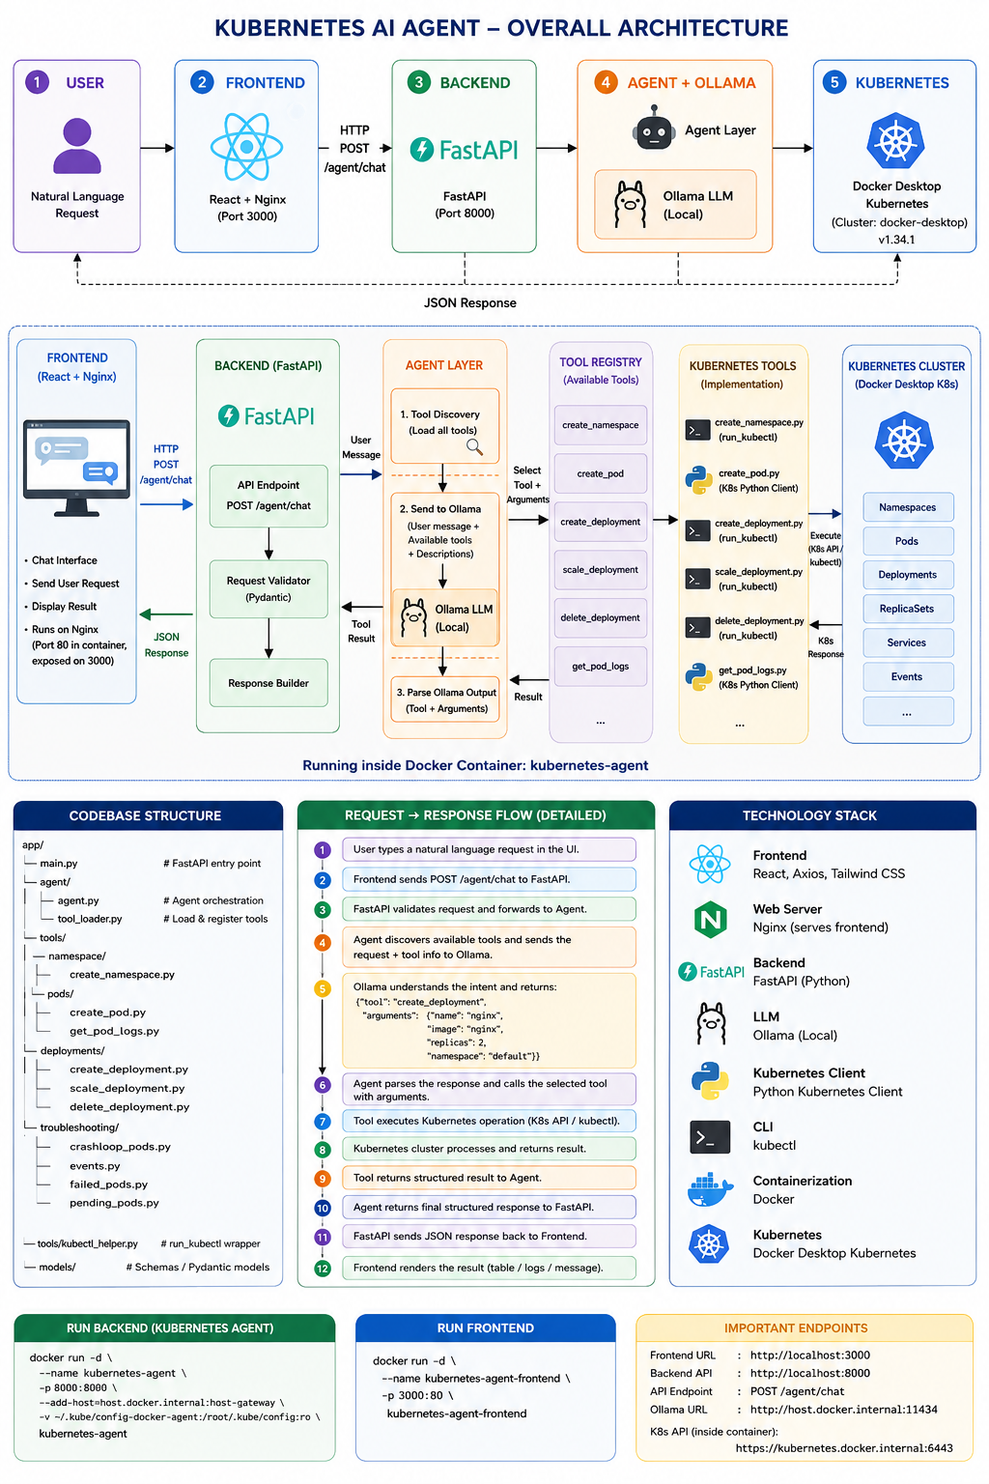
Figure 1 — Kubernetes AI Agent overall architecture
This project is a Kubernetes AI Agent that lets a user manage and troubleshoot a Kubernetes cluster using plain, natural-language commands through a web chat interface — instead of memorising kubectl syntax.
The system combines the following building blocks:
- React frontend — the chat interface the user types into
- Nginx — serves the built frontend in production
- FastAPI backend — receives requests and orchestrates the response
- Ollama (local LLM) — understands what the user is asking for
- Agent / tool-selection layer — decides which Kubernetes tool to run
- Python Kubernetes tools — one focused function per Kubernetes operation
- Docker Desktop Kubernetes — the actual cluster the tools operate on
In one line: "A React/Nginx frontend sends natural-language Kubernetes requests to a FastAPI backend; the backend uses Ollama for intent and tool selection, invokes a specific Python Kubernetes tool, performs the operation against Docker Desktop Kubernetes through the Kubernetes API or kubectl, and returns a structured result back to the frontend."

1. System Architecture
Figure 1 on the cover page summarises the full request path, the backend's internal layers, the codebase layout, and the technology stack in one view. The sections below walk through each part of that picture in detail.

2. How a Request Flows Through the System
Every request — whether typed in the chat UI or sent directly to the API — moves through the same twelve steps:
- The user types a natural-language request in the chat UI (for example, "create deployment nginx with 2 replicas").
- The React frontend sends it as POST /agent/chat to the FastAPI backend.
- FastAPI validates the request body (via Pydantic) and forwards it to the Agent layer.
- The Agent discovers the available tools and sends the user's message, along with tool descriptions, to Ollama.
- Ollama interprets the intent and returns a structured decision, e.g. tool: create_deployment with arguments name, image, replicas, namespace.
- The Agent parses Ollama's response and calls the matching Python tool with those arguments.
- The tool executes the operation against Kubernetes, either via kubectl or the Kubernetes Python client.
- The Kubernetes cluster (Docker Desktop) processes the request and returns a result.
- The tool returns a structured result back to the Agent.
- The Agent hands the final structured response to FastAPI.
- FastAPI sends the JSON response back to the frontend.
- The frontend renders it as a table, log view, or message card in the chat.

Ollama vs. the Kubernetes Tools
This distinction matters when explaining the project — Ollama and the tools have very different jobs:
Layer | Responsible for
Ollama | “What does the user want?” — understanding intent and choosing a tool
Tool | “How do I perform that Kubernetes operation?” — the actual implementation
Kubernetes | “Actually execute the operation” — the cluster itself

3. Component Responsibilities
Component | Responsibility
React | User interface / chat experience
Nginx | Serves the built frontend application
FastAPI | Backend HTTP/API layer
Agent | Orchestrates the request and the tool execution
Ollama | Understands natural-language intent
Tool Registry | Exposes available tools to the agent
Kubernetes Tools | Perform individual K8s operations
Kubernetes Python Client | Programmatic K8s communication for applicable tools
kubectl | CLI-based K8s operations for applicable tools
Docker | Packages and runs the frontend/backend
Docker Desktop Kubernetes | The actual Kubernetes cluster

4. Codebase Structure
Kubernetes operations are organised by resource type, so each capability lives in its own small, testable file:
KubernetesAgent/
├── app/
│ ├── main.py # FastAPI entry point
│ ├── agent/
│ │ ├── agent.py # Agent orchestration
│ │ └── tool_loader.py # Loads & registers tools
│ └── tools/
│ ├── namespace/
│ │ └── create_namespace.py
│ ├── pods/
│ │ ├── create_pod.py
│ │ └── get_pod_logs.py
│ ├── deployments/
│ │ ├── create_deployment.py
│ │ ├── scale_deployment.py
│ │ └── delete_deployment.py
│ └── troubleshooting/
│ ├── crashloop_pods.py
│ ├── events.py
│ ├── failed_pods.py
│ └── pending_pods.py
├── Dockerfile
└── requirements.txt

frontend/
├── src/
├── public/
├── Dockerfile
├── nginx.conf
└── package.json

Tool Metadata
Every tool exposes a small piece of metadata so the loader can discover it automatically and Ollama knows when to pick it:
create_pod.is_agent_tool = True
create_pod.tool_name = "create_pod"
create_pod.tool_description = """
Create a Kubernetes Pod...
"""
Conceptually: a Python function → carries is_agent_tool, tool_name, tool_description → gets picked up by the Tool Registry → made available to the Agent → described to Ollama.

5. Worked Examples
A few representative commands, and exactly what happens behind the scenes for each one:
Natural-language request | Tool invoked | What happens
create namespace agent-test | create_namespace | Runs kubectl create namespace agent-test against the cluster.
create pod agent-nginx using image nginx in namespace default | create_pod | Uses the Kubernetes Python client: load_kube_config() → CoreV1Api() → create_namespaced_pod().
create deployment nginx-deployment using image nginx with 2 replicas | create_deployment | Builds and runs kubectl create deployment <name> --image=<image> --replicas=<replicas> -n <namespace>.
scale deployment nginx-deployment to 3 replicas | scale_deployment | Runs kubectl scale deployment against the selected namespace.
delete deployment nginx-deployment from namespace default | delete_deployment | Runs kubectl delete deployment for the given name/namespace.
show logs of pod agent-nginx in namespace default | get_pod_logs | Uses the Kubernetes Python client's read_namespaced_pod_log(), accepting name, namespace, container, and tail_lines.

Important: create_pod currently accepts name, image, and namespace only — it does not accept replicas. Use create_deployment whenever replicas are required.

6. Kubernetes Connectivity Inside Docker
One real problem this project had to solve: the backend runs inside its own Docker container, so 127.0.0.1 inside that container refers to the container itself — not the Docker Desktop host or its Kubernetes API.
The fix is to point the backend's kubeconfig at Docker Desktop's internal Kubernetes endpoint instead:
https://kubernetes.docker.internal:6443
This was verified directly from inside the running container:
docker exec -it kubernetes-agent kubectl config current-context
docker exec -it kubernetes-agent kubectl get nodes

# Expected output:
docker-desktop Ready control-plane ... v1.34.1

7. Docker Architecture
There are two application containers, each mapped to a host port:
Container | Contains | Container port | Host mapping
kubernetes-agent | FastAPI + Agent + Tools | 8000 | localhost:8000 → :8000
kubernetes-agent-frontend | React + Nginx | 80 | localhost:3000 → :80

8. Why This Architecture Is Useful
Instead of letting the LLM run arbitrary shell commands against the cluster, the project restricts it to a fixed set of approved, well-defined tools:
- create_namespace
- create_pod
- create_deployment
- scale_deployment
- delete_deployment
- get_pod_logs
This keeps the LLM's job limited to “choose the right approved tool and its arguments,” rather than “execute anything it wants” — which makes the system considerably easier to understand, extend, test, and keep safe.

Adding a New Tool
Because each operation is a small, self-contained function, new capabilities can be added without touching the rest of the system. For example, adding get_services:
- Create app/tools/services/get_services.py.
- Implement the function and expose its metadata: is_agent_tool = True, tool_name = "get_services", tool_description = "Get Kubernetes services...".
- The tool loader automatically discovers it and registers it in the Tool Registry.
- It becomes available to the Agent, which can now describe it to Ollama and route matching natural-language requests to it.

9. Setup & Running the Project

Prerequisites
- Docker Desktop
- Docker Desktop Kubernetes enabled
- Python 3.x (for local backend development)
- kubectl
Check that Kubernetes is ready:
kubectl config current-context
kubectl get nodes

# Expected context: docker-desktop

Backend
cd KubernetesAgent

# optional local virtual environment
source venv/bin/activate
pip install -r requirements.txt

# run locally
uvicorn app.main:app --host 0.0.0.0 --port 8000
# FastAPI: http://127.0.0.1:8000
# Swagger: http://127.0.0.1:8000/docs

# build & run with Docker
docker build -t kubernetes-agent .
docker rm -f kubernetes-agent 2>/dev/null || true
docker run -d --name kubernetes-agent -p 8000:8000 kubernetes-agent

# verify
docker ps
docker logs kubernetes-agent
docker exec -it kubernetes-agent kubectl config current-context
docker exec -it kubernetes-agent kubectl get nodes

Frontend
cd frontend
docker build -t kubernetes-agent-frontend .
docker rm -f kubernetes-agent-frontend 2>/dev/null || true
docker run -d --name kubernetes-agent-frontend -p 3000:80 kubernetes-agent-frontend

# verify
curl -I http://localhost:3000
# open http://localhost:3000

Quick Start (Two Terminals)
# Terminal 1 — Backend
cd KubernetesAgent
docker build -t kubernetes-agent .
docker rm -f kubernetes-agent 2>/dev/null || true
docker run -d --name kubernetes-agent -p 8000:8000 kubernetes-agent
docker exec -it kubernetes-agent kubectl get nodes

# Terminal 2 — Frontend
cd frontend
docker build -t kubernetes-agent-frontend .
docker rm -f kubernetes-agent-frontend 2>/dev/null || true
docker run -d --name kubernetes-agent-frontend -p 3000:80 kubernetes-agent-frontend
curl -I http://localhost:3000

# then open http://localhost:3000

10. Backend API Testing
All examples target POST http://127.0.0.1:8000/agent/chat.
Goal | Example request body
Create namespace | {"message":"create namespace agent-test"}
Create pod | {"message":"create pod agent-nginx using image nginx in namespace default"}
Create deployment | {"message":"create deployment agent-nginx using image nginx with 2 replicas in namespace default"}
Scale deployment | {"message":"scale deployment agent-nginx to 3 replicas in namespace default"}
Get pod logs | {"message":"show logs of pod agent-nginx in namespace default"}
Delete deployment | {"message":"delete deployment agent-nginx from namespace default"}

Example call and verification:
curl -X POST http://127.0.0.1:8000/agent/chat \
-H "Content-Type: application/json" \
-d '{"message":"create namespace agent-test"}'

kubectl get namespace agent-test

UI Test Prompts
The same operations can be exercised from the chat UI at http://localhost:3000:
- create namespace test-agent-ui
- create pod nginx-test using image nginx in namespace test-agent-ui
- create deployment nginx-deployment using image nginx with 2 replicas in namespace test-agent-ui
- scale deployment nginx-deployment to 3 replicas in namespace test-agent-ui
- show logs of pod nginx-test in namespace test-agent-ui
- delete deployment nginx-deployment from namespace test-agent-ui
Verify everything created in that namespace with:
kubectl get all -n test-agent-ui

11. Live Demo Screenshots
The chat UI in action, running against the local Docker Desktop cluster:
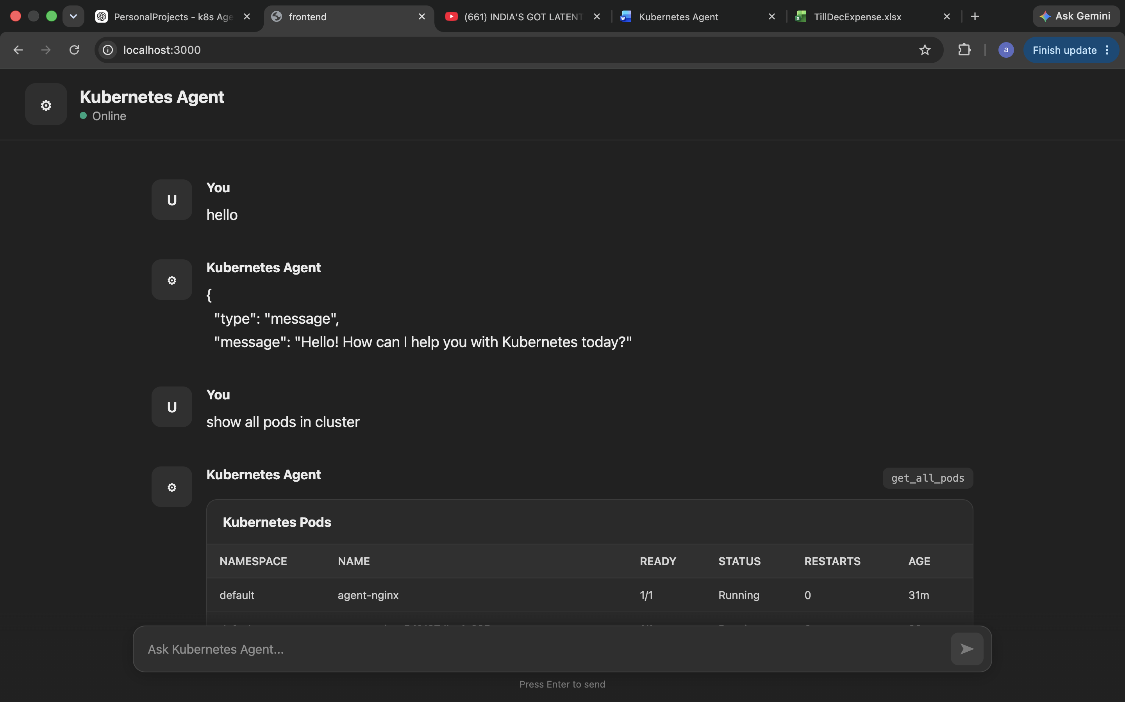
Figure 2 — Greeting the agent and listing all pods in the cluster
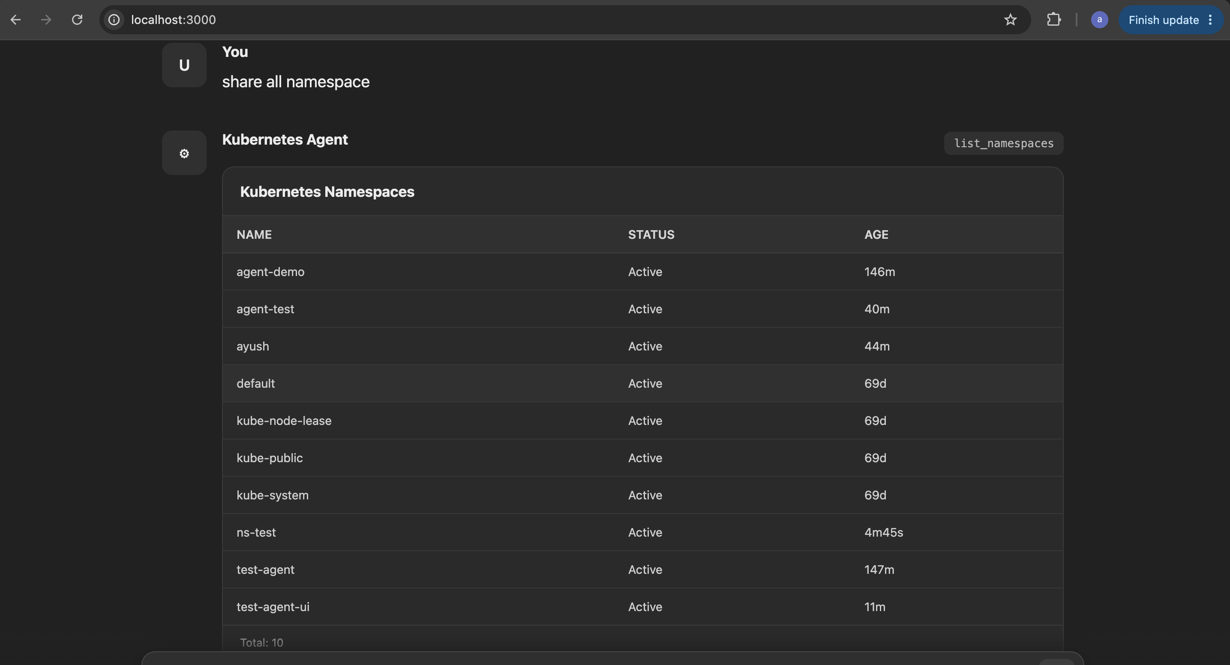
Figure 3 — Listing every namespace in the cluster
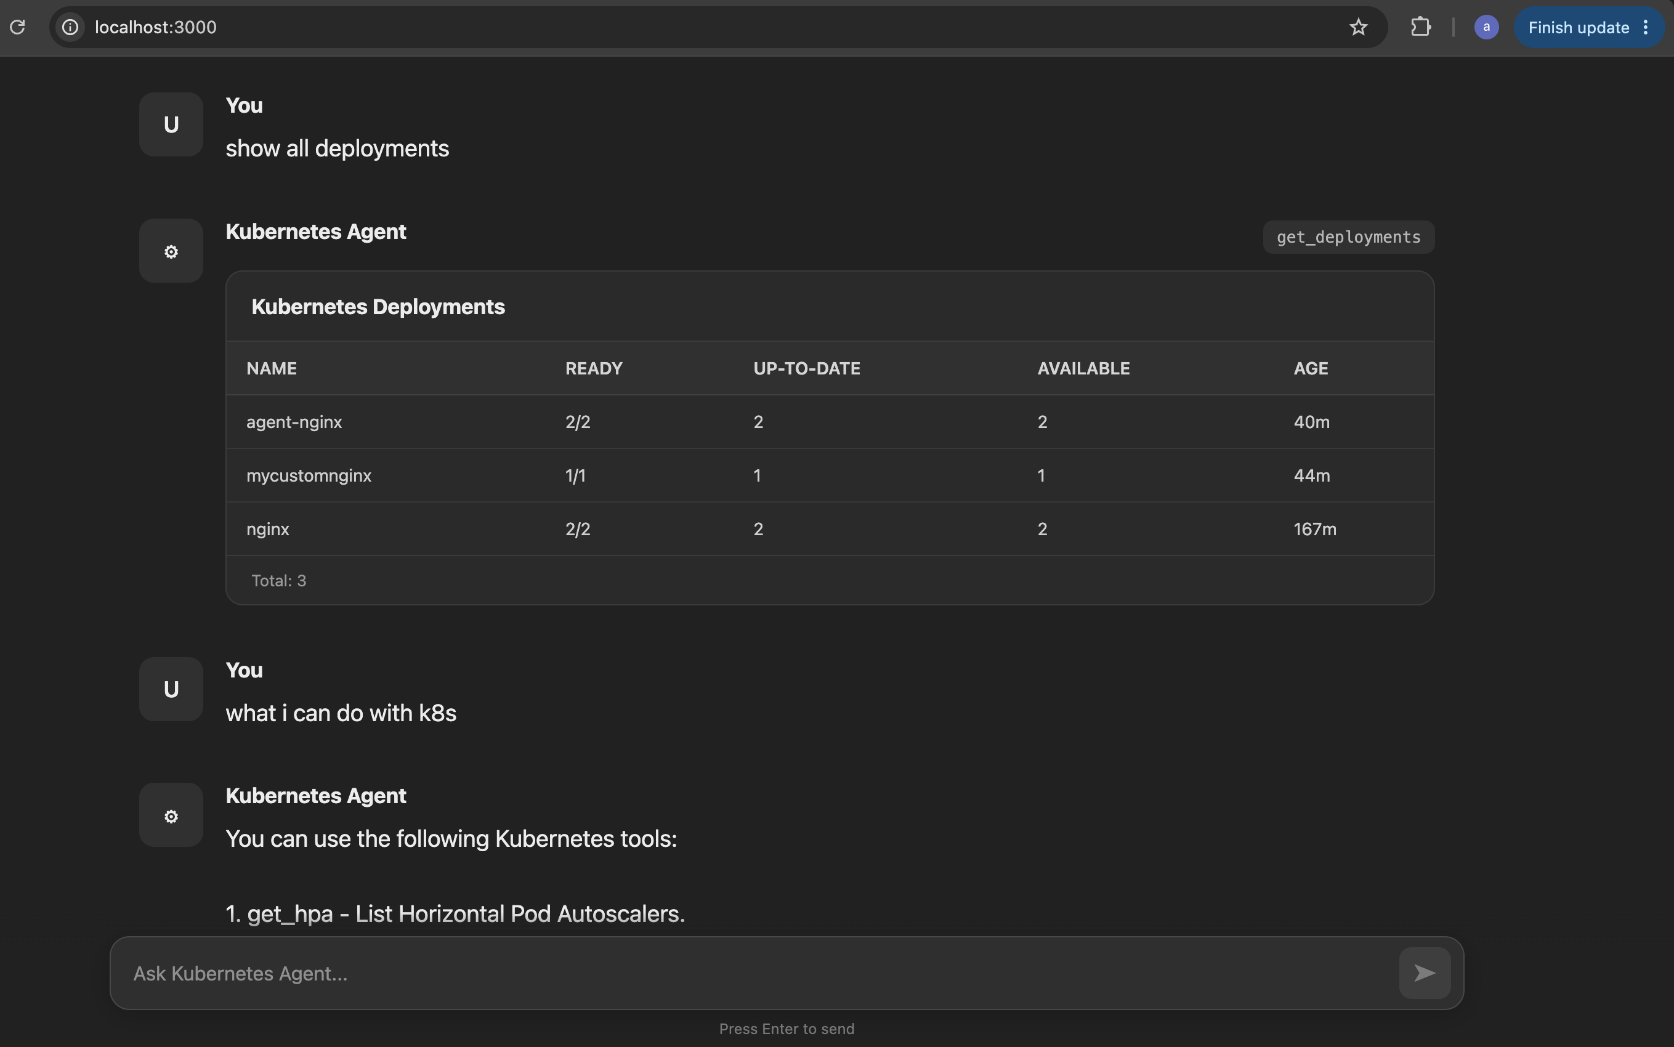
Figure 4 — Listing all deployments and asking the agent what it can do
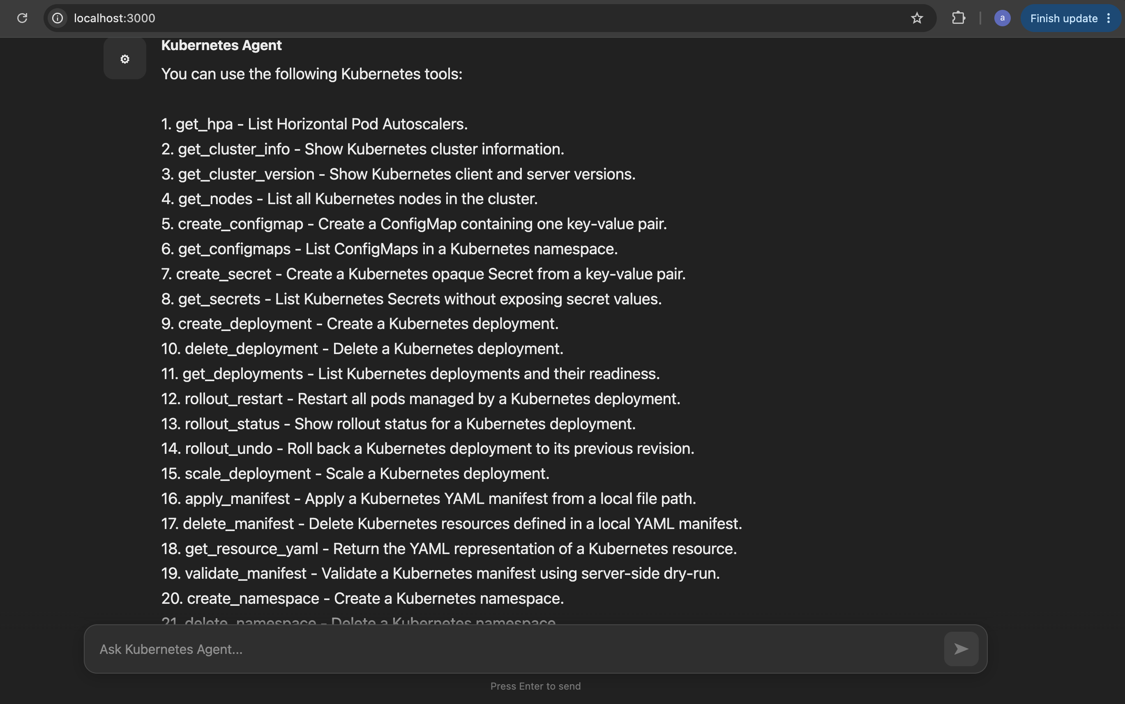
Figure 5 — Full list of Kubernetes tools the agent can call

12. Troubleshooting
Symptom | Likely cause / fix
“Unknown tool: create_pod” | Check that the tool exists under app/tools/, is imported/discovered by the tool loader, and has is_agent_tool = True, tool_name, and tool_description set.
“create_pod() got an unexpected keyword argument 'replicas'” | The agent selected create_pod, which doesn't accept replicas. Use create_deployment for replica-based workloads.
Backend cannot reach Kubernetes | Run docker exec -it kubernetes-agent kubectl config current-context and kubectl get nodes. The container's kubeconfig should point to https://kubernetes.docker.internal:6443.
Frontend does not open | Run docker ps, docker logs kubernetes-agent-frontend, and curl -I http://localhost:3000 — expect HTTP/1.1 200 OK from nginx.

Cleanup
# remove project containers
docker rm -f kubernetes-agent kubernetes-agent-frontend

# remove project images
docker rmi kubernetes-agent kubernetes-agent-frontend

# remove a test namespace and everything inside it
kubectl delete namespace test-agent-ui

13. Summary
The Kubernetes AI Agent turns plain-English requests into safe, controlled Kubernetes operations. A React/Nginx frontend collects the request, FastAPI orchestrates it, Ollama figures out the intent, a small library of Python tools performs the actual work through kubectl or the Kubernetes Python client, and the result flows back to the UI as a readable card. The modular tool structure means new Kubernetes capabilities can be added at any time without touching the rest of the system.

