Project Name : Restaurant Reservation and Table Management System

Submitted by- 1. Arpit Saxena Submitted To : Mrs Nidhi Arora

2. Shivam Kumar Singh

3. Anshu Kumari

Content:-

* Introduction
* About Project
* Technologies Used
* Module
* Screenshot
* Reference

Introduction

In the realm of modern restaurant management, the implementation of a robust Restaurant Reservation and Table Management System emerges as a pivotal project aimed at enhancing the efficiency and customer experience within the hospitality sector. Recognizing the evolving needs of both diners and restaurant operators, this project seeks to seamlessly integrate technology into the reservation process and table allocation, revolutionizing the way establishments interact with their patrons. The primary objective of this project is to create a user-friendly digital platform that facilitates the reservation of tables through various channels, including online platforms and mobile applications. By providing a convenient and accessible means for customers to secure their dining arrangements, the system eliminates traditional constraints associated with phone-based bookings, ultimately fostering a more efficient and modernized reservation experience.

Operationally, the project aims to equip restaurant managers and staff with a real-time Table Management System, offering insights into table availability, reservation status, and customer preferences. The implementation of such a system enables establishments to optimize seating arrangements, reduce waiting times, and enhance overall service delivery. Moreover, the integration of a comprehensive customer database empowers staff to personalize service interactions based on individual preferences, fostering a more intimate and tailored dining experience.As a technology-driven initiative, the Restaurant Reservation and Table Management System project aspire to be at the forefront of the industry's digital transformation. By embracing innovation and leveraging the power of data, this project endeavors to redefine the standards of restaurant management, ensuring that both patrons and operators alike reap the benefits of a seamlessly integrated, efficient, and enjoyable dining experience.

About Project

**Project Overview: Restaurant Reservation and Table Management System**

* **Objective:** The aim of our project is to revolutionize the restaurant experience by developing a state-of- the-art Restaurant Reservation and Table Management System. This digital solution focuses on simplifying the reservation process for customers and optimizing table management for restaurant staff, ultimately enhancing the efficiency and satisfaction levels in the hospitality industry.
* **Key Features:**

1. **User-Friendly Reservation System:** Implementing a straightforward online reservation system accessible through websites and mobile applications to empower customers with a hassle-free and convenient booking process.
2. **Real-Time Table Management:** Creating a digital dashboard for restaurant managers to gain instant insights into table availability, reservation statuses, and dynamically allocate resources for improved service efficiency.
3. **Personalized Customer Experience:** Integrating a comprehensive customer database to store preferences, dietary restrictions, and special occasions, allowing staff to provide personalized services and enhance the overall dining experience.
   * **Benefits:**
4. **Enhanced Customer Convenience:** Providing customers with a user-friendly platform for easy and convenient table reservations, catering to the preferences of the modern, tech-savvy diner.
5. **Improved Operational Efficiency:** Empowering restaurant staff with real-time data to optimize table allocations, minimize waiting times, and streamline service, leading to improved operational efficiency and resource management.

Technologies Used

Our Restaurant Reservation and Table Management System website have been skillfully developed using a trifecta of fundamental web technologies:

HTML, CSS, and JavaScript. Let's delve into how each of these components plays a crucial role in bringing this innovative platform to life.

* 1. HTML (HyperText Markup Language):

HTML serves as the backbone of our website, providing the structural foundation for content presentation. It defines the various elements and layout of the web pages, allowing seamless integration of text, images, forms, and other essential components. With HTML, we've created a user-friendly interface that facilitates easy navigation and ensures a clear structure for both restaurant operators and customers.

* 1. CSS (Cascading Style Sheets):

CSS brings aesthetic appeal and visual coherence to our web platform. It is responsible for styling and formatting the HTML elements, ensuring a consistent and visually pleasing design across all pages. By leveraging CSS, we've enhanced the user experience, creating an interface that is not only functional but also aesthetically engaging. From color schemes to layout design, CSS contributes to the overall polished look and feel of the website.

* 1. JavaScript:

JavaScript adds interactivity and dynamic functionality to our website. With JavaScript, we've implemented real-time updates for table availability, ensuring that users receive prompt and accurate information during the reservation process. This scripting language also allows us to capture and utilize user preferences within the session, providing a personalized touch without relying on a traditional database. JavaScript plays a pivotal role in making our Restaurant Reservation and Table Management System responsive, user-friendly, and technologically advanced.

In summary, the combination of HTML, CSS, and JavaScript forms the technological backbone of our innovative web platform, offering a seamless and efficient solution for restaurant reservations and table management without the need for a conventional database.

Login Page

       <!--Book a Table-->

        <section class = "banner">

            <h2>BOOK YOUR TABLE NOW</h2>

            <div class = "card-container">

                <div class = "card-img">

                    <!-- image here -->

                </div>

                <div class = "card-content">

                    <h3>Reservation</h3>

                    <form>

                        <div class = "form-row">

                            <select name = "days">

                                <option value = "day-select">Select Day</option>

                                <option value = "sunday">Sunday</option>

                                <option value = "monday">Monday</option>

                                <option value = "tuesday">Tuesday</option>

                                <option value = "wednesday">Wednesday</option>

                                <option value = "thursday">Thursday</option>

                                <option value = "friday">Friday</option>

                                <option value = "saturday">Saturday</option>

                            </select>

                            <select name = "hours">

                                <option value = "hour-select">Select Hour</option>

                                <option value = "10">10: 00</option>

                                <option value = "10">12: 00</option>

                                <option value = "10">14: 00</option>

                                <option value = "10">16: 00</option>

                                <option value = "10">18: 00</option>

                                <option value = "10">20: 00</option>

                                <option value = "10">22: 00</option>

                            </select>

                        </div>

                        <div class = "form-row">

                            <input type = "text" placeholder="Full Name">

                            <input type = "text" placeholder="Phone Number">

                        </div>

                        <div class = "form-row">

                            <input type = "number" placeholder="How Many Persons?" min = "1">

                            <input type = "submit" value = "BOOK TABLE">

                        </div>

                    </form>

                </div>

            </div>

        </section>

html

<!DOCTYPE html>

<html lang="en">

<head>

    <link rel="shortcut icon" href="C:\Users\arpit\OneDrive\Desktop\Restauant\33996b80-ff35-4d84-b296-230aa5ac11a5-cover.png"

    type="image/x-icon">

    <meta charset="UTF-8">

    <meta name="viewport" content="width=device-width, initial-scale=1.0">

    <title>Restaurant Mangement System</title>

    <link rel="stylesheet" href="Foodweb.css">

    <link href="https://fonts.googleapis.com/css2?family=Abril+Fatface&family=Catamaran:wght@200

    &family=Courgette&family=Edu+TAS+Beginner:wght@700&family=Lato:wght@300;900&family=Mukta:wght@700&family=Mulish:wght@300&family=

    Open+Sans&family

    =PT+Sans:ital,wght@1,700&family=Poppins:wght@300&family=Raleway:wght@100&family=Roboto&family=Roboto+Condensed:wght@700&family

    =Roboto+Slab&display=swap"

    rel="stylesheet">

    <script src="https://kit.fontawesome.com/f30fac2c61.js" crossorigin="anonymous"></script>

</head>

<body>

    <div class="container">

        <nav>

            <div class="logo">

                <h1>Food HUB</h1>

            </div>

            <div class="input">

                <input type="text" value="" id="inp" placeholder="Search Here ..." onkeyup="myFun()">

                <i class="fa-solid fa-magnifying-glass"></i>

            </div>

            <div class="icon">

                <i onclick="login()" class="fa-solid fa-user"></i>

                <i class="fa-solid fa-cart-shopping"></i>

                <i onclick="nav()" class="fa-solid fa-bars"></i>

            </div>

        </nav>

        <div class="login">

            <h2>Log In </h2>

            <input type="text" placeholder="Enter Your Name">

            <input type="password" placeholder="Enter Password"> <br>

            <button>Log In</button>

        </div>

        <div class="nav">

            <p>Home</p>

            <p>Foods</p>

            <p>Blog</p>

            <p>Customer</p>

            <p>Book Table</p>

            <p>About us</p>

            <p>Contact</p>

        </div>

        <!-- main Page -->

        <div class="main">

            <div class="text">

                <h1>Simple & Tasty Recipes</h1>

                <p>Step into the world of culinary magic at our award-winning restaurant where our chefs create

                    dishes that are not only delicious, but visually stunning as well.</p>

                <button>Explore More</button>

            </div>

            <img src="burger (2).png" alt="">

        </div>

        <!--  Card Food -->

        <table>

            <tr>

                <td>

                    <div class="head">

                        <h1>Our <span>Foods</span></h1>

                    </div>

                    <div class="crd">

                        <div class="card">

                            <img src="fds (1).jpg" alt="">

                            <h2>299 Rupees Only</h2>

                            <p>Lorem ipsum dolor sit amet consectetur adipisicing elit. Quidem, aspernatur iusto.</p>

                            <button>Order Now</button>

                        </div>

                        <div class="card">

                            <img src="fds (2).jpg" alt="">

                            <h2>299 Rupees Only</h2>

                            <p>Lorem ipsum dolor sit amet consectetur adipisicing elit. Quidem, aspernatur iusto.</p>

                            <button>Order Now</button>

                        </div>

                        <div class="card">

                            <img src="fds (7).jpg" alt="">

                            <h2>299 Rupees Only</h2>

                            <p>Lorem ipsum dolor sit amet consectetur adipisicing elit. Quidem, aspernatur iusto.</p>

                            <button>Order Now</button>

                        </div>

                    </div>

                    <div class="crd">

                        <div class="card">

                            <img src="fds (4).jpg" alt="">

                            <h2>299 Rupees Only</h2>

                            <p>Lorem ipsum dolor sit amet consectetur adipisicing elit. Quidem, aspernatur iusto.</p>

                            <button>Order Now</button>

                        </div>

                        <div class="card">

                            <img src="fds (5).jpg" alt="">

                            <h2>299 Rupees Only</h2>

                            <p>Lorem ipsum dolor sit amet consectetur adipisicing elit. Quidem, aspernatur iusto.</p>

                            <button>Order Now</button>

                        </div>

                        <div class="card">

                            <img src="fds (6).jpg" alt="">

                            <h2>299 Rupees Only</h2>

                            <p>Lorem ipsum dolor sit amet consectetur adipisicing elit. Quidem, aspernatur iusto.</p>

                            <button>Order Now</button>

                        </div>

                    </div>

                </td>

            </tr>

            <tr>

                <td>

                    <div class="head">

                        <h1>Our <span>Blogs</span></h1>

                    </div>

                    <div class="crd">

                        <div class="blog">

                            <img src="fds (6).jpg" alt="">

                            <h2>Fact About Indian Food</h2>

                            <p>Indian cuisine is part of the landscape in most cities across America...</p>

                            <a href="https://www.littleindiaofdenver.com/blog/7-facts-you-never-knew-about-indian-food/">Read More</a>

                        </div>

                        <div class="blog">

                            <img src="fds (4).jpg" alt="">

                            <h2>Diffrent Type of Burger</h2>

                            <p>The burger is one of the most satisfying yet simple foods, an icon of modern society...</p>

                            <a href="https://www.finedininglovers.com/article/burger-types-famous-to-make">Read More</a>

                        </div>

                        <div class="blog">

                            <img src="fds (7).jpg" alt="">

                            <h2>Delicious Checken Recipes</h2>

                            <p>Consider for a moment if the dreaded dinnertime conversation went like this:...</p>

                            <a href="https://themodernproper.com/60-best-chicken-breast-recipes">Read More</a>

                        </div>

                    </div>

                </td>

            </tr>

        </table>

        <!-- Customer Review -->

        <div class="head">

            <h1>Customer <span>Review</span></h1>

        </div>

        <div class="review">

            <div class="customer">

                <img src="men (1).jpg" alt=""> <br>

                <i class="fa-solid fa-star"></i>

                <i class="fa-solid fa-star"></i>

                <i class="fa-solid fa-star"></i>

                <i class="fa-solid fa-star"></i>

                <i class="fa-regular fa-star-half-stroke"></i>

                <p>A gem of a find! The cozy atmosphere and warm hospitality made us feel right at home. The menu had a great variety, and

                    the chef's attention to detail was evident in every bite. Can't wait to return and explore more of their delectable

                    offerings!"</p>

            </div>

            <div class="customer">

                <img src="men (2).jpg" alt=""> <br>

                <i class="fa-solid fa-star"></i>

                <i class="fa-solid fa-star"></i>

                <i class="fa-solid fa-star"></i>

                <i class="fa-solid fa-star"></i>

                <i class="fa-regular fa-star-half-stroke"></i>

                <p>Great ambiance and delicious food! The staff was friendly and accommodating, making sure our dining experience was

                    top-notch. The presentation of the dishes was impressive, and the flavors were exceptional. A must-visit for food

                    senthusiasts!</p>

            </div>

            <div class="customer">

                <img src="men (3).jpg" alt=""> <br>

                <i class="fa-solid fa-star"></i>

                <i class="fa-solid fa-star"></i>

                <i class="fa-solid fa-star"></i>

                <i class="fa-solid fa-star"></i>

                <i class="fa-regular fa-star-half-stroke"></i>

                <p>Amazing dining experience! The service was impeccable, and the food was bursting with flavor. I highly recommend

                    trying their signature dish - it's a culinary masterpiece. Will definitely be coming back for more!</p>

            </div>

        </div>

        <div class="btn">

            <button onclick="pre()">Prev</button>

            <button onclick="next()">Next</button>

        </div>

<!-- About Us-->

        <div class="footer">

            <div class="txt">

                <h2>About US</h2>

                <p>Introduction:<br>

                    Welcome to our restaurant management system, designed to simplify and optimize the operations of your food

                    establishment. Our comprehensive software solution is tailored to meet the unique needs of restaurant owners and

                    managers, empowering them to streamline processes and deliver exceptional dining experiences.<br>

                    Benefits:

                    Our restaurant management system enables you to:<br>

                    1.Boost productivity and efficiency in day-to-day operations.<br>

                    2.Reduce operational costs through effective inventory and staff management.<br>

                    3.Enhance the overall dining experience for your customers.<br>

                    4.Make informed business decisions based on comprehensive data and insights.</p>

        </div>

    </div>

<!--contact -->

<div class="container">

    <h2>Contact Us</h2>

    <form id="contactForm">

        <label for="fname">First Name</label>

        <input type="text" id="fname" name="firstname" placeholder="Your name.." required>

        <label for="lname">Last Name</label>

        <input type="text" id="lname" name="lastname" placeholder="Your last name.." required>

        <label for="email">Email</label>

        <input type="text" id="email" name="email" placeholder="Your email.." required>

        <label for="subject">Subject</label>

        <textarea id="subject" name="subject" placeholder="Write something.." style="height:200px" required></textarea>

        <input type="submit" value="Submit" onclick="submitForm()">

    </form>

</div>

<script src="script.js"></script>

    <script src="Foodweb.js"></script>

</body>

</html>

CSS

*{

    margin: 0%;

    padding: 0%;

}

body{

    font-family: 'Roboto', sans-serif;

    background-color: black;

   color: #fff;

}

nav{

    display: flex;

    justify-content: space-between;

    background-color: black;

    color: white;

    padding: 33px;

    box-shadow: 0px 1px 5px 0px  rgb(252, 252, 252);

}

.logo h1{

    font-size: 37px;

    color: rgb(255, 106, 0);

    margin-top: -2px;

}

.icon{

    margin-left: -11px;

}

.icon i{

    font-size: 22px;

    margin-inline: 8px;

    background-color: #fff;

    color: black;

    padding: 9px;

    border-radius: 2px;

}

.icon i:hover{

    color: rgb(255, 98, 0);

    cursor: pointer;

}

nav input{

    width: 600px;

    padding: 11px;

    height: 20px;

    border: none;

    outline: none;

    font-size: 18px;

    border-radius: 2px;

}

.input i{

    margin-left: -28px;

    color: black;

    font-size: 20px;

}

.main{

    display: flex;

    justify-content: space-around;

}

.main img{

    width: 33%;

    margin-top: 33px;

}

.main .text{

    width: 500px;

    margin-top: 62px;

}

.text h1{

    font-size: 66px;

}

.text p{

    color: #f6f5f5;

    margin-top: 22px;

}

.text button{

    margin-top: 24px;

    border: none;

    outline: none;

    background-color: rgb(255, 119, 0);

    color: white;

    border-radius: 2px;

    font-size: 22px;

    width: 160px;

    height: 40px;

}

.crd{

    display: flex;

    /* justify-content: center; */

    margin-left: 115px;

    color: black;

}

.crd .card {

    width: 300px;

    background-color: #fff;

    border-radius: 4px;

    padding: 11px;

    color: black;

    margin-inline: 11px;

    margin-top: 84px;

}

.card img{

    width: 100%;

}

.card h2{

    margin-top: 12px;

}

.card p{

    margin-top: 12px;

}

.card button{

    margin-top: 25px;

    border: none;

    outline: none;

    background-color: rgb(255, 119, 0);

    color: white;

    border-radius: 2px;

    font-size: 22px;

    width: 140px;

    height: 38px;

}

.blog{

    width: 380px;

    height: 380px;

    background-color: #fff;

    border-radius: 4px;

    padding: 11px;

    color: black;

    margin-inline: 11px;

    margin-top: 84px;

}

.blog h2{

    margin-top: 12px;

}

.blog p{

    margin-top: 12px;

}

.blog a{

    position: relative;

    top: 32px;

    width: 160px;

    padding: 10px;

    background-color: rgb(255, 106, 0);

    color: white;

    font-size: 20px;

    border-radius: 2px;

    transform: translateY(60px);

}

.blog img{

    width: 100%;

}

.review{

    position: relative;

    display: flex;

    overflow: hidden;

    margin: auto;

    width: 800px;

    height: 400px;

    margin-top: 63px;

}

.review .customer{

    position: absolute;

    width: 100%;

    height: 80%;

    background-color: #fff;

    color: black;

    text-align: center;

    padding: 11px;

    transition: 0.5s ease;

}

.customer img{

    width: 33%;

    border-radius: 50%;

}

.customer i{

    font-size: 22px;

    color: rgb(255, 132, 0);

    margin-top: 11px;

}

.head h1{

    text-align: center;

    font-size: 44px;

    margin-top: 53px;

    margin-left: 22px;

}

.head span{

    color: rgb(255, 119, 0);

}

.btn{

    text-align: center;

}

.btn button{

    width: 140px;

    height: 38px;

    border: none;

    outline: none;

    border-radius: 3px;

    color: white;

    font-size: 20px;

    margin-inline: 11px;

    background-color: rgb(255, 111, 0);

    transform: translateY(-50px);

}

.footer{

    display: flex;

    justify-content: space-around;

    background-color: #fff;

    padding: 55px;

    margin-top: 77px;

}

.footer .txt{

    color: black;

}

.txt p{

    margin-top: 12px;

}

/* Login */

.login{

    display: none;

    position: absolute;

    margin-left: 80%;

    width: 200px;

    padding: 22px;

    background-color: #fff;

    text-align: center;

    border-radius: 4px;

    margin-top: 6px;

}

.login h2{

    color: black;

}

.login input{

    border: none;

    border-bottom: 2px solid black;

    width: 160px;

    font-size: 18px;

    padding: 8px;

    margin-top: 13px;

}

.login button{

    width: 140px;

    height: 35px;

    border: none;

    outline: none;

    background-color: rgb(255, 111, 0);

    color: white;

    border-radius: 2px;

    font-size: 18px;

    margin-top: 22px;

}

/* nav */

.nav{

    display: none;

    position: absolute;

    margin-left: 82%;

    width: 160px;

    padding: 22px;

    background-color: #fff;

    border-radius: 4px;

    margin-top: 6px;

}

.nav P{

    width: 110px;

    color: black;

    margin-left: 20%;

    padding: 11px;

    border-radius: 4px;

}

.nav p:hover{

    background-color: #f1efef;

    color: rgb(255, 111, 0);

    cursor: pointer;

}

@import url('https://fonts.googleapis.com/css2?family=Poppins:wght@300;500;700&display=swap');

*{

    box-sizing: border-box;

    padding: 0;

    margin: 0;

}

body{

    font-family: 'Poppins', sans-serif;

}

.banner{

    min-height: 100vh;

    background: linear-gradient(rgba(0, 0, 0, 0.5), rgba(0, 0, 0, 0.5)), url("banner-img.jpg") center/cover no-repeat;

    display: flex;

    flex-direction: column;

    justify-content: center;

    align-items: center;

    color: #fff;

    padding-bottom: 20px;

}

.card-container{

    display: grid;

    grid-template-columns: 420px 420px;

}

.card-img{

    background: url("card-img.jpg") center/cover no-repeat;

}

.banner h2{

    padding-bottom: 40px;

    margin-bottom: 20px;

}

.card-content{

    background: #fff;

    height: 330px;

}

.card-content h3{

    text-align: center;

    color: #000;

    padding: 25px 0 10px 0;

    font-size: 26px;

    font-weight: 500;

}

.form-row{

    display: flex;

    width: 90%;

    margin: 0 auto;

}

form select, form input{

    display: block;

    width: 100%;

    margin: 15px 12px;

    padding: 5px;

    font-size: 15px;

    font-family: 'Poppins', sans-serif;

    outline: none;

    border: none;

    border-bottom: 1px solid #eee;

    font-weight: 300;

}

form input[type = text], form input[type = number], form input::placeholder, select{

    color: #9a9a9a;

}

form input[type = submit]{

    color: #fff;

    background: #f2745f;

    padding: 12px 0;

    border-radius: 4px;

    cursor: pointer;

}

form input[type = submit]:hover{

    opacity: 0.9;

}

@media(max-width: 992px){

    .card-container{

        grid-template-columns: 100%;

        width: 100vw;

    }

    .card-img{

        height: 330px;

    }

}

Java Script (js)

function myFun(){

    let searchVal = document.getElementById("inp").value.toUpperCase() ;

    let table = document.getElementsByTagName("table")

    let tr = document.getElementsByTagName("tr");

    let front = document.querySelector(".main")

    for(let i=0; i<tr.length; i++){

        let td = tr[i].getElementsByTagName("td")[0];

        if(td){

            let text = td.innerText;

            if(text.toLocaleUpperCase().indexOf(searchVal) > -1){

                tr[i].style.display="";

                front.style.display="none"

            }else{

                tr[i].style.display="none"

            }

        }

    }

    if(searchVal == ""){

        front.style.display="flex"

    }

    console.log(searchVal);

}

function nav(){

    let nav = document.querySelector(".nav");

    nav.style.display="block"

    let login = document.querySelector(".login");

    login.style.display="none";

}

function login(){

    let login = document.querySelector(".login");

    login.style.display="block";

    let nav = document.querySelector(".nav");

    nav.style.display="none"

}

// Slide bar

let slide = document.querySelectorAll(".customer");

let count = 0;

console.log(slide);

slide.forEach(function(customer, index){

    customer.style.left=`${index * 100}%`

})

function next(){

    count ++;

    if(count == slide.length){

        count=0;

    }

    bar()

}

function pre(){

    count--;

    if(count == -1){

        count = slide.length-1

    }

    bar()

}

function bar(){

    slide.forEach(function(customer){

        customer.style.transform = `translateX(-${count * 100}%)`

    })

}

let a = {

    greet:"HI"

}

let c;

c=a;

a.age=11;

console.log(c.age);

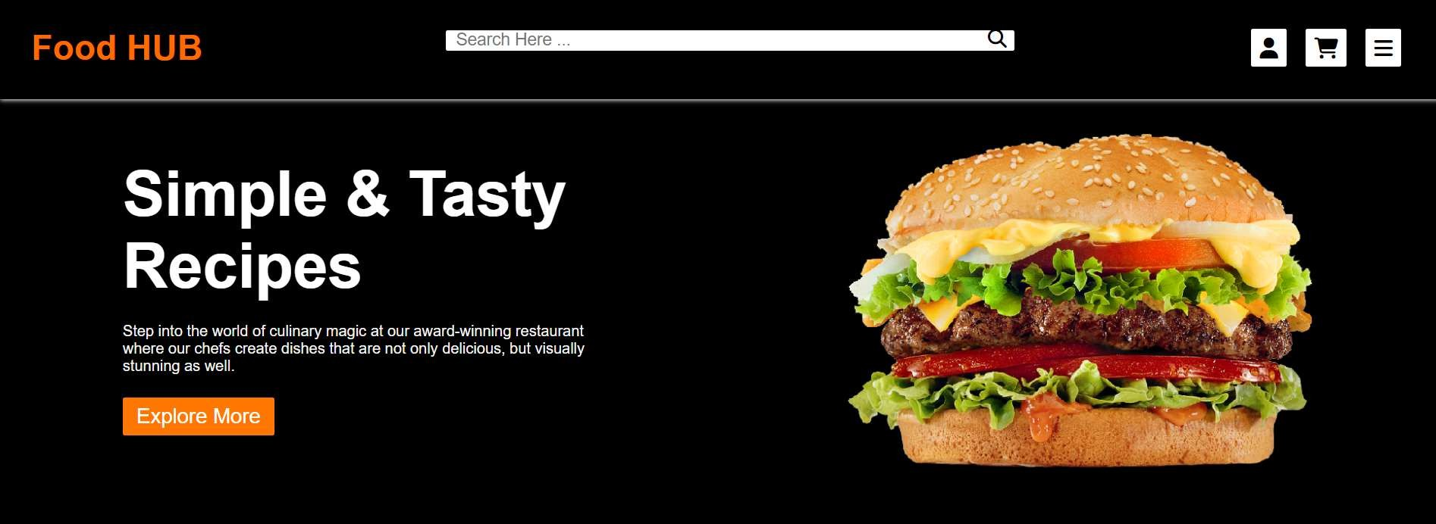Screenshot: first page

Our Food

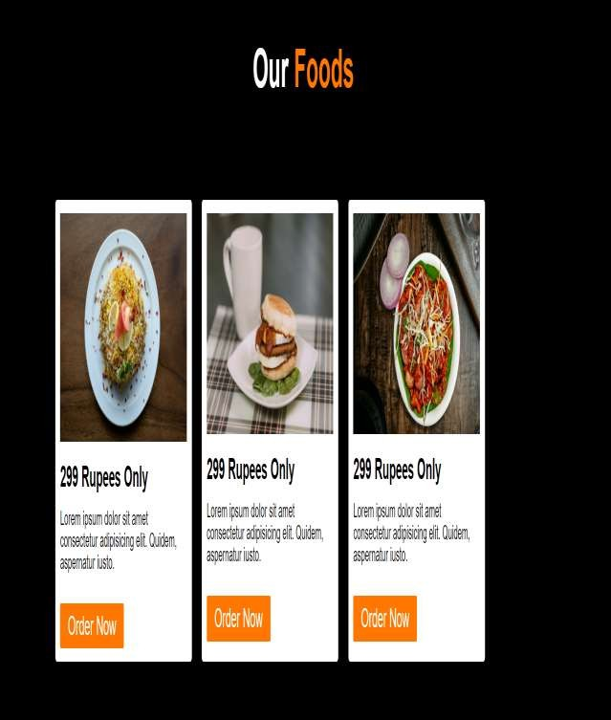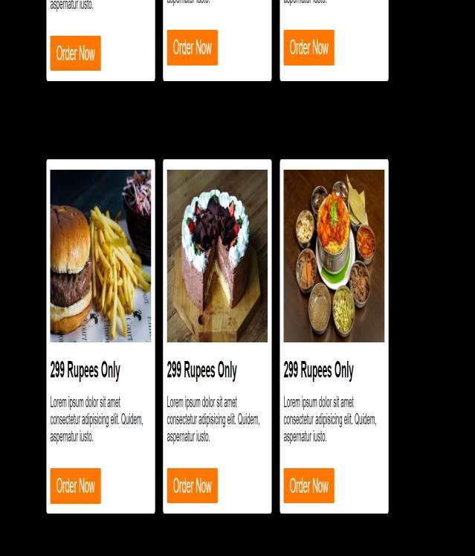

Blogs

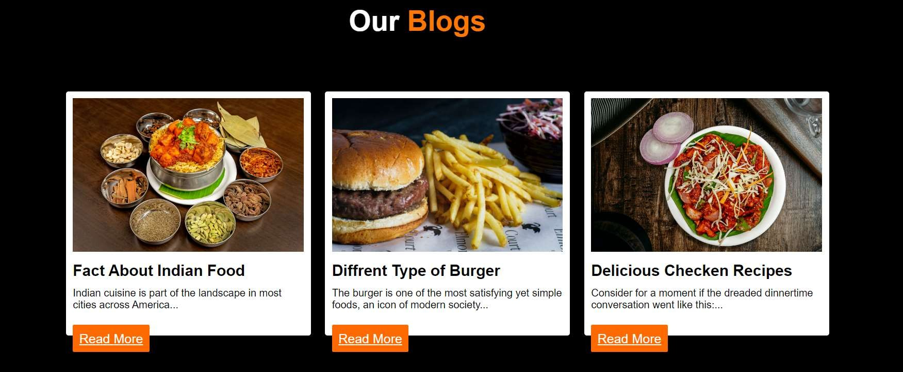

Customer Review

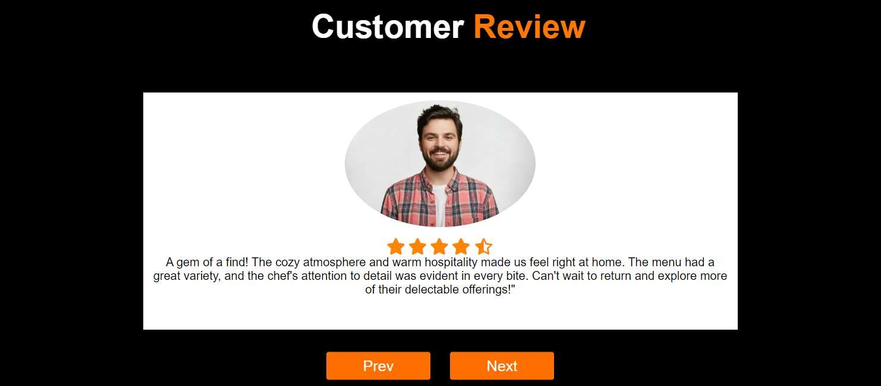

Book Your Table

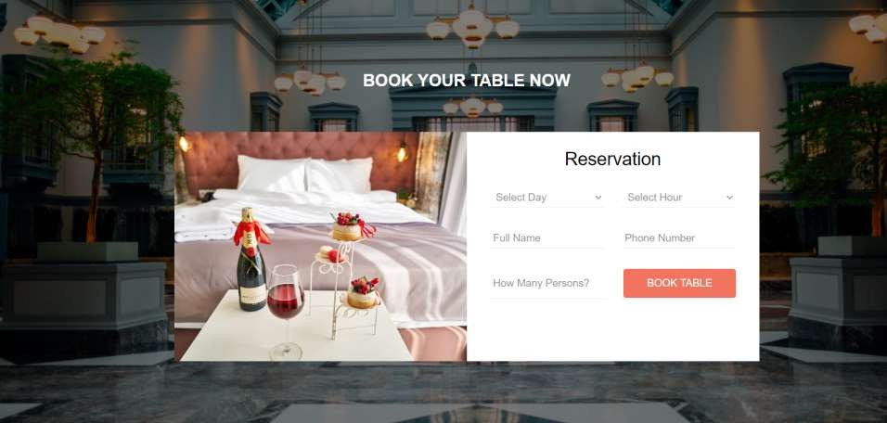

About us

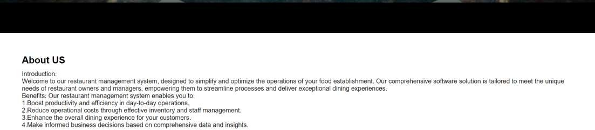

Contact us

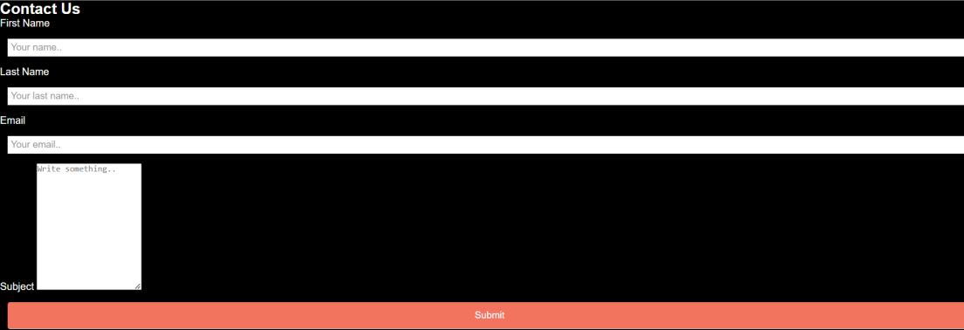

Reference

* Provided Lectures by Respective Mam
* W3School
* You tube