**Pre-Report**

**1. Problem Statement**

Organizations face challenges in managing and addressing consumer complaints efficiently. This analysis uses consumer complaint data to:

* Identify trends and patterns in complaints.
* Highlight performance differences across companies in handling complaints.
* Provide actionable insights to improve customer satisfaction and response timeliness.
* Use a Power BI dashboard for interactive data storytelling and analysis.

**2. Data Requirement**

Key data points used in this analysis include:

* Complaint Trends: Complaint counts by product, sub-product, and company.
* Company Performance: Timeliness of response, type of response, and company-specific complaint volumes.
* Geographical Analysis: State-wise breakdown of complaints.
* Sub-Product Analysis: Issues associated with various financial products like mortgages, credit cards, vehicle loans, and checking accounts.

**3. Data Collection**

The dataset provides comprehensive data on:

* Complaints lodged by consumers regarding financial products.
* The companies to which complaints are directed.
* Details about timely responses and the type of sub-products associated with complaints.
* Complaint counts segregated by states for geographic analysis.

**4. Data Validation**

To ensure reliability and accuracy of the data:

* Validate completeness and consistency of fields such as "Company," "Sub-product," and "State."
* Ensure the dataset has no missing critical information for primary visuals (e.g., complaint counts or timely responses).
* Verify categories and ensure no duplications exist in "Sub-product" or "Company" fields.

**5. Data Cleaning**

The dataset underwent cleaning to enhance clarity and usability:

* Standardized company names and sub-product categories for consistency.
* Removed duplicate records or irrelevant entries.
* Addressed missing data, especially in fields like "Sub-product" and "State."

**6. Tools**

**Power BI** was chosen for the analysis due to its:

* Ability to handle interactive and visual storytelling.
* Support for diverse chart types like bar charts, donut charts, and stacked visuals.
* Robust filtering and slicing capabilities for in-depth analysis.

**7. Dashboard Description**

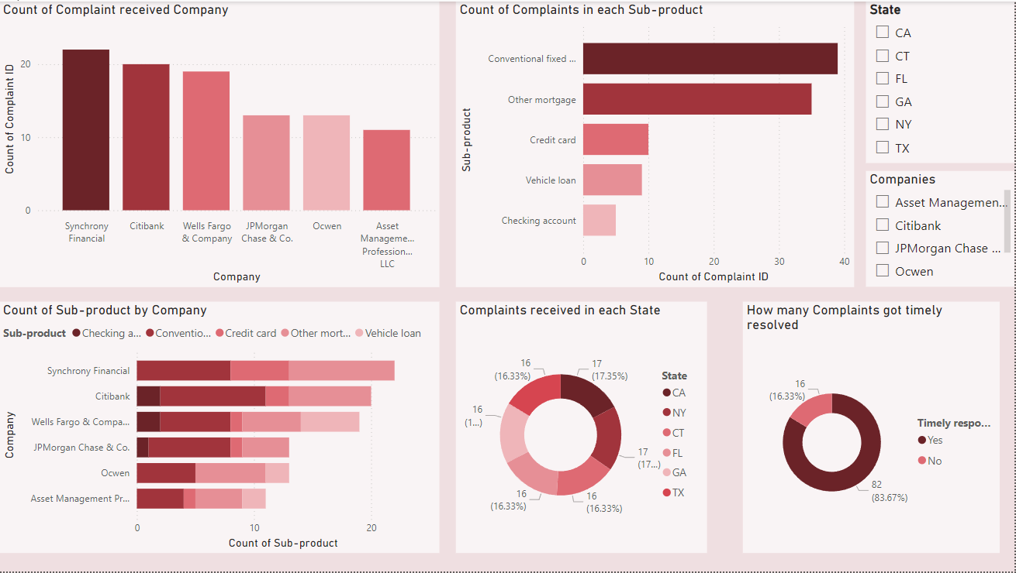

**Complaint Trends by Company**

* **Synchrony Financial** received the highest number of complaints, followed by **Citibank** and **Wells Fargo & Company**.
* Companies like **JPMorgan Chase & Co.**, **Ocwen**, and **Asset Management Professionals LLC** have fewer complaints in comparison.

**Sub-Product Analysis**

* The most complained-about sub-products are:
  + **Conventional fixed mortgage** and **Other mortgage**, which dominate the complaint count.
  + **Credit cards** and **Vehicle loans** also contribute significantly to complaints but are less frequent than mortgages.
* A stacked bar chart provides company-wise details:
  + **Synchrony Financial** has a significant number of complaints related to **credit cards**.
  + **Mortgage-related complaints** are most notable for **Citibank**, **Wells Fargo**, and **JPMorgan Chase & Co.**

**Geographic Distribution**

* A pie chart indicates the distribution of complaints by state:
  + **CA (California)** and **NY (New York)** lead, each accounting for **17.35%** of the total complaints.
  + Other states like **FL (Florida)**, **GA (Georgia)**, **CT (Connecticut)**, and **TX (Texas)** closely follow, each with **16.33%** of the complaints.

**Timeliness of Response**

* A donut chart shows that **83.67%** of complaints were resolved in a timely manner.
* **16.33%** of complaints did not receive a timely response.

**8. Storytelling and Insights**

Using the dashboard, the following insights emerge:

1. Complaint Concentration:
   * Most of the complaints are concentrated in specific companies like Synchrony Financial and Citibank. Efforts should focus on these companies to investigate root causes.
   * Mortgage-related issues dominate the sub-products, indicating potential systemic challenges in mortgage management or communication.
2. Geographic Trends:
   * States like California and New York see higher complaint volumes. Regional action plans might be necessary to address state-specific issues.
3. Timeliness of Response:
   * While most complaints are addressed in a timely manner, a significant 16.33% are delayed. Companies need to focus on improving response rates for better consumer satisfaction.
4. Sub-Product Insights:
   * Companies should prioritize addressing consumer dissatisfaction with conventional and other mortgage products. Credit card-related complaints also warrant attention, particularly for Synchrony Financial.

**9. Actionable Recommendations**

* Focus on High-Complaint Companies:
  + Investigate why Synchrony Financial and Citibank receive a disproportionately high number of complaints.
* Improve Mortgage Processes:
  + Identify gaps in mortgage services, especially for conventional fixed-rate and other mortgage types.
* Regional Interventions:
  + Implement region-specific measures to address complaints in high-volume states like CA and NY.
* Enhance Timeliness:
  + Develop strategies to address the 16.33% of delayed responses to improve overall customer satisfaction.
* Product-Specific Improvements:
  + Focus on resolving issues for heavily complained-about sub-products like credit cards and vehicle loans.