**SEO**

**Search Engine Optimization**

SEO is all about improving a site’s rankings in the organic (non-paid) section of the search results.

**How Search Engines Work**

When you search for something in Google (or any other search engine), an algorithm works in real-time to bring you what that search engine considers the “best” result.



Specifically, Google scans its index of “[hundreds of billions](https://www.google.com/search/howsearchworks/crawling-indexing/)” of pages in order to find a set of results that will best answer your search.

How does Google determine the “best” result?

Even though Google doesn’t make the inner workings of its algorithm public, based on filed patents and statements from Google, we know that websites and web pages are ranked based on:

****Relevancy****

If you search for “chocolate chip cookie recipes”, you don’t want to see web pages about truck tires.

That’s why Google looks first-and-foremost for pages that are ****closely-related to your keyword****.

However, Google doesn’t simply rank “the most relevant pages at the top”. That’s because there are thousands (or even millions) of relevant pages for every search term.

For example, the keyword “cookie recipes” brings up 349 million results in Google:

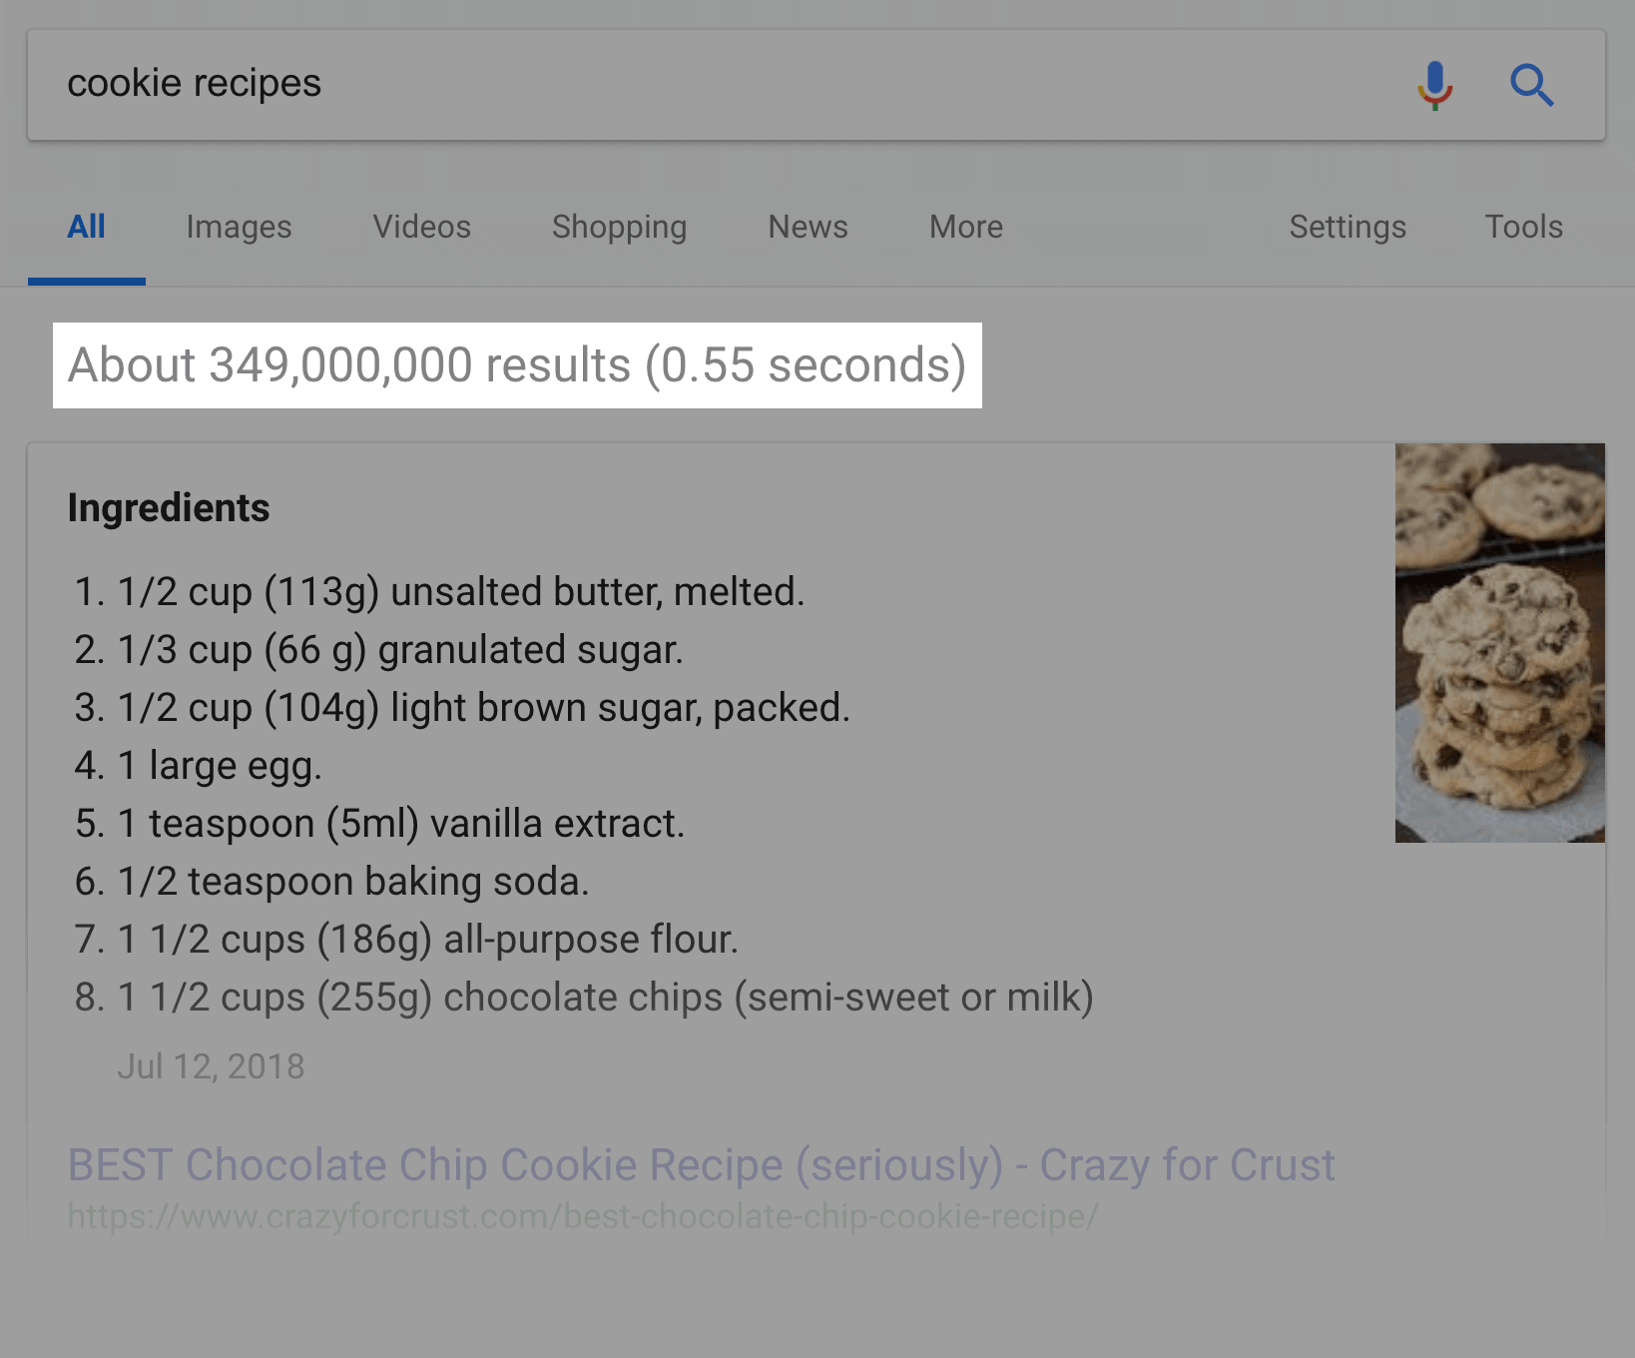

So to put the results in an order that bubbles the best to the top, they rely on three other elements of their algorithm:

****Authority****

Authority is just like it sounds: it’s Google’s way of determining if the content is accurate and trustworthy.

The question is: how does Google know if a page is authoritative?

They look at the number of other pages that link to that page:

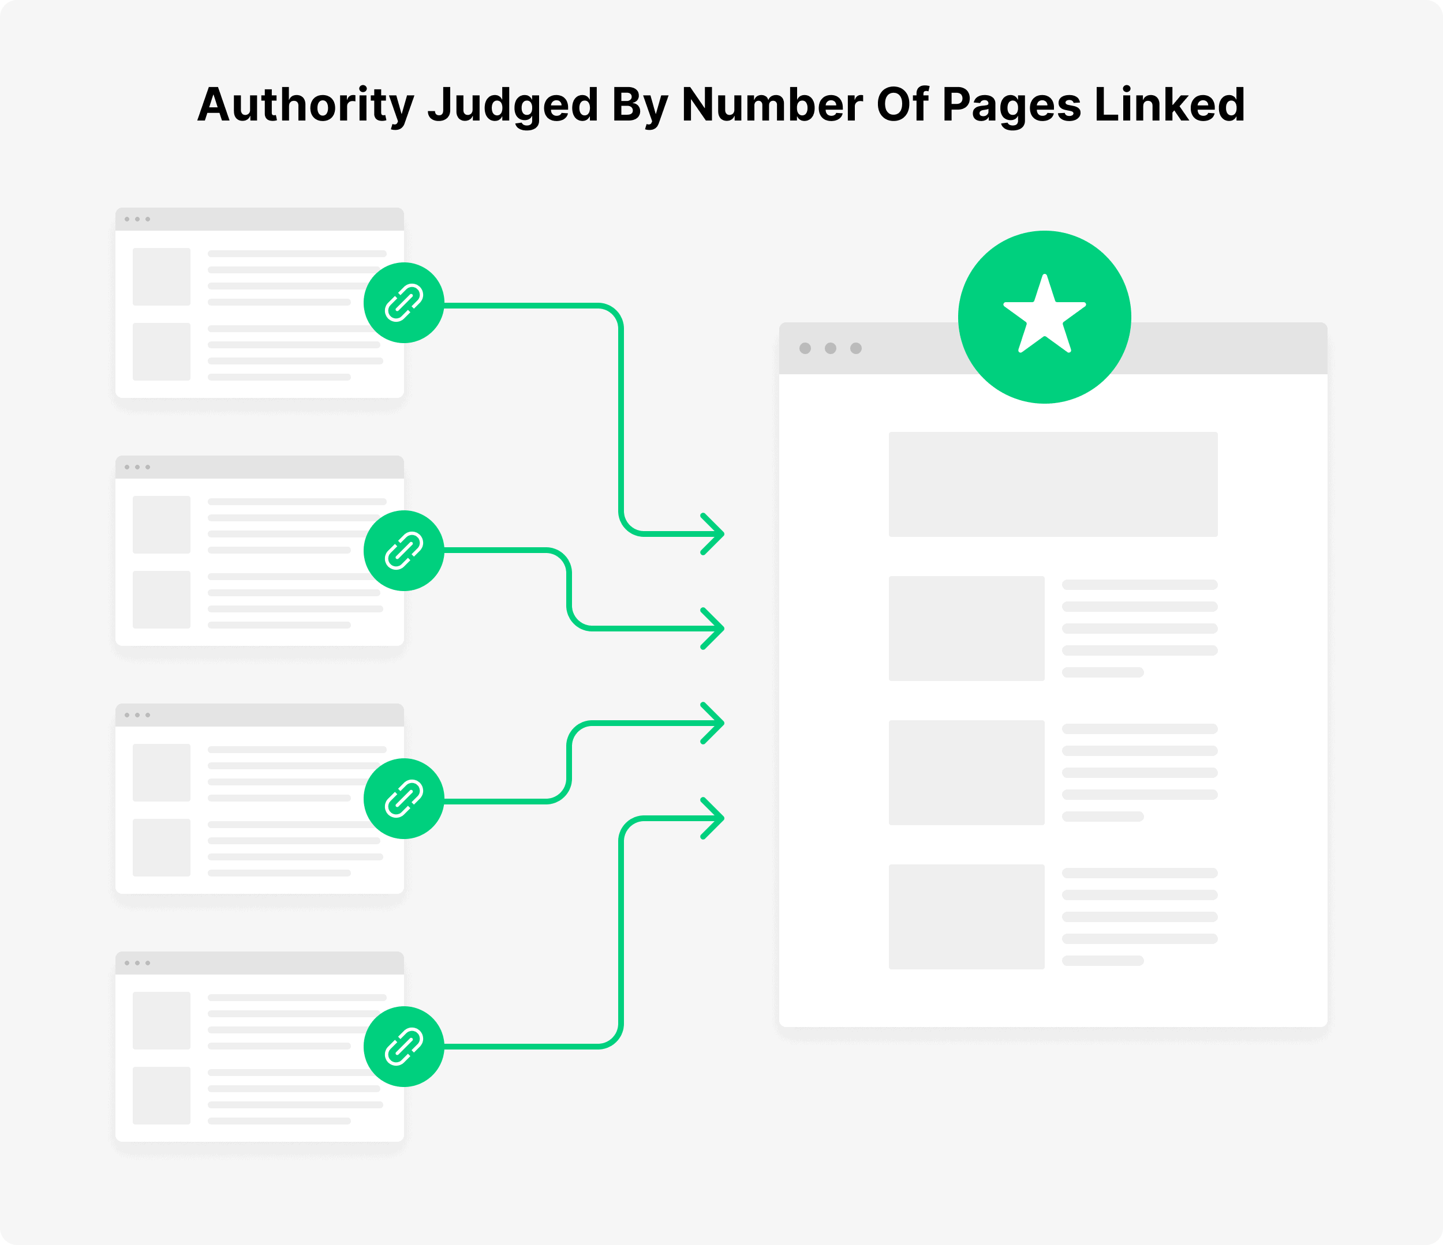

(Links from other pages are known as “[backlinks](https://backlinko.com/backlinks-guide)”.)

In general, the more links a page has, the higher it will rank:

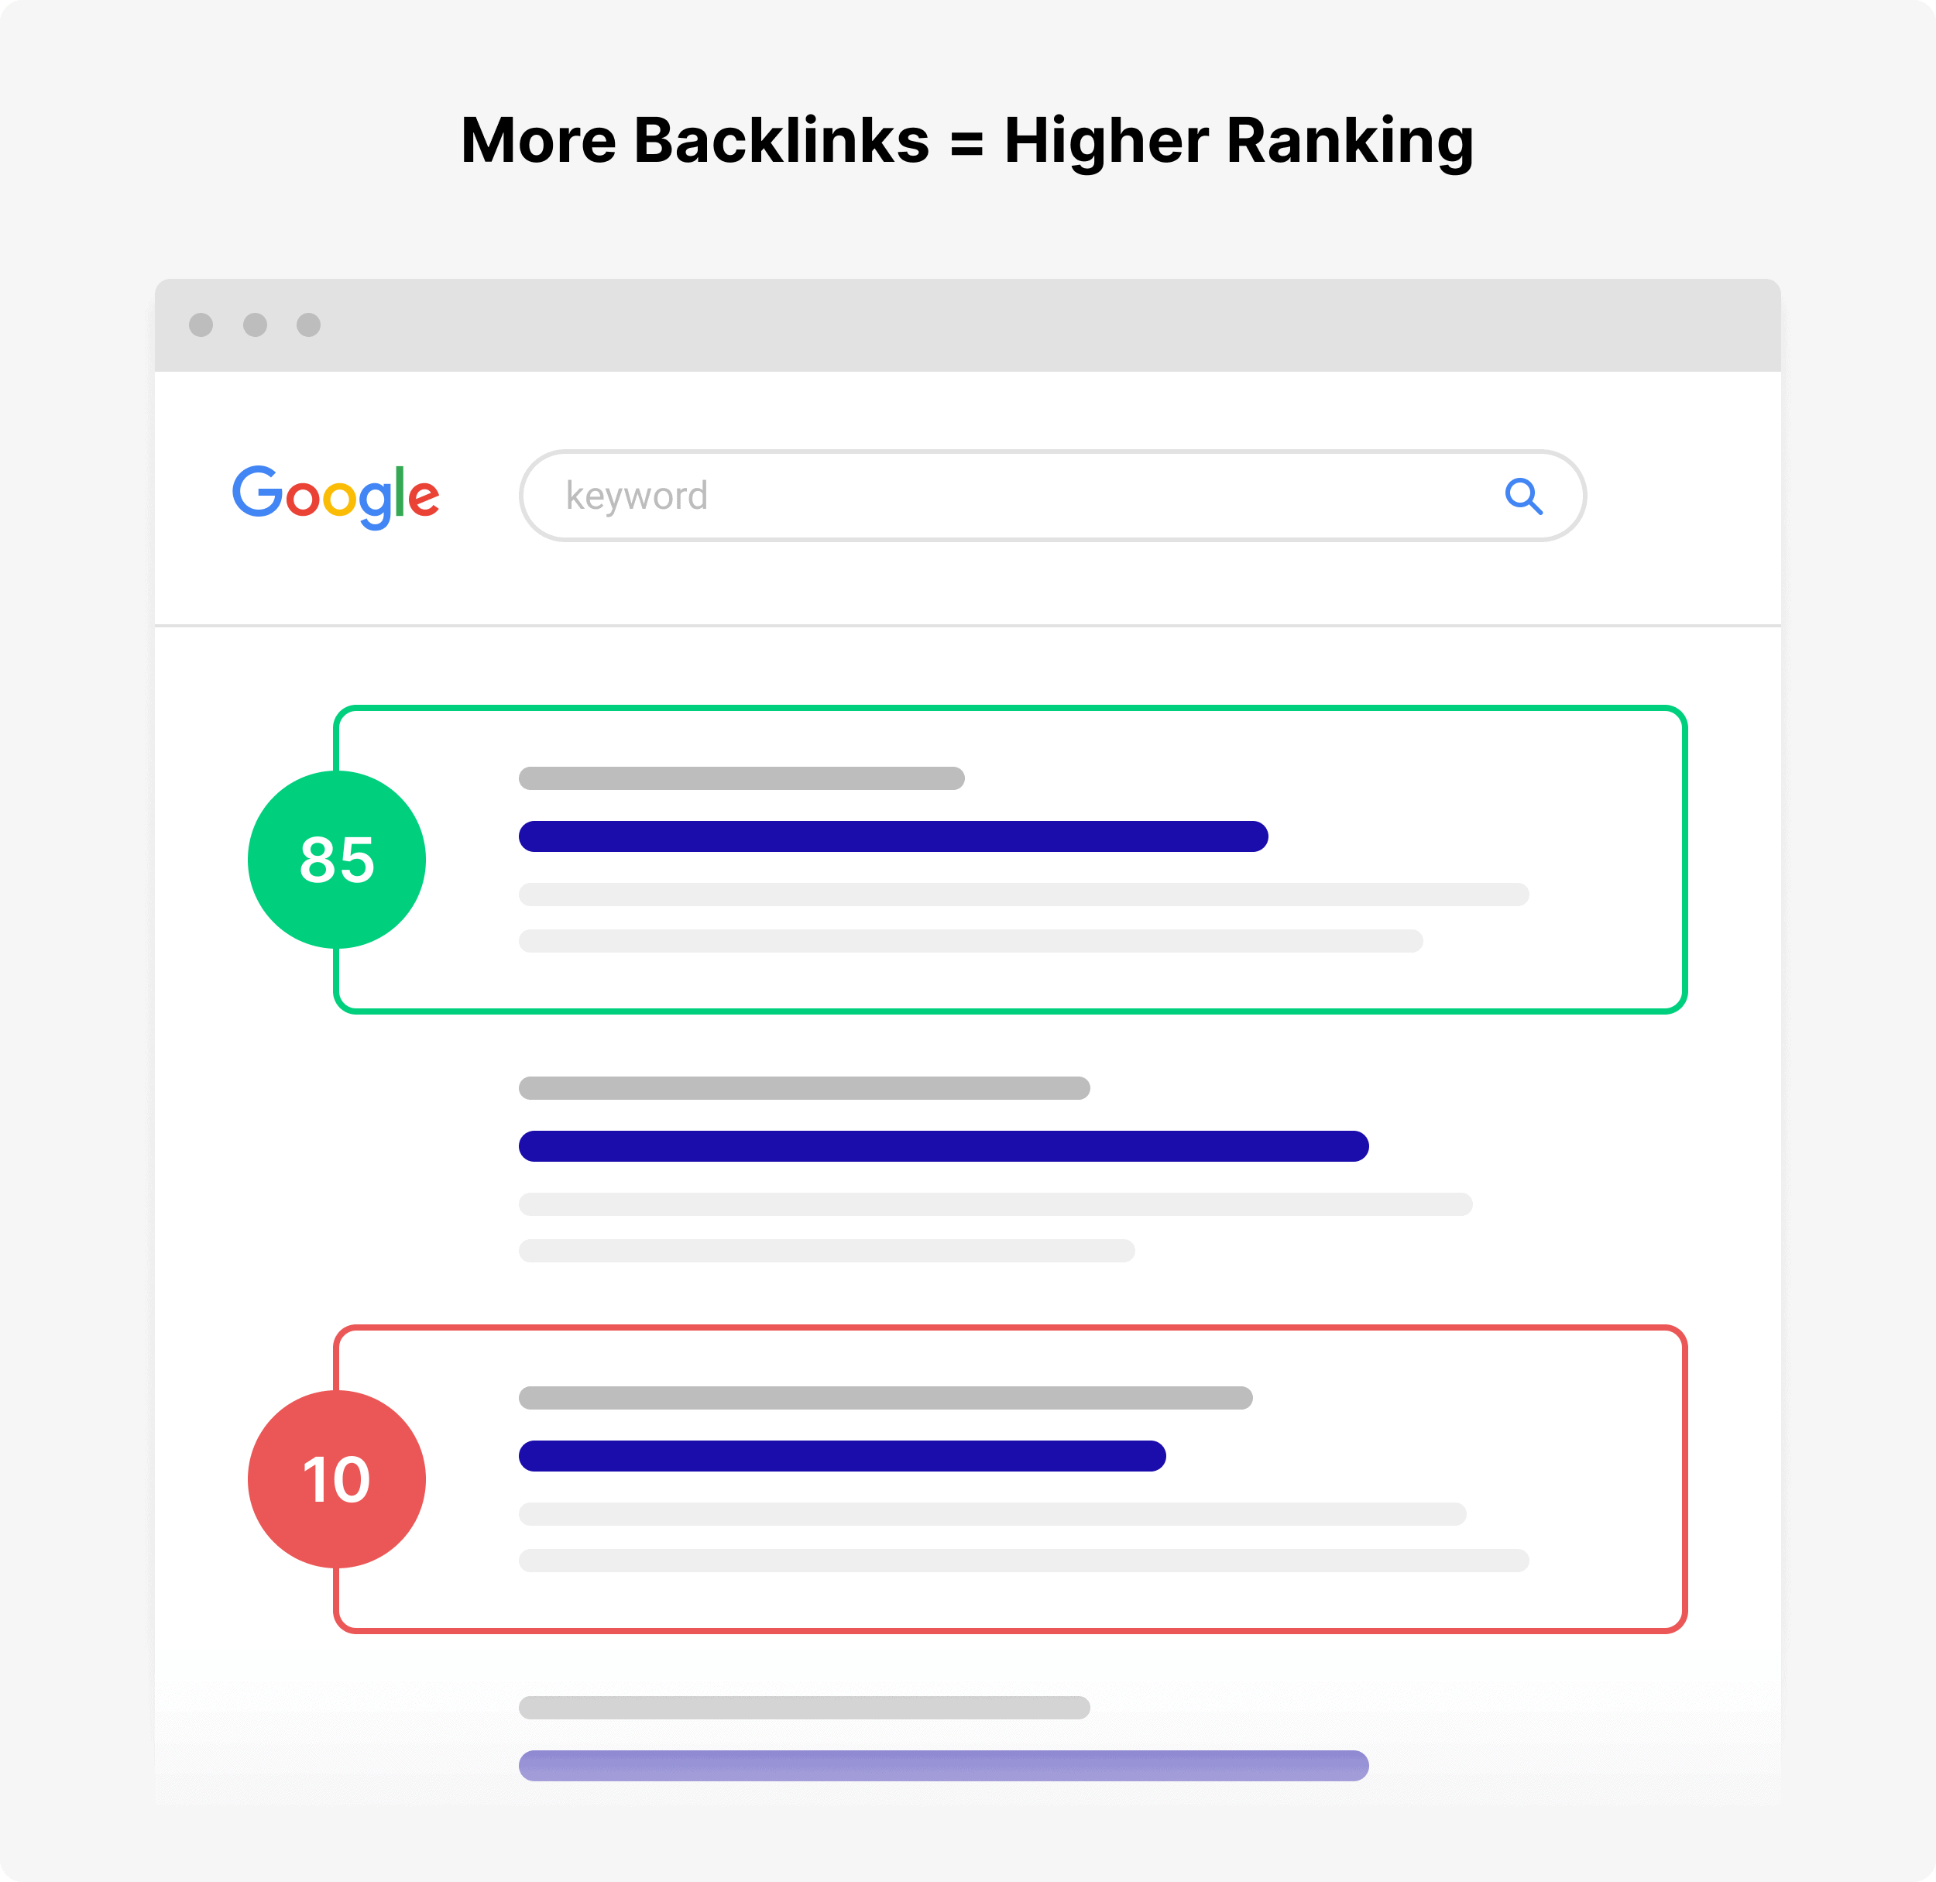

****Usefulness****

Content can be relevant and authoritative. But if it’s not ****useful****, Google won’t want to position that content at the top of the search results.

In fact, Google has publicly said that there’s a distinction between “higher quality content” and “useful” content.

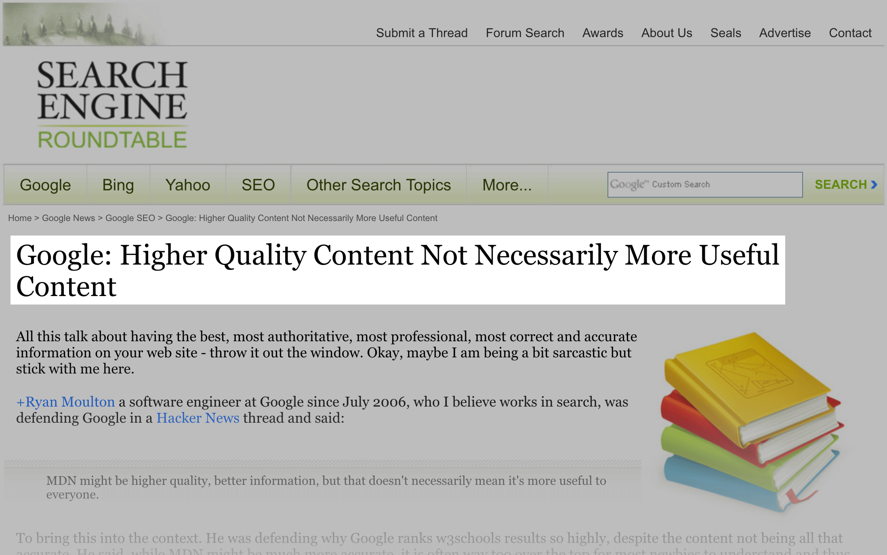

For example, let’s say that you search for “Paleo Diet”.

The first result you click on (“Result A”) is written by the world’s foremost expert on Paleo. And because the page has so much quality content on it, lots of people have linked to it.

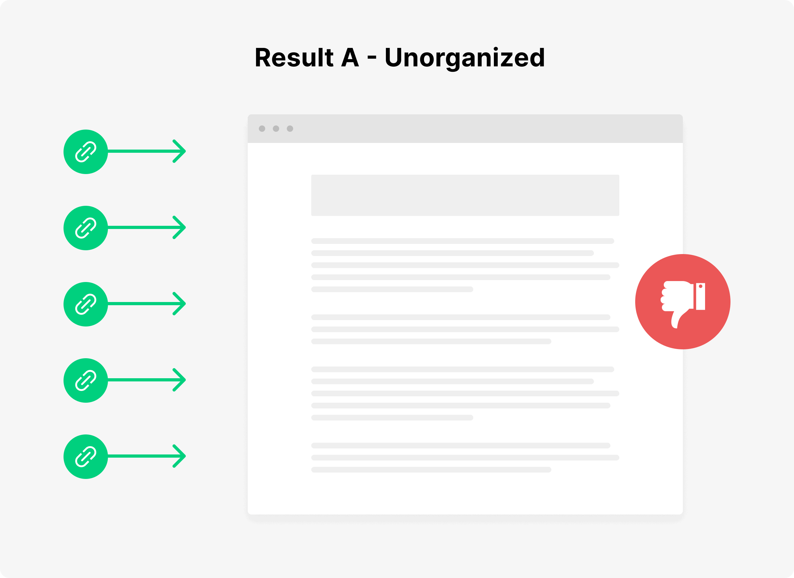

However, the content is completely unorganized. And it’s full of jargon that most people don’t understand.

Contrast that with another result (“Result B”).

It’s written by someone relatively new to the Paleo Diet. And their website doesn’t have nearly as many links pointing to it.

However, their content is organized into distinct sections. And it’s written in a way that anyone can understand:

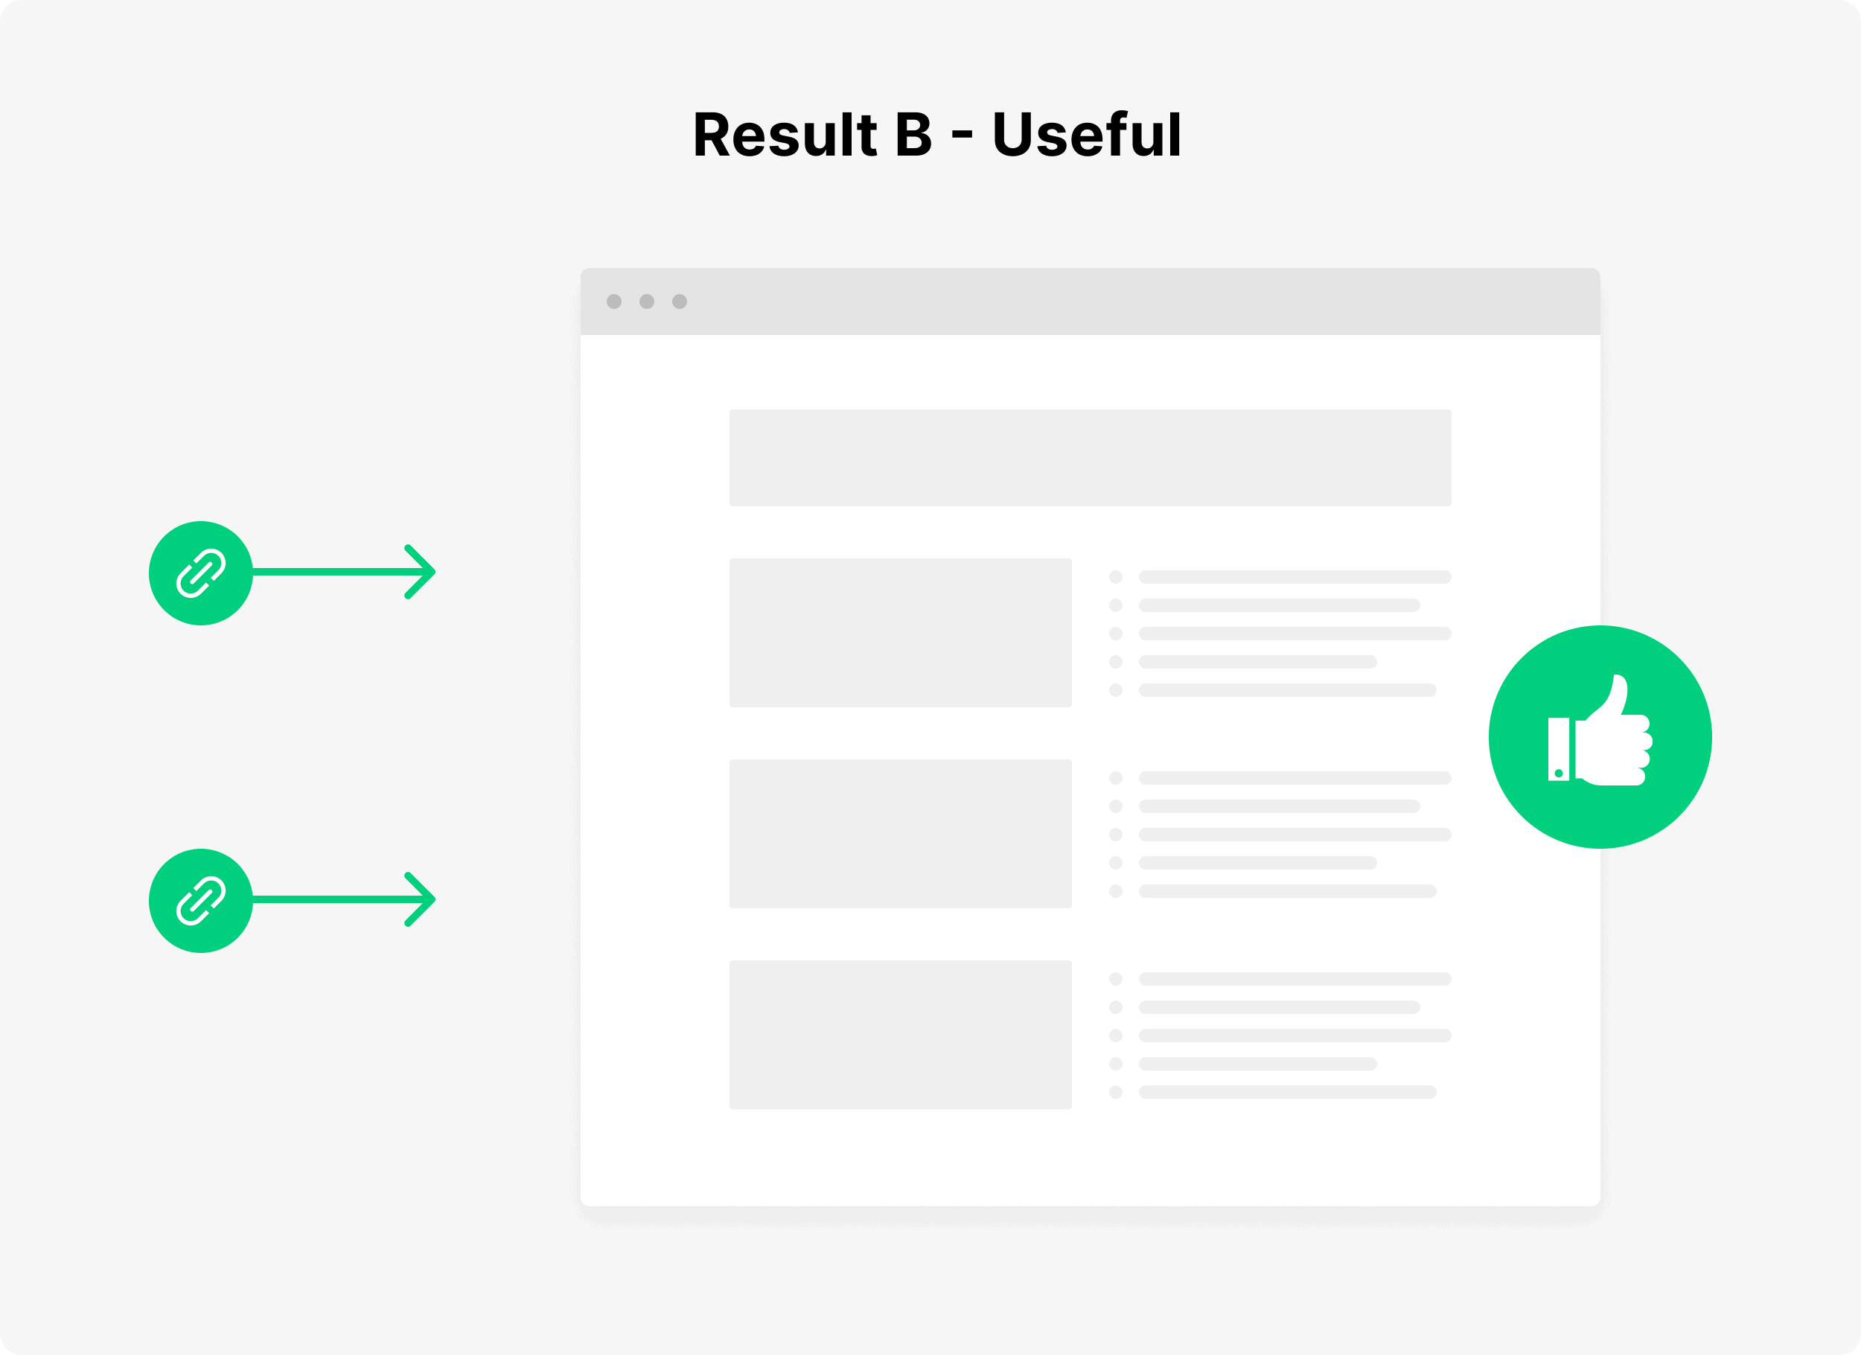

Well, that page is going to rank highly on the “usefulness scale”. Even though Result B doesn’t have as much trust or authority as Result A, it will still perform well in Google.

(In fact, it may even rank HIGHER than Result A.)

Google measures usefulness largely based on “User Experience Signals”.

In other words: how users interact with the search results. If Google sees that people really like a particular search result, it will get a significant ranking boost:

