**HTML**

**Hypertext Markup Language**

* HTML stands for Hyper Text Markup Language
* **Develop by Tim Berners Lee**
* HTML is the standard markup language for creating Web pages
* It describe the structure of web page
* HTML is case insensitive language
* Hypertext can be added to the text
* It is a markup language

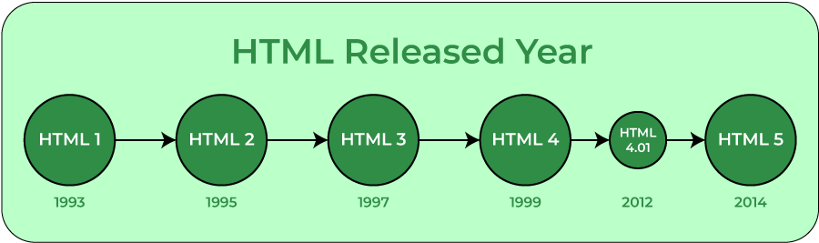

**Advantages**

* HTML is used to build websites
* Helps in developing fundamental about web programming
* Implementation is easy
* It supported by all browsers (edge, chrome… )
* It can be integrated with other languages like CSS, JavaScript, etc.

**Disadvantages**

* HTML can only create static web pages
* A large amount of code has to be written to create simple web page.
* Security features is not good.