**Protocol**

**HTTP : Hypertext transfer protocol**

**HTTPS: Hypertext transfer protocol secure**

Communication between client computers and web servers is done by sending **HTTP Requests** and receiving **HTTP Responses**

**“The protocol is a standard that specifies how data are transmitted between computers”**

To understand this difference between HTML and HTTP

Now one can write C programs in C language and then one can transfer these C programs from Server to Clients using FTP (i.e. File transfer protocol).

**Same way, web pages (which are mostly HTML pages) are written in HTML and these web pages are exchanged between Server and Clients using HTTP.**

HTTP Request / Response

1. A client (a browser) sends an **HTTP request** to the web
2. A web server receives the request
3. The server runs an application to process the request
4. The server returns an **HTTP response** (output) to the browser
5. The client (the browser) receives the response

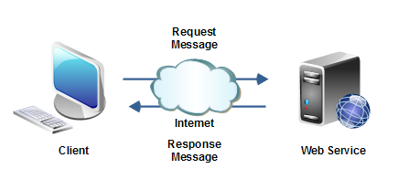

**HTTP VS HTTPS**

