**url**

**(Uniform Resource Locator)**

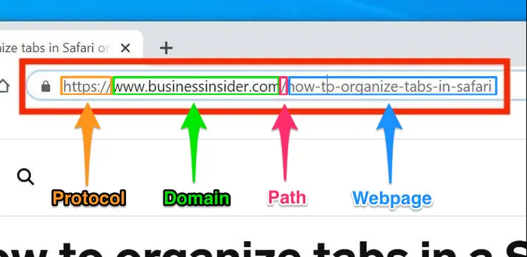

A URL (Uniform Resource Locator) is a unique identifier used to locate a resource on the Internet. It is also referred to as a web address. URLs consist of multiple parts -- including a protocol and domain name -- that tell a web browser how and where to retrieve a resource.



**Scheme**

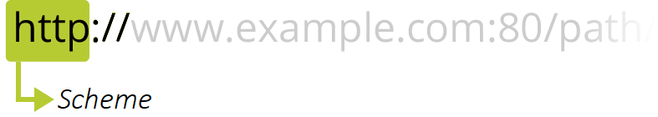

The first part of the URL is the scheme, which indicates the protocol that the browser must use to request the resource (a protocol is a set method for exchanging or transferring data around a computer network). Usually for websites the protocol is HTTPS or HTTP (its unsecured version).

**Authority**

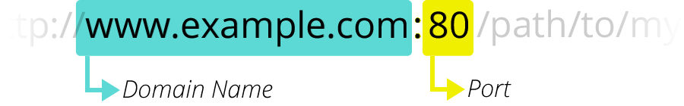

Next follows the authority, which is separated from the scheme by the character pattern ://. If present the authority includes both the domain (e.g. www.example.com) and the port (80), separated by a colon:

* The domain indicates which Web server is being requested. Usually this is a domain name, but an IP address may also be used (but this is rare as it is much less convenient).
* The port indicates the technical "gate" used to access the resources on the web server. It is usually omitted if the web server uses the standard ports of the HTTP protocol (80 for HTTP and 443 for HTTPS) to grant access to its resources. Otherwise it is mandatory.

**Path to resource**

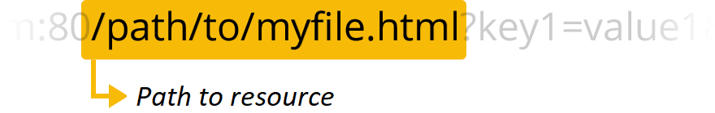

/path/to/myfile.html is the path to the resource on the Web server. In the early days of the Web, a path like this represented a physical file location on the Web server. Nowadays, it is mostly an abstraction handled by Web servers without any physical reality.

**Parameters**

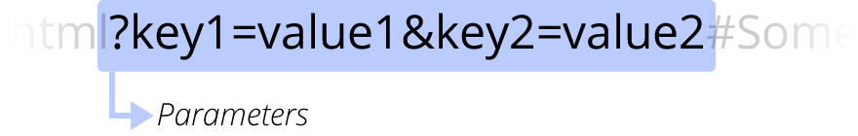

?key1=value1&key2=value2 are extra parameters provided to the Web server. Those parameters are a list of key/value pairs separated with the & symbol.

**Anchor**

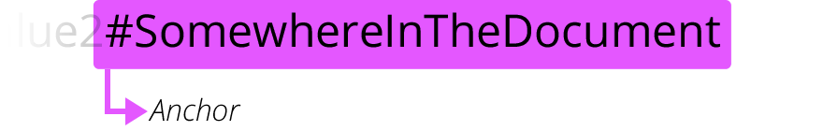

#SomewhereInTheDocument is an anchor to another part of the resource itself. An anchor represents a sort of "bookmark" inside the resource, giving the browser the directions to show the content located at that "bookmarked" spot.

**Types of URL**

1. **Absolute URL**

<a href="https://www.holisticseo.digital">

1. **Relative URL**

<a href="/example-path.html"/>

<a href="//example.com/example-path.html"/>