Spring Boot

- Spring Boot is a powerful, open-source framework built on top of the Spring Framework in Java.

- Its primary goal is to simplify and accelerate the process of creating production-ready, stand-alone Spring applications with minimal manual configuration, providing autoconfiguration features.

- It helps programmers to reduce the boilerplate configuration (especially XML configuration) required to set up a Spring application.

- Spring boot provides its own JPA called as Spring Data JPA which has been built over JPA which is implemented by Hibernate framework.

- Every Spring boot project will have a dedicated server which will be auto configured by the Spring itself. Spring boot uses Apache tomcat as a web server.

- Majorly used for developing RESTful APIs, microservices, web applications, and backend services.

- Spring boot can be used to implement web services or microservices.

Webservice:

- It is a server-side application which will provide a service (only data, not ui) for multiple clients on the web.

- Server can have a service (a piece of software logic), hosted on a network (usually the internet) which can be accessed over web, that’s why it is called as web service.

- Real-Time Example:

- A weather service API that provides current temperature data when requested by a mobile app.
- The mobile app (client) and the weather service (server) are communicating via a web service.

Microservice :
- It is a webservice itself but in small scale.

- An architectural approach is used where server-side application will be divided into smaller, independent, loosely coupled modules/services in order to maintain the server-side application in more efficient way.

- Those small modules can be considered as microservices.

- Each service runs in its own process, can be developed and deployed independently, and communicates with others, usually via an API.

- Real-Time Example:

- An e-commerce website might have separate microservices for User Authentication, Product Catalog, Shopping Cart, and Order Processing.
- If the Product Catalog gets a lot of traffic or got some issue, it can be scaled independently without affecting the other services.
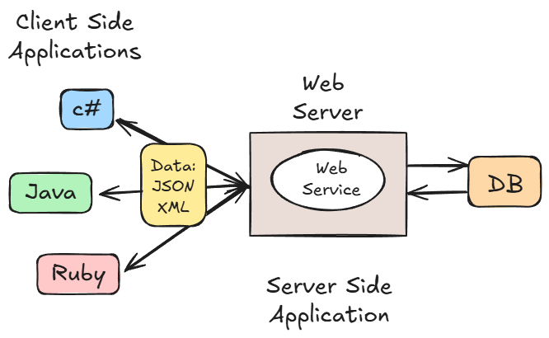

- Data can be exchanged between client-side applications and server-side applications in text format using JSON or XML, as they are language-independent!

- Since client-side applications and server-side applications are developed using different programming languages that leads to incompatibility between them.

- But in order to make client-side application communicate with server-side application, we must develop an API layer which will be a part of server-side application.

Those API's can be implemented or developed using different architectures with SpringBoot

1. SOAP architecture
- SOAP stands for simple object access protocol.

- Protocol is a set of rules and regulations which have to be followed in order to develop API's.

- It relies heavily on XML (eXtensible Markup Language) for its message format and often uses the HTTP protocol but can use others like SMTP. It's considered strict and heavyweight.

- SOAP architecture supports XML in order to transfer data from client-side application to server-side application and vice-versa
,which is the limitation of SOAP architecture, that’s why REST architecture is widely used in the development of API's.

2. REST architecture
- REST stands for representational state transfer.

- It is the way of developing APIs without any protocols, along with this, REST architecture supports transfer of data from client-side application to server-side application and vice-versa in JSON format(light weight).

- It is stateless (each request contains all necessary info) and cacheable.

RESTful APIs
- A RESTful API (or REST API) is an API that follows the principles of the REST architectural style.

- Real-Time Example:
When you use a service like Google Maps, your application sends requests to the Google Maps RESTful API to get map tiles, calculate routes, or find points of interest.

JSON : JavaScript Object Notation

- It’s a language-independent data format used to store and transfer data.

- It's primarily used for:
- Data Transmission: Sending data from a server to a web page (e.g., getting a list of products for an online store).
- Configuration: Storing settings for applications.
- Data Storage: Sometimes used as a simple database format.

- Structure of JSON
JSON is built on two simple structures:
- Objects (Key-Value Pairs):

  - These represent a record or a collection of data.
- They start and end with curly braces { }
- Data is stored as key: value pairs, separated by a colon.
- Each pair is separated by a comma.
- Keys must be strings (enclosed in double quotes).
Example:
{
"name": "Alex",
"age": 30
}

- Arrays (Ordered Lists):

- These are ordered lists of values, like an array in Java/C++.
- They start and end with square brackets []
- The values within an array can be any valid JSON datatype, including other objects or arrays.
Example:
[
"apple",
"banana",
"cherry"
]
An array of objects:
[
{ "city": "New York" },
{ "city": "London" }
]

- JSON Allowed Datatypes

JSON supports a specific set of basic datatypes for the values in its key-value pairs:
Datatype | Description
String | A sequence of characters. Must be in double quotes.
Number | Integers or floating-point numbers.
Boolean | true or false.
Object | A collection of key-value pairs (nested JSON).
Array | An ordered list of values (nested lists).
null | Represents an empty or non-existent value. Must be lowercase.

- Advantages of Using JSON

- The structure is simple and organized, making it easy for developers to read and understand the data.

- JSON's structure is very simple, which means most programming languages have built-in, fast, and efficient methods to read (or "parse") the data and convert it into native data structures (like objects or lists).

- JSON is a plain text format. This means it is understandable by the applications written in any programming language !

- Compared to older data formats like XML, JSON uses less "markup" (fewer extra characters), resulting in smaller file sizes. This means faster data transmission and less bandwidth usage.

- Because it's lightweight and easily parsed, the entire process of sending, receiving, and processing JSON data is very fast, which is crucial for high-performance web applications.

Examples:
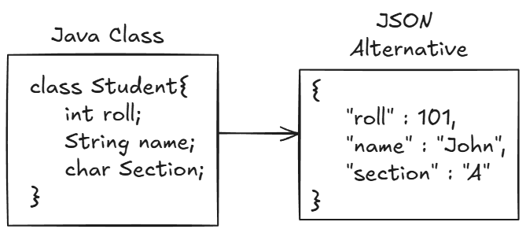

- JSON Array
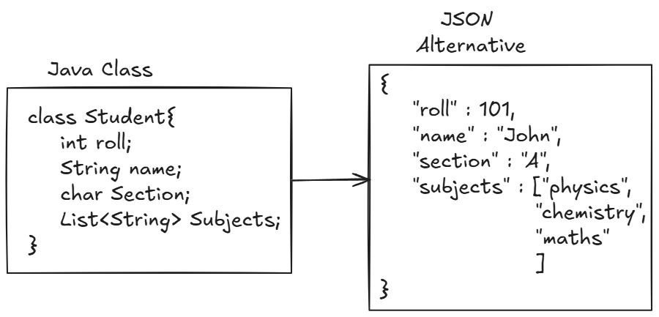

- Nested JSON Object

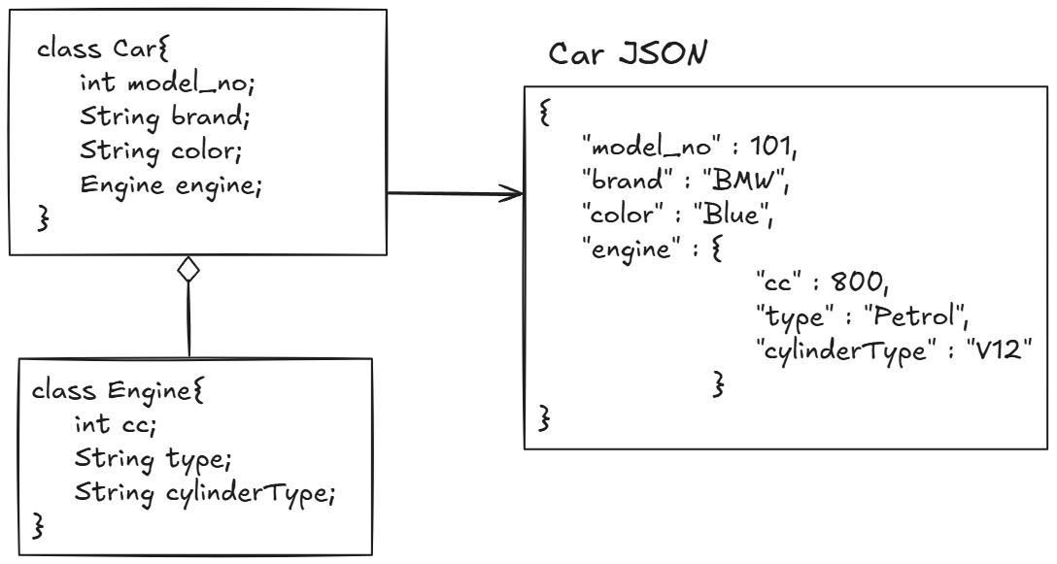

- JSON Object Array

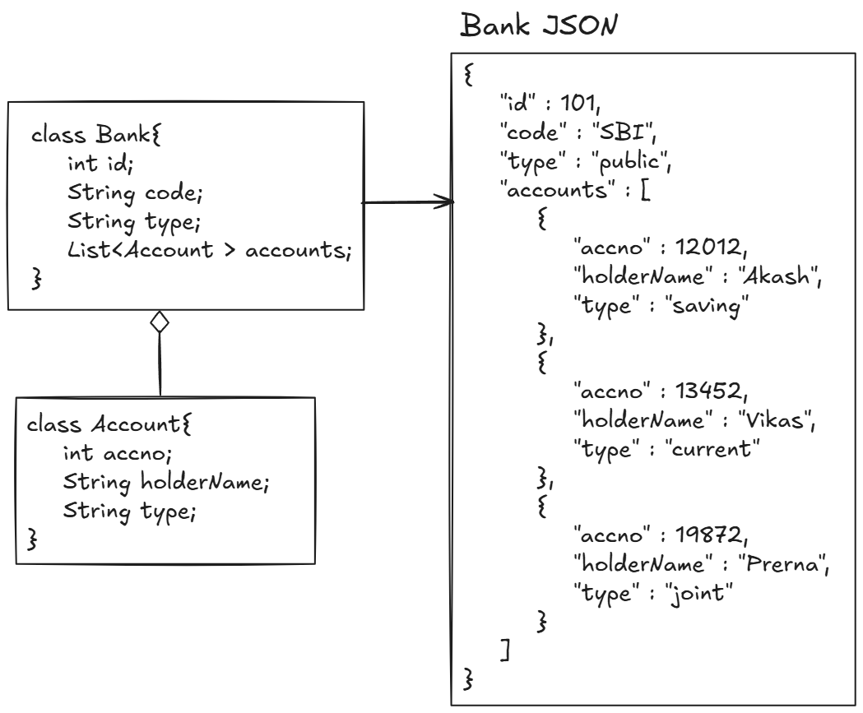

Project Setup:

- Go to https://start.spring.io/ or search Spring Initializer

- Make proper selections and click on generate:

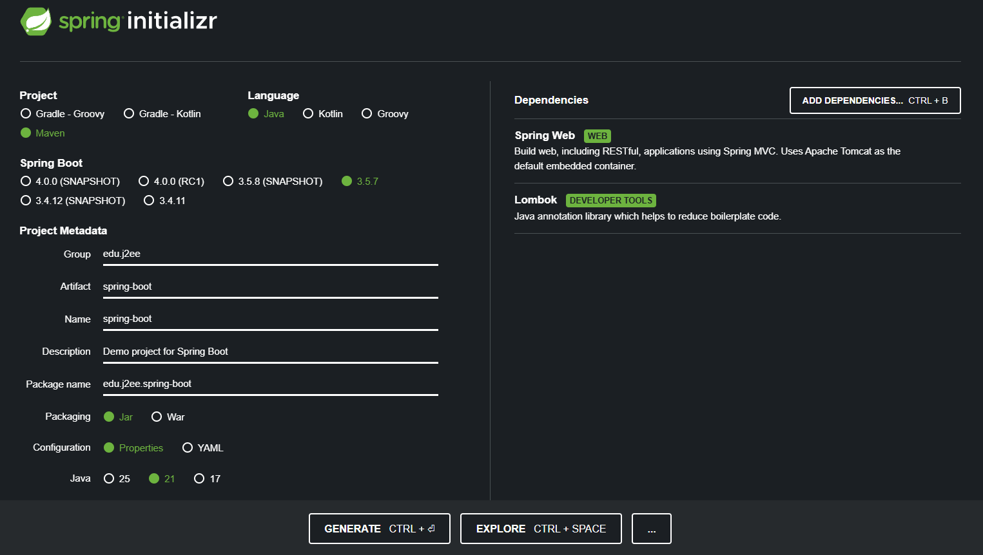

- Extract the downloaded zip file into any directory/workspace.

- Loading the project:

- Fileimportimport existing maven project.

- Select the extracted folder and import

- Class name Application, will be present annotated with @SpringBootApplication, which will act as an entry point of the springboot application.(Driver class)

- @SpringBootApplication

this annotation is a combination of @ComponentScan and @EnableAutoConfiguration. This annotation is used for the configuration of spring boot project automatically.

- Create one Controller class and a demo method to display random message

[refer edu.j2ee.spring_boot.TestController]

- Access this url: http://localhost:8081/start, content of method should be displayed on the web!

- To Terminate the application(stop listening on port)

- Press cross button(x) on right hand side of terminate button, then terminate the application.

Or

- Press Ctrl + Alt + Shift + T, to open the local terminal
- Type: netstat -ano | findstr 8080(replace this with your port)
- Something like this will be displayed:

TCP 0.0.0.0:8080 0.0.0.0:0 LISTENING 19236
TCP 192.168.0.82:8080 192.168.0.46:59298 TIME_WAIT 0
TCP 192.168.0.82:8080 192.168.0.46:59299 TIME_WAIT 0
TCP [::]:8080 [::]:0 LISTENING 19236

- Then type: taskkill /pid 19236 /f
- If: SUCCESS: The process with PID 19236 has been terminated. Is shown, then the application running is terminated

Controller Class

- Controller is a Java class that:
- Handles incoming requests (like from a browser or API client)
- Processes them (with the help of services or repositories)
- And then sends back a response (like a web page, JSON, or message)
- It is like a “traffic controller” of the web app —
it receives user requests, decides what to do, and sends back the correct response.

Real Time Example:

- Imagine a restaurant:

- Customer = User (sending a request)
- Waiter = Controller (takes order and sends to kitchen)
- Chef = Service (prepares the food/data)
- Controller (waiter) brings the response (food) back to the customer.

So, the Controller acts as a middle layer between the user and the backend logic.

- Working:

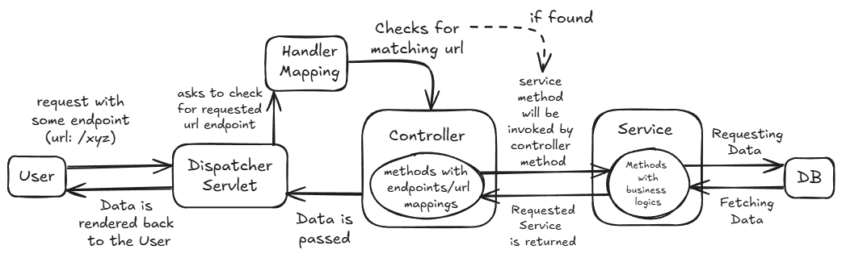

- A user sends a request → GET /employees

- The request is received by DispatcherServlet

- DispatcherServlet asks HandlerMapping to find
which Controller method is mapped to this URL.

- HandlerMapping looks for a matching Controller method (based on URL and HTTP method)

- If found, method with that endpoint in the Controller is called.

- The method executes (interacts with the Service, Repository and Database),

- The method returns:
- A response body (like JSON or text)

- DispatcherServlet sends that response back to the user.

Type | Annotation | Returns | Used For
Controller | @Controller | HTML View Pages (like JSP, Thymeleaf) | Web MVC applications
RestController | @RestController | JSON / XML / Text Data | RESTful APIs

- In SpringBoot, we are going to make use of RestController, to design and build RESTful web services (Rest APIs).

@RestController:
- Annotation used to mark this class as a controller and ensures the return value is sent as a response body (not a view page).

- it is a combination of @Controller and @ResponseBody.

@ResponseBody
- Normally, a controller method returns a view (like a JSP or HTML page).

- But when we use @ResponseBody, the return value is converted to JSON or XML (using Jackson library by default) and sent back as the HTTP response.

- @ResponseBody annotation tells Spring to perform marshalling (serialization) of the Java object returned by a controller method into a format suitable for the HTTP response — usually JSON (or sometimes XML), using the Jackson library by default.

- Marshalling is a process of converting the java object into JSON or XML (text format that can be sent over HTTP).

- UrlMapping Annotations

- @GetMapping

- Equivalent to @RequestMapping (method = RequestMethod.GET).
- Used for fetching the data.

- @PostMapping

- Equivalent to @RequestMapping (method = RequestMethod.POST).
- Used for sending the data.

- @PutMapping

- Equivalent to @RequestMapping (method = RequestMethod.PUT).
- Used for updating the existing data.

- @PatchMapping

- Equivalent to @RequestMapping (method = RequestMethod.PATCH).
- Used for partially updating the existing data (updating some fields).

- @DeleteMapping

- Equivalent to @RequestMapping (method = RequestMethod.DELETE).
- Used for deleting the existing the data.

[refer edu.j2ee.spring_boot.TestController]

- Note: we can only access get endpoint over web!

Using post/put or delete will show the error like:
Whitelabel Error Page
This application has no explicit mapping for /error, so you are seeing this as a fallback.
Fri Oct 31 18:09:37 IST 2025
There was an unexpected error (type=Method Not Allowed, status=405).

- So, we can test all endpoints on Postman!

Step 1: Create a new request on postman
Step 2: Select method type(GET or POST or PUT or DELETE)
Step 3: Enter the url in the following format:

http://localhost:8081/[your-urlendpoint]

and click on send.

- Passing data using query string

- A Query String is a part of a URL that contains data to be sent to the server.

- It’s used to pass small pieces of information from the client (browser) to the server.

- It contains the data in the form of key and value pair.

- ? indicates the start of query string, followed by key and value pairs, separated by &.

Example:
@GetMapping("/student")
public String info(@RequestParam("id") int stud_id, @RequestParam String name, @RequestParam(required = false) String surname) {
return "Student id: "+stud_id+"\nName: "+name;
}
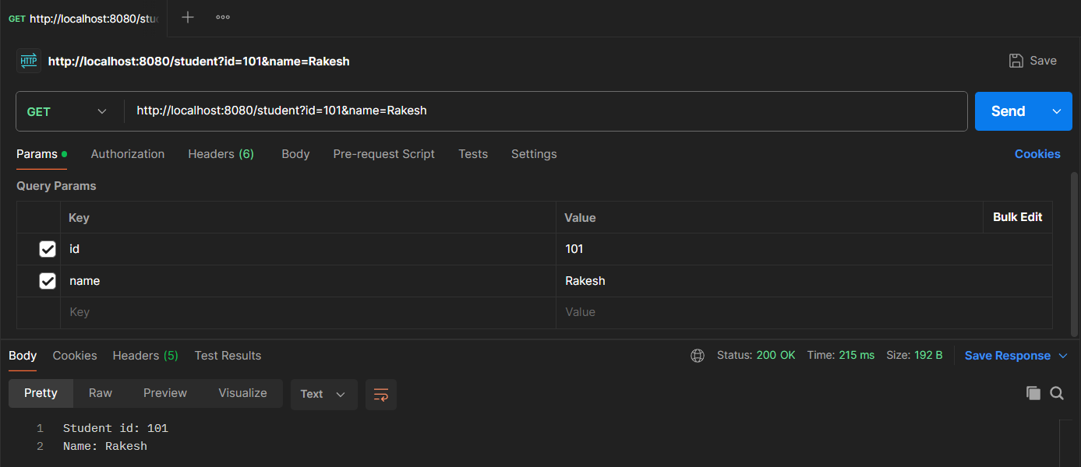

- @RequestParam is an annotation in Spring MVC/Spring Boot used to extract query parameters or form data from an HTTP request and bind them to method parameters in a controller.

- Passing data using path variable

- Here, we can pass the variable directly in the url, enclosed within {}.

Example:
@GetMapping("/user/{id}/{name}")
public String userInfo(@PathVariable("id") int user_id, @PathVariable String name) {
return "User id: "+user_id+"\nName: "+name;
}
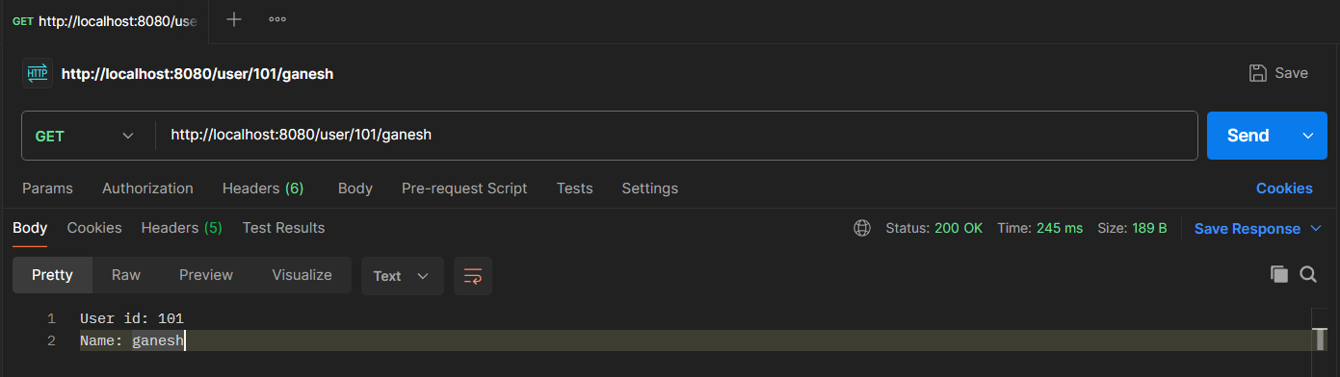

Feature | @RequestParam | @PathVariable
Location in URL | After a? — in the query string | Inside the URI path itself, inside{}
Example URL | /employees?id=10 | /employees/10
Use | Used to extract query parameters from the URL | Used to extract path segments dynamic data from the URL
Annotation usage | @RequestParam("id") int id | @PathVariable("id") int id
Primary purpose | For filtering, sorting, optional parameters | For identifying specific resources
Optionality | Easily made optional using required = false | Usually mandatory — defines resource identity(Static url pattern)

- Use @PathVariable when:
- The value is a part of the resource identity.
- You’re following RESTful API design principles.
- The endpoint represents a specific object or entity.

Example:
- /users/10 → “the user with ID 10”
- /orders/55/items → “the items of order 55”

More convenient for REST APIs, because:
- It makes URLs clean and meaningful.
- It matches RESTful best practices (resources identified via URIs).
- Clients can easily navigate your API using simple, readable paths.

- Use @RequestParam when:
- The value is not part of the resource identity, but a filter, option, or configuration.
- We want optional parameters (like sorting, searching, or pagination).

Example:
/employees?department=HR&sort=salary&limit=10

More convenient for optional or variable inputs, because:
- We can specify defaults (defaultValue).
- We can make them optional (required = false).
- It’s flexible — no need to change your URL structure.

- Passing data using Header parameter

- @RequestHeader is an annotation used to access HTTP header information sent by the client in a request.

- An HTTP header is a field in an HTTP request or response message that passes additional context and metadata about the communication between a client (like web browser) and a server.

- Purpose: Headers allow the client and server to convey vital information that goes beyond the main content (the body) of the request or response. This metadata helps them correctly interpret and handle the message

Typical Uses
HTTP headers are used for a variety of critical functions, including:
- Content Negotiation: Determining the best representation of a resource (e.g., which language or file format to send).

- Authentication & Security: Sending credentials (Authorization), enforcing security policies (Content-Security-Policy), and handling cookies (Cookie, Set-Cookie).

- Caching: Controlling how long a response can be stored by the client or an intermediary cache (Cache-Control, Expires).

- Connection Management: Handling persistent connections between the client and server (Connection).
Example:
@GetMapping("/token")
public String test(@RequestHeader("token") String auth_token) {
auth_token=UUID.randomUUID().toString();
return "Token: "+auth_token;
}
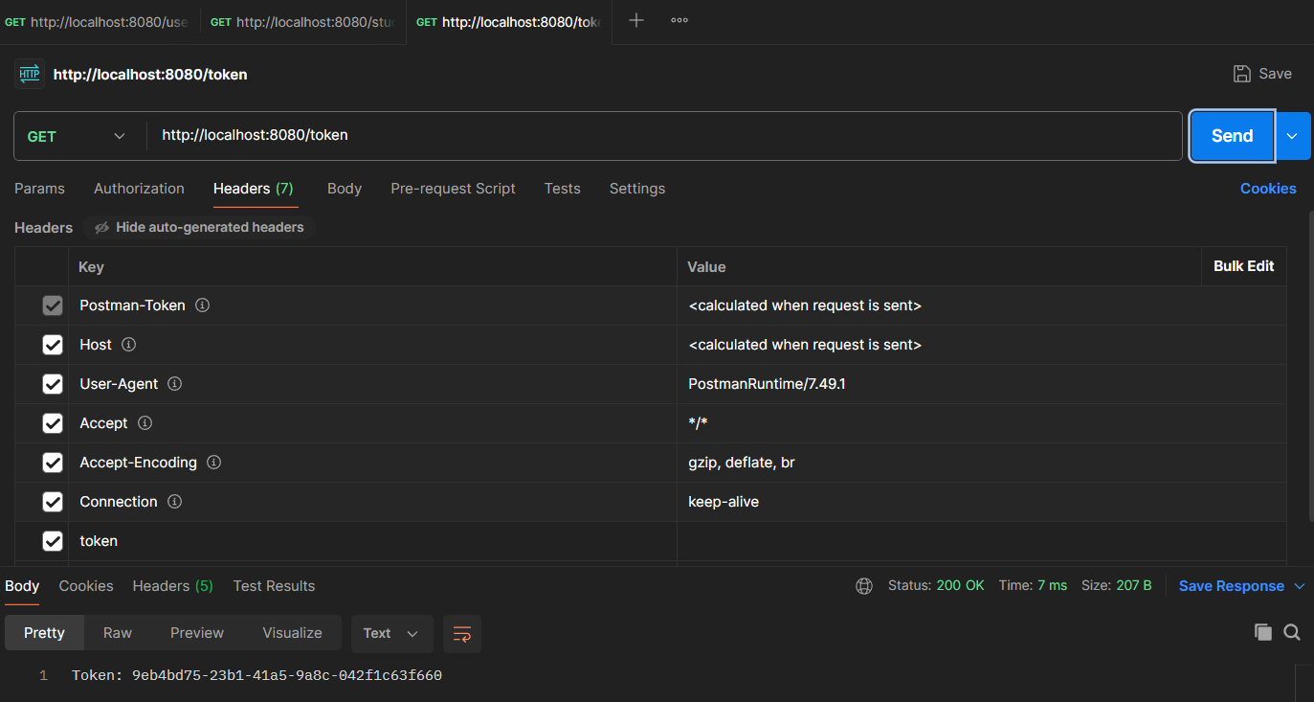

- Passing data using cookie

- Cookie is a small piece of information stored on client’s side.

Example:

@GetMapping("/info")
public String testCookie(@CookieValue("name") String prod_name,@CookieValue double price) {
return "Product Name: "+prod_name+"\nPrice: "+price;
}

- Create cookie on postman, with same name as @CookieValue! and save

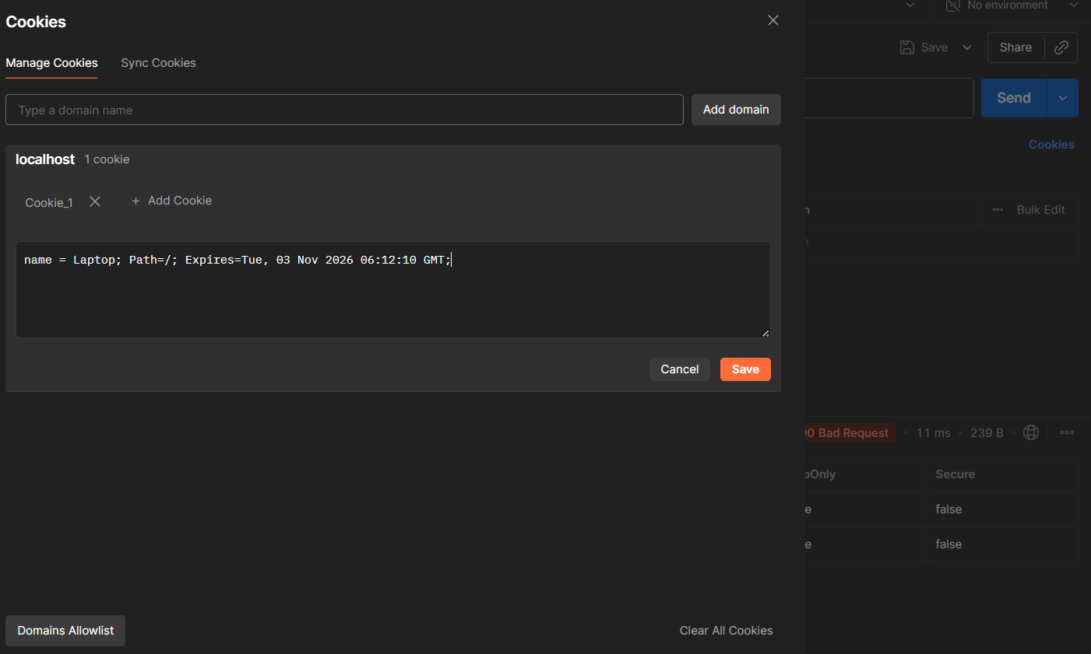

- Access cookie using url end point:
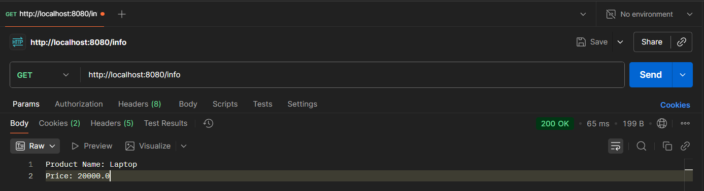
- Passing JSON Object using request body

- @RequestBody:
Annotation indicating a method parameter should be bound to the body of the web request.

- It is responsible for the conversion from the external data format (typically JSON or XML) contained in the HTTP request body into a Java object (class instance) is known as unmarshalling (or deserialization).

- Create one Student class,with fields such as id, name , height, etc with getters and setters for all.

- [refer edu.j2ee.spring_boot.Student and edu.j2ee.spring_boot.StudentController]

Example:
@PostMapping("/student")
public String studentInfo(@RequestBody Student student) {
return
"Id: "+student.getId()+"\n"+
"Name: "+student.getName()+"\n"+
"Height: "+student.getHeight()+"\n"
;
}
- Provide the data in JSON format in Postman:

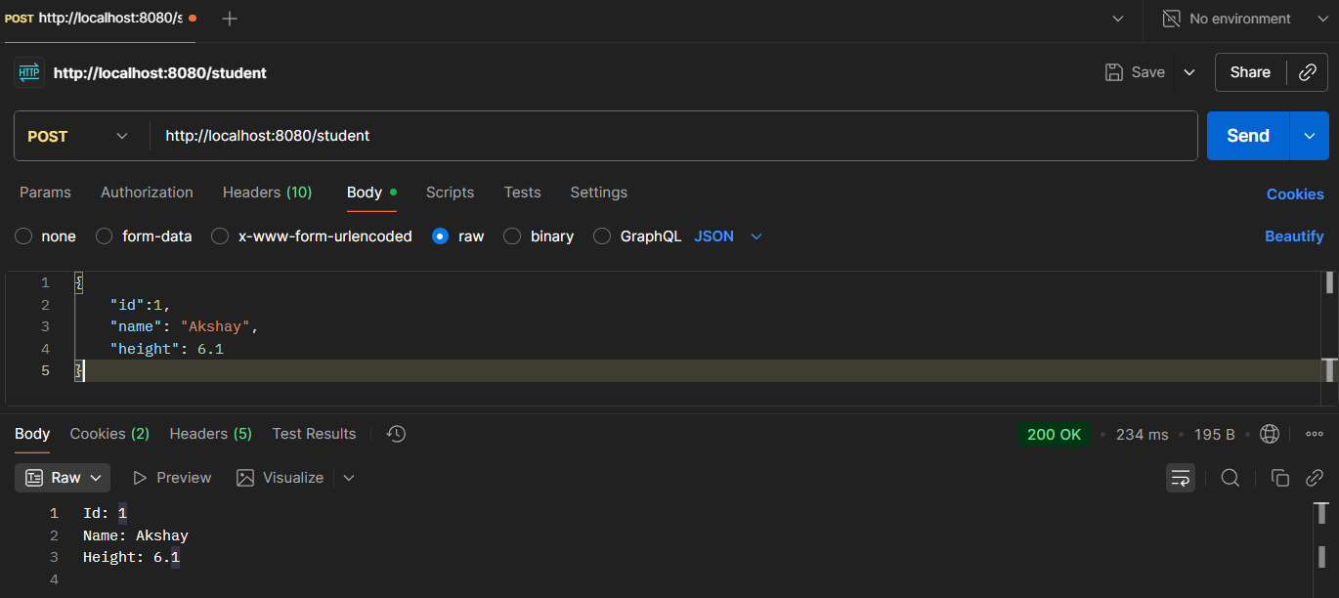

- It will also work for the data passed in param.

- SpringBoot project with DB

- Go to https://start.spring.io/ and create a project like:
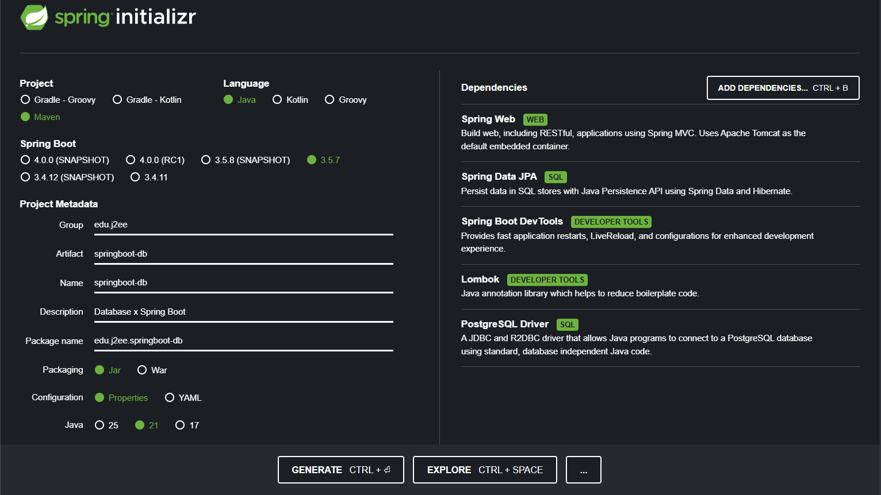

- Load the downloaded Project in any workspace

- Go to https://github.com/ArpitKharche123/Configuration-Files , and select application.properties for postgres SQL, copy the content and paste it into src/main/resources/application.properties

- Update it with appropriate database configuration.

- Layered Architecture in Spring Boot

- In Spring Boot, a layered architecture is a software design pattern that divides the application into separate layers — each having a distinct responsibility.
- It is made of layers like :
- Controller Layer (Presentation)
- Service Layer (Business Logic)
- Repository Layer (Data Access / DAO)
- Model or Entity Layer (Data Representation), etc
Each layer talks only to the layer directly below it — ensuring separation of concerns.

- Example:

Think it like a restaurant:

- Controller → Waiter (takes your order / sends response)
- Service → Chef (prepares the dish)
- Repository → Kitchen storage (fetches ingredients)
- Model → Recipe / Dish (data representation)

- Layered architecture makes REST APIs:
- More modular (easy to extend with new endpoints)
- Easier to debug (know exactly where logic lives)
- Cleaner to document/More Readable (each endpoint’s flow is predictable)
- Enterprise-ready (standard architecture for large teams)

- Detailed workflow:
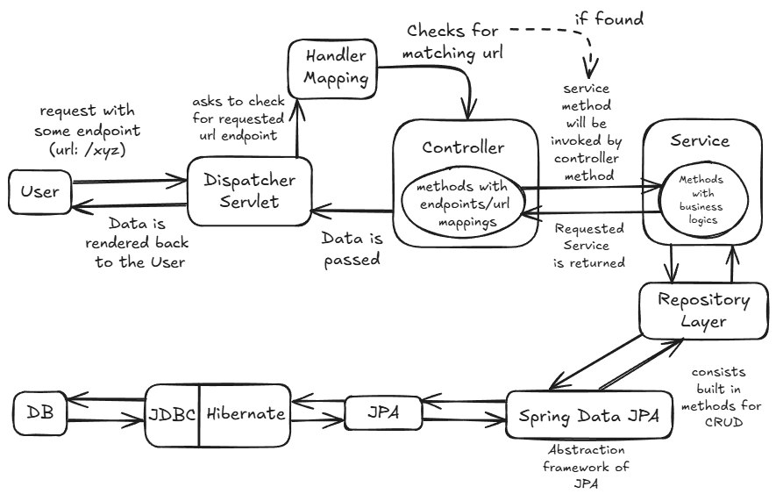

- Implementing layered architecture in Spring Boot

- In Spring Boot project, inside the base package, create sub packages like controller, service, repository, model and DTO.

- In model package, create one Entity class named Product, annotate it with @Entity and declare some fields with getters and setters

- In DTO package, create one simple java class named ProductDTO ,(with getters and setters) with the fields which has to be requested from the client while hitting POST / PUT / PATCH endpoints.

- ProductDTO will act as a data transfer object, used to transfer the data between the client and the controller, then further mapped to model.

- In repository package, create one interface named ProductRepository , which extends JpaRepository<Product, Integer>

- public interface JpaRepository<T, ID>

- JpaRepository<T, ID> is the central Spring Data JPA repository interface, which can be extended when we want Spring to generate a JPA-based data-access implementation(internal(default) DAO implementation) for an entity.

- It provides CRUD, pagination & sorting, batch operations and a number of JPA-specific convenience methods so you rarely need to write boilerplate EntityManager code.

- It provides methods like save(), findByID(ID id), findAll(), deleteById(ID id), etc. to perform basic to complex CRUD operations on any entity.

- T : placeholder for any Entity type
- ID: datatype of primary key , in non-primitive type
[refer prod.repository.ProductRepository]

@Repository
this annotation is the specialized form of @Component, which is used to mark an interface as repository,
or
we can say it marks a class as a Data Access Layer (DAO) component.

- Even though we don’t use @Repository, it is considered internally by Spring Boot’s auto-configuration feature!!!

- In service package, create one interface named IProductService with some basic CRUD methods, and its implementing class ProductService
- Annotate ProductService class with @Service annotation

@Service
- It is a specialization of @Component annotation.
- It marks a class as a service-layer Spring bean.
- Class annotated with @Service is used to hold business logic.

- In ProductService class methods, perform dependency injection of ProductRepository using one of the ways:

  - @Autowired
  - Constructor Injection(recommended)
  - @RequiredArgConstructor and making field final( alternative of constructor injection with less boilerplate code)

so that we can use built-in methods provided by JPARepository to perform CRUD operation on Product Entity Class.

[refer prod.service.ProductService]

- In controller package, create one class named ProductController ,annotated with @RestController

- Also annotate it with @RequestMapping(“/some-base-url”)

@RequestMapping:
- It is used to map an HTTP request (like GET, POST, PUT, DELETE) to a specific controller method or class.

- @RequestMapping tells Spring:
“When a user sends a request to this URL, run this controller method.”

- It can be used as:
- Class level → defines a base URL for all methods in that class.
- Method level → defines a specific endpoint under that base URL.

- Perform dependency injection of IProductService in ProductController
- Create controller methods with annotations specifying method types and invoking the IProductService methods.
[refer prod.controller.ProductController]

- After running the application, test all the endpoints in PostMan, and check whether CRUD operation is getting performed on the database table or not in PG Admin

- PostMan Requests:

- POST addProduct
URL: http://localhost:8080/products
Request Body: raw (json)
e.g.
{
"name":"Television",
"price": 123999.0
}

- GET getAllProducts

URL: http://localhost:8080/products
No Request Body

- GET getProductById

URL: http://localhost:8080/products/1
No Request body
- PUT updateProduct

URL: http://localhost:8080/products/1
Request Body raw (json)
e.g.
{
"name": "iphone",
"price": 130000.0
}
- DELETE deleteProduct
URL: http://localhost:8080/products/1
No Request body

- Custom Repository Methods:

- Along with the built-in methods of JPARepository, we can also create our custom method by following Spring Data JPA naming convention rules!
- Spring will automatically generate SQL queries as per keywords.

✅ Rule 1: Start with the right prefixes
- Spring detects intent from the method name.

- Some common prefixes are:

Prefix | Meaning
findBy | Select records
readBy | Same as findBy
getBy | Same as findBy
queryBy | Same as findBy
countBy | Count records
existsBy | Check if record exists
deleteBy | Delete records

✅ Rule 2: Use Entity Field Names exactly as they appear in the class

- If entity fields are like:

private int id;
private String name;
private double price;

So the field names in methods should be like:
➡ id, name, price

- e.g.: List<Product> findByName(String name);

will be internally translated to:
SELECT * FROM product WHERE name = ?

- e.g. List<Product> findByPriceGreaterThan(double price);

  - SELECT * FROM product WHERE price > ?
[refer prod.repository.ProductRepository]

Keyword | SQL Equivalent
LessThan | <
LessThanEqual | <=
GreaterThan | >
GreaterThanEqual | >=
Between | BETWEEN ... AND ...
Like | LIKE
NotLike | NOT LIKE
In | IN
NotIn | NOT IN
IsNull | IS NULL
IsNotNull | IS NOT NULL
StartingWith | LIKE 'value%'
EndingWith | LIKE '%value'
Containing | LIKE '%value%'
True / False | for boolean fields

- Custom JPQL Queries

- When naming convention are not enough to perform some complex , operation, we can explicitly specify JPQL queries to custom methods using @Query tag!

e.g:
@Query("SELECT p FROM Product p WHERE p.name = :name AND p.price < :price")
List<Product> findProductsUnderPrice(@Param("name") String prod_name, @Param("price") double price);

- @Param is used to set methods arguments to the placeholders/query parameters in the JPQL query!!
- If method param and query param are same, then there is not need to use @Param
- But it may not work sometimes(due to IDE configurations)
- So, the safer practice is always use @Param

- Or match all the method parameters with query parameters (here no need of @Param)

e.g.
@Query("SELECT p FROM Product p WHERE p.name = :name AND p.price <: price")
List<Product> findProductsUnderPrice2(String name, double price);

- Media Types:

- It tells the client and server what format the request body is in and what format the client wants back.

- Comon media types/formats like JSON, XML, plain text, form, file, csv, etc can be exchanged between client and sever.

- MediaType is a class present in org.springframework.http , which helps programmer to decide the type/format of request body as well as response body, with the help of some attributes and variables.

- The default MediaType for RestController is JSON (internally serialization/marshalling happens)

e.g.
@PostMapping(value = "/addProduct", consumes = MediaType.APPLICATION_JSON_VALUE , produces = MediaType.APPLICATION_XML_VALUE )
public Product addProductXML(@RequestBody ProductDTO productDto) {
Product product = new Product();
// Data mapping from DTO to Entity
product.setName(productDto.getName());
product.setPrice(productDto.getPrice());
return productService.saveProduct(product);
}
[refer prod.controller.ProductController]

- consumes: declares which media types, the controller method accepts for request body

in the above example, controller accepts the request body in JSON format(which is default/(works same if not provided!!))

- produces: declares which media types, the controller method will produce and returns as a response body

in the above example, controller returns the response body in XML format

- To get the response body in the form of XML, we have to add Jackson Dataformat XML » 2.20.0 dependency in pom.xml!

- Response Structure

- It refers to the standard format in which RESTful API returns data and information to the client.

- Instead of just returning raw data, it can be wrapped in a consistent object or pattern for both success and error scenarios.

- It is a way to return the complete information regarding the data, (instead of raw data itself) in a consistent, managed and precise manner.

- This structure can be implemented by creating a user defined generic class.[refer prod.DTO.ApiResponseDTO<T>]

e.g.
@Data
public class ApiResponseDTO<T> {
private int statusCode;
private String message;
private T data;
}

- In Controller:

@GetMapping("/getProduct/{id}")
public ApiResponseDTO<Product> getProduct(@PathVariable int id) {
Optional<Product> opt = productService.getProductById(id);

ApiResponseDTO<Product> response = new ApiResponseDTO<Product>();

if (opt.isPresent()) {
response.setStatusCode(HttpStatus.OK.value());
response.setMessage("Product fetched successfully!");
response.setData(opt.get());
} else {
response.setStatusCode(HttpStatus.NOT_FOUND.value());
response.setMessage("Product Not Found!");
}
return response ;
}

- If the product is found, we will get response like:

{
"statusCode": 200,
"message": "Product fetched successfully!",
"data": {
"id": 1,
"name": "iphone",
"price": 130000
}
}

- If product is not present, then:

{
"statusCode": 404,
"message": "Product Not Found!",
"data": null
}

- Note: This will help to change the response structure only, not the complete/actual response!

for above example , we will get the actual status code (shown on left of the response body in swagger) as 200 only!, regardless of the response body!!

So, to overcome this, we can make use of Response Entity!

- ResponseEntity

- It represents the entire HTTP response that the API sends back to the client.

- Instead of just returning the data (the response body/structure), ResponseEntity allows us to have full control over all three essential components of an HTTP response:

- HTTP Status Code
- HTTP Headers
- Response Body

- It is a generic class, declared as ResponseEntity<T>, where T is the type of the response body to return.

- We have created a response body type: ApiResponseDTO<T>, which can be used with ResponseEntity to obtain full control over the response.

e.g:

@GetMapping("/getAll")
public ResponseEntity<ApiResponseDTO<List<Product>>> getAllProducts() {
List<Product> products = productService.getAllProducts();

//to trigger 404
//products=new ArrayList<Product>();

ApiResponseDTO<List<Product>> response = new ApiResponseDTO<List<Product>>();
if (!products.isEmpty()) {
response.setStatusCode(HttpStatus.OK.value());
response.setMessage("Products fetched successfully!");
response.setData(products);
return new ResponseEntity<ApiResponseDTO<List<Product>>>(response, HttpStatus.OK);

} else {
response.setStatusCode(HttpStatus.NOT_FOUND.value());
response.setMessage("Products Not Found!");
return new ResponseEntity<ApiResponseDTO<List<Product>>>(response, HttpStatus.NOT_FOUND);
}
}

- Here, Both user given status code and actual API response status code can be managed, unlike using only ApiResponse generic class!

- In this way we can achieve full control over Http response, as well as we can customize the response structure with consistency!

- Exception Handling in SpringBoot

- There is a chance we might get some exceptions in response body due to some wrong configurations, data type mismatch , field constraints and many more reasons.

- In SpringBoot, we can handle these exceptions with the help of user defined Exception Handler class.

- This class will:

- Be annotated with @ControllerAdvice (or @RestControllerAdvice) to make it a global exception handler that can catch exceptions thrown from any controller in the application.

- Contain methods annotated with @ExceptionHandler that are responsible for catching specific types of exceptions (e.g., ProductNotFoundException, MethodArgumentNotValidException, etc).

- Inside each @ExceptionHandler method, we can transform the caught exception into a user-friendly and well-structured ResponseEntity containing a custom error body and an appropriate HTTP Status Code (e.g., HttpStatus.NOT_FOUND for a 404, or HttpStatus.BAD_REQUEST for a 400).

- Pre-Requites:

- For @RestControllerAdvice to work, change the starter web mv cui version:

<!-- https://mvnrepository.com/artifact/org.springdoc/springdoc-openapi-starter-webmvc-ui -->
<dependency>
<groupId>org.springdoc</groupId>
<artifactId>springdoc-openapi-starter-webmvc-ui</artifactId>
<version>2.7.0</version>
</dependency>

- Create a response structure/dto class, named ErrorResponseDTO, with some fields like timestamp, statusCode, error, message
[refer prod.DTO.ErrorResponseDTO]

@Data
public class ErrorResponseDTO {
private LocalDateTime timeStamp;
private int statusCode;
private String error;
private String message;
}

- Create one Exception Handler class, named ProductExceptionHandler

[refer prod.exceptionHandler.ProductExceptionHandler]

e.g.

@RestControllerAdvice
public class ProductExceptionHandler extends ResponseEntityExceptionHandler {

@ExceptionHandler(DataIntegrityViolationException.class)
public ResponseEntity<ErrorDetails> dataIntegrityViolationException(DataIntegrityViolationException e) {
ErrorDetails error = new ErrorDetails();
error.setTimeStamp(LocalDateTime.now());
error.setStatusCode(HttpStatus.BAD_REQUEST.value());
error.setError("Contraint Violation!");
error.setMessage(e.getMessage());

return new ResponseEntity<ErrorDetails>(error, HttpStatus.BAD_REQUEST);
}
}

- This method will automatically get triggered whenever the specified exception occurs! e.g when we give null in place of product name while inserting or updating, and we will get response like:

{
"timeStamp": "2025-11-07T15:46:10.3049827",
"statusCode": 400,
"error": "Contraint Violation!",
"message": "not-null property references a null or transient value: prod.model.Product.name"
}

- This approach ensures consistency, decouples error handling logic from the business logic in the controllers, and provides a clean, predictable JSON response to the client instead of a default server error page.

- Swagger UI with SpringBoot

- Swagger UI in Spring Boot is an interactive, browser-based documentation and testing tool for RESTful APIs.

- It presents the API endpoints in a clean, user-friendly interface, allowing both developers and non-developers to understand, interact with, and test APIs with minimal effort.

Implementation:

- Go to https://mvnrepository.com/ and search for SpringDoc OpenAPI Starter WebMVC UI

- Copy the dependency and add it to pom.xml, of the existing springboot project

- Run the application and on web, access this url:

http://localhost:8080/swagger-ui/index.html

- Annotations of swagger

- We can use some swagger-based annotations to provide extra information about the Controller, methods, response body ,etc, on the swagger ui page while testing the api endpoints

- [refer prod.controller.ProductController]

- @Tag(name = "Product Management", description = "CRUD on Product Entity"): This will give the info about the complete api set, what they can do

- @Operation(summary = "Add a new product", description = "Adds a new product to the database and returns the created product info.") : This tag can be used with controller method to tell specify about their task

- @ApiResponses (value =
{
@ApiResponse (responseCode = "200", description = "Product Added successfully"),
@ApiResponse (responseCode = "400", description = "Constraint Violation, null not allowed!",
content = @Content(schema = @Schema (implementation = ErrorResponseDTO.class))) })

- @ApiResponse can be used to provide the info about responses the method may return.
- @Content and @Schema can be used to specify the particular response structure for a particular API response

