Spring MVC

Any application basically consists of three layers those are:
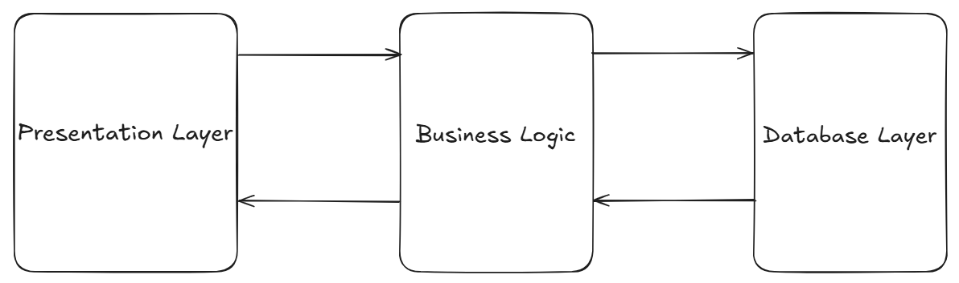

- Presentation layer:

This layer of an application deals with user interaction with the application.

- Business logic:

This layer of an application deals with data processing and database connectivity.

- Database layer:

This layer of an application deals with data management and data storage.

Monolithic application: If all the above layers of an application are present as a single application, then that application is called as monolithic application.

Spring MVC

- MVC stands for model, view, controller.
- Spring MVC is part of the Spring Framework and offers tools and conventions to create web applications (web pages, REST APIs, etc.).
- It is an architectural design pattern that divides an application into three parts/layers to make code cleaner and easier to maintain.

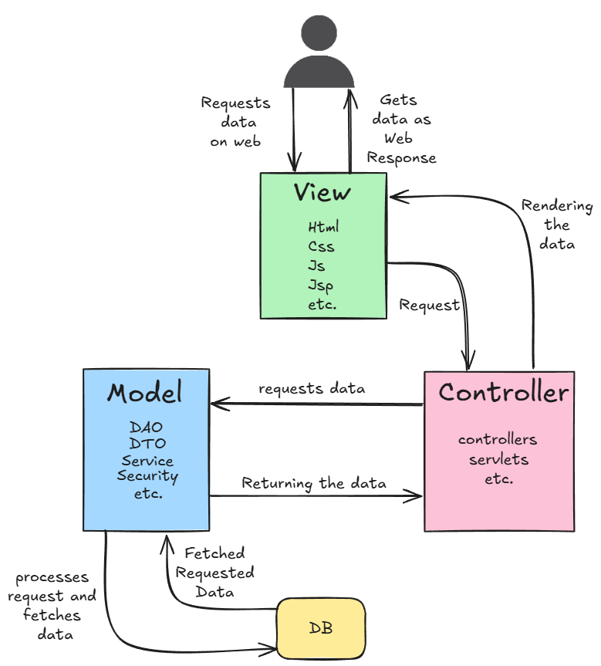
- Model:

- It represents business logic(backend) of an application, application data along with the database connectivity.
- It can have layers like Service, DAO, DTO, Security, Repository, etc.

- View:

- It represents presentation layer or user interface(frontend).
- It generally holds the HTML, CSS, JS, Thymeleaf , JSP ,etc codes.

- Controller:

- It acts like an interface between view and model.
- Controller controls all the requests and responses.

Real time example:
- Think of a restaurant:

- Controller is the waiter (takes your request)
- Model is the kitchen (the data and business logic)
- View is the plated food (what the user sees).
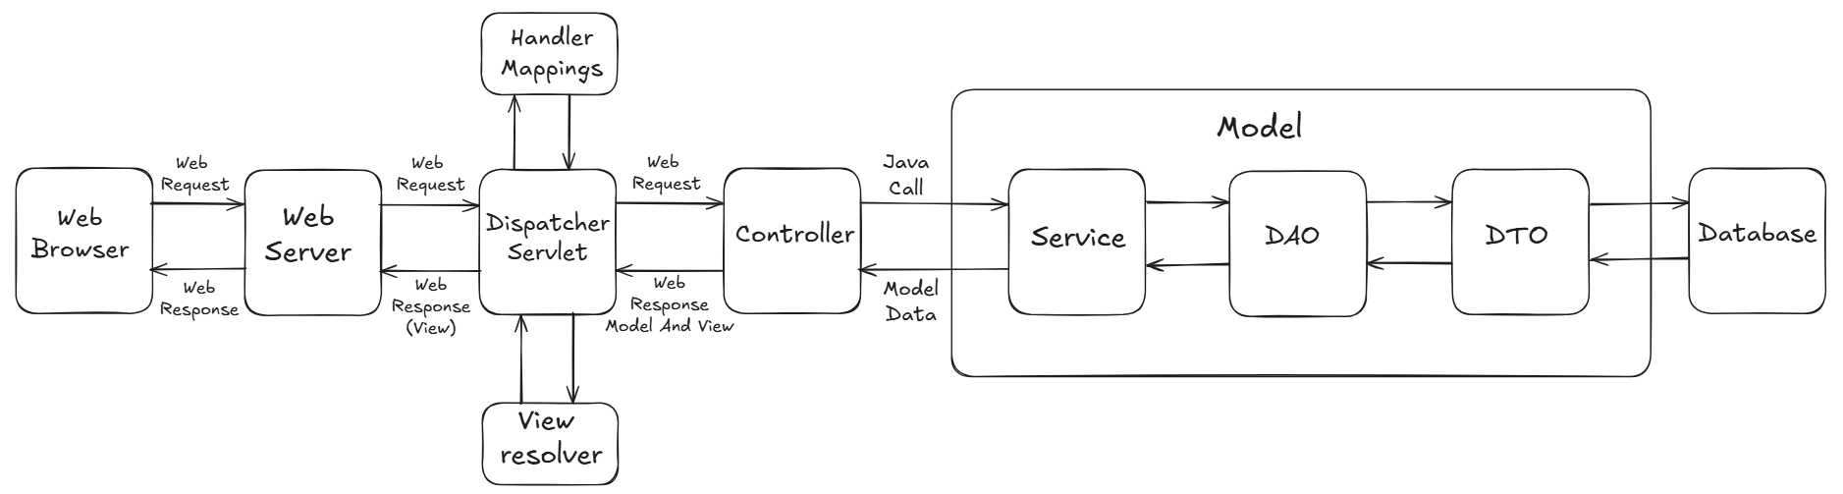
Steps to create maven project

Step 1: Press ctrl + N and search for maven project and select the maven project option
Step 2: Don’t skip the architype selection and click on next
Step 3: In next window search for maven-archetype-webapp (1.5) and select it.
Step 4: In the next window provide the appropriate group id and artifact id and click on finish.
Step 5: Go to Build Path-> Configure Build Path , select all in Order and Export , then apply and close. Update Maven Project, Build Project and Refresh.

Dependencies and Components required for spring MVC project

- Spring Web MVC » 6.2.10
- Jakarta Servlet » 6.0.0
- Apache tomcat 10.1+ version.

Make sure the pom.xml has this section:
<properties>
<project.build.sourceEncoding>UTF-8</project.build.sourceEncoding>
<maven.compiler.source>17</maven.compiler.source>
<maven.compiler.target>17</maven.compiler.target>
</properties>

- XML Based:

Example:
- Create one class in src/main/java like:

import org.springframework.stereotype.Controller;
import org.springframework.web.bind.annotation.GetMapping;

@Controller
public class TestController {
@GetMapping("/hii")
public String demoMethod() {
return Demo.jsp;
}
}
- Create one Demo.jsp ,with some content in webapp folder.

- Go to another src->main->webapp->WEB-INF->web.xml
- Inside web.xml below display name tag, add:
- <servlet>
- <servlet-name>Demo</servlet-name>
- <servlet-class></servlet-class>
- </servlet>

- In servlet-class tag, add the fully qualified name of DispatcherServlet class.

- Location: Library/Maven Dependencies/ spring-webmvc-6.2.10.jar/org.springframework.web.servlet/DispatcherServlet.class

Or

- To get the qualified name of the DispatcherServlet , press ctrl + shift + T, search for DispatcherServlet.

- Copy the fully qualified name of DispatcherServlet Class, and paste it inside the servlet-class tag.

- Servlet Registration and url mapping should look like:…

<!-- Registering Servlet -->
<servlet>
<servlet-name>Dispatcher</servlet-name>
<servlet-class>org.springframework.web.servlet.DispatcherServlet</servlet-class>
</servlet>

<!-- Url mapping -->
<servlet-mapping>
<servlet-name>Dispatcher</servlet-name>
<url-pattern>/</url-pattern>
</servlet-mapping>

- Create one more xml file in:
Location : src/main/webapp/WEB-INF/Dispatcher-servlet.xml

- File name should be same as value passed in sevlet-name tag, followed by -servlet

- Go to github.com/ArpitKharche123/Configuration-Files/ , select Dispatcher-servlet.xml, copy the content and paste it in the above xml file.

- Give the appropriate base package name.

- Run the project on server, give the url pattern http://localhost:8080/spring-mvc/hii

It should display the content of Demo.jsp!!!

- Annotation Based:

- Comment out Dispatcher-servlet.xml and content in web.xml.
- Create a package, inside that create a class for WebInitializer, which extends AbstractAnnotationConfigDispatcherServletInitializer, and implement 3 abstract methods as follows:

- WebInitializer will act as an alternative for web.xml

- @Override
- protected Class<?>[] getRootConfigClasses() {
- return null;
- }

- @Override
- protected Class<?>[] getServletConfigClasses() {
- return new Class[] {AppConfig.class};
- }
- S
- @Override
- protected String[] getServletMappings() {
- return new String[] {"/"};
- }

- Create a class named AppConfig, and annotate it with
@Configuration
@ComponentScan("annotation_config")
- Here, annotation_config is a base package name.

- AppConfig will act as an alternative for bean configuration xml file(e.g. Dispatcher-servlet.xml)

- Create class name AppController, and annotate it with
@Controller:

- This is a class level annotation which is used to mark the class as controller class.
- Controller class contains Handler methods which are responsible for handling web requests.

- Create a non static method returning String, annotate the method with @GetMapping(“/home”)
- return "home.jsp"; inside the method
- Make sure you have home.jsp, in webapp folder!
- Run the project on server and try to access:
http://localhost:8080/spring-mvc/home

- It should display the content of home.jsp file!!!

Binding Data to the Web Page

- Using Model Interface (Most Recommended)

- In controller, add one method returning a jsp page as :
- //Binding data(passing data to jsp page) using model
- @GetMapping("/model")
- public String displayModelData(Model model) {
- model.addAttribute("name","Arpit");//key and value
- model.addAttribute("message","This is the tutorial of how to pass data from controller to Web using Model Interface!!");
- return "model.jsp";
- }
- Make use of Expression language in a model.jsp as:
- <%@ page language="java" contentType="text/html; charset=UTF-8"
- pageEncoding="UTF-8" isELIgnored="false"%>
- <!DOCTYPE html>
- <html>
- <head>
- <meta charset="UTF-8">
- <title>Display Model Data</title>
- </head>
- <body>
- <h1>Name: ${name }</h1>
- <h2> ${message }</h2>
- </body>
- </html>

- isELIgnored="false" should be present

- Inside ${ }, we have to provide the key name of an attribute, passed in addAttribute() method!!!

- Using Model ensures clear separation of the data preparation (Model) from the view name resolution (the returned String).

- Using ModelMap Class

- It is Child class of LinkedHashMap, which works similar to Model Interface.
- [Refer annotation_config.AppController and modelMap.jsp]

- Using ModelAndView

- Use ModelAndView when you need to programmatically change the view name (or redirect) based on logic inside the method.

- [refer annotation_config.AppController and model-view.jsp]

Handling form data:
- [refer annotation_config.AppController, register.jsp and success.jsp]

@RequestParam:
- This annotation is field level annotation which is used along with the formal arguments of handler methods.
- This annotation binds request parameter to a specific formal argument of a handler method.
- refer annotation_config.AppController.

