Serialization And Deserialization
Serialization : When two java applications communicate with each other to send or receive a data from each other then original java object cannot be transferred over a network through which both the applications are connected to each other, because network doesn't support java object. In order to transfer a java object over a network, the object has to be converted into network supported format this process is called as serialization.

Deserialization : It is the process of converting the network supported format of data into the original java object

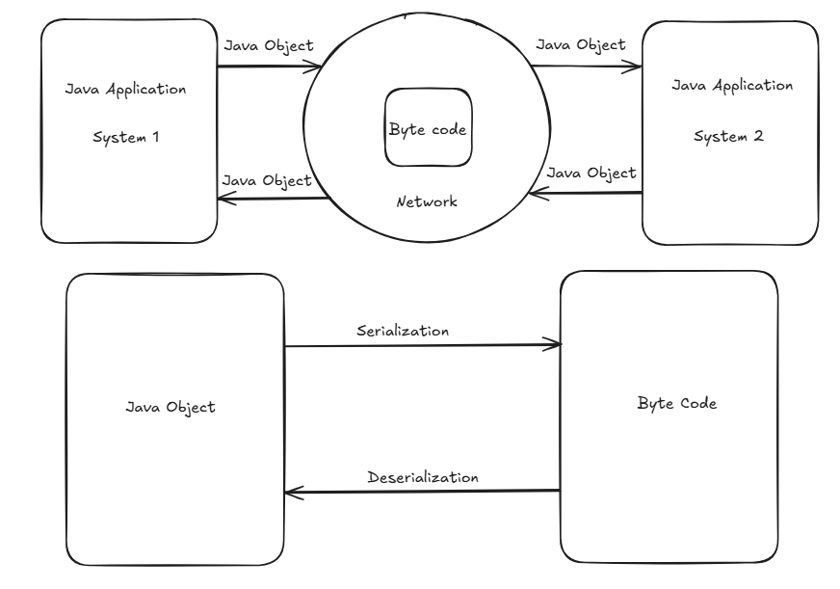

In the above diagram we are considering byte code as network supported format of data in order to provide a data security over a network.
A class has to implement Serializable interface in order to make its objects eligible for serialization and deserialization process.
Serializable is a marker interface which is used to mark a class as Serializable

