JDBC (Java Database connectivity)

- JDBC stands for java database connectivity. It is the technology , the standard API in java which is used to connect java application with any database application.

The need of connecting java application with the database application.
Within the java application it is not possible to store the data permanently, so that we will lose the processed data once the application is closed, in order to overcome this problem, the application data must be stored somewhere outside the application permanently so that the data can be accessed in the application whenever required in future.

API : API stands for Application Programming Interface.
An API is a set of rules or specifications which will help two different software communicate with each other which are incompatible to each other.

Real Time Examples:
1.Vyantkat knows: Tamil
Martin knows: Spanish

- So, the third person (some name ) which will know both Tamil and Spanish will help Vyankat and Martin to communicate with each other!

2. API is like a waiter in a restaurant
- Customer(End-User/Client)tell the waiter(API) what they want.
- The waiter(API) transfers the order(request) to the Kitchen(Back-end logic/Database)
- The kitchen takes the order(request),prepares the food(response) and the waiter(API) brings it back to the Customer(End-User/Client)

- JDBC is an API which will help java application to communicate with database application which are incompatible to each other.

Incompatibility between java application and database application
Since the java application understands java commands or instructions and the database application understands structured queries (SQL) which makes both the application incompatible to each other.
To overcome this incompatibility and to establish the connection between java application and database application we can make use of JDBC technology that's why JDBC is also called as API.

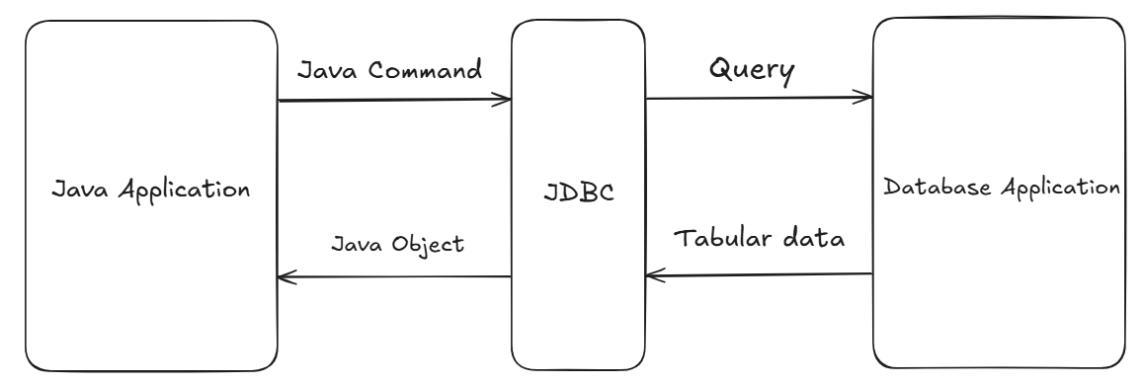

- JDBC sends SQL queries written by the developer to the database and converts database results into Java-accessible objects.
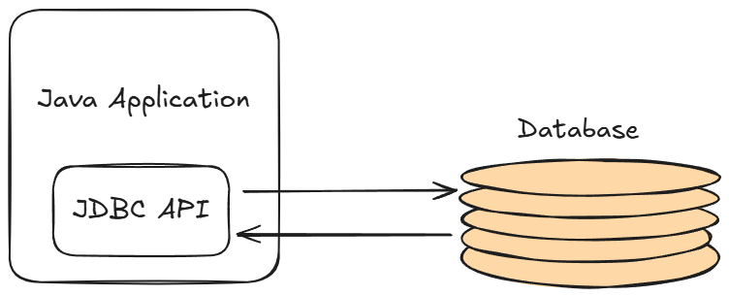

JDBC API

- Data stored in a relational database can be accessed with the help of JDBC API and respective Database Driver
- The API provides a mechanism for dynamically loading the correct java packages and registering them with the JDBC Driver Manager

JDBC with Database Driver

- Driver is a software which will help JDBC API to communicate with database application. Since JDBC API is a part of java application it will take the help of database driver to communicate with database application, each database application comes up with dedicated driver software.

- Every Database has its own Driver Software! using which a JDBC API can communicate with database. So, Drivers are dependent on the Database Application!
- JDBC API is independent of any Driver Software/Database, but to communicate with database, a particular Driver must be integrated in the java application!

- JDBC API has a built-in mechanism which loads the respective Driver classes into the memory if integrated.

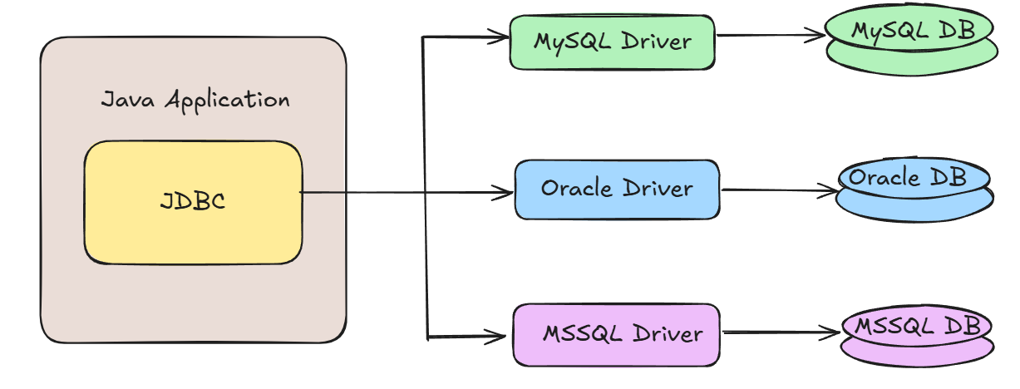

Postgre SQL Installation
Step 1: Visit postgresql.org ,click on download installer and download compatible PostgreSQL
Step 2: Run as administrator
-->Select all except stack builder
--> Select Installation directory
-->Set Password
-->press next and finish the installation
--> Open pgAdmin and run as administrator

Creating a simple Maven Project

Step 1: Create a simple maven project, provide following
- Group ID: domain name(com/edu/org)
- Artifact ID: project name

Step 2: Add Driver dependency in pom.xml
- Create a parent tag:
<dependencies>
</ dependencies>
- In the standard web browser search for mvnrepository.com and click on the link of official website of the maven repository
- In the search bar search for postgresql and click on search or press enter
- Select the first search result as PostgreSQL JDBC Driver
- Choose the appropriate version with high usage and no vulnerabilities
- Copy the maven code and paste it inside <dependencies>
</ dependencies>

Creating the table in pgAdmin

- Databases->(your_created_database)->schema->Tables
- Right click and create a new table
- Provide table name and columns datatype and constraints

Note: It is always recommended to give table/stored procedure/function name in complete lowercase or lower snake case
e.g.: employee, student_details,etc

- If table name includes upper case, e.g Demo, then we must use it like:

SELECT * FROM "Demo"

Steps to connect the Java application with the database application

- Step 1: Load or register the driver (Not required from JDBC 4+/Java 6, as it will automatically load and register the driver!)

- Step 2: Open/Create the connection between java application and the database application

- Step 3: Create or prepare the statement

- Step 4: Execute the statement/Query

- Step 5: Close the connection between java application and database application

- Step 6: Deregister the Driver if registered (Not required from JDBC 4+/Java 6)

- In java library we have a package called as java.sql package which represents JDBC API.

Closing the Connection
- If we don’t close the connection, it may lead to memory leakage.
- Connections are costly in terms of execution, so to manage the load overhead and to maintain efficiency, closing the connection is recommended and a good practice!

- After Java 8, it is recommended to use try - resource block , where
Compiler will close all the connections when we exit try block!

ResultSet

- ResultSet Interface is present in java.sql package.It is a table of data representing a database result set, which is usually generated by executing a statement that queries the database.

- Its object holds the data, which is returned from the database when select query is executed.

- We can get ResultSet Object by calling some built in methods like executeQuery(), getResultSet(), etc

- The ResultSet Object maintains the cursor that points to row of the result set fetched from the select query

- The next() method is used to move the cursor to the next position in a forward direction

- We can get the data from the column by calling built in overloaded getter methods for e.g getInt(int columnIndex), getString(String columnLabel),etc. We can pass column name or column position to it!

- int getInt(String columnLabel) throws SQLException;
- int getInt(int columnIndex) throws SQLException;, etc

Connection
- Connection is an interface present in java in java.sql package
- We can get the connection object by calling getConnection() method
- getConnection() is a public static overloaded method present in DriverManager class
public static Connection
getConnection(formal arguments..) throws SQLException

- Connection object is created only when the URL, user and password are accurate!

Statement
- Statement is an interface present in java.sql package
- We can get the statement object by calling createStatement() method
public Statement createStatement() throws SQLException
- Statement objects are generally used to execute the static queries!
- Static queries is an SQL command which will not change during runtime i.e it will not include user input
e.g. Select queries, Creation queries with hardcoded values
- Insert, Update , delete is not recommended using statement objects!

PreparedStatement

- It is an interface present in java.sql package. It is the child of (sub-interface)of Statement.

- We use Prepared Statement Object to execute dynamic queries.
- Dynamic query: Query consisting input from User or Inputs constructed at Runtime

- To execute a dynamic query, we have to write it with Placeholders(?)
e.g. String query=”INSERT INTO products VALUES(?,?,?,?,?)”;

- We can create a prepared statement object by calling prepareStatement() method

public PreparedStatement prepareStatement(args) throws SQLException;

- We can set the data from the column by calling built in setter methods for e.g setInt(), setString(), etc.
e.g.: "INSERT INTO products VALUES(?,?,?,?)";
//number represents the position of placeholders!!!
preparedStatement.setInt(1, scanner.nextInt());

***Note: In JDBC, Auto-commit is enabled by default,!!!***

Statement | PreparedStatement
Used for executing a static SQL | Used for executing a dynamic SQL
Cannot accept parameters at Runtime | Can accept parameters at Runtime
Slower as compared to PreparedStatement | Faster than Statement if used repeatedly
Preferable for executing DDL commands  (CREATE, ALTER, DROP, TRUNCATE) | Preferable for executing DML commands  (INSERT, UPDATE, DELETE)
Cant be used for storing /retrieving image and file in database | Can be used for storing /retrieving image and file in database (CLOB/BLOB)
Same SQL query can’t be executed repeatedly for different values | Same SQL query can be executed repeatedly for different values
Less Secure(Prone to SQL injection) | More Secure

Methods used to execute statements

- boolean execute(String sql) throws SQLException

- It is used to execute both select as well as non-select queries i.e. any type of statements (DDL, DML, DCL, TCL, DQL) .

- ResultSet executeQuery(String sql) throws SQLException;

- This method is used to execute only select queries i.e only DQL statements.

- This method returns the object of type ResultSet which will contain result returned form the query.

- int executeUpdate(String sql) throws SQLException

- This method is used to execute only non-select queries i.e. only DML or DDL statements(INSERT, UPDATE, DELETE,CREATE).

- This method returns int type value i.e. number of rows affected after execution of DML statement.(0 for create)

Stored procedures
- Stored procedures are the set of SQL statements (grouped together) to be executed to perform specific task on the database.
- These are beneficial when we are dealing with multiple tables with complex scenarios.
- It is similar to a method with void return type of java.
- Stored Procedures:
• Does not return a value (directly).
• Is called with CALL
• Can have IN, OUT or both parameters.
• Can perform transaction control (COMMIT, ROLLBACK)(default in pgAdmin)

Functions
- A function is a named block of SQL/PLpgSQL code used to execute
SQL queries .

Function:
- Returns a value
- Can be called from a SELECT, WHERE, JOIN, or another function.
- Can be used inside SQL expressions.

Advantages of Procedures & Functions Over Normal SQL Queries

1. Better Performance (Faster Execution)
- Stored procedures are compiled once and stored in the database.
- Execution plans are cached, so repeated calls are faster.
- Normal SQL queries must be parsed and planned every time.

2. Better Security
- We can restrict direct table access and allow only procedure execution.
- Sensitive logic stays inside the DB.
- Prevents SQL injection when parameters are used.

3. Code Reusability
- The logic written once can be reused in multiple applications.

4. Easier Maintenance
- Fix a bug or change logic in one stored procedure instead of hundreds of SQL lines in the application.
- Developers don’t have to modify the application code frequently.

CallableStatement

- It is an interface, which can be used to call or execute the stored procedures and functions
- prepareCall() method is used to get CallableStatement object

