Servlet:

- It is an API generally used for developing web applications.

- All the classes and interfaces related to Servlet API are present in javax.servlet/jakarta.servlet package

- Servlet is an interface present in javax.servlet/ jakarta.servlet package

- It is the technology which is used to accept web request in the Java application and to generate web response from the java application.

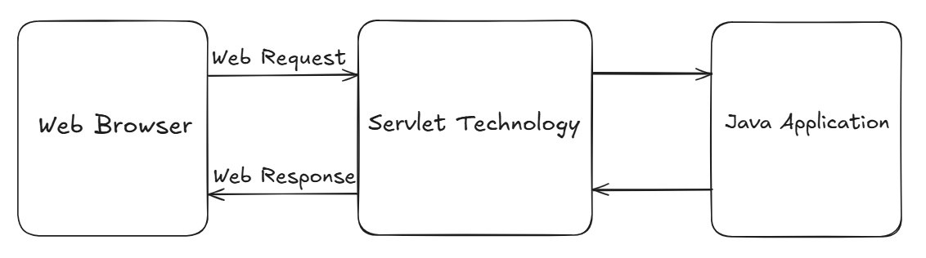

Web Based Application / Web Application:

A Web Application is a software application that:
- Runs on a server
- Is accessed via a web browser (client) over the internet

Client-Server Interaction
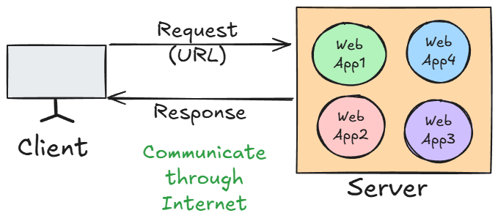

- Request Side Parameters
These parameters are sent from the client (browser or any testing tool) to the server.
1. URL (Uniform Resource Locator)
- The address used to access a particular resource on the server.
- Example:
https://flipkart.com/products?id=5
- Parts:
  - https → Protocol
  - flipkart.com → Domain name
  - /products → Path to the resource
  - ?id=5 → Query parameter (used to send data in GET request)

2. Method Type
- HTTP method used to send the request.
- Common Types:
  - GET → Fetch data
  - POST → Send new data
  - PUT → Update existing data
  - DELETE → Delete data

3. Data
- Data sent by the client to the server (mostly in POST, PUT).
- Can be sent as:
  - Query Parameters (e.g., ?id=1&name=John)
  - Form Data
  - JSON/XML payload in the request body
- Example
{
"username": "john",
"password": "abc123"
}

- Response Side Parameters
These parameters are sent from the server back to the client as a result of the request.

1. Status Code
- A 3-digit code representing the result of the request.
- Common Status Codes:
  - 200 OK → Request successful
  - 201 Created → Resource created
  - 400 Bad Request → Invalid input
  - 401 Unauthorized → Authentication required
  - 404 Not Found → Resource doesn’t exist
  - 500 Internal Server Error → Server crashed
  - 405 – Method Not Allowed → Invalid Method type

2. Content Type
  - text/html → HTML page
  - application/json → JSON data
  - text/plain → Plain text
  - application/xml → XML data

3. Actual Content
- The real body/content of the response (data or HTML page).
- Examples:
  - HTML webpage
  - JSON data (API response)
  - Image, PDF, etc.

What is a Server?
A Server is a system/software that:
- Receives requests
- Processes them
- Sends responses

Types of Servers:

1. Web Server
- Handles HTTP requests
- Example: Apache HTTP Server, Nginx

2. Application Server
- Executes business logic

Tomcat = Web Server + Servlet Container

Servlet container/Web container

- It is the component of web server which is responsible to manage servlet life cycle.
When the request is sent to any specific servlet then the servlet container will create request and response objects internally.

Responsible for:
- Managing Servlet lifecycle
- Creating request & response objects

Servlet life cycle

- Done by Servlet Container/Web Container

- Loading Servlet Class
- Instantiation of Servlet Class
- Initialization of members of Servlet Class by invoking init()
(All the above steps will be executed only once!!!)

- invoking service()
(service() method will get invoked N number of times for N number of requests!!!)

- Destroying the Servlet by invoking destroy() method

Servlet hierarchy:

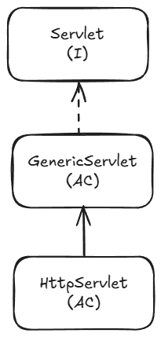

- Servlet is an interface present in javax.servlet package
- It has some methods used to implement the Servlet API. and perform some tasks when implemented further.

- GenericServlet is called as protocol independent servlet, since it allows any web request associated with any protocol.
- It is an abstract class which implements the Servlet interface.
- It will provide implementation to all the methods of servlet interface except service method(remains abstract).
- To create our servlet class, we must extend/inherit GenericServlet class.

Creating a Servlet Class
- Create a normal class in java resourcesrc/main/java
- Extend GenericServlet and implement the methods

- To register the Servlet
@WebServlet(value="/message")
public class MyServlet extends GenericServlet {

- Whenever the URL contain /message , MyServletClass service method will be invoked
- http://localhost:8080/servlets/message will execute the service method

HttpServlet

- It is an abstract class present in javax.servlet package without any abstract methods
- Its is the Child class of GenericServlet Class, which provides some implementation for service method
- HttpServlet is called as protocol dependent servlet, since it allows any web request associated with only http protocol.
- It is always recommended to create A Servlet Class by extending HttpServlet as it provides higher security to the web application

- Using doGet() method:

- The doGet() method is used in Java Servlets to handle HTTP GET requests from a client (usually a web browser).
- When a client sends a request to a servlet using the HTTP GET method (e.g., by entering a URL in the browser, clicking a link, or submitting a form without method="post"), the servlet container (like Tomcat) automatically calls the servlet’s doGet() method.

- Purpose:
- Receive data from the client (via query parameters in the URL).
- Process the request (e.g., fetch from a database, generate dynamic HTML, return a file).
- Send a response back to the client.

- Using doPost() method:

- The doPost() method is used in Java Servlets to handle HTTP POST requests from a client (usually a web browser).
- It is automatically called by the servlet container (like Tomcat) when it receives a POST request for any servlet.

- Purpose
- Process POST Requests
  - Handles requests where data is sent in the HTTP request body (not in the URL).
  - Commonly used for:
    - Form submissions with sensitive data (passwords, personal info)
    - File uploads
    - Sending large amounts of data
    - API calls where request body contains JSON/XML.

- Secure & Large Data Handling
  - POST requests are not cached and not stored in browser history.
  - Suitable for large payloads (unlike GET, which has a URL length limit).

Step 1: Make form tag as:
<form action="register" method="post" id="form">
(We have to specify method type as post explicitly!!!)

Step 2: Override doPost() method and provide implementation.

- Difference

Aspect | doGet() | doPost()
HTTP Method | Handles GET requests | Handles POST requests
Where Data is Sent | Appended to the URL as query string (e.g., ?name=John&age=25) | Sent in the request body, not visible in the URL
Data Size Limit | Limited (around 2 KB depending on browser/server) | Can handle much larger amounts of data (depends on server configuration)
Security | Less secure — data is visible in URL and stored in browser history/server logs | More secure — data is hidden from URL and not stored in history/logs
Use Cases | Fetching/displaying data, navigation, search queries | Submitting sensitive or large data, uploading files, API requests with JSON/XML
Performance | Faster for small requests because of URL-based data | Slightly slower due to sending data in the body
Default Method in HTML Forms | Yes — if no method attribute is given, default is GET | No — must explicitly set method="POST"

Query String
- It represents the data to be sent from the client side to the server in order to perform specific task at the server side.
- We can pass the data through url using Query String.
- Data can be sent in key-value pair, separated by &

- If we change the query string in url, changes will also get affected in the Page Content!
- getParameter() is for Client-to-Server communication. It retrieves data sent by the user (forms, URL query strings).

How Servlet Works?

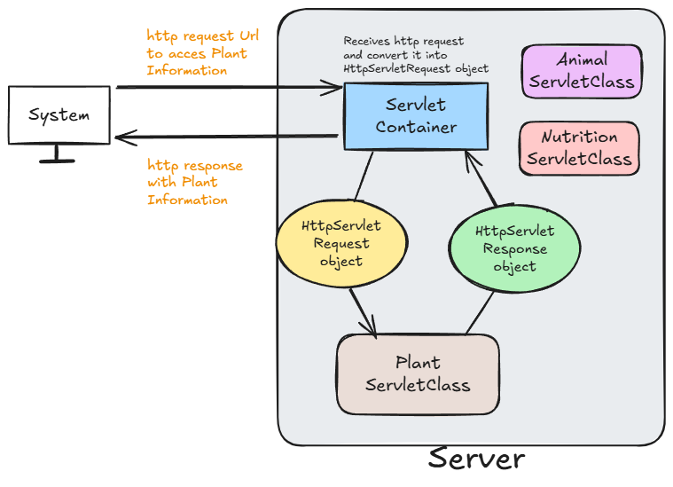

Session Management
- http protocol is a stateless protocol i.e. Every request to the server is treated as new request bcz Server will not remember the client! In every next/new request.
- So, Client needs to introduce self for each new request
e.g. Providing username and password for every request in insta: login, then for accessing photos again and so on….

- So, to avoid this, we will make use of Session.
- Session is a state which will include the data of the client and store it for a particular time.

Why is Session Management Needed?
- HTTP is stateless: Each request is treated independently, and the server does not remember who made previous requests.
- For personalized experiences, such as:
  - Logging in users
  - Shopping carts
  - User preferences
  - Tracking user activity
We need a way to persist information across requests. That’s where session management comes in.
- So, Session management helps us maintain user state/data across multiple requests.

JSP
- JSP stands for java server page.
- It allows developers to embed Java code directly into HTML pages using special tags.
- Servlets can be used if the focus is more on java logic and JSP's can be used if the focus is more on HTML logic.

- All the JSP files will be translated into servlets by jsp translator.

Creating a jsp file
- src/main/webappnew jsp file

- JSP Tags
1. Declaration tag <%! %>
- This tag is used to declare the variables or methods of a java.
- Anything inside this tag will be present outside the service() method!
- Variables declared here are global variables.

2. Scriptlet tag <% %>
- This tag is used to write java logic for dynamic response.
- Anything inside this tag will be returned within the service() method!.

3. Expression tag <%= %>
- This tag is used to print/display results on web browser.
- It is used to evaluate and output the result of an expression
- We cannot use void methods , as it don’t return anything!!
4. Directive tag <%@ %>
- This tag is used to import external resources in a JSP file.

- All the JSP files are capable of serving only HTTP requests because all the JSP files will be translated/converted into HttpServlet.

JSP life cycle:
JSP life cycle is very much similar to servlet life cycle.

Different phases of JSP life cycle
1. JSP file will be translated to the servlet by the component called as JSP translator, a part of Web Container and then compiled.
2. The translated servlet class will be loaded.
3. An instance will be created for the servlet class.
4. The servlet instance will be initialized by invoking jspInit() method.
5. The service will be provided for each request by invoking jspService() method, for n number of times, whenever the request is made!!!
6. Once the server stops, the jsp will get destroyed by invoking jspDestroy().

- Servlet container itself will manage the JSP life cycle.

