Servlets and JSP's

Web Based Application / Web Application:
An application which runs inside a distant system called as server and which can be accessed using standard web browsers by clients is called as web application or web-based application.

Web resource:
Web resource is the Data or the information present on the web or internet. It can be classified in two types as static web resource and dynamic web resource.

1.Static web resource: If the data or the information associated with the web resource will not change based on some inputs or conditions then that web resource is called as static web resource.

2.Dynamic web resource: If the data or the information associated with the web resource will change based on some inputs or conditions is called as dynamic web resource.

Client-Server Interaction
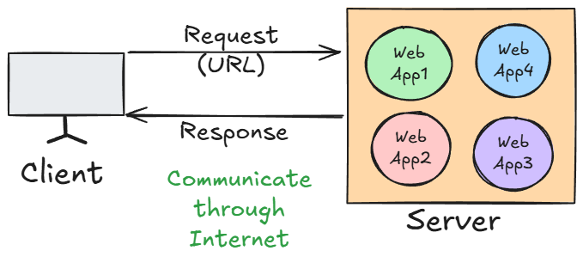
- Request Side Parameters
These parameters are sent from the client (browser or any testing tool) to the server.
1. URL (Uniform Resource Locator)
- The address used to access a particular resource on the server.
- Example:
https://flipkart.com/products?id=5
- Parts:
  - https → Protocol
  - flipkart.com → Domain name
  - /products → Path to the resource
  - ?id=5 → Query parameter (used to send data in GET request)

2. Method Type
- HTTP method used to send the request.
- Common Types:
  - GET → Fetch data
  - POST → Send new data
  - PUT → Update existing data
  - DELETE → Delete data

3. Data
- Data sent by the client to the server (mostly in POST, PUT).
- Can be sent as:
  - Query Parameters (e.g., ?id=1&name=John)
  - Form Data
  - JSON/XML payload in the request body
- Example
{
"username": "john",
"password": "abc123"
}

- Response Side Parameters
These parameters are sent from the server back to the client as a result of the request.
1. Status Code
- A 3-digit code representing the result of the request.
- Common Status Codes:
  - 200 OK → Request successful
  - 201 Created → Resource created
  - 400 Bad Request → Invalid input
  - 401 Unauthorized → Authentication required
  - 404 Not Found → Resource doesn’t exist
  - 500 Internal Server Error → Server crashed
  - 405 – Method Not Allowed → Invalid Method type

2. Content Type
- Tells the client the format of the response content.
- Common Values:
  - text/html → HTML page
  - application/json → JSON data
  - text/plain → Plain text
  - application/xml → XML data

3. Actual Content
- The real body/content of the response (data or HTML page).
- Examples:
  - HTML webpage
  - JSON data (API response)
  - Image, PDF, etc.

Servlet:
- It is an API generally used for developing web applications
- All the classes and interfaces related to Servlet API are present in javax.servlet/jakarta.servlet package
- Servlet is an interface present in javax.servlet package
- It is the technology which is used to accept web request in the Java application and to generate web response from the java application.

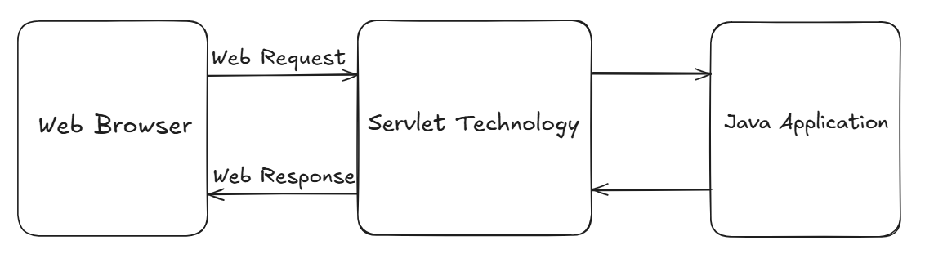

Servlet container/Web container

- It is the component of web server which is responsible to manage servlet life cycle.
When the request is sent to any specific servlet then the servlet container will create request and response objects internally.

Servlet life cycle

- Done by Servlet Container/Web Container

- Loading Servlet Class
- Instantiation of Servlet Class
- Initialization of members of Servlet Class by invoking init()
(All the above steps will be executed only once!!!)

- invoking service()
(service() method will get invoked N number of times for N number of requests!!!)
- Destroying the Servlet by invoking destroy() method

web.xml (Deployment Descriptor):

- web.xml acts as an instruction manual for the web server, telling it about information about servlets, components, their configurations etc.

- We have to provide a deployment descriptor (web.xml) to the web server so that the web server will refer deployment descriptor to forward the request to the application server to serve the request for web resource.

Servlet hierarchy:

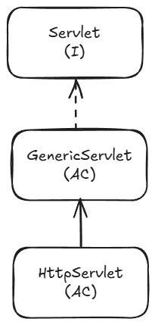

- Servlet is an interface present in javax.servlet package
- It has some methods used to implement the Servlet API. and perform some tasks when implemented further.
public void init(ServletConfig config) throws ServletException;
public ServletConfig getServletConfig();
public void service(ServletRequest req, ServletResponse res) throws ServletException, IOException;
public String getServletInfo();
public void destroy();

- GenericServlet

It is a protocol independent servlet, since it allows any web request associated with any protocol.
- It is an abstract class which implements the Servlet interface.
- It will provide implementation to all the methods of servlet interface except service method(remains abstract).
- To create our servlet class, we must extend/inherit GenericServlet class.

HttpServlet

- It is an abstract class present in javax.servlet package without any abstract methods
- Its is the Child class of GenericServlet Class, which provides some implementation for service method
- HttpServlet is called as protocol dependent servlet, since it allows any web request associated with only http protocol.
- It is always recommended to create A Servlet Class by extending HttpServlet as it provides higher security to the web application

- Using doGet() method:

- The doGet() method is used in Java Servlets to handle HTTP GET requests from a client (usually a web browser).
- When a client sends a request to a servlet using the HTTP GET method (e.g., by entering a URL in the browser, clicking a link, or submitting a form without method="post"), the servlet container (like Tomcat) automatically calls the servlet’s doGet() method.

- Purpose:
- Receive data from the client (via query parameters in the URL).
- Process the request (e.g., fetch from a database, generate dynamic HTML, return a file).
- Send a response back to the client.

- Using doPost() method:

- The doPost() method is used in Java Servlets to handle HTTP POST requests from a client (usually a web browser).
- It is automatically called by the servlet container (like Tomcat) when it receives a POST request for any servlet.

- Purpose
- Process POST Requests
  - Handles requests where data is sent in the HTTP request body (not in the URL).
  - Commonly used for:
    - Form submissions with sensitive data (passwords, personal info)
    - File uploads
    - Sending large amounts of data
    - API calls where request body contains JSON/XML.

- Secure & Large Data Handling
  - POST requests are not cached and not stored in browser history.
  - Suitable for large payloads (unlike GET, which has a URL length limit).

- Difference

Aspect | doGet() | doPost()
HTTP Method | Handles GET requests | Handles POST requests
Where Data is Sent | Appended to the URL as query string (e.g., ?name=John&age=25) | Sent in the request body, not visible in the URL
Data Size Limit | Limited (around 2 KB depending on browser/server) | Can handle much larger amounts of data (depends on server configuration)
Security | Less secure — data is visible in URL and stored in browser history/server logs | More secure — data is hidden from URL and not stored in history/logs
Use Cases | Fetching/displaying data, navigation, search queries | Submitting sensitive or large data, uploading files, API requests with JSON/XML
Performance | Faster for small requests because of URL-based data | Slightly slower due to sending data in the body
Default Method in HTML Forms | Yes — if no method attribute is given, default is GET | No — must explicitly set method="POST"

Query String
- It represents the data to be sent from the client side to the server in order to perform specific task at the server side.
- We can pass the data through url using Query String.
- Data can be sent in key-value pair, separated by &

- If we change the query string in url, changes will also get affected in the Page Content!
- getParameter() is for Client-to-Server communication. It retrieves data sent by the user (forms, URL query strings).

How Servlet Works?

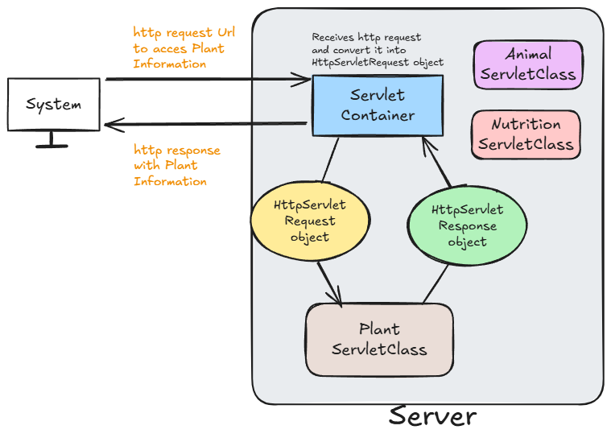

<welcome-file-list>
- The <welcome-file-list> is an element in the web.xml deployment descriptor in a Java web application.

- It defines the default resource(s) (usually HTML or JSP files) that the web container should serve when a user accesses a root URL of the application without specifying a file in url. (Initial file e.g. Home.html)

e.g.
<welcome-file-list>
<welcome-file>PageA.html</welcome-file>
<welcome-file>PageB.html</welcome-file>
<welcome-file>PageC.html</welcome-file>
</welcome-file-list>

- Working:
- It works as else-if ladder
- If PageA is available, display it. If A is not available display PageB and so on.
- If none of the page is available, it will Give 404 Error (page not found).

- If we don’t provide <welcome-file-list>, Web container will search for index.html and opens it as welcome file.
- If index.html is not present, it will look for index.htm and opens it as welcome file.
- If index.htm is not present, it will look for index.jsp and opens it as welcome file.

- Note: Priority is given to <welcome-file-list> over other files!!!
✅ Purpose of welcome-file-list
- It is used when we want to set a custom html/jsp file as our welcome page, rather than the built in file like index.html.

RequestDispatcher<<I>>
- It is an interface present in javax.servlet package.
- It is used to forward a request to another resource (like another servlet, JSP, or HTML file) on the server side, or
- to include the content of another resource in the response.

- It is used to dispatch the request from
- Servlet to Servlet
- Servlet to jsp/html
- Jsp to jsp
- Jsp to Servlet

- getRequestDispatcher() method is used to get the RequestDispatcher object with the help of Servlet request object
- Using RequestDispatcher object, we can use some methods like:

- forward (req, resp): forwards the request to another resource (no response sent yet)

- include(req,resp): Includes the content of another resource in the current response.
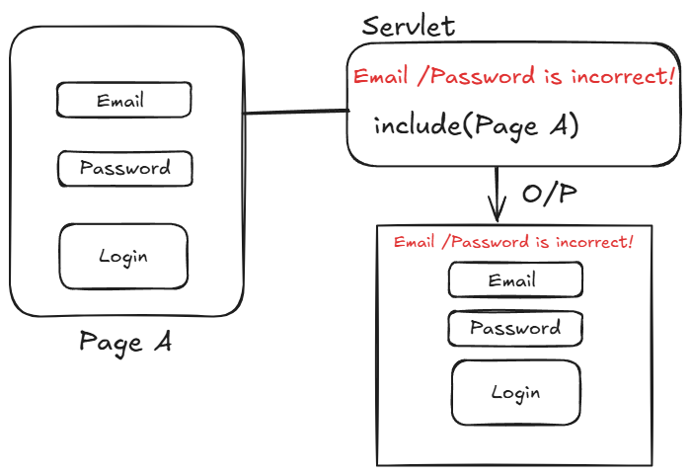

sendRedirect()

- It is used to redirect the client to a different resource (URL).
- This method is part of the HttpServletResponse interface.
e.g.: resp.sendRedirect("index.jsp");
//it will redirect user to index.jsp page!

Servlet Context

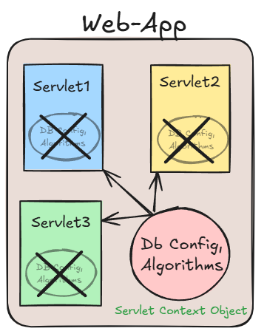
- ServletContext is an interface provided by the Servlet API that allows servlets to interact with their servlet container and share data across the entire web application.

- One ServletContext object per web application, created by ServletContainer/Web Container.
- ServletContext object is shared among all servlets in the application.
- Used for application-wide parameters and resources.
- Accessed via getServletContext() method from Servlet

ServletConfig

- ServletConfig is an interface in the javax.servlet package that provides configuration information to a single servlet.
- It is used to pass initialization parameters from the web.xml (deployment descriptor) file to a particular servlet instance.
- ServletConfig Objects are one for the Servlet, independent of other Servlets.!! and are created by Web Container when Servlet Class get instantiated.
- We can get ServletConfig Object by calling getServletConfig() method.

When is ServletConfig Used?
When you want to provide custom configuration data (like file paths, DB connection info, etc.) to a specific servlet during its initialization, you use ServletConfig.

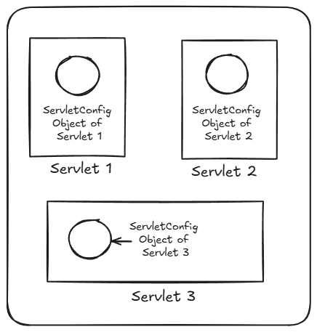

Session Management
- http protocol is a stateless protocol i.e. Every request to the server is treated as new request bcz Server will not remember the client! In every next/new request.
- So, Client needs to introduce self for each new request
e.g. Providing username and password for every request in insta: login, then for accessing photos again and so on….

- So, to avoid this, we will make use of Session.
- Session is a state which will include the data of the client and store it for a particular time.

Why is Session Management Needed?
- HTTP is stateless: Each request is treated independently, and the server does not remember who made previous requests.
- For personalized experiences, such as:
  - Logging in users
  - Shopping carts
  - User preferences
  - Tracking user activity
We need a way to persist information across requests. That’s where session management comes in.
- So, Session management helps us maintain user state/data across multiple requests.

- Cookie

- Cookie is an object which can store a small piece of information.
- It is stored on the Client Side.(Client’s Browser)
- In Cookie, small piece of information is stored in Key-Value pair.(Only String data)
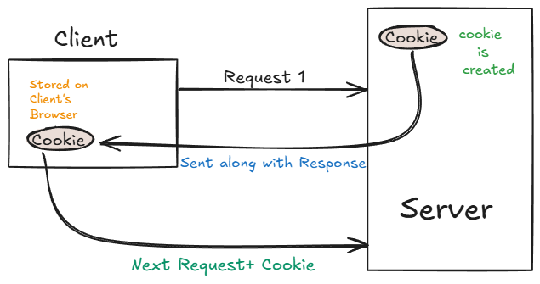

- In Java, Cookie is a class present in javax.servlet.http package
- We can create a Cookie object using:
- new Cookie()
- new Cookie(String key, String value)
Advantages:
- Simple Design
- Client Side Management

Dis-Advantages:
- Only Stores data in form of String
- Can be disabled from Client Side

- Checking Cookie data on Browser:
SettingsPrivacy and SecurityCookiesSee all site data and permissions
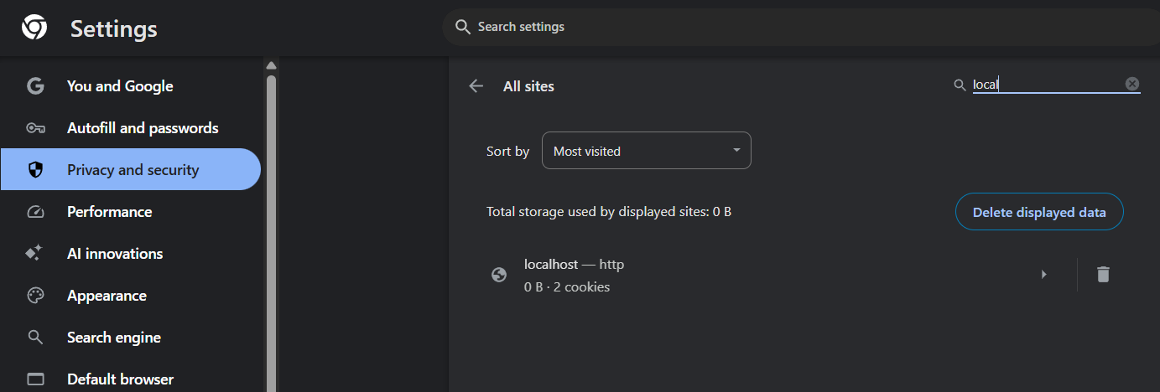

Managing Session using HttpSession

- It is an interface present in javax.servlet.http package.
- We can create HttpSession object by invoking:
- getSession(), which will return us the existing HttpSession object if present, else it will return new HttpSession object.
- getSession(boolean)
- if true is passed, it will return new HttpSession object even If it exists
- if false is passed, It will work similar to getSession()

JSP
- JSP stands for java server page.
- It allows developers to embed Java code directly into HTML pages using special tags.
- Servlets can be used if the focus is more on java logic and JSP's can be used if the focus is more on HTML logic.

- All the JSP files will be translated into servlets by jsp translator.

Creating a jsp file
- src/main/webappnew jsp file

- JSP Tags
1. Declaration tag <%! %>
- This tag is used to declare the variables or methods of a java.
- Anything inside this tag will be present outside the service() method!
- Variables declared here are global variables.

2. Scriptlet tag <% %>
- This tag is used to write java logic for dynamic response.
- Anything inside this tag will be returned within the service() method!.

3. Expression tag <%= %>
- This tag is used to print/display results on web browser.
- It is used to evaluate and output the result of an expression
- We cannot use void methods , as it don’t return anything!!
4. Directive tag <%@ %>
- This tag is used to import external resources in a JSP file.

- All the JSP files are capable of serving only HTTP requests because all the JSP files will be translated/converted into HttpServlet.

JSP life cycle:
JSP life cycle is very much similar to servlet life cycle.

Different phases of JSP life cycle
1. JSP file will be translated to the servlet by the component called as JSP translator, a part of Web Container and then compiled.
2. The translated servlet class will be loaded.
3. An instance will be created for the servlet class.
4. The servlet instance will be initialized by invoking jspInit() method.
5. The service will be provided for each request by invoking jspService() method, for n number of times, whenever the request is made!!!
6. Once the server stops, the jsp will get destroyed by invoking jspDestroy().

- Servlet container itself will manage the JSP life cycle.

