Spring Boot

- Spring Boot is a powerful, open-source framework built on top of the Spring Framework in Java.

- Its primary goal is to simplify and accelerate the process of creating production-ready Spring applications with minimal manual configuration, providing autoconfiguration features.

- It helps programmers to reduce the boilerplate configuration (especially XML configuration) required to set up a Spring application.

- Spring boot provides its own JPA called as Spring Data JPA which has been built over JPA which is implemented by Hibernate framework.

- Every Spring boot project will have a dedicated server which will be auto configured by the Spring itself. Spring boot uses Apache tomcat as a web server.

- Majorly used for developing RESTful APIs, microservices, web applications, and backend services.

Spring Framework vs Spring Boot

Parameter | Spring Framework | Spring Boot
Definition | A comprehensive Java enterprise application framework that provides core features like IoC, DI, AOP, and MVC. | An extension of Spring Framework that simplifies application development using auto-configuration and convention over configuration.
Primary Goal | Provide flexibility and fine-grained control over application configuration and architecture. | Reduce development time and eliminate boilerplate configuration.
Dependency Relationship | Independent core framework. | Built on top of Spring Framework.
Configuration Style | XML, Java-based, or annotation-based (manual setup). | Mostly annotation-based with auto-configuration.
Auto-Configuration | ❌ Not available. Developer must configure everything explicitly. | ✅ Available. Automatically configures beans based on classpath dependencies.
Boilerplate Code | High – requires extensive setup and configuration. | Very low – minimal configuration required.
Project Setup Time | Time-consuming. | Very fast.
Dependency Management | Manual dependency selection and version management. | Starter dependencies manage compatible versions automatically.
Starter Dependencies | ❌ Not available. | ✅ Available (e.g., spring-boot-starter-web).
Embedded Server | ❌ Not supported. Requires external server like Tomcat or JBoss. | ✅ Supported (Tomcat, Jetty, Undertow).
Application Startup | Slower due to external server and configuration overhead. | Faster due to embedded server and optimized startup.
Microservices Support | Possible but requires heavy configuration. | Highly suitable and widely used for microservices.
External Configuration | Complex and verbose (XML/property files). | Simple configuration using application.properties or application.yml.
Convention Over Configuration | ❌ Not followed strictly. | ✅ Strongly followed.
Testing Support | Requires manual test configuration. | Provides auto-configured test utilities.
Spring Initializr Support | ❌ Not available. | ✅ Available for quick project bootstrap.
Use in Legacy Systems | Commonly used. | Less common for legacy monolithic systems.
Cloud-Native Support | Limited and manual. | Strong cloud and container support.
Typical Use Cases | Legacy projects, complex enterprise applications requiring control. | REST APIs, microservices, cloud-based applications.

- Spring boot can be used to implement web services or microservices.

Webservice:

- It is a server-side application/set of codes or logics which will provide a service (only data, not ui) for multiple clients on the web.

- Server can have a service (a piece of software logic), hosted on a network (usually the internet) which can be accessed over web, that’s why it is called as web service.

- Real-Time Example:

- A weather service API that provides current temperature data when requested by a mobile app.
- The mobile app (client) and the weather service (server) are communicating via a web service.

Data Exchange:

- Data can be exchanged between client-side applications and server-side applications in text format using JSON or XML, as they are language-independent!

- Since client-side applications and server-side applications are developed using different programming languages that leads to incompatibility between them.

- But in order to make client-side application communicate with server-side application, we must develop an API layer which will be a part of server-side application.

Those API's can be implemented or developed using different architectures with SpringBoot

1. SOAP architecture
- SOAP stands for simple object access protocol.

- Protocol is a set of rules and regulations which have to be followed in order to develop API's.

- It relies heavily on XML (eXtensible Markup Language) for its message format and often uses the HTTP protocol but can use others like SMTP. It's considered strict and heavyweight.

- SOAP architecture supports XML in order to transfer data from client-side application to server-side application and vice-versa
,which is the limitation of SOAP architecture, that’s why REST architecture is widely used in the development of APIs.

2. REST architecture
- REST stands for representational state transfer.

- It is the way of developing APIs without any protocols, along with this, REST architecture supports transfer of data from client-side application to server-side application and vice-versa in JSON format ,which is light weight in nature.

REST Principles:

1. Client–Server Architecture

The system is divided into:
- Client → UI / Frontend (Browser, Mobile App)
- Server → Backend / API / Business Logic

Key Points
- Client and server are independent
- Changes in UI do not affect backend and vice versa
- Improves scalability and maintainability

Example
React / Angular → Spring Boot REST API

2. Statelessness

Each request from client to server must contain all the information required to process the request.

Key Points
- Server does not store client session
- Authentication via JWT / OAuth token

4. Resource Identification
- Resources are identified using URIs
- URLs represent nouns, not actions
/users/10
/orders/25

5 .Resource Manipulation Through Representations
- Client interacts with resource representations (JSON/XML)
- Client does not access DB directly
PUT /users/10
{
"email": "new@mail.com"
}

6. Layered System

Different Components managed in Layered Architecture way.

RESTful APIs

- A RESTful API (or REST API) is an API that follows the principles of the REST architectural style.

- These APIs are stateless in nature, i.e., the server does not store any client session information. Each request from the client must contain all the information required to process that request.

- RESTful APIs use standard HTTP methods such as:

• GET – to retrieve data
• POST – to create new resources
• PUT/PATCH – to update existing resources
• DELETE – to remove resources

- Data is usually exchanged in JSON format (most common), though XML can also be used.

- RESTful APIs follow a client–server architecture, where the client and server are independent of each other.

- They support scalability, as statelessness allows requests to be handled by any server instance.

- They are lightweight, simple, and widely used in web and mobile applications.

- Real-Time Example:

When you use a service like Google Maps, your application sends requests to the Google Maps RESTful API to perform any action.

Rest API vs RESTful API

- REST API: Any API that claims to use REST concepts but may not strictly follow all REST constraints.
- RESTful API: An API that fully adheres to REST architectural principles and best practices.

Aspect | REST API | RESTful API
Definition | An API built using HTTP and some REST ideas | An API that strictly follows REST architecture
Follows REST Principles | Partial or loose | Strict and complete
Use of HTTP Methods | May misuse methods (e.g., GET for delete) | Correct use of GET, POST, PUT, DELETE, PATCH
URL Structure | Can be action-based | Noun-based (represents resources)
Statelessness | May violate statelessness | Strictly stateless
HTTP Status Codes | May return generic responses | Uses proper HTTP status codes
Caching | Optional or ignored | Proper caching support
Industry Best Practice | Acceptable but not ideal | Recommended standard

JSON : JavaScript Object Notation

- It’s a language-independent data format used to store and transfer data.

- It's primarily used for:
- Data Transmission: Sending data from a server to a web page (e.g., getting a list of products for an online store).

- Configuration: Storing settings for applications.

- Data Storage: Sometimes used as a simple database format.

- Structure of JSON
JSON is built on two simple structures:

- Objects (Key-Value Pairs):

  - These represent a record or a collection of data.
- They start and end with curly braces { }
- Data is stored as key: value pairs, separated by a colon.
- Each pair is separated by a comma.
- Keys must be strings (enclosed in double quotes).
Example:
{
"name": "Alex",
"age": 30
}

- Collections (Ordered Lists):

- These are ordered lists of values, like an array/collections in Java.
- They start and end with square brackets []
- The values within an array can be any valid JSON datatype, including other objects or arrays.
Example:
[
"apple",
"banana",
"cherry"
]
An array of objects:
[
{ "city": "New York" },
{ "city": "London" }
]

- JSON Allowed Datatypes

JSON supports a specific set of basic datatypes for the values in its key-value pairs:
Datatype | Description
String | A sequence of characters. Must be in double quotes.
Number | Integers or floating-point numbers.
Boolean | true or false.
Object | A collection of key-value pairs (nested JSON).
Array/Collection | An ordered list of values (nested lists).
null | Represents an empty or non-existent value. Must be lowercase.

- Advantages of Using JSON

- The structure is simple and organized, making it easy for developers to read and understand the data.

- JSON's structure is very simple, which means most programming languages have built-in, fast, and efficient methods to read (or "parse") the data and convert it into native data structures (like objects or lists).

- JSON is a plain text format. This means it is understandable by the applications written in any programming language !

- Compared to older data formats like XML, JSON uses less "markup" (fewer extra characters), resulting in smaller file sizes. This means faster data transmission and less bandwidth usage.

- Because it's lightweight and easily parsed, the entire process of sending, receiving, and processing JSON data is very fast, which is crucial for high-performance web applications.

Examples:
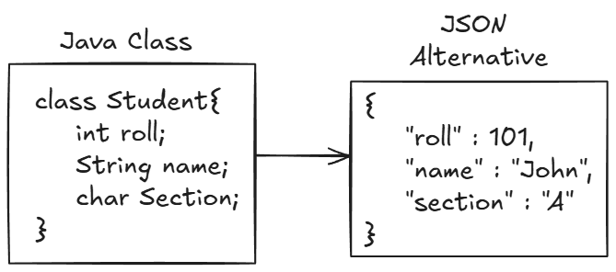

- JSON Array
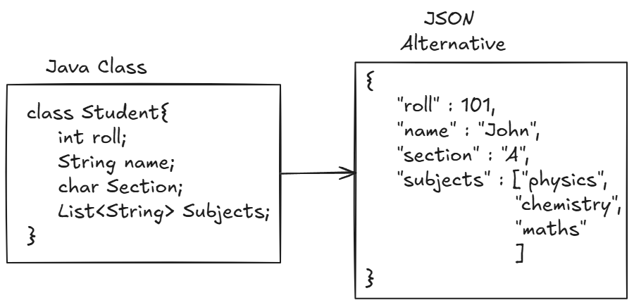

- Nested JSON Object

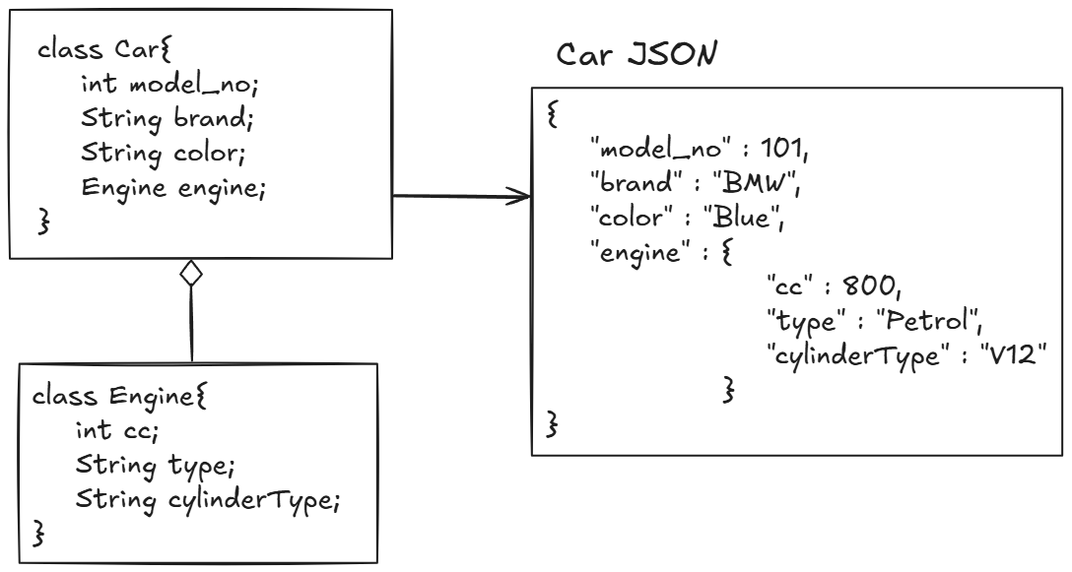

- JSON Object Array

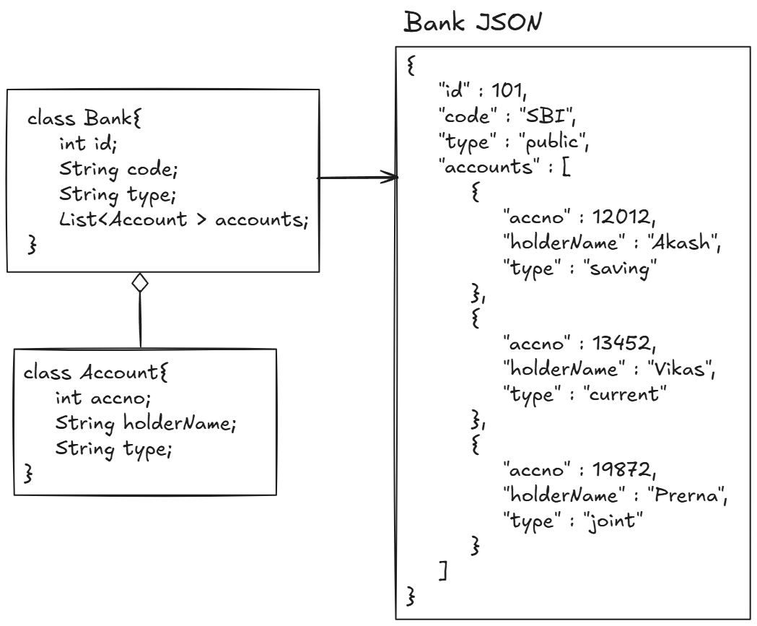

Project Setup:

- Go to https://start.spring.io/ or search Spring Initializer

- Make proper selections and click on generate

- Load the downloaded Project in any workspace

- Fileimportimport existing maven project.

- Select the extracted folder and import

- Go to https://github.com/ArpitKharche123/Configuration-Files , and select application.properties for postgres SQL, copy the content and paste it into src/main/resources/application.properties

- Update it with appropriate database configuration.

- One Class will be present annotated with @SpringBootApplication, which will act as an entry point of the springboot application.(Driver class)

- @SpringBootApplication

this annotation is a combination of @ComponentScan and @EnableAutoConfiguration. This annotation is used for the configuration of spring boot project automatically.

- Access this url: http://localhost:8080/, content of method should be displayed on the web!

- To Terminate the application(stop listening on port)

- Press cross button(x) on right hand side of terminate button, then terminate the application.

Controller Class

- Controller is a Java class that:
- Handles incoming requests (like from a browser or API client)
- Processes them (with the help of services or repositories)
- And then sends back a response (like a web page, JSON, or message)
- It is like a “traffic controller” of the web app —
it receives user requests, decides what to do, and sends back the correct response.

Real Time Example:

- Imagine a restaurant:

- Customer = User (sending a request)
- Waiter = Controller (takes order and sends to kitchen)
- Chef = Service (prepares the food/data)
- Controller (waiter) brings the response (food) back to the customer.

So, the Controller acts as a middle layer between the user and the backend logic.

- Working:

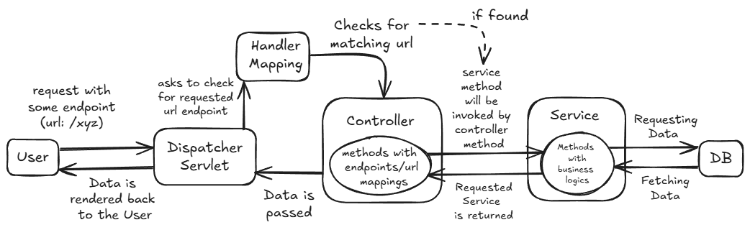

- A user sends a request → GET /employees

- The request is received by DispatcherServlet

- DispatcherServlet asks HandlerMapping to find
which Controller method is mapped to this URL.

- HandlerMapping looks for a matching Controller method (based on URL and HTTP method)

- If found, method with that endpoint in the Controller is called by a component named Handler Adapter.

- The method executes (interacts with the Service, Repository and Database),

- The method returns:
- A response body (like JSON or text)

- DispatcherServlet sends that response back to the user.

Type | Annotation | Returns | Used For
Controller | @Controller | HTML View Pages (like JSP, Thymeleaf) | Web MVC applications
RestController | @RestController | JSON / XML / Text Data | RESTful APIs

- In SpringBoot, we are going to make use of RestController, to design and build RESTful web services (Rest APIs).

@RestController:
- Annotation used to mark this class as a controller and ensures the return value is sent as a response body (not a view page).

- it is a combination of @Controller and @ResponseBody.

@ResponseBody
- Normally, a controller method returns a view (like a JSP or HTML page).

- But when we use @ResponseBody, the return value is converted to JSON or XML (using Jackson library by default) and sent back as the HTTP response.

- @ResponseBody annotation tells Spring to perform marshalling (serialization) of the Java object returned by a controller method into a format suitable for the HTTP response — usually JSON (or sometimes XML), using the Jackson library by default.

- Marshalling is a process of converting the java object into JSON or XML (text format that can be sent over HTTP).

- UrlMapping Annotations

- @GetMapping

- Used for fetching the data.

- @PostMapping

- Used for sending the data.

- @PutMapping

- Used for updating the existing data.

- @PatchMapping

- Used for partially updating the existing data (updating some fields).

- @DeleteMapping

- Used for deleting the existing the data.

- So, we can test all endpoints on Postman!

Step 1: Create a new request on postman
Step 2: Select method type(GET or POST or PUT or DELETE)
Step 3: Enter the url in the following format:

http://localhost:8081/[your-urlendpoint]

and click on send.

- Passing data using query string

- A Query String is a part of a URL that contains data to be sent to the server.

- It’s used to pass small pieces of information from the client (browser) to the server.

- It contains the data in the form of key and value pair.

- ? indicates the start of query string, followed by key and value pairs, separated by &.

Example:
@GetMapping("/student")
public String info(@RequestParam("id") int stud_id, @RequestParam String name, @RequestParam(required = false) String surname) {
return "Student id: "+stud_id+"\nName: "+name;
}
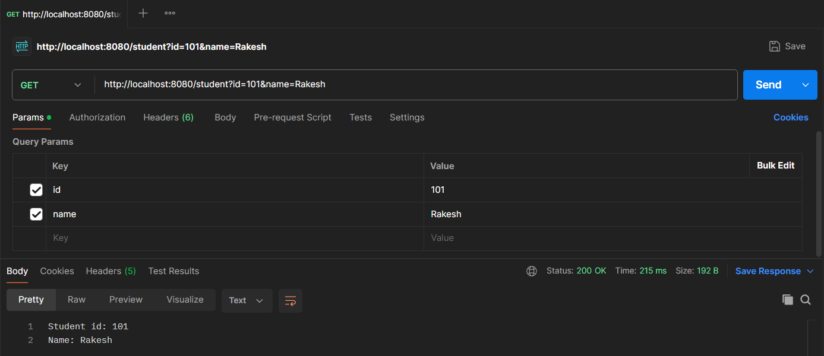

- @RequestParam is an annotation in Spring MVC/Spring Boot used to extract query parameters or form data from an HTTP request and bind them to method parameters in a controller.

- Passing data using path variable

- Here, we can pass the variable directly in the url, enclosed within {}.

Example:
@GetMapping("/user/{id}/{name}")
public String userInfo(@PathVariable("id") int user_id, @PathVariable String name) {
return "User id: "+user_id+"\nName: "+name;
}
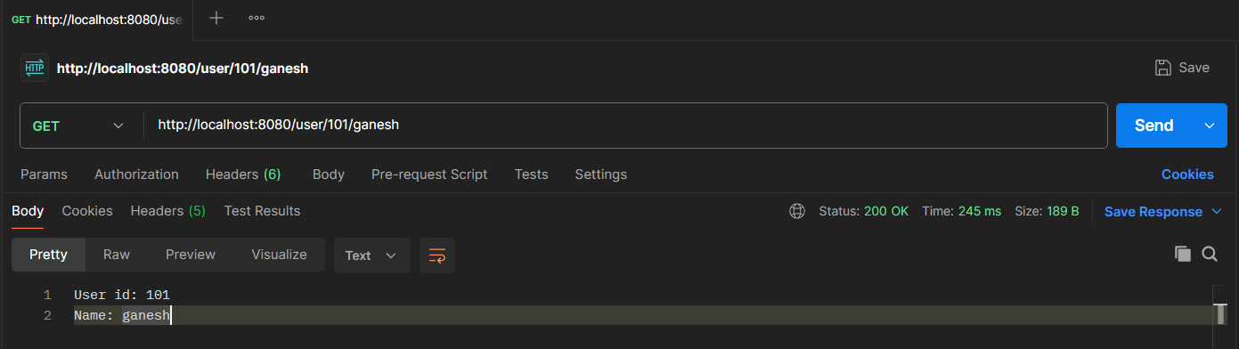

Feature | @RequestParam | @PathVariable
Location in URL | After a? — in the query string | Inside the URI path itself, inside{}
Example URL | /employees?id=10 | /employees/10
Use | Used to extract query parameters from the URL | Used to extract path segments dynamic data from the URL
Annotation usage | @RequestParam("id") int id | @PathVariable("id") int id
Primary purpose | For filtering, sorting, optional parameters | For identifying specific resources
Optionality | Easily made optional using required = false | Usually mandatory — defines resource identity(Static url pattern)

- Use @PathVariable when:
- The value is a part of the resource identity.
- You’re following RESTful API design principles.
- The endpoint represents a specific object or entity.

Example:
- /users/10 → “the user with ID 10”
- /orders/55/items → “the items of order 55”

More convenient for REST APIs, because:
- It makes URLs clean and meaningful.
- It matches RESTful best practices (resources identified via URIs).
- Clients can easily navigate your API using simple, readable paths.

- Use @RequestParam when:
- The value is not part of the resource identity, but a filter, option, or configuration.
- We want optional parameters (like sorting, searching, or pagination).

Example:
/employees?department=HR&sort=salary&limit=10

More convenient for optional or variable inputs, because:
- We can specify defaults (defaultValue).
- We can make them optional (required = false).
- It’s flexible — no need to change your URL structure.

- Passing JSON Object using request body

- @RequestBody:
Annotation indicating a method parameter should be bound to the body of the web request.

- It is responsible for the conversion from the external data format (typically JSON or XML) contained in the HTTP request body into a Java object (class instance) is known as unmarshalling (or deserialization).

- Create one Student class,with fields such as id, name , height, etc with getters and setters for all.

Example:
@PostMapping("/student")
public String studentInfo(@RequestBody Student student) {
return
"Id: "+student.getId()+"\n"+
"Name: "+student.getName()+"\n"+
"Height: "+student.getHeight()+"\n"
;
}
- Provide the data in JSON format in Postman:

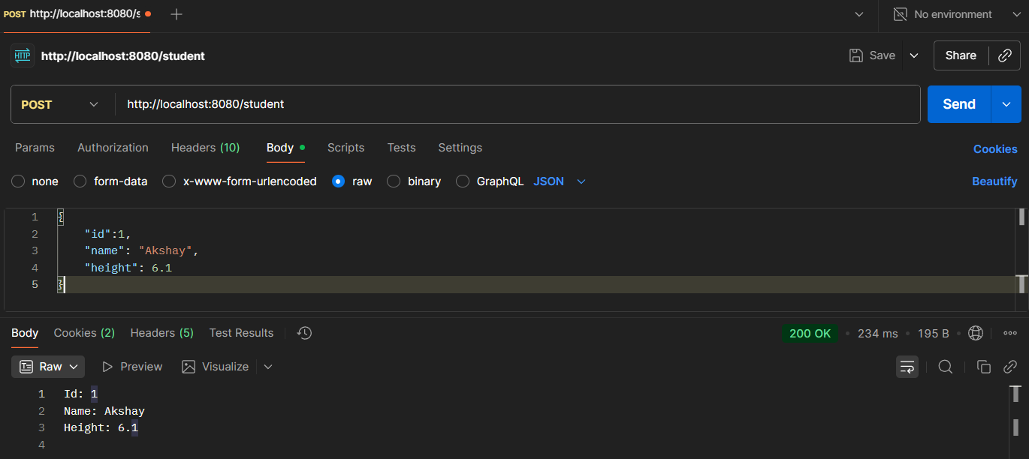

- Layered Architecture in Spring Boot

- In Spring Boot, a layered architecture is a software design pattern that divides the application into separate layers — each having a distinct responsibility.
- It is made of layers like :
- Controller Layer (Presentation)
- Service Layer (Business Logic)
- Repository Layer (Data Access / DAO)
- Model or Entity Layer (Data Representation), etc
Each layer talks only to the layer directly below it — ensuring separation of concerns.

- Example:

Think it like a restaurant:

- Controller → Waiter (takes your order / sends response)
- Service → Chef (prepares the dish)
- Repository → Kitchen storage (fetches ingredients)
- Model → Recipe / Dish (data representation)

- Layered architecture makes REST APIs:
- More modular (easy to extend with new endpoints)
- Easier to debug (know exactly where logic lives)
- Cleaner to document/More Readable (each endpoint’s flow is predictable)
- Enterprise-ready (standard architecture for large teams)

- Detailed workflow:
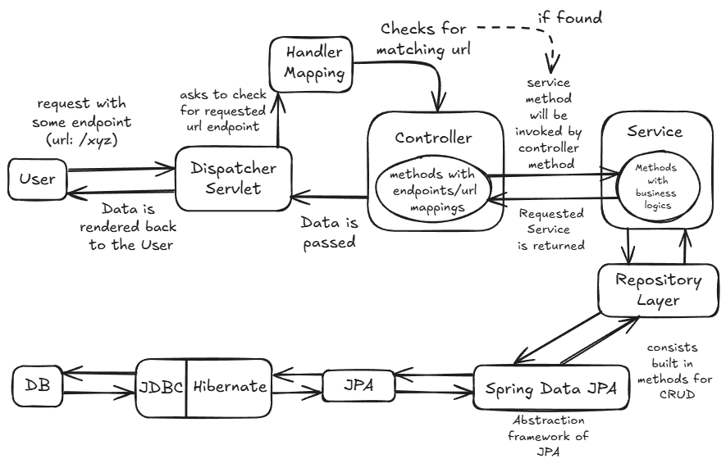

- Controller Layer

- The Controller acts as the API's front door. It listens for specific HTTP requests and handles the basic communication between the client and the server.

- Its main job is to extract data from the request, pass it to the next layer, and then wrap the results in a proper HTTP response status

- It will consists of Controller classes annotated with @RestController and handler methods

- Handler Method will be accepting and handling a specific type of request(GET/POST/PUT/PATCH or DELETE) and a particular URI/endpoint(e.g. http://localhost:8080/products/1)

- HandlerMapping looks for a matching Controller and its handler method (based on URL and HTTP method)

- If found, method with that endpoint in the Controller is called by a component named Handler Adapter.

- Service Layer

- Service Layer contains the business rules, calculations, and logic required to fulfil a request.

- It sits in the middle, coordinating data flow between the Controller and the Repository.

- It consists of Service interfaces and classes with method containing business logic.
- These methods are called in controller layer with the help of injected service bean.

@Service
- It is a specialization of @Component annotation.
- It marks a class as a service-layer Spring bean.
- Class annotated with @Service is used to hold business logic.

- Repository Layer

- The Repository acts as an abstraction for the database. It uses Spring Data JPA to translate Java operations into SQL queries.

- Instead of writing complex database connection code, this layer allows for simple method calls to save, find, or delete records.

@Repository
- this annotation is the specialized form of @Component, which is used to mark an interface as repository,
or
- we can say it marks a class as a Data Access Layer (DAO) component.

- public interface JpaRepository<T, ID>

- JpaRepository<T, ID> is the central Spring Data JPA repository interface, which can be extended when we want Spring to generate a JPA-based data-access implementation(internal(default) DAO implementation) for an entity.

- It provides CRUD, pagination & sorting,and a number of JPA-specific convenience methods so you rarely need to write boilerplate EntityManager code.

- It provides methods like save(), findByID(ID id), findAll(), deleteById(ID id), etc. to perform basic to complex CRUD operations on any entity.

- T : placeholder for any Entity type
- ID: datatype of primary key , in non-primitive type

@RequestMapping:
- It is used to map an HTTP request (like GET, POST, PUT, DELETE) to a specific controller method or class.

- @RequestMapping tells Spring:
“When a user sends a request to this URL, run this controller method.”

- It can be used as:
- Class level → defines a base URL for all methods in that class.
- Method level → defines a specific endpoint under that base URL.

- Data Transfer Object (DTO)

Data Transfer Objects are used to control exactly what data enters and leaves the API.
- Request DTOs ensure the API only accepts the specific fields it needs from a user.

- Response DTOs filter out sensitive or unnecessary information (like internal IDs or passwords) before the data is sent back to the client.

ModelMapper

- ModelMapper is a utility used to automate the conversion between different object types.

- In a typical flow, it transforms an incoming Request DTO into an Entity for the database
or
converts a retrieved Entity back into a Response DTO for the user.

- This removes the need for manual, repetitive mapping code.

- After running the application, test all the endpoints in PostMan or swagger, and check whether CRUD operation is getting performed on the database table or not in PG Admin

- PostMan Requests:

- POST addProduct
URL: http://localhost:8080/products
Request Body: raw (json)
e.g.
{
"name":"Television",
"price": 123999.0
}

- GET getAllProducts

URL: http://localhost:8080/products
No Request Body

- GET getProductById

URL: http://localhost:8080/products/1
No Request body
- PUT updateProduct

URL: http://localhost:8080/products/1
Request Body raw (json)
e.g.
{
"name": "iphone",
"price": 130000.0
}
- DELETE deleteProduct
URL: http://localhost:8080/products/1
No Request body

- Swagger UI with SpringBoot

- Swagger UI in Spring Boot is an interactive, browser-based documentation and testing tool for RESTful APIs.

- It presents the API endpoints in a clean, user-friendly interface, allowing both developers and non-developers to understand, interact with, and test APIs with minimal effort.

Implementation:

- Go to https://mvnrepository.com/ and search for SpringDoc OpenAPI Starter WebMVC UI

- Copy the dependency and add it to pom.xml, of the existing springboot project

- Run the application and on web, access this url:

http://localhost:8080/swagger-ui/index.html
- Custom Repository Methods:

- Along with the built-in methods of JPARepository, we can also create our custom method by following Spring Data JPA naming convention rules!
- Spring will automatically generate SQL queries as per keywords.

✅ Rule 1: Start with the right prefixes
- Spring detects intent from the method name.

- Some common prefixes are:

Prefix | Meaning
findBy | Select records
readBy | Same as findBy
getBy | Same as findBy
queryBy | Same as findBy
countBy | Count records
existsBy | Check if record exists
deleteBy | Delete records

✅ Rule 2: Use Entity Field Names exactly as they appear in the class

- If entity fields are like:

private int id;
private String name;
private double price;

So the field names in methods should be like:
➡ id, name, price

- e.g.: List<Product> findByName(String name);

will be internally translated to:
SELECT * FROM product WHERE name = ?

- e.g. List<Product> findByPriceGreaterThan(double price);

  - SELECT * FROM product WHERE price > ?

Keyword | SQL Equivalent
LessThan | <
LessThanEqual | <=
GreaterThan | >
GreaterThanEqual | >=
Between | BETWEEN ... AND ...
Like | LIKE
NotLike | NOT LIKE
In | IN
NotIn | NOT IN
IsNull | IS NULL
IsNotNull | IS NOT NULL
StartingWith | LIKE 'value%'
EndingWith | LIKE '%value'
Containing | LIKE '%value%'
True / False | for boolean fields

- Custom JPQL Queries

- When naming convention are not enough to perform some complex , operation, we can explicitly specify JPQL queries to custom methods using @Query tag!

e.g:
@Query("SELECT p FROM Product p WHERE p.name = :name AND p.price < :price")
List<Product> findProductsUnderPrice(@Param("name") String prod_name, @Param("price") double price);

- @Param is used to set methods arguments to the placeholders/query parameters in the JPQL query!!
- If method param and query param are same, then there is not need to use @Param
- But it may not work sometimes(due to IDE configurations)
- So, the safer practice is always use @Param

- Or match all the method parameters with query parameters (here no need of @Param)

e.g.
@Query("SELECT p FROM Product p WHERE p.name = :name AND p.price <: price")
List<Product> findProductsUnderPrice2(String name, double price);

- Response Structure

- It refers to the standard format in which RESTful API returns data and information to the client.

- Instead of just returning raw data, it can be wrapped in a consistent object or pattern for both success and error scenarios.

- It is a way to return the complete information regarding the data, (instead of raw data itself) in a consistent, managed and precise manner.

- This structure can be implemented by creating a user defined generic class.
e.g.
@Data
public class ApiResponseDTO<T> {
private int statusCode;
private String message;
private T data;
}

- Note: This will help to change the response structure only, not the complete/actual response!

- ResponseEntity

- It represents the entire HTTP response that the API sends back to the client.

- Instead of just returning the data (the response body/structure), ResponseEntity allows us to have full control over all three essential components of an HTTP response:

- HTTP Status Code
- HTTP Headers
- Response Body

- It is a generic class, declared as ResponseEntity<T>, where T is the type of the response body to return.

- We have created a response body type: ApiResponseDTO<T>, which can be used with ResponseEntity to obtain full control over the response.

- Exception Handling in SpringBoot

- There is a chance we might get some exceptions in response body due to some wrong configurations, data type mismatch , field constraints and many more reasons.

- In SpringBoot, we can handle these exceptions with the help of user defined Exception Handler class.

- This class will:

- Be annotated with @RestControllerAdvice to make it a global exception handler that can catch exceptions thrown from any controller in the application.

- Contain methods annotated with @ExceptionHandler that are responsible for catching specific types of exceptions (e.g., NotFoundException, MethodArgumentNotValidException, etc).

- Inside each @ExceptionHandler method, we can transform the caught exception into a user-friendly and well-structured ResponseEntity containing a custom error body and an appropriate HTTP Status Code (e.g., HttpStatus.NOT_FOUND for a 404, or HttpStatus.BAD_REQUEST for a 400).

- This approach ensures consistency, decouples error handling logic from the business logic in the controllers, and provides a clean, predictable JSON response to the client instead of a default server error page.

- Pagination

- It means fetching data in smaller chunks (pages) instead of loading the entire dataset at once.

❌ Without Pagination
GET /products
→ returns 50,000 records
→ slow API
→ high memory usage

✅ With Pagination
GET /products?page=0&size=10
→ returns only 10 records

Importance of Pagination

Reason | Explanation
Performance | Reduces DB & memory load
Faster API | Smaller response size
Scalability | Works even with millions of records
User Experience | Easy navigation (page 1, page 2…)

Pagination Support in Spring Boot

Spring Boot provides built-in pagination support via:
🔹 Pageable
Interface representing pagination information.
🔹 Page<T>
Represents paginated response + metadata.

- All are present in org.springframework.data.domain

Microservice :

Microservices architecture is a design approach where an application is broken into small, independent, loosely coupled services, and each service:
- Performs one business function
- Runs as a separate application
- Has its own database
- Communicates with other services using HTTP/REST or messaging
- Can be developed, deployed, and scaled independently

Example (E-commerce App)
Instead of one big application:
- User Service
- Product Service
- Order Service
- Payment Service
- Notification Service

Each is a separate Spring Boot application.

Monolith vs Microservices

Monolithic Architecture
- Single application
- Single database
- Tight coupling
- One deployment unit
Microservices Architecture
- Multiple small applications
- Separate databases
- Loose coupling
- Independent deployment

Feature | Monolith | Microservices
Deployment | Single | Independent
Scalability | Entire app | Per service
Fault isolation | Poor | Better
Technology flexibility | Limited | High
Complexity | Low initially | High

Problems with Monolith
- One small bug can crash entire app
- Hard to scale specific modules
- Slow deployments
- Difficult to maintain large codebases
- Teams step on each other’s code

Microservices
- Independent scaling
- Faster development & deployment
- Better fault isolation
- Suitable for large teams
- Cloud-friendly

Used by: Netflix, Amazon, Uber, Flipkart, Swiggy

