Spring MVC

Any application basically consists of three layers those are:
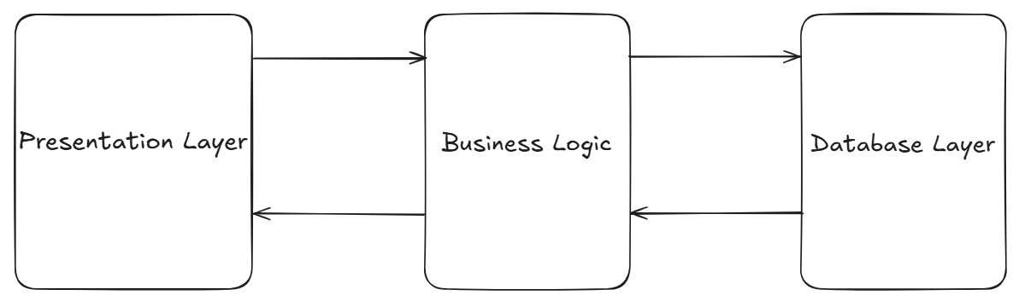

- Presentation layer:

This layer of an application deals with user interaction with the application.

- Business logic:

This layer of an application deals with data processing and database connectivity.

- Database layer:

This layer of an application deals with data management and data storage.

Spring MVC

- MVC stands for model, view, controller.
- Spring MVC is part of the Spring Framework and offers tools and conventions to create web applications (web pages, REST APIs, etc.).
- It is an architectural design pattern that divides an application into three parts/layers to make code cleaner and easier to maintain.

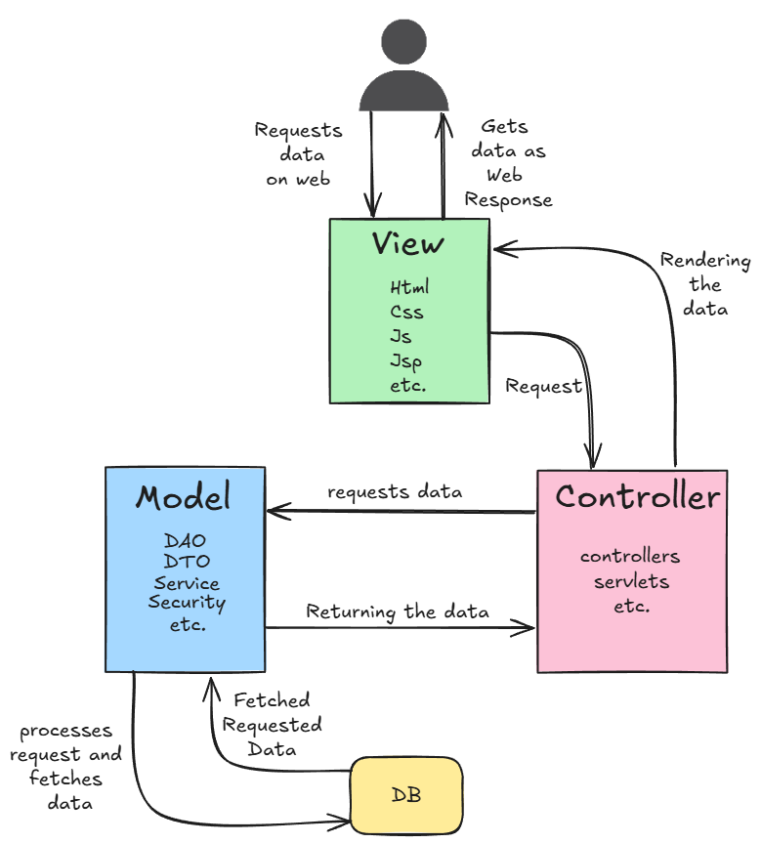
- Model:

- It represents business logic(backend) of an application, application data along with the database connectivity.
- It can have layers like Service, DAO, DTO, Security, Repository, etc.

- View:

- It represents presentation layer or user interface(frontend).
- It generally holds the HTML, CSS, JS, Thymeleaf , JSP ,etc codes.

- Controller:

- It acts like an interface between view and model.
- Controller controls all the requests and responses.

Real time example:
- Think of a restaurant:

- Controller is the waiter (takes your request)
- Model is the kitchen (the data and business logic)
- View is the plated food (what the user sees).

Limitations of Traditional MVC
- In traditional patterns, the Controller is tightly bound to the View.

- Because it returns a specific page (like html/jsp file)it suffers from several limitations like:
- Tight Coupling: The backend and frontend are locked together. A change in the UI often requires a change in the backend controller and related components
- Heavy Payload: Every user interaction requires the server to reload the entire HTML page. This wastes bandwidth and leads to a "flicker" that degrades user experience.
- Platform Restriction: A controller returning a web-based view is useless for a mobile app. We would have to write entirely separate logic to support Android or iOS devices.
- Limited Scalability: Since the server handles both the logic and the rendering of the UI, it consumes more CPU and memory, making it harder to scale as traffic grows.

The Advancement: MVC + REST API

- To solve these issues, the industry shifted toward Decoupled Architecture.
- In this model, the Controller no longer returns a "View" file; instead, it returns Raw Data (typically in JSON format).

- Stateless Communication: The server doesn't need to keep track of the UI state. It simply provides data when asked.
- One Backend, Many Frontends: A single Spring Boot backend can now serve a React web application, an Android app, and an iOS app simultaneously because they all "consume" the same JSON data.
- Parallel Development: Frontend and backend teams can work independently. As long as they agree on the API "contract" (the JSON structure), the backend team can build logic while the frontend team builds the interface

Advantages of Modern Alternatives

- The modern standard involves using Single Page Applications (SPA) like Angular or React alongside a Microservices and Monolithic/Modulithic backend.

- This offers several key benefits:

- Better User Experience: Only the data changes, not the whole page. This makes the application feel like a desktop app—fast and responsive.
- Reduced Server Load: The user's browser handles the "rendering" (turning data into a pretty UI). The server is freed up to focus purely on business logic and database operations.
- Ease of Deployment: You can update the frontend styles or fix a UI bug without ever touching the backend code or taking the API offline.

