**FirstFlight Web App Using Azure**

**Services**

**Project Documentation Created By: Arpit Mallah , Sanjay Yadav &**

**Aaditya Jaiswar Project Guide: John Devassy**

**Abstract**

**"FirstFlight"** is a **Azure Web App** designed to streamline user interactions through a combination of customized domain management, intelligent chatbot integration, and robust monitoring capabilities. Leveraging **Azure DNS Zone**, the application seamlessly integrates with custom domains, ensuring a branded and cohesive user experience. The inclusion of **Azure QnA** facilitates efficient communication through a chatbot interface, empowering users with instant access to relevant information and support. Additionally, monitoring alerts have been configured to ensure proactive management of the web application, enabling swift response to potential issues and optimizing overall performance. **"FirstFlight"** represents a comprehensive solution tailored to enhance user engagement, streamline operations, and ensure the reliability of web-based services.

# Table of Contents

### Introduction ..............................................................................................

* 1. Fundamentals ..................................................................................
  2. Objectives .......................................................................................
  3. Scope ...............................................................................................

### System requirements and specifications ..................................................

* 1. What is SRS? ..................................................................................
  2. Role of SRS ...................................................................................

2.3 Requirements Specification Document ..........................................

* 1. Functional requirements .................................................................
  2. Non-Functional Requirements ........................................................
  3. Performance ....................................................................................
  4. Software Requirements ...................................................................
  5. Hardware Requirements .................................................................

1. **Azure Services Used ..................................................................................**
2. **Chapter 4: Implementation ......................................................................**
3. **Chapter 5: Website Overview ...................................................................**
4. **Chapter 6: Benefits ....................................................................................**
5. **Chapter 7: Conclusion ...............................................................................**

# Introduction

## Background:

The travel industry thrives on seamless user experiences that blend convenience with personalized services. With the proliferation of digital platforms, travelers seek efficient ways to plan, book, and manage their journeys. However, traditional web applications often fall short in delivering the level of engagement and support required to meet modern travelers' expectations.

"FirstFlight" emerges as a response to this challenge, offering a holistic solution that leverages Azure's advanced capabilities to redefine the travel experience. By integrating customized domain management, intelligent chatbot support, and robust monitoring features, "FirstFlight" aims to elevate user engagement and streamline operations for both travelers and service providers.

## Objective:

The objectives for "FirstFlight" are to create a highly engaging platform for travelers, streamline operational processes for users and service providers, and improve overall customer experience through personalized assistance and seamless interactions.

Additionally, the project aims to ensure reliability and scalability to accommodate varying levels of user traffic while fostering innovation and adaptability to stay competitive in the travel technology market.

## Scope:

The scope of "FirstFlight" encompasses the development of a robust web application aimed at revolutionizing the travel experience. It involves integrating Azure services for domain management, chatbot support, and monitoring capabilities.

The platform will prioritize user engagement through intuitive interfaces and personalized recommendations. Operational processes for booking, management, and customer support will be streamlined for both travelers. Emphasis will be placed on improving overall customer experience through proactive issue resolution and prompt assistance.

# System Requirements and Specifications

## What is SRS?

The Software Requirements Specification (SRS) serves as the cornerstone of our software development process.

It involves a thorough analysis of client needs and the translation of these requirements into a formal document.

The ultimate objective of the SRS phase is to produce a validated document that serves as a blueprint for further development.

## Role of SRS:

The SRS plays a pivotal role in facilitating effective communication between clients and developers.

It serves as a roadmap, outlining the needs and expectations of all stakeholders involved in the project.

A well-crafted SRS ensures alignment and clarity, ultimately leading to successful project outcomes.

## Requirements Specification Document:

Our Requirements Specification Document serves as a comprehensive guide, detailing the scope and nature of our software project.

It encompasses various aspects such as project purpose, scope, functional and non- functional requirements, and environmental considerations.

Additionally, it outlines safety and security requirements, ensuring the integrity and reliability of our software solution.

## Functional Requirements:

Functional requirements define the specific functionalities that our system must support.

These requirements outline the various states of input data, as well as the processing methods required to generate output data.

Essentially, functional requirements dictate the precise behaviors and functions that our software application must exhibit.

## Non-Functional Requirements:

Non-functional requirements focus on evaluating the performance and operation of our system.

These requirements encompass aspects such as reliability, performance, and security, setting the standards for our system's performance and operational constraints.

For instance, our system must operate smoothly without bugs and ensure minimal lag when displaying content.

## Performance:

Evaluating the performance of our deployed website is essential to ensure it meets predefined goals.

This evaluation involves identifying any bottlenecks that may impact performance and determining whether the application aligns with performance targets.

Defining metrics such as response time, latency, throughput, and resource utilization is critical to this evaluation process, enabling us to optimize performance and efficiency.

## Software Requirements:

* + - Operating System: Windows 10/11 or MAC OS.
    - Platform: Microsoft Azure, Visual Studio Code
    - Microsoft Azure Subscription (Free Trial or Azure for student or Pay- as- you-go)
    - Website Programming Language: HTML, CSS

## Hardware Requirements:

* + - Processor: Intel core i3 and above
    - Hard disk: 256 GB or above
    - RAM: 4GB or above
    - Internet: 1 Mbps or above

# Used Azure Services

## Azure App Service:

Azure App Service is a Platform as a Service (PaaS) offering. This means you or your organization is only responsible for managing your business application and its data. Everything else is managed by Azure. You don't have to worry about any of the things like, managing the network or underlying infrastructure. Installing

the operating system updates, critical patches, runtime or middleware components. All these are taken care by Azure. This gives you, even more time to concentrate on what matters to your business.

Benefits of using azure app service:

### Fully managed environment

It's a fully managed environment, meaning App Service automatically

patches and maintains the OS and language frameworks for you. You get the time to focus on designing, developing and maintaining your application and data.Azure App Service supports a wide variety of programming languages and frameworks.

* + - .NET
    - .NET Core
    - Java
    - Ruby
    - Node.js
    - PHP
    - Python

You can also run PowerShell and other scripts or executables as background services.

### Scalability

Based on the demand for your application, App Service can scale resources up and down or in and out. You can do this either manually if you want to or automatically based on metrics like CPU utilization for example.

### Compliance

App Service is ISO (International Organization for Standardization), SOC (Service Organization Controls), and PCI (Payment Card Industry compliant.

### Security

Authenticate users with Azure Active Directory or any of the external authentication providers like Google, Facebook, Twitter, or Microsoft.

### Support for Containerization and Docker

You can also host a custom Windows or Linux container in App Service. So, if you want to, you can dockize your app and host it in App Service. You can also run multi-container apps with Docker Compose. We will discuss how to do all these in our upcoming videos.

### DevOps optimization

Set up CI/CD i.e. continuous integration and deployment with Azure DevOps, GitHub, Bitbucket, Docker Hub, or Azure Container Registry.

### Access on-premises data

With App Service you can still access data on your on-premise servers using Hybrid Connections and Azure Virtual Networks.

## Azure QnA Service:

Azure QnA Maker is a cloud-based Natural Language Processing (NLP) service that allows you to create a natural conversational layer over your data.

It is used to find the most appropriate answer for any input from your custom knowledge base (KB) of information.

Azure QnA Maker is commonly used to build conversational client applications, which include social media applications, chat bots, and speech-enabled desktop applications.

Azure QnA Maker doesn't store customer data. All customer data (question answers and chat logs) are stored in the region the customer deploys the dependent service instances in.

Azure Bot Service is basically Microsoft’s artificial intelligence (AI) chatbot platform offered as a service on the Azure cloud service marketplace. Azure Bot Services offers the ability to chatbot developers to add intelligent agents to their bots that are capable of conversation without having to commit the resources to develop one’s own AI.

## Azure Resource Group:

Resources are instances of azure services that you create, like virtual machines, app services, storage accounts, SQL databases, function apps etc. All these are azure services. Every time you create an instance of a service, you are creating a resource. There are hundreds of azure services.

As the name implies, a Resource Group is a group of azure resources like virtual machines, app services, storage accounts, SQL databases etc. It's a logical container for grouping related azure resources.

## Azure Web App - Monitoring Alerts

### Monitoring Alerts:

* + Monitor various aspects of your application and trigger actions based on thresholds.

# Implementation

## Since I have already created so I will just demonstrate the steps.

Go to Home -> All Resource -> AI + Machine Learning -> Language Service

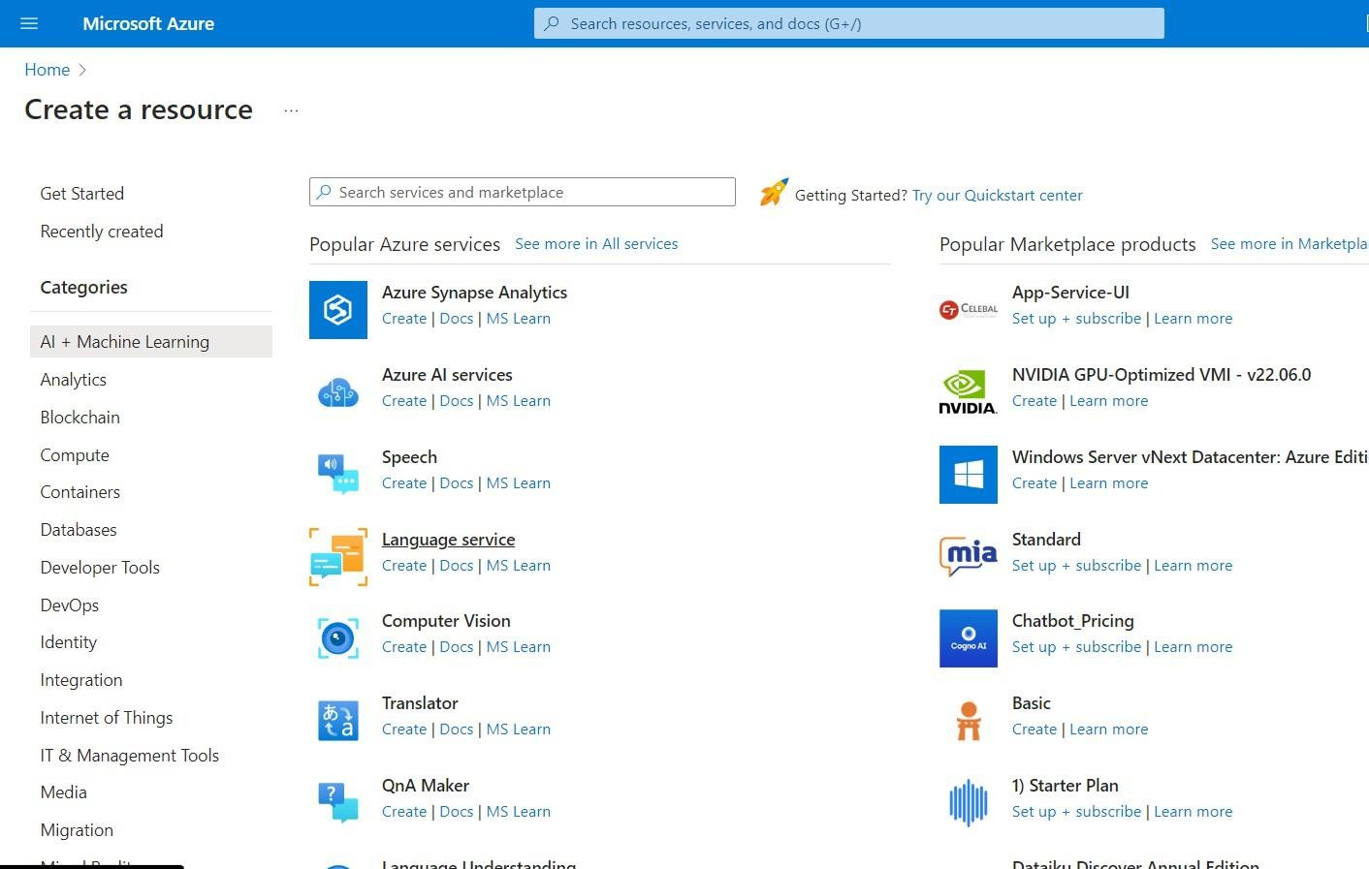

Select Custom Question Answering ->Continue to Create Your Resource-> In Create Language fill all the details -> Review + Create

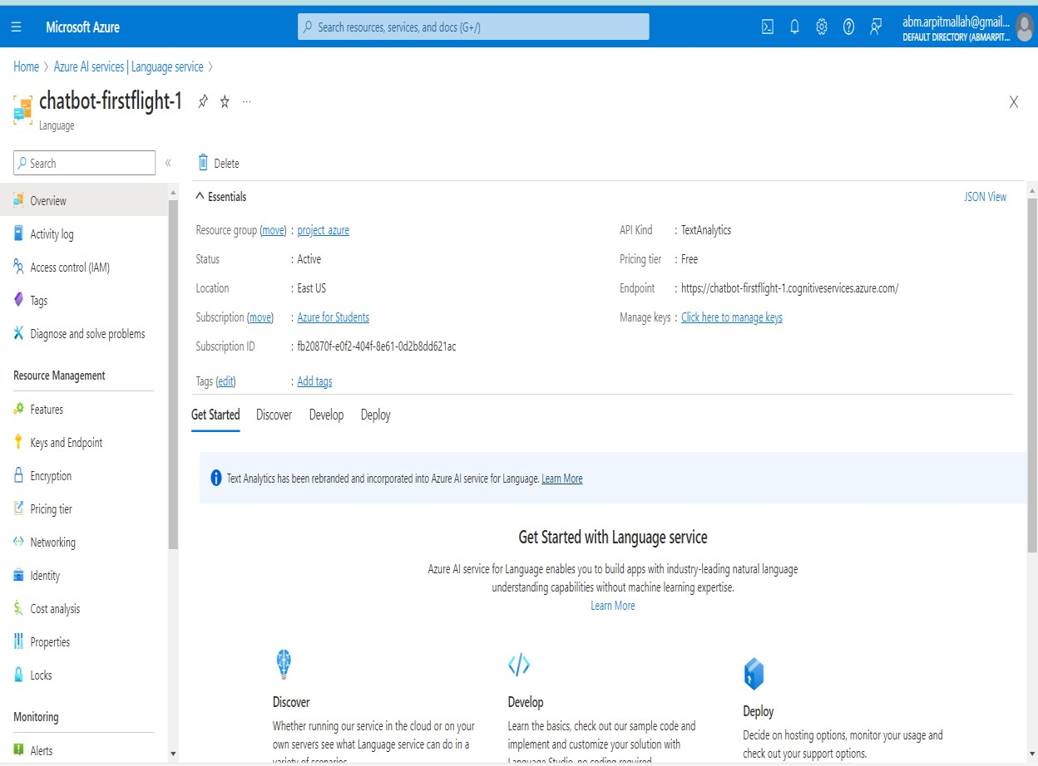

Click on Language Studio ->

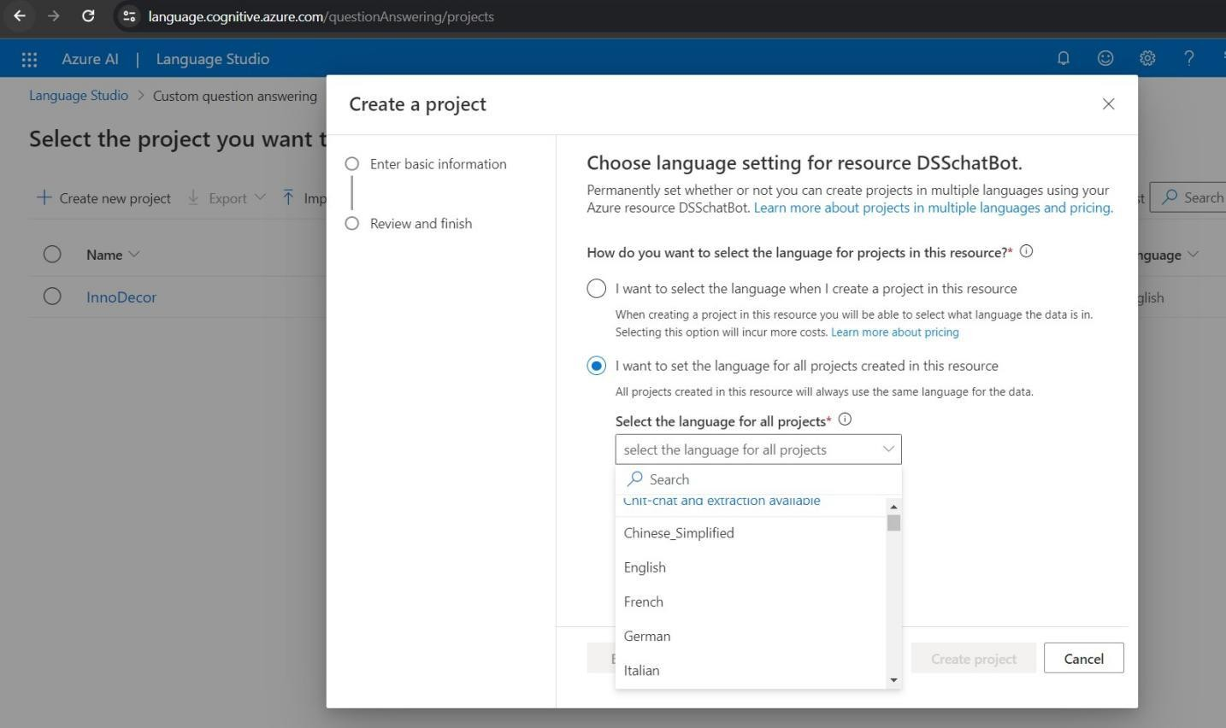

Fill all the details by clicking Next and then Click on Create Project

Add you excel file of customized question and answer in Manage sources

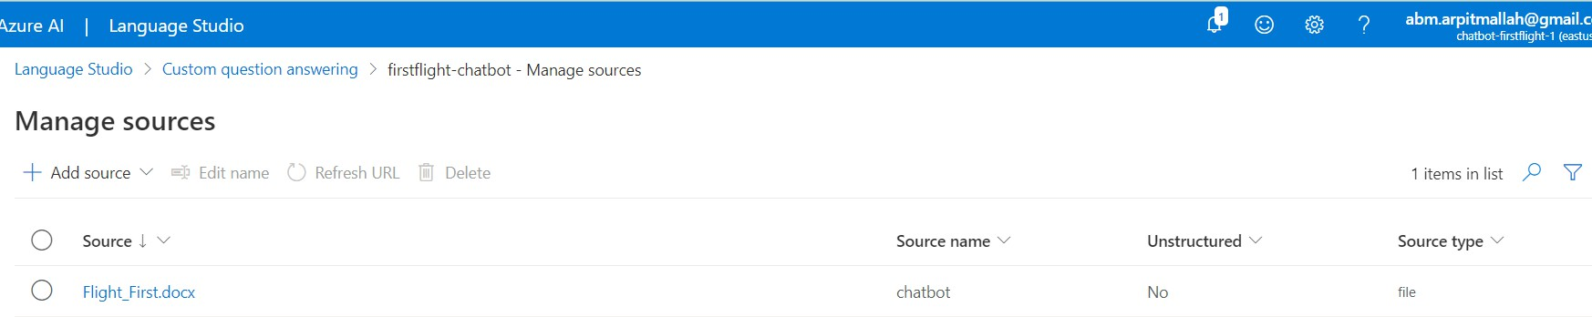

Click on Deploy (in Deploy Knowledge Base)->Click on Bot to create Chatbot

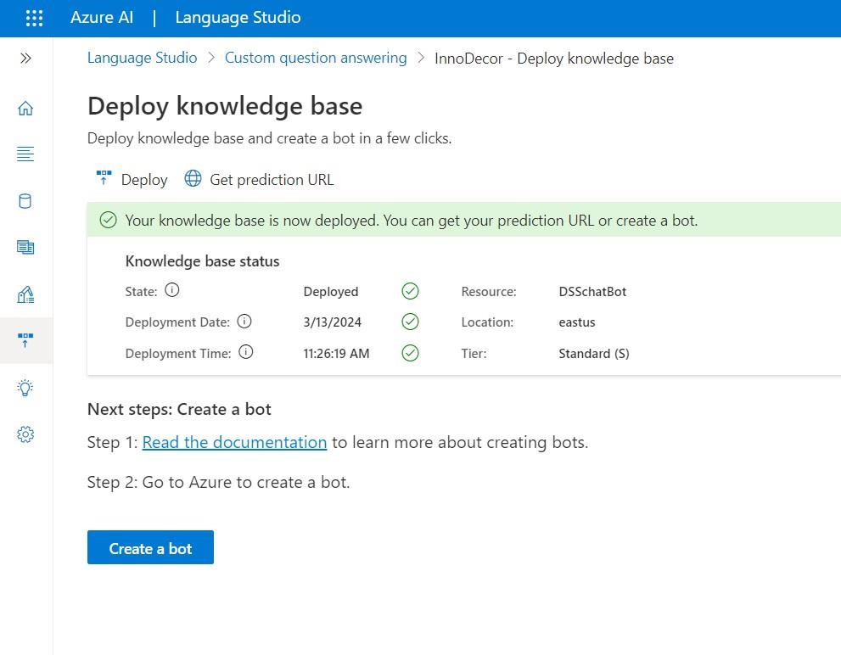

After Clicking on Create a Bot -> In Azure Portal Fill Custom Deployment Section

In Web App for language resources key you can go to chatbot (language) In key and endpoint, you will get a key copy it and paste it in Custom Deployment Web App Part.

After filling all details click on Review+Create

We can also test our Chatbot Now Let’s

make Our Web App

For Creating WebApp we have two options

1. Azure Portal
2. Visual Studio Code

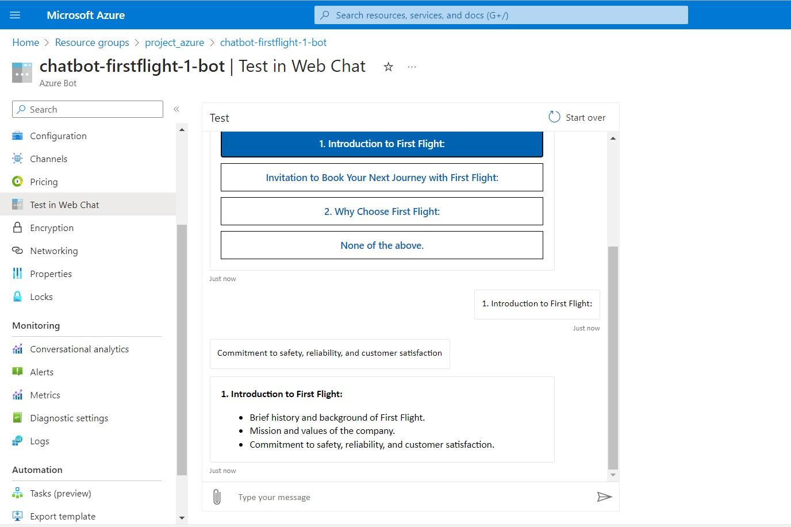

## Azure Portal

Go to App Services -> Create -> Web App ->

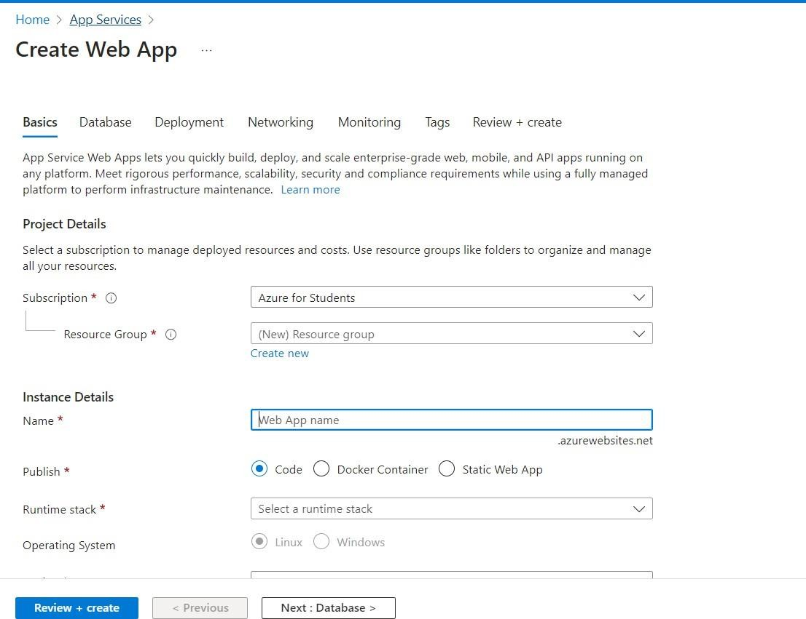

Fill the details and Click on Review + Create -> Go to resource

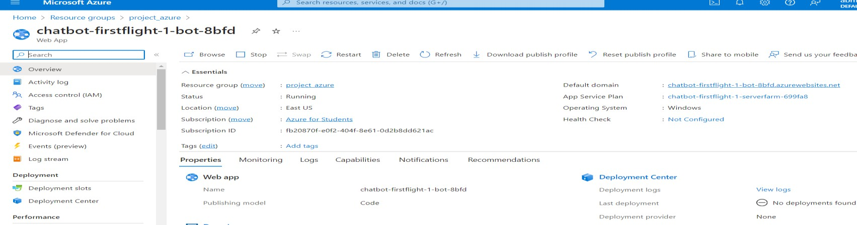

## FileZilla

Web App -> Deployment Center -> copy FTPS endpoints, Username, Password Paste in FileZilla and Click on Quickconnect

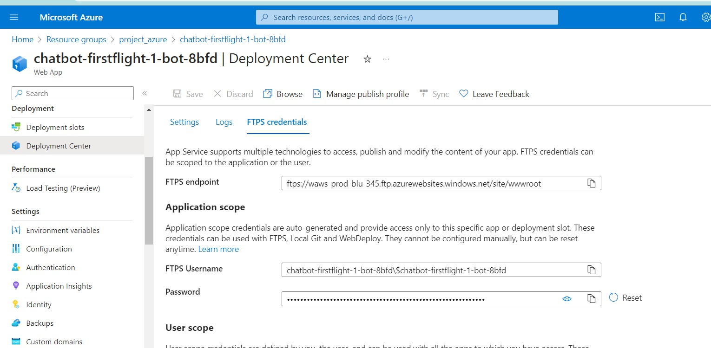

Drag files and folder from left of ‘Local Site’ to Right of ‘Remote Site’ Now it is completed we can host our website.

Creating DNS Zone for Custom Domain Binding

DNS Zone -> Create DNS Zone -> Under name select Domain name which we have buyed from Hostinger Web Hosting

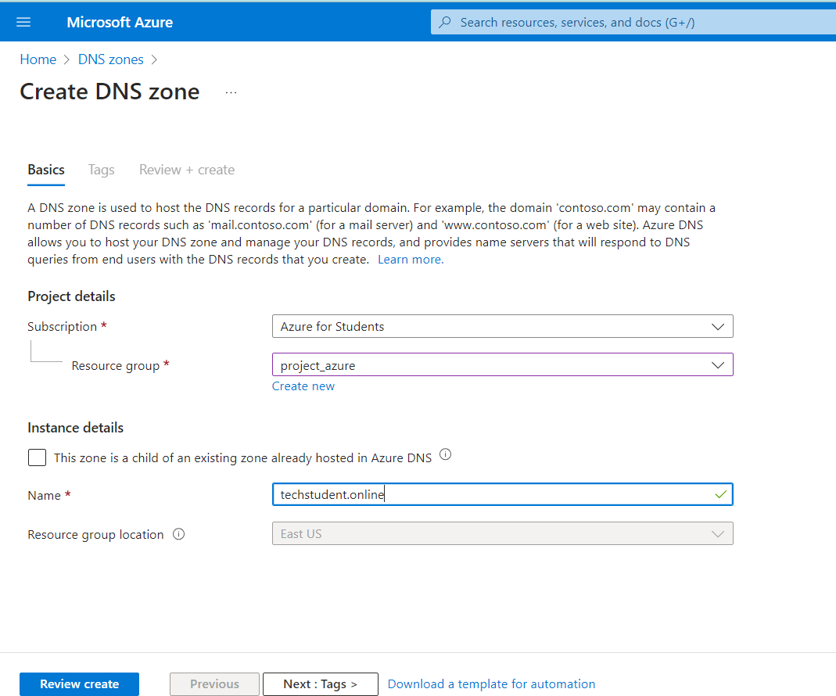

Copy Name Servers and paste it in Hostinger

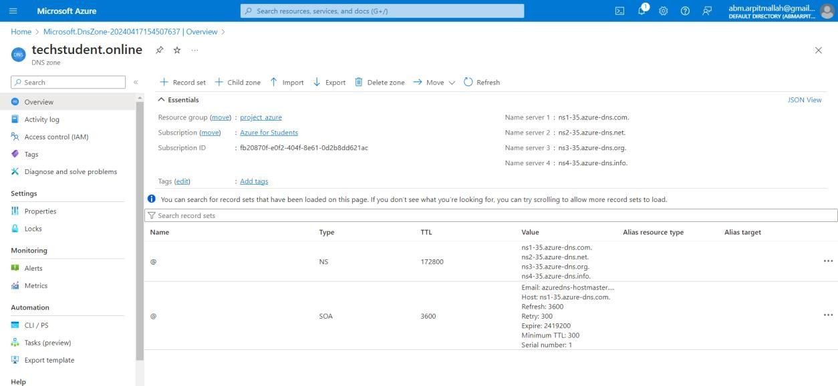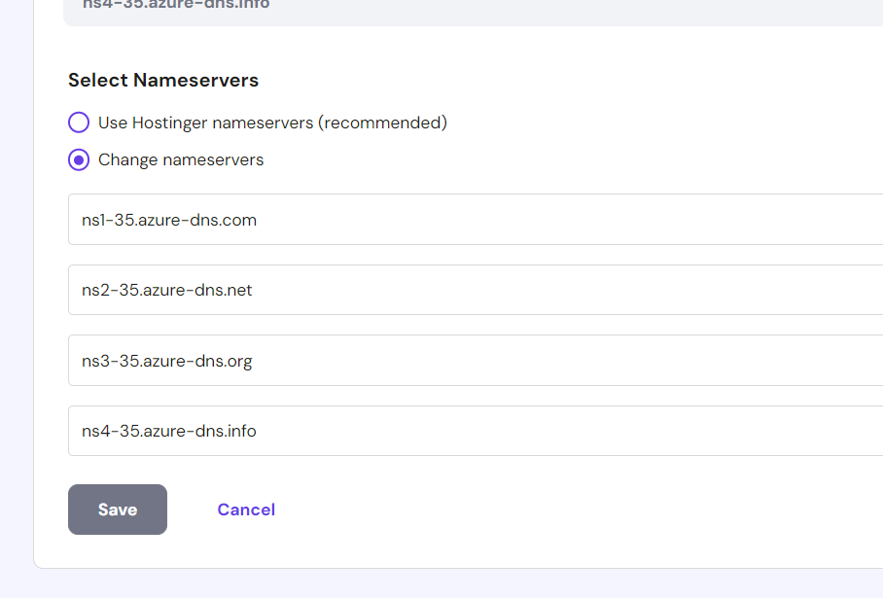

Add New Record Set as follows :

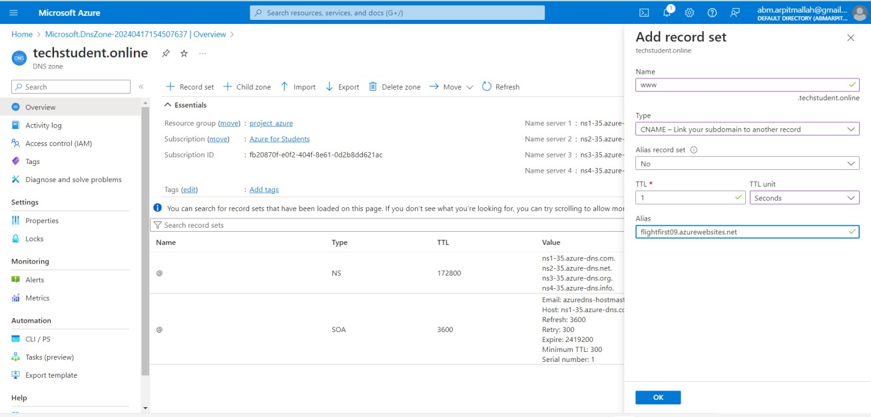

Go to Web App -> Custom Domains -> Add Custom Domain

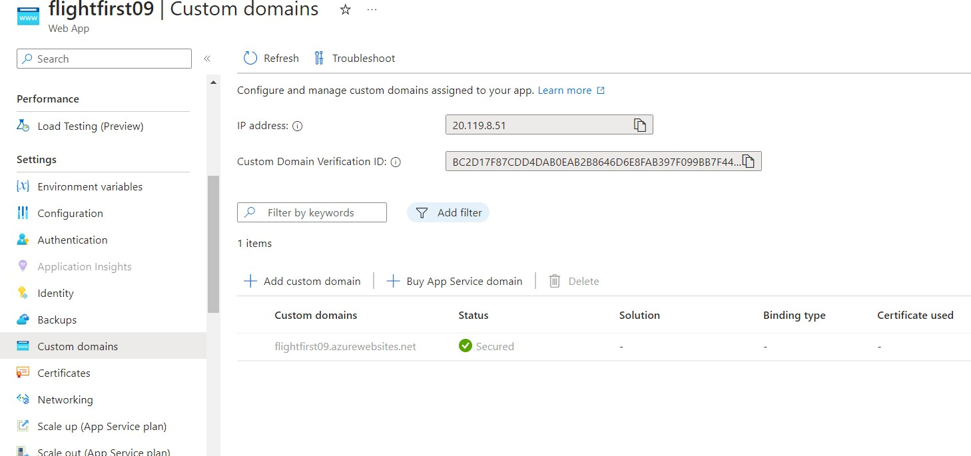

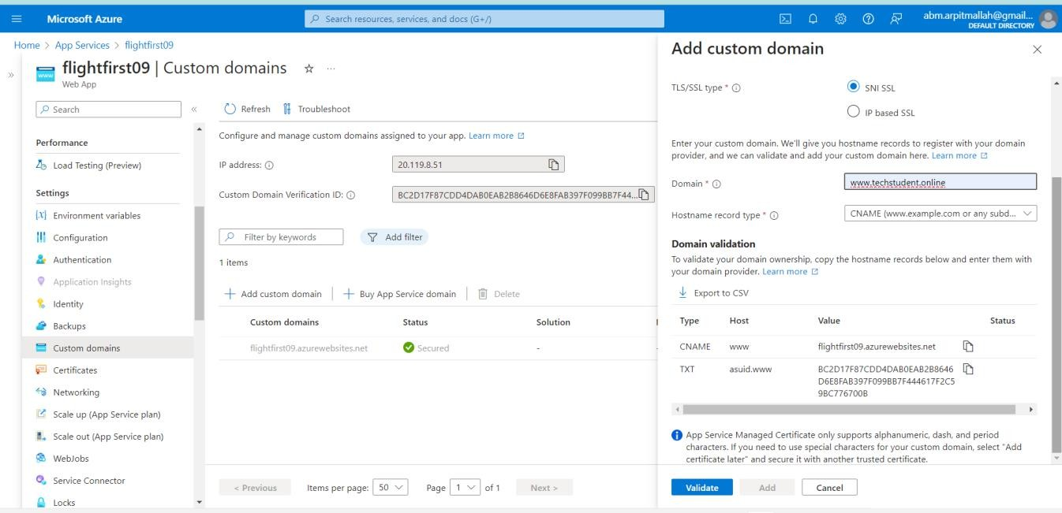

Once Custom Domain is Added successfully Final Website will be open as Custom Domain w[www.techstudent.online](http://www.techstudent.online/)

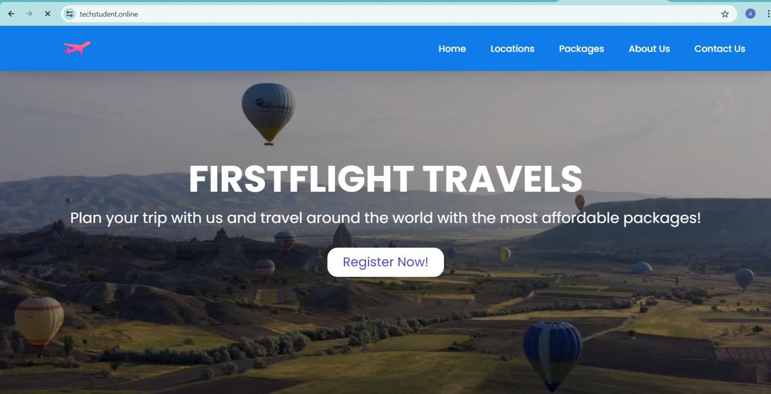

Adding Monitoring Alerts for Web App

Go to Web App -> Monitoring -> Alerts -> Create New Alert Rule

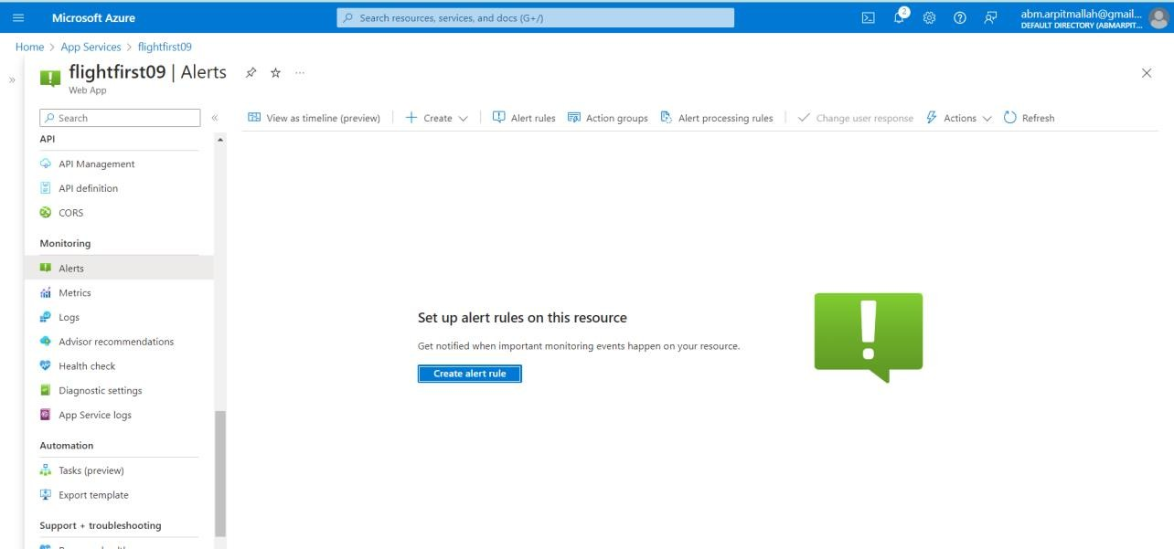

Signal Name - > I am using Web 4## and do following settings :

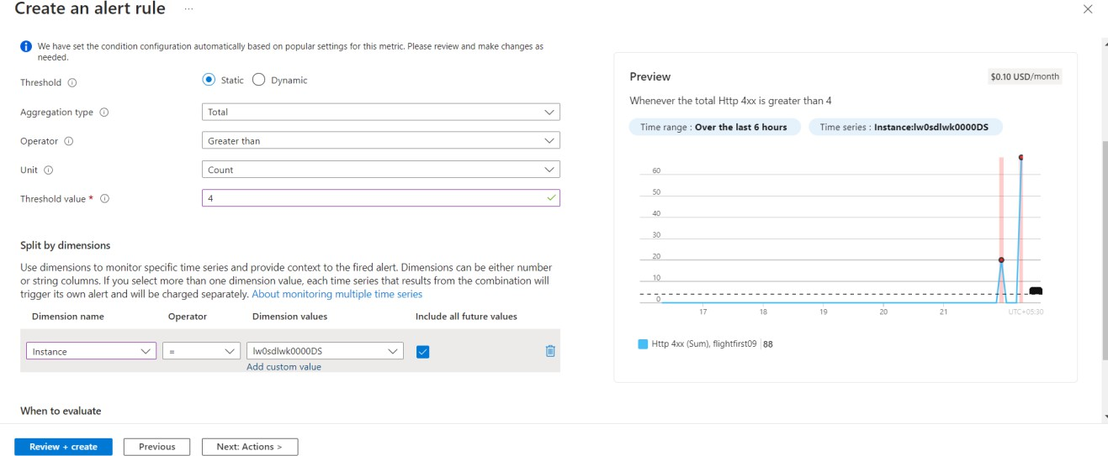

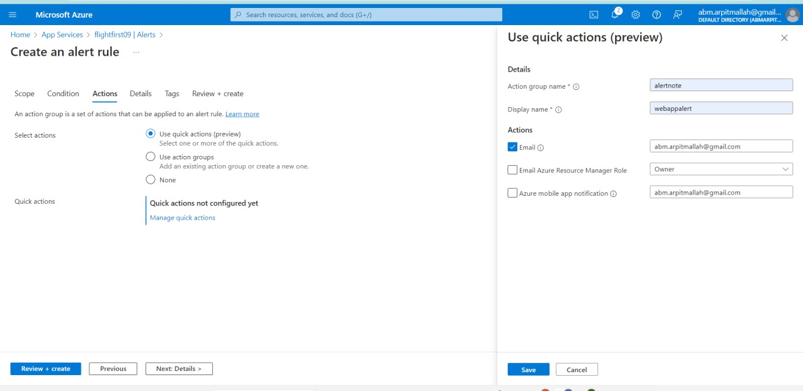

Alerts created sucessfully

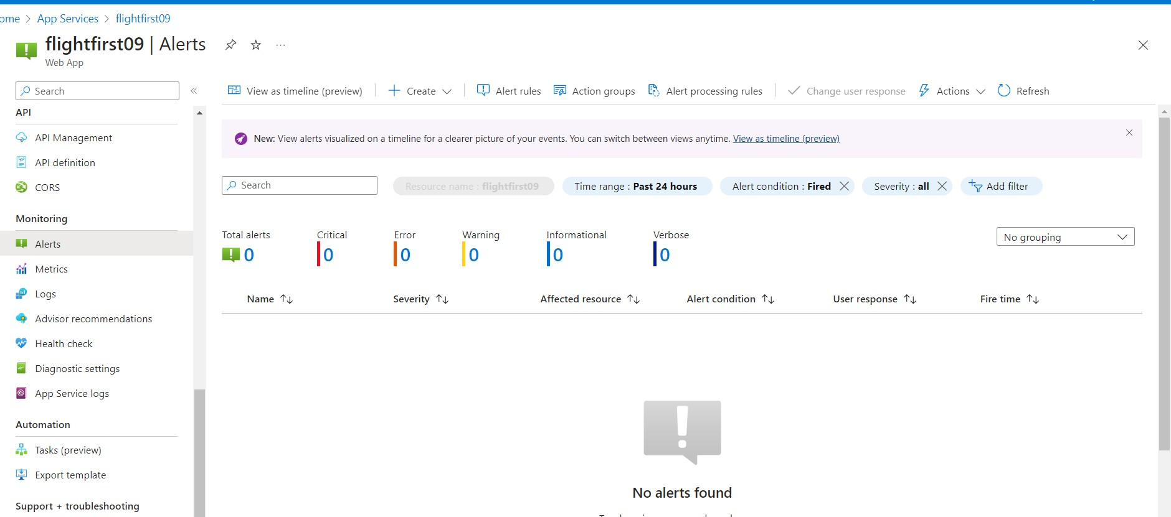

**Resource Visualizer**

**Resource Groups**

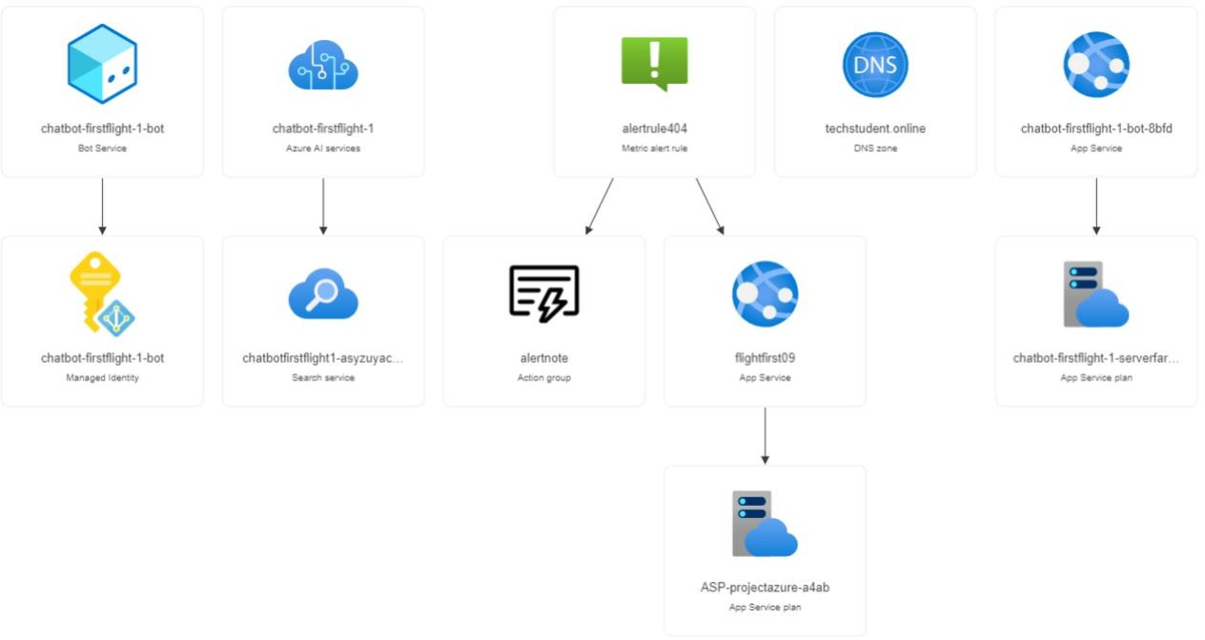

# Website Overview

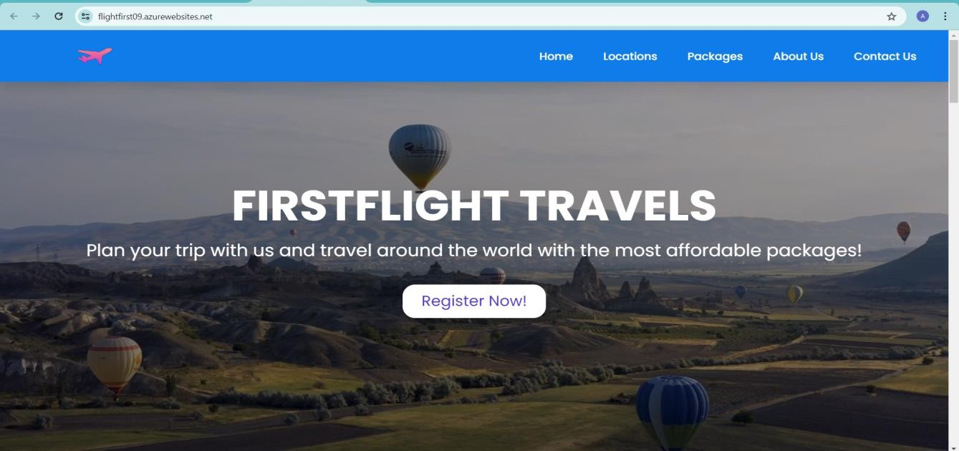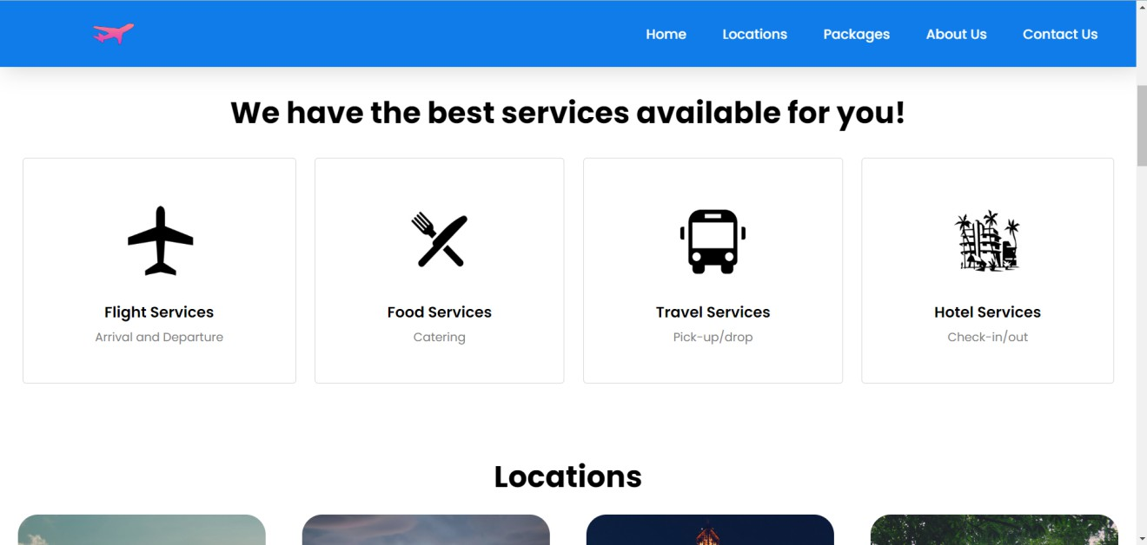This is Our Home Page

Click on **Chat with Us** to connect with **Azure QnA Maker**

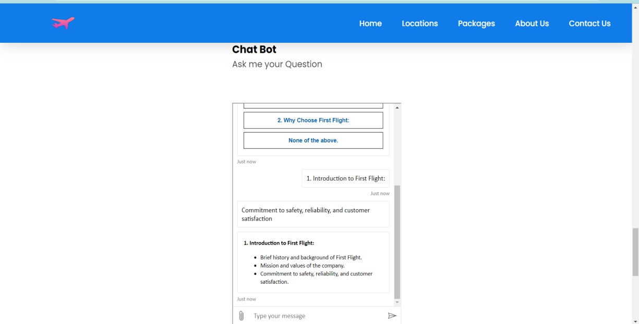

# Benefits

* **Interactive Assistance:** This Website offers a unique solution through its "Chat-Bot " feature, powered by Azure QnA. This allows users to engage in real-time conversations to receive personalized suggestions for enhancing their browsing experience.

# Conclusion

In conclusion, "FirstFlight" emerges as a promising solution poised to redefine the travel experience by seamlessly integrating cutting-edge technology with user-centric design. With its emphasis on enhancing engagement, streamlining operations, and prioritizing customer satisfaction, "FirstFlight" represents a significant step forward in the evolution of travel technology. By leveraging Azure's advanced capabilities and fostering a culture of innovation, the platform is well-positioned to meet the evolving needs of modern travelers and adapt to the dynamic landscape of the travel industry. As "FirstFlight" takes flight, it holds the promise of delivering unparalleled convenience, efficiency, and delight to users worldwide, ushering in a new era of travel technology excellence.