FULL STACK PROJECT REPORT

**On**

**“E Voting Website”**

**Submitted by**

**Arpit Mittal**

**(191500148)**

**Aman Pandey**

**(191500094)**

Department of Computer Engineering & Applications

**Institute of Engineering & Technology**



**GLA University**

**Mathura- 281406, INDIA**

**2020-2021**

**Department of computer Engineering and Applications**

**GLA University, Mathura**

**17 km. Stone NH#2, Mathura-Delhi Road, P.O. – Chaumuha,**

**Mathura – 281406**



**Declaration**

We hereby declare that the work which is being presented in the Full Stack Project “**E VOTING WEBSITE”,** in partial fulfillment of the requirements for Full Stack Project viva voce, is an authentic record of our own work carried by the team members under the supervision of our mentor Mr. Pankaj Kapoor.

Group Members: Arpit Mittal (191500148)

Aman Pandey (191500094)

Course: B.Tech (Computer Science and Engineering)

Year: 3rd

Semester: 6th

## Supervised By:

Mr. Pankaj Kapoor, Assistant Professor,

GLA University, Department of Computer Engineering & Application

**Department of computer Engineering and Applications**

**GLA University, Mathura**

**17 km. Stone NH#2, Mathura-Delhi Road, P.O. – Chaumuha,**

**Mathura – 281406**



**Certificate**

This is to certify that the above statements made by the candidates are correct to the best of my/our knowledge and belief.

_______________________

Supervisor

Mr. Pankaj Kapoor

Technical Trainer

Dept of CEA, GLA University

____________________ ____________________________ Project Coordinator Program Coordinator

(Mr. Mayank Srivastava) (Mr. Shashi Shekar)

**About the Project**

It would be a voting website, with polling system. In this website any user would have authority to create a poll and as well as cast the vote for a poll. A user would also be able to track statistics of an ongoing poll. The idea is to provide social experiments and surveys easily available on your device with real time data.

The objective is to provide best service for voting with utmost securities of individual’s votes. User would be surely relaxed for non-partial voting system.

**Requirements**

**a). Software Requirements:**

* Technology Implemented: Full Stack Web Development
* Languages/Technologies Used: MERN Stack
* IDE Used: Visual Studio Code
* Web Browser: Google Chrome
* GitHub: GitHub is a code hosting platform for version control and collaboration. It lets you and others work together on projects from anywhere. GitHub Repository: A GitHub repository can be used to store a development project. It can contain folders and any type of files (HTML, CSS, JavaScript, Documents, Data, Images). A GitHub repository should also include a license file and a README file about the project. A GitHub repository can also be used to store ideas, or any resources that you want to share.
* Visual Studio Code: Visual Studio Code is a free source-code editor made by Microsoft for Windows, Linux and macOS. [7] Features include support for debugging, syntax highlighting, intelligent code completion, snippets, code refactoring, and embedded Git. Users can change the theme, keyboard shortcuts, preferences, and install extensions that add additional functionality. Microsoft has released Visual Studio Code's source code on the VS Code repository of GitHub.com, under the permissive MIT License, while the compiled binaries are freeware.

**b). Hardware Requirements:**

* Processor Required: Intel i5
* Operating System: Windows 10
* RAM: 8GB
* Hardware Devices: Computer System
* Hard Disk: 256GB

**Acknowledgement**

We thank the almighty for giving us the courage and perseverance in completing the project. This project itself is an acknowledgement for all those people who have given us their heartfelt co-operation in making this project a grand success. We extend our sincere thanks to Mr. Pankaj Kapoor, Assistant Professor at “GLA University, Mathura” for providing his valuable guidance at every stage of this project work. We are profoundly grateful towards the unmatched services rendered by him. And last but not least, we would like to express our deep sense of gratitude and earnest thanks giving to our dear parents for their moral support and heartfelt cooperation in doing the main project.

**E Voting WEBSITE**

**Abstract**

Our website will provide opportunity to public to get the real time reaction of others over a several topic or poll. This website can also act as survey system where people can request vote not only by the existing users of the website but can also demand for action from their own acquaintance by inviting them over on this web page. This website can help analyze certain type of results.

* . Any User would be able to create a poll and join a poll.
* A user has to make a profile in order to cast the vote which will specify max authenticity of real and actual data.
* A user verification via email would also be there to validate user’s unique identity.
* Real Time Data would be displayed while polling and once Voting is done any user whosoever has participated in voting would get the detailed result and statistics.

**Contents**

**Acknowledgment…………………………………….........**

1. **Introduction:**

**2. List of Figures...……………………………………**20-26

**3. Software Testing..............................................................**27-31

**4.Conclusion……………………………………………**32

**5.Bibliography………………………………………….**33

**Chapter 1**

**Introduction**

Today Developers around the world are making efforts to enhance user experience of using application as well as to enhance the developer’s workflow of designing applications to deliver projects and rollout change requests under strict timeline. Stacks can be used to build web applications in the shortest span of time. The stacks used in web development are basically the response of software engineers to current demands. They have essentially adopted pre-existing frameworks (including JavaScript) to make their lives easier.

This architecture allows you to easily construct a 3-tier architecture (frontend, backend, database) entirely using HTML, CSS, JavaScript.

Front end: It is the visible part of website or web application which is responsible for user experience. The user directly interacts with the front end portion of the web application or website.  
Front end Languages: The front end portion is built by using some languages which are discussed below:

* + [HTML:](https://www.geeksforgeeks.org/html-tutorials/) HTML stands for Hyper Text Markup Language. It is used to design the front-end portion of web pages using markup language. HTML is the combination of Hypertext and Markup language. Hypertext defines the link between the web pages. The markup language is used to define the text documentation within tag which defines the structure of web pages.
  + [CSS:](https://www.geeksforgeeks.org/css-tutorials/) Cascading Style Sheets, fondly referred to as CSS, is a simply designed language intended to simplify the process of making web pages presentable. CSS allows you to apply styles to web pages. More importantly, CSS enables you to do this independent of the HTML that makes up each web page.
  + [JavaScript:](https://www.geeksforgeeks.org/javascript-tutorial/) JavaScript is a famous scripting language used to create the magic on the sites to make the site interactive for the user. It is used to enhancing the functionality of a website to running cool games and web-based software.

**Chapter 2**

**List of Figures**

**1. Login Page**

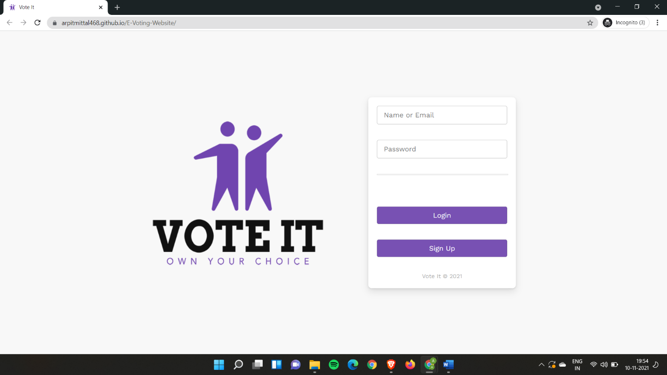

**2. SignUp Page**

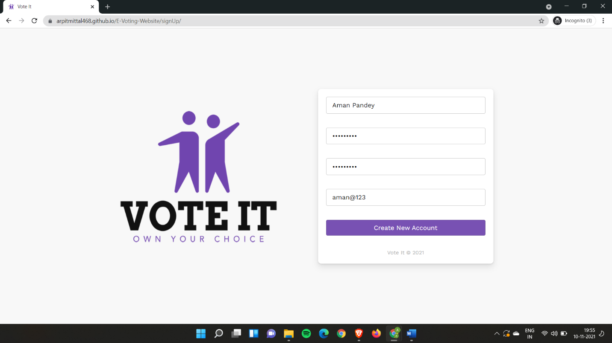

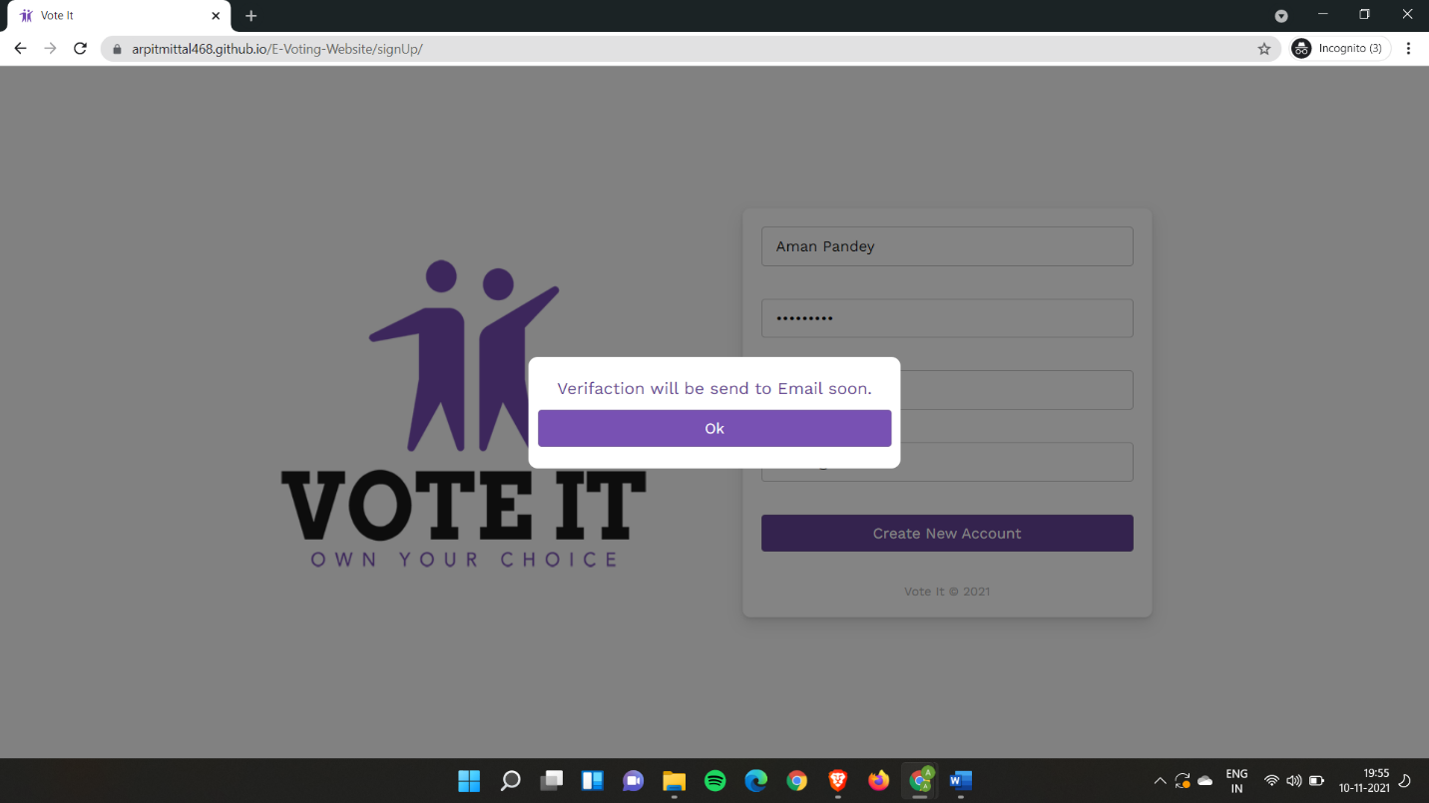

**3. Home Page**

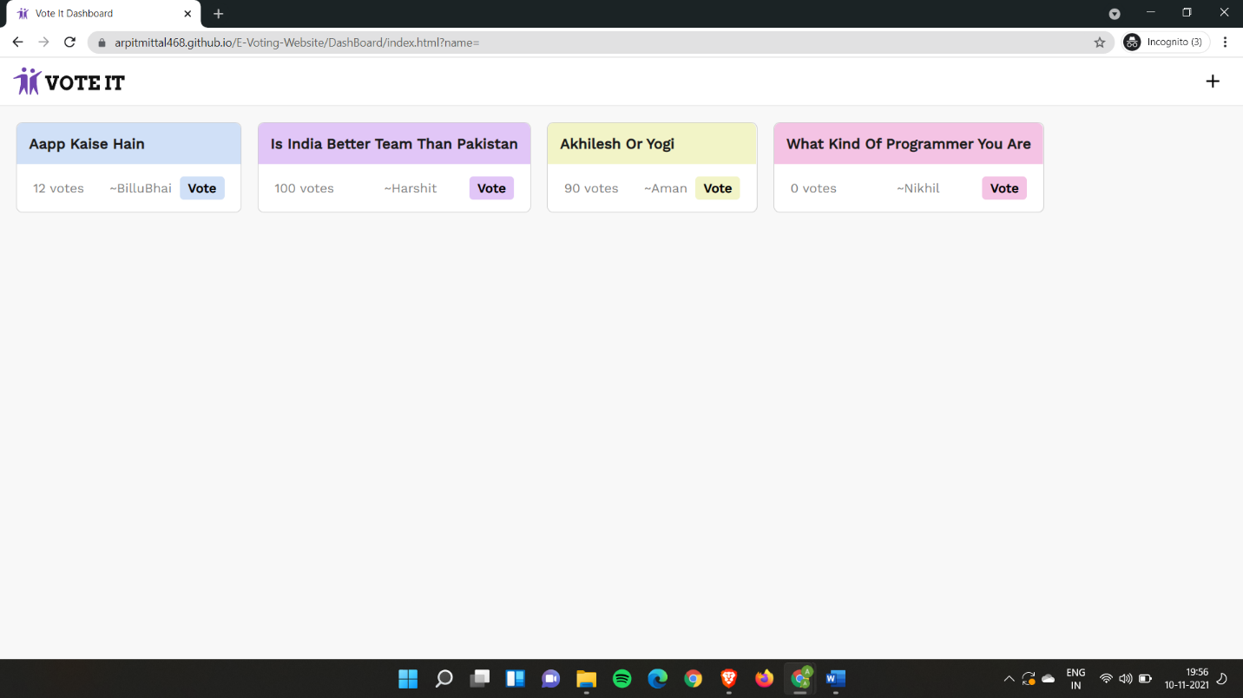

1. **Adding a Question**

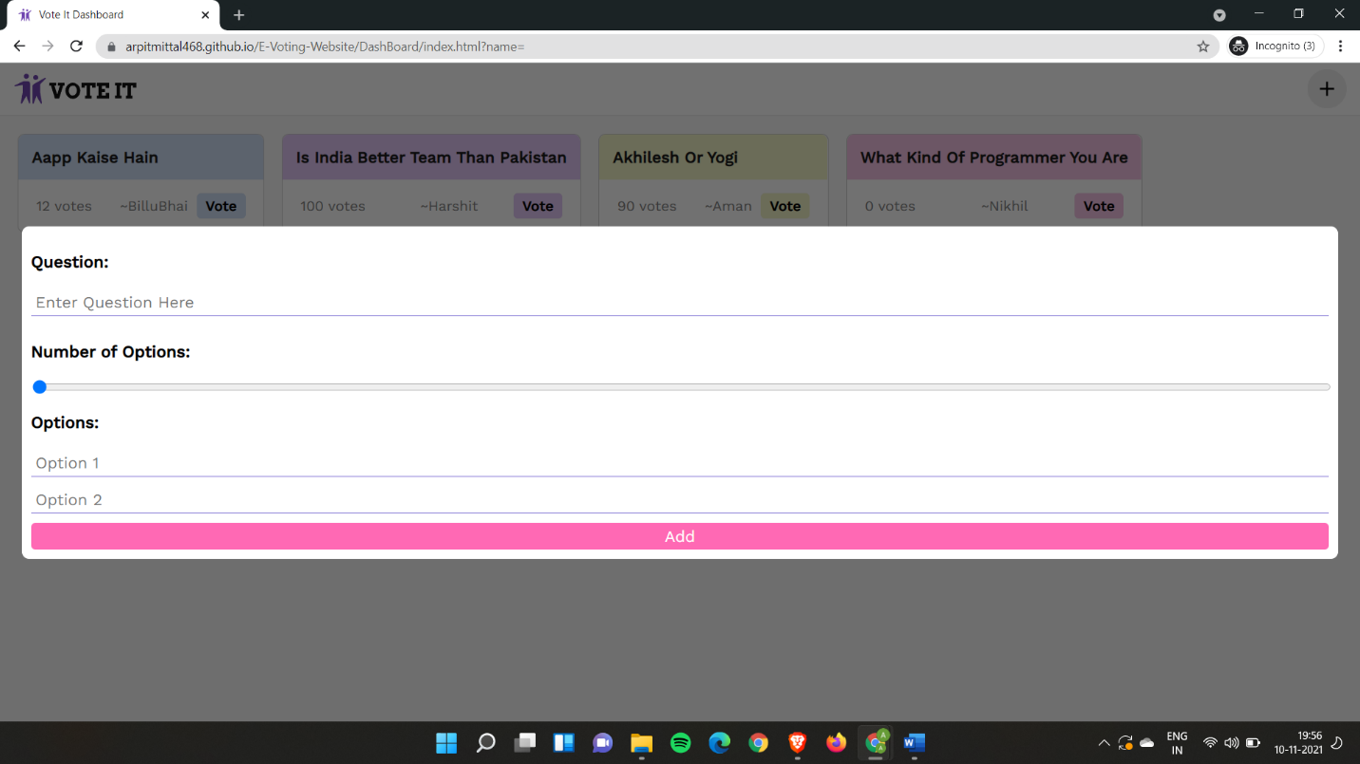

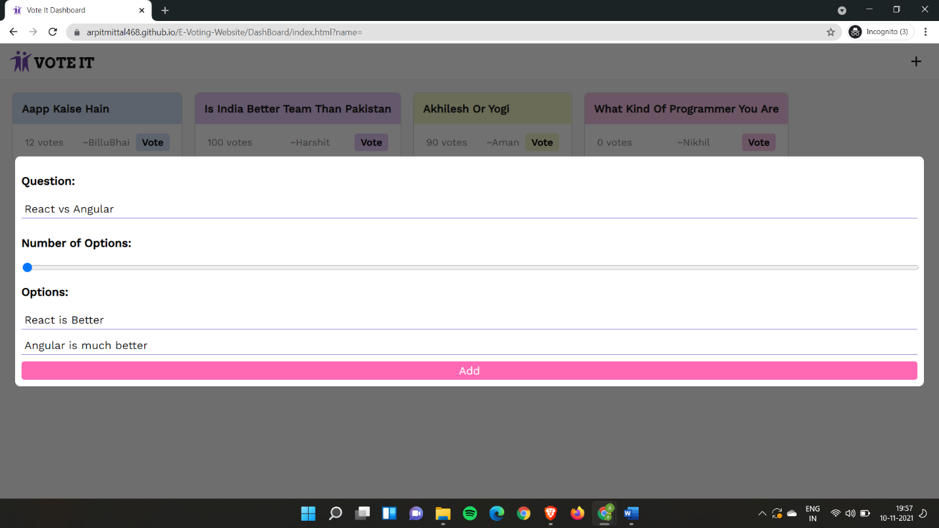

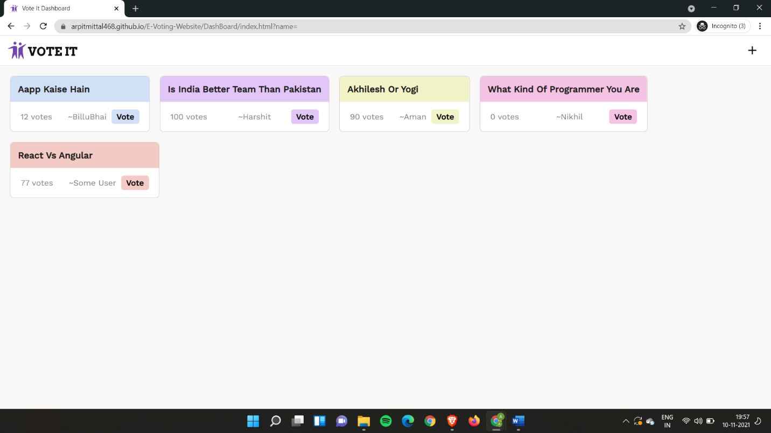

1. **How to Vote**

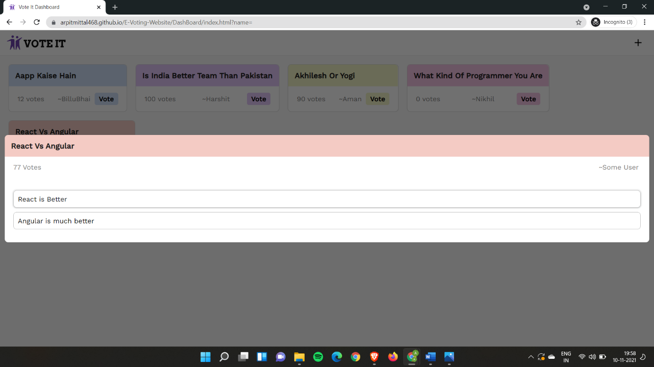

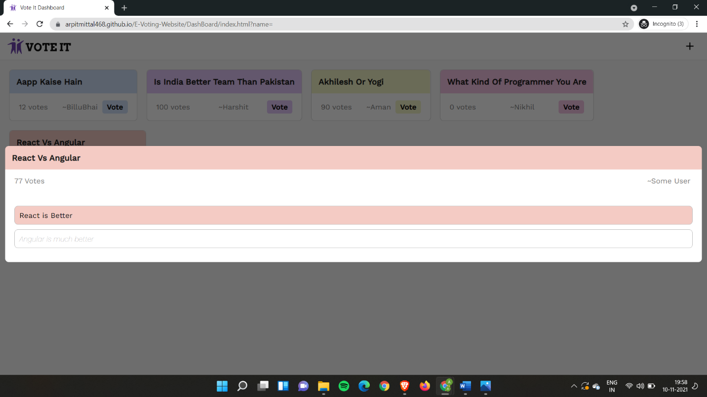

**Chapter 3**

**Software Testing**

Once source code has been generated, software must be tested to uncover as many errors as possible before delivery. It is very important to work the system successfully and achieve high quality of software. Testing include designing a series of test cases that have a high likelihood of finding errors by applying software-testing techniques. System testing makes logical assumptions that if all the parts of the system are correct, the goal will be successfully achieved. The system should be checked logically. Validations and cross checks should be there. Avoid duplications of record that cause redundancy of data. In other Words, Testing is the process of evaluating a system or its component(s) with the intent to find whether it satisfies the specified requirements or not. It is executing a system in order to identify any gaps, errors, or missing requirements in contrary to the actual requirements.

The preliminary goal of implementation is to write source code and internal documentation so that conformance of the code to its specifications can be easily verified, and so that debugging, testing and modifications are eased. This goal can be achieved by making the source code as clear and straightforward as possible. Simplicity, clarity and elegance are the hallmark of good programs, obscurity, cleverness, and complexity are indications of inadequate design and misdirected thinking. Source code clarity is enhanced by structured coding techniques, by good coding style, by, appropriate supporting documents, by good internal comments, and by feature provided in modern programming languages. The implementation team should be provided with a well-defined set of software requirement, an architectural design specification, and a detailed design description. Each team member must understand the objectives of implementation.

4.1 TERMINOLOGY

Error The term error is used in two ways. It refers to the difference between the actual output of software and the correct output, in this interpretation, error is essential a measure of the difference between actual and ideal. Error is also to used to refer to human action that result in software containing a defect or fault.

Fault is a condition that causes to fail in performing its required function. A fault is a basic reason for software malfunction and is synonymous with the commonly used term Bug.

Failure is the inability of a system or component to perform a required function according to its specifications. A software failure occurs if the behavior of the software is the different from the specified behavior. Failure may be caused due to functional or performance reasons.

4.2 TYPES OF TESTING

**a. Unit Testing** The term unit testing comprises the sets of tests performed by an individual programmer prior to integration of the unit into a larger system. A program unit is usually small enough that the programmer who developed it can test it in great detail, and certainly in greater detail than will be possible when the unit is integrated into an evolving software product. In the unit testing the programs are tested separately, independent of each other. Since the check is done at the program level, it is also called program teasing.

**b. Module Testing** A module and encapsulates related component. So can be tested without other system module.

**c. Subsystem Testing** Subsystem testing may be independently design and implemented common problems are sub-system interface mistake in this checking we concenton it. There are four categories of tests that a programmer will typically perform on a program unit.

i Functional test

ii Performance test

iii Stress test

iv Structure test

**Functional Test** Functional test cases involve exercising the code with Nominal input values for which expected results are known; as well as boundary values (minimum values, maximum values and values on and just outside the functional boundaries) and special values.

**Performance Test** Performance testing determines the amount of execution time spent in various parts of the unit, program throughput, response time, and device utilization by the program unit. A certain amount of avoid expending too much effort on fine-tuning of a program unit that contributes little to the overall performance of the entire system. Performance testing is most productive at the subsystem and system levels.

**Stress Test** Stress test are those designed to intentionally break the unit. A great deal can be learned about the strengths and limitations of a program by examining the manner in which a program unit breaks.

**Structure Test** Structure tests are concerned with exercising the internal logic of a program and traversing particular execution paths. Some authors refer collectively to functional performance and stress testing as “black box” testing. While structure testing is referred to as “white box” or “glass box” testing. The major activities in structural testing are deciding which path to exercise, deriving test date to exercise those paths, determining the test coverage criterion to be used, executing the test, and measuring the test coverage achieved when the test cases are exercised.

**Chapter 4**

**Conclusion**

We have completed our project within time limit with the coordination of our team members under the supervision of our mentor Mr. Pankaj Kapoor.

Our project repository is available at

<https://github.com/ArpitMittal468/E-Voting-Website>

Live Website:

<https://arpitmittal468.github.io/E-Voting-Website/>

**Chapter 5**

**Bibliography**

[**www.google.com**](http://www.google.com)

**www.geeksforgeeks.org**

[**www.youtube.com**](http://www.youtube.com)

**www.w3schools.com**

**www.beta-labs.in**