

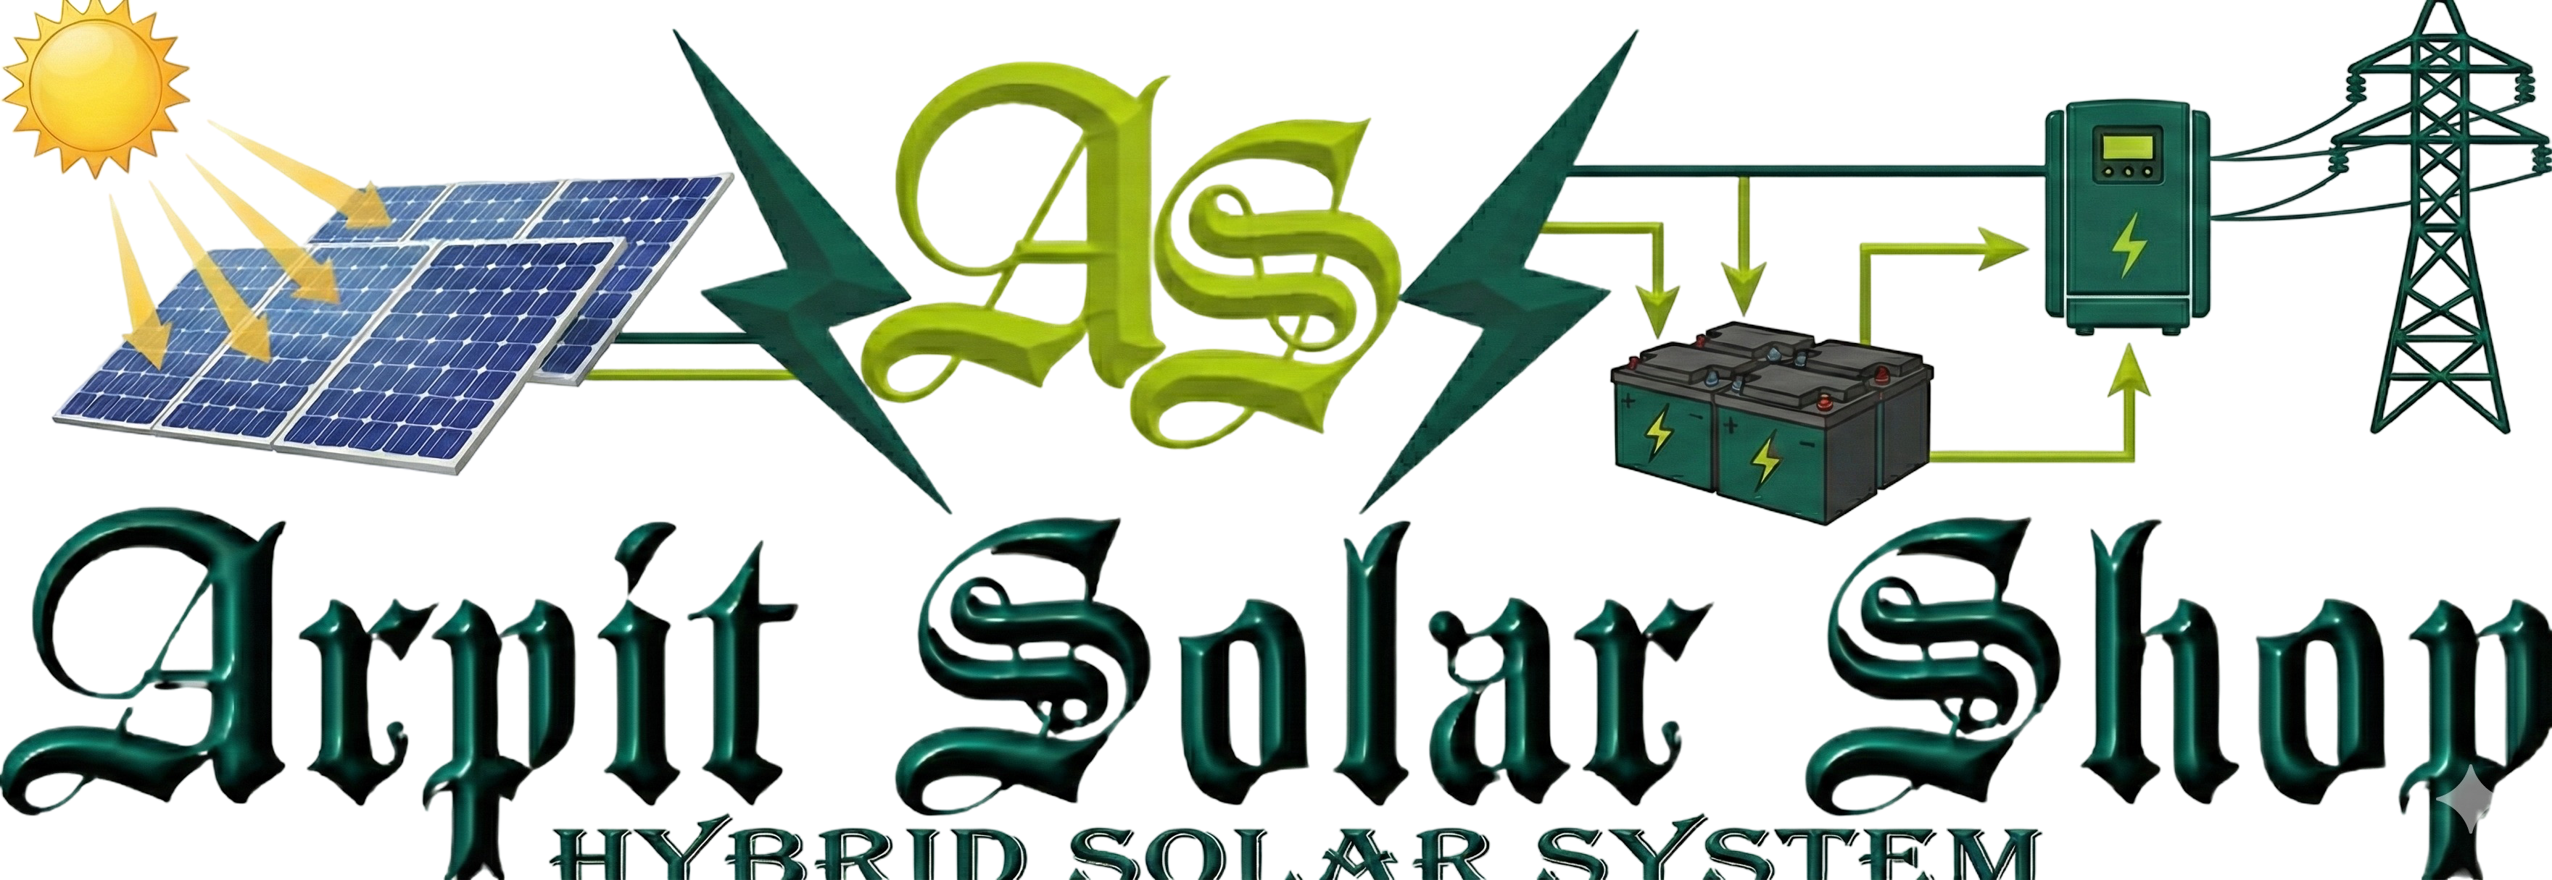
Solar Hybrid Power System Quotation
👤 Customer Details
- Customer Name: Karan Gond
- Mobile Number: 7081957371
- Project Location: Varanasi, Uttar Pradesh
- Customer Type: residential
📄 Quotation Details
- Quotation Date: 17 December 2025 at 02:47 pm
- System Capacity: 2.32 kW Hybrid Solar System
- Product: 2.32 kW 1Ph Hybrid with Battery
⚡ Site Information
- Current Monthly Bill: ₹undefined
- Estimated Roof Area: undefined sq. ft.
🔧 System Technical Specifications
⚡ Inverter & Storage
- Inverter Capacity: 3.6 kW
- Battery Backup: 2.5 kWh
☀️ Solar Modules
- Module Wattage: 580 W
- Number of Modules: 4
🏗️ Mounting Structure
- Structure Type: 3x6
🔌 Protection & Distribution
- ACDB Quantity: 1
- DCDB Quantity: 1
🌍 Earthing & Lightning Protection
- Earthing Rods: 3
- Earthing Chemical: 3 bags
- Lightning Arrester: 1
🧵 Cabling & Wiring
- AC Cable: 10 meters
- DC Cable: 20 meters
- Earthing Wire: 90 meters
💰 Pricing Details
Description | Amount
Base Price (Excl. GST): | ₹2,03,398
GST @ 8.9%: | ₹18,102
Price per kWp (Incl. GST): | ₹95,474
TOTAL PAYABLE AMOUNT: | ₹2,21,500
GST Breakup
- 70% of Base Price: Taxed at 5% GST
- 30% of Base Price: Taxed at 18% GST
- Overall Effective GST Rate: Approximately 8.9%
The GST calculation is designed to ensure compliance with regulations and provide a clear understanding of the tax components involved in your purchase.
📝 Terms & Conditions
- This quotation is valid for 15 days from the date of issue.
- Prices are inclusive of supply, installation, and standard civil work.
- Net metering charges (if applicable) are to be paid directly to DISCOM.
- Additional civil work, elevated structure, or long-distance cabling will be charged extra after site survey.
- System includes remote monitoring and standard manufacturer warranties:
  - Solar Panels: 25 years performance warranty
  - Inverter: 5–10 years
  - Battery: As per manufacturer policy
- Installation as per MNRE guidelines and industry safety standards.
🤝 Thank You for Choosing Clean Energy!
We look forward to powering your home/business with reliable solar energy.
Authorized Partner: Arpit Solar Shop
Contact: 9044555572
Website: Arpit Solar Shop
Email: support@arpitsolar.com
☀️ Let’s Go Solar Together!

