

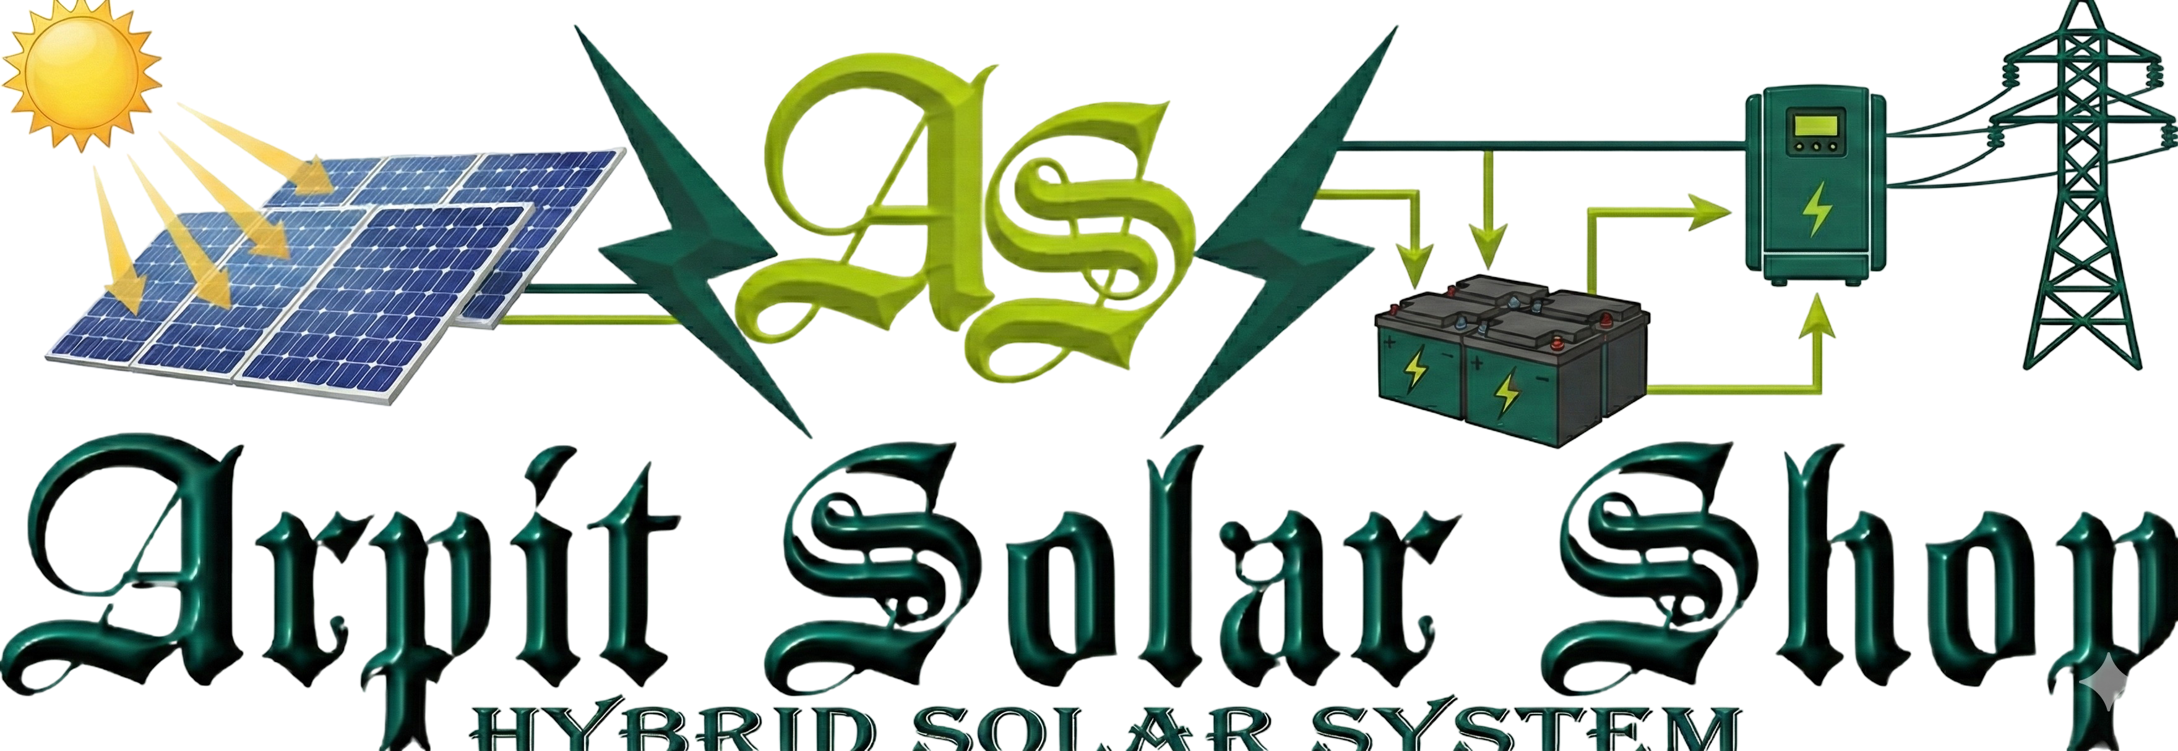
Solar Hybrid Power System Quotation
👤 Customer Details
- Customer Name: {name}
- Mobile Number: {phone}
- Project Location: {project_location}
- Customer Type: {customer_type}
📄 Quotation Details
- Quotation Date: {quote_date}
- System Capacity: {system_size} kW Hybrid Solar System
- Product: {product_name}
⚡ Site Information
- Current Monthly Bill: ₹{monthly_bill}
- Estimated Roof Area: {estimated_area_sqft} sq. ft.
🔧 System Technical Specifications
⚡ Inverter & Storage
- Inverter Capacity: {inverter_capacity} kW
- Battery Backup: {battery_capacity} kWh
☀️ Solar Modules
- Module Wattage: {module_wattage} W
- Number of Modules: {number_of_modules}
🏗️ Mounting Structure
- Structure Type: {structure_type}
🔌 Protection & Distribution
- ACDB Quantity: {acdb_qty}
- DCDB Quantity: {dcdb_qty}
🌍 Earthing & Lightning Protection
- Earthing Rods: {earthing_rod_qty}
- Earthing Chemical: {earthing_chemical_qty} bags
- Lightning Arrester: {lightning_arrester_qty}
🧵 Cabling & Wiring
- AC Cable: {ac_wire_mtr} meters
- DC Cable: {dc_wire_mtr} meters
- Earthing Wire: {earthing_wire_mtr} meters
💰 Pricing Details
Description | Amount
Base Price (Excl. GST): | ₹{base_price}
GST @ 8.9%: | ₹{gst_amount}
Price per kWp (Incl. GST): | ₹{price_per_kwp}
TOTAL PAYABLE AMOUNT: | ₹{total_price}
GST Breakup
- 70% of Base Price: Taxed at 5% GST
- 30% of Base Price: Taxed at 18% GST
- Overall Effective GST Rate: Approximately 8.9%
The GST calculation is designed to ensure compliance with regulations and provide a clear understanding of the tax components involved in your purchase.
📝 Terms & Conditions
- This quotation is valid for 15 days from the date of issue.
- Prices are inclusive of supply, installation, and standard civil work.
- Net metering charges (if applicable) are to be paid directly to DISCOM.
- Additional civil work, elevated structure, or long-distance cabling will be charged extra after site survey.
- System includes remote monitoring and standard manufacturer warranties:
  - Solar Panels: 25 years performance warranty
  - Inverter: 5–10 years
  - Battery: As per manufacturer policy
- Installation as per MNRE guidelines and industry safety standards.
🤝 Thank You for Choosing Clean Energy!
We look forward to powering your home/business with reliable solar energy.
Authorized Partner: Arpit Solar Shop
Contact: 9044555572
Website: Arpit Solar Shop
Email: support@arpitsolar.com
☀️ Let’s Go Solar Together!

