POWERING INDIA’S ROOFTOPS
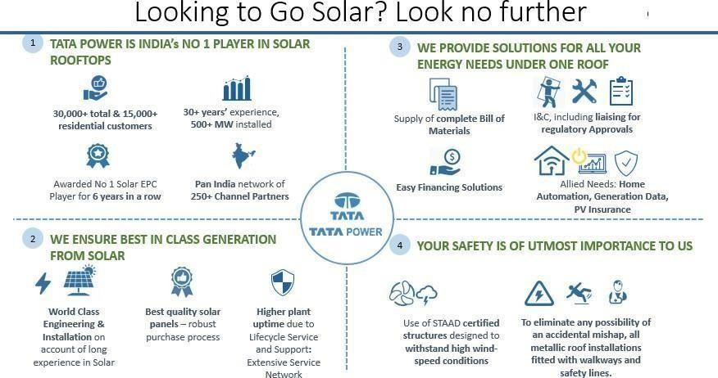
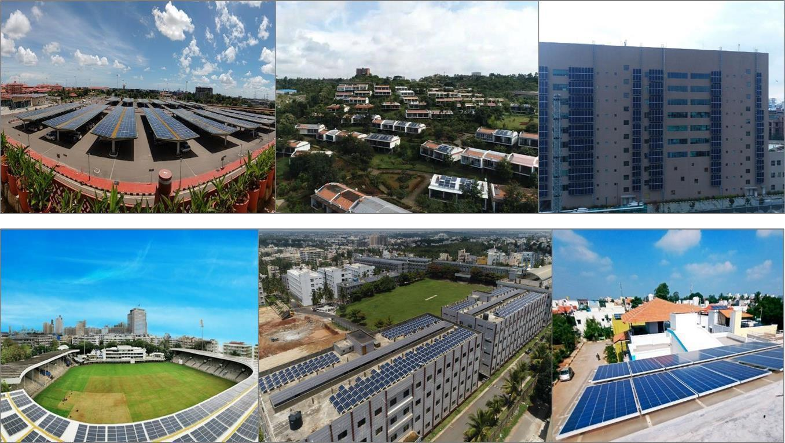

To,
Name: Karan Gond Date: 2 October 2025 at 02:39 pm
Mo No: 7081957371 Email: undefined
Location: Varanasi, Uttar Pradesh

QUOTATION
Quotation for Tata Solar System 2.24 KW.

Sr. No. | Description | Quantity
1 | System Size | 2.24
2 | DCR Module 560 Wp Solar Modules | 4
3 | Inverter Capacity (kW) | 2
4 | Phase | Single
5 | Base Price (Exclusive of GST) | ₹1,19,376
6 | GST @ 8.9% | ₹10,624
7 | Total Amount (Inclusive of GST) | ₹1,30,000

Subsidy Applicable (For 3Kw and above Name : Arpit Solar Shop
Residential): CA A/c : 28660200000614
- State Government = Rs 30,000/- Bank : Bank of Baroda Shivpur, Varanasi, Varanasi
- Central Subsidy = Rs 78,000/- IFSC : BARB0SHIVBS

Subsidy Applicable (For 2Kw Residential):
- State Government = Rs 30,000/-
- Central Subsidy = Rs 60,000/-
Subsidy rate may change as per Government regulations at the time of Disbursal.

TERMS AND CONDITIONS:
  - 10% Advance Structure should be installed.
  - 85 % Before delivery of Tata kit. 5% Post installation.
  - Freight and transit insurance included.
  - Net meter fee will be charged to consumer’s electricity bill directly by Discom.
  - Structure elevation Charges & Civil Material Is in Consumers Scope.
  - Name change, load increment new connection will be charged extra.
  - GST-Applicable- 5% on 70% (Supply) of base value & 18% on 30% (Service) of base value.
  - We will facilitate (Submit Documents etc.) for replacing Net Meter.
  - For synchronizing with Grid power, voltage range of Grid should be between 185V to 275V without frequent fluctuation.
  - Delivery: - Within 4 weeks from the date of technically and commercially clear order and site whichever is later.
  - Installation: To be completed within 45 days from date of confirmed Purchase Order and payment.
  - AC wire will be provided up to a limit of 10m. Extra wire will be charged as per actual.
  - Earthing wire will be provided up to a limit of 30m. Extra wire will be charged as per actual.
  - Warranty: - Solar Module: 25 Years, PCU: 5 Years from the date of supply. External damages are not
Covered in warranty.

Note: The above-mentioned data will be applicable as per site conditions ideal to installation of a solar power plant.

For Arpit Solar Shop.


Ratnesh Mishra (Authorized Signatory)
(Customer acceptance with sign)

