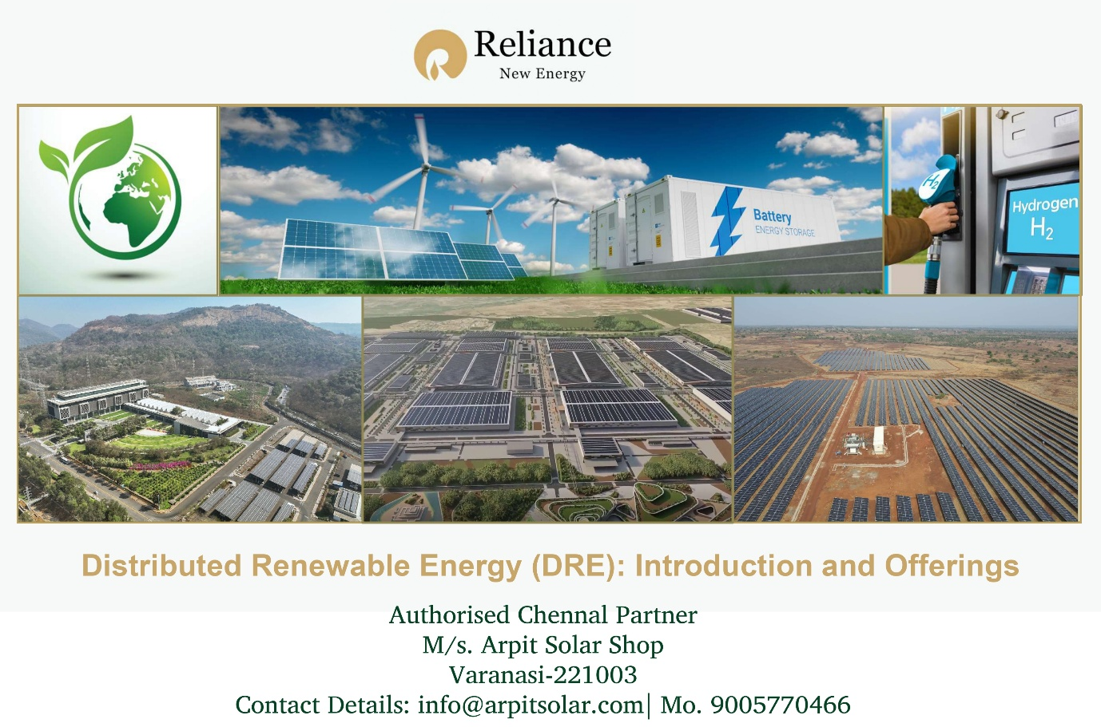

**Quotation: RNES-{power_demand_kw}KW-HJT-2025-26**

**To**

**Name: {name} Date:** **{quote_date}**

**Phone no.: {phone} Valid Until:** 30 Days

**Email: {email}**

**Location: {project_location}**

# **Subject: Quotation for {product_category} Residential HJT Solar System {power_demand_kw} KW, {mounting_type}.**

Dear Sir,

Arpit Solar Shop is pleased to present this comprehensive quotation for the installation of a solar power generation system, featuring cutting-edge Heterojunction (HJT) technology from Reliance New Energy. This system is designed to significantly reduce your electricity bills, contribute to a sustainable future, and provide a reliable power source for your premises.

**1. System Overview: Reliance New Energy HJT NDCR Solar Power Generation System**

We propose the installation of a solar power generation system utilizing advanced **Reliance New Energy HJT NDCR (Non-Destructive Cell Reconstruction)** solar modules. This system is ideal for commercial and offers superior performance and longevity.

**2. Briefing on Key Technologies:**

**a) Heterojunction (HJT) Technology:** Heterojunction Technology (HJT) represents a significant leap forward in solar cell efficiency. Unlike conventional solar cells, HJT panels combine the best of crystalline silicon and amorphous silicon technologies. Here's why HJT stands out:

* **Higher Efficiency:** HJT cells achieve superior conversion efficiencies by minimizing energy losses due to electron recombination. They typically offer average efficiencies above 23%, surpassing traditional PERC (Passivated Emitter and Rear Cell) technology.
* **Excellent Performance at Higher Temperatures:** HJT modules exhibit a lower temperature coefficient, meaning their efficiency degrades less significantly at elevated temperatures. This makes them particularly well-suited for warmer climates like India.
* **Enhanced Bifacial Performance:** Many HJT modules are bifacial, capable of absorbing sunlight from both the front and rear sides, thereby increasing overall energy generation, especially when installed in environments where reflected light can be captured.
* **Superior Durability and Longevity:** The unique cell structure and passivation layers in HJT panels reduce degradation mechanisms like Potential Induced Degradation (PID), leading to a longer operational lifespan (often exceeding 25-30 years).
* **Improved Low-Light Performance:** HJT cells are designed to generate power even in low-light conditions, extending daily energy harvest during early mornings, late evenings, and cloudy days.

**b) Hot-Dip Galvanized (HDG) Structure:** The solar mounting structure will be fabricated from **Hot-Dip Galvanized (HDG) steel**. This process involves immersing fabricated steel in a bath of molten zinc, creating a metallurgically bonded coating that provides exceptional protection against corrosion. The benefits of HDG structures include:

* **Superior Corrosion Resistance:** The zinc coating acts as a barrier, preventing rust and extending the lifespan of the mounting structure significantly, even in harsh environmental conditions.
* **High Strength and Durability:** HDG steel structures offer excellent structural integrity, capable of withstanding high wind loads, seismic activity, and other environmental stresses.
* **Low Maintenance:** Due to its inherent corrosion resistance, HDG structures require minimal to no maintenance over their long service life, reducing operational costs.
* **Sustainability:** Both steel and zinc are 100% recyclable, making HDG structures an environmentally friendly choice for your solar installation.

**3. Scope of Work & Inclusions:**

The following is included in this quotation:

* **Design & Engineering:** Detailed system design tailored to your site requirements.
* **Supply of Components:**
  + Reliance New Energy HJT NDCR Solar PV
  + High-efficiency Solar Inverter
  + Hot-Dip Galvanized (HDG) Mounting Structure.
  + All necessary DC and AC cables, connectors, earthing kits, lightning arrestors, and other balance of system components.
  + Net metering equipment
* **Installation:** Professional installation of the entire solar power generation system by our certified technicians.
* **Testing & Commissioning:** Comprehensive testing and commissioning of the system to ensure optimal performance.
* **Approvals & Documentation:** Assistance with necessary government approvals and documentation for grid connectivity (if applicable).
* **Warranty:**
  + 30-year performance warranty on Reliance New Energy HJT solar panels.
  + 5-year complete system warranty (including inverter and workmanship).
  + 10-year inverter warranty.

**Note:**

* Prices are subject to change based on market fluctuations at the time of final order.
* The above price is an estimate for an on-grid system. Pricing for off-grid or hybrid systems will differ.

**4. Payment Terms:**

* **Advance Payment:** 20% of the total quoted price upon acceptance of the quotation and signing of the agreement. Structure Work will be Done.
* **Second Instalment:** 70% Against Proforma Invoice Before Main Components Dispatch.
* **Final Payment:** 10% upon successful commissioning and hand-over of the system.

**5. Project Timeline:**

* **System Delivery:** Approximately 4-6 weeks from the date of advance payment.
* **Installation & Commissioning:** Approximately 10-15 days from the date of equipment delivery.

We are confident that this Reliance New Energy HJT solar power generation system, coupled with our professional installation and maintenance services, will prove to be a highly valuable and sustainable investment for your property.

Please feel free to contact us for any clarifications or to schedule a site visit.

Thank you for considering Arpit Solar Shop as your trusted solar partner.

Sincerely,

|  |  |  |
| --- | --- | --- |
| **Sr. No.** | **Description** | **Quantity** |
| 1 | System Size | **{power_demand_kw}** |
| **2** | 690 Wp HJT NDCR Solar Modules | **{number_of_modules}** |
| 3 | Inverter Capacity (kW) | **{inverter_capacity}** |
| 4 | Price/Watt (₹) | **{price_per_watt}** |
| 5 | Phase | **{phase}** |
| 6 | **Total Amount (₹)**  ***(Exclusive of GST)*** | **{total_price}** |

# **Disclaimer:** Prices are subject to change. Final price will be confirmed at the time of purchase.

**For Arpit Solar Shop**



Ratnesh Mishra

(Proprietor)

**(Customer acceptance with sign)**