**POWERING INDIA’S ROOFTOPS**

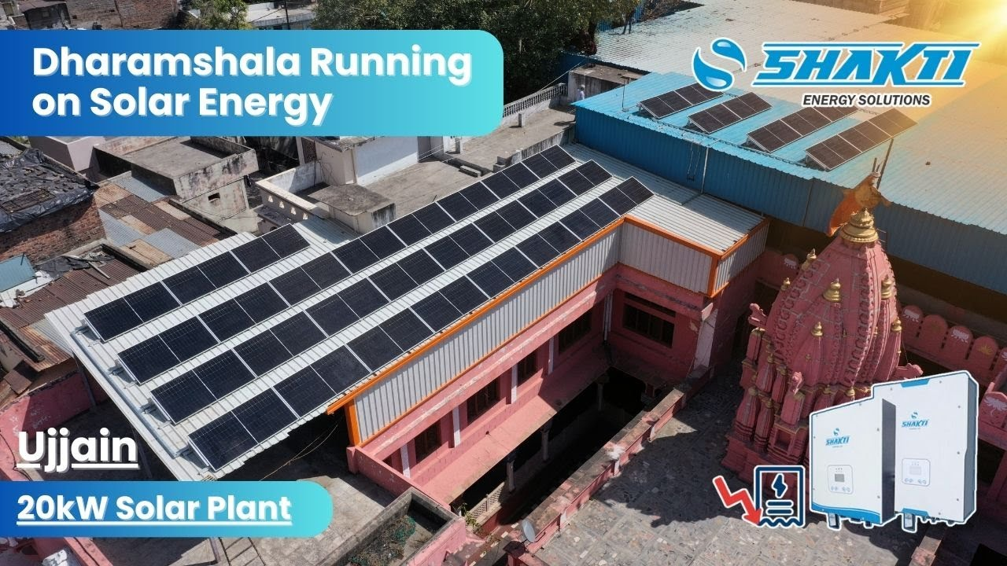

**To,**

**Name: {name} Date: {quote_date}**

**Mo No: {phone} Email: {email}**

**Location: {project_location}**

# QUOTATION

|  |  |  |
| --- | --- | --- |
| **Sr. No.** | **Description** | **Quantity** |
| 1 | System Size | **{system_size}** |
| **2** | DCR Module 535 Wp Solar Modules | **{number_of_modules}** |
| 3 | Inverter Capacity (kW) | **{inverter_capacity}** |
| 4 | Price/Watt (₹) | **{price_per_watt}** |
| 5 | Phase | **{phase}** |
| 6 | **Total Amount (₹)** | **{total_price}** |

# Quotation for {product_category} Solar System {system_size} KW.

# Disclaimer: Prices are subject to change. Final price will be confirmed at the time of purchase.

**Subsidy** 3Kw and above Residential): Name : Arpit Solar Shop

CA A/c : 28660200000614

1. **State Government = Rs 30,000/-** Bank : Bank of Baroda Shivpur, Varanasi, Varanasi
2. **Central Subsidy = Rs 78,000/- IFSC :** BARB0SHIVBS

**Subsidy Applicable** (For 2Kw Residential):

1. **State Government = Rs 30,000/-**

**2) Central Subsidy = Rs 60,000/-**

**Subsidy rate may change as per Government regulations at the time of Disbursal.**

# TERMS AND CONDITIONS:

* 1. 10% Advance Structure should be installed.
  2. 85 % Before delivery of Tata kit. 5% Post installation.
  3. Freight and transit insurance included.
  4. Net meter fee will be charged to consumer’s electricity bill directly by Discom.
  5. Structure elevation Charges & Civil Material Is in Consumers Scope.
  6. Name change, load increment new connection will be charged extra.
  7. **GST**-Applicable- 12% on 70% (Supply) of base value & 18% on 30% (Service) of base value.
  8. We will facilitate (Submit Documents etc.) for replacing Net Meter.
  9. For synchronizing with Grid power, voltage range of Grid should be between 185V to 275V without frequent fluctuation.
  10. **Delivery**: - Within 4 weeks from the date of technically and commercially clear order and site whichever is later.
  11. **Installation**: To be completed within 45 days from date of confirmed Purchase Order and payment.
  12. **AC wire will be provided up to a limit of 10m. Extra wire will be charged as per actual.**
  13. Earthing wire **will be provided up to a limit of 30m. Extra wire will be charged as per actual.**
  14. **Warranty**: - Solar Module: 25 Years, PCU: 5 Years from the date of supply. External damages are not

Covered in warranty.

# Note: The above-mentioned data will be applicable as per site conditions ideal to installation of a solar power plant.

**For Arpit Solar Shop.**



# Ratnesh Mishra (Authorized Signatory)

**(Customer acceptance with sign)**