Lab Program - 1

Develop a Java program that prints all the real solutions to the quadratic equation ax²+bx+c=0.

Read in a, b, c and use the quadratic formula. If the discriminate b²-4ac is negative, display a

Message stating that there are no real solutions.

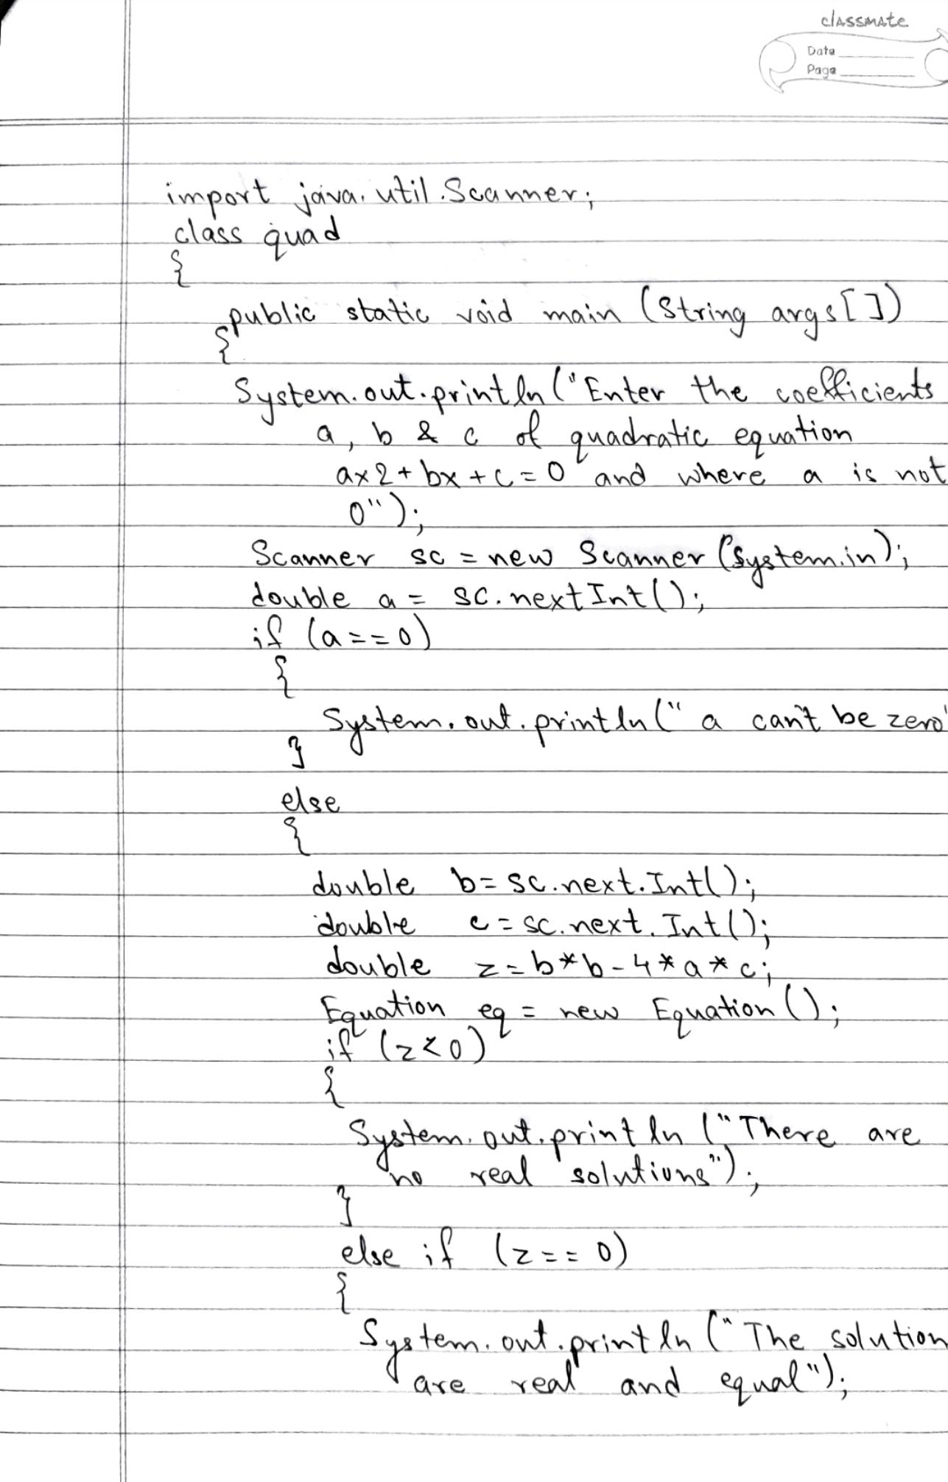

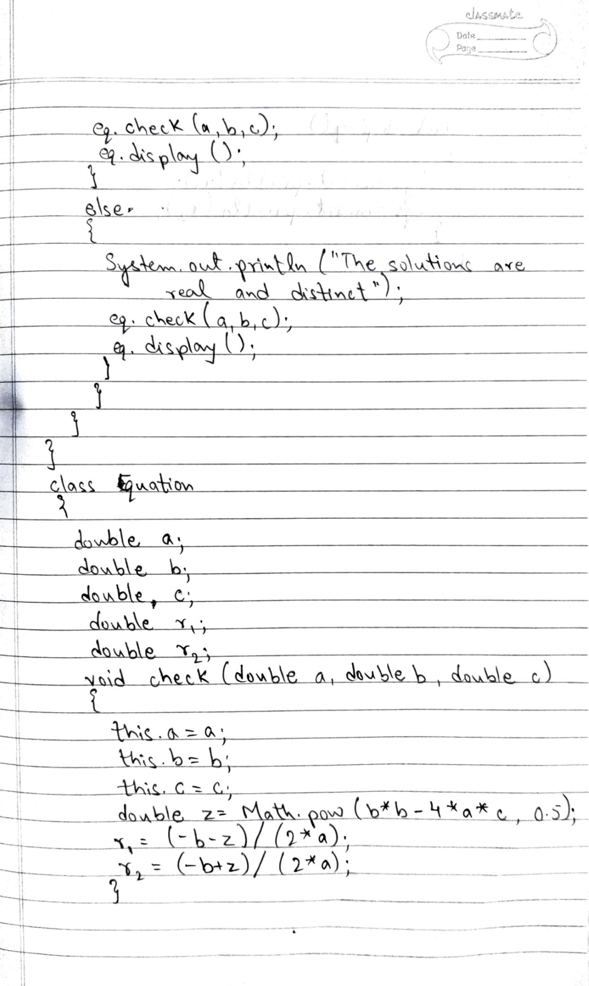

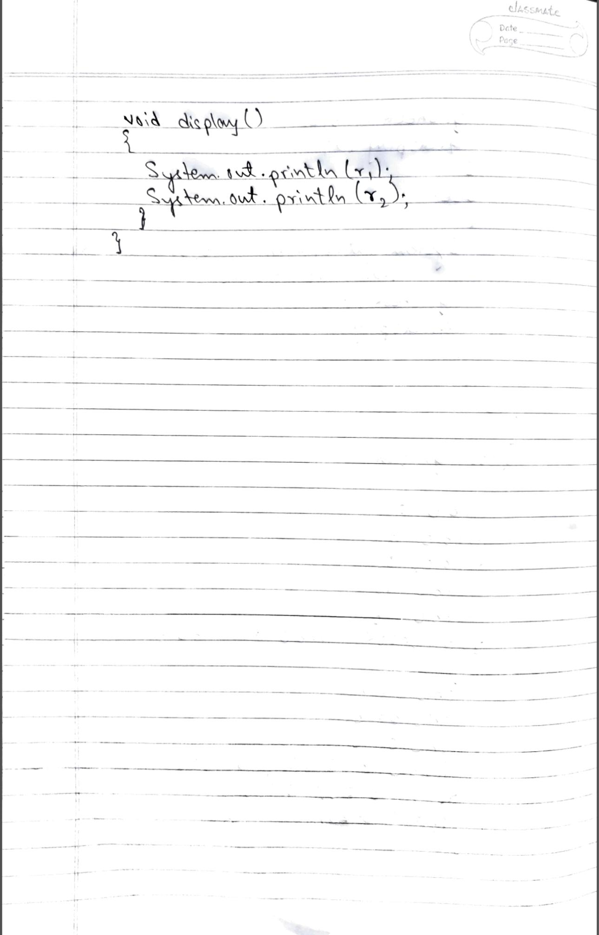

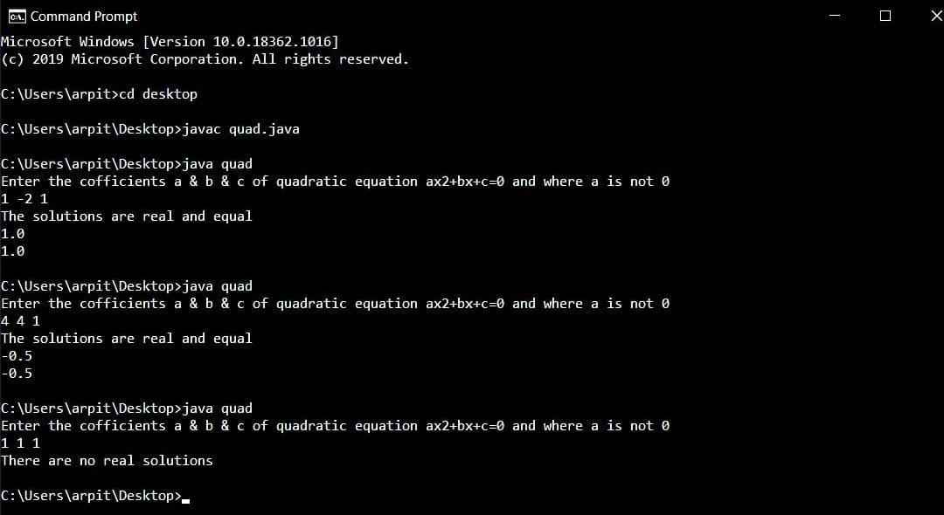

Lab Program - 2

Develop a Java program to create a class Student with members usn, name, an array

Credits and an array marks. Include methods to accept and display details and a method to

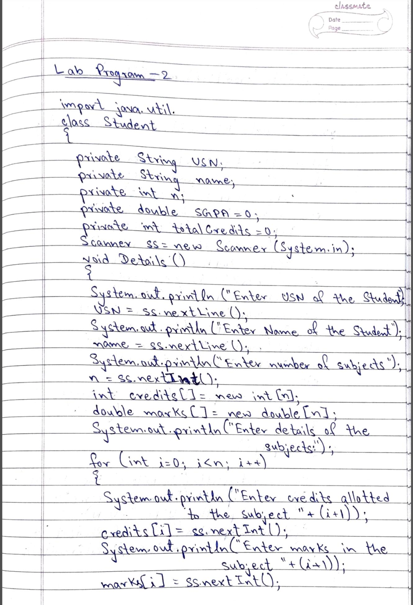Calculate SGPA of a student.

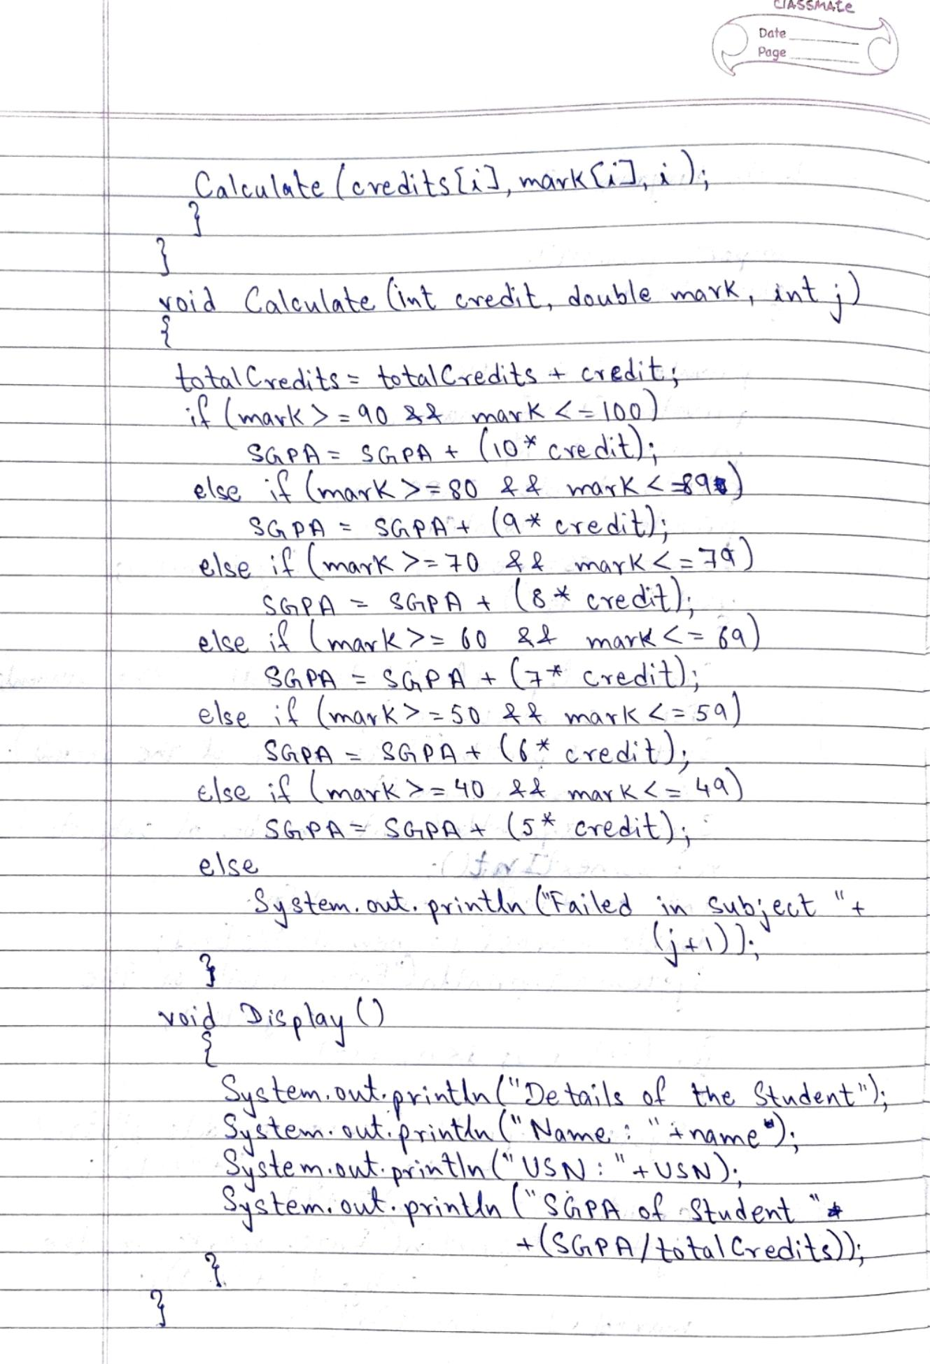

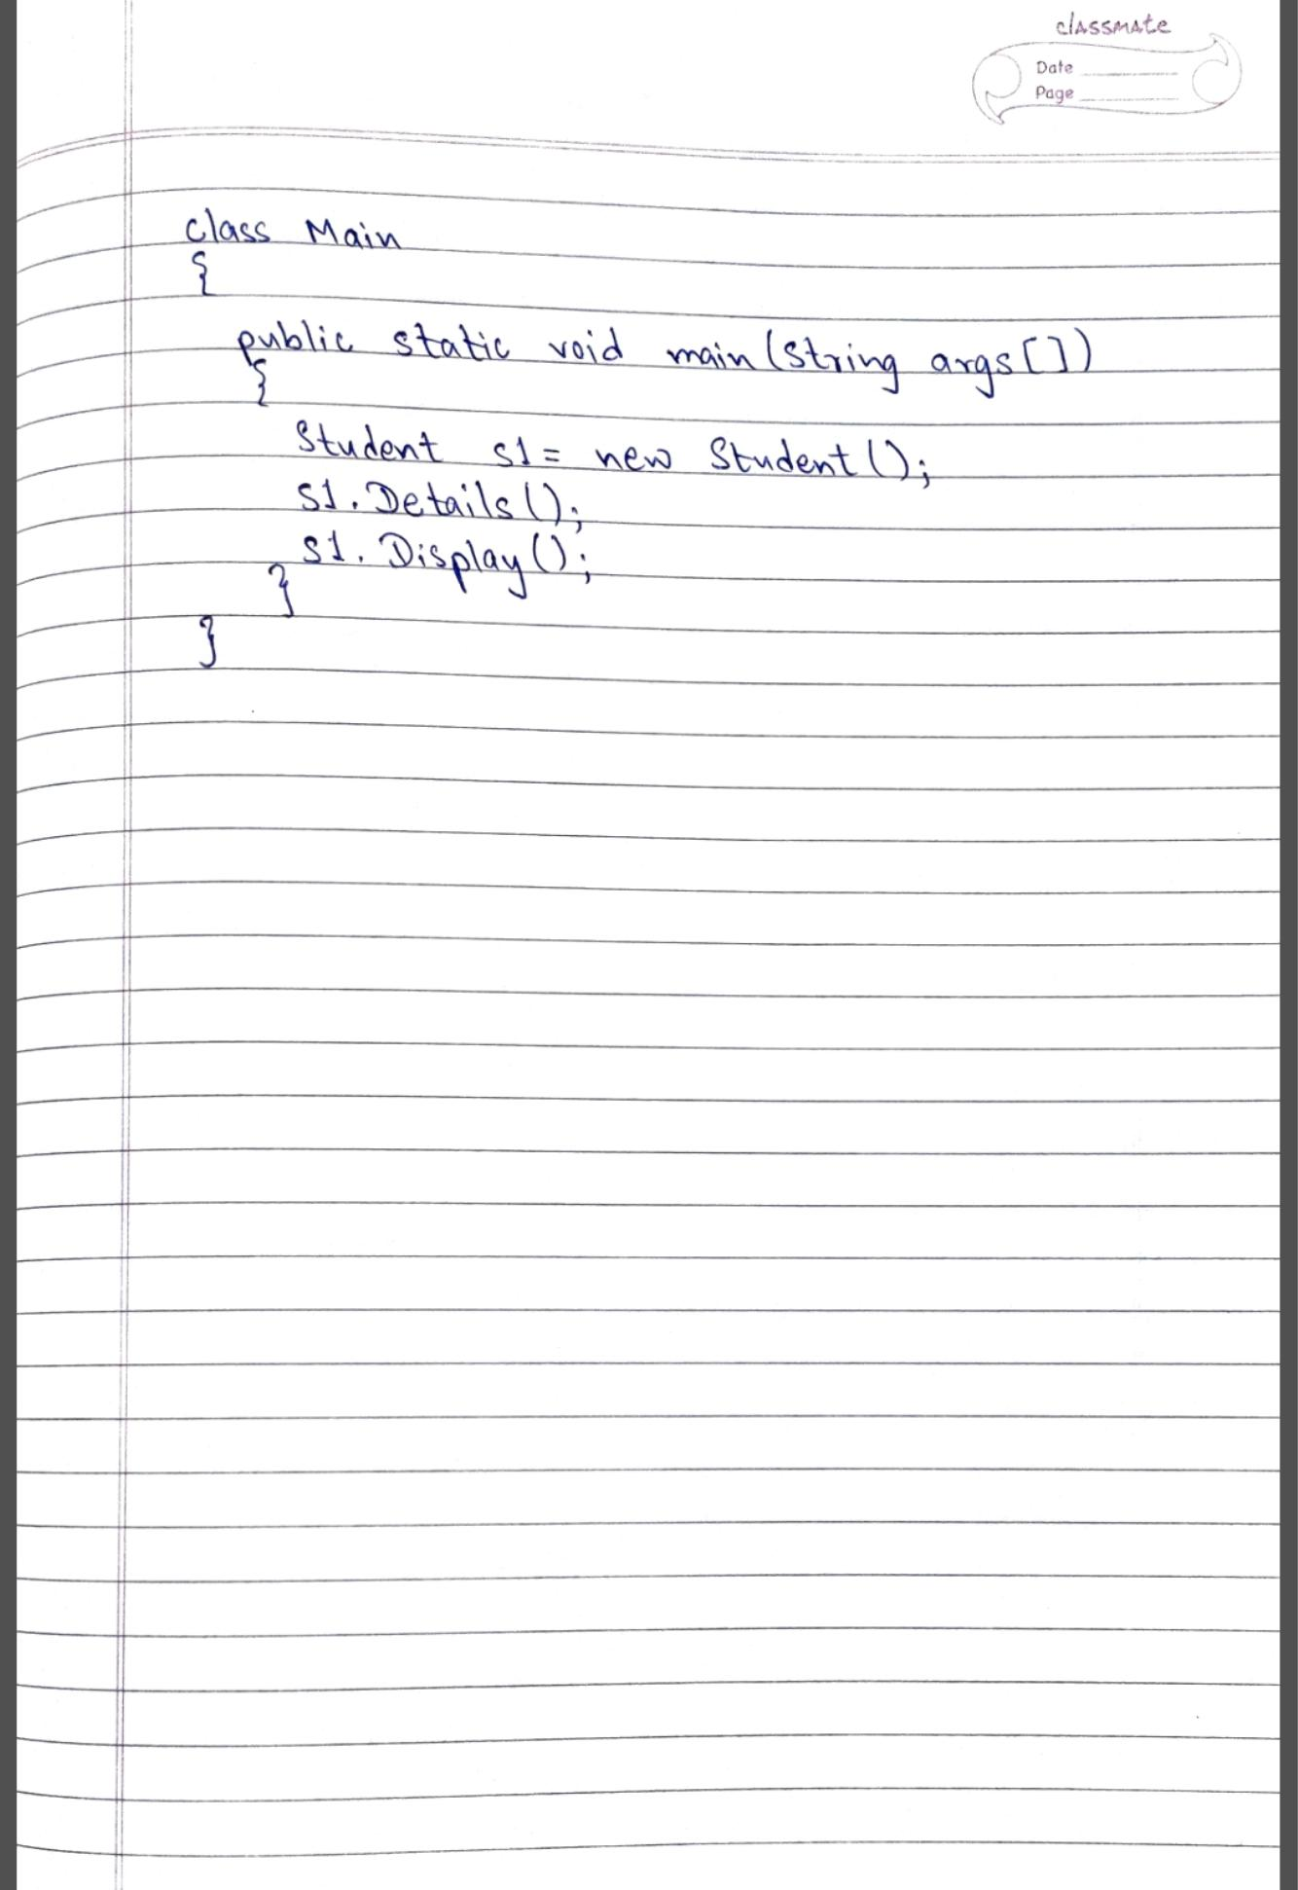

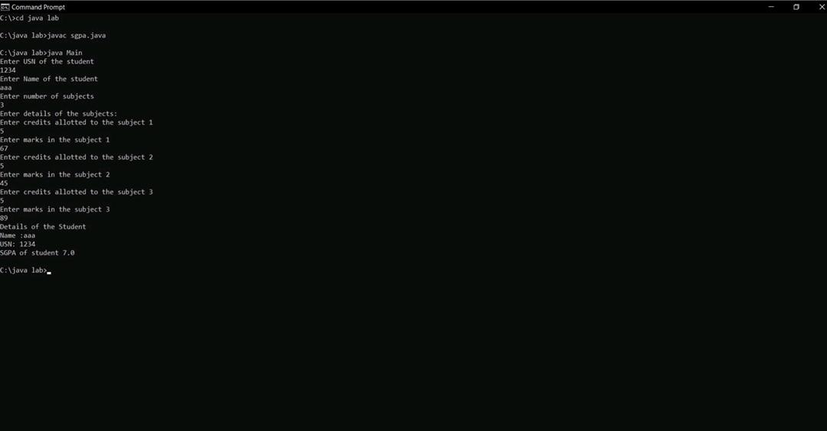

Lab Program – 3

Create a class Book which contains four members: name, author, price, num_pages. Include a constructor to set the values for the members. Include methods to set and get the details of the objects. Include a toString( ) method that could display the complete details of the book. Develop a Java program to create n book objects.

Info about toString( ) method:

Class Test

{

Int a=10;

Public String toString() // when an object is printed this method is automatically called

{ return(“a=”+a);} //return statement with String is required

}

Class TestMain

{

Public static void main (String ss[])

{

Test t1=new Test ();

System.out.println (t1);

//t1 – First example where an object is printed directly

//calls toString method with the object given as the invoking object

}

}

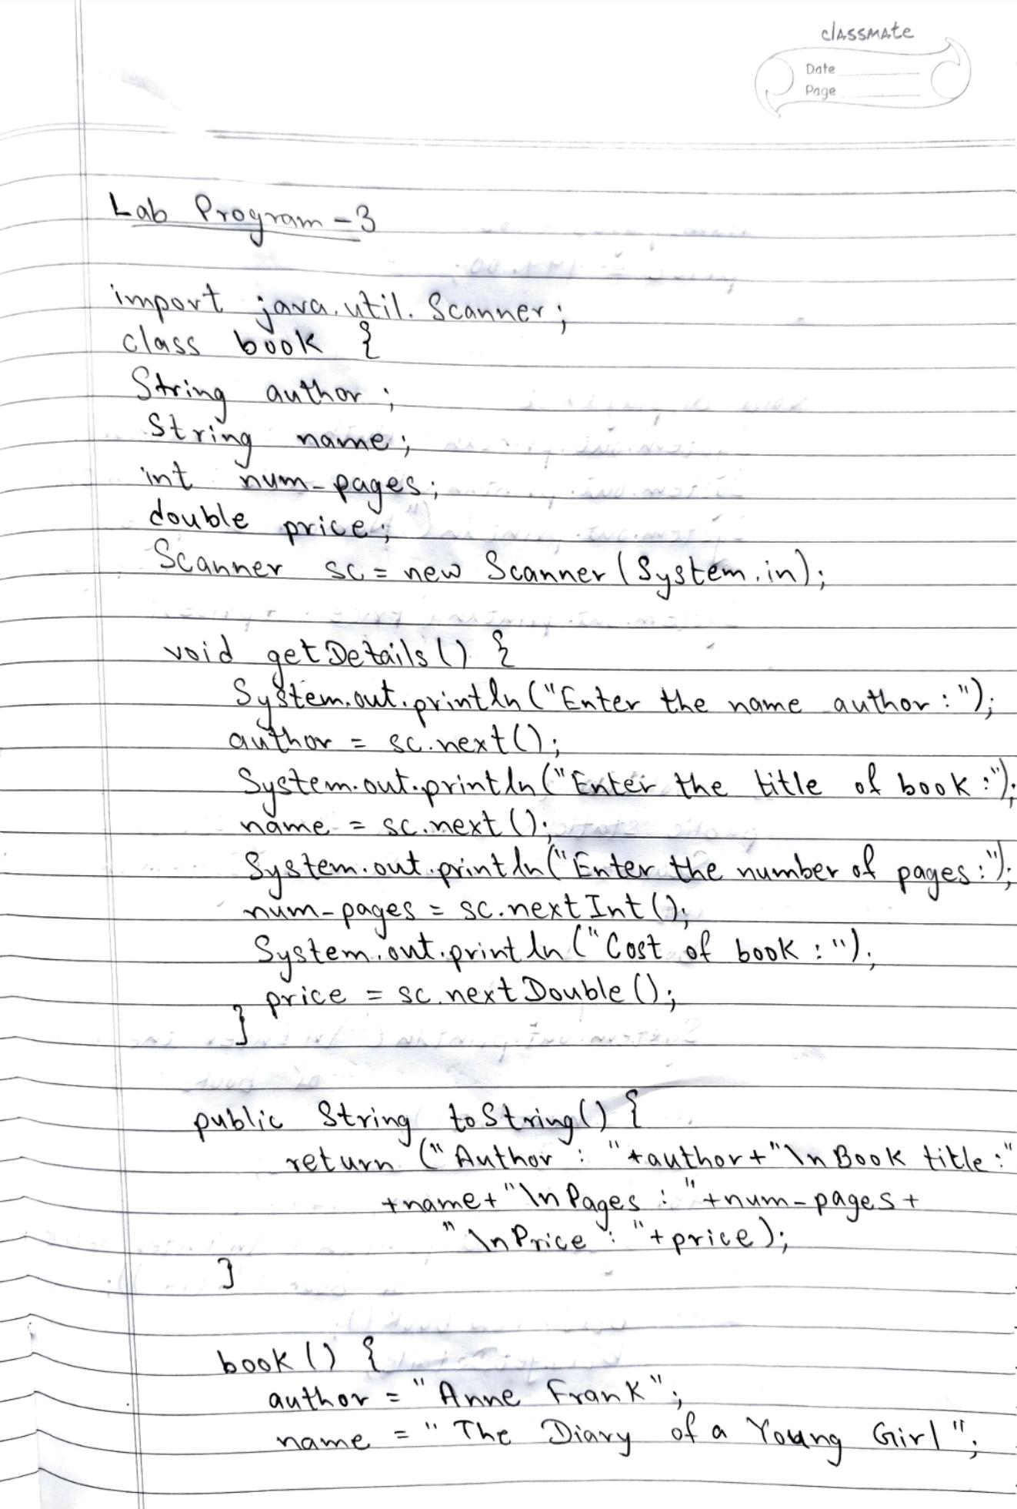

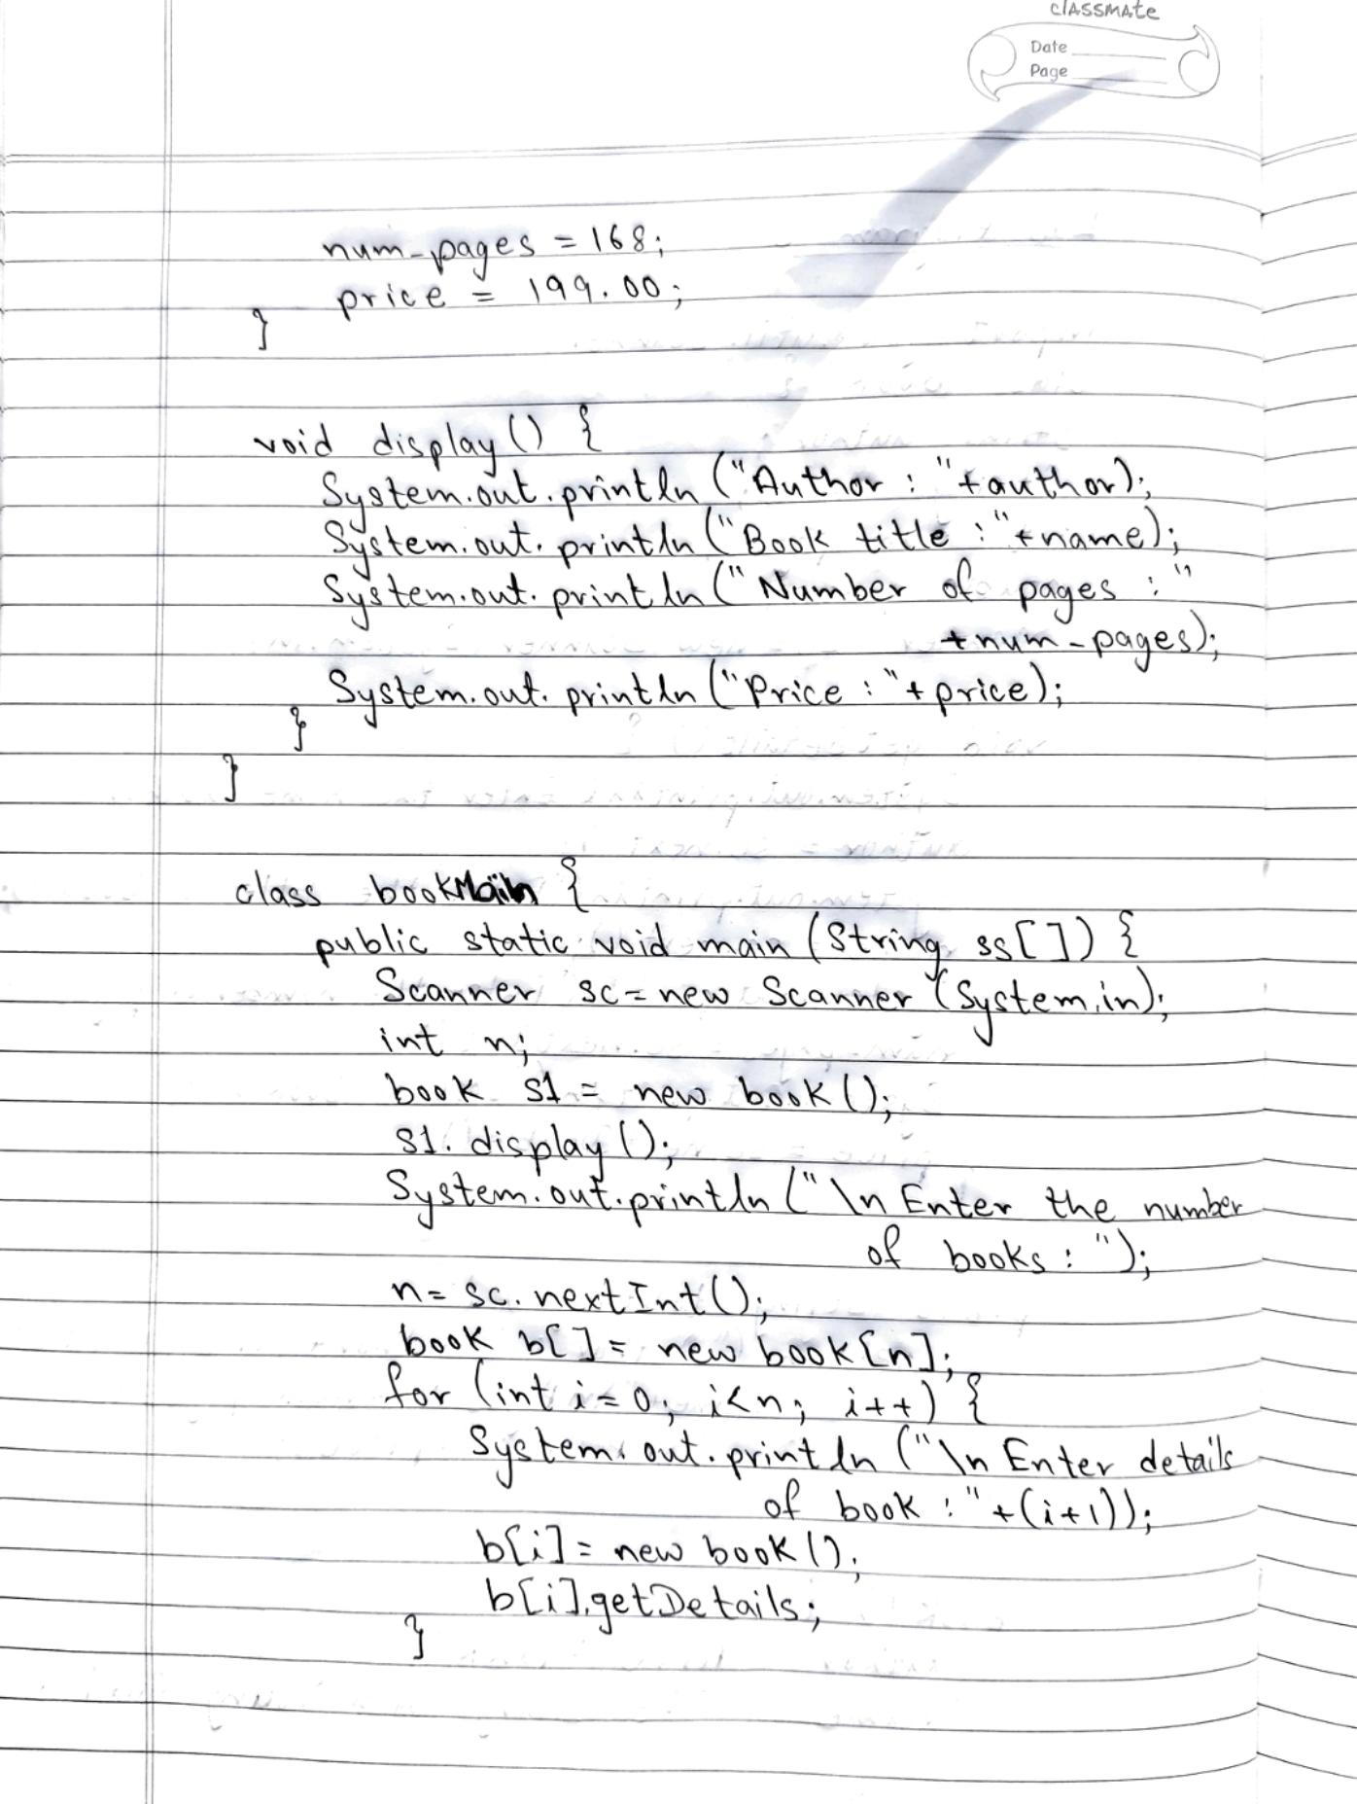

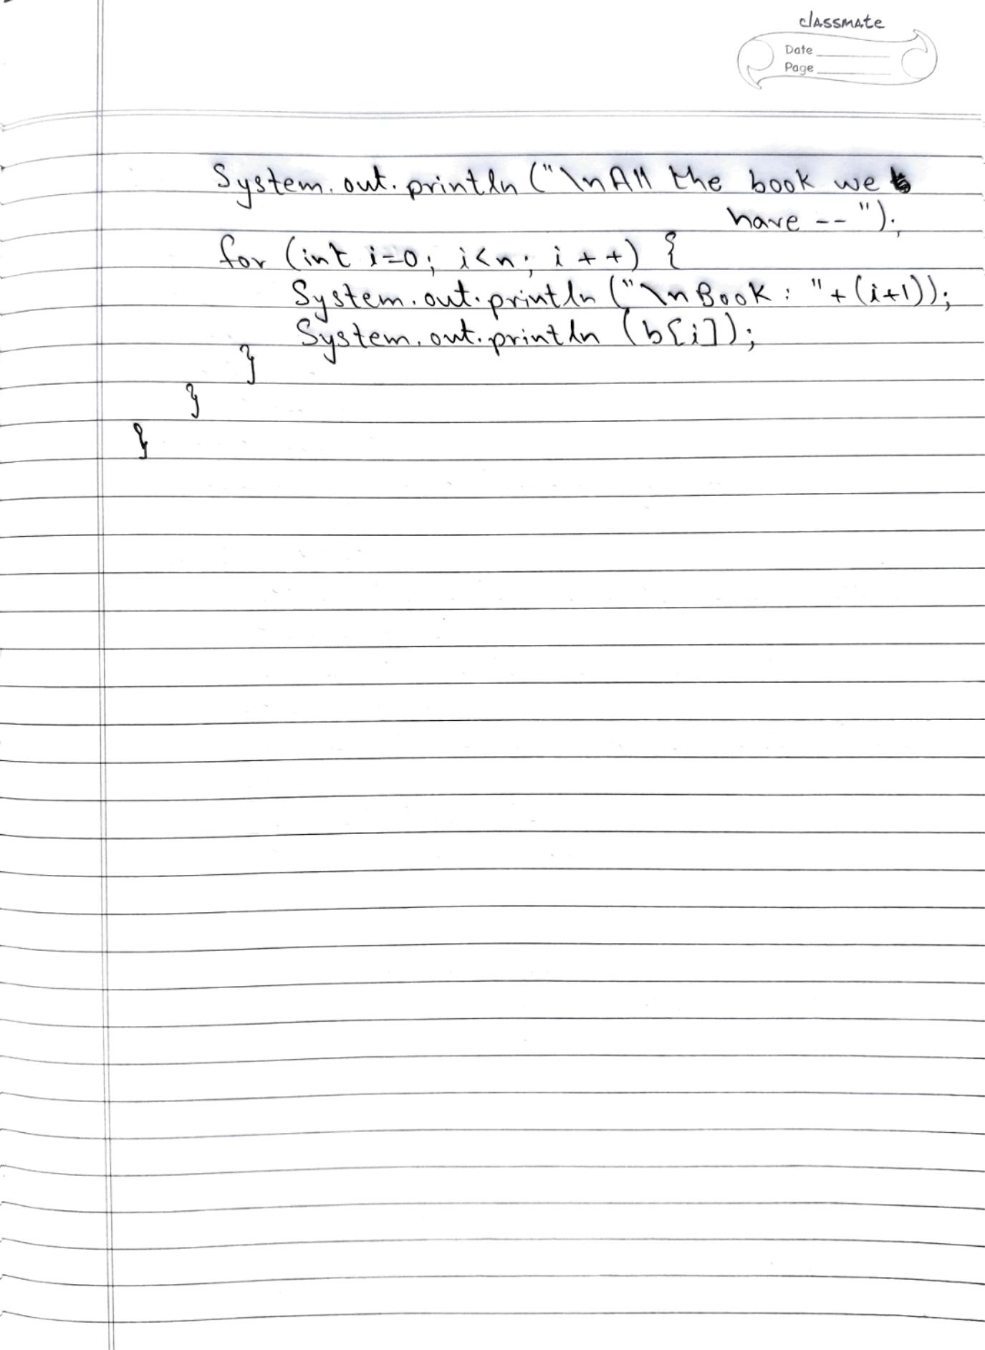

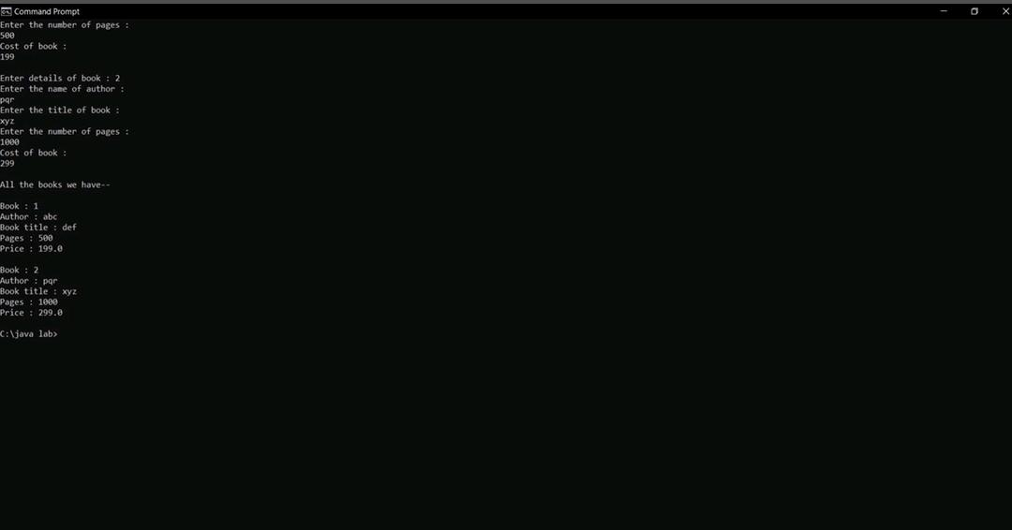

Lab Program – 4

Develop a Java program to create an abstract class named Shape that contains two integers and

An empty method named printArea( ). Provide three classes named Rectangle, Triangle and

Circle such that each one of the classes extends the class Shape. Each one of the classes contain

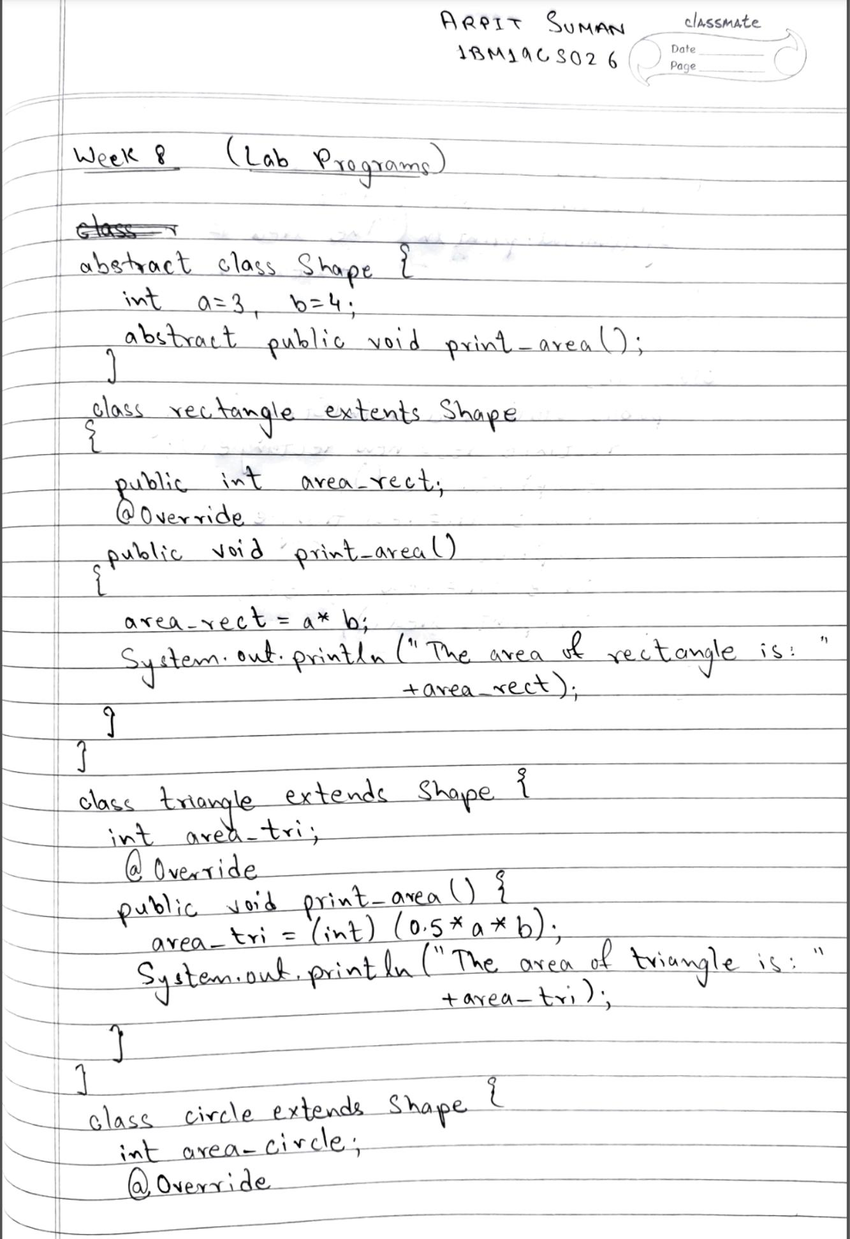Only the method printArea( ) that prints the area of the given shape.

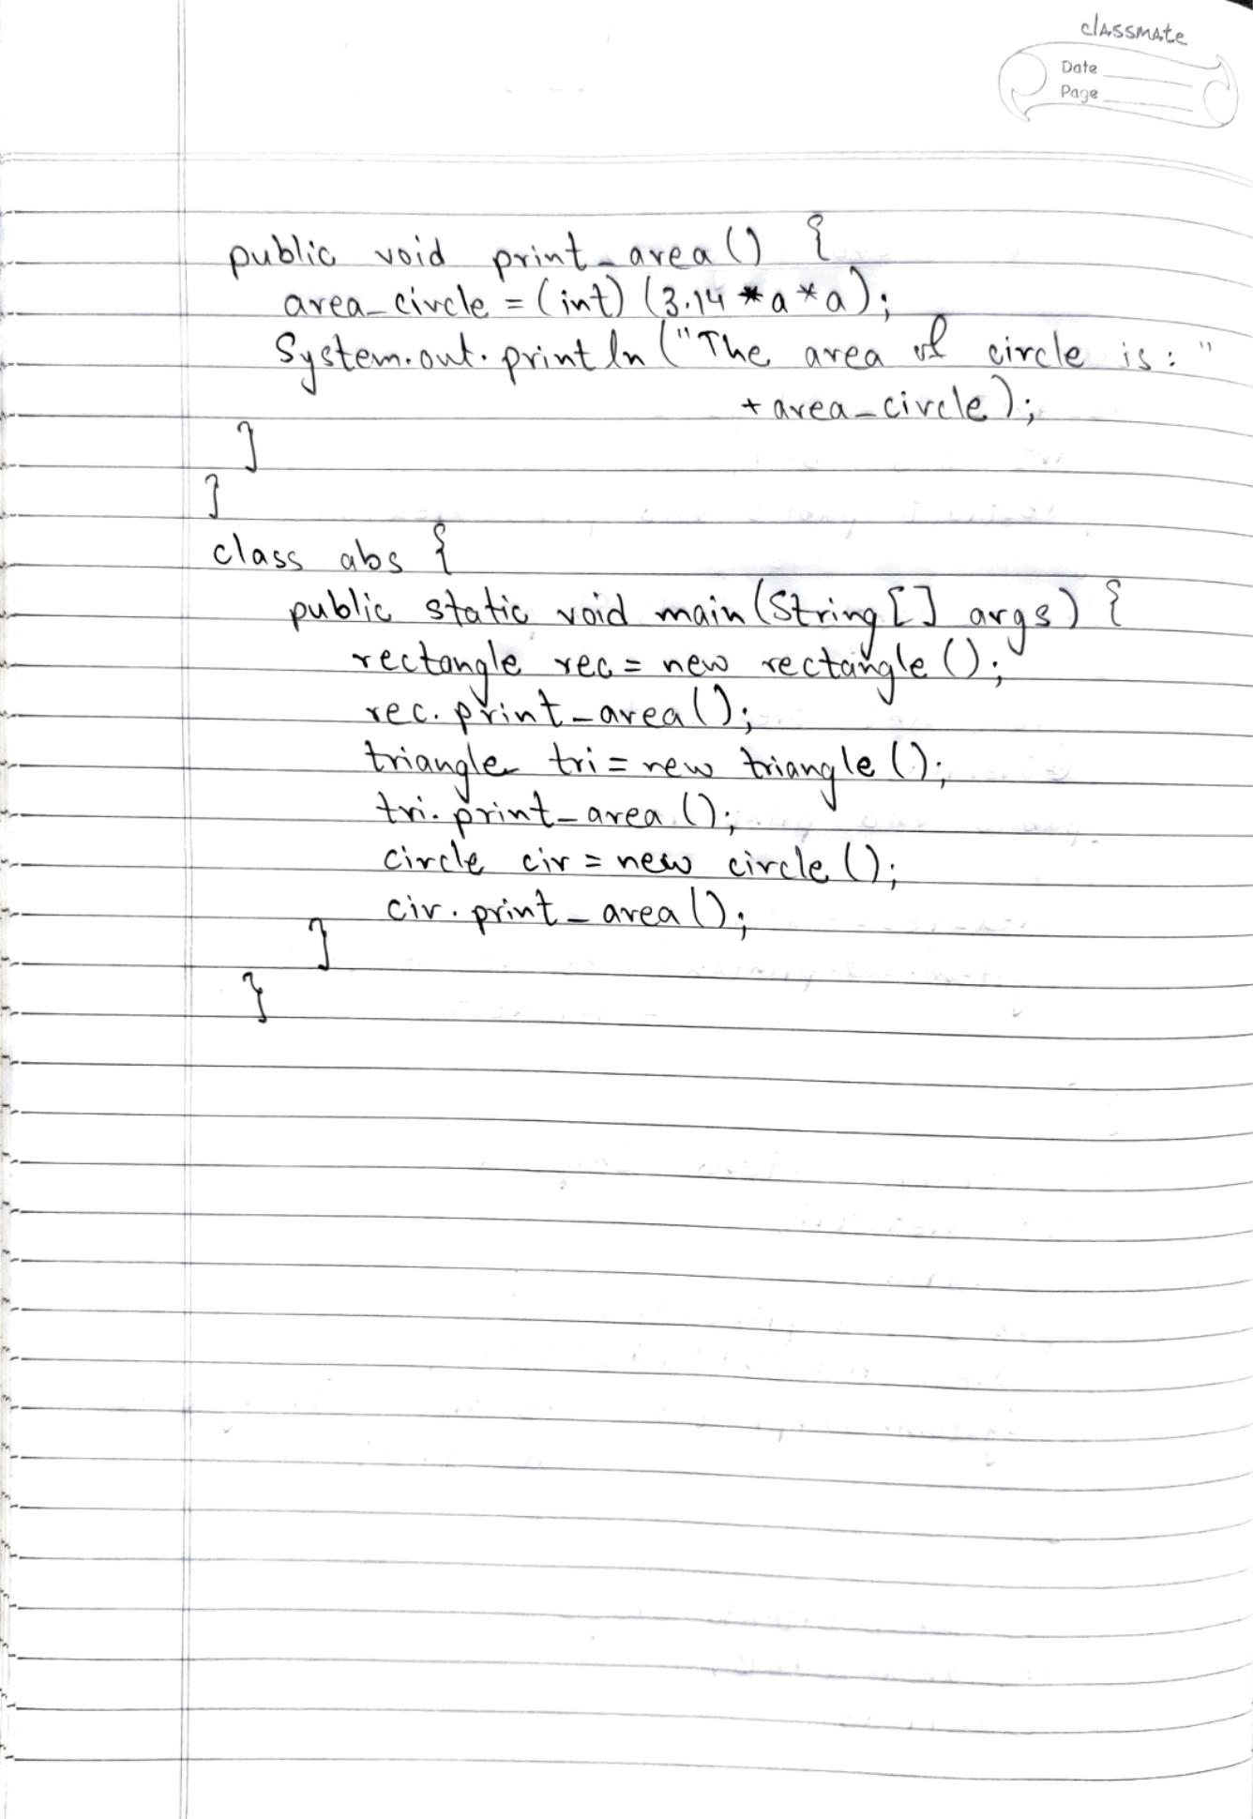

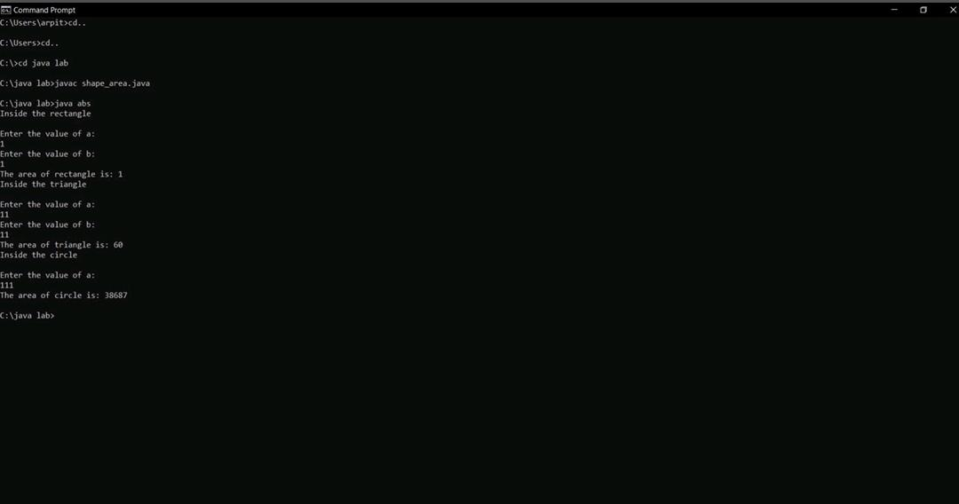

Lab Program - 5

Develop a Java program to create a class Bank that maintains two kinds of account for its

Customers, one called savings account and the other current account. The savings account

Provides compound interest and withdrawal facilities but no cheque book facility. The current

Account provides cheque book facility but no interest. Current account holders should also

Maintain a minimum balance and if the balance falls below this level, a service charge is

Imposed. Create a class Account that stores customer name, account number and type of

Account. From this derive the classes Curr-acct and Sav-acct to make them more specific to

Their requirements. Include the necessary methods in order to achieve the following tasks: •

Accept deposit from customer and update the balance. • Display the balance. • Compute and

Deposit interest • Permit withdrawal and update the balance • Check for the minimum balance,

Impose penalty if necessary and update the balance

