Experiment 3: Creation of a Simple Network Topology Using
Open-Source Network Virtualization Tools

Objective :

To create and configure a simple network topology using an open-source network
virtualization tool and verify communication between the virtual network nodes.

- Mininet:
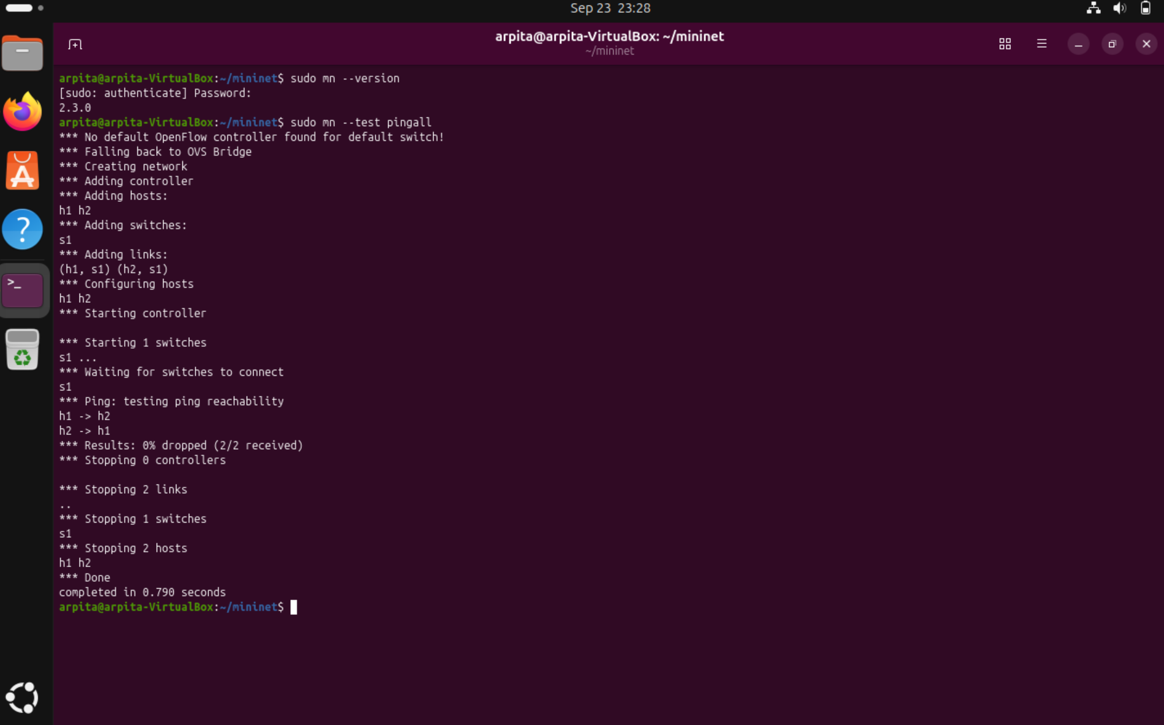

- Start a simple Network Topology:

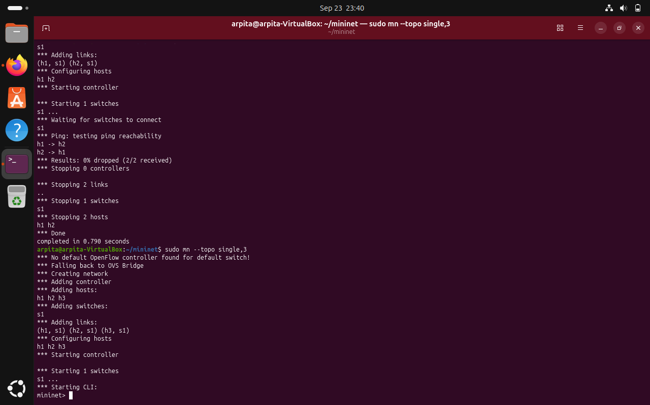

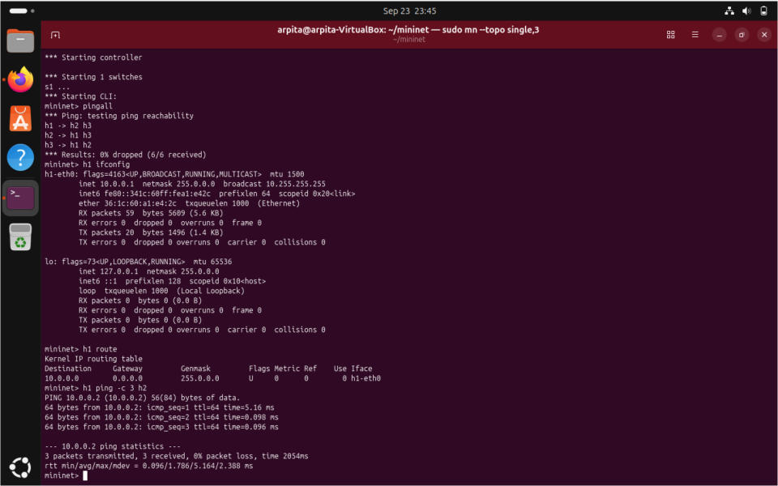

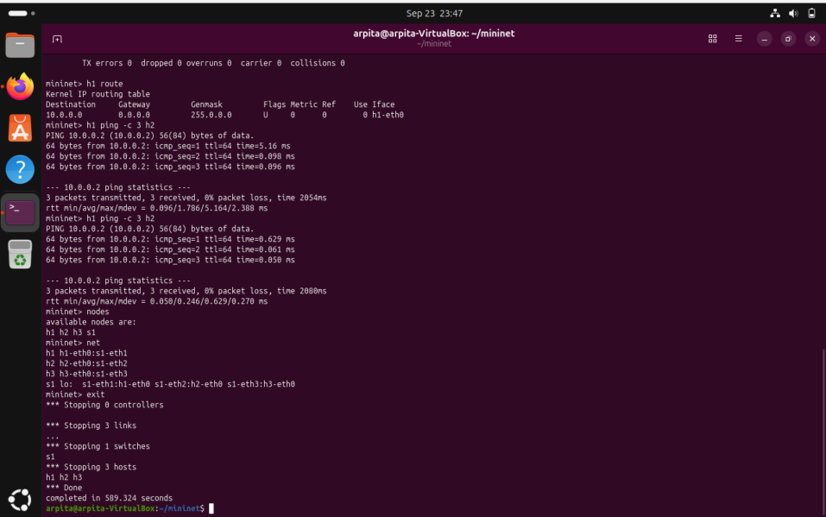

- Start a Tree Network Topology:



