EXPERIMENT 6: Familiarization and Usage of Cloud Services Using AWS and OpenSource Cloud Tools

Aim: To become familiar with different cloud services and perform basic cloud operations using Amazon Web Services (AWS), Ubuntu Linux, Oracle VirtualBox and AWS Command Line Interface (CLI).
Task 1: VM Setup:
Step 1: Create a Virtual Machine
Step 2: Install Ubuntu
Step 3: Update Ubuntu
Open the Ubuntu Terminal and execute:
sudo apt update
sudo apt upgrade -y
Step 4: Install Basic Utilities
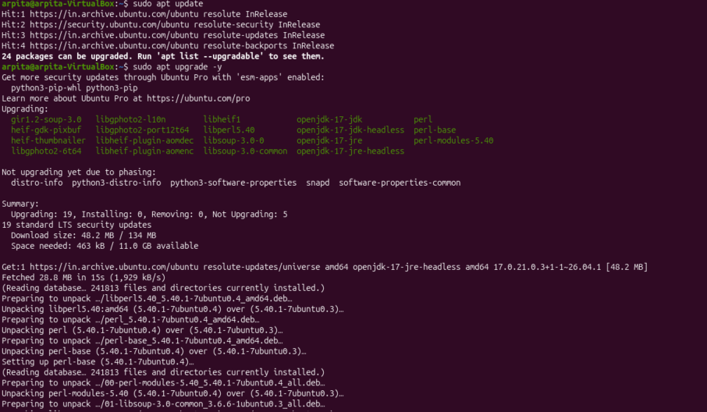
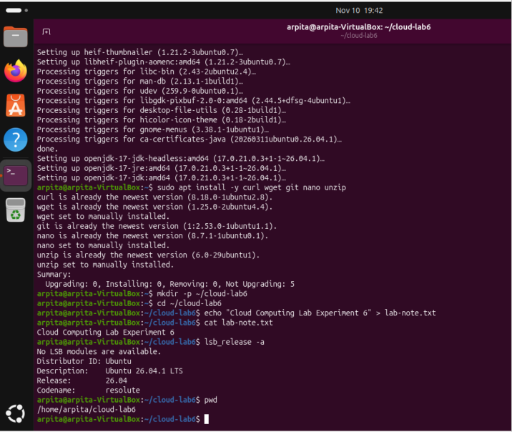

Task 2A: Introduction to AWS Management Console
Step 1: Access AWS Management Console
1. Open a web browser.
2. Visit https://console.aws.amazon.com/
3. Sign in using an authorised AWS account.
4. Explore the AWS Management Console home page.
5. Observe the search bar used to locate different AWS service.
Task 2B: Implementation of Cloud Storage Using Amazon S3
Introduction to Amazon S3
Amazon Simple Storage Service (Amazon S3) is an object storage service used to store and
retrieve data over the internet.
Step 1: Open Amazon S3
1. Log in to the AWS Management Console.
2. Search for S3.
3. Open Amazon S3.
4. Select Create bucket.
Step 2: Create an S3 Bucket
1. Enter a globally unique bucket name.
Example:
cse12045-cloud-lab6-student01
2. Select the AWS Region.
3. Keep Block Public Access enabled.
4. Keep default encryption enabled.
5. Select Create bucket.
Note: Never make the bucket public for this experiment.
Step 3: Create a Sample File in Ubuntu
Open the Ubuntu Terminal and execute:
mkdir cloud-lab6
cd cloud-lab6
echo "Cloud Computing Lab Experiment 6" > lab-note.txt
cat lab-note.txt
Explanation:
• mkdir: Creates a directory.
• cd: Changes the current directory.
• echo: Writes text into a file.
• cat: Displays the contents of a file.
Step 4: Upload a File to S3
1. Open the created S3 bucket.
2. Select Upload.
3. Click Add files.
4. Select lab-note.txt.
5. Click Upload.
6. Verify that the file appears inside the bucket.
Step 5: Download the File
1. Select the uploaded object.
2. Click Download.
3. Open the downloaded file.
4. Verify that the contents match the original file.
Step 6: Delete the Test Object and Bucket
1. Select the uploaded object.
2. Choose Delete.
3. Confirm deletion.
4. Once the bucket is empty, delete the bucket.
Expected Result: A private S3 bucket should be created successfully, and a sample file should be uploaded, downloaded and deleted.
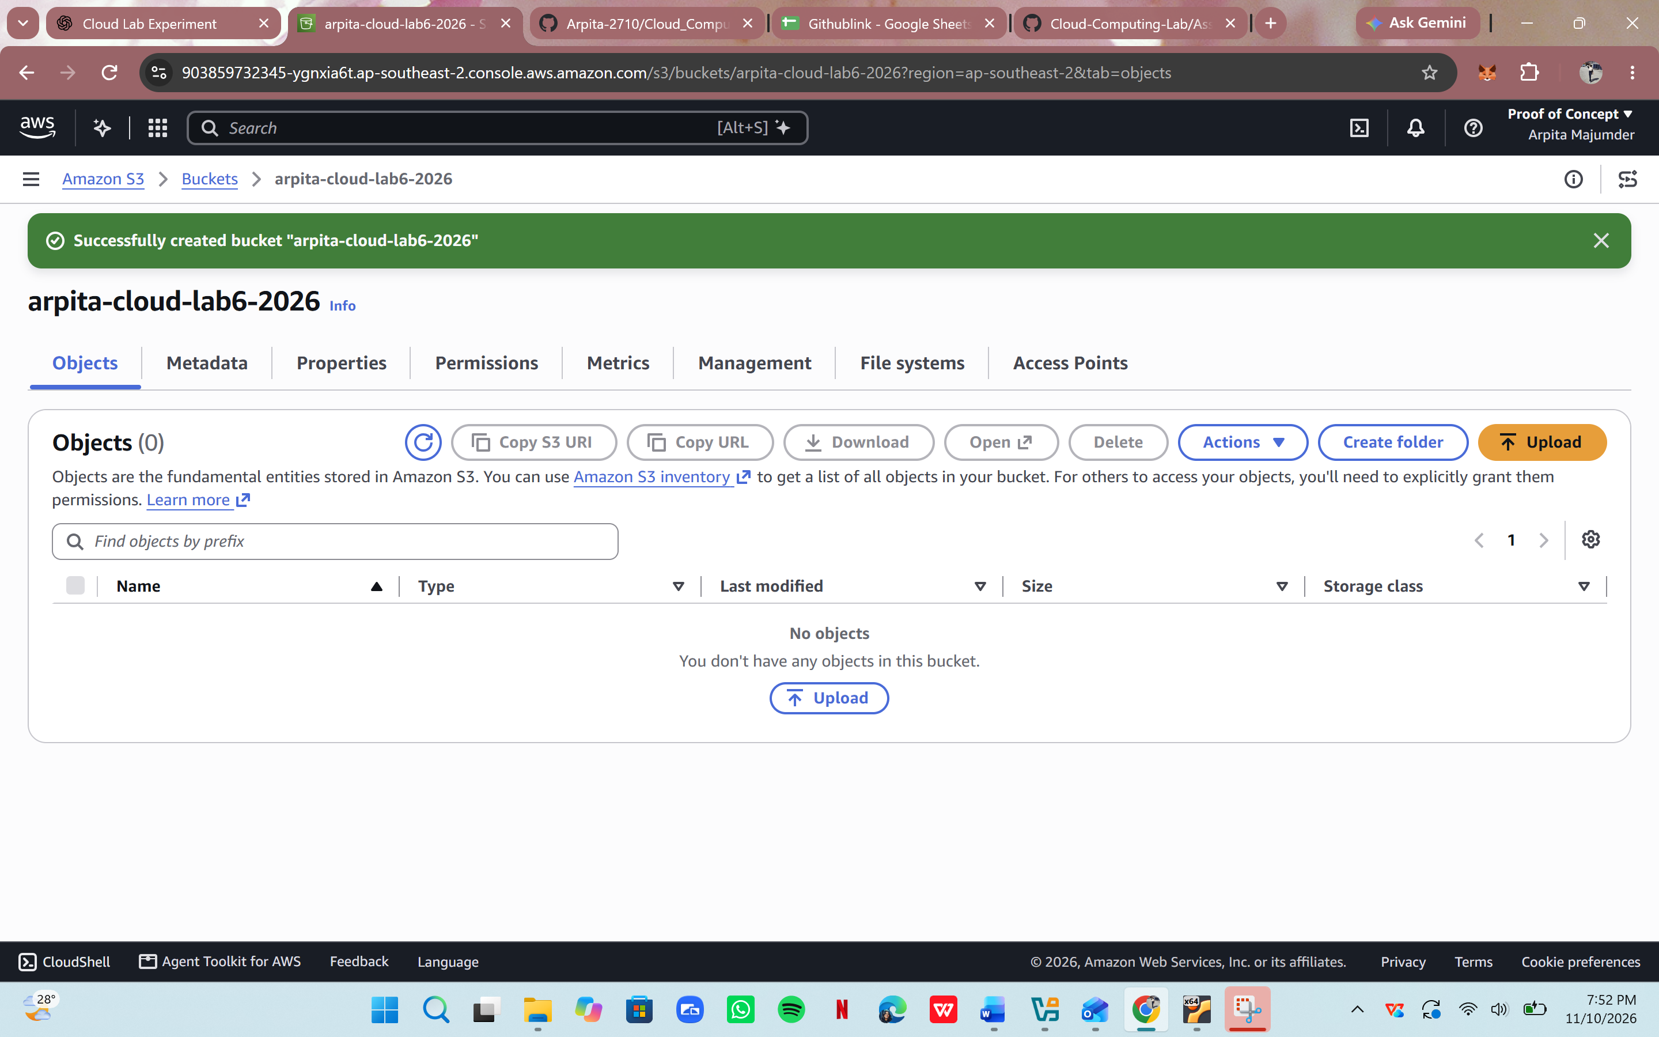

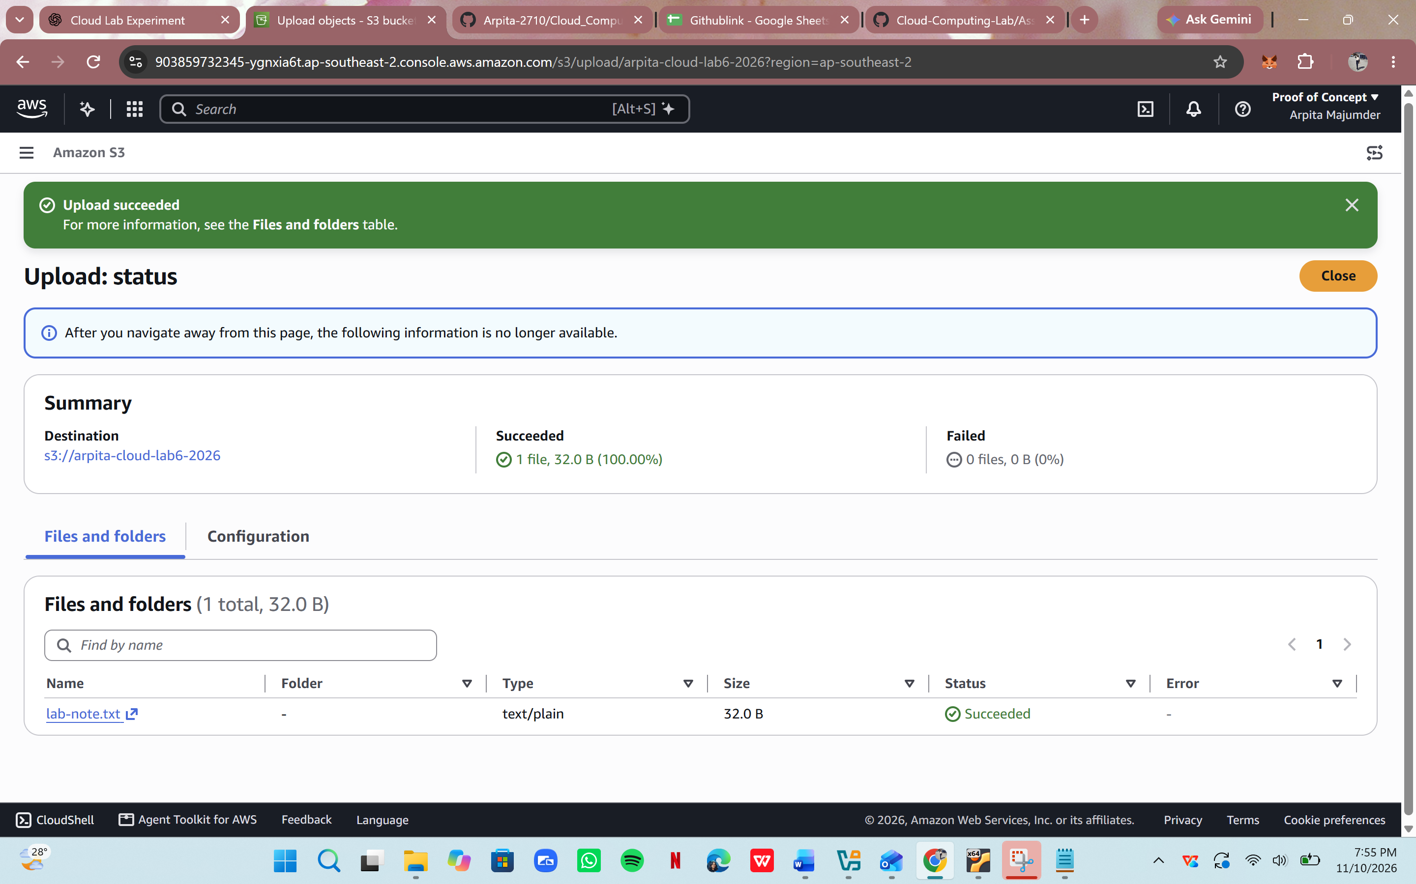
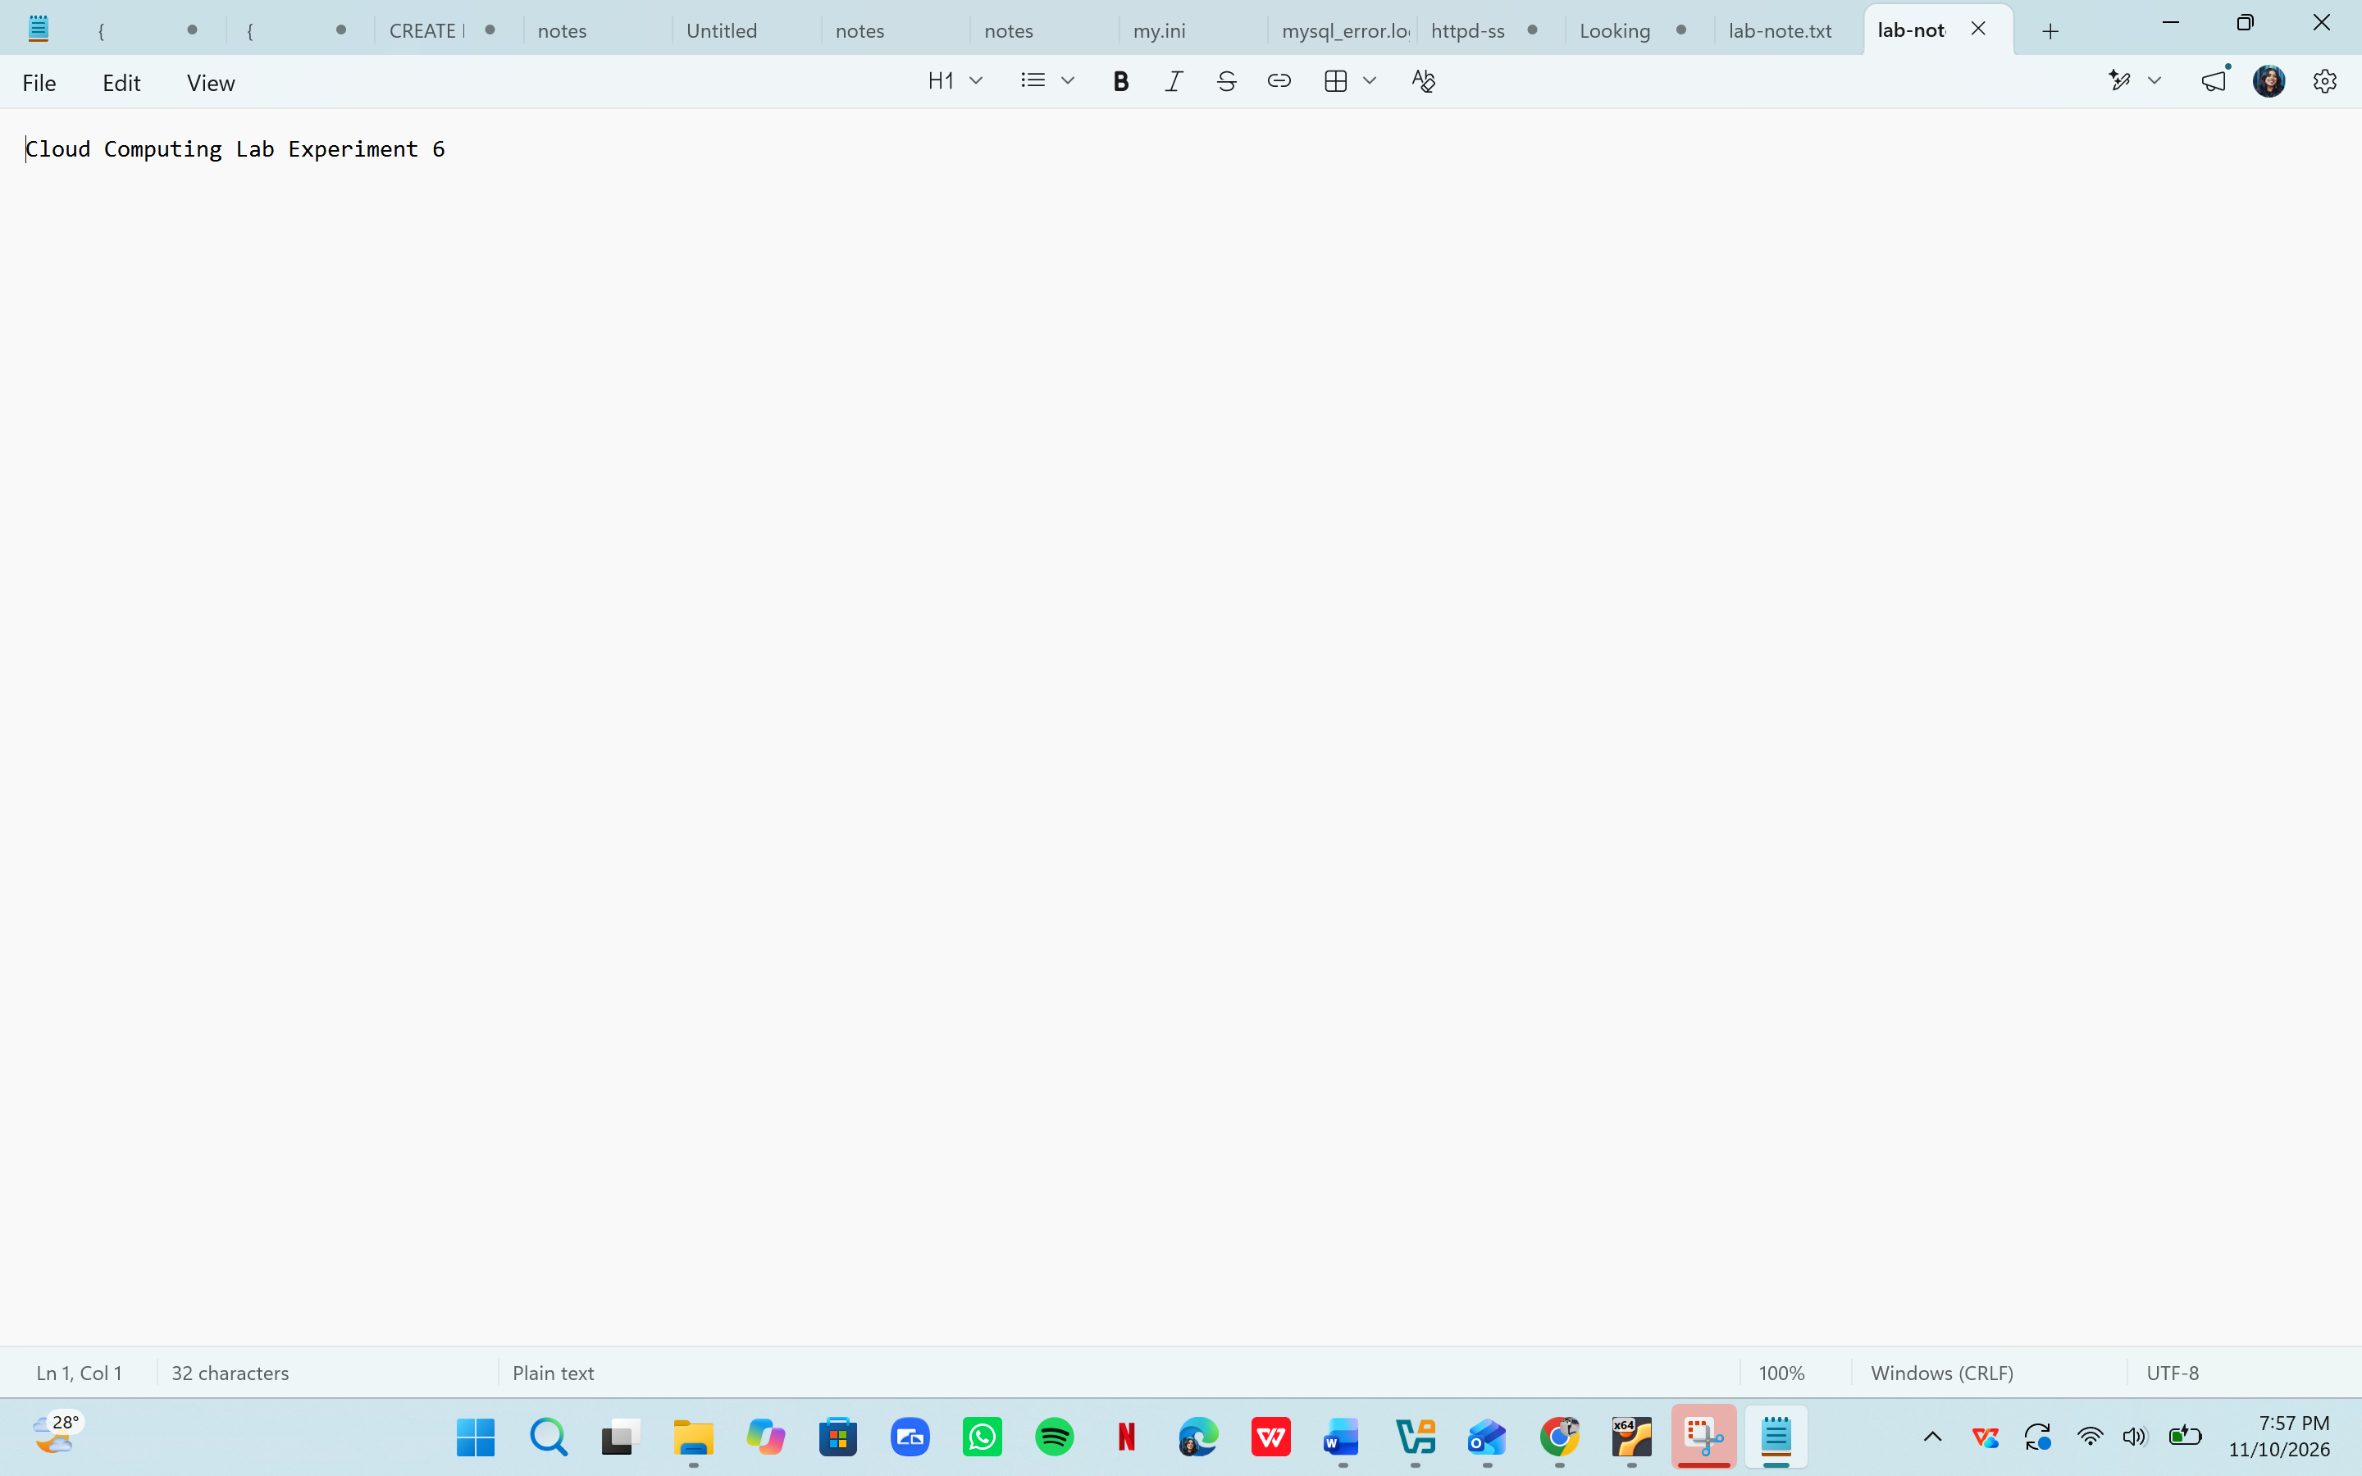
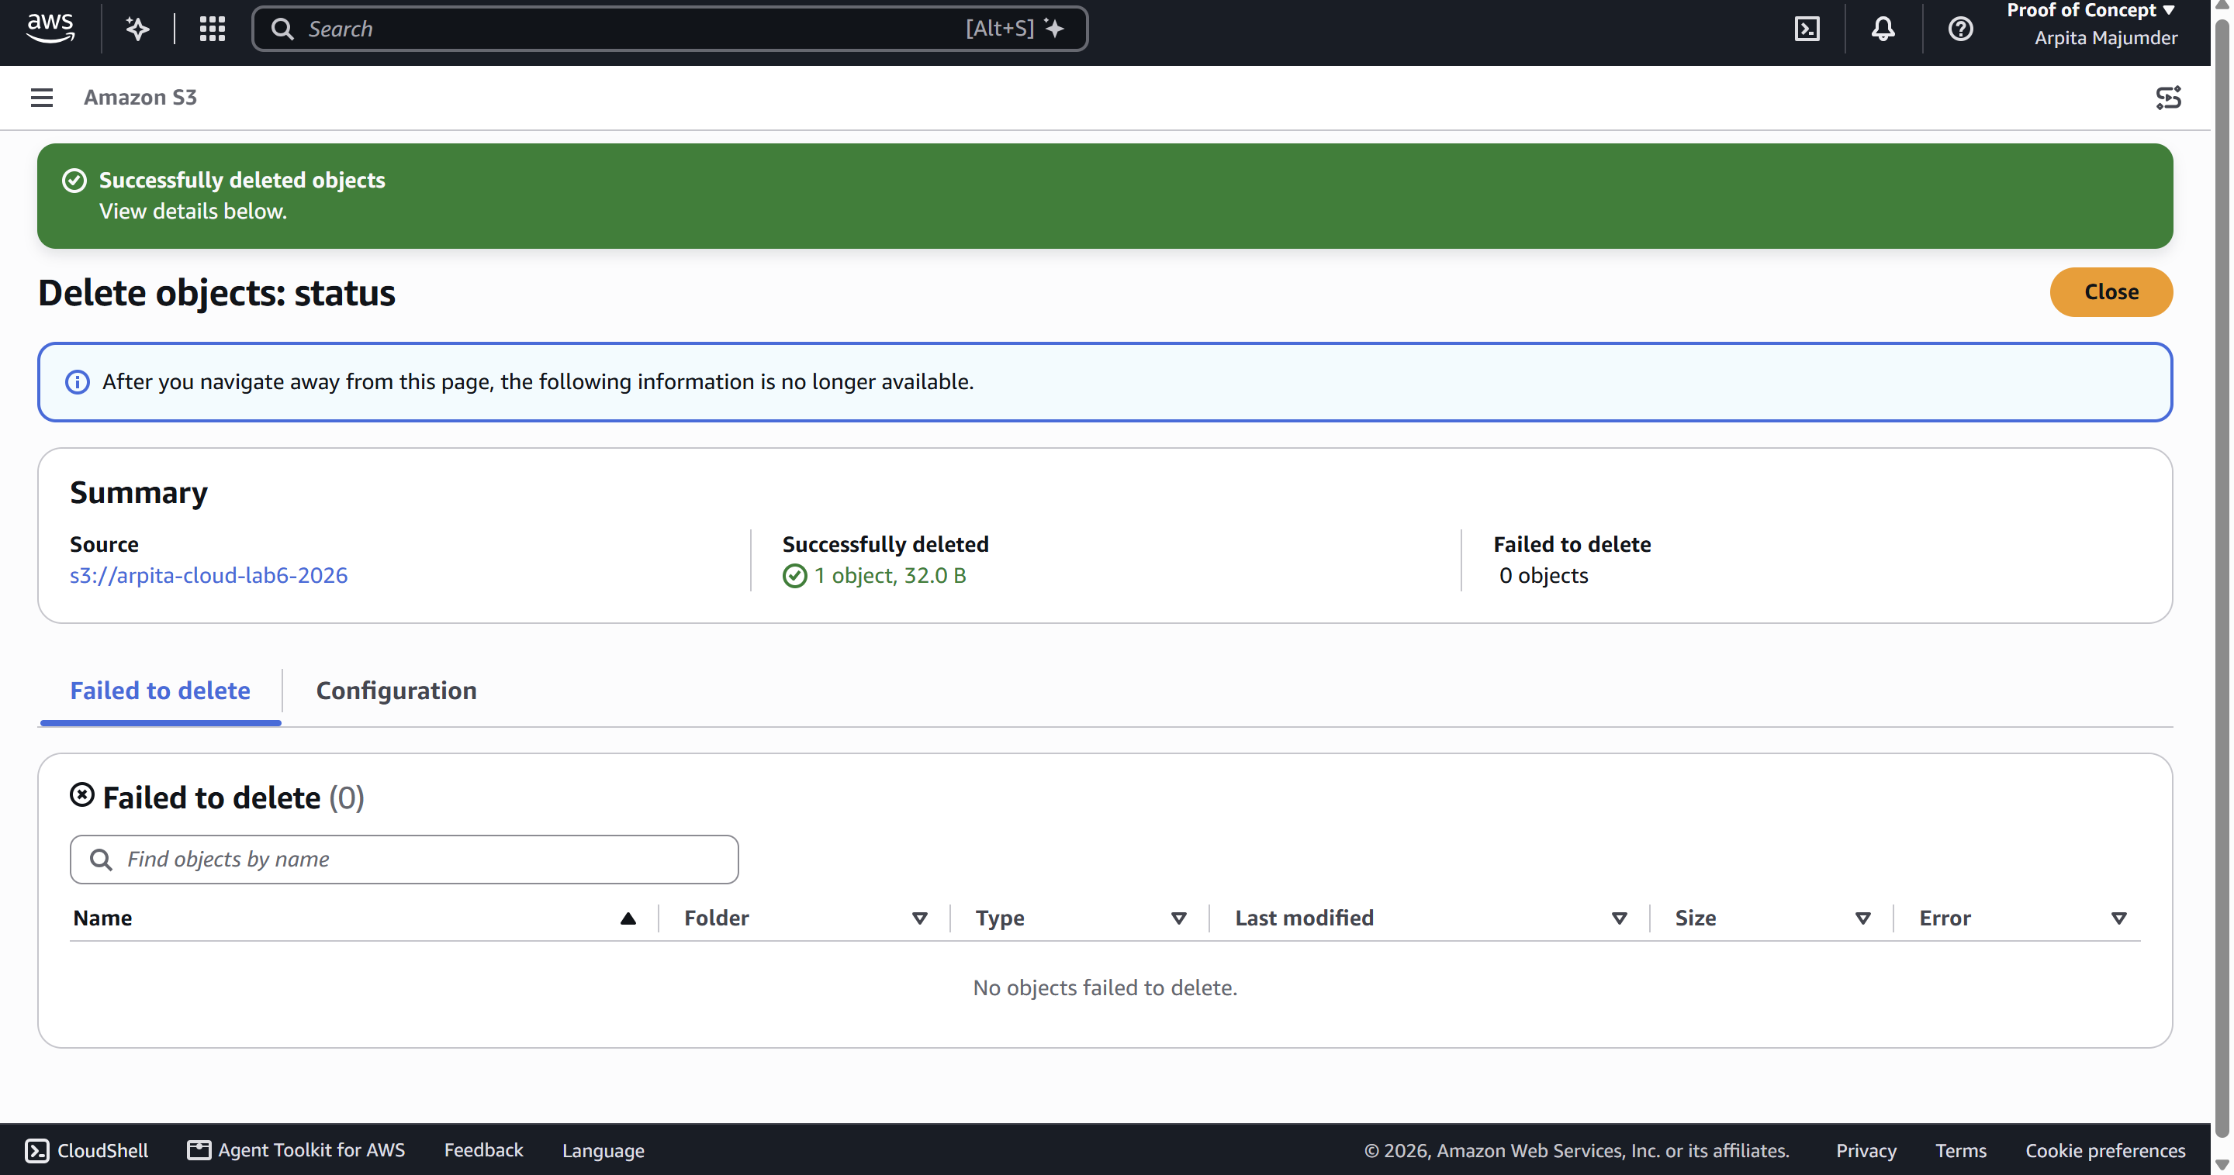
Task 3A: Identity and Access Management Using AWS IAM
Introduction to IAM
AWS Identity and Access Management (IAM) is a service used to manage access to AWS
resources securely. It controls who can access AWS services and what actions they can
perform.
Step 1: Open IAM
1. Log in to AWS Management Console.
2. Search for IAM.
3. Open the IAM Dashboard.
4. Explore the Users, Groups, Roles and Policies sections.
Step 2: Understand IAM Policies
An IAM policy defines which actions are allowed or denied for a particular AWS resource.
Example of a basic IAM policy structure:
{
"Version": "2012-10-17",
"Statement": [
{
"Effect": "Allow",
"Action": [
"s3:ListBucket"
],
"Resource": "arn:aws:s3:::example-bucket"
}
]
}
Explanation:
• Version: Specifies the policy language version.
• Effect: Specifies whether an action is allowed or denied.
• Action: Specifies the AWS operation.
• Resource: Specifies the AWS resource to which the permission applies.
This is an illustrative policy that permits listing the contents of the specified bucket. It does not grant permission to upload or download objects.
Step 3: Understand the Principle of Least Privilege
The principle of least privilege means that a user should receive only the minimum
permissions required to perform their assigned tasks.
Safety Note: This is primarily an observation activity. Do not create users, generate access
keys or change policies in a shared institutional AWS account without instructor approval.
Task 3B: Virtual Machine Provisioning Using Amazon EC2
Introduction to Amazon EC2
Amazon Elastic Compute Cloud (EC2) is a cloud computing service that provides virtual
servers.
An EC2 instance acts like a virtual machine hosted on AWS infrastructure.
Step 1: Open EC2
1. Log in to AWS Management Console.
2. Search for EC2.
3. Open the EC2 Dashboard.
4. Explore the Instances section.
Step 2: Explore the Instance Launch Process
1. Select Launch Instance.
2. Enter an instance name.
3. Explore the available Amazon Machine Images.
4. Observe the available instance types.
5. Explore the key pair configuration.
6. Observe the network and security-group settings.
7. Review the storage configuration.
For this experiment, you may stop at the review stage without launching an instance.
Optional Practical Activity: Launch an EC2 Instance
Only perform this activity if the instructor has approved it and the account's current Free Tier
offer explicitly covers the selected configuration.
1. Select an eligible Linux AMI.
2. Select an instance type eligible under the account's current offer.
3. Configure minimum required storage.
4. Configure a key pair.
5. Configure a security group with only the required access.
6. Launch the instance.
7. Observe its instance ID and state.
8. Terminate the instance after the demonstration.
9. Verify that no unwanted storage volumes, snapshots or public IP resources remain.
Important: Do not assume that every EC2 instance is free. Charges can depend on instance
type, Region, operating system, storage and account eligibility.
Expected Result: Students should understand the process of creating and managing a cloudbased virtual machine.
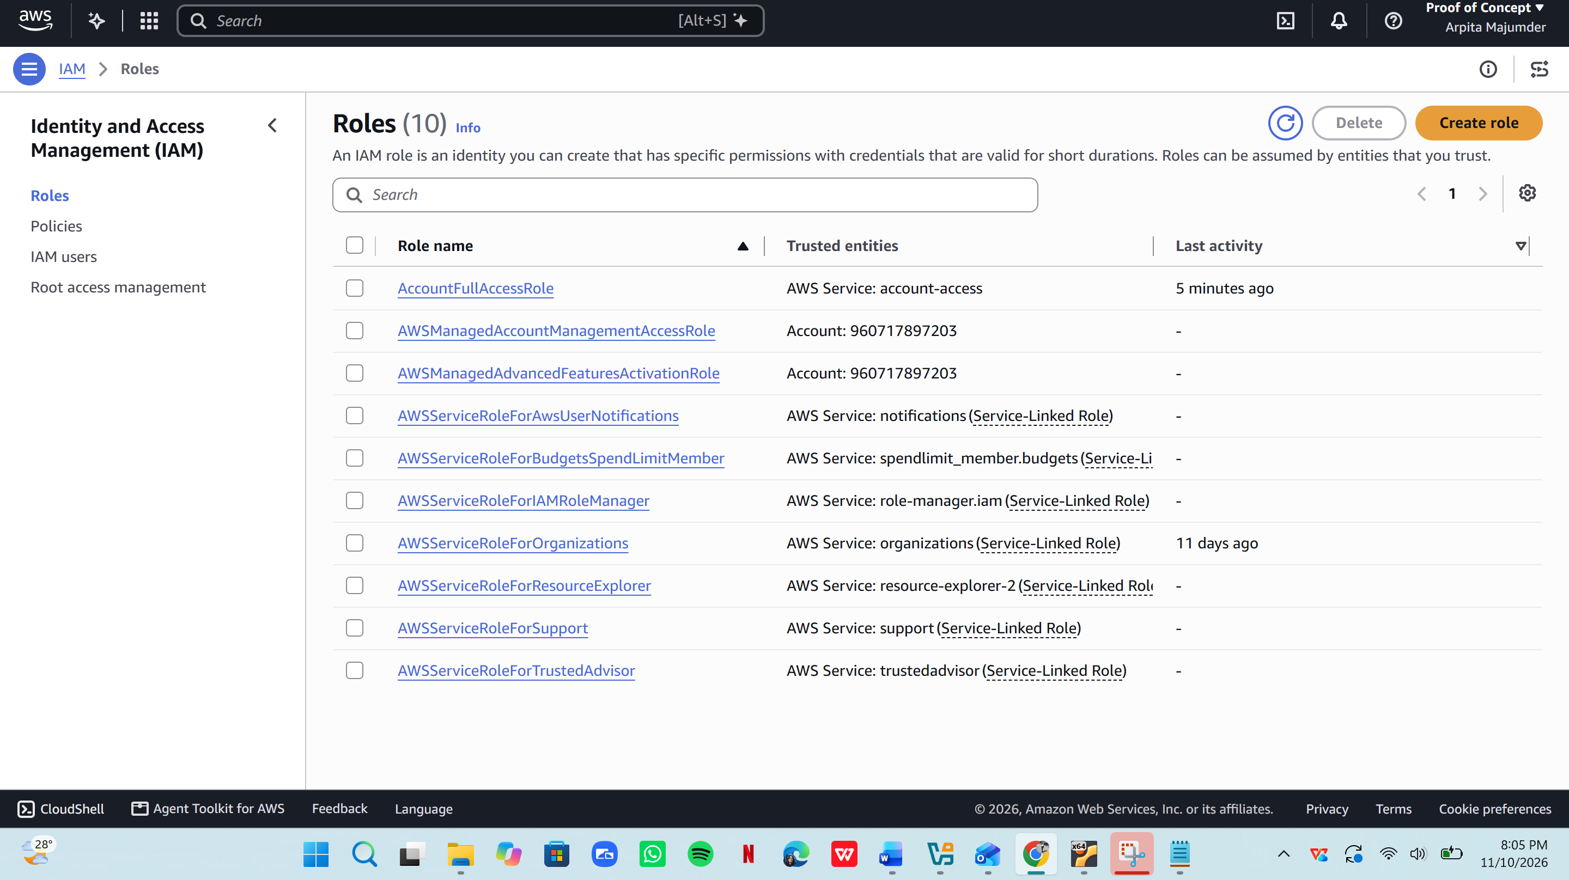
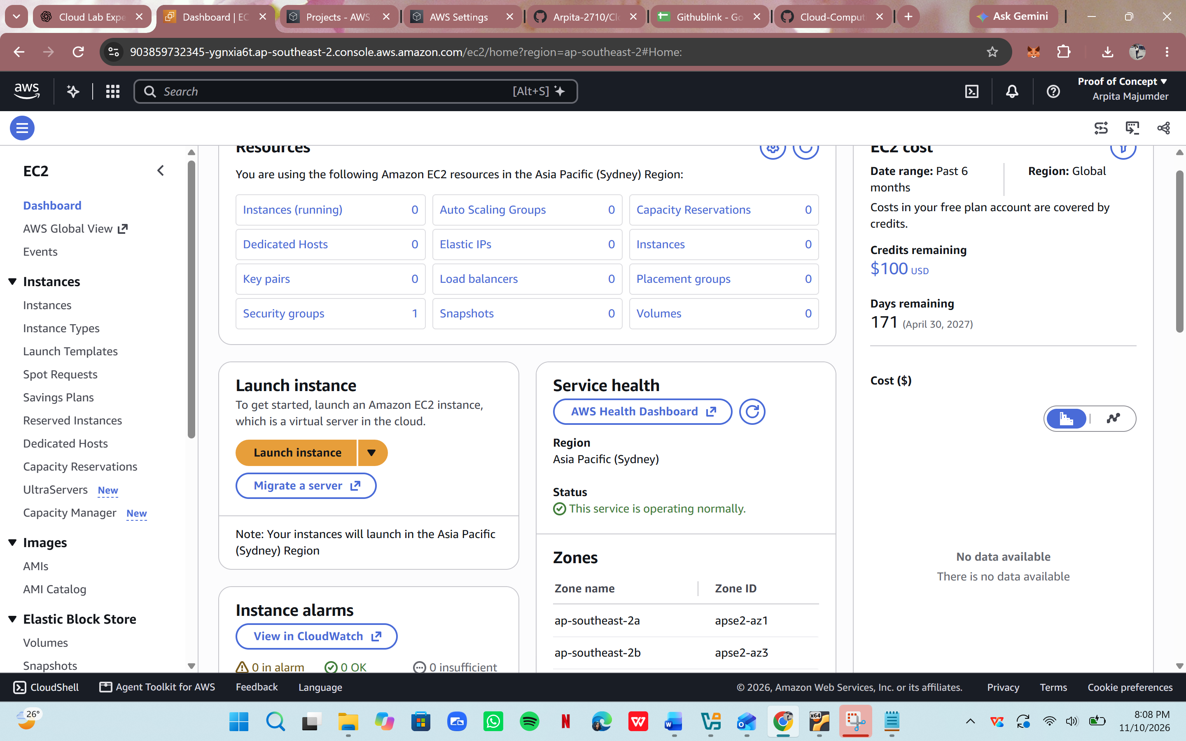
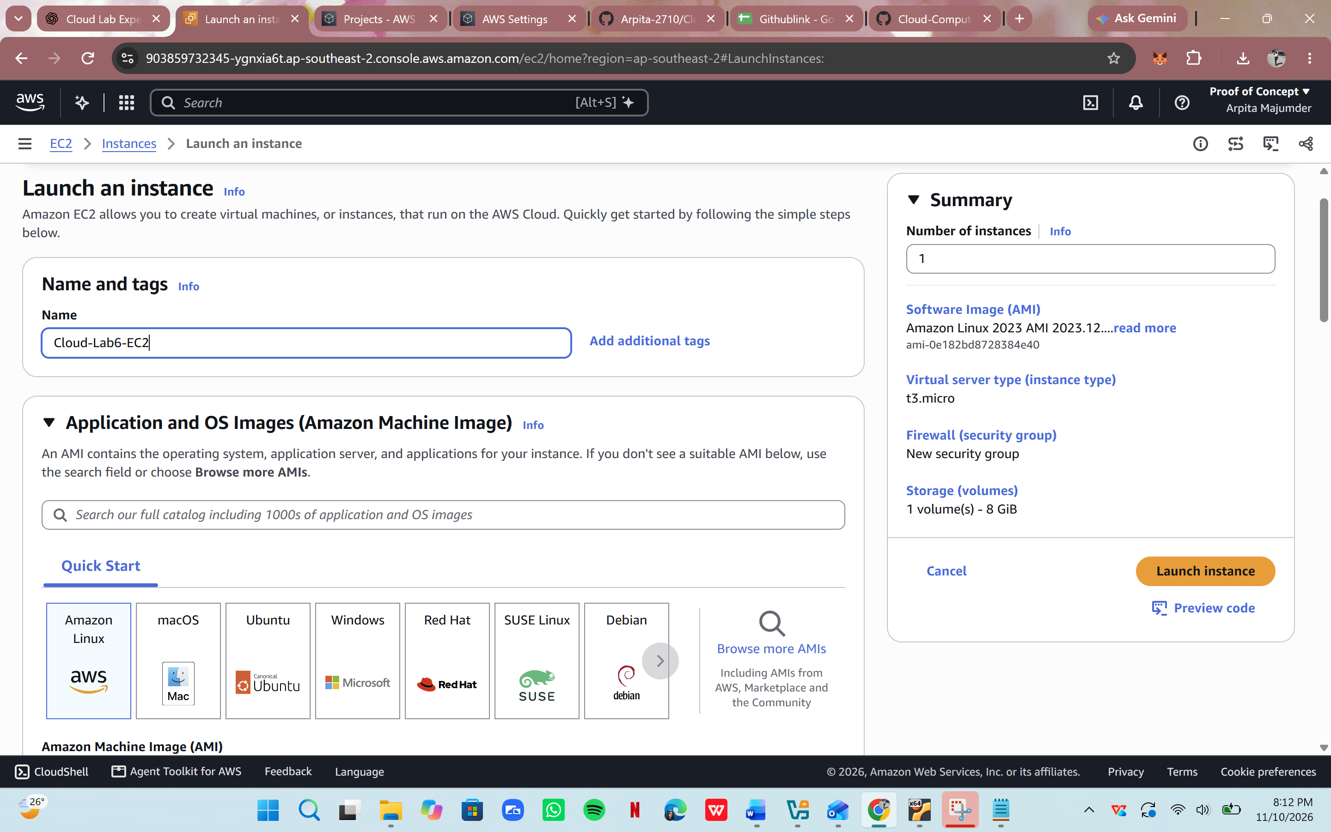
Task 4A: Virtual Networking Using Amazon VPC
Introduction to Amazon VPC
Amazon Virtual Private Cloud (VPC) allows users to create a logically isolated virtual
network within AWS.
It provides control over IP address ranges, subnets, routing and network security.
Step 1: Open Amazon VPC
1. Open the AWS Management Console.
2. Search for VPC.
3. Open the VPC Dashboard.
4. Explore the Your VPCs section.
Step 2: Explore VPC Components
1. Open the Subnets section.
2. Observe the available subnets.
3. Open Route Tables.
4. Identify the associated VPC.
5. Explore Internet Gateways.
6. Open Security Groups.
7. Observe the inbound and outbound rules.
Step 3: Understand Network Communication
A typical cloud network architecture may contain:
• A VPC
• A public subnet
• A private subnet
• An internet gateway
• Route tables
• Security groups
A public subnet can provide internet connectivity when its routing and security configuration allow it. A private subnet generally does not have a direct route to an internet gateway.
Expected Result: Students should understand the basic architecture of AWS virtual
networking and identify the different VPC components.
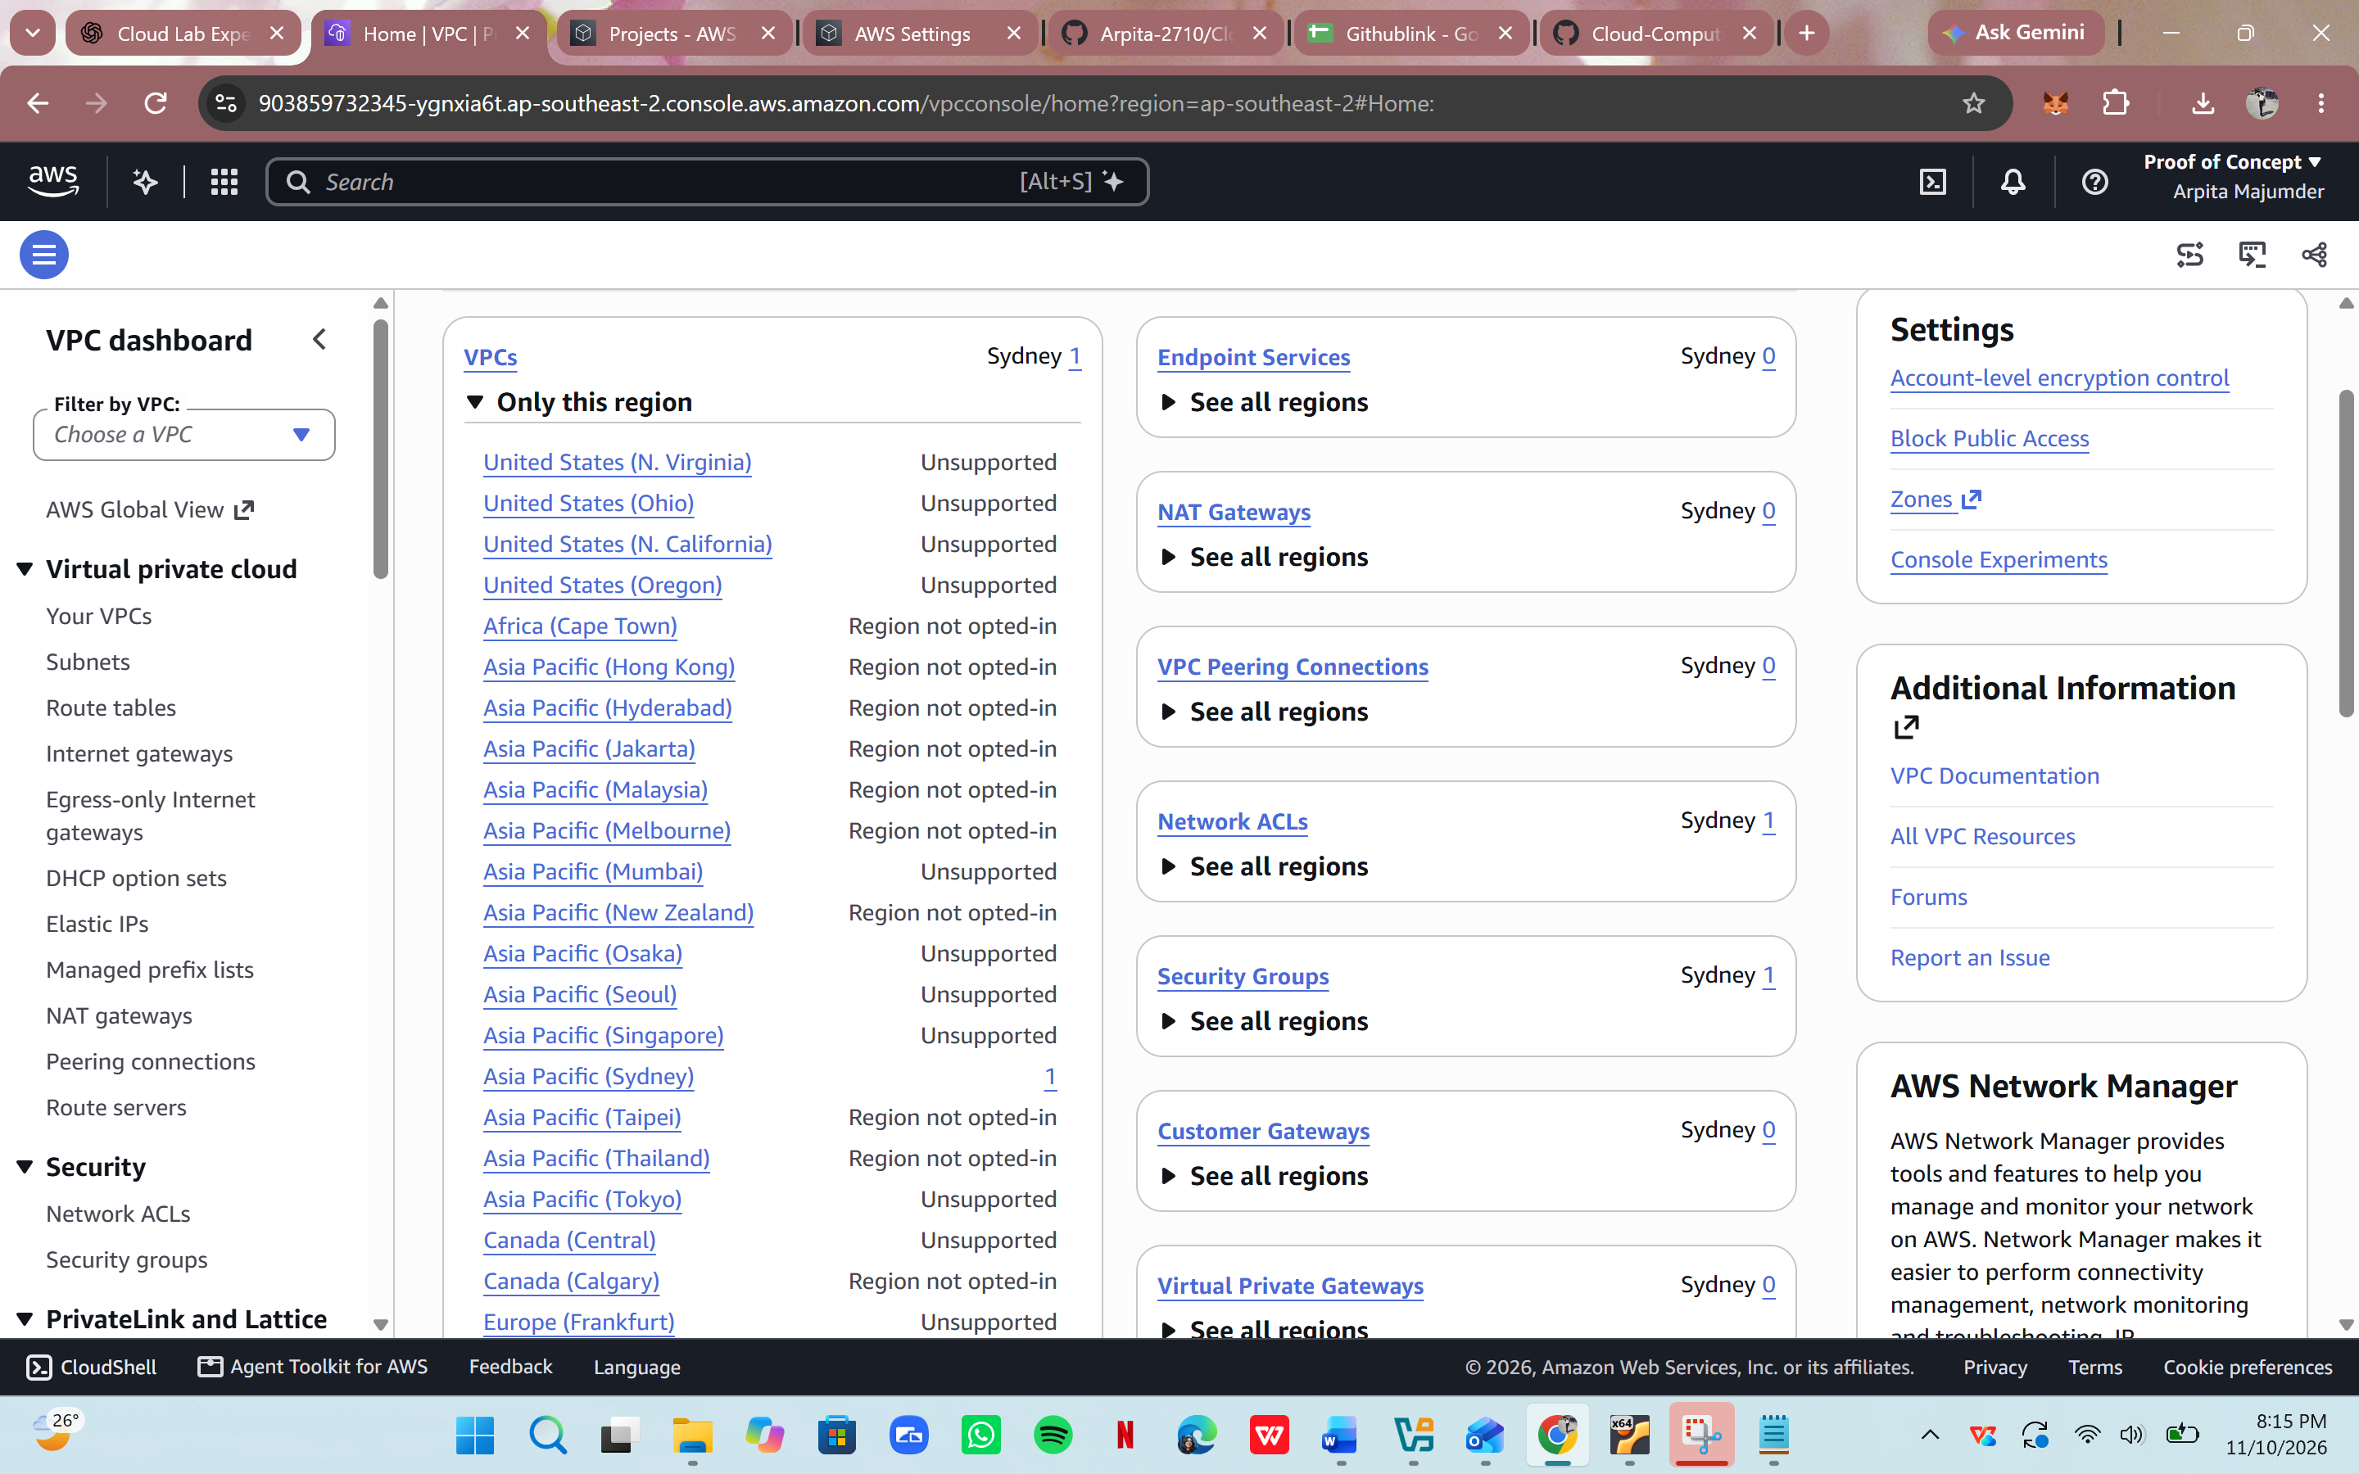
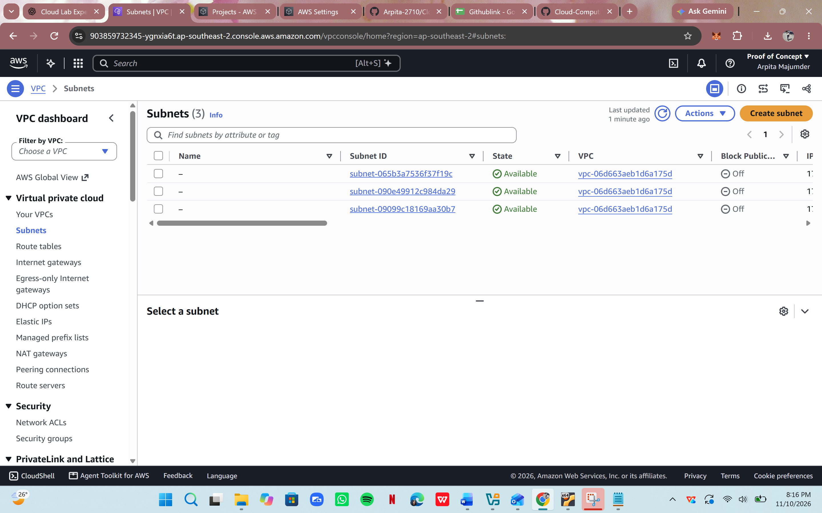
Task 3D: Cloud Monitoring Using Amazon CloudWatch
Introduction to CloudWatch
Amazon CloudWatch is a monitoring and observability service used to monitor AWS
resources and applications.
It collects and displays metrics, logs and other monitoring information.
Step 1: Open CloudWatch
1. Log in to AWS Management Console.
2. Search for CloudWatch.
3. Open the CloudWatch Dashboard.
Step 2: Explore Metrics
1. Open the Metrics section.
2. Explore the available AWS service metrics.
3. Identify how metrics are organised by service.
4. Observe the different metric dimensions.
For example, EC2 instances can provide CPU utilisation metrics.
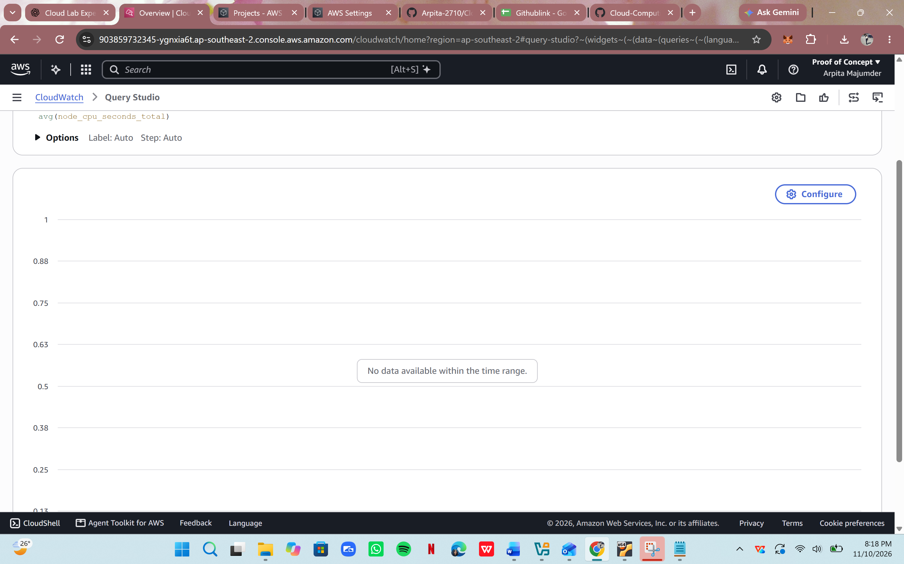
Step 3: Explore CloudWatch Alarms
1. Open the Alarms section.
2. Observe the option to create an alarm.
3. Understand how a metric is selected.
4. Observe how a threshold can be configured.
5. Understand how an alarm can change its state when a threshold condition is met.
Example: An alarm can be configured to notify an administrator when CPU utilisation
exceeds a specified threshold for a defined period.
Expected Result: Students should understand the role of CloudWatch in monitoring cloud resources and detecting performance-related issues.
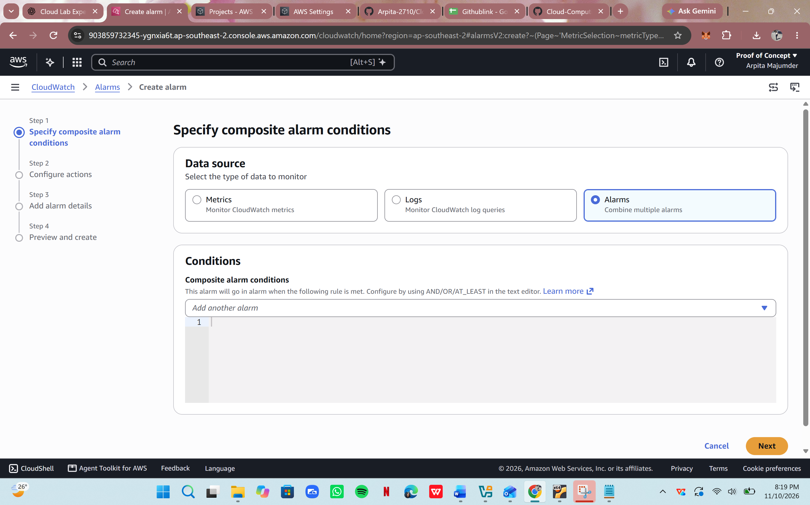
Task 4B: Basic AWS Operations Using AWS CLI
Introduction to AWS CLI
AWS Command Line Interface (CLI) is a tool that allows users to interact with AWS services
through terminal commands.
Instead of using the graphical AWS Management Console, users can execute commands to
manage cloud resources.
Step 1: Open AWS CloudShell
1. Log in to AWS Management Console.
2. Locate the CloudShell icon.
3. Open CloudShell.
4. Wait for the command-line environment to initialise.
CloudShell provides a browser-based terminal connected to the authenticated AWS account.
Alternatively, AWS CLI can be installed in Ubuntu using the official AWS installation
instructions.
Step 2: Verify AWS CLI Installation
For Ubuntu installations:
aws --version
Explanation: Displays the installed AWS CLI version.
Step 3: Verify AWS Account Identity
aws sts get-caller-identity
Explanation: Displays information about the identity associated with the current AWS credentials.
The output includes account and caller information. Avoid sharing sensitive account details in public reports.
Step 4: List Available S3 Buckets
aws s3 ls
Explanation: Lists the S3 buckets accessible to the current identity.
Step 5: Create a Local File
mkdir cloud-lab6-cli
cd cloud-lab6-cli
echo "AWS CLI Cloud Storage Test" > sample.txt
Step 6: Upload the File to S3
aws s3 cp sample.txt s3://YOUR-BUCKET-NAME/sample.txt
Replace YOUR-BUCKET-NAME with the name of the bucket created in Part C.
Explanation: Uploads the local file to the specified S3 bucket.
Step 7: List Objects in the Bucket
aws s3 ls s3://YOUR-BUCKET-NAME/
Explanation: Displays the objects stored inside the specified S3 bucket.
Step 8: Download the File
aws s3 cp s3://YOUR-BUCKET-NAME/sample.txt downloaded.txt
Explanation: Downloads the specified S3 object to the local system.
Step 9: Verify the Downloaded File
cat downloaded.txt
Expected Result: The content of the downloaded file should match the original file.
Step 10: Delete the Test Object
aws s3 rm s3://YOUR-BUCKET-NAME/sample.txt
Explanation: Deletes the specified object from the S3 bucket.
Important: Use only authorised temporary credentials or an approved CloudShell session.
Never place root credentials, secret access keys or private keys in source code, screenshots or reports


