Building and Installing Python3 from Source Using SLURM

Objective
The objective of this task is to:
- Create a SLURM job script
- Build Python 3.12.2 from source code
- Install it system-wide
- Execute the script using sbatch
- Verify successful installation
System Environment Operating System: Ubuntu (WSL)
SLURM Version: 24.11.1
CPUs Available: 12
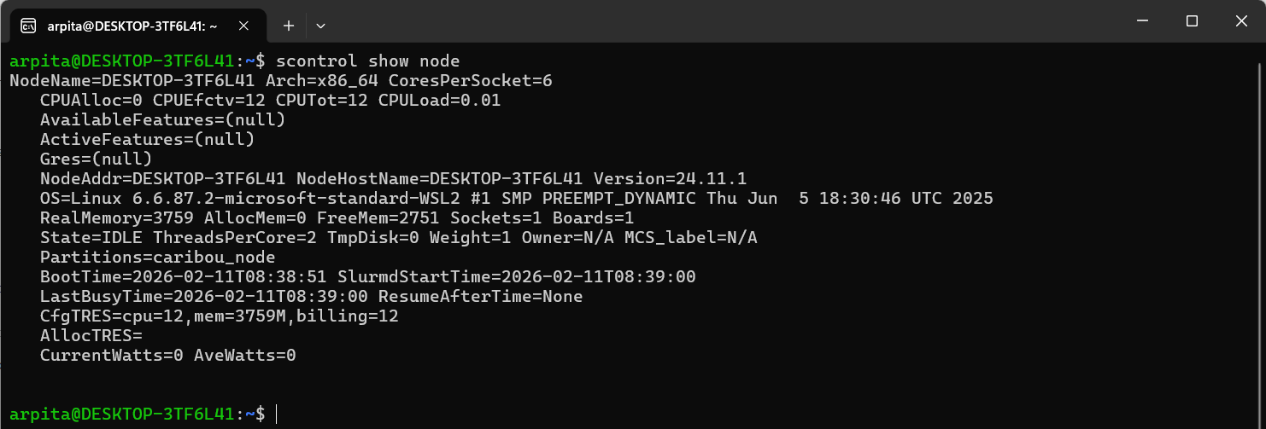
root@DESKTOP-3TF6L41:~# nano python_install.sh
#!/bin/bash
#SBATCH --job-name=build_python
#SBATCH --cpus-per-task=8
#SBATCH --time=00:15:00
#SBATCH --output=build_output.txt
sudo apt update
sudo apt install -y build-essential zlib1g-dev libncurses5-dev libgdbm-dev libnss3-dev libssl-dev libreadline-dev libffi-dev libsqlite3-dev libbz2-dev liblzma-dev wget
wget https://www.python.org/ftp/python/3.12.2/Python-3.12.2.tgz
tar -xvf Python-3.12.2.tgz
cd Python-3.12.2
./configure --prefix=/usr/local
make -
sudo make altinstall
python3.12 –version
OUTPUT:

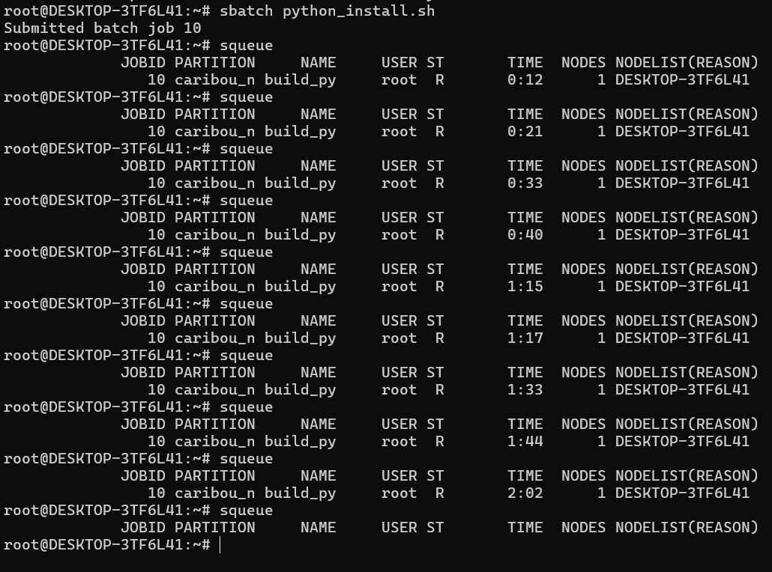
- cat build_output.txt

