Week2:JUnit Basic Testing Exercise

# Exercise 1: Setting Up JUnit

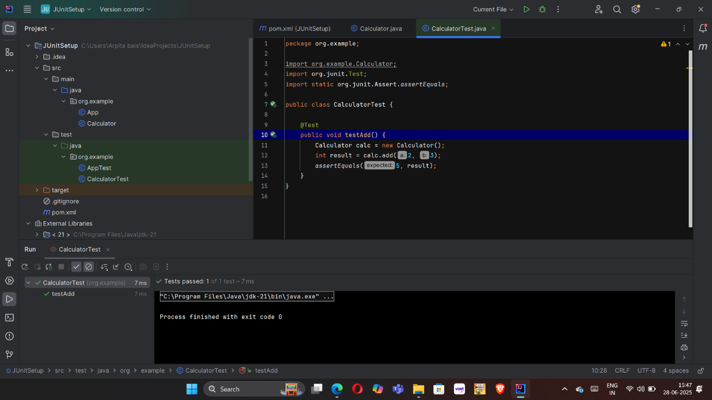

# Exercise 3: Assertions In JUnit

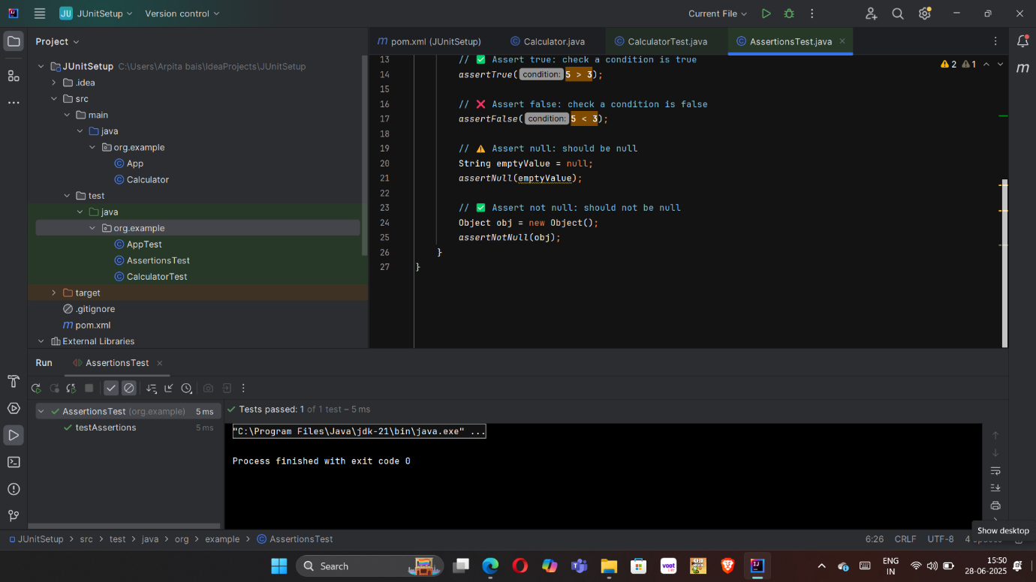

# Exercise 4: Arrange-Act-Assert (AAA) Pattern, Test Fixtures, Setup and Teardown Methods in JUnit

**-- SampleCalculator.java**

package org.example;  
  
public class SimpleCalculator {  
 public int add(int a, int b) {  
 return a + b;  
 }  
 public int subtract(int a, int b) {  
 return a - b;  
 } **}**

**-- SampleCalculatorTest.java**

package org.example**;**import org.junit.After**;**import org.junit.Before**;**import org.junit.Test**;**import static org.junit.Assert.\***;**public class SimpleCalculatorTest {  
  
 private SimpleCalculator calculator**;** @Before  
 public void setUp() {  
 calculator = new SimpleCalculator()**;** System.*out*.println("Setup complete.")**;** }  
  
 @After  
 public void tearDown() {  
 calculator = null**;** System.*out*.println("Teardown complete.")**;** }  
  
 @Test  
 public void testAddition() {  
 int result = calculator.add(**10, 5**)**;** *assertEquals*(**15,** result)**;** }  
  
 @Test  
 public void testSubtraction() {  
 int result = calculator.subtract(**20, 8**)**;** *assertEquals*(**12,** result)**;** }  
}

**OUTPUT**

