Week2: Mockito Exercises

# Exercise 1: Mocking and Stubbing

--ExternalApi.java

package org.example**;**public interface ExternalApi {  
 String getData()**;**}

--MyService.java

package org.example**;**public class MyService {  
 private ExternalApi externalApi**;** public MyService(ExternalApi externalApi) {  
 this.externalApi = externalApi**;** }  
  
 public String fetchData() {  
 return externalApi.getData()**;** }  
}

**OUTPUT**

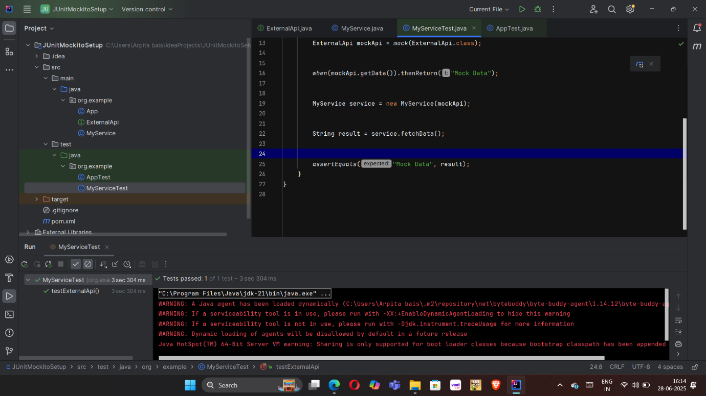

# Exercise 2: Verifying Interactions

