Week6: React

HandsOn 1: my-react-app

**FILE NAME: App.js**

import React from 'react'

function App() {

  return (

    <div>

      <h1 style={{textAlign:"center"}}>Welcome to first session of React</h1>

    </div>

  )

}

export default App;

**OUTPUT:**

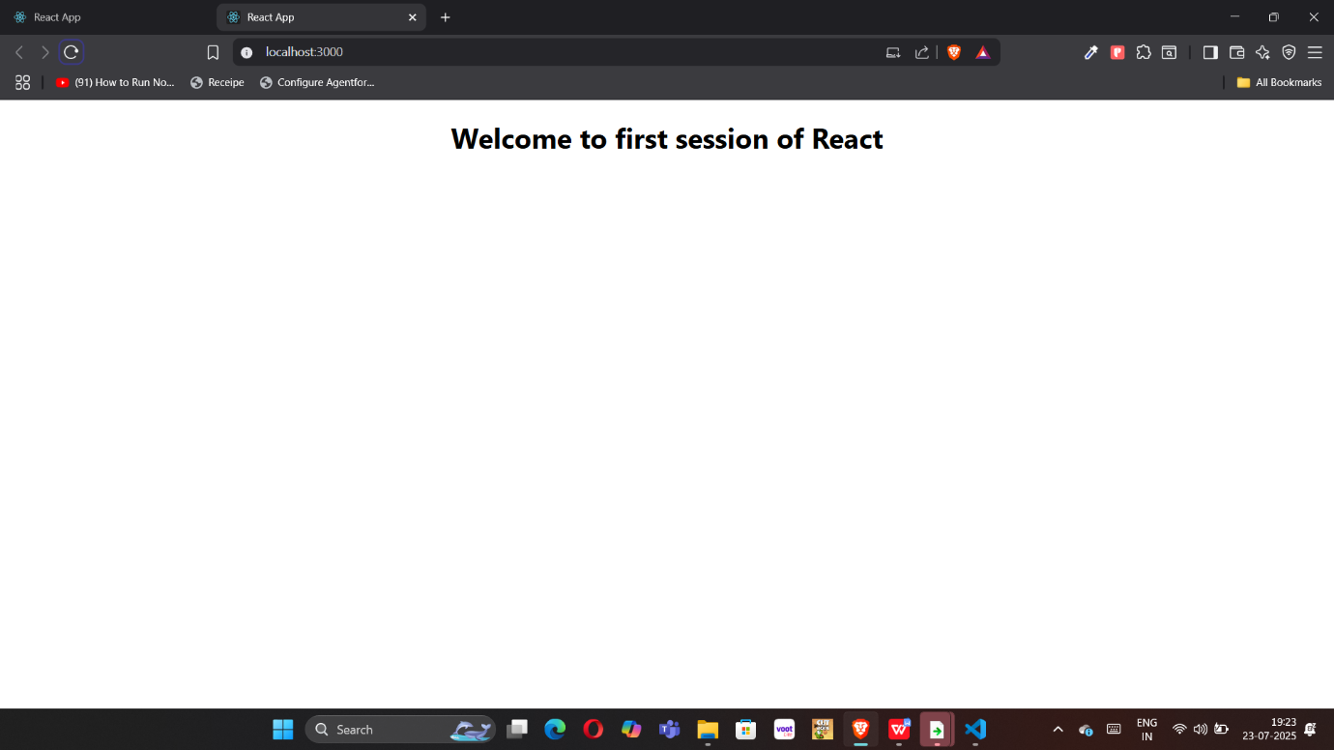

HandsOn 2:studentapp

**FILE NAME: Components/About.js**

import React from 'react'

function About() {

  return (

    <div>

      <h1 style={{textAlign:"center"}}>Welcome to About page of Student Management Portal</h1>

    </div>

  )

}

export default About

**FILE NAME: Components/ Home.js**

import React from 'react'

function Home() {

  return (

    <div>

      <h1 style={{textAlign:"center"}}>Welcome to Home page of Student Management Portal</h1>

    </div>

  )

}

export default Home;

**FILE NAME: Components/Contact.js**

import React from 'react'

function Contact() {

  return (

    <div>

<h1 style={{textAlign:"center"}}>Welcome to Contact page of Student Management Portal</h1>

    </div>

  )

}

export default Contact

**FILE NAME: App.js**

import React from 'react'

import Home from './Components/Home'

import Contact from './Components/Contact'

import About from './Components/About'

function App() {

  return (

    <div >

      <Home/>

      <Contact/>

      <About/>

    </div>

  )

}

export default App;

**OUTPUT:**

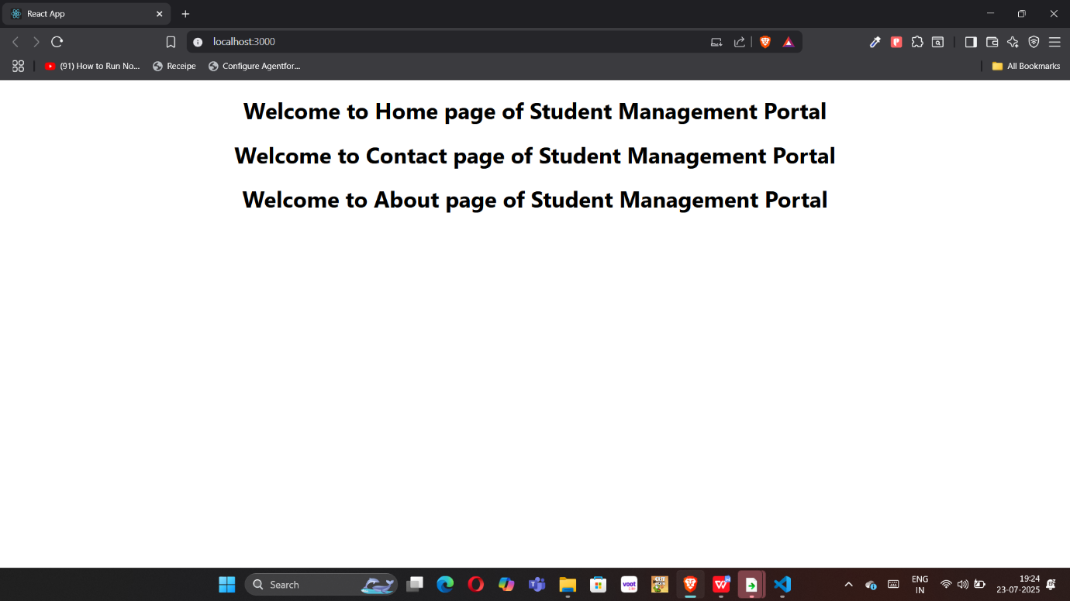

HandsOn 3:scorecalculatorapp

**FILE NAME: Components/Calculator.js**

import '../Stylesheets/mystyle.css';

// Converts a decimal to a percentage string

const percentToDecimal = (decimal) => {

  return (decimal * 100).toFixed(2) + '%';

};

// Calculates the score as a percentage

const calcScore = (total, goal) => {

  return percentToDecimal(total / goal);

};

// Main component

export const CalculateScore = ({ Name, School, total, goal }) => (

  <div className="formatstyle">

    <h1 style={{ color: 'brown' }}>Student Details:</h1>

    <div className="Name">

      <b><span>Name: </span></b>

      <span>{Name}</span>

    </div>

    <div className="School">

      <b><span>School: </span></b>

      <span>{School}</span>

    </div>

    <div className="Total">

      <b><span>Total:</span></b>

      <span>{total}</span>

      <span> Marks</span>

    </div>

    <div className="Score">

      <b>Score:</b>

      <span>{calcScore(total, goal)}</span>

    </div>

  </div>

);

**FILE NAME: StyleSheets/mystyle.css**

.Name {

  font-weight: 300;

  color: blue;

}

.School {

  color: crimson;

}

.Total {

  color: darkmagenta;

}

.formatstyle {

  text-align: center;

  font-size: large;

}

.Score {

  color: forestgreen;

**FILE NAME: App.js**

import React from 'react'

import { CalculateScore } from './Components/CalculateScore'

function App() {

  return (

    <div>

      <CalculateScore Name={"Steeve"}

      School={"DNV Public School"}

      total={284}

      goal={3}/>

    </div>

  )

}

export default App;

**OUTPUT**

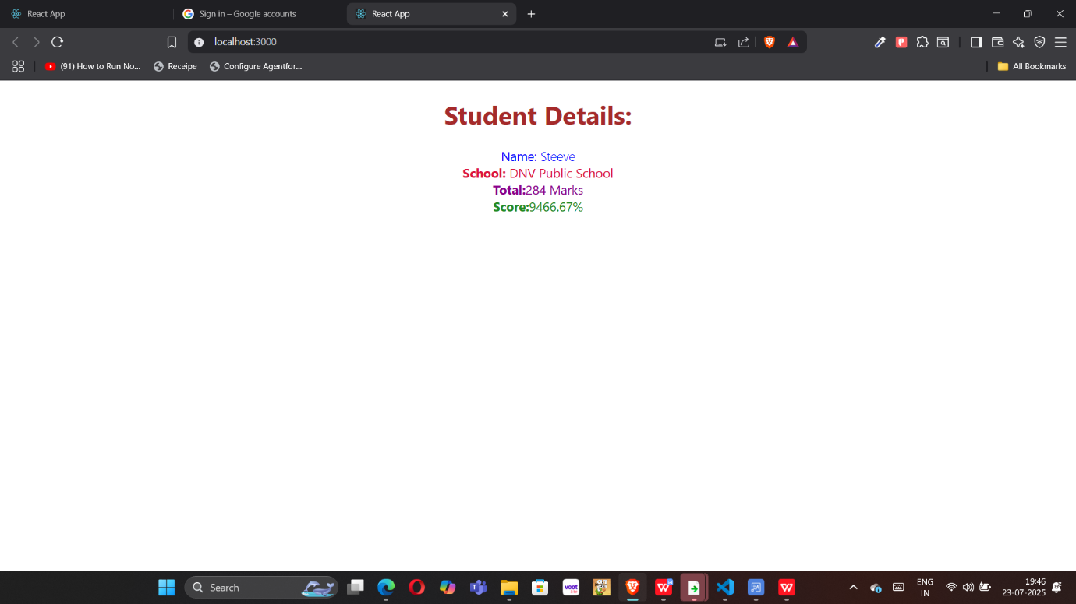

HandsOn 4:blogapp

**FILE NAME: Post.js**

class Post{

    constructor(id, title,body){

        this.id = id;

        this.title = title;

        this.body = body;

    }

}

export default Post;

**FILE NAME: Posts.js**

**// Posts.js**

import React from 'react';

import Post from './Post'; // The model class

class Posts extends React.Component {

    constructor(props) {

        super(props);

        this.state = {

            posts: [],

            hasError: false

        };

    }

    async loadPosts() {

        try {

            const response = await fetch("https://jsonplaceholder.typicode.com/posts");

            const data = await response.json();

            // Use your Post model to create instances

            const postObjects = data.map(item => new Post(item.id, item.title, item.body));

            this.setState({ posts: postObjects });

        } catch (error) {

            console.error("Fetch error:", error);

            this.setState({ hasError: true });

        }

    }

    componentDidMount() {

        this.loadPosts();

**}**

    componentDidCatch(error, info) {

        alert("An error occurred while rendering the component.");

        console.error("Error caught:", error, info);

    }

    render() {

        if (this.state.hasError) {

            return <h1>Something went wrong!</h1>;

        }

        return (

            <div>

                <h1>Blog Posts</h1>

                {this.state.posts.map(post => (

                    <div key={post.id} style={{ marginBottom: '20px' }}>

                        <h2>{post.title}</h2>

                        <p>{post.body}</p>

                    </div>

                ))}

            </div>

        );

    }

}

export default Posts;

**FILE NAME: App.js**

import React from 'react';

import Posts from './Posts';

function App() {

  return (

    <div className="App">

      <Posts />

    </div>

  );

}

export default App;

**OUTPUT** 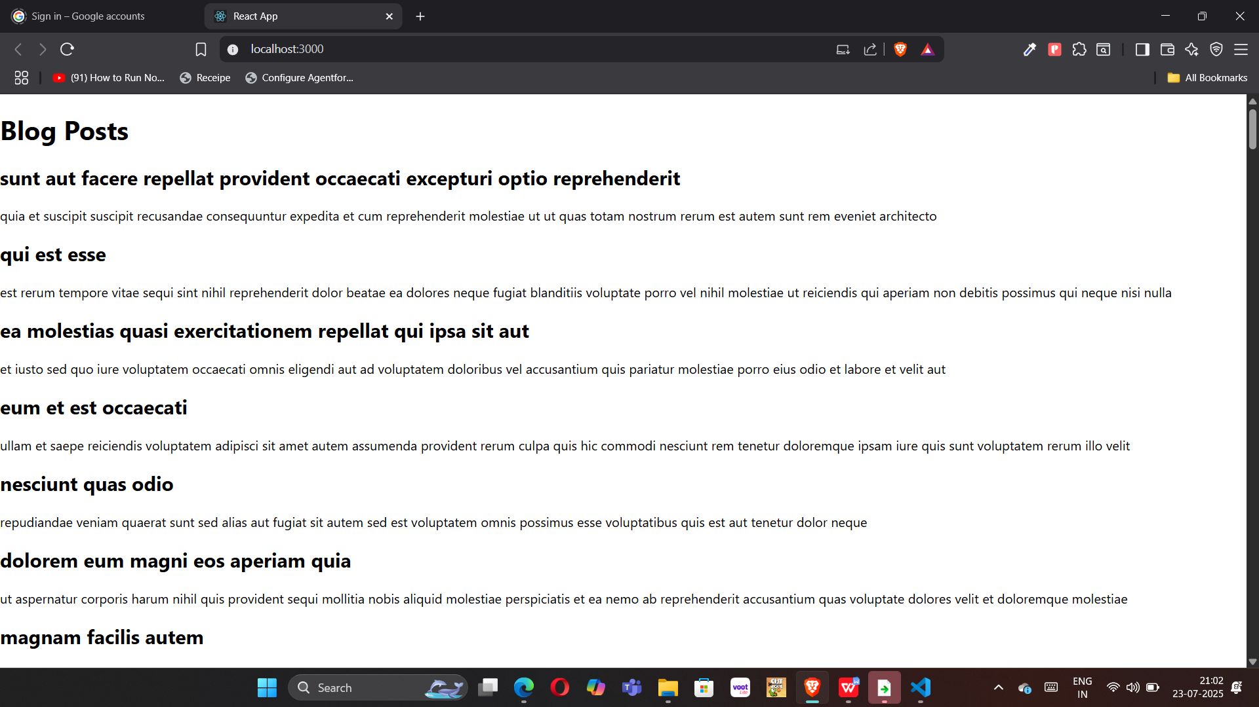

HandsOn 5:cohorttracker

**FILE NAME: Cohort.js**

class Cohort {

    constructor(cohortCode,

        startDate,

        technology,

        trainerName,

        coachName,

        currentStatus) {

        this.cohortCode = cohortCode;

        this.coachName = coachName;

        this.trainerName = trainerName;

        this.technology = technology;

        this.startDate = startDate;

        this.currentStatus = currentStatus;

    }

}

const CohortsData =[

    new Cohort('INTADMDF10','22-Feb-2022', '.NET FSD', 'Jojo Jose','Aathma', 'Scheduled'),

    new Cohort('ADM21JF014','10-Sep-2021', 'Java FSD', 'Elisa Smith','Apoorv', 'Ongoing'),

    new Cohort('CDBJF21025','24-Dec-2021', 'Java FSD', 'John Doe','Aathma', 'Ongoing'),

    new Cohort('INTADMJF12','22-Feb-2022', 'Java FSD', 'To Be Assigned','Ibrahim', 'Scheduled'),

    new Cohort('CDE22JF011','24-Dec-2021', 'Java FSD', 'Emma Swan','Apoorv', 'Ongoing'),

    new Cohort('INTADMDF09','22-Feb-2022', 'Dataware Housing', 'Babjee Rao','Aathma', 'Scheduled'),

    new Cohort('ADM22DF001','10-Sep-2021', '.NET FSD', 'Marie Curie','Ibrahim', 'Ongoing'),

];

export {Cohort, CohortsData};

**FILE NAME: CohortDetails.js**

import styles from "./CohortDetails.module.css"

function CohortDetails(props) {

    return (

        <div className={styles.box}>

            <h3 style={{color:props.cohort.currentStatus == "Ongoing" ? "green": "blue"}}>

                {props.cohort.cohortCode} -

                <span>{props.cohort.technology}</span>

            </h3>

            <dl>

                <dt>Started On</dt>

                <dd>{props.cohort.startDate}</dd>

                <dt>Current Status</dt>

                <dd>{props.cohort.currentStatus}</dd>

                <dt>Coach</dt>

                <dd>{props.cohort.coachName}</dd>

                <dt>Trainer</dt>

                <dd>{props.cohort.trainerName}</dd>

            </dl>

        </div>

    );

}

export default CohortDetails;

**FILE NAME: App.js**

import logo from './logo.svg';

import './App.css';

import { CohortsData} from './Cohort'

import CohortDetails from './CohortDetails';

function App() {

  return (

  <div>

    <h1>Cohorts Details</h1>

    {CohortsData.map(cohort => <CohortDetails cohort={cohort}/>)}

  </div>

  );

}

export default App;

**OUTPUT**

