Week7: React

HandsOn 1: cricketapp

**FILE NAME: IndianPlayer.js**

import React from 'react';

const IndianPlayers = () => {

  const T20players = ["Virat", "Rohit", "Bumrah", "Hardik"];

  const RanjiPlayers = ["Pujara", "Iyer", "Vihari", "Jadeja"];

  // Merging arrays using ES6 spread operator

  const allPlayers = [...T20players, ...RanjiPlayers];

  // Destructuring to get Odd and Even index players

  const oddTeam = allPlayers.filter((_, i) => i % 2 !== 0);

  const evenTeam = allPlayers.filter((_, i) => i % 2 === 0);

  return (

    <div>

      <h2>Odd Team Players</h2>

      <ul>

        {oddTeam.map((player, i) => <li key={i}>{player}</li>)}

      </ul>

      <h2>Even Team Players</h2>

      <ul>

        {evenTeam.map((player, i) => <li key={i}>{player}</li>)}

      </ul>

       <h2>List of IndianPlayers Merged</h2>

      <ul>

        {allPlayers .map((player, i) => <li key={i}>{player}</li>)}

      </ul>

    </div>

  );

};

export default IndianPlayers;

**FILE NAME: ListOfPlayer.js**

import React from 'react';

const ListofPlayers = () => {

  const players = [

    { name: "Virat", score: 85 },

    { name: "Rohit", score: 45 },

    { name: "Dhoni", score: 90 },

    { name: "Hardik", score: 60 },

    { name: "Jadeja", score: 95 },

    { name: "Bumrah", score: 75 },

    { name: "Shami", score: 65 },

    { name: "Rahul", score: 55 },

    { name: "Gill", score: 80 },

    { name: "Surya", score: 68 },

    { name: "Pant", score: 92 },

  ];

  const highScorers = players.filter(p => p.score >= 70);

  return (

    <div>

      <h2>All Players</h2>

      <ul>

        {players.map((player, index) => (

          <li key={index}>{player.name} - {player.score}</li>

        ))}

      </ul>

      <h2>Players with Score ≥ 70</h2>

      <ul>

        {highScorers.map((player, index) => (

          <li key={index}>{player.name} - {player.score}</li>

        ))}

      </ul>

    </div>

  );

};

export default ListofPlayers;

**FILE NAME: App.js**

  import React from 'react';

  import ListofPlayers from './ListofPlayers';

  import IndianPlayers from './IndianPlayers';

  function App() {

    const flag = true; // Toggle between true or false to test

    return (

      <div className="App">

        <h1>Cricket App</h1>

        {flag ? <ListofPlayers /> : <IndianPlayers />}

      </div>);} export default App;

**OUTPUT: when flag == false**

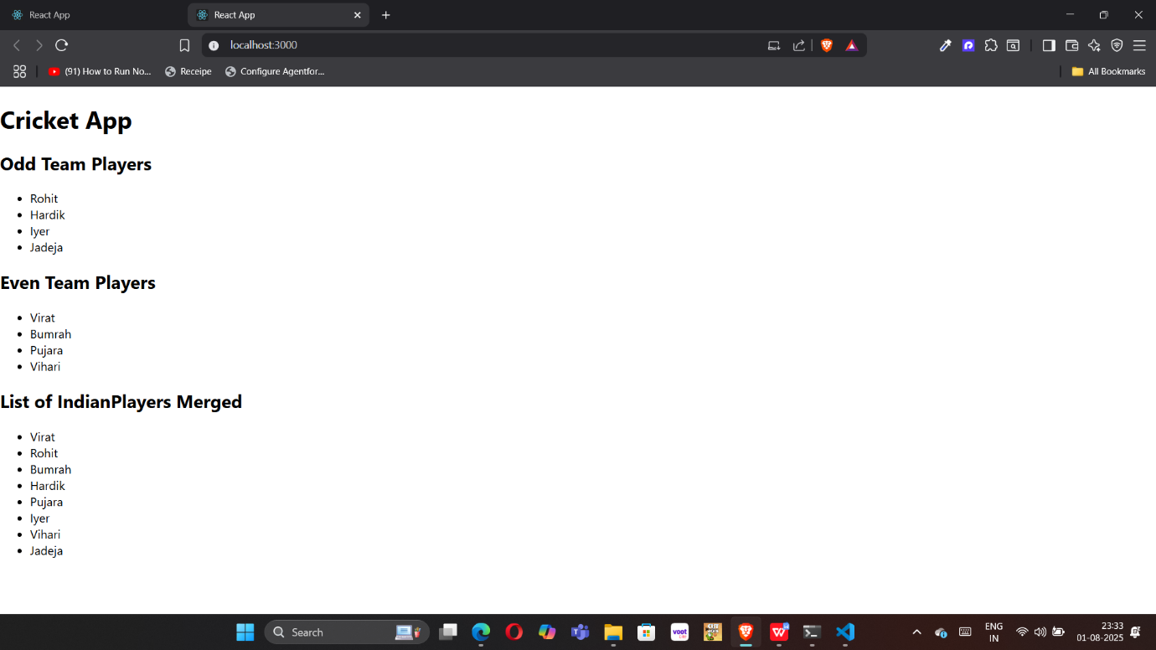

**when flag == true**

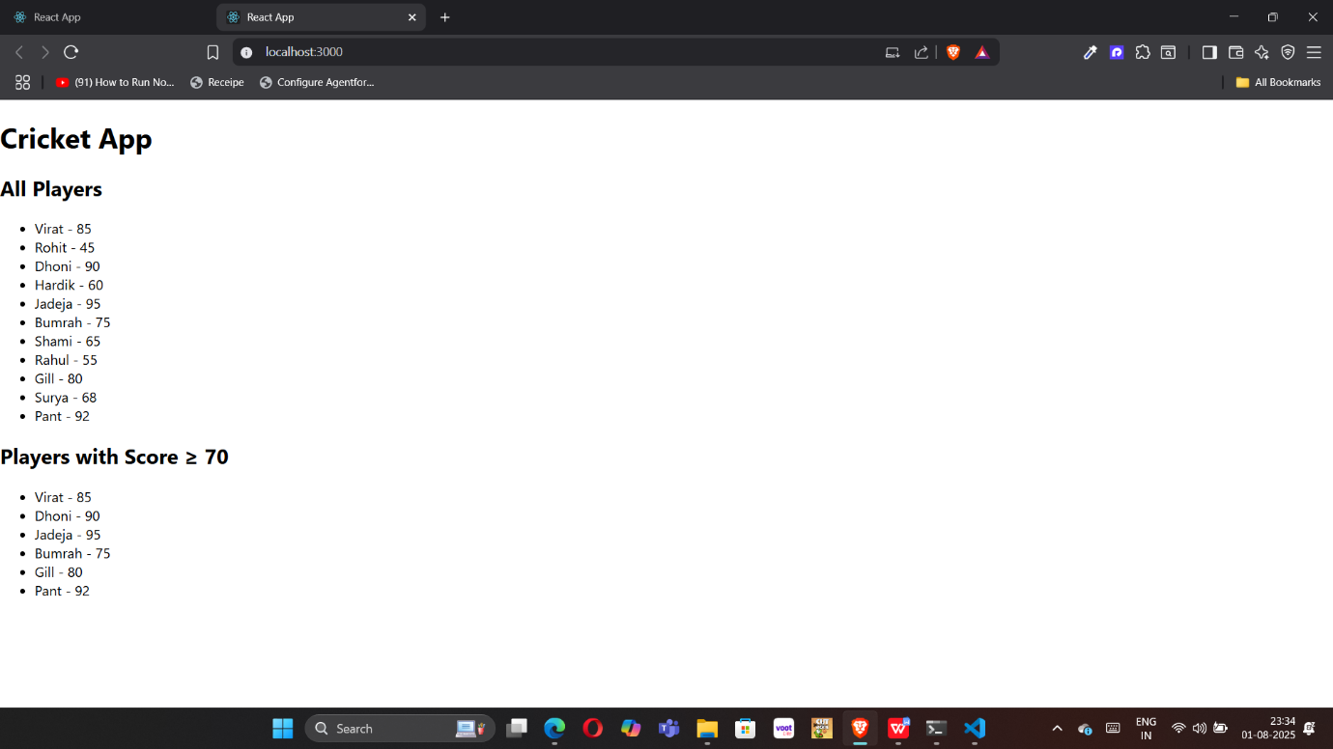

HandsOn 2: officespacerentalapp

**FILE NAME: App.js**

import React from 'react';

function App() {

  const office = {

    name: "AB Foundation",

    rent: 55000,

    address: "Arera, Bhopal",

    image: "20250801_2355_Modern Office Space_simple_compose_01k1ke133venxt2ytd52jnrk06.png"

  };

  const officeList = [

    { name: "PB Park", rent: 70000, address: "Bandra, Mumbai" },

    { name: "Noida Sector", rent: 23000, address: "Kondapur, Hyderabad" },

    { name: "Techno Park", rent: 80000, address: "HSR Layout, Bangalore" },

    { name: "Jk Power", rent: 45000, address: "Wakad, Pune" }

  ];

  // JSX rendering logic

  return (

    <div style={{ textAlign: 'center', fontFamily: 'Arial' }}>

      <h1>Office Space Rental</h1>

      <img src={office.image} alt="Office" style={{ width: '300px', height: '200px' }} />

      <h2>{office.name}</h2>

      <p><strong>Address:</strong> {office.address}</p>

      <p style={{ color: office.rent < 60000 ? 'red' : 'green' }}>

        <strong>Rent:</strong> ₹{office.rent}

      </p>

      <h2>Available Office Spaces</h2>

      {officeList.map((item, index) => (

        <div key={index} style={{

          border: '1px solid gray',

          margin: '10px',

          padding: '10px',

          width: '300px',

          marginLeft: 'auto',

          marginRight: 'auto'

        }}>

          <h3>{item.name}</h3>

          <p><strong>Address:</strong> {item.address}</p>

          <p style={{ color: item.rent < 60000 ? 'red' : 'green' }}>

            <strong>Rent:</strong> ₹{item.rent}

          </p>

        </div>

      ))}

    </div>

  );

}

export default App;

**OUTPUT:**

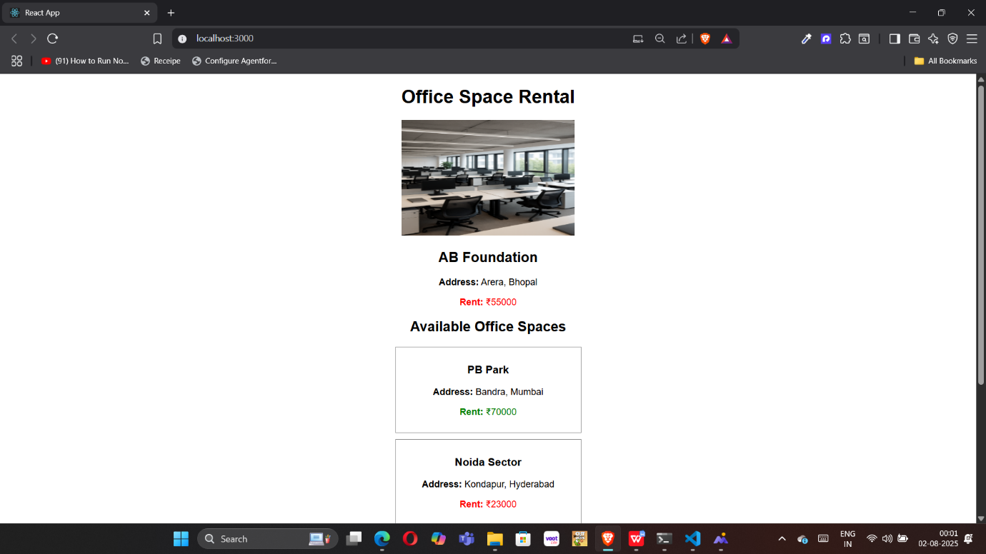

HandsOn 3: eventexamplesapp

**Filename:Counter.js**

import React, { Component } from 'react';

class Counter extends Component {

  constructor() {

    super();

    this.state = {

      count: 0

    };

    // Bind methods

    this.increment = this.increment.bind(this);

    this.decrement = this.decrement.bind(this);

    this.sayHello = this.sayHello.bind(this);

    this.handleMultiple = this.handleMultiple.bind(this);

  }

  increment() {

    this.setState({ count: this.state.count + 1 });

  }

  decrement = () => {

    this.setState({ count: this.state.count - 1 });

  };

  sayHello() {

    alert("Hello! This is a static message.");

  }

  handleMultiple() {

    this.increment();

    this.sayHello();

  }

  render() {

    return (

  <div className="component-box">

    <h2>Counter: {this.state.count}</h2>

    <button onClick={this.handleMultiple}>Increase</button>

    <button onClick={this.decrement}>Decrease</button>

  </div>

);

  }

}

export default Counter;

**Filename:Welcome.js**

import React from 'react';

const Welcome = () => {

  const sayWelcome = (msg) => {

    alert(msg);

  };

  return (

  <div className="component-box">

    <button onClick={() => sayWelcome("Welcome to React Event Handling!")}>

      Say Welcome

    </button>

  </div>

);

};

export default Welcome;

**Filename:SyntheticEventDetails.js**

import React from 'react';

const SyntheticEventDemo = () => {

  const handleClick = (e) => {

    e.preventDefault();

    alert("I was clicked!");

  };

  return (

  <div className="component-box">

    <button onClick={handleClick}>Click Me</button>

  </div>

);

};

export default SyntheticEventDemo;

**Filename:CurrentCurrency.js**

import React, { useState } from 'react';

const CurrencyConvertor = () => {

  const [rupees, setRupees] = useState('');

  const [euros, setEuros] = useState('');

  const handleSubmit = () => {

    const euroRate = 0.011; // Example rate

    const converted = parseFloat(rupees) * euroRate;

    setEuros(converted.toFixed(2));

  };

  return (

  <div className="component-box">

    <h3 style={{color:"green"}}>Currency Convertor</h3>

    <input

      type="number"

      placeholder="Enter amount in INR"

      value={rupees}

      onChange={(e) => setRupees(e.target.value)}

    />

    <br />

    <button onClick={handleSubmit}>Convert</button>

    {euros && <p>Converted Amount: €{euros}</p>}

  </div>

);

};

export default CurrencyConvertor;

**Filename:App.js**

import React from 'react';

import Counter from './Counter';

import Welcome from './Welcome';

import SyntheticEventDemo from './SyntheticEventDemo';

import CurrencyConvertor from './CurrencyConvertor';

function App() {

  return (

    <div className="App">

      <h1 style={{ textAlign: 'center' }}>React Event Handling Lab</h1>

      <Counter />

      <Welcome />

      <SyntheticEventDemo />

      <CurrencyConvertor />

    </div>

  );

}

export default App;

**OUTPUT**

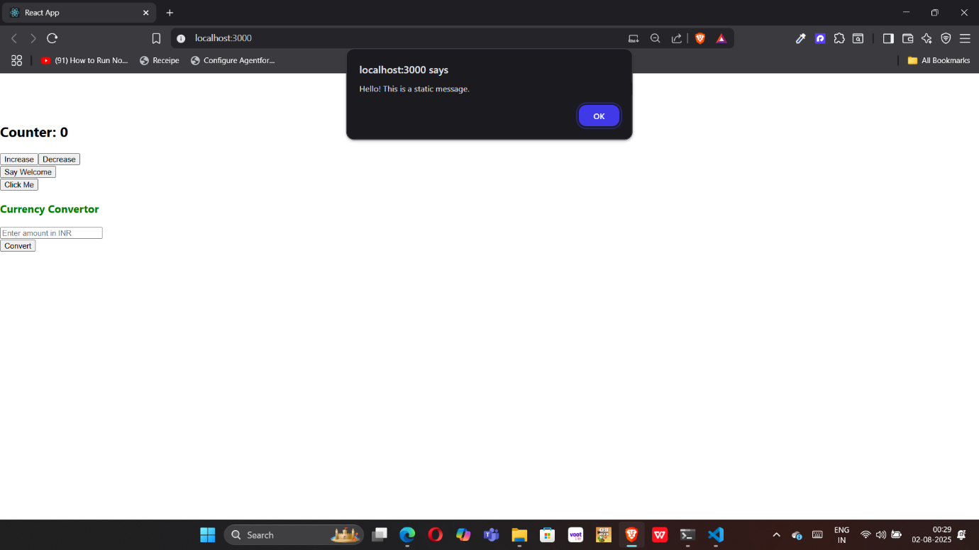

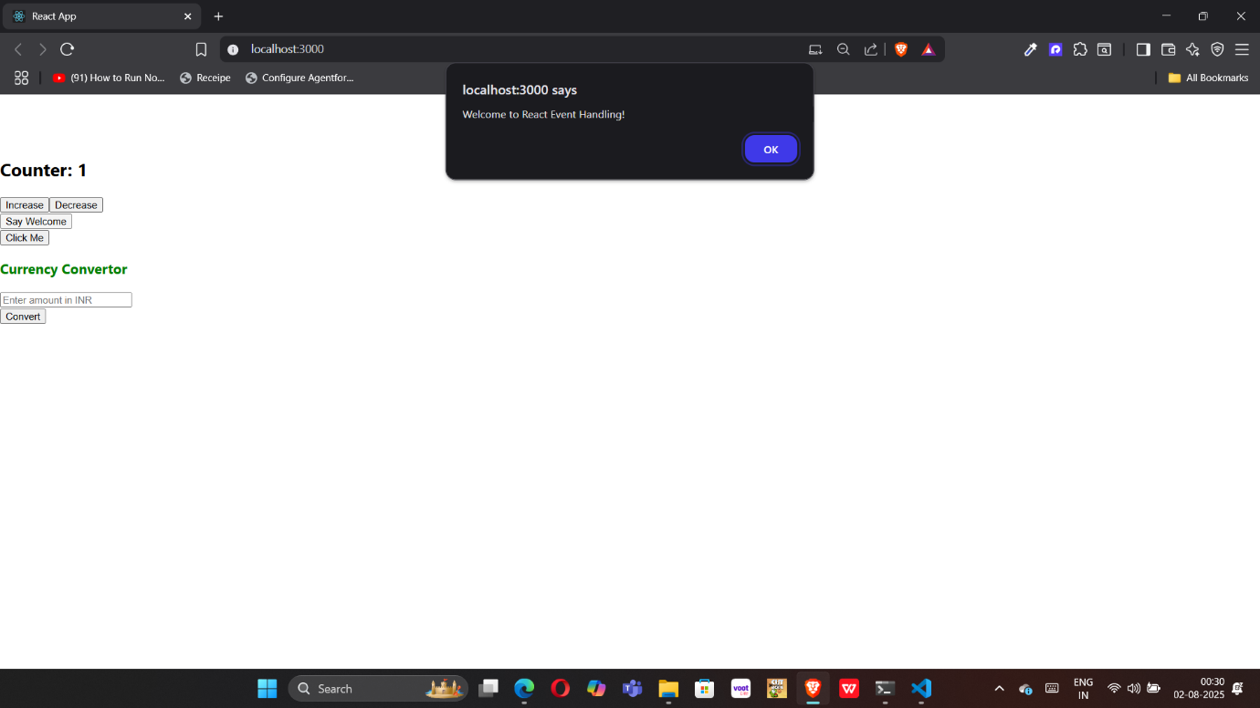

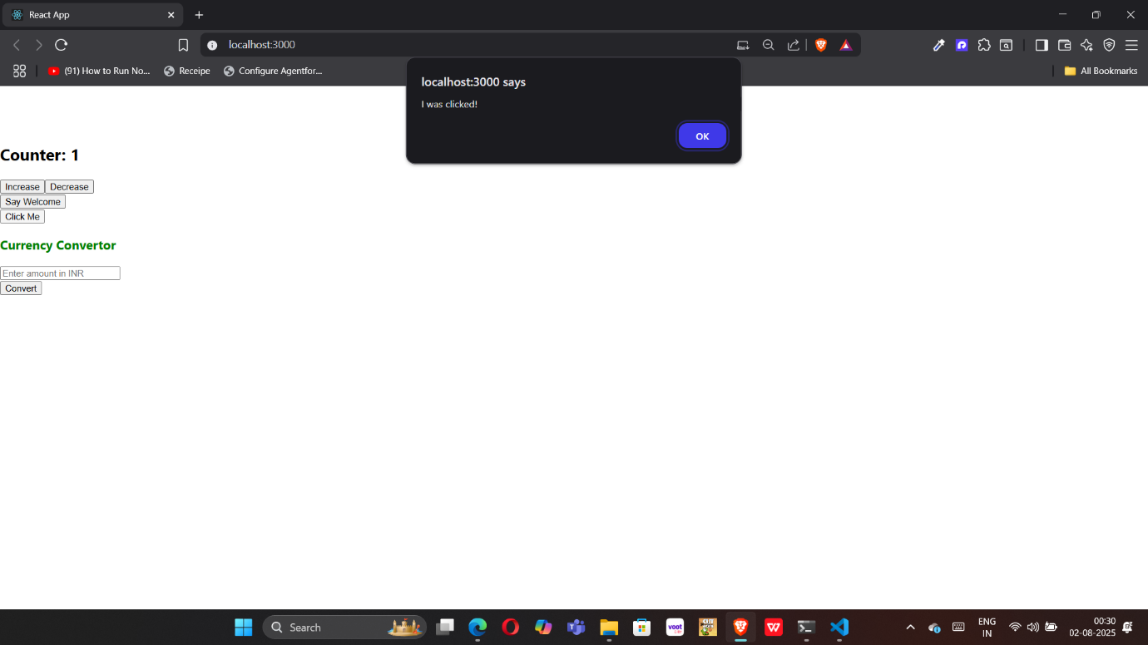

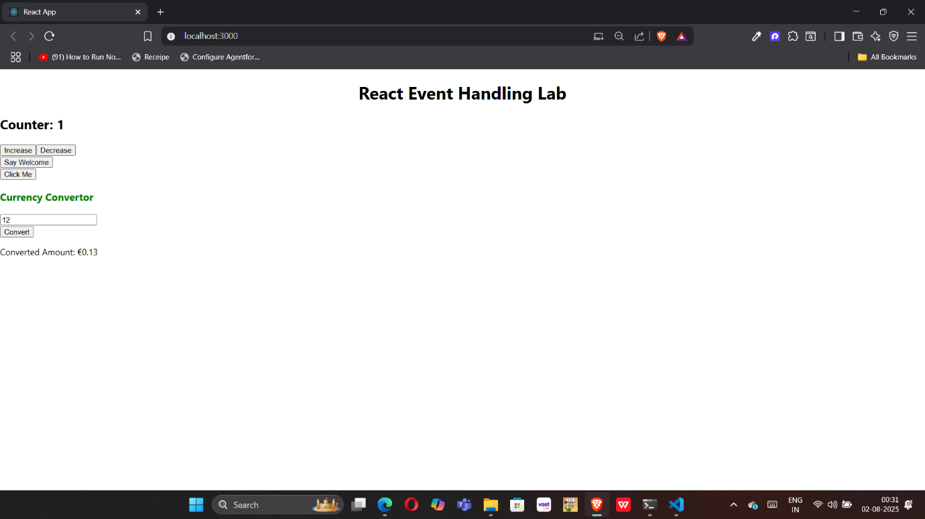

HandsOn 4: ticketbookingapp

**Filename:App.js**

import React, { useState } from 'react';

import GuestPage from './GuestPage';

import UserPage from './UserPage';

import './App.css';

function App() {

  const [isLoggedIn, setIsLoggedIn] = useState(false);

  // Optional: Use element variable (for learning purpose)

  let content;

  if (isLoggedIn) {

    content = <UserPage />;

  } else {

    content = <GuestPage />;

  }

  return (

    <div className="App">

      <h1>Flight Ticket Booking App</h1>

      {/* Conditional button rendering */}

      {isLoggedIn ? (

        <button onClick={() => setIsLoggedIn(false)}>Logout</button>

      ) : (

        <button onClick={() => setIsLoggedIn(true)}>Login</button>

      )}

      {/* Conditional content */}

      {content}

    </div>

  );

}

export default App;

**Filename:Guest.js**

import React from 'react';

const GuestPage = () => {

  return (

    <div className="component-box">

      <h2>Hello, Guest!</h2>

      <p>You can browse flight details here.</p>

    </div>

  );

};

export default GuestPage;

**Filename:UserPage.js**

import React from 'react';

const UserPage = () => {

  return (

    <div className="component-box">

      <h2>Welcome, User!</h2>

      <p>You can now book tickets and view all flight details.</p>

    </div>

  );

};

export default UserPage;

**OUTPUT**

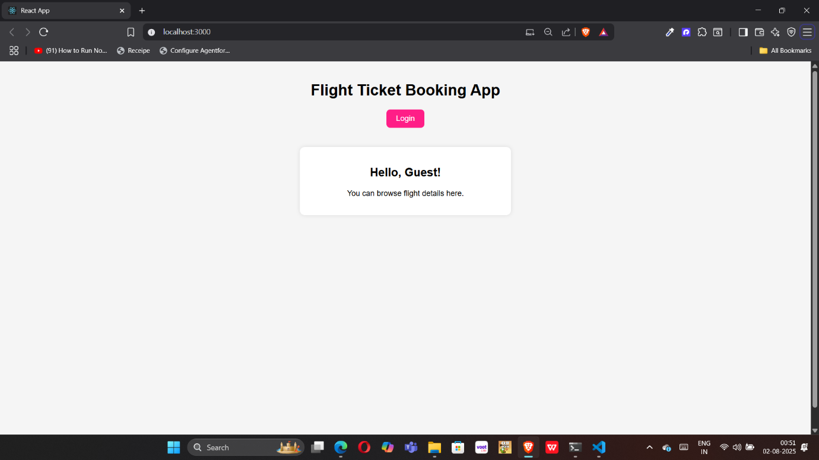

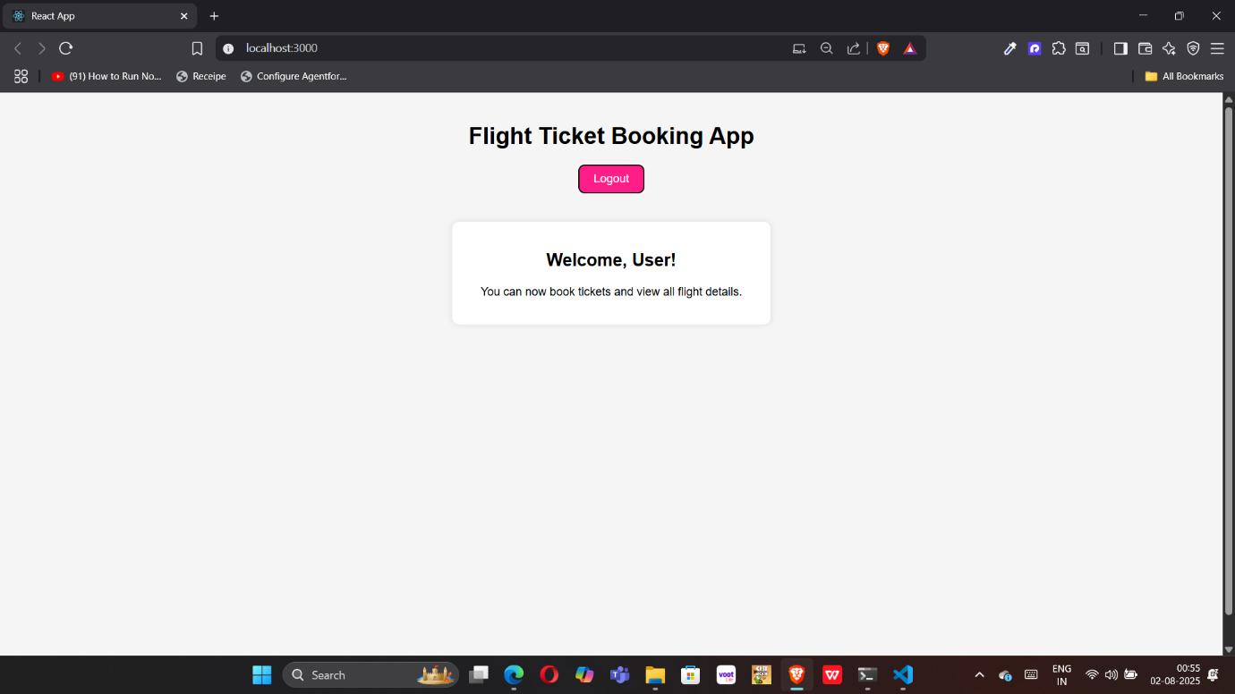

HandsOn 5: bloggerapp

**Filename:App.js**

import React from 'react';

import './App.css';

function App() {

  const courses = [

    { name: "Angular", date: "4/5/2021" },

    { name: "React", date: "6/3/20201" }

  ];

  const books = [

    { title: "Master React", price: 670 },

    { title: "Deep Dive into Angular 11", price: 800 },

    { title: "Mongo Essentials", price: 450 }

  ];

  const blogs = [

    { title: "React Learning", author: "Stephen Biz", content: "Welcome to learning React!" },

    { title: "Installation", author: "Schewzdenier", content: "You can install React from npm." }

  ];

  return (

    <div className="container">

      <div className="column">

        <h2>Course Details</h2>

        {courses.map((c, i) => (

          <div key={i}>

            <strong>{c.name}</strong>

            <p>{c.date}</p>

          </div>

        ))}

      </div>

      <div className="column border-left">

        <h2>Book Details</h2>

        {books.map((b, i) => (

          <div key={i}>

            <strong>{b.title}</strong>

            <p>{b.price}</p>

          </div>

        ))}

      </div>

      <div className="column border-left">

        <h2>Blog Details</h2>

        {blogs.map((b, i) => (

          <div key={i}>

            <strong>{b.title}</strong>

            <p><b>{b.author}</b></p>

            <p>{b.content}</p>

          </div>

        ))}

      </div>

    </div>

  );

}

export default App;

**Filename:BlogDetails.js**

const BlogDetails = () => {

  return (

    <div>

      <h2>Blog Details</h2>

      <p>Title: Why React is Awesome</p>

      <p>Author: John Smith</p>

    </div>

  );

};

export default BlogDetails;

**Filename:BookDetails.js**

const BookDetails = () => {

  return (

    <div>

      <h2>Book Details</h2>

      <p>Title: React for Beginners</p>

      <p>Author: Jane Doe</p>

    </div>

  );

};

export default BookDetails;

**Filename:CourseDetails.js**

const CourseDetails = () => {

  return (

    <div>

      <h2>Course Details</h2>

      <p>Course: Fullstack with React</p>

<p>Instructor: Mary Poppins</p>

    </div>

  );

};

export default CourseDetails;

**OUTPUT:**

