Developer Portal

Anypoint Platform’s API portals provide a centralized place for consumers to discover interactive documentation, tutorials, code snippets, examples and other tools developers need to successfully use your API.

Organisation Exchange Administrator has permission to control the portal.

API Notebook

API Notebook lets you document an API’s functionality with explanations that accompany code windows. Users can change the code and execute it by clicking the Play button in each code block. You can create a new API Notebook from the Exchange editor and use JavaScript code in the code blocks.

API documentation for each resource (the RAML) is often good enough. Especially if you put effort into writing good descriptions and examples of both request and responses.

However the API Notebook can be useful as additional documentation to describe an API. This can be useful when the RAML (or OAS) does not include good documentation or examples. Such as when the OAS is generated from code by some framework.

Another situation is when there are complex relations between different resources of your API. Such so that a normal client would need to make multiple calls to different resources in a certain order.

Also since API Notebooks are interactive, it allows the user to directly execute the code and even change the code and re-execute it. This allows the user to play around with and get a feeling for how the API works.

Also some ppl just like that way of learning better than just reading the specs.

But to be honest I normally do not use API Notebooks as part of the API documentation. I only use it to be able to better explain specific complex use cases.

## Request for access

* To register a client application to an existing API instance or API Group instance, the client application requests access. When the owner of the instance approves the request, a contract is created between the client application and the instance, and the client application is registered.
* Request Access is visible in Exchange only if its configured in API Manager.

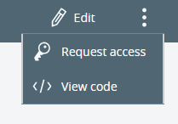

We can see number of approved clients in API Manager.

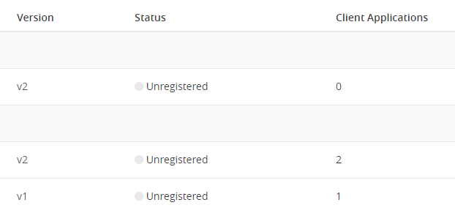

## Share Resources to public portal

* You can use your organization’s public portal to share API assets publicly so that developers inside and outside your organization can access the assets on the public portal.
* one can add and delete the asset in the portal. Adding or deleting asset in the portal will not delete assets in Exchange.
* A public portal is visible to anyone who has the URL of the portal.

<https://anypoint.mulesoft.com/exchange/portals/Domain_Name/>

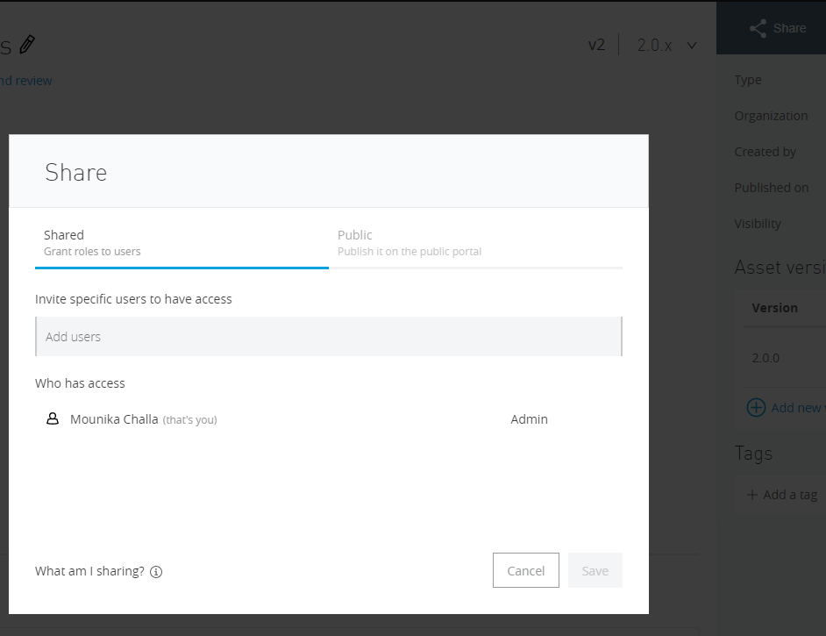

## External Access

Organizations can share API specifications, connectors, and other assets in Anypoint Exchange with each other, without making them public.

* Administrator can add other organisation by using External Access under Access Management.
* Permissions shared between organizations are granted at the organization level. For example, if Organization A grants Organization B permission to view an asset, it grants that permission to every user in Organization B. Organization A does not receive any information about Organization B’s users, sub-organizations, or internal layout.

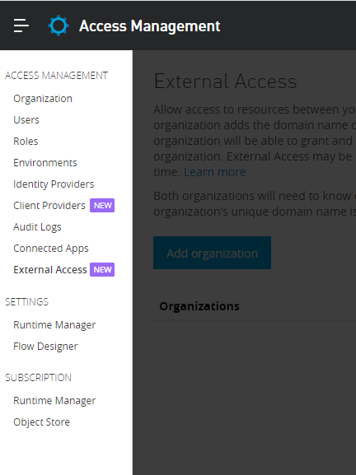

## Deprecate a version of API

* While transitioning from old version to new version of API, we can prevent developers to get access for the old version.
* API Administrator can do that by making the old one as deprecated in API Manager.
* Old contracts remain same but new ones will not be given.
* Indicator will be shown in place of request access button in both version details page and developer portal.

**In API Manager**

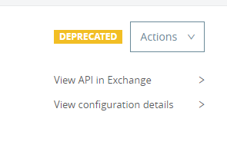

**In Public Portal**

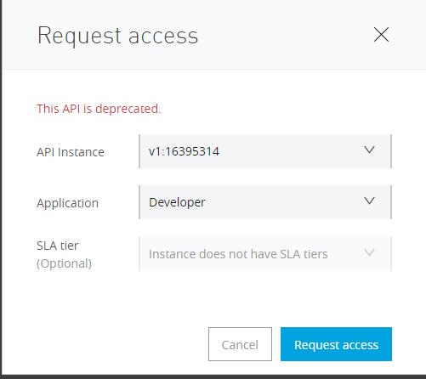

**API Community Manager**

To drive developer adoption of your APIs, you must help them discover and learn how to use your APIs effectively, and provide a personalized, branded experience to motivate them to work with you. You must also engage with these developers during every step of their journey to ensure their success. Anypoint API Community Manager enables you to create this personalized, connected experience for your developers so they can interact with your APIs: APIs designed, cataloged, and managed in Anypoint Platform.

With Anypoint API Community Manager, you can build and operate communities around your APIs for developers and partners, both inside and outside of your organization, who write applications that use your APIs.

API Community Manager is powered by [Salesforce Community Cloud](https://www.salesforce.com/products/community-cloud/overview/) and provides customization, branding, marketing, and engagement capabilities to serve the different needs of your developer audiences. APIs cataloged in [Anypoint Exchange](https://docs.mulesoft.com/exchange/) can be surfaced in API Community Manager for developers to discover them and use them to manage client applications, API access credentials, and consumption metrics.

API Community manager is extending the capabilities of Exchange and useful for the companies who plans to increase the investment in the API products and marketing the developer relations, evangelism and support.