## Title

A

Project Report

*submitted in partial fulfillment of the requirements for the award of the degree of*

#### BACHELOR OF TECHNOLOGY

#### In

#### COMPUTER SCIENCE & ENGINEERING

#### with Specialization in CCVT

###### by

|  |  |  |
| --- | --- | --- |
| **SAP ID** | **Roll No.** | **Name** |
| **500088021** | **R2142201939** | **Harsh Yadav** |

under the guidance of

###### Mr. Saurabh Shanu

Assistant Professor - Senior Scale, Systemics Cluster

School of Computer Science



###### Systemics Cluster School of Computer Science

###### University of Petroleum & Energy Studies Bidholi, Via Prem Nagar, Dehradun, UK April – 2023

1



#### CANDIDATE’S DECLARATION

We hereby certify that the project work entitled **“online File Storage System”** in partial fulfilment of the requirements for the award of the Degree of BACHELOR OF TECHNOLOGY in COMPUTER SCIENCE AND ENGINEERING with specialization in CCVT, and submitted to the Systemics Cluster at School of Computer Science, University of Petroleum & Energy Studies, Dehradun, is an authentic record of my work carried out during the period from **January**, **2023** to **April, 2023** under the supervision of **Mr. Saurabh Shanu,** Assistant Professor - Senior Scale, Systemics Cluster, School of Computer Science.

The matter presented in this project has not been submitted by me for the award of any other degree of this or any other University.

###### Name: Harsh Yadav

###### SAP ID: 500088021

This is to certify that the above statement made by the candidate is correct to the best of my knowledge.

Date: 2023 **Mr. Saurabh Shanu**

(Subject Faculty)

2



School of Computer Science

##### University of Petroleum & Energy Studies, Dehradun

#### Project Based Learning:

###### PROJECT TITLE: Online File Management System ABSTRACT (250-300 words)

Technology is evolving on the day to day basis and there is a wast change on how we can share and store files. With the growing market and the demand for the data storage and the need of cloud computing on the daily basis. With computers becoming a part of our lives at work, at home and even while traveling, the development of the internet has revolutionised our daily lives and complex online applications have enabled us to communicate effectively.

The Internet provides services ranging from mail servers and domain name servers to Web-based workgroup tools. With the growing need to transfer and store digital data, online storage options are becoming popular on the web. There are many different types of storage on the web, from free web servers to online photo libraries to online personal storage. These storage options often allow data to be stored and retrieved online.

Although most of these websites still focus on providing free websites and homepage, we have created an online virtual data center. The system is specially designed for colleges and community colleges. Data storage helps people from various fields such as students and teachers easily, efficiently and reliably manage, access, share and store their online data.

Cloud storage technology is now mature enough to handle large and rapidly changing data called big data. But because cloud storage systems contain large hardware components, failure is inevitable. Improving the performance of cloud storage systems for big data is a huge challenge. Replication and erasure coding are the most important data reliability methods used in cloud storage systems. Both technologies have their own economic differences in many parameters such as durability, availability, storage overhead, network connectivity and traffic, power consumption and recovery operations.

3

The purpose of this project is to design and create an online database that provides information to users to store and share. The website will be built using HTML, CSS, JavaScript and PHP and will be hosted on a web server. The website will have a user-friendly interface that will allow users to easily navigate the website and perform various tasks such as uploading, downloading and sharing files.

###### Keywords: Retrieved,Reliability,Replication,Durability,Recovery.

4

### Contents

INTRODUCTION 1

PROBLEM STATEMENT 7

OBJECTIVE 8

RELATED WORK 9

WHY DO WE NEED CLOUD FOR THE PROJECT 14

4. Accessibility: Cloud computing technology provides the ability to access data easily and securely from anywhere in the world. Online data storage plans can securely store and access data on the Internet using cloud computing technology. This means organizations can access their data from any device or location, making it easy to collaborate and share information. 16

METHODOLOGY 18

ALGORITHM 21

RESULT AND DISCUSSIONS 24

Screenshot: 34

Key Bibliography/References 36

0

# INTRODUCTION

**Title:** Online File Storage System Project: Frontend using PHP, backend using AWS EC2, S3, RDS, phpMyAdmin

###### Introduction

With increasing demand of digital content, businesses and individuals need stable power to store, manage and access information from anywhere. To meet this need, I have developed an online storage plan that leverages the power of PHP for front-end development and Amazon Web Services (AWS) for back-end processing. The front-end and the back-end are the two primary parts of the online file storage system. The user interface, via which users upload, download, and manage their files, is the responsibility of the front-end. Business logic, authentication, and file storage are all taken care of by the back-end.

Online File Storage System project, a web application designed to provide users with a secure platform to store and access their files anytime, anywhere. This project has been developed using modern technologies such as HTML, CSS, JavaScript and PHP.

Online data store has two main parts, front-end and back-end. The front end is responsible for the user interface where users can upload, download and manage their files. The backend manages the business logic, authentication, and data storage.To deploy this project to an EC2 instance, we need to perform a few steps. First of all, we need to create an EC2 instance, configure it and install the necessary packages such as Python, Apache, MySQL. Next, we need to load our project files into the instance, configure the Apache web server, and configure the files.

in order to deploy this project on an EC2 server, I have undergo some steps, We must first establish an EC2 instance, set it up, and install the required applications like Php, Apache, and MySQL. The Apache web server must then be configured and the database must be set up before we can upload our project files to the instance.

Users can view the project through a web browser after it has been deployed on the EC2 instance. Any device with an internet connection can access the responsive user interface. After creating an account, users can log in and begin uploading files to the server.

Users can save and access their data on a safe platform thanks to the project's online file storage system. For people and companies who need a dependable and accessible platform to store their data, it is the perfect answer. This project can be modified to meet various demands and specifications because to its simplicity of use and flexibility.

Online data storage has become an integral part of daily business and personal life. With the rise of digital information, people need a secure platform to store and access their information anytime and anywhere. This is where the online file storage system project comes in handy. Online File Storage System Project is a web application designed to provide users with a secure platform to store and access their files anytime, anywhere. I explain the whole process and how we use it on an EC2 instance.

Functionalities of an Online Storage System

Online storage solutions, commonly referred to as cloud storage, have integrated seamlessly into our daily lives. They enable us to securely store our data, provide others access to it from wherever, and collaborate on it. We shall thoroughly examine the features of online storage solutions in this post.

* File Storage and Backup: Providing file storage and backup is one of the main functions of an online storage system. Users can upload items to the cloud storage platform, including documents, images, videos, and other forms of data. The user can still access the files via the cloud even if they lose their device or unintentionally delete them because the contents are safely saved on the cloud server.
* File sharing is another important feature of online storage platforms. By sending them a link or inviting them to access the data stored on the cloud server, users can share their files with other people. Businesses that need to share huge files with customers, staff members, or suppliers may find this capability especially helpful. Users can determine who gets access to their files, for how long, and how file sharing is managed.
* Collaboration is possible between users of online storage systems. The same file can be updated simultaneously by several individuals, with real-time changes visible to all. Businesses that need to work together on projects, whether they be talks, documents, or databases, will find this option to be especially useful.
* Online storage platforms effectively sync data between devices. As a result, any modifications made to a file on one device will be reflected on all of the user's other devices. Regardless of the device they are using, this feature makes sure users always have access to the most recent version of their data.
* Access Control: Users have access control with online storage systems. Users have control over who and how long has access to their files. Users can manage who accesses and updates their files thanks to this functionality, which is crucial for sensitive data.
* Security: To protect user data, online storage solutions offer high levels of security. Data is encrypted during both transport and storage to prevent access from unauthorised parties. In order to prevent unauthorised access, online storage systems also use authentication protocols like two- factor authentication.
* Integration: Online storage solutions can be integrated with other programmes, including project management software, productivity software, and email clients. Users may access their files from within these programmes thanks to this connection, making it simpler to collaborate and complete tasks.

###### Online file storage components:

online file storage system has two main parts: front-end and back-end. The front end is responsible for the user interface where users can upload, download and manage their files. The backend manages the business logic, authentication, and data storage.

###### Front-End Development with PHP

* PHP is used for front-end development, and AWS EC2, S3, RDS, and phpMyAdmin are used for back-end development. PHP is a well-known server-side scripting language that is utilized extensively in web development. For the following reasons, PHP was our choice: PHP is well-supported and open source, with frequent updates and a large community of supporters. PHP makes it simple to create dynamic web pages that interact with databases, making it ideal for web development. PHP has a lot of extensions and libraries that make it easy to develop applications quickly and connect them to other technologies.
* Our project for online data storage aims to provide users with a safe and effective platform for digital data storage, management, and access. Options for file management, sharing, and user authentication will be included in the system. PHP will be used to build the front end for the best user experience, and AWS services like EC2, S3, RDS, and phpMyAdmin will use the backend.

###### Front-End Components:

The front-end of the Online File Storage System project is built using modern web technologies such as HTML, CSS, and PHP. The user interface is responsive and can be accessed from any device with an internet connection.The front end is responsible for the following functions:

1. User Registration: User can create an account by providing a name, email and password. The registration process is simple and straightforward.
2. User login: After creating an account, the user can log in to the system using his e-mail address and password.
3. File Upload: Users can upload their files to the server by selecting the file and clicking the upload button.
4. File Download: Users can download their files from the server by selecting the file and pressing the download button.
5. Data Management: Users can manage their own data by renaming, deleting and sharing it with other users.

Our front end will include the following functions:

* A user interface for saving, logging in and managing user data.
* Ability to upload, download and delete files.
* Files organized by folders and metadata tags.
* The data search function has a fast data collection feature.
* Share option to easily collaborate with other users.

###### Back-End Infrastructure Using AWS

I choose Amazon Web Services (AWS) as our back-end infrastructure because of its reliability, scalability, and overall services. AWS provides a variety of tools and specialized services that meet our data needs.

EC2 (Elastic Compute Cloud): We will deploy our application on an EC2 instance that provides flexible computing power in the cloud.This allows us to easily scale our system as needed.

S3 (Simple Storage Service): S3 will be the solution for our data storage. It is efficient, durable and secure, making it ideal for storing and storing large amounts of data.

RDS (Relational Database Service): RDS will be used to host our MySQL database, which will store user information and metadata information. RDS simplifies database management through functions such as backup, patching, and scaling.

phpMyAdmin: An open source tool, phpMyAdmin can be used to manage our MySQL database via a web user interface.

###### Backend Components:

Online File Storage System Project backend made with PHP and MySQL. The backend is responsible for the following functions:

1. User Authentication: The backend manages the user authentication process by authenticating the user's email and password.
2. File Storage: The backend stores the uploaded files in the AWS RDS.
3. Metadata data storage: backend stores metadata data in MySQL database. Metadata includes the file name, size, and owner.
4. Data Management: The backend ensures that users can only access their own data, not other users' data.

I have deployed the online storage application on AWS cloud by using services like EC2 instance, S3 bucket, Cloud Watch;

**Amazon elastic compute(EC2)**

* PHP is used for front-end development, and AWS EC2, S3, RDS, and phpMyAdmin are used for back-end development. PHP is a well-known server-side scripting language that is utilized extensively in web development. For the following reasons, PHP was our choice: PHP is well-supported and open source, with frequent updates and a large community of supporters. PHP makes it simple to create dynamic web pages that interact with databases, making it ideal for web development. PHP has a lot of extensions and libraries that make it easy to develop applications quickly and connect them to other technologies.
* Our project for online data storage aims to provide users with a safe and effective platform for digital data storage, management, and access. Options for file management, sharing, and user authentication will be included in the system. PHP will be used to build the front end for the best user experience, and AWS services like EC2, S3, RDS, and phpMyAdmin will use the backend.

**S3(Simple Storage Service)**

* Securing, scalable, and dependable cloud object storage is provided by Amazon Web Services (AWS) web service Amazon Simple Storage Service (S3). S3 is planned to offer IT groups and designers a straightforward, reliable, and reasonable capacity answer for putting away and getting to any volume of information, whenever, from any area.
* Objects, which may be documents, photographs, films, or some other sort of information, are the way S3 stores information. Things are stored in buckets, which are basically containers for storage. Each object is identified by a unique key that includes the bucket's and object's names. S3 buckets can be used to store both unstructured data like pictures and videos and structured data like backups of databases and application logs.

###### CloudWatch

* AWS's (Amazon Web Administrations) Amazon CloudWatch is a checking and perceptibility device that empowers clients to assemble, show, and dissect measurements, logs, and occasions from AWS assets and applications. CloudWatch is designed to provide developers, system administrators, and IT teams with real-time insights on the health and performance of their apps and infrastructure in order to assist them in resolving issues, optimizing resource utilization, and enhancing user experience.
* CloudWatch is a robust and adaptable monitoring solution that comes equipped with a wide range of features and functions. Among these characteristics are:
  + Metrics: CloudWatch Measurements offer a system to accumulate and see mathematical insights from AWS assets and applications, for example, computer chip use, network traffic, or memory utilization. To create individual dashboards and alarms, metrics can be gathered from EC2 instances, RDS databases, Lambda functions, and a wide variety of other AWS services.

###### Amazon RDS

The Relational Database Service (RDS) from Amazon Web Services (AWS) is a database service that makes it simple to set up, manage, and track relational databases in the cloud. RDS provides a range of database engines, including MySQL, PostgreSQL, MariaDB, Oracle, and Microsoft SQL Server, enabling enterprises to fulfil their specific demands.

AWS RDS simplifies database management tasks such as hardware configuration, patching, and backups. Users can focus on their applications and business needs without worrying about the underlying system.

RDS allows users to scale their data vertically and horizontally as needed.

Vertical scaling can be done by changing the size, while horizontal scaling can be done using text or text.

AWS RDS has a Multiple Availability Zone (Multi-AZ) deployment option that automatically creates a pending copy of the database in a different Availability Zone. This provides secure and seamless support for the database instance in case of infrastructure issues.

RDS provides automatic backup that allows users to restore data to a specific time during the storage period. In addition, users can create manual snapshots to save the state of the data at a specific time. AWS RDS provides multiple layers of security, including network isolation using Amazon Virtual Private Cloud (VPC) to manage access to resources, data encryption at rest and in transit, and Identity and Access Management Access Management (IAM).

# PROBLEM STATEMENT

As the use of digital information increases, online information management must be effective. Current data management systems on the market are limited and often insecure. Also, data management across multiple devices becomes difficult as users have to monitor different versions of the same data.

Also, sharing information with others can be difficult, as most information systems do not have consensus on what information users are allowed to share. Methods of sharing information, such as email connections or physical devices, can lead to security breaches and time-consuming tasks.

Therefore, the problem report is to solve the above problems and create a safe, efficient and easy- to-use online information management system for users, manage and share their digital information. The system should provide a good experience by allowing users to access and manage their information from any device with an internet connection.

The system should provide advanced features such as version control that allow users to monitor changes made to files and remove them if necessary. Additionally, the system should have security integration that allows users to easily share information with others without compromising the security of paper information.

Contracts must be well protected to protect user data from unauthorized access, malware attacks, and data loss.

The system should adopt encryption technology to ensure the confidentiality of user data and have a backup system to ensure the availability of user data when the system is off.

The system should have a user-friendly interface that allows users to access the system and perform various tasks such as uploading, downloading and sharing files. The system is also searchable, allowing users to quickly find specific information.

In general, an online information management system should provide a reliable, secure and efficient platform for managing and displaying digital information and provide a good experience for users.

# OBJECTIVE

The aim of the Online Document Management System project is to create a secure, efficient and easy-to-use system for managing and distributing digital documents online. The system, which allows users to access and manage their data from any device with an internet connection, eliminates the need for physical storage, is designed to provide users with a unique experience.

The specific objectives of the project are:

Ensuring user compatibility: The system should have a user interface that allows the user to access the system and perform various tasks such as uploading, downloading and sharing files.

Simplify data sharing: The system should provide an intuitive interface that allows users to easily share data with others without compromising their security.

Ensure Data Security: The system must have good security to protect users' data from unauthorized access, malware attacks, and data loss.

The system should adopt encryption technology to ensure the confidentiality of user information.

Provide version control: The system should allow users to track changes to files and revert to previous versions if necessary.

Provide a search function: The system should have a search function that allows users to quickly find specific information.

Enable Offline Access: The system should provide users with the option to download and access files offline without sacrificing data security.

Ensure data backup: The system must have a backup system to ensure the availability of user data in case of failure.

Support for different file types: The system should support different file types and allow users to upload and manage different file types such as documents, photos, videos and audio files.

Provide Access Control: The system should provide access control that allows users to control who can access and change their information. Controls should include read-only, edit, and share permissions.

Provide Collaboration Tools: The system should provide collaboration tools that allow multiple users to work on the same data at the same time. Collaboration tools should include features such as feedback, version control, and document registration.

# RELATED WORK

The other related work include the deployment of an application on AWS cloud. The application is deployed on AWS with the following service:

###### Amazon Elastic Compute Cloud(EC2)

Amazon online Services (AWS) offers the online service Amazon Elastic Compute Cloud (EC2), which offers scalable computing capability in the cloud. Virtual machines called EC2 instances let users rent out computational power on an hourly basis. These instances can be used for a number of things, such as hosting databases, running machine learning models, and running web applications.

Virtual servers that operate on Amazon's cloud platform are known as EC2 instances. They come in a wide range of configurations, each created to address a particular use case. Based on variables like processing speed, memory, storage, and network speed, these configurations change. Customers can select from a variety of instance types to suit their particular requirements and can scale up or down as necessary to take into account shifting workloads.

Using the AWS Management Console, the AWS CLI, or the AWS SDKs (software development kits), users can access and launch EC2 instances quickly and easily. AMIs (Amazon Machine Images) can be customised by customers to store and deploy their own server images. AWS services like Amazon Simple Storage Service (S3) for object storage, Amazon Elastic Block Store (EBS) for persistent storage, and Amazon Virtual Private Cloud (VPC) for private cloud computing can also be connected with EC2 instances.

* The scalability of EC2 instances is one of their main advantages. Customers can set up auto scaling to dynamically change the number of instances based on demand and deploy extra instances as needed to manage rising workloads. Customers can take use of this to easily and quickly scale their infrastructure up or down in response to shifting business requirements.
* The adaptability of EC2 instances is another advantage. Customers can select from a variety of instance types to suit their unique requirements and can also configure and personalise their instances with their own software. Additionally, they can scale up or down as needed to accommodate different types of needs.

One of EC2 instances' key benefits is that they are scalable. Customers can configure auto scaling to flexibly adjust the number of instances based on demand and deploy additional instances as required to handle increasing workloads. As a result, customers can rapidly and effectively scale their infrastructure up or down in response to changing business needs.

*. Another benefit of EC2 instances is their versatility. Customers can modify and customise their instances with their own software in addition to choosing from a choice of instance kinds to meet their specific needs. In order to meet various needs, they can also scale up or down as needed.

**S**3

The web service Amazon Simple Storage Service (S3) from Amazon Web Services (AWS) offers scalable, reliable, and secure object storage in the cloud. S3 is intended to offer IT teams and developers a simple, dependable, and affordable storage solution for storing and accessing any volume of data, at any time, from any location.

Objects, which might be files, photos, movies, or any other kind of data, are how S3 stores data. Buckets, which are essentially storage containers for objects, are used to store things. A special key that contains the name of the bucket and the object is used to uniquely identify each object. Unstructured data, including pictures and videos, as well as structured data, such application logs and database backups, can both be stored in S3 buckets.

High levels of availability and endurance are features of S3. Data stored in S3 is designed to resist the simultaneous loss of two facilities thanks to automated replication across various availability zones within a region, giving it durability of 99.999999999% (11 nines). With 99.99% uptime service level agreements (SLAs), S3 also offers high availability. S3 offers a variety of features and functionalities that combine to make it a strong and adaptable storage option. These qualities include, among others:

Using the Object Lifecycle Management functionality, you may automatically move things to various storage classes, destroy them, or perform other operations based on the age, version, or other parameters of the object.

* Versioning: By storing numerous copies of an object, this feature protects it from inadvertent overwriting or destruction.
* Data can be automatically replicated from one S3 bucket to another in a different region using the cross-region replication functionality, adding more durability and availability.e.
* Access Control: S3 offers several choices, such as bucket policies, access control lists (ACLs), and IAM policies, for limiting who has access to your data.
* Among the options S3 provides for securing your data are AWS Key Management Service (KMS) encryption, server-side encryption, and client-side encryption.

* S3 Select's ability to retrieve a subset of data from an object using SQL-like queries may be useful when evaluating large amounts of data.

* S3 Transfer Acceleration: This feature provides faster data transfers over the open internet by utilising Amazon CloudFront edge locations and improved network paths.

###### CloudWatch

The monitoring and observability tool Amazon CloudWatch from AWS (Amazon Web Services) enables

users to collect, display, and analyse metrics, logs, and events from AWS resources and app

In order to help developers, system administrators, and IT teams solve problems, optimise resource usage, and enhance user experience, CloudWatch is designed to give them real-time insights on the health and performance of their apps and infrastructure.

A variety of features and functionalities make CloudWatch a strong and adaptable monitoring solution. These qualities include, among others:

Metrics: CloudWatch Metrics offer a mechanism to gather and view numerical statistics from AWS resources and applications, such as CPU utilisation, network traffic, or memory usage. Metrics can be gathered from EC2 instances, RDS databases, Lambda functions, and a wide range of other AWS services and utilised to build unique dashboards and alarms.

* Logs: A mechanism to gather, store, and analyse log data from AWS resources and applications is provided by CloudWatch Logs. With the help of CloudWatch Logs Insights, logs can be gathered from EC2 instances, Lambda functions, and numerous other AWS services and searched and analysed.
* Events: AWS Lambda functions or other actions can be triggered in response to changes in AWS resources and applications, such as the starting or stopping of an EC2 instance, using CloudWatch Events. A wide variety of criteria can be used to plan or trigger events, which can be used to automate workflows and tasks.
* Alarms: CloudWatch Alarms offer a mechanism to keep track of events and metrics and to send out notifications or perform automated tasks when specified criteria are satisfied. Alarms can be set up depending on one or more metrics, and they can send out emails, SMS messages, or other types of notifications using other AWS services.

Users may monitor any number of resources and applications with CloudWatch's highly scalable and adaptable features, and they can also tailor the monitoring and alerting procedures to suit their individual requirements. Through its APIs and CLI, CloudWatch may be connected to other AWS services including EC2, Lambda, and SNS as well as other third-party monitoring tools and services.

With a pay-as-you-go pricing mechanism that enables users to only pay for the resources and data they use, CloudWatch is also very cost-effective. The cost of CloudWatch is determined by the quantity of metrics, logs, events, alerts, and dashboards that are produced.

Last but not least, Amazon CloudWatch is a robust and adaptable monitoring and observability tool that enables users to gather, evaluate, and analyse metrics, logs, and events from AWS resources and applications. By offering users real-time insights into the performance and health of their resources and applications through features like metrics, logs, events, alarms, dashboards, APIs, and CLI, CloudWatch enables users to troubleshoot problems, maximise resource usage, and enhance user experience. CloudWatch is a scalable and affordable option for monitoring and observability in the cloud because to its pay-as-you-go pricing model, interfaces with other AWS services, and third-party solutions.

###### Amazon RDS

Amazon Web Services (AWS) Relational Database Service (RDS) is a database service that makes it easy to configure, operate, and measure relational databases in the cloud. RDS enables businesses to meet their unique needs by offering a variety of database engines, including MySQL, PostgreSQL, MariaDB, Oracle and Microsoft SQL Server.

Key Features of AWS RDS:

Ease of Management: AWS RDS simplifies database management tasks such as hardware configuration, patching, and backups. Users can focus on their applications and business needs without worrying about the underlying system.

Scalability: RDS allows users to scale their data vertically and horizontally as needed.

Vertical scaling can be done by changing the size, while horizontal scaling can be done using text or text.

High Availability: AWS RDS has a Multiple Availability Zone (Multi-AZ) deployment option that automatically creates a pending copy of the database in a different Availability Zone. This provides secure and seamless support for the database instance in case of infrastructure issues.

Backup and recovery: RDS provides automatic backup that allows users to restore data to a specific time during the storage period. In addition, users can create manual snapshots to save the state of the data at a specific time.

Security: AWS RDS provides multiple layers of security, including network isolation using Amazon Virtual Private Cloud (VPC) to manage access to resources, data encryption at rest and in transit, and Identity and Access Management Access Management (IAM).

Monitoring and Evaluation: RDS provides a set of monitoring and evaluation tools such as Amazon CloudWatch, AWS Management Console, and RDS Events to help users monitor the performance and health of their database health.

Compatibility: AWS RDS supports many popular database systems, making it easy for users to migrate existing applications to the cloud without major changes.

AWS RDS Benefits:

Cost-Effective: AWS RDS eliminates the upfront investment in hardware and software, allowing businesses to pay for the resources they use.

Less administrative overhead: With RDS, users do not need to dedicate time and resources to manage database systems, freeing up time to focus on application development and other important business activities.

Improved performance: RDS offers the best sampling and storage options, enabling users to optimize their data and reduce latency.

Enhanced Security: RDS integrates various AWS security features to provide a secure environment for storing and processing sensitive data.

Flexibility: AWS RDS supports a variety of database engines and configurations, making it suitable for a variety of applications and business needs.

In a nutshell AWS RDS is the best choice for businesses that want to simplify data management while taking advantage of the scalability, security, and changes that the cloud has. By putting the burden of database management on AWS, companies can focus on building and optimizing their applications to meet their business needs.

###### FOR WEBSITE DEVELOPMENT (PHP)

PHP (Hypertext Preprocessor) is an open source server-side scripting language widely used for web development and backend processing. First released by Rasmus Lerdorf in 1994, PHP has grown rapidly over the years and has become a popular choice among web developers due to its ease of use, compatibility, and community support.

In web development, PHP is used to create dynamic web pages and create content based on user interaction or requests. Unlike HTML, which is a markup language for creating and displaying static content, PHP allows developers to create web applications with more interactivity and functionality.

Backend work, also known as server-side development, involves the creation and maintenance of components and processes that drive the web, including databases, APIs, and server logic.

PHP is a popular choice for backend development as it integrates with various databases such as MySQL, PostgreSQL and SQLite to store and store data. Additionally, PHP can manage user login, manage sessions and cookies, manage file uploads, and interact with various web services.

Key features of PHP for backend operations include:

Platform independent: PHP can run on most operating systems, including Windows, macOS and Linux, and is compatible with many web servers such as Apache and Nginx. .

Extensibility: PHP supports many extensions and libraries, allowing developers to easily add functionality and features to their web applications.

Scalability: PHP can be used to build large, complex websites as well as small ones, making it a great choice for developers.

Community support: PHP has a large developer community that helps it continue to evolve, provides a variety of courses, and provides support through forums and documentation.

Rapid development: PHP's simple syntax and functionality make it easier, faster, and more efficient to write code.

In a nutshell PHP is a powerful and versatile scripting language that can be used to build dynamic web applications and manage backend processes. Its compatibility, extensibility and scalability along with strong community support make it an attractive choice for web developers working on a variety of tasks.

# WHY DO WE NEED CLOUD FOR THE PROJECT

The rise of cloud computing has changed the way we store, manage and access information. An online data storage project requires a reliable and efficient system that can manage and store data securely. In this article, we discuss why cloud computing is the best solution for online storage plans.

Cloud computing technology is a trend that increases the need for access to a shared pool of resources. These resources are easily provisioned and released with minimal management.

Cloud computing technology allows organizations to store, manage, and access their data and applications over the Internet, rather than relying on local servers or hard drives.

Here are some reasons why cloud computing is the best solution for online storage project:

1. **Scalability**: One of the most important features of cloud computing is its ability to scale resources up or down as needed. Cloud computing technology enables organizations to quickly and easily expand their storage resources without the need for additional hardware or infrastructure. This means organizations can adapt to the needs of the business, saving money and time.

Scalability is important for any online storage system as it allows the system to manage increasing or decreasing demand for storage resources while maintaining performance, stability and reliability. In other words, scalability ensures that the system can grow or shrink as needed to accommodate changes in users, applications, and processes.

Here are some reasons why Scalability is important in an online storage project: Customer Requirements:

A online storage system must be able to meet different customer needs. Scalability allows the

system to keep up with more users and their data without slowing down or failing.

Big Data:

As the amount of online data storage increases, the need for more storage space also increases. Scalability allows the system to add more storage capacity as needed without disrupting existing services.

Changing Activities:

Online storage usually has different activities depending on the number of days, days of the week and seasons. Scalability allows the system to adjust its resources to process changes in operation and increase efficiency and reliability.

New Features and Services:

As new features and services are added to online data storage, it will require additional resources to function properly. Scalability allows the system to allocate the necessary resources to support new functions and services without affecting existing functions and services.

Business Growth:

As the business grows, Scalability ensures that the system can support business growth without requiring major upgrades or changes. As a result, scalability is crucial for an online data storage

project because it allows the system to adjust its resources to meet changing needs, business and business replication needs. Without scalability, as the volume of data and users grows, the system struggles to maintain performance, security, and reliability. Therefore, scalability is an essential feature for any online file storage system project that aims to provide a smooth and reliable service to its users.

2 **Cost-effective:** Cloud computing technology is a great solution for online storage projects. Organizations can meet their storage needs instantly instead of investing in expensive equipment and infrastructure. This means organizations only pay for the storage they use and save money by not having to purchase and maintain additional equipment and assets.

Cost effectiveness is an important consideration for any online storage plan for the following reasons:

Cost Savings: Using online databases using good technology can reduce costs associated with hardware, software, maintenance and upgrades. This is especially beneficial for small and medium businesses with limited budgets.

ROI: Cost-effective online data storage can provide a good return on investment by creating products, reducing the need for physical storage and reducing the risk of data loss. At the same time, this can save a lot of money, making it more profitable for the business.

Scalability: Cost-effective technologies such as cloud storage can meet scalability needs, allowing businesses to expand storage as demand grows. This can help organizations avoid allocating storage resources and overpaying for what is actually required.

Accessibility: Cost-effective online data storage allows users to easily access their data from anywhere with an Internet connection.

This saves time and money by reducing the need for physical information transfer or face-to-face meetings.

Competitive Advantage: By using an effective online data storage system, businesses can gain competitive advantage and provide reliable and affordable services to their customers. This can attract new customers and retain existing customers, increasing revenue and business.

In summary, cost effectiveness is an important consideration for any online storage plan. By using technology, businesses can reduce expenses, increase return on investment, increase efficiency, increase availability and profitability.

Therefore, businesses should carefully consider their options and choose the right solution for their needs and budgets.

1. **Reliability**: Cloud computing technology provides a high level of reliability and uptime. Cloud service providers use persistent data and failover systems to ensure data is always available and available. This means that organizations can rely on cloud computing technology to store and manage their data.

Reliability is important in all online data storage for the following reasons:

Data Protection: Reliable online data storage ensures information is protected and safe at all times. This is especially important when storing sensitive or confidential information.

Minimum Time: A reliable online storage system reduces time and allows users to access their information when they need it. This is important for businesses that rely on data for their day-to- day operations.

disaster recovery: reliable online data storage with backup, recovery and other disaster recovery measures. This ensures that data can be recovered in the event of a disaster such as a natural disaster or a cyberattack.

User Satisfaction: A reliable online storage system ensures user satisfaction by providing an unmatched experience with little or no downtime.

This provides greater productivity and better customer interaction.

Business Continuity: A reliable online storage system is essential for business continuity as it ensures that important information is always available and accessible. This is especially important for businesses that rely on data to make strategic and operational decisions.

Compliance: A reliable online data storage system is essential for compliance with industry regulations and standards. This includes keeping information securely and restricting access to authorised personnel only.

reliability is essential in any online data storage operation. A reliable system ensures data is protected, downtime is minimised, disaster prevention measures are taken, user satisfaction is high, business continuity is maintained and monitored. That's why companies should prioritise reliability when choosing online data storage to keep their business running smoothly and securely.

1. **Accessibility:** Cloud computing technology provides the ability to access data easily and securely from anywhere in the world. Online data storage plans can securely store and access data on the Internet using cloud computing technology. This means organizations can access their data from any device or location, making it easy to collaborate and share information.

Accessibility is an important factor in any online marketing strategy for the following reasons:

Engagement: Accessibility ensures that many users can easily access and share information wherever they are. This improves collaboration and productivity, especially for remote teams.

Flexibility: Access allows users to access their information from any device with an internet connection, including desktop computers, laptops, tablets and smartphones. This change makes it easier for users to work anywhere, anytime.

Productivity: Access enables users to quickly and easily access the information they need, reducing the time and effort spent on finding and storing information. This increases efficiency and can save operating money.

Customer Service: Accessibility can improve customer service by allowing customers to access their data and information online rather than requiring them to visit body parts.

Tools can be used to make information easy to share and access, increase efficiency, improve customer experience, support disaster recovery, and ensure availability. Businesses should prioritise accessibility when choosing online data storage to ensure their data is available to teams and stakeholders when needed.

1. S**ecurity:** Cloud computing technology has strong security that protects data from unauthorized access and cyber threats. Cloud service providers use the most advanced security techniques and encryption to ensure data is always safe. This means organizations can store and manage their data to ensure it is protected against cyber threats and is inaccessible. Security is an important consideration for any online storage plan for the following reasons:

Privacy: A secure online data storage system for verifying confidential or non-confidential information. This is especially important for businesses that store personal or financial information about their customers or clients.

Integrity: Secure online data storage to ensure data cannot be altered or corrupted in any way. This ensures that the information is accurate and consistent.

Available: A secure online data storage system that ensures data is always accessible to authorised users, while preventing unauthorized access or cyber attacks to relevant data.

Compliance: Security is critical to compliance with industry standards and regulations such as HIPAA, PCI-DSS, and GDPR. Compliance requires businesses to protect sensitive data from unauthorized access, theft or disclosure.

Reputation: Security is important to protect the reputation and trust of customers, buyers and other stakeholders. Any data breach or loss of sensitive data can affect a business's reputation.

Legal Actions: Security breaches can result in legal consequences and penalties, including fines, lawsuits, and criminal prosecution. This can lead to significant financial losses for the business.

security is an important aspect of any online storage plan. Security systems ensure the confidentiality, integrity, and availability of information while complying with business laws, protecting reputation, and avoiding legal interference. Businesses should consider security when choosing an online database to protect their sensitive information and keep their business running smoothly.

# METHODOLOGY

The procedures below must be followed in order to construct an online storage application in PHP:

1. Analysis and planning

We must design and assess the needs of the online storage software before we begin the development process. We must decide what functions and features the app should have as well as how it should look and feel. The target market and the level of market rivalry should also be studied.

1. Designing the user interface

After reviewing the specifications, we may begin creating the user interface for the online storage application. To see how the app will look and work, we should make wireframes and prototypes. We should also think about the colour palette and branding of the app.

1. Setting up the development environment.

Setting up the development environment is necessary in order to create the online storage application in PHP. Installing PHP, an internet server like Apache or Nginx, and a database like MySQL or PostgreSQL is recommended.

1. Creating the database schema

The database schema for the online storage application has to be created. The tables, columns, and connections between them should be defined. Data should also be taken into account.

1. Implementing user authorisation and authentication

We must put user authentication and permission into place in order to guarantee the security of the online storage software. The app should have a login system that enables users to access it using their email address and password. Access control should be implemented as well to limit users' access to their own data.

1. Implementing file upload and download.

File upload and download capabilities that let users upload their files to the app's server and then download them later must be implemented. To conserve storage space, we should also think about integrating file compression and decompression tools.

Step 7: Putting file management features into practise

File management functions including file renaming, moving, copying, and deletion should be implemented. Additionally, we ought to think about adding folder administration options like making, renaming, relocating, and deleting folders.

Step 8: Putting sharing and collaboration tools into practise

Users should be able to share their files and folders with other users using our sharing and collaboration capabilities. Additionally, we ought to think about adding rights management tools that let users choose who has access to their files and folders.

Step 9: Putting security measures in place

To safeguard the online storage application against unauthorised access to data, security elements like SSL encryption, a secure login system, and access control must be implemented.

Testing and deployment in

1. We must thoroughly test the online storage application after adding all the functionality to make sure it functions as intended. After testing, we may deploy the application to a web server and make it accessible to users.
2. Picking a cloud storage provider .

There are several companies that offer cloud storage services, including Amazon S3, Google Cloud Storage, Microsoft Azure, Dropbox, etc. We must pick a cloud storage service that matches our requirements and price range.

12: Opening an account with the provider of cloud storage

We must register with the cloud storage company after making our choice. As a result, we will have access to the cloud storage system and the resources we require to build our online storage system.

1. Setting up the PHP environment

We must first set up the PHP environment on our local machine before we can begin developing the online storage system in PHP.

1. Installing the cloud storage SDK is step four.

Installing the cloud storage SDK (Software Development Kit) that the cloud storage provider has made available is necessary. To access and control the cloud storage resources, we can use the SDK's APIs (Application Programming Interfaces).

1. Writing PHP code to interact with the cloud storage

We may begin developing PHP code to interface with the cloud storage after installing the SDK. To upload, download, delete, and manage files in the cloud storage, we can utilise the SDK's APIs.

1. Implementing user authorisation and authentication

It is necessary to develop a login system that enables users to access the online storage system in order to execute user authentication and authorisation.

Step 17: Putting file management features into practise

The ability to upload, download, delete, rename, move, and copy files is only one of the many file management features that we can use. We can also use folder management tools, like the ability to create, rename, move, and delete folders.

Step 18: Putting sharing and collaboration tools into practise

Users can exchange files and folders with other users using our shared and collaborative capabilities. Additionally, we may integrate tools for permission management that let users manage who has access to their files and folders.

Conclusion:

Planning and analysis, user interface design, database schema creation, development environment setup, user authentication and authorization, file upload and download, file management features, sharing and collaboration features, security features, testing, and deployment are all steps in the creation of an online storage PHP application. We can develop a reliable and secure online storage application that satisfies the requirements of both corporations and people by using this methodology.

# ALGORITHM

Online file management system uses different type of algorithms which are required to perform different operations. Algorithm which are used are Hashing, Encryption, Compression, Deduplication, Indexing and access control. These algorithm are necessary to manage and organize the files efficiently. The detailed explanation of the algorithm that are used under the project are :-

1. **Hashing:-** Hash is an algorithm that calculates the value of data bits. The file actually contains a data block. Hashing transforms this data into short-length values or keys that represent the original string. The hash value can be thought of as the content of everything in that file.

The avalanche effect is a function of a good hash algorithm that allows the hash value to change

significantly or entirely when even a single bit or byte of data in the data file changes.

The lack of this makes hash functions susceptible and simple targets for hackers. Typically, the

hash is a long hexadecimal string of characters. Since hash is also a method, the original data

cannot be recovered by going backwards.

The complexity of a hash algorithm should prevent it from producing the same hash value from

two separate inputs. In that case, a hash collision has occurred.

Only when a hash algorithm can guarantee a very low likelihood of collisions can it be said to be

good and effective.

Hash algorithms are often used in online database management to generate a unique identifier or checksum for each document. The hash value is usually a single-length string generated from the contents of the file.

1. **Encryption:-** Data encryption is a way of protecting data from encoding so that it can only be decrypted or accessed by people with the correct encryption key. When someone or an organization gains unauthorized access to encrypted data, the data can appear cluttered or unreadable.

The process of transforming data from readable text to encrypted data is known as data encryption.

This is done to stop eavesdroppers from viewing private information while it is being transmitted.

Files, documents, messages, and other online exchanges can all be encrypted.

It is impossible to undervalue encryption as a technique for preserving the integrity of our data.

Whether it's a website or an app, almost everything we see online is encrypted in some way.

Well-known Kaspersky antivirus and endpoint security experts define encryption as "...conversion of data from a readable format to an encoded format that can only be read or processed after decryption”.

Encryption algorithms are often used in online data management to protect sensitive data by encrypting it so that it can only be read by authorised users. Encryption algorithms work by exchanging data using a code called a cipher, which can only be reversed using a key.

1. **Compression:-** Data compression is the process of "compressing" data files to use less storage space, whether on a hard drive or other media. Many different types of software use this technique, including backup services, operating systems, media applications, and data management. While the file type and compression algorithm type determine how well the compression works, the average hash file compression usually takes up about 50% less space than the original file. Applications for this technology range from storage and backup to media and software distribution.

There are two basic types of compression lossless and lossy.

Opening a compressed file that has been losslessly compressed recovers the original data.

Abraham Lempel and Jacob Ziv, who were pioneers in the development of an algorithm called

LZ in the late 1970s, were the source of the majority of lossless compression algorithms (many

compression algorithms developed later in this work, hence their names in this model start with LZO, LZW, LSWL, LZX, LZJB, etc.). To find repeated sequences in the data, the method modifies It can spread the data out more widely the longer the string it can find and the more times that string appears in the file.

1. LZ-based algorithms and other weak algorithms frequently use documents, reports, and other related data.

By removing data that will not have an impact on the ultimate resolution of the data, lossy compression can frequently yield more results. Because the data may be at a greater resolution than what humans can really perceive, lossy compression is frequently used with data based on human perception. An image in raw format, for instance, requires 5MB, but placing that image on a web page will make it load more slowly. You may produce a 200 KB compressed version of this image using lossy compression and an image editon

It will lose some of the clarity of the original, but it still works flawlessly and downloads faster. The compression algorithm is often used in online data management to reduce data size and increase storage capacity. Compression algorithms work by identifying and removing redundant information from a file, thereby reducing its size.

1. **Deduplication:-**

Data deduplication is a unique type of compression that eliminates extraneous data and is frequently used to increase storage efficiency. In the deduplication process, duplicate data is removed, leaving only one copy of the data. All file indexes are kept, nevertheless, in case the information is required. As only unique data is stored, data deduplication decreases the requirement for storage space.

Deduplication methods

When a file has several copies, file-level deduplication examines them all, maintains the original copy,

and then uses the original copy in linkages to other information. A disk/tape archive only stores one

piece of information. Finally, the number of copies in the file system has an impact on how much space

you acquire on disc.

Block-level deduplication, also known as variable block-level deduplication, examines the

data block in question to determine whether it already contains any other blocks. the link or pointer is made to the first copy and the second copy (and upwards) is not recorded on disc or tape.

Online data management frequently uses deduplication algorithms to locate and eliminate duplicates. As a result, less data needs to be processed and stored, which can save storage costs and boost efficiency.

1. **Indexing:-** By limiting the amount of information needed to access a query, indexing can improve the efficiency of data. It is a database system made to identify and access data in a database rapidly.

A few database entries were used to generate an index.

A duplicate of the primary table or match key is found in the first column, which is the lookup key. The outcomes are kept in a directory where pertinent data is easily accessible.

The reference file or pointer, which is on the second line, contains a pointer to the address of the disc block containing the key value.

Indexes have several characteristics.

Access Types: Multiple access, value-based search, etc. identifies the sort of access. Access Period: Describes the

parameter. The additional room needed for the instrument is referred to as "space overhead."

In online database administration, indexing techniques are frequently used to organise and find better information. By creating an index of the data's content, indexing algorithms make it simple to search for particular data or information inside the data.

# RESULT AND DISCUSSIONS

###### To deploy the website on the AWS, I used some of the AWS services which are AWS EC2, S3, CloudWatch, AWS RDS, CloudFront.

###### How I deploy the website on AWS EC2

Detailed step-by-step deployment of a PHP website with MySQL on AWS EC2 using Public Cloud Deployment:

Create an AWS Account: If you do not already have an AWS account, the first step is to create one. This can be done by visiting the AWS website and following the registration instructions.

Starting an EC2 Instance: The next step after creating an AWS account is to create an EC2 Instance. This can be done by selecting EC2 from the AWS console dashboard and clicking Start Instance. Select the desired AMI (Amazon Machine Image), instance type, storage and security group options. The appropriate AMI for PHP websites with MySQL is the Amazon Linux AMI.

Configure Security Group: After you start your EC2 instance, you need to configure your security group to allow access to your EC2 instance. For a PHP website with MySQL, you must allow access on port 80 (HTTP) and 443 (HTTPS) for the website, and on port 3306 for MySQL. You can do this by creating a new security group in the EC2 console and adding the appropriate inbound rules.

Connect to your EC2 instance: After starting your EC2 instance and configuring your security cluster, you can connect to your instance using SSH (Secure Shell) from your local computer. For Windows users, you can use an SSH client such as PuTTY to connect to the EC2 instance. For Mac and Linux users, you can use Terminal to connect to the instance.

Install Apache and PHP: After connecting to the EC2 instance, you need to install Apache and PHP to run the PHP website. You can do this by running the following command in Terminal: Sudo yum update -y

Sudo yum install -y httpd24 php56 php-56-mysql

This will install the Apache, PHP 5.6 and MySQL PHP extensions.

Install and configure MySQL: After installing Apache and PHP, you need to install and configure MySQL to store website data. You can do this by running the following command in Terminal: Sudo yum install -y mysql56-server

Sudo service mysql start

Sudo mysql_secure_installation

This will install MySQL, start the MySQL service and run scripts to secure the MySQL installation by setting a root password and removing anonymous users.

Deploy a PHP website: After installing Apache, PHP, and MySQL, you can deploy a PHP website by copying the website file to the /var/www/html directory of the EC2 instance. You can do this on your local computer using SCP (Secure Copy) or SFTP (Secure File Transfer Protocol).

Configure Website: After copying the website files to the EC2 instance, you need to configure the website by editing the Apache configuration file. You can do this by running the following command in Terminal:

Sudo nano /etc/httpd/conf/httpd.conf

This will open the Apache configuration file in the Nano text editor. Then you can add the following line at the end of the file:

<Directory /var/www/html> AllOverride All

</Directory>

This will allow the .htaccess file in the website directory to override Apache settings.

Restart Apache: After installing the website, you must restart Apache to apply the changes. You can do this by running the following command in Terminal:

Sudo service httpd restart

This will restart the apache server with all the changes that we made Test the website by accessing the public IP address.

###### How I integrate the AWS S3 with the AWS EC2.

Amazon Simple Storage Service (S3) is a large-capacity and capable cloud-based storage that can be used to store and store data anytime, anywhere on the network. You can use S3 to store your code and other valuable data as usual, and then integrate it with your Amazon EC2 instance. Here are the steps to use

S3 to store code and integrate with AWS EC2:

To create an S3 bucket: Log in to the AWS Management Console and navigate to the S3 service. Click the "Create Package" button and enter a unique name for your bucket. Select the region where you want to save your data and leave the area as default.

Upload code to S3 folder: Upload your code and other static assets to the S3 group you created in Step 1. You can upload data using the S3 console or automate the upload process using the AWS CLI or SDK.

Create an IAM role: Create an IAM role with permission to access the S3 bucket. In the AWS Management Console, navigate to the IAM service, click "Role" and then "Create Role". Select the "Amazon EC2" service and then the "AmazonS3ReadOnlyAccess" rule. Enter a name for your role and click Create Role.

Launch EC2 Instance: Start an EC2 instance and select an AMI (Amazon Machine Image) that supports your PHP application. Make sure to select the IAM role you created in step 3 as the sample IAM role.

Install and configure the AWS CLI: Install the AWS CLI on your EC2 instance and configure it with your AWS credentials. This will allow your EC2 instance to access your S3 bucket.

Mount an S3 bucket on an EC2 instance: Mount an S3 bucket on an EC2 instance using S3FS tools. This allows you to access files in your S3 bucket as if they were stored locally on your EC2 instance.

Update your PHP application: Update your PHP application to use data from the S3 folder instead of local data. This will ensure that your PHP application has access to the latest version of your code and other static assets stored in your S3 bucket.

In summary, using S3 for code storage and integration with your AWS EC2 instance is a simple and cost-effective way to store and manage code and other static assets.

It also gives you a large resolution and storage capacity accessible from anywhere in the world.

###### How I Set a alarm under the cloud watch for the 50% CPU utilization.

Open the CloudWatch console and select Alarms from the left menu. Click the "Create Alert" button in the upper right corner.

Select EC2 Metrics as the metric type you want to track.

Select the specific EC2 instance you want to monitor from the list. Select CPU usage.

Set the alert by setting the threshold to 50% and choose the time (for example, 5 minutes) to evaluate the data.

When the alert occurs, select the action you want to take, such as sending an e-mail alert.

Click Create Alert to create an alert. After you create an alarm, you can view its status on the Alarms page of the CloudWatch console. If the CPU usage of the EC2 instance exceeds 50%, CloudWatch will trigger an alarm and notify you of a configuration.

To verify that the alert is working, you can test the high CPU usage of your EC2 instance by running some CPU-intensive tasks such as video playback or compressing large files. When the CPU usage threshold exceeds, an alarm is displayed and alerts you to high usage.

By integrating CloudWatch with your EC2 instances, we can monitor their performance and take appropriate action before critical issues arise. You can set alerts for various metrics such as CPU usage, disk usage, and network connectivity to keep your EC2 instances running efficiently and effectively.

###### How I use AWS cloud front with AWS EC2

create an Amazon CloudFront distribution:

Open the AWS Management Console and go to the CloudFront console.

Click the Create Deployment button and select Web as the distribution type. In the

Location section, specify the domain name or IP address of your EC2 instance location. In section

Default Cache Behavior Settings, specify the pattern for the partition and set the cache behavior. Complete the additional steps to create Distribution

Configure your EC2 instance:

Open the EC2 console and select your instance.

Select Security Group from the left menu, then click Edit.

Add a rule to allow access to port 80 (HTTP) or 443 (HTTPS) depending on your deployment.

Test Distribution:

Open CloudFront console and select your distribution. On the General tab, enter a format of your domain name.

In a web browser, enter your CloudFront name and the path to the file you want to share. If the deployment is working properly, you should be able to access data from CloudFront.

Using the CloudFront with your EC2 instance, we can distribute our content globally with low latency and high throughput. CloudFront automatically caches our content at edge locations around the world, reducing the load on EC2 instances and improving performance for users. In addition, CloudFront offers features such as SSL/TLS encryption, content compression, and real- time access to increase security, reduce bandwidth usage, and provide information about our deployment.

**How I Integrate AWS RDS with the EC2 and phpmyadmin for mysql database**

Integrating AWS RDS with EC2 and deploying a PHP website using phpMyAdmin involves several steps. Here are step-by-step instructions to help you through this process:

1. To create an RDS instance:

Log into your AWS Management Console. Navigate to RDS service.

Click "Create Database" and select "MySQL" as database engine.

Configure instance settings such as database instance identifier, master username, and master password.

Configure advanced settings including VPC, subnet groups, and security groups. Click Create Database to start the sample.

1. Launch the EC2 instance:

Navigate to the EC2 service in the AWS Management Console. Click Start Instance and select Amazon Linux 2 AMI.

configure the instance, making sure it's on the same VPC as the RDS instance.

Add a new security group or edit an existing security group to allow access to HTTP (port 80), HTTPS (port 443), and SSH (port 22).

Launch the instance and download the key pair (.pem file) for SSH access.

1. Connect to the EC2 instance:

Open the terminal or the command prompt Change the directory to the per file directory Connect to the. EC2 instance using SSH:

Ssh -I “.pem file” ec2-user@ec2-public-ip-address

1. Install The LAMP Stack in EC2:

Update the package Install the lamp stack

1. Install phpmyadmin

Sudo yum install -y phpmyadmin

Configure the phpmyadmin to connect to public ip address Restart the apache2

1. Connect phpmyadmin to AWS RDS

Retrieve the RDS instance endpoint from the AWS RDS console.

Edit the configuration file of a PHP application that uses the RDS endpoint as the host and provide a pre-generated host username and password.

1. Submit your PHP request:

Copy your PHP applications to an EC2 instance using SCP or SFTP.

Feathers First configure Apache virtual hosts to serve your application by editing the configuration file

Restart the apache2 server.

Now, we are successfully integrated the phpmyadmin with the AWS RDS and successfully deployed the PHP website on the EC2.

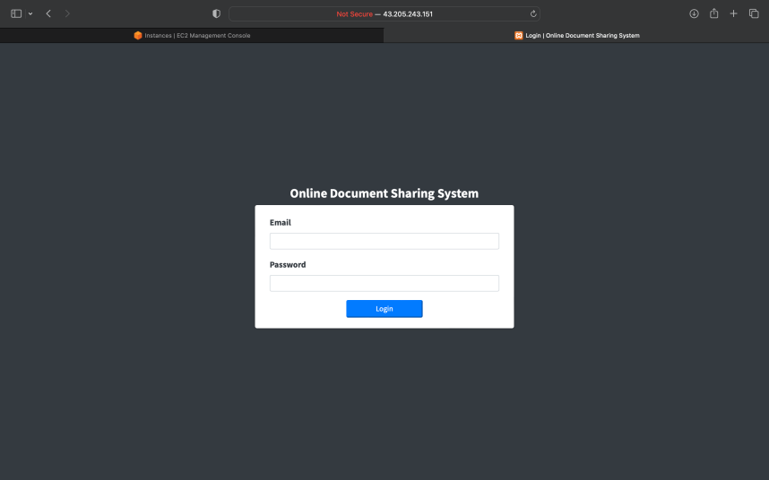 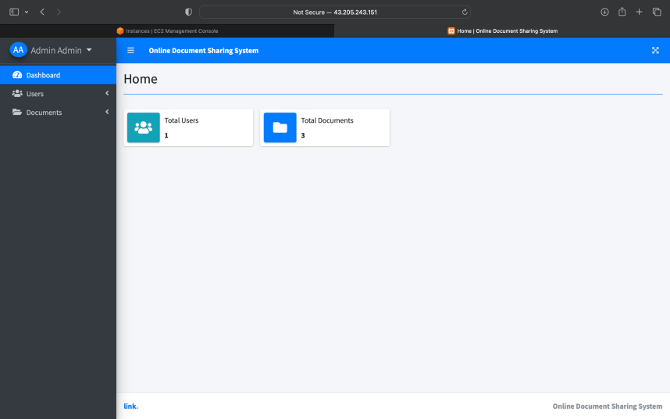

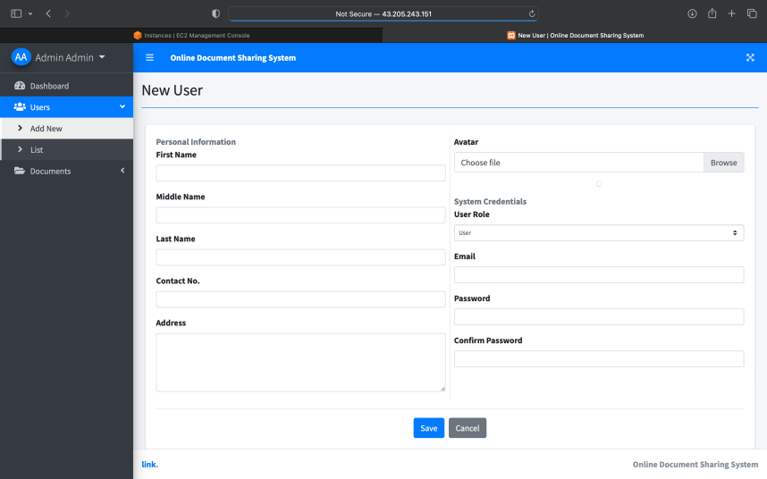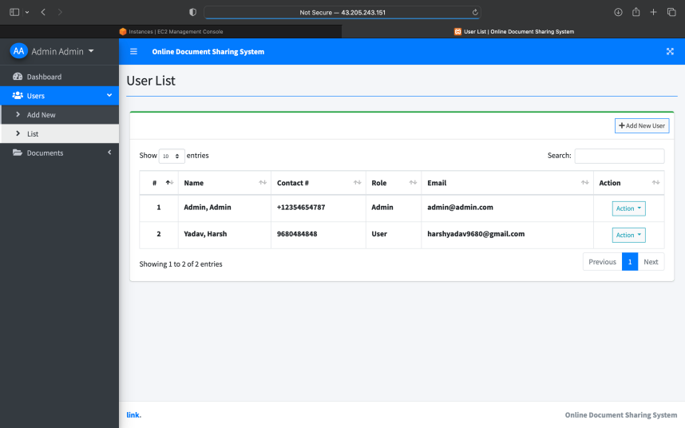

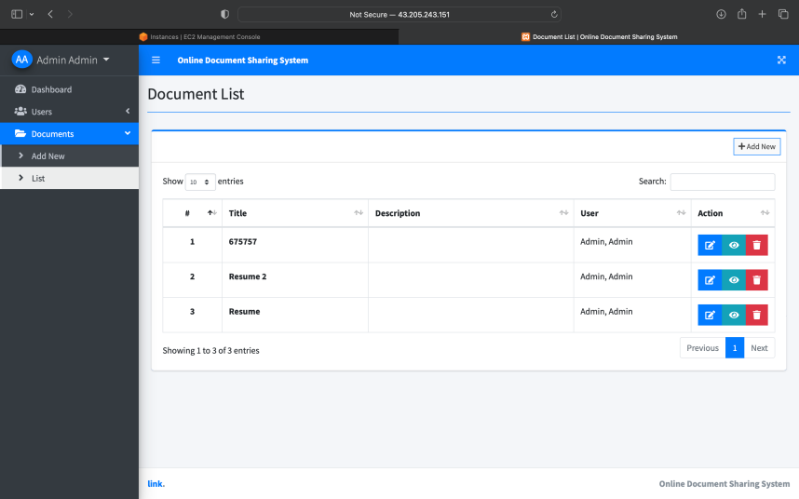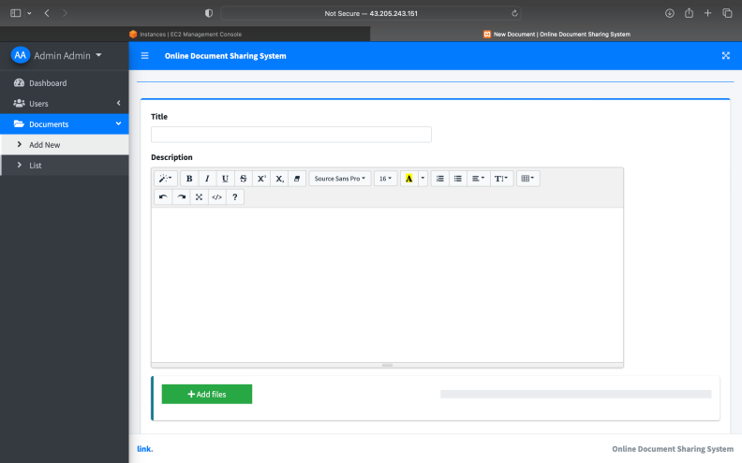

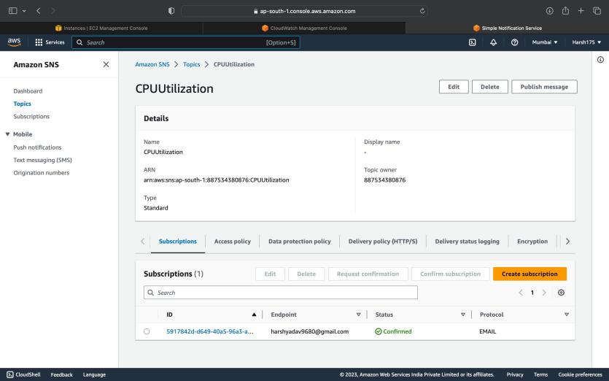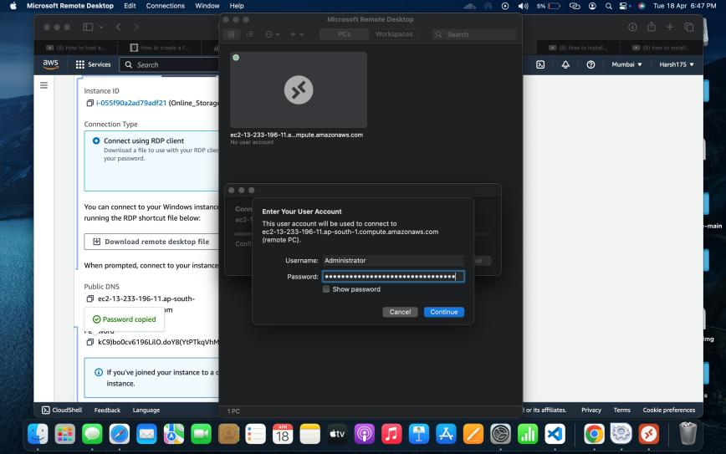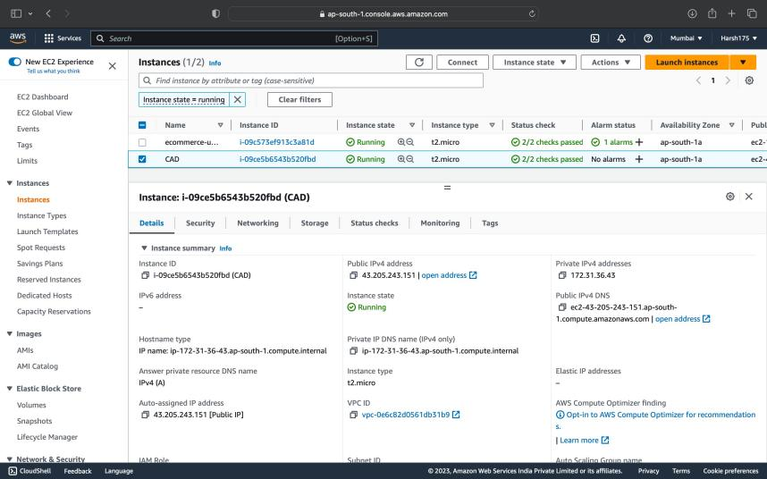 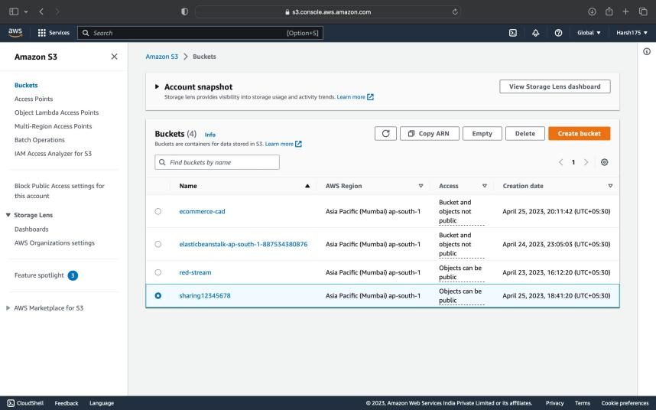

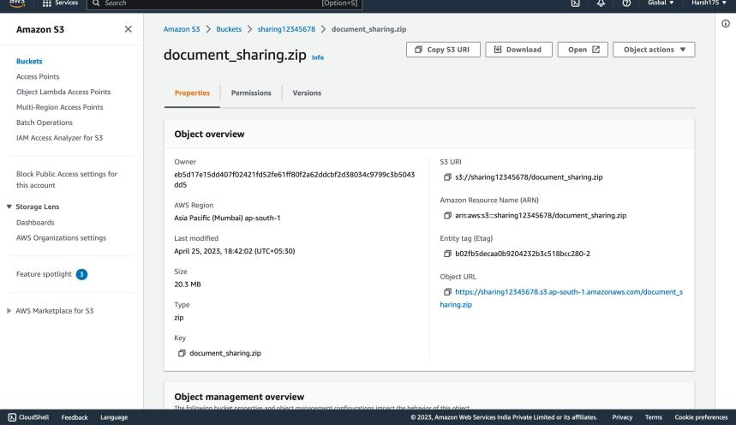

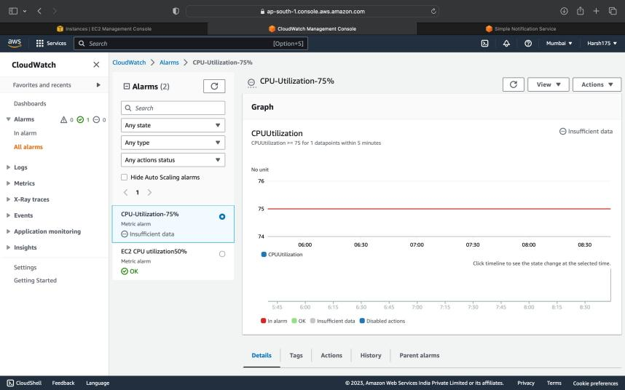

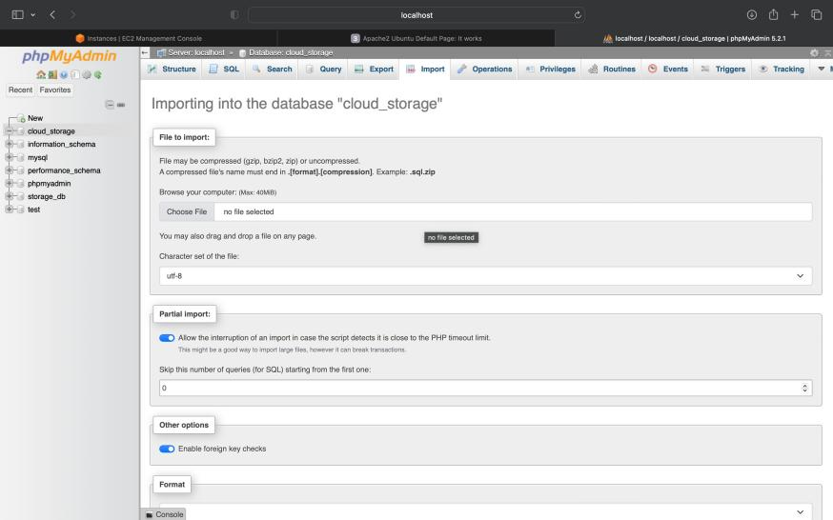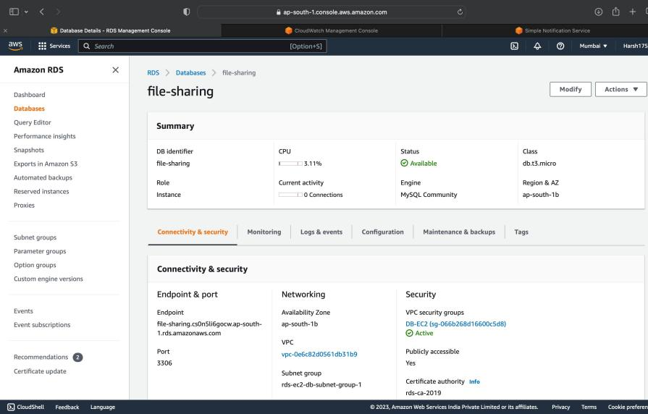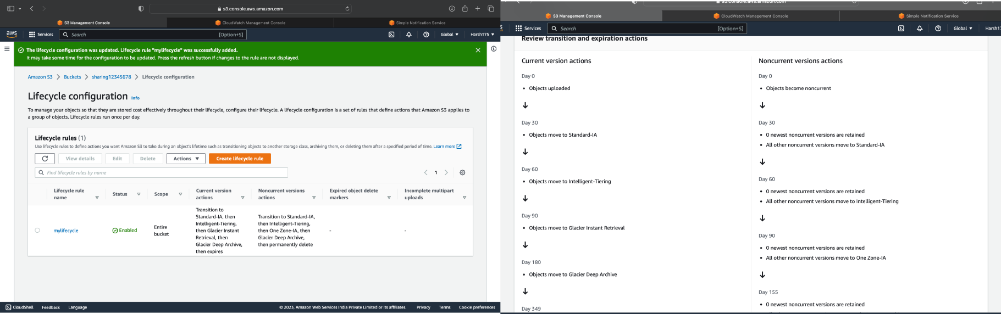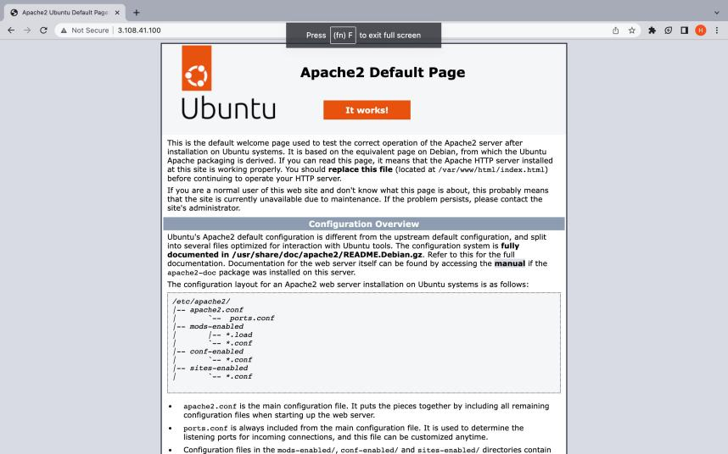

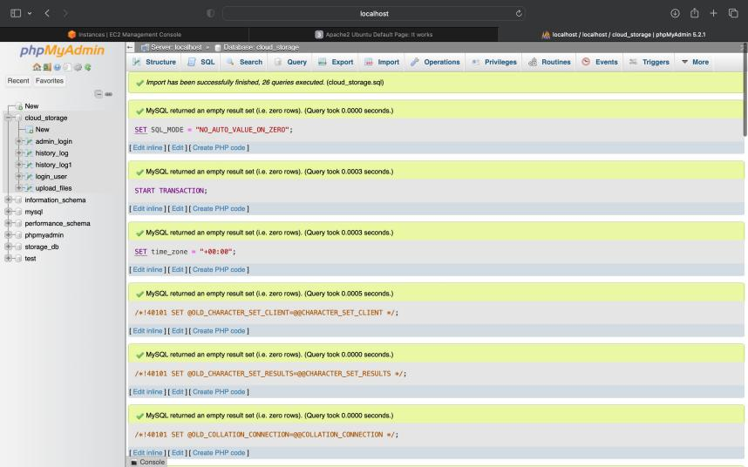

**PUBLIC CLOUD DEPLOYEMENT**

A public cloud deployment model is a kind of cloud computing model in which a third-party provider hosts an organisation's computing resources and makes them accessible to customers online. In this approach, the company just pays for the computing resources it uses on a pay-as- you-go basis; it neither owns nor manages the underlying infrastructure.

Virtual machines, storage, networking, databases, and application development tools are just a few of the services that public cloud providers like Amazon Web Services (AWS), Microsoft Azure, and Google Cloud Platform (GCP) offer. Developers can provide and manage resources on-demand using these services, which can be accessed via a web-based dashboard or an SDK.

There are several advantages to the public cloud deployment approach, including scalability, efficiency, accessibility, dependability, and innovation. It does, however, also come with a number of difficulties, including security, vendor lock-in, latency, and compliance. Before selecting a public cloud provider and implementing a public cloud deployment methodology, organisations must thoroughly assess their needs and requirements.

For businesses using cloud computing services, deployment models are crucial because they offer a standardised method for setting up and managing computing resources in the cloud. The architecture, rules, and practises for allocating and controlling computer resources in the cloud are specified by a deployment model.Organisations using cloud computing services need deployment models because they offer a standardised, scalable, secure, compliant, manageable, effective, and affordable method for setting up and managing computing resources in the cloud. Organisations can increase their productivity, adaptability, security, compliance, administration, and cost-effectiveness by implementing a deployment strategy.

Public clouds are a better choice for online data management than private clouds for the following reasons:

Pay-as-go:- so you only go where you pay for the resources you have. used. This is more expensive than installing and managing a private cloud, which requires a large investment in hardware, software and maintenance. Organisations just pay for the resources they use when using public cloud deployment models, which makes them affordable. Pay-as-you-go pricing is available from public cloud providers, allowing businesses to scale up or down as appropriate without accumulating extra fees. Public cloud providers also take care of the infrastructure's upkeep, management, and updates, which lessens the organisation's workload.

Scalability: Scalability is one of the main advantages of a public cloud deployment architecture. Public cloud providers offer a sizeable pool of computing resources that may be scaled up or down in accordance with the requirements of the organisation. As a result, businesses don't need to spend money on new infrastructure or technology to accommodate demand spikes.

Cloud services can be easily scaled up or down as you need, ensuring you have the resources you need to support your data management. This flexibility is important when dealing with different workloads and user needs because it helps you avoid over-provisioning or underutilising resources.

Reliability and Reproducibility: Public cloud providers have multiple data centers spread across different geographies. This redundancy ensures that if one database goes into trouble, your managed data can be accessed by other databases. Achieving this level of trust with private clouds is difficult and expensive. Through redundant infrastructure, data backups, and disaster recovery options, public cloud companies deliver high availability and reliability. This guarantees that users will always have access to the data, notwithstanding a hardware or software malfunction. Additionally, public cloud providers provide service-level agreements (SLAs) that ensure uptime and performance, giving businesses peace of mind that they can depend on the public cloud provider to maintain the seamless operation of their applications.

Security: While it may seem counterintuitive, cloud service providers often have stricter protections than many cloud services. They have a dedicated team of security experts who regularly monitor and update their systems for threats.

Ease of use and management: Data management in a cloud platform usually comes with prebuilt templates, tools and APIs that make it easy to implement, edit and manage your body.

This saves you time and resources compared to creating and managing a private cloud.

Innovation: Cloud service providers continually invest in research and development to ensure their customers have access to the latest technology and capabilities. By using the public cloud, your online data management system can take advantage of these updates without any additional effort from you. Innovation: Public cloud providers provide a wide range of cutting-edge services and technologies, enabling businesses to quickly and effectively develop, test, and deploy applications. These tools, which can greatly improve the organisation's development capabilities, include machine learning, artificial intelligence, server-less computing, and containerisation.

In the event of a natural disaster or system failure, public cloud providers give disaster recovery alternatives like backups and replication to make sure that data is always accessible. This guarantees that businesses can resume operations as soon as a disruption occurs, cutting downtime and preserving business continuity.

Collaboration: Public cloud deployment models provide capabilities for collaboration including messaging, file sharing, and video conferencing that let users work together easily no matter where they are. This enhances teamwork and communication, which can result in more effective and productive work.

However, it is important to remember that cloud computing may not be the best solution for every organization. Depending on your specific needs, such as compatibility, data privacy, or special hardware/software requirements, private cloud or hybrid solutions may be more appropriate. Before deciding on an appropriate climate solution, it is important to evaluate the organisation's needs and priorities.

# Screenshot:-

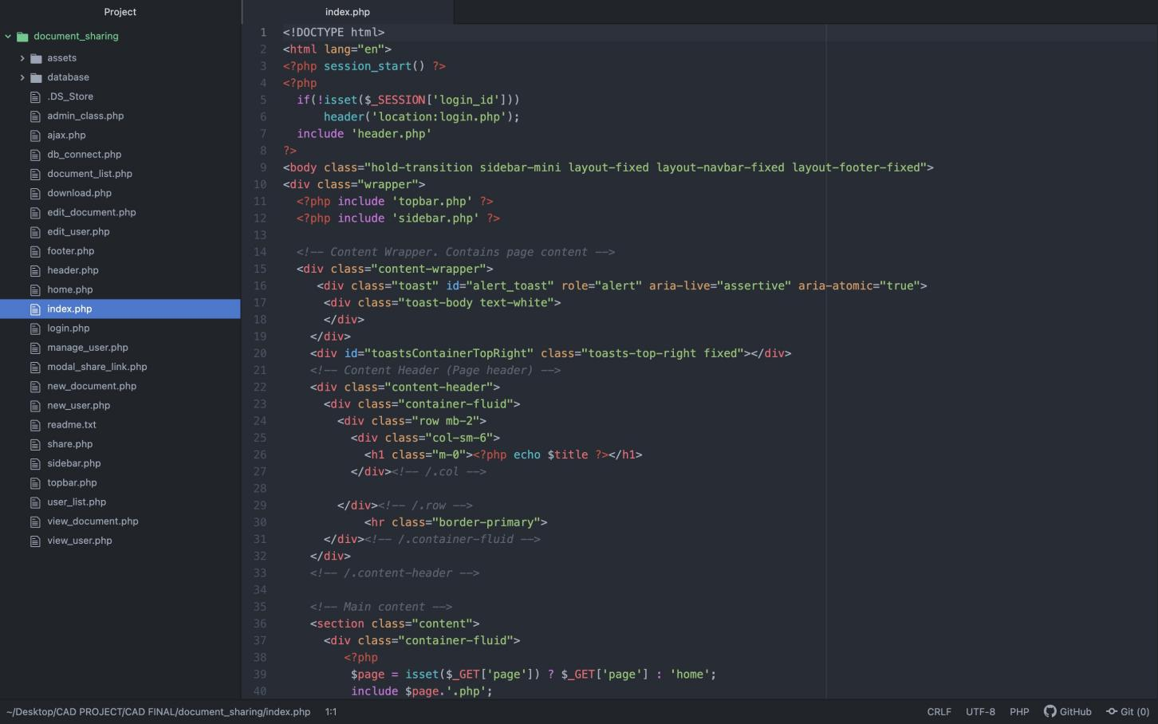

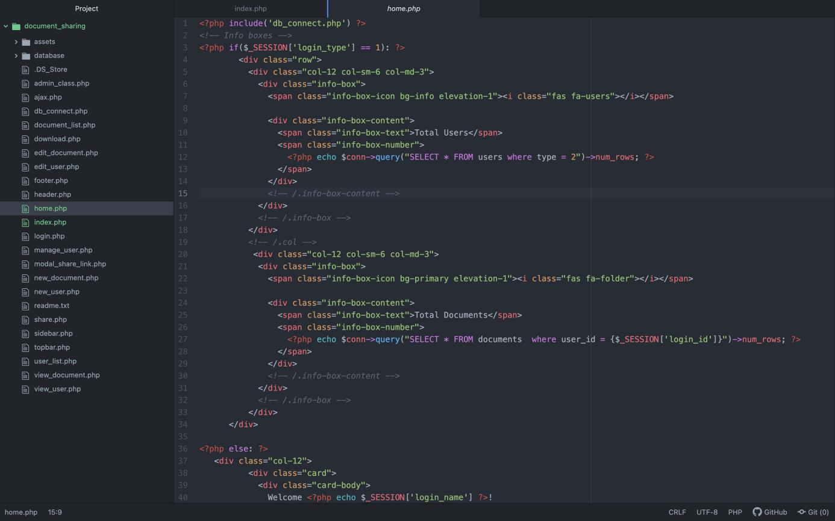

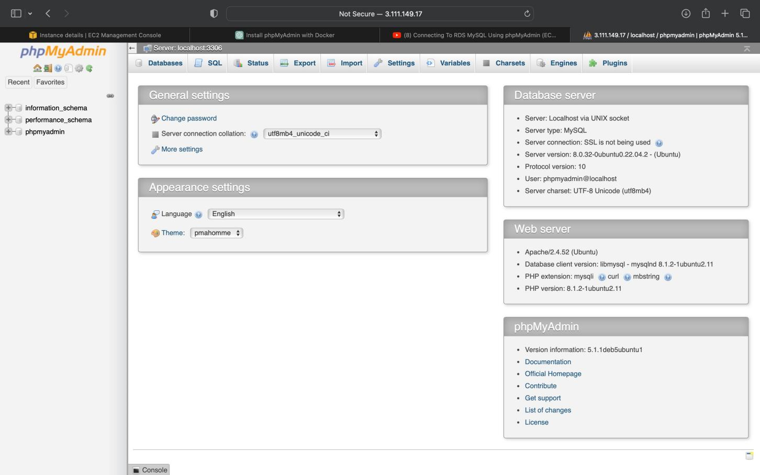

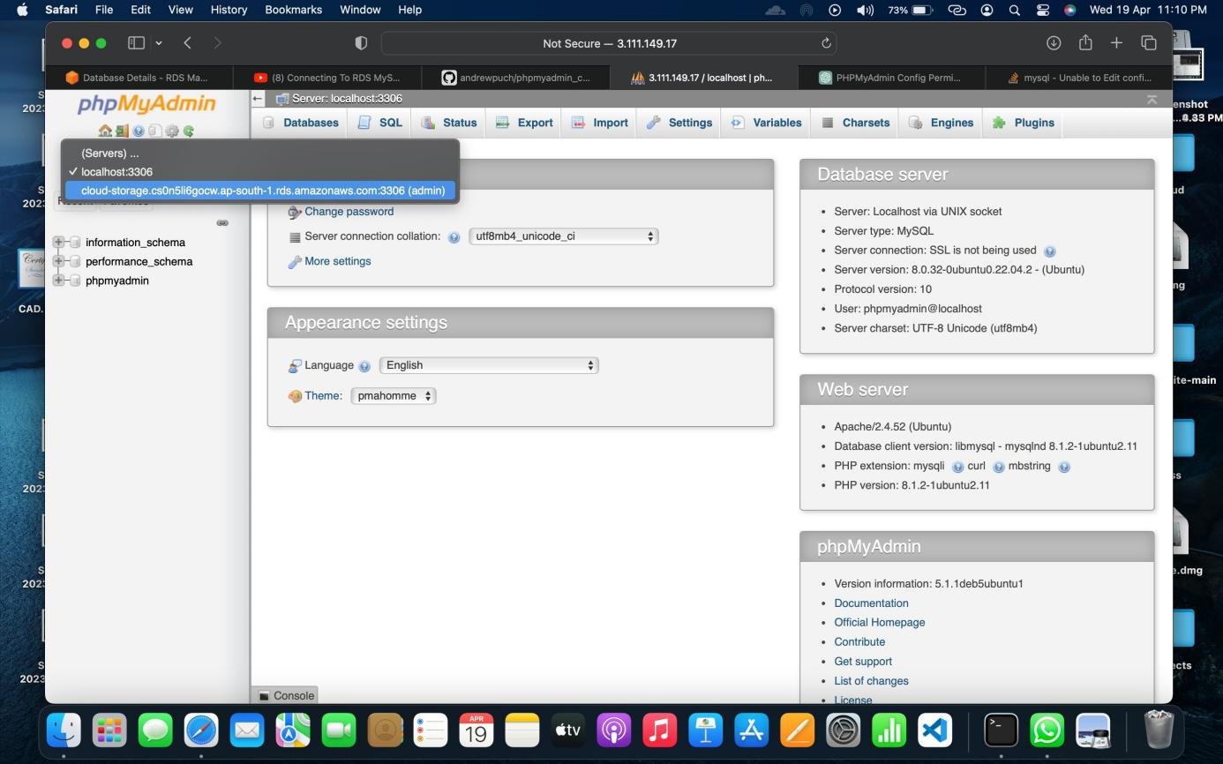

# Key Bibliography/References

https://code.tutsplus.com/tutorials/online-file-storage-with-php--net-5818

https://projectworlds.in/free-projects/php-projects/php-online-file-storage-project-mini-dropbox- or-google-drive/

https://[www.researchgate.net/publication/](http://www.researchgate.net/publication/) 271617185_Building_a_Cloud_Storage_Service_System

https://t4tutorials.com/cloud-based-file-sharing-system-using-php/ https://[www.slideshare.net/RachitSinghal17/project-report-on-cloud-storage](http://www.slideshare.net/RachitSinghal17/project-report-on-cloud-storage)