Linkedin_job_data
Analysis of Indian job market

Overview
Check the number of rows – 7927 rows and 15 columns
Make the copy of the original sheet(raw_data) and rename the copy as clean_data (now onwards all the data cleaning is doing in this sheet 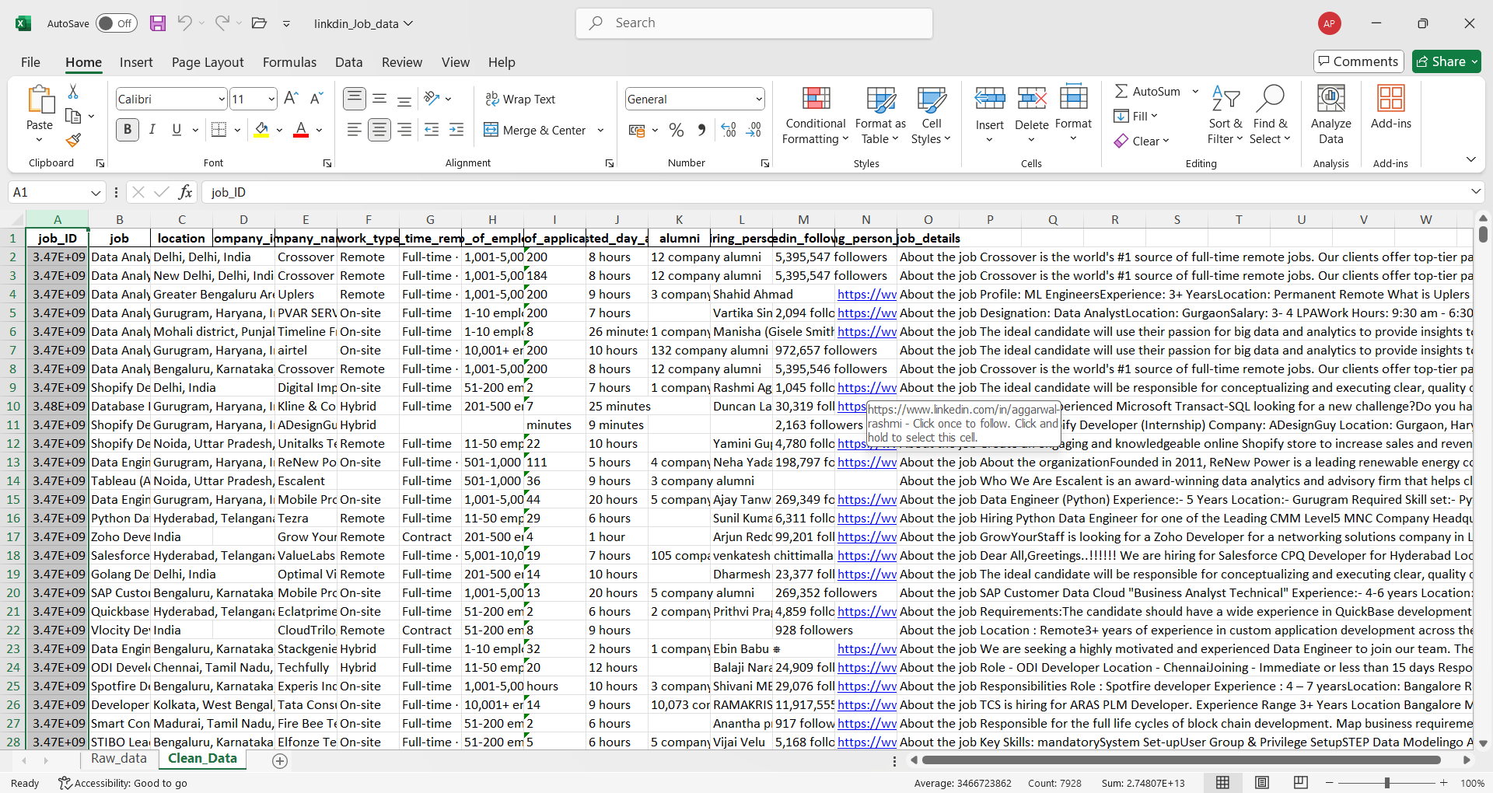
Fix the width of the entire sheet – Alt H O I
Fix the height of the entire sheet – Alt H O A
Turn the filter on by – ctrl shift L

----- Data Cleaning -----

- Remove duplicates-
- Select all - cltr A
- Click on DATA tab
- Select “remove duplicates”
- A dialogue box appears – check all boxes and headers – click OK
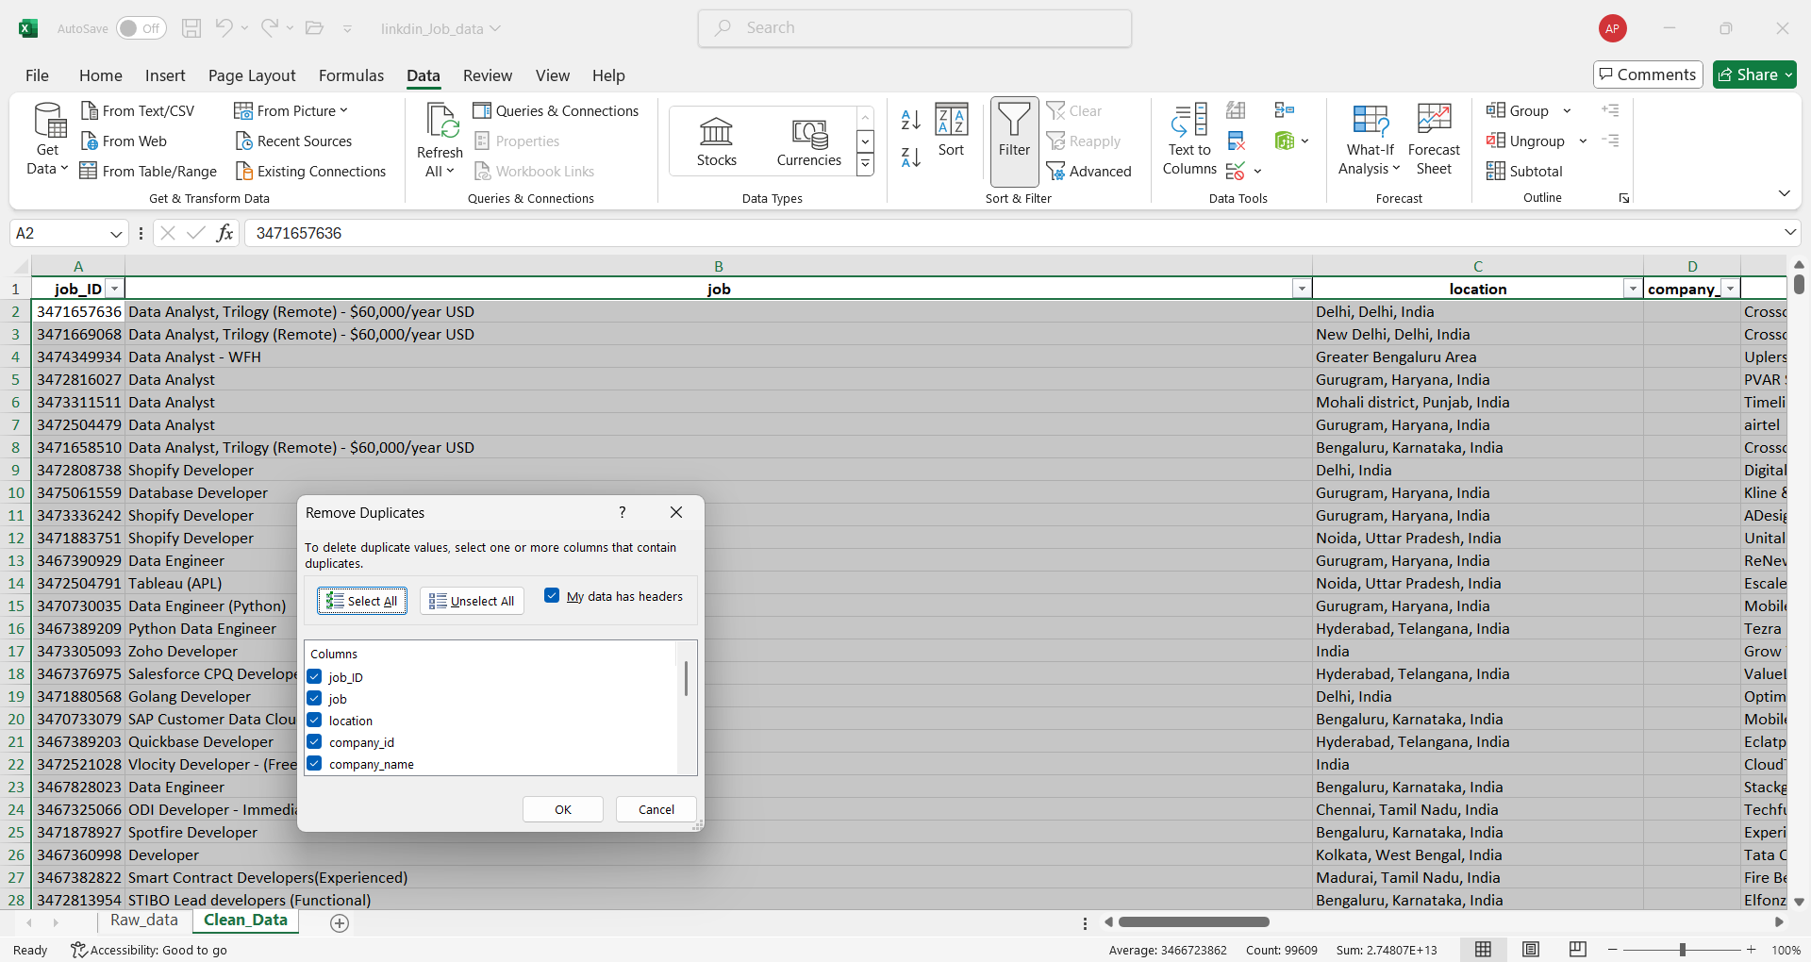
79 duplicates values found and removed.
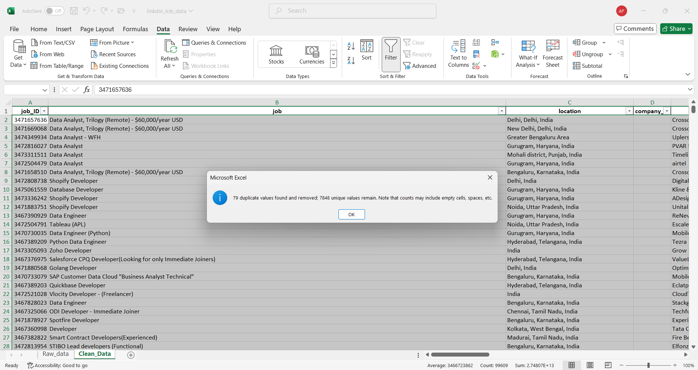
- Remove the “column_id” column – because it is empty
- Select the entire column
- Right click and select the “delete” option
- Now we have only 14 columns

- Remove some more empty rows
Find out that there are some rows where only job id column is filled and rest other 13 columns are empty. 33 empty rows are found. We need to remove that.
- Go to the job column
- Select “Blank” from the filter drop down button
- Click ok
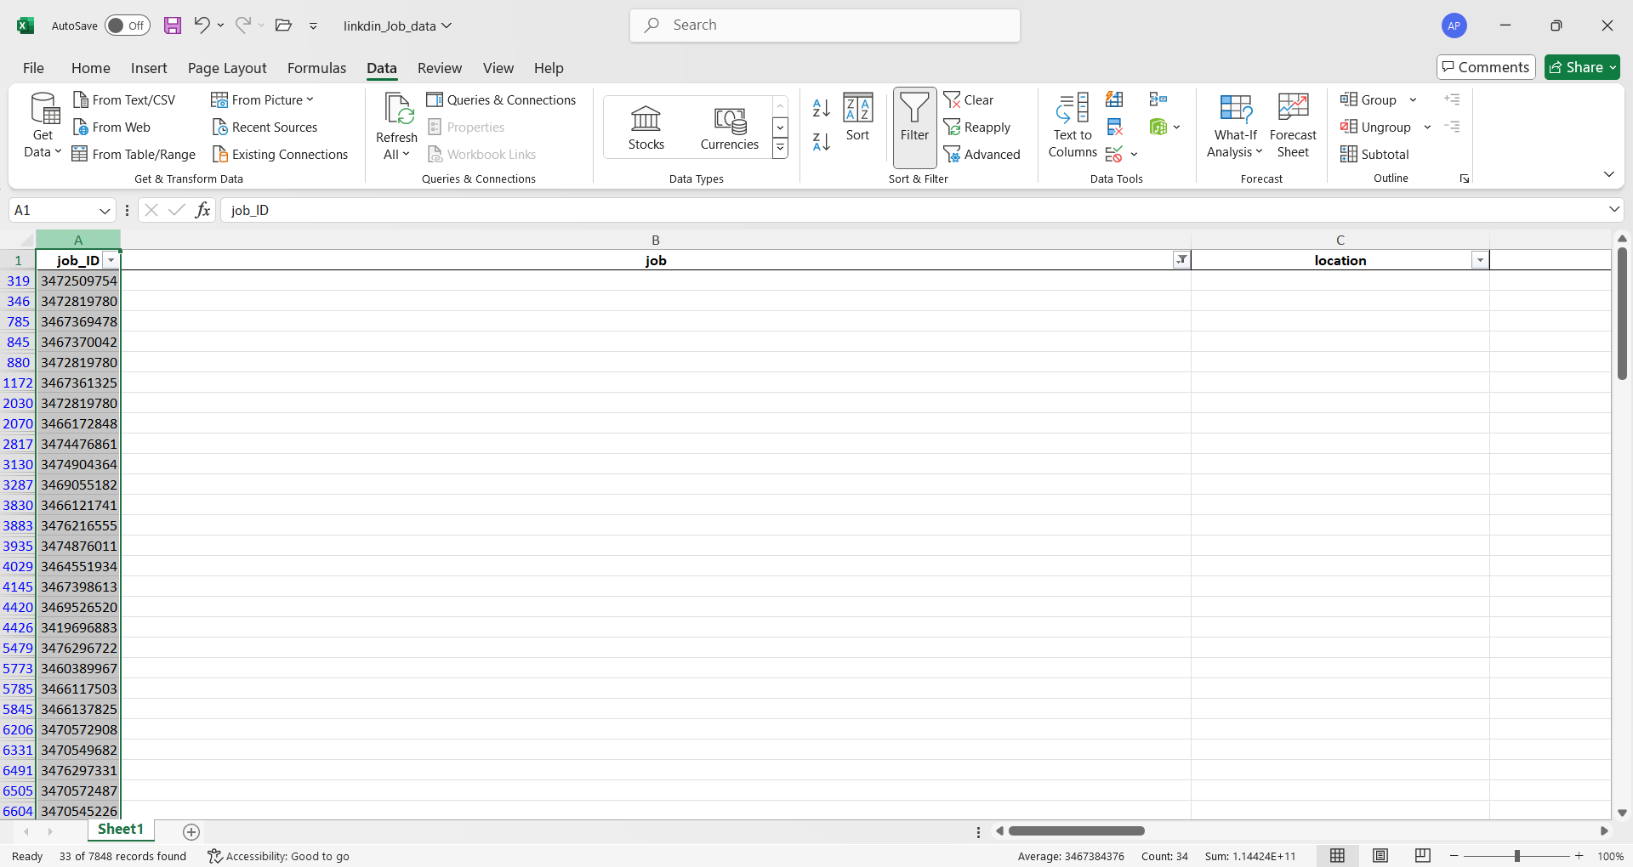
- Now me select the entire data – ctrl A
- Right click – select the “delete rows” option
- Remove the filter
- Now we have 7816 rows

- Clean the job column
Copy pastes the job column into the new sheet and named the sheet as “clean_job_col”
Step 1 – Extract Main Job title
- In the sheet “clean_job_col” – create a new column “Clean_job_step1”
- Write a formula in the “clean_job_step1” column – to remove the data after commas
=TRIM(LEFT(A2, FIND(",", A2&",")-1))
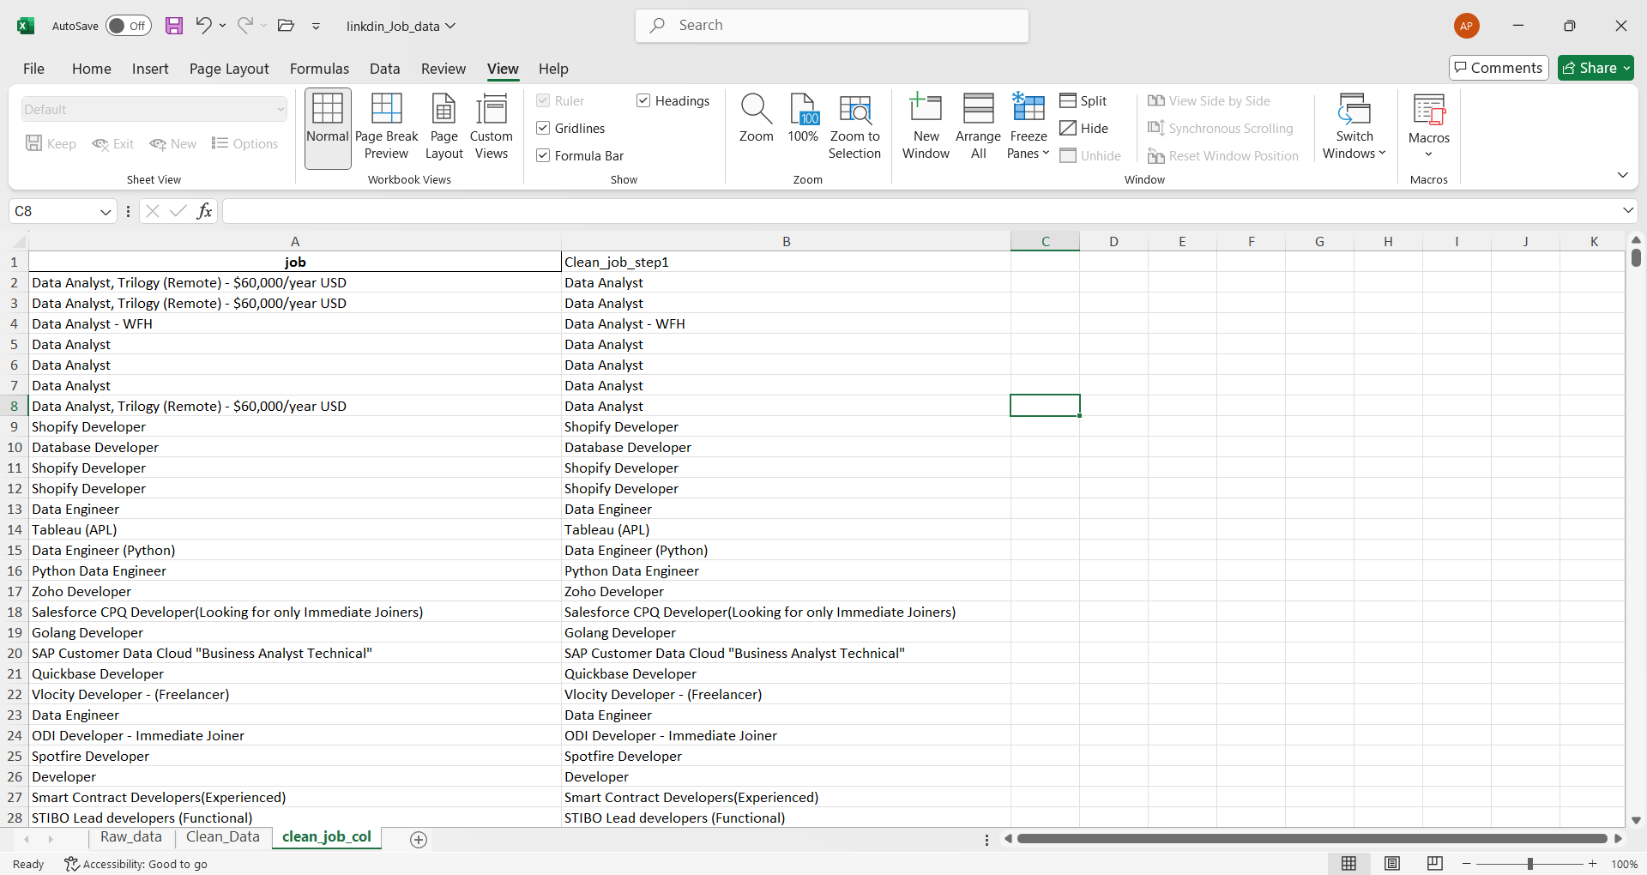
Step 2- Remove hyphen (-) “-WFH”, “-Remote”, etc
- Create new column “Clean_job_step2”
- Write a formula here
=TRIM(LEFT(B2, FIND("-", B2&"-")-1))
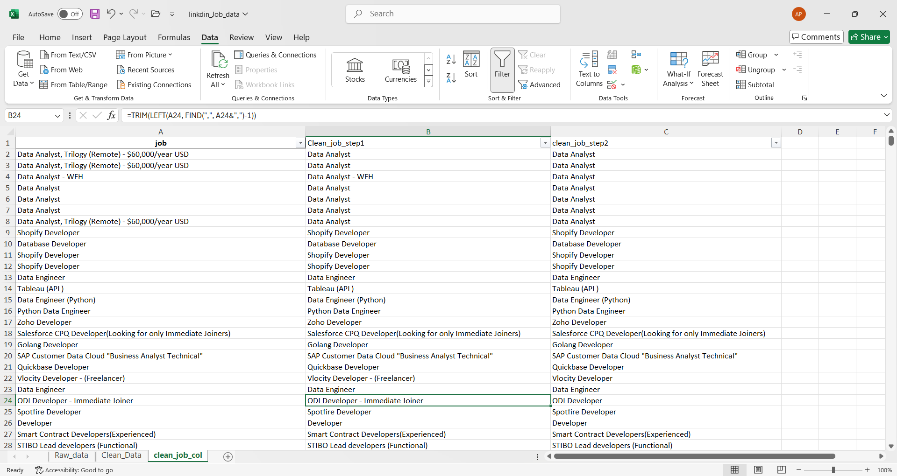
Step 3 – Remove Bracket ()
- Create a new column “clean_job_step3”
=TRIM(LEFT(C2, FIND("(", C2&"(")-1))
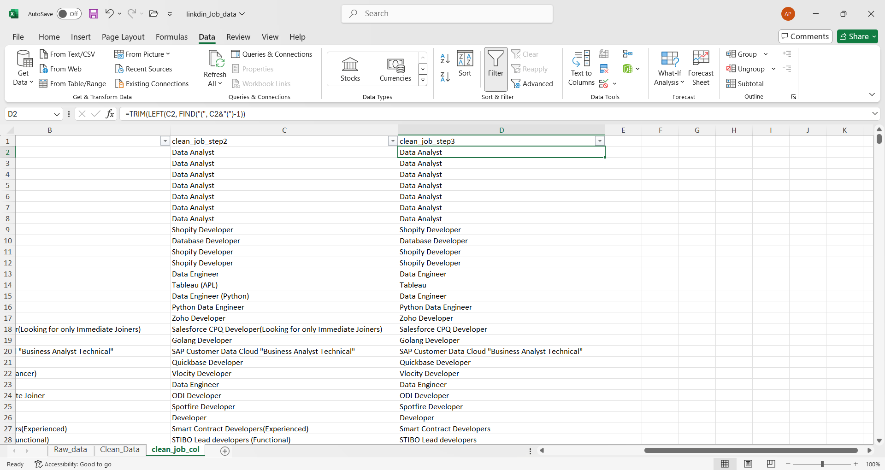
Step – 4 Job Mapping
- Create a new worksheet and name it as “job-mapping”
- Name a column “Raw_job” – extract unique job from the “clean_job_step3” by using
= =UNIQUE(clean_job_col!D2:D7816)
- Create a “Standard_job” column
- Apply filter on – “Raw job”
- Choose text filter --- > contain
- A dialogue box appears
- Write “data analyst” there and click ok
- Now all the data analyst in “raw_job”column filtered out
- Then write Data Analyst into Final_job column
- Now flash fill by ctrl E into the remaining rows
- Repeat the same for all other job roles, to make a proper making chart
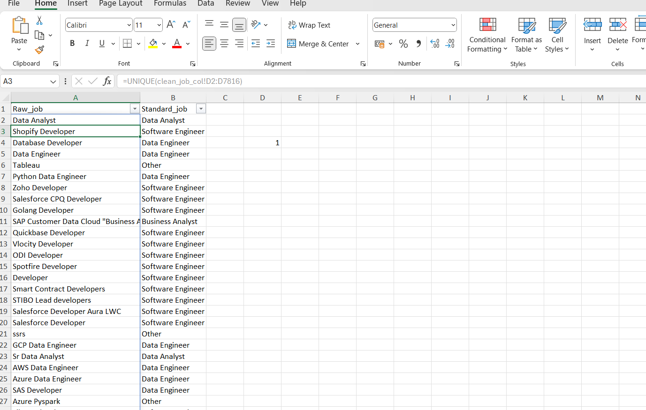
Step 5 – Final step
- Now we go into clean_data worksheet
- Select a cell in job column
- Apply lookup function-
=XLOOKUP(clean_job_col!D2,job_mapping!A:A,job_mapping!B:B, " Other")
- Now drag it down

- Clean location column
In location column there is city,state,country.
I choose to make three columns separately
For that insert three columns besides “location”
And name them as city , state, country respectively
- Apply the formula to extract city name – in city column
=IFERROR(TRIM(LEFT(C4, FIND(",", C4)-1)), "")
- Apply the formula to extract state name – in state column
=IFERROR(TRIM(MID(C4,
FIND("@", SUBSTITUTE(C4, ",", "@", LEN(C4)-LEN(SUBSTITUTE(C4,",",""))-1))+1,
FIND("@", SUBSTITUTE(C4, ",", "@", LEN(C4)-LEN(SUBSTITUTE(C4,",","")))) -
FIND("@", SUBSTITUTE(C4, ",", "@", LEN(C4)-LEN(SUBSTITUTE(C4,",",""))-1))-1
)), "")
- Apply the country to extract country name – in country column
=IFERROR(
TRIM(
RIGHT(
C4,
LEN(C4) - FIND("@", SUBSTITUTE(C4, ",", "@", LEN(C4) - LEN(SUBSTITUTE(C4, ",", ""))))
)
),
"India")

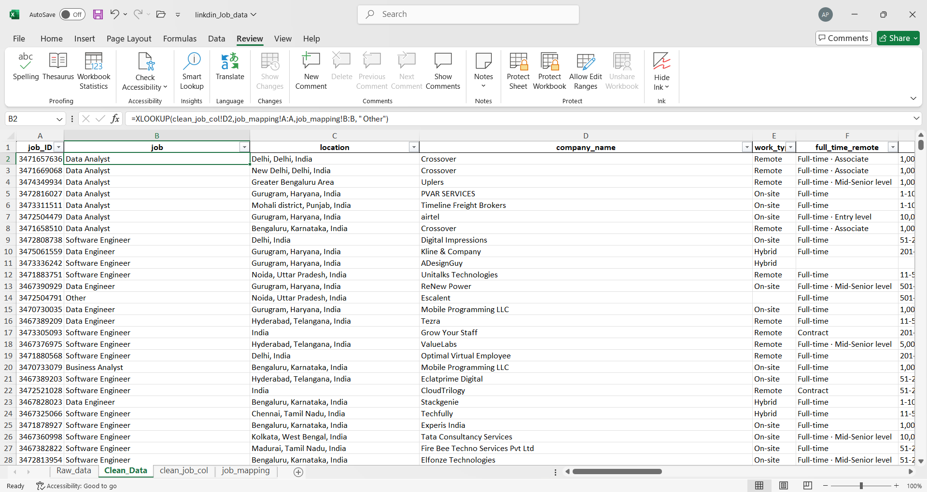
- Clean “full_time_remote” column
  - Insert a new column
  - Select the column “full_time_remote”
  - Go to the DATA ribbon
  - Select ‘text to column’ option
  - A dialogue box appears in the screen
  - Select delimited
  - Click next
  - Select ‘other’ , mid point (·)
  - Click next - finish
  - Now delete the new column that has created
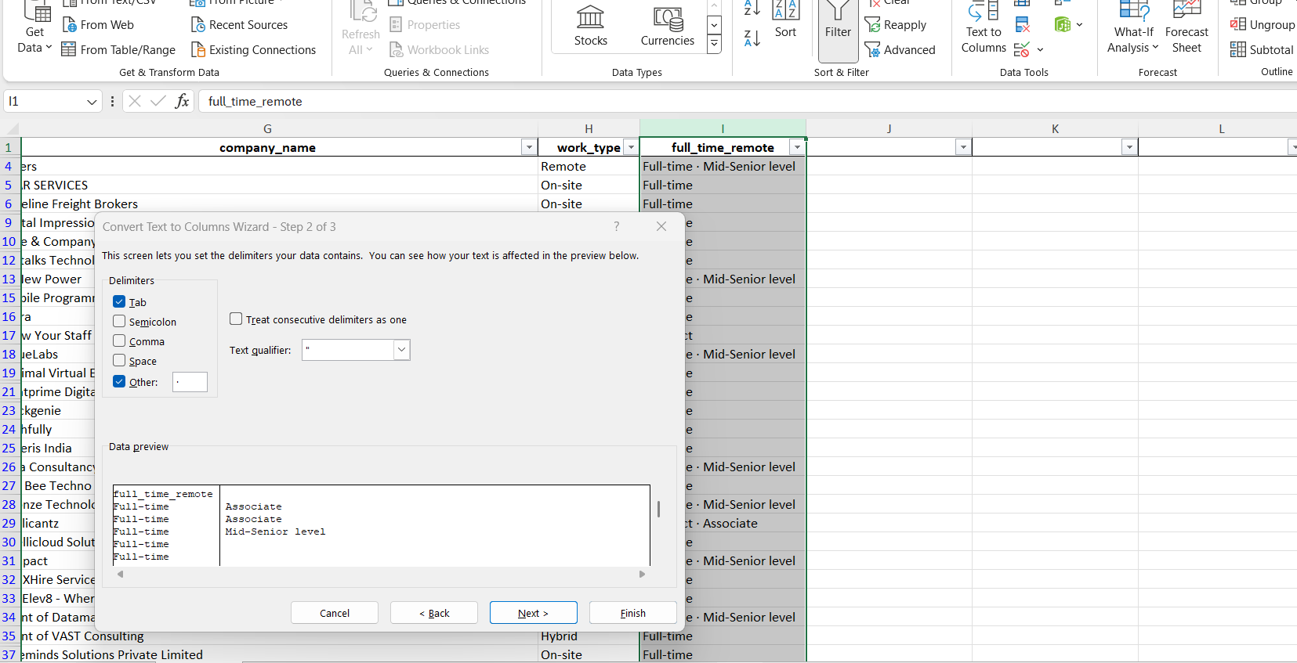
- Clean “no_of_employ” column
This column contains no. of employees and industry in some case - want to placed separately in different column
  - Insert a new column
  - Select the column “no_of_employ”
  - Go to the DATA ribbon
  - Select ‘text to column’ option
  - A dialogue box appears in the screen
  - Select delimited
  - Click next
  - Select ‘other’ , mid point (·)
  - Click next - finish
  - Rename the new column created as “industry”

- Clean “no_of_application” column
Here numbers stored in text format – to remove this error
Select the column (without header)
- Click on the error icon
- Select “convert to number” option
Still the data is inconsistent due to presence of ‘hours’, ‘minutes’ etc
- Filter the inconsistent data from the filter drop down button
- Now select the column
- Do Right click
- Select “clear content”
- Now remove the filter

- Clean “posted_day_ago” column
Lets validate the data by converting days, weeks , minutes into hours
Separate the number and unit into two columns
- Insert a new columns
- Select column
- Then DATA text to column
- Rename the new column as “time_unit”
- Create a new column “posted_hours_ago”
=IF(N5="minutes", M5/60, IF(N5="hour", M5, IF(N5="hours", M5, IF(N5="day", M5*24, IF(N5="days", M5*24, IF(N5="week", M5*168, IF(N5="weeks", M5*168, "")))))))

- Clean “alumni” column
Validate the column by removing ‘company alumni’
- To replace press - Ctrl H
- a dialogue box appears
- replace company alumni to blank
- select replace all
go to the home ribbion – convert the datatype to number
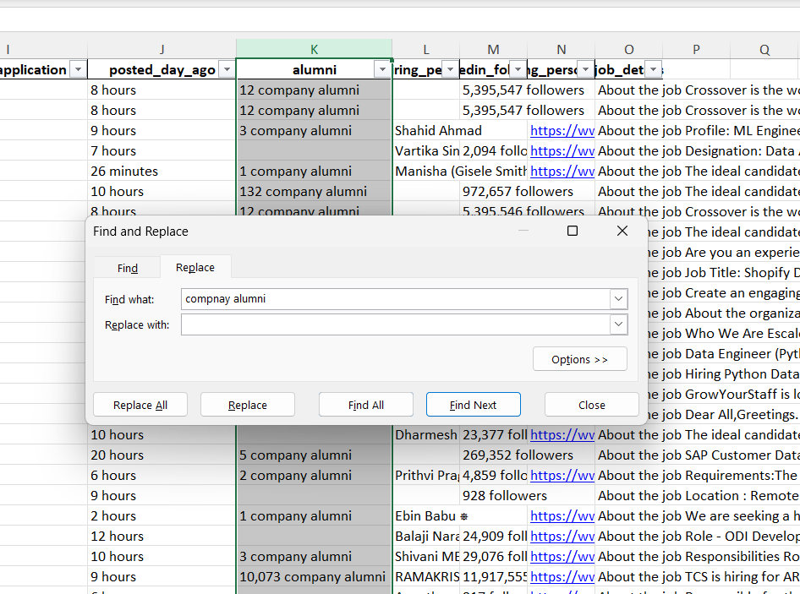

- Clean “linkdine_followers” column
- Insert 2-3 columns
- Data text to column
- Then delete the newly created column
- Now validate the remain by filter out the inconsistent data
- Do right click and click clear content
- Remove the filter

