**Interview Question AWS**

**EC2 ( Elastic cloud comput**e) – used to create instance

When try to launch instance with required requirement it will ask to select existing pair of key or create new (select based on requirement) , If you create new key it will be in pemp format

Then follow below steps to connect server.

* **Unix servers :**

**Login through GitBash -**

Select instance -> connect in AWS -> copy ssh link -> open git bash & paste the link and hit

**Or**

**Login through putty**

Convert pepm key file to ppk file putty zen app -> Putty enter server name -> browse ppk file to AUT in putty -> connect

* **Windows server :** Select instance -> connect in AWS-> generate key using pemp file -> RDP to connect server

**Action ->Instance -> change termination policy :** If you enable this user cant terminate the server.

**EBS ( Elastic block storage) –**  Used to backup Volume

**Volume:** Used to create new volume to existing instance

Create volume -> action -> attach to instance

**Note** : Region of the volume should be same as instance volume else we have to copy volume to instance region later we can attach the volume.

**Snapshot :** Used to copy volume(data) from one instance to another instance.

* We can create snapshot of default volume or elastic volume
* We can copy data of same region or different region.

Select Volume -> Action -> create snapshot : This will create snapshot

Go to Snapshots -> select required Sanpshot -> Action -> Create Volume -> attach to required instance

**IMAGES :** Used to Backup instance

# AMIs (Amazon Machine Images) : Used to Backup instance and when we use this image to create an other instance that will be having same configuration and volume of old instance.

Select instance -> Action -> create image : this will create an image

While creating instance we can use the image which we create will be having same configuration and data

**Load balancing :** Used to balance load by adding or removing instance when ever required.

**ELB(Elastic Load balance) or Load balancer :**

There are 3 types of load balancer :

* [**Application Load Balancers**](https://docs.aws.amazon.com/elasticloadbalancing/latest/application/): makes routing decisions at the application layer (HTTP/HTTPS
* **Network Load Balancer** : makes routing decisions at the transport layer (TCP/SSL)
* **Classic Load Balancer** : makes routing decisions at either the transport layer (TCP/SSL) or the application layer (HTTP/HTTPS).

Load Balance -> Create load balancer -> Classic Load Balancer -> add protocol if any ->  Configure Health Check -> Add EC2 Instances -> create

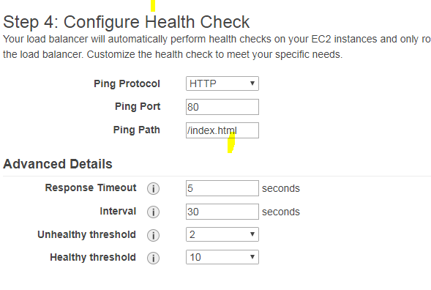**Response Timeout :** time to wait when receiving a response from the health check

**HealthCheck Interval :** time between health checks of an individual instance

**Unhealthy Threshold:** number of consecutive failed health checks that must occur before declaring an EC2 instance unhealthy

**Healthy Threshold :** number of consecutive successful health checks that must occur before declaring an EC2 instance healthy.

**Auto Scaling :** Adding or removing the instance based on the traffic flow.

We have 2 steps here

**Launch Configuration :** This is similar to instance creation. After this need create auto scaling group

**Create auto scaling group :** Configuration set up is below

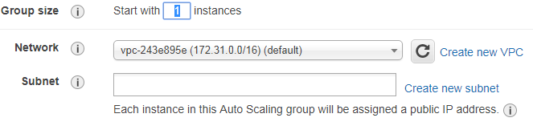**group :** initial size of the group

**Subnet :** Select the subnet or region where instance need to get created. Configure Auto Scaling group details

In **Configure scaling policies** select Use scaling policies to adjust the capacity of this group -> select min and max group size -> Execute policy when (here add new alarm) for increase and decrease instance

Here provide recipients for email notification(1) , when instance need to be added (2), based on what criteria(3) , condition(4) , percentage(5) , how much instance needs to be add(6), with in what time instance need to be added(7).  
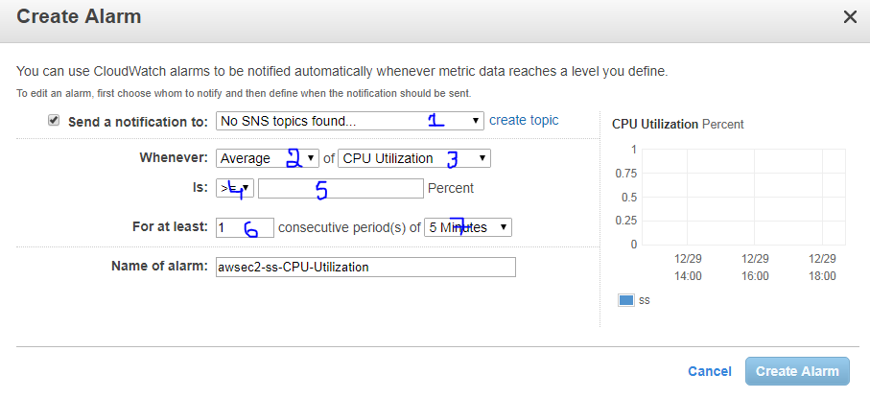 **VPS (Virtual Private Cloud) :** Used to create private virtual network on cloud in AWS and defines IP address in one range.

**Required Networking concept to create VPC :**

**Subnet :** Is a smaller part of a network and all the subnets in the networks will be having IP address with same prefix.

**SubNetMask** : Determine the size of the IP address of the subnet

**Internet gateway :** Is a public network routing If the subnet as internet gateway then it will public subnet else private subnet

**Route table :** Determine how traffic will flow in internet gateway or Ethernet

**NAT :** It enable traffic from private subnet to internet or other **AWS** services , but prevent the internet from initiating a connection with those instance.(Charges will be applied to create NAT in AWS)

**VPC peering :** Used to connect VPC with another VPC via network route using private **IP** address.

**Benefits and difference between default/Non default VPC :** Mobile screenshot

**VPC wizard scenarios :**

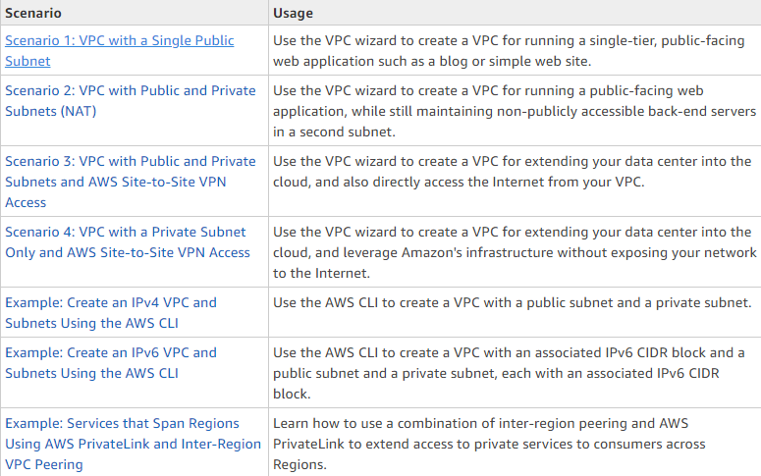

Based on the above VPC wizard we will create VPC , Then this VPC is used to launch instance but public IP wont be available for instance.

But we can create allocate new public IP to VPC using Elastic IP option .

**IAM(Identity access management) :** Used to create user and provide required permission for the user.

**Create user** -> we can add user to existing user or we can copy permission of other user or we can add existing permission (policies)

**Create group** -> we can give permission to group -> create -> then add required user to created group.

**S3 (simple storage service) :** used to store data in cloud , it stores any data as object. It stores the data as global , we can give permission to S3 also

Amazon S3 **access control lists (ACLs)** enable you to manage access to buckets and objects. Each bucket and object has an ACL attached to it as a subresource. It defines which AWS accounts or groups are granted access and the type of access. When a request is received against a resource, Amazon S3 checks the corresponding ACL to verify that the requester has the necessary access permissions.

When you create a bucket or an object, Amazon S3 creates a default ACL that grants the resource owner full control over the resource.