Kiddo SDUI — Server-Driven UI Homepage Renderer
Technical Assignment Submission
Submitted by: __________________________ Email: __________________________
GitHub Repository: https://github.com/Arpita34/payload-canvas
README: https://github.com/Arpita34/payload-canvas/blob/master/kiddo-sdui/README.md

1. Overview
A production-grade, configuration-driven React Native (Expo) homepage that renders entirely from a JSON payload. The server decides what to show; the client is a 'dumb' rendering engine that parses the payload, builds the screen tree dynamically, injects live campaign themes over-the-air, and dispatches declarative actions — all with zero App Store / Play Store release cycles.

2. Tech Stack
Framework | React Native (Expo SDK 54)
Language | TypeScript — strict mode, isolatedModules
List rendering | @shopify/flash-list (single vertical list + nested horizontal lists)
Animations | lottie-react-native + expo-image (WebP), memory-disk cached
State | Zustand with narrow selectors + React Context (theme)
Tests | Jest + ts-jest — 15 unit tests

3. Requirements — Implementation Map
Requirement | How it is implemented
A. Component Registry (Factory) | Hash-map registry (type -> Component), O(1) lookup, no switch. Adding a block = one line.
A. Block types | BANNER_HERO, PRODUCT_GRID_2X2, DYNAMIC_COLLECTION, plus a custom EVENT_BOOKING block.
A. Resilience (unknown types) | resolveBlock() returns null -> node dropped silently; surrounding tree intact.
B. Dynamic Collections | Horizontal FlashList nested in the master vertical FlashList; nestedScrollEnabled keeps momentum; independent virtualization -> flat memory.
C. Universal Action Dispatcher | Centralized handleAction(action); atoms are decoupled and only emit raw triggers. Discriminated union + never exhaustiveness check.
D. High Frame-Rate | Single FlashList, getItemType recycling pools, stable keyExtractor (block.id), React.memo on every block/atom, useCallback render items.
Adv A. Live Campaigns + Overlay | 3 distinct campaigns; canonical FULL_SCREEN_OVERLAY node normalized by resolveOverlay(); pointerEvents='none'; fails gracefully on dead asset; cached media.
Adv B. OTA Theming | Theme matrix -> React Context Provider at root; all skins (CTA, headers, borders) sample the context; swap payload = instant recolor.
Adv C. Render Isolation | ProductCard subscribes only to its own cart slice; adding one item re-renders only that card + header badge, never the other 30+ blocks.

4. Architecture Highlights

Three layers of defensive resilience
- 1. Parse-time (engine/parsePayload.ts): normalizes untrusted JSON, drops corrupt / id-less / duplicate blocks before render.
- 2. Registry: unknown but structurally-valid block types are dropped at lookup.
- 3. Error boundary: a known block that throws mid-render is isolated to a blank slot.
homepage.json intentionally ships four corrupt/edge blocks (unknown type, missing id, null node, duplicate id) so every layer is provably exercised — the homepage still renders perfectly.

State & rendering
- Zustand narrow selectors + React.memo isolate re-renders to a single product card.
- Theme uses Context intentionally (campaign switch is a rare, whole-tree event).
- Single virtualized FlashList for the whole screen; nested horizontal carousels virtualize independently.

5. Screenshots
All four live campaigns rendered from the same JSON engine. The small counters in the corners are render-count badges (DEV-only) that prove render isolation.
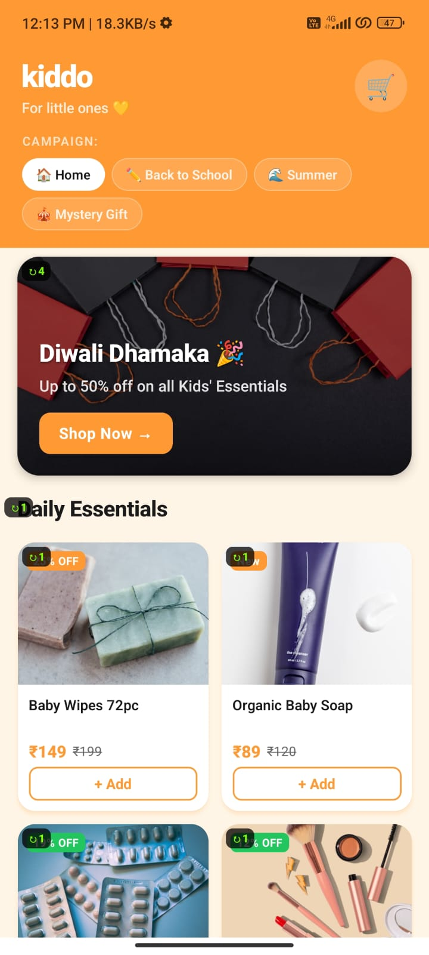  Home — Diwali Dhamaka | 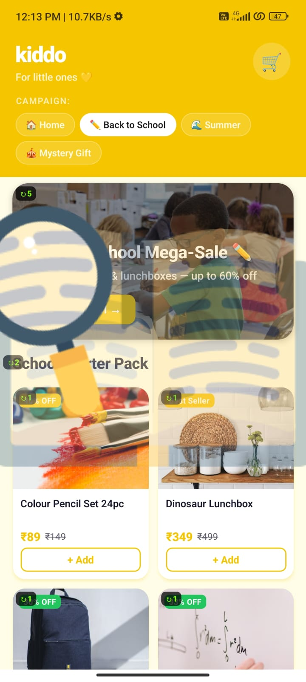  Back to School Mega-Sale
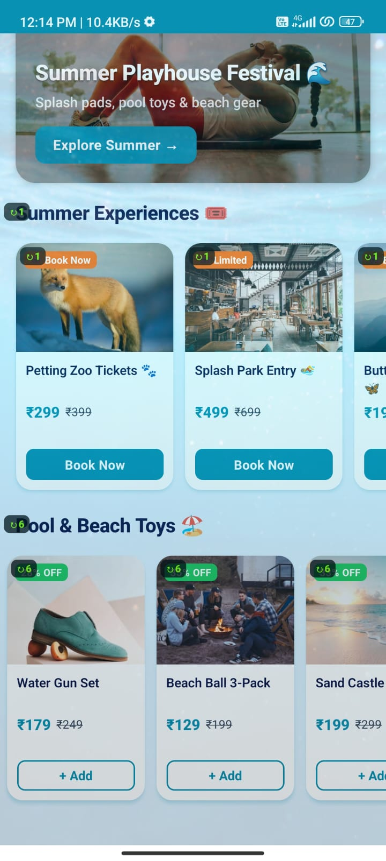  Summer Playhouse (EVENT_BOOKING) | 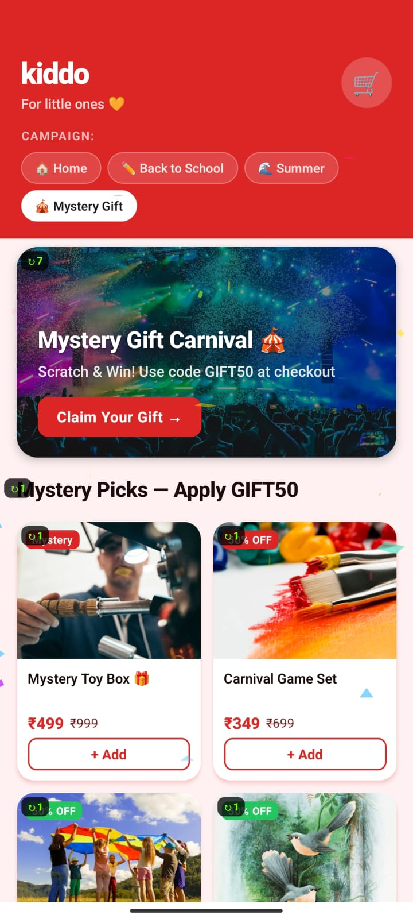  Mystery Gift Carnival (confetti)

6. Demo Videos (Google Drive)
Engineering-proof clips — click to play:
- 1 — Render Isolation: Watch
- 2 — Scroll Performance: Watch
- 3 — Resilience: Watch

7. How to Run & Verify
From the kiddo-sdui directory:
- npm install — install dependencies
- npx expo start — run the app (press 'w' for web, or scan QR with Expo Go)
- npm test — run 15 unit tests (parser / overlay / cart) — all pass
- npm run typecheck — tsc --noEmit strict mode — 0 errors

8. Verification Status
- TypeScript strict (isolatedModules): 0 type errors.
- Jest: 15 / 15 tests passing.
- 3 distinct live campaigns + base home, instant OTA theme switch.
- Three-layer resilience demonstrated with seeded corrupt blocks.

