# ABSTRACT

The "Real Estate Chatbot" project aims to develop an intelligent conversational agent specifically for the real estate industry. It uses natural language processing and machine learning to provide personalized assistance to users looking to buy, sell, or rent properties. The chatbot offers property search, mortgage guidance, neighborhood information, and appointment scheduling. It integrates with existing databases and ensures data security. The goal is to enhance user experience, reduce response times, and revolutionize real estate interactions for both buyers and sellers.

# REAL ESTATE CHATBOT

**1. Introduction :**

A real estate chatbot system is an automated conversational agent designed to assist users in various aspects of real estate transactions. It utilizes natural language processing (NLP) and artificial intelligence (AI) techniques to understand and respond to user queries or requests. The chatbot can provide information about available properties, schedule viewings, calculate mortgages, answer frequently asked questions, and even connect users with real estate agents. It aims to streamline the real estate experience, provide instant support, and enhance customer engagement by delivering personalized and efficient interactions through messaging platforms or websites. The system can improve efficiency, save time, and offer convenience to both real estate professionals and potential buyers or renters.

**1.1. Problem Statement :**

* 1. Limited Availability: Real estate professionals may not be available 24/7 to assist potential buyers or renters.
  2. Overwhelmed with Information: Customers may feel overwhelmed by the vast amount of information available when searching for properties or making real estate-related decisions.
  3. Lack of Personalization: Finding relevant properties or receiving tailored assistance can be challenging, leading to a suboptimal user experience.
  4. Time Constraints: Scheduling property viewings or obtaining immediate answers to inquiries may be time-consuming due to manual processes.
  5. Inefficient Communication: Traditional methods like phone calls or emails can result in delays or miscommunication between parties involved in real estate transactions.

**1.2. Solution:**

* 1. 24/7 Availability: A real estate chatbot system can provide round-the-clock support, ensuring that users can access information and assistance at any time.
  2. Simplified Information Retrieval: The chatbot can streamline the search process by presenting relevant property listings, neighborhood details, pricing information, and other data in a user-friendly manner.
  3. Personalized Recommendations: By leveraging user preferences and past interactions, the chatbot can offer personalized property recommendations and tailored advice to enhance the user experience.
  4. Instantaneous Responses: Chatbots can quickly respond to user queries, schedule property viewings, and provide real-time updates, saving time and improving efficiency.
  5. Seamless Communication: The chatbot system can facilitate smooth communication between buyers, renters, real estate agents, and other stakeholders, ensuring that information is exchanged accurately and promptly.

By addressing these challenges and providing effective solutions, a real estate chatbot system can enhance the overall real estate experience, making it more efficient, convenient, and personalized for both buyers and real estate professionals.

1. **System Design :**

**2.1. Mindmap :**

A mind map is a graphical tool used to visualize and organize information. It starts with a central idea or concept, and related ideas branch out in a hierarchical and interconnected manner. It promotes creativity,brainstorming, and structured thinking by capturing ideas, concepts, and relationships in a visually appealing and intuitive format. Mind maps can be created on paper or using digital tools, allowing for easy modification and expansion of ideas. They are commonly used for planning, problemsolving, note-taking, and knowledge organization.

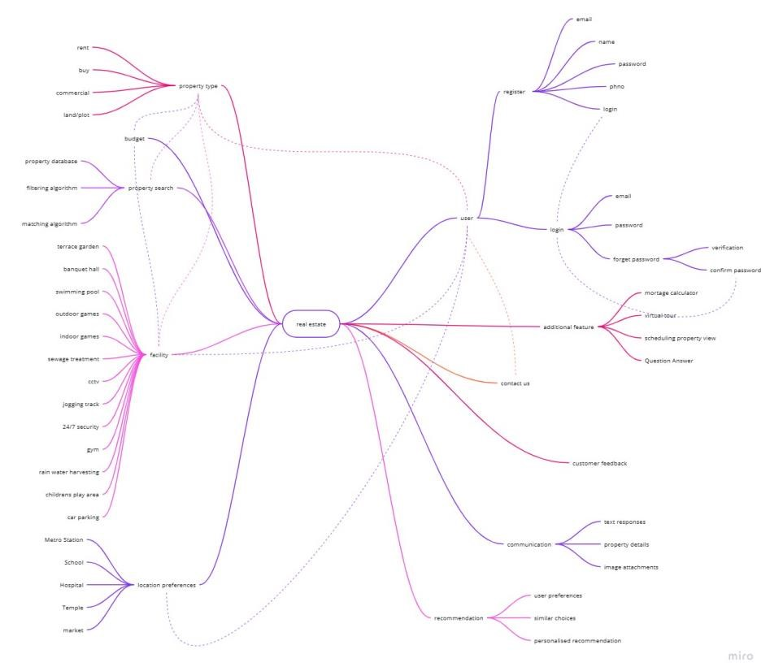

2.1 Mindmap

1. **2.Functional Requirements for Real Estate Chatbot :**

1.User Registration and Authentication:

•Allow users to create accounts via email and Phone number.

•Secure login and user profile management.

•If user has lost their password, they can again login by email verification.

2.Property Search:

•Allow users to search for properties like rental houses, new house, commercial spaces and plots based on criteria such as location, budget, property type etc.

•Provide advanced search filters to refine the search results.

•Present results in a user-friendly format, including property details, images, and relevant information.

1. Additional Feature:

•Mortgage Calculator: A mortgage calculator to estimate monthly mortgage payments based on user input such as loan amount, interest rate, loan term, down payment. It will calculate the monthly payment.

•Virtual Tour: A virtual tour is a digital representation of a physical space that allows users to explore and interact with it remotely. Virtual tours are used in various industries, including real estate, tourism, and education, and can be viewed on websites or through virtual reality devices. They offer a convenient way to visualize and explore spaces without being physically present.

•Scheduling Property View: It involves setting up appointments for interested individuals to physically visit a property. User can ensures a smooth and efficient process.

•Question Answer Session: A real estate chatbot refers to the feature that allows users to ask questions and receive relevant answers regarding various aspects of the real estate industry. It enables users to obtain information, clarification, and guidance on specific topics or queries they may have.

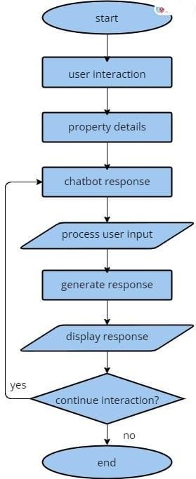

4.Contact Us :

In case of any query and clarification user can contact with Customer Support section using our mail id.

5.Customer Feedback :

User can give their valuable feedback after going through a property. They can also provide a feedback after renting, buying and site seeing is done by themselves.

6. Communication:

•Text Responses: Text responses in real estate chatbots are written messages that provide information and answers to user queries. They are generated based on the chatbot's knowledge base and aim to deliver accurate and relevant information.

•Property Details: In a real estate context refer to specific information about a property that is relevant to potential buyers or renters. These details typically include key features, specifications, and attributes of the property, such as the number of bedrooms and bathrooms, square footage, location and any additional noteworthy characteristics. Property details provide users with essential information to evaluate and make informed decisions about a property of interest.

•Image Attachment: Image attachment in a real estate chatbot allows users to view property photos, features, and condition. It enhances the user experience by showcasing the property and complementing other information provided.

7.Recommendation:

•User Preferences: User preferences in real estate are the specific choices and criteria that users have when searching for properties. These preferences guide their decision-making by considering factors such as location, property type, size, amenities, and price range.

•Similar Choices: Similar choices in a real estate context refer to properties that share common characteristics or meet similar criteria as the user's specified preferences. These choices are relevant alternatives that closely match the user's desired criteria and provide viable options for consideration.

•Personalized Recommendation: Personal recommendations in a real estate context refer to suggestions or advice provided to users based on their specific preferences, requirements, and previous interactions.

8.Property type:

•Rent: Here the tenant can check a property and also check facilities of the property. The amount of rent can be vary depending on factors such as the location of the property, size, amenities, condition and market demand.

•Buy: When tenant buys a property, they become the owner and gain the rights and responsibilities associated with property ownership.

•Commercial properties: This will offer a range of commercial properties such as office spaces, retail spaces, warehouses, industrial properties, and restaurants/bars.

•Land/Plots: This will include vacant land or plots that can be purchased for future development or construction.

9.Location preferences:

•Metro Station: This allow users to select properties that are located near metro stations or have easy access to public transportation. This option can be helpful for individuals who rely on public transit their daily commute.

•Schools: This enable users to prioritize properties located near schools, including primary schools, secondary schools, or specific educational institutions. This option is beneficial for families with school going children.

•Hospitals: This provide an option for users to prioritize properties that are in close proximity to hospitals or medical facilities. This preference is important for individuals who value easy access to healthcare services.

•Temples: This allow users to indicate their preference for properties located near temples, churches, mosques, or other places of worship. This option caters to individuals who value religious or spiritual proximity.

•Markets: This enable users to select properties that are located near markets, supermarkets, shopping centers, or commercial areas. This preference is useful for those who want convenient access to shopping and daily necessities.

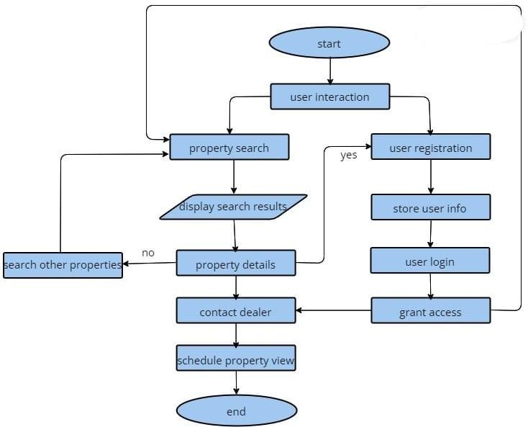

1. Budget:

Budget in real estate refers to the financial resources available for purchasing or renting a property. It determines affordability, helps narrow down options, and involves considering expenses and financial goals. Setting a realistic budget allows user for effective financial planning and flexibility.

1. Facility:

Facilities in real estate refer to amenities and services provided within a property or development. Common facilities include terrace garden, banquet hall, swimming pool, outdoor and indoor games, sewage treatment, jogging track, security, gym, rain water harvesting, play area, parking and sustainable features. These facilities enhance convenience, comfort, and quality of living or working in the property.

**2.3. Set of Question and Answer for Chatbot :**

1.Can you help me find a house/apartment/condo for sale/rent in a specific location?

Yes, I can help you with that. Please provide me with the location and any specific requirements you have, such as the number of bedrooms, price range, or amenities you're looking for.

2. What is the average price of homes in a particular neighborhood or city?

The average price of homes can vary depending on the location and other factors. To provide you with accurate information, please specify the neighborhood or city you are interested in.

3.How can I calculate my mortgage payments?

Mortgage payments can be calculated using factors such as loan amount, interest rate, and loan term. I can help you with the calculations if you provide me with these details.

4.What are the current interest rates for home loans?

Interest rates for home loans can fluctuate regularly. It is best to check with financial institutions or mortgage brokers for the most up-to-date interest rate information.

5.Can you provide information on schools, parks, and amenities in a specific area?

Yes, I can provide information on schools, parks, and amenities in a specific area. Please let me know the name of the area or neighborhood you are interested in.

6.Are there any upcoming open houses or property viewings in my desired location?

To find information about upcoming open houses or property viewings in your desired location, it is recommended to check with real estate agents, online listings, or local newspapers for the most recent updates.

7.What is the process for buying a home?

The home buying process typically involves steps such as getting pre-approved for a mortgage, finding a suitable property, making an offer, conducting inspections, negotiating terms, securing financing, and closing the deal. It is a good idea to work with a real estate agent who can guide you through the process.

8.How do I sell my property?

The process of selling a property usually includes tasks such as pricing the property, preparing it for sale, marketing the listing, showing the property to potential buyers, negotiating offers, and completing the necessary paperwork for the closing process. A real estate agent can assist you in navigating the selling process.

9.What is the current real estate market like in a particular area?

Real estate markets can vary by location and are subject to change. To obtain accurate information about the current real estate market in a specific area, it is best to consult local real estate professionals who have access to the latest market data.

10.Can you recommend a real estate agent or broker in my area?

I can help you find real estate agents or brokers in your area. Please provide me with the location, and I will gather a list of professionals you can consider contacting.

11.Are there any foreclosed properties available for sale?

Foreclosed properties, also known as bank-owned properties or REO (Real Estate Owned) properties, may be available for sale. It's recommended to check with local banks, real estate agents, or online listing platforms that specialize in foreclosed properties to find relevant listings in your desired area.

12. What are the zoning regulations in a specific area?

Zoning regulations determine how land can be used within a particular area. These regulations can vary from one jurisdiction to another. To obtain specific information about zoning regulations in a particular area, it is best to consult the local planning or zoning department of the city or municipality where the property is located.

13.Can you provide information on property taxes in a particular location?

Property taxes can vary depending on the location and assessed value of the property. To obtain information on property taxes in a specific location, it is recommended to contact the local tax assessor's office or visit their website for the most accurate and up-to-date details.

14. What are the steps involved in applying for a home loan?

The steps involved in applying for a home loan typically include gathering financial documents, obtaining pre-approval, selecting a lender, completing the loan application, providing necessary documentation, undergoing a credit check, property appraisal, loan underwriting, and ultimately, loan closing. It is advisable to consult with a mortgage lender or broker for detailed guidance on the specific requirements and processes involved.

15.Can you suggest some interior design tips to enhance my home's value?

Certainly! Some interior design tips to enhance a home's value include decluttering and organizing the space, repainting with neutral colors, upgrading lighting fixtures, enhancing curb appeal, ensuring good natural light, upgrading kitchen and bathroom fixtures, and staging the home to highlight its best features. These are general tips, and the specific improvements needed may vary depending on the property and target market.

16.What are the best neighborhoods for families/singles/retirees in a specific city?

The best neighborhoods for families, singles, or retirees in a specific city can vary depending on individual preferences, amenities, safety, proximity to schools or workplaces, and other factors. It is recommended to research local resources, consult with real estate agents, or explore online platforms that provide neighborhood insights and ratings specific to the desired city.

17.Are there any upcoming real estate developments or new construction projects?

Upcoming real estate developments or new construction projects can vary by location and may change over time. It is advisable to consult local real estate agencies, developers, or online resources that track and provide information on planned or ongoing projects in the desired area.

18.Can you provide information on rental laws and regulations in a specific area?

Rental laws and regulations can vary from one jurisdiction to another. It is recommended to consult the local housing authority, tenant rights organizations, or legal professionals specializing in real estate law to obtain accurate information about rental laws and regulations specific to the desired area.

19.How do I negotiate the price of a property?

Negotiating the price of a property involves factors such as researching comparable sales, understanding market conditions, assessing the property's condition, identifying any potential issues, and making a reasonable offer based on these factors. It is advisable to work with a real estate agent who can provide guidance and assist in the negotiation process.

20.Are there any special financing options available for first-time homebuyers?

Yes, there are often special financing options available for first-time homebuyers. These may include programs such as FHA (Federal Housing Administration) loans, VA (Veterans Affairs) loans, or various state or local government-sponsored programs designed to assist

1. **Result :**



* 1. Figure shows login page.



* 1. Figure shows Signup page with validation.

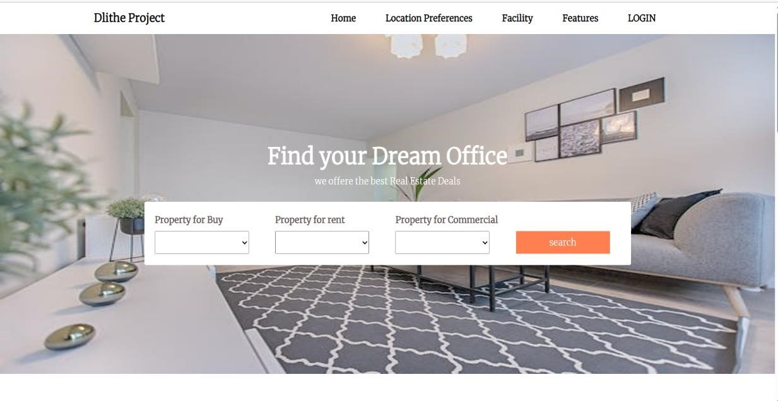

* 1. Homepage of the website.

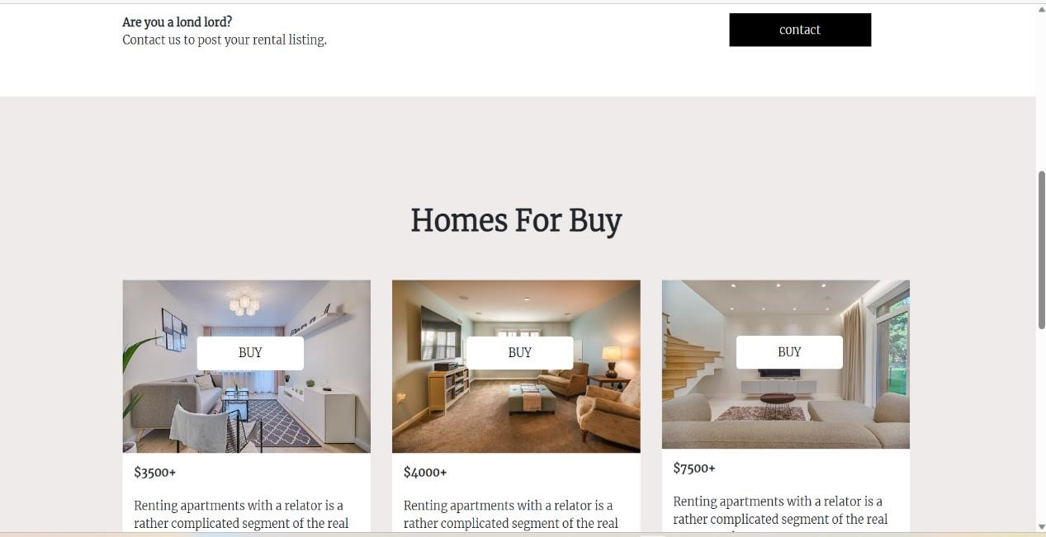

* 1. Scrolling down to the webpage.

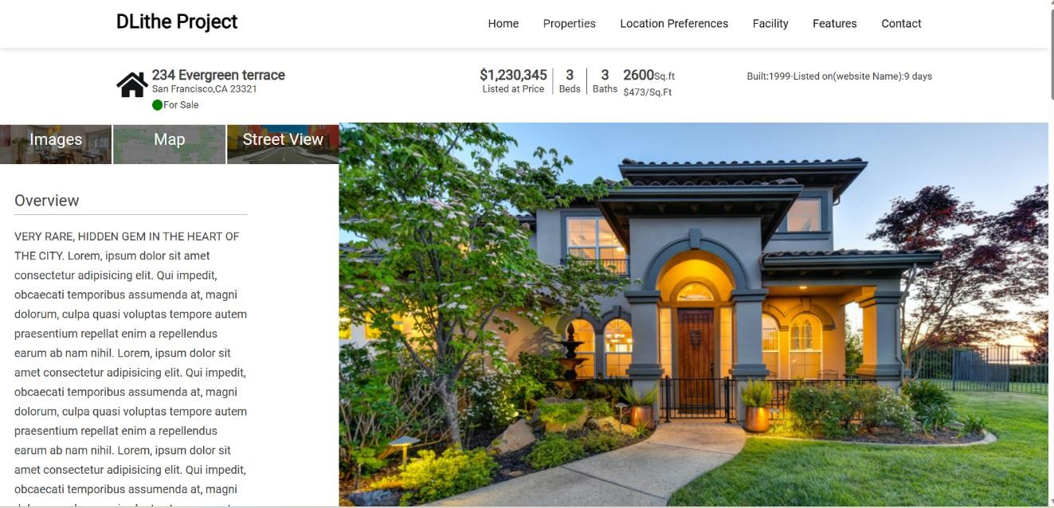

* 1. Card page containing House Information.

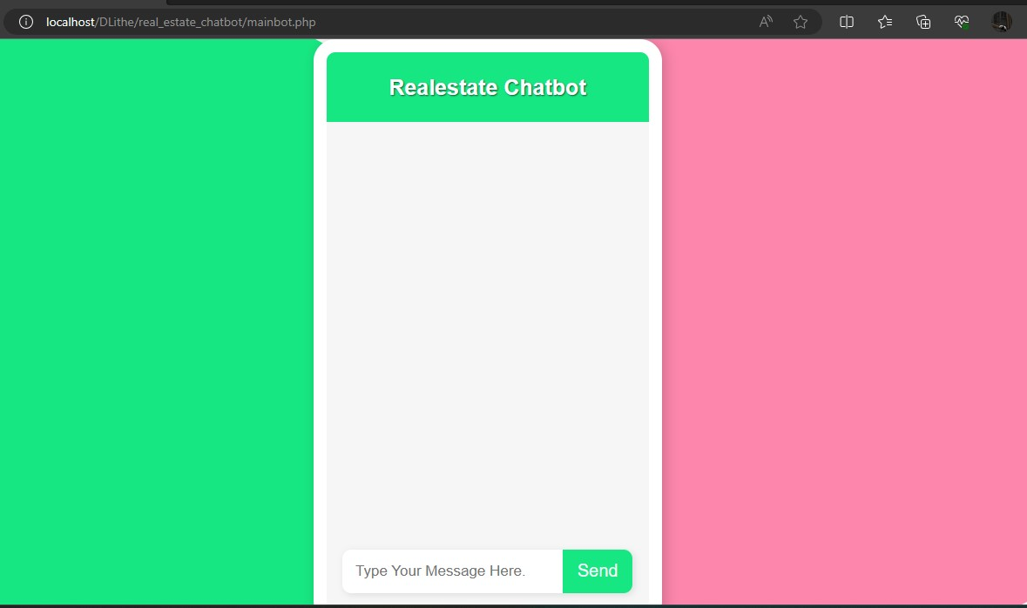

* 1. View of chatbot