AI-Powered Customer Review Analyzer
Data Analytics with AI — Internship Project

1. Problem Statement
The aim of this project is to analyze Amazon product review data to understand customer sentiment, ratings, and pricing/discount patterns across product categories, and to use AI (sentiment analysis and an LLM-generated summary) to convert raw statistics into actionable business insights.

2. Dataset
Amazon Sales Dataset — Kaggle (Karkavelraja J)
Link: https://www.kaggle.com/datasets/karkavelrajaj/amazon-sales-dataset
The dataset contains 1,465 product records with pricing, ratings, and customer review text. It includes product name, category, discounted price, actual price, discount percentage, rating, rating count, and combined review content per product.

3. Steps Used for Analysis
- Collect and load the dataset (CSV) into Pandas.
- Inspect the data for missing values, incorrect types, and structural issues; drop 1 corrupted row (mismatched column shift) and 2 rows with missing rating_count.
- Clean price and percentage columns (strip currency symbols, commas, % signs) and convert to numeric types.
- Extract a top-level product category from the nested category field, and restrict category-level comparisons to the three categories with sufficient sample size.
- Group and summarize the data using averages (rating, discount %) by category.
- Run sentiment analysis (VADER) on review text to classify each product's combined reviews as positive, negative, or neutral.
- Create charts to compare ratings and discount levels across categories.
- Use an LLM to convert the aggregated statistics into a plain-English insights and recommendations summary.

4. Live Analysis

Average Rating and Discount by Category
Category | Avg. Rating | Avg. Discount %
Computers & Accessories | 4.16 | 53.92%
Electronics | 4.08 | 50.83%
Home & Kitchen | 4.04 | 40.23%

Sentiment Distribution by Category
Category | Negative | Neutral | Positive
Computers & Accessories | 15 (3.3%) | 2 | 434
Electronics | 19 (3.6%) | 1 | 506
Home & Kitchen | 26 (5.8%) | 1 | 419

Which category has the best average rating?
Computers & Accessories rates highest on average (4.16), followed by Electronics (4.08) and Home & Kitchen (4.04).
Which category has the highest negative-sentiment rate?
Home & Kitchen, at 5.8% of reviews classified negative — nearly double the rate of Computers & Accessories (3.3%), despite receiving the lowest average discount (40.2% vs. 53.9% and 50.8% for the other two categories).
What is the overall sentiment split across all reviewed products?
Of 1,423 products analyzed: 1,359 positive (95.5%), 60 negative (4.2%), and 4 neutral (0.3%).
Is there a relationship between discount level and customer satisfaction?
Not a positive one. Home & Kitchen receives the smallest discount and has the highest negative-sentiment rate, suggesting dissatisfaction there is more likely driven by product quality than by price.

5. AI-Generated Insights & Recommendations
Across 1,423 product reviews spanning Electronics, Computers & Accessories, and Home & Kitchen, sentiment is overwhelmingly positive (95.5%), with only 60 reviews (4.2%) classified as negative. However, negative sentiment is not evenly distributed: Home & Kitchen has the highest negative-review rate at 5.8%, compared to 3.6% for Electronics and 3.3% for Computers & Accessories — nearly double the rate of the best-performing category. This is despite Home & Kitchen carrying the lowest average discount (40.2%, versus 53.9% for Computers & Accessories and 50.8% for Electronics), suggesting dissatisfaction here is more likely tied to product quality or expectations than pricing.
Ratings tell a consistent story: Computers & Accessories rates highest on average (4.16), followed by Electronics (4.08) and Home & Kitchen (4.04) — the same ranking as the sentiment data, reinforcing that Home & Kitchen is the category most in need of attention.
Recommendations:
- Prioritize a quality/complaint review for Home & Kitchen products specifically — its negative-sentiment rate is disproportionate to its discount levels, ruling out price as the likely driver.
- Computers & Accessories is the strongest-performing category on both rating and sentiment, despite already carrying the deepest average discount — a good candidate for continued or expanded promotion.
- Given VADER's tendency to skew positive on aggregated review text, treat the 4.2% negative rate as a conservative lower bound — true dissatisfaction, particularly in Home & Kitchen, may be understated.

6. Visual Report
The charts below summarize the sentiment, rating, and discount patterns discussed above, and mirror the interactive dashboard built for this project.
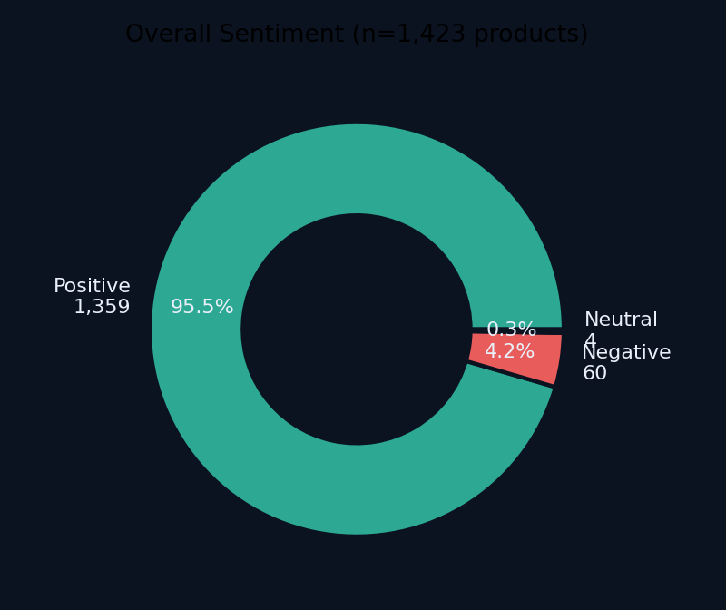

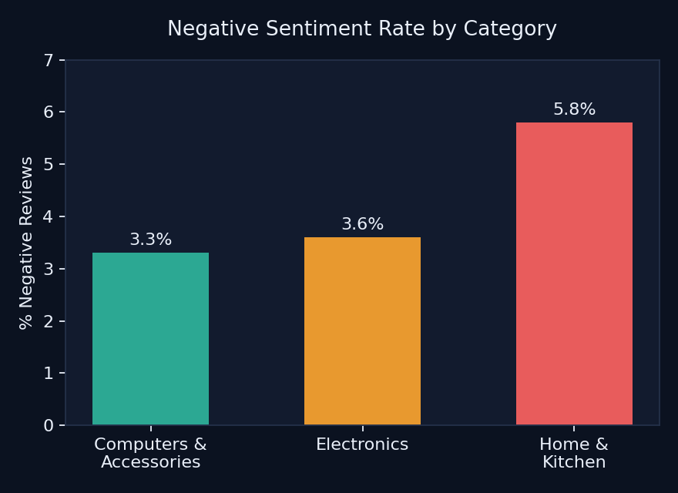
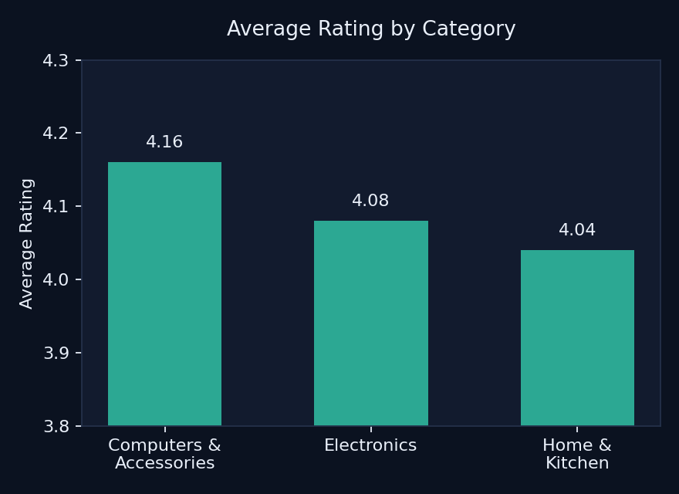
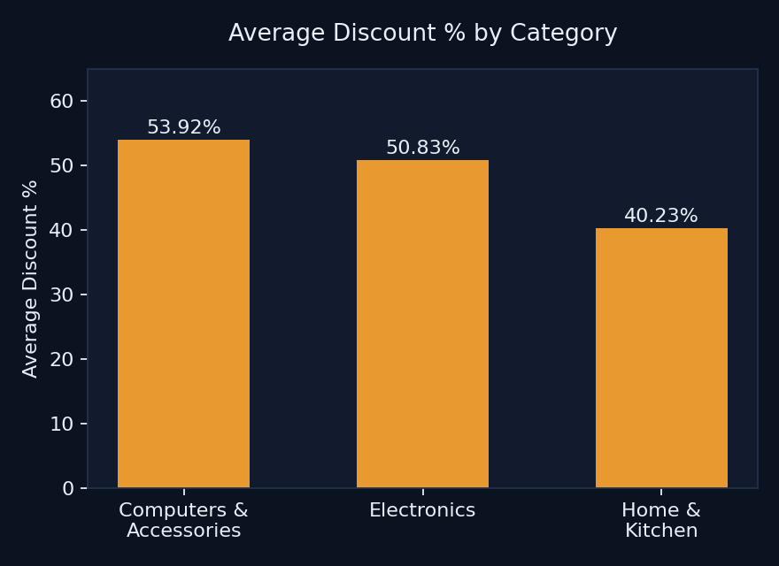

7. Machine Learning — Sentiment Classification
Beyond rule-based (VADER) sentiment scoring, a supervised ML model was trained to predict sentiment directly from review text: TF-IDF vectorization (3,000 features, English stop-words removed) feeding a Logistic Regression classifier with balanced class weights, trained on 1,139 reviews and evaluated on 284 held-out reviews.
Class | Precision | Recall | F1-score
Positive | 0.97 | 0.98 | 0.98
Negative | 0.50 | 0.42 | 0.45

Overall accuracy was 95.8%, but this figure is inflated by class imbalance (only 60 of 1,423 reviews were negative). Recall on the negative class was just 42%, meaning the model misses more than half of actual negative reviews — a limitation worth stating explicitly rather than relying on the headline accuracy figure alone.

8. Data Limitations
- One row had a shifted-column error (a comma inside a category field) and was dropped.
- Reviews are stored one cell per product (combining all reviewers), not one row per review — sentiment was therefore analyzed at the product level rather than the individual-review level.
- A small number of categories (e.g., Toys & Games, Car & Motorbike) had only 1 sample each and were excluded from comparative claims due to insufficient sample size.

9. Conclusion
This project shows how combining traditional data analysis (cleaning, aggregation, visualization) with an AI sentiment-analysis layer, a trained ML classifier, and an LLM-generated summary can turn raw e-commerce review data into clear, actionable business insights — identifying which product category needs attention (Home & Kitchen) and which is performing well despite less discounting (Computers & Accessories).

Author: Arpita — Data Analyst (Fresher) | AICTE–IBM SkillsBuild Internship (BharatCares)

