./



**GENESIS AUGUST 2021**

**APPLIED SDLC**

**C PROJECT ON**

**HEALTH MONITORING SYSTEM**

Contents

Introduction 3

research 3

the idea behind healthy me 3

advantages 4

disadvantages 4

cost and features 5

Detail Requirements 5

swot analysis 5

4W’s and 1h 6

High level requirements 8

Low level requirements 9

DESIGN 10

High Level 10

• Activity Diagram 10

• Use Case Diagram 11

Low Level 12

• Workout Plan 12

• Diet Plan 13

• Workout plan 14

• Component Diagram 15

TEST PLAN: 16

High level test plan 16

Low level test plan 17

Daily Stand up 18

Contributers list 19

Git inspector 20

Challenges faced 22

# Introduction

Physical fitness and health plays an important role in our day to day life. Regular exercise and physical activity in terms of sports, workouts and running promotes strong muscles and bones. It also improves respiratory, cardiovascular and overall health. With the recent unprecedented times of the Covid-19 pandemic the need for home workouts and a manageable diet based on individual needs has become one of the most common requirements to maintain a healthy lifestyle.

## **Research**

### The idea behind HealthyMe!

With the advent of Fast-food chain restaurants there are unhealthy yet tasty fast food items that are available at cheaper prices and with the introduction of food delivery aggregators people are inclined to order out rather than maintain a balanced or healthy diet. Improving technology has also played a major role in our everyday lives with an increase in jobs that promote an increasingly sendentary lifestyle. All these factors have contributed to a decline in the over all health and lifestyle of people these days.

With the recent spread of awareness in terms of social media over the various health concerns with an increasingly inactive lifestyle and its drawbacks people have now realised the benifit of exercise and a balanced but yet do not find the time to join Gym memberships and also find these overly expesive. Thus the solution in this case comes in terms of home workouts and health trackers that would allow user's to monitor not just their physical activity but their calorie intake as well.

HealthyMe is an inexpensive and easy to use application that can recommend a custom health plan consisting of both a balanced, healthy diet as well as a rigorous workout session based on the user's:

* Height
* Weight
* Age
* Gender

This data is used to calculate the user's **BMI, BMR** index and these values would then be used to ensure that the best possible fitness regime is recommended. The user may also accurately track their calorie intake to ensure they stick to the set plan and also keep a track of their water intake and set personalised goal that meets their requirements and comfort. All this coupled with easy access anytime and anywhere makes HealthyMe a convincing application that would be of great to use to a large demographic of young users and working professionals.

### Advantages

* **Work out Anywhere:** As an application that is available on the go workouts are no longer restricted to a particular and can be done at any location as per the users convenience.
* **Cost Effective:** As these workouts do not require any specialised equipments they are usually cost effective with only a small subscription charge billed monthly or yearly based on the users requirement.
* **All in one Health App:** The can not only provide workout sessions but also recomend balanced diet plans and also help keep a track of daily calorie intake and help improve your lifestyle habits and health.
* **Keep you motivated:** A personalised notification can always serve as motivation to meet the fitness goals set for the day, this coupled with custom rewards goes a long way in keeping focused on your overall activities and fitness.

### Disadvantages

* **May be inaccurate:** Fitness app rely to a large extend on the data provided by the user and may sometimes be inaccurate in case the user data is not updated frequently and accurately.
* **May or may not be helpful:** Unlike a paid membership at the Gym where a trainer ensures you achieve your workout goals fitness app rely on the user to make a conscious effort else there would be no scope for improvement in the user's lifestyle.
* **May be unregulated and sometimes harmful:** As of now there are multiple fitness apps availabe to be downloaded for free online but a majority of these apps are unregulated and do not have set standards due to which there is o certain assurance that the recomended plan might benifit the user.

## **Cost and Features**

Development of a fitness application involve large costs in terms of UI/UX design, quality assurance services, DevOps services and project management. A **Minimum value product** is first developed which is the app with only the basic and used to get user feedback after which advanced features can be gradually added.

On an average considering the development time spent on the various aspects of an app with an estimated cost of around $50/hour rate:

| **Type of work** | **Back-end development** | **iOS development** | **Android development** |
| --- | --- | --- | --- |
| Features | 228 hours | 438 hours | 438 hours |
| Frameworks and libraries integration | 35 hours | 36 hours | 36 hours |
| UI/UX design | - | 120 hours | 120 hours |
| Quality assurance | 194 hours | 343 hours | 343 hours |
| DevOps | 36 hours | 62 hours | 62 hours |
| Project management | 124 hours | 218 hours | 218 hours |
| Total time | 617 hours | 1217 hours | 1217 hours |

Based on the above data we can estimate a cost of at least **$88,250** for one platform and **$150,850** for two platforms.

**Reference:** [*https://www.cleveroad.com/blog/how-much-does-it-cost-to-make-a-fitness-app*](https://www.cleveroad.com/blog/how-much-does-it-cost-to-make-a-fitness-app)

## **SWOT Analysis**

[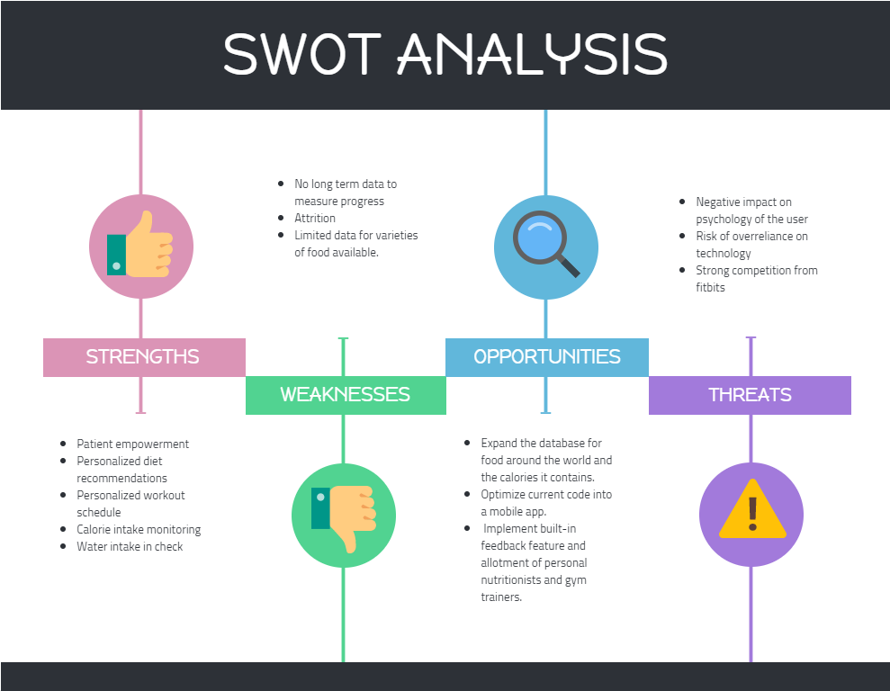](https://user-images.githubusercontent.com/57947483/130075269-d707a97e-0cd4-4105-9767-613ea794aa26.png)

# 4W's & 1H

## **Who**

* BMI calculators and BMR calculators are popularly used by people on a weight loss regime.

## **What**

* Taking the height and weight of a person and calculating BMI (Body Mass Index) and BMR (Basal Metabolic Rate).
* BMR is the number of calories required to keep body functioning at rest while BMI is a measure of body fat based on height and weight.
* Scheduling the diet plan and workout plan based on the data.

## **When**

* During health complications, related to weight gain or weight loss.
* Whenever the user requires to actively monitor their calorie and water intake.

## **Where**

* The user can access this application at the comfort of their home/office.

## **How**

* The user can access the console through laptops/computer and get personalized diet and workout charts at the comfort of their home/office.

# Detail requirements

## **High Level Requirements:**

| **ID** | **Description** | **Status (Implemented/Future)** |
| --- | --- | --- |
| HR.01 | User should be able to enter data in SI and Imperial system of units | Implemented |
| HR.02 | System should be able to output personalized calorie intake | Implemented |
| HR.03 | System should be able to output personalized workout routine | Implemented |
| HR.04 | System should be able to provide workout intensity choices to the user (Basic, Moderate, Extensive) | Implemented |
| HR.05 | System should be able to provide the ideal water intake to the user | Implemented |
| HR.06 | System should be able to provide a dedicated report in a text file format for each Health parameter | Implemented |

## **Low level Requirements:**

| **ID** | **Description** | **Status (Implemented/Future)** |
| --- | --- | --- |
| LR.01 | User should be able to enter weight, height, age and gender to calculate BMI and BMR | Implemented |
| LR.02 | User should be able to select SI/Imperial units as per their requirement | Implemented |
| LR.03 | System should allowthe user to choose if they want to generate new report or view previous reports | Implemented |
| LR.04 | User should be able to choose the report they want to generate | Implemented |
| LR.05 | System should be able to plan a diet chart based on the calorie requirements for a specific BMI | Implemented |
| LR.06 | System should be able to planout a workout regime based on users body type | Implemented |
| LR.07 | System should be allow the user to choose diets and workouts based on their body type and requirements | Implemented |
| LR.08 | System should be able to provide long and short term workput plans | Implemented |
| LR.09 | User should be able to view the water intake cosidering their workout schedule | Implemented |
| LR.10 | System should be able to consider the workout time session in Hrs and minutes | Implemented |
| LR.11 | System should be able to output the water intake user must have in a day | Implemented |
| LR.12 | User should be able to keep track of their health history reports | Implemented |
| LR.13 | User should be able to view and track the records on a dedicated mobile application | Future |
| LR.14 | Enhanced database for different varieties of foods & drinks and the calories it contains | Future |
| LR.15 | System should be able to give notification alerts to remind the user to drink more water | Future |
| LR.16 | System should provide the nutritional contents and calories of food items consumed across the world | Future |

# Design

## **High Level Design**

**Architecture Design**

[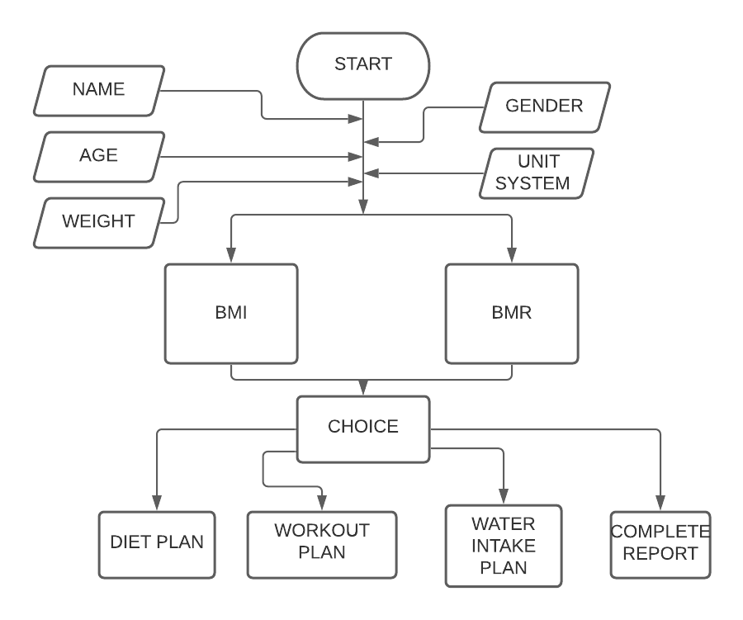](https://user-images.githubusercontent.com/57947483/130231221-582b513c-f0a9-404a-9865-d7efce31a989.png)

**Use Case diagram**

[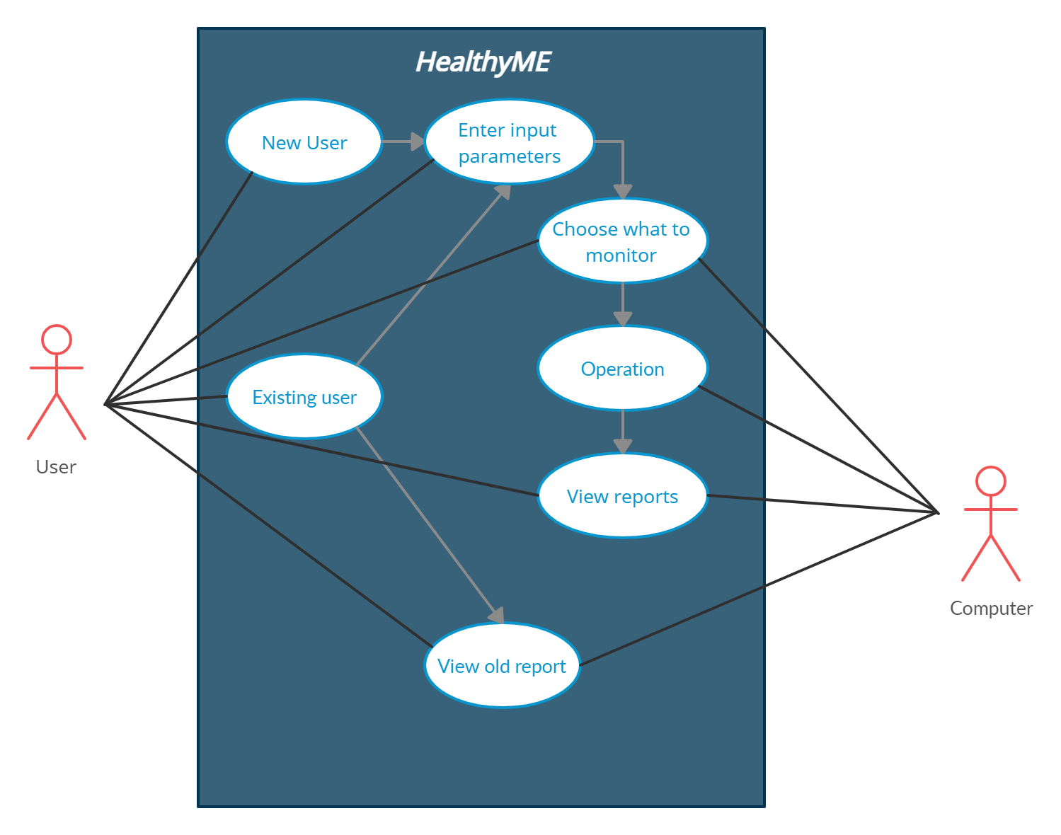](https://github.com/99Pp/SDLC_Team4_HealthyMe/blob/main/2_Architecture/use%20case%20diag.png)

## **Low Level Design**

**Workout Plan**

[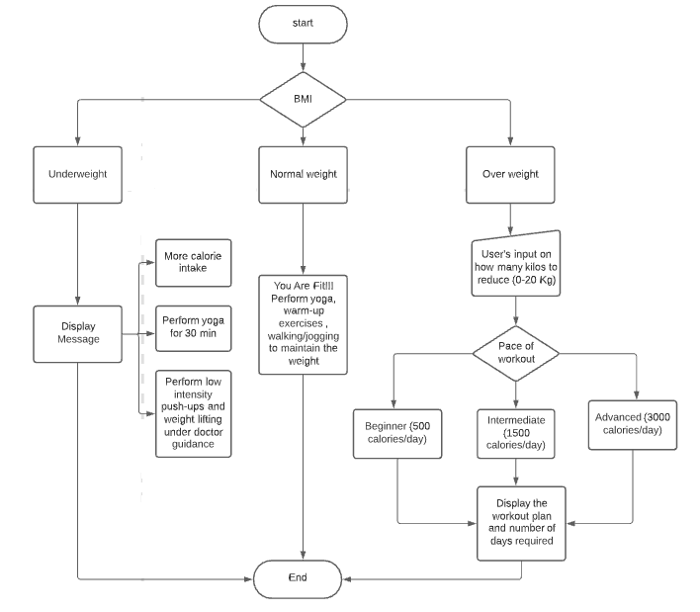](https://github.com/99Pp/SDLC_Team4_HealthyMe/blob/main/2_Architecture/WorkPlan.png)

**Diet Plan**

[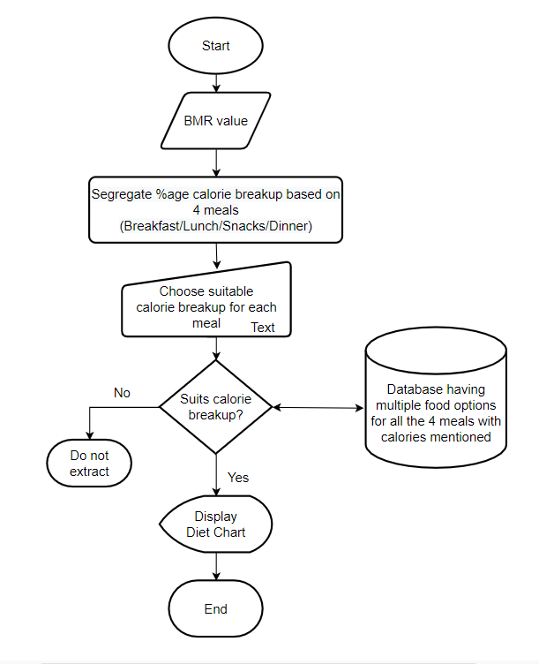](https://github.com/99Pp/SDLC_Team4_HealthyMe/blob/main/2_Architecture/Diet%20plan%20flowchart.PNG)

**Water In-take**

[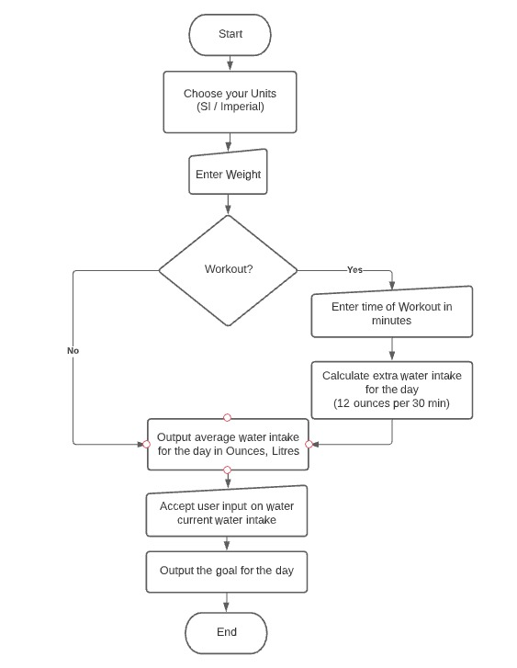](https://user-images.githubusercontent.com/57947483/130231390-1b5649ee-712a-4b0d-903e-11164bcafb09.jpeg)

# Test Plan

## **High level Test Plan**

| **Test ID** | **Description** | **Exp o/p** | **Exp i/p** | **Actual o/p** | **Type of test** |
| --- | --- | --- | --- | --- | --- |
| HT01 | Check functionality of the BMI and BMR calculation module | Expected output was obtained | User data | Expected output was obtained | Technical |
| HT02 | Check functionality of the Diet Plan and Calorie intake module | Expected output was obtained | User's choice to view dietplan | Expected output was obtained | Technical |
| HT03 | Check functionality of the Water intake module | Water intake is measured for the user | User's choice to view water intake | Water intake report generated | Technical |
| HT04 | Check functionality of the Workout module | Workout plan generated | User's choice to view workout plan | Workout plan generated | Technical |
| HT05 | Check if the program fetches details of existing user | Fetches details of existing user | User ID | Fetches details of existing user | Scenario based |
| HT06 | Check functionality of the Report generation module | Report was generated | User selects to generate a report | Report was generated | Scenario based |
| HT07 | Check if the program exits with proper Exit Code | Program exits | User chooses to exit | Program exits | technical |

## **Low level Test Plan**

| **Test ID** | **Description** | **Exp o/p** | **Exp i/p** | **Actual o/p** | **Type of test** |
| --- | --- | --- | --- | --- | --- |
| LT-1.1 | Check if user is able to choose between Imperial and SI unit system | SI system | Selects 1 | Data in SI system | technical |
| LT-1.2 | Check if user is alerted for improper inputs | Incorrect Entry | NULL | Incorrect entry | technical |
| LT-2.1 | Check if the system correctly outputs diet choices below calorie intake specified | Expected output was obtained | User's choice | Expected output was obtained | technical |
| LT-2.2 | Check if the user is alerted of the weight category they belong to | User's weight category | User data | Expected output was obtained | technical |
| LT-3.1 | Check if the system accurately accounts the units used SI/Imperial | BMI and BMR values in respective units | User's choice | Expected output was obtained | technical |
| LT-3.2 | Check if the system can keep a track of user workout duration | Expected output was obtained | User data | Expected output was obtained | technical |
| LT-3.3 | Estimate recommended water intake for the day based on user data | Expected output was obtained | User data | Expected output was obtained | technical |
| LT-3.4 | Ensure a record of the water data estimated is kept track of | Expected output was obtained | User data | Expected output was obtained | technical |
| LT-4.1 | Check if the user is able to provide the workout intensity choices | Expected output was obtained | User's choice | Expected output was obtained | technical |
| LT-4.2 | Check if the system is able to provide the maximum range of weight needed to shed by the user | Expected output was obtained | User data | Expected output was obtained | technical |
| LT-5.1 | Check if the user has chosen the correct index and choice or not | Incorrect entry | NULL | Incorrect entry | technical |
| LT-5.2 | Check if the user has selected the correct choice | CalcBMI,CalcBMR functions called | 1 | Calculate BMI and BMR values | technical |
| LT-5.3 | Check if the user has selected the correct choice | CalcBMR,calorie functions called | 2 | Calculate BMR and calorie values | technical |
| LT-5.4 | Check if the user has selected the correct choice | calcwaterquant and workoutcheck functions called | 3 | Calculate water quantity and workout of user | technical |
| LT-5.5 | Check if the user is able to select the correct choice | CalcBMI,CalcBMR functions called | 4 | Calculate BMI and BMR values | technical |
| LT-5.6 | Check if the user user had chosen a choise which is not present | Incorrect entry | 6 | Incorrect entry | technical |
| LT-6.1 | Check if the user had not sent data | NULL | NULL | Incorrect entry | technical |

## **Contributors List and Summary**

| **PS No.** | **Name** | **Features** | **Issues Raised** | **Issues Resolved** | **#Test Cases** | **# Test Case Passed** |
| --- | --- | --- | --- | --- | --- | --- |
| 99005666 | Archana R Bailkeri | worked on workout Module and created test plan and created flowcharts for Workout Module | * | 1 | * | * |
| 99005586 | Jenikaben Rajendrakumar Patel | Creating Report,Creating Standup Meetings,Added File Handling |  | 1 | * | * |
| 99005387 | Varna M | worked on BMi Module and created test plan and created flowcharts for Bmi Module |  | 1 | * | * |
| 99005668 | Suraj Kumar | createed Architectural and High level digrams, worked on bmi bmr modules | * | 1 | * | * |
| 99005644 | Madhura M | Activioty diagrams, Reprt generation tool and utility program | 1 | 1 | 1 | 1 |
| 99005650 | Gopika H | worked on BMR Module and created essentials function and its respective test cases | * | 1 | * | * |
| 99005690 | Paras Panda | Code Integration , Bug Fix , Workflows Makefile | 3 | 2 | 2 | 2 |
| 99005596 | Pallavi Sharma | Calorie module and respective test cases,Uses case Diagrams | 1 | 2 | 2 | 2 |
| 99005590 | Ajay Victor | Water Intake Module,Unified Data Structure to be used by all modules | 2 | 3 | 2 | 2 |
| 99005608 | Manasa K | Made the flowchart for Workout Plan and Improved and development of Workout module | * | 2 | * | * |

## **Git Inspector**

[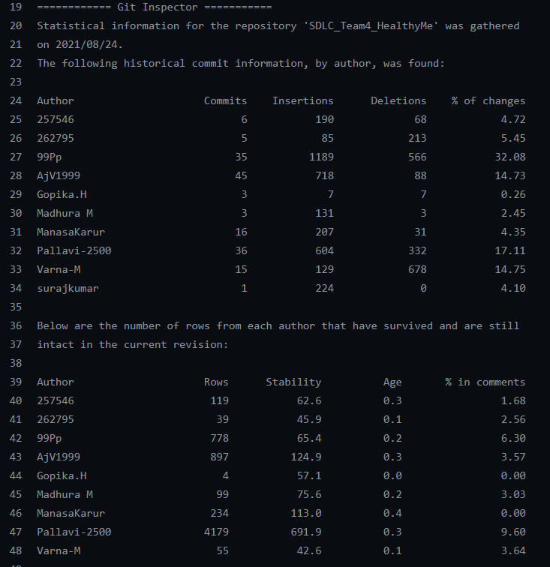](https://user-images.githubusercontent.com/57947483/130591622-d6055142-a78a-4660-a1d2-b73dd70ec3cb.PNG)

## **Challenges Faced and How Was It Overcome**

1. Selection of common programming language
   * With the amount of varied expertise brought in by the team setting on a common language was challenging. We finally settled on C programming.
2. Integration of developed modules
   * Integration of individual modules was challenging as each member had their own approach and comming up with a common structure based approach was both challenging and time consuming.
3. Testing of modules
   * Testing of each individual modules and also ensuring that each function adhered to the common structure format required re-work on everyone's part.
4. Setting up of Git workflows
   * Setting up of individual workflows for the various batches and ensuring the required criteria was met required bug fixes and improvement on code quality.