1. Command:netsh interface show interface

Or: netsh interface ipv4 show interfaces

Interfaces: Local Area Connection, Ethernet 2, VMware Network Adapter VMnet1, VMware Network Adapter VMnet8, Wi-Fi, Loopback Pseudo-Interface 1

Using :ipconfig/all

2.

When I tried to assign IP address to wifi interface using following command

netsh interface ip set address name=” Loopback Pseudo-Interface 1" static 192.168.1.100 255.255.255.0 192.168.1.1

netsh interface ip set dnsservers name="Loopback Pseudo-Interface 1" static 8.8.8.8 primary validate=no

netsh interface ip add dnsservers name= "Loopback Pseudo-Interface 1" address=8.8.4.4 index=2 validate=no

it’s giving me object already exists suggesting that ip address is already assigned to somebody.

For unique ip address I tried to find unused ip I cheked with ping -n 192.168.123.15

ping -n 4 192.168.123.15

It gave me destination host unreachable

netsh interface ip set address name= "Loopback Pseudo-Interface 1" static 192.168.123.15 255.255.255.0 192.168.1.1

netsh interface ip set dnsservers name="Loopback Pseudo-Interface 1" static 8.8.8.8 primary validate=no

netsh interface ip add dnsservers name= "Loopback Pseudo-Interface 1" address=8.8.4.4 index=2 validate=no

and for checking whether it is assigned or not in powershell I used :Get-DnsClientServerAddress



3. Data is send over network in form of small packet of information(division of data in small form ) .

Each packet contain source , destination and data . When this packet fails to travel to its desired destination packet loss occurs .

ping youtube.com

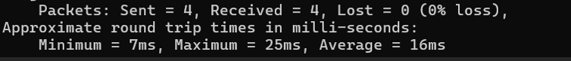

Round trip time minimum:7ms, average ;16ms, maximum:25ms

Standard deviation:



Here 4 packets are send

And result is saved in ap.tst file

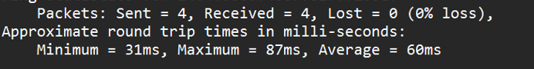

By retrieving values and using power shell following :





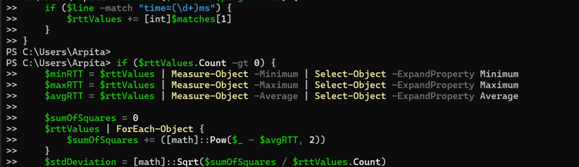

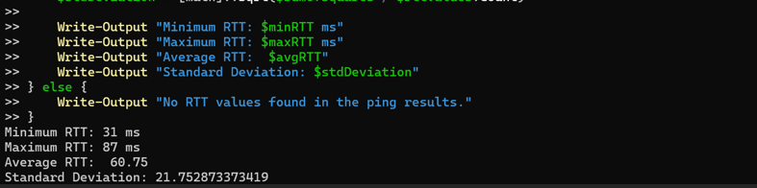

4.

tracert www.google.com

Hop: It is move data makes form one router to another . From my pc to google server 7 routers(excluding my pc and google server) are there and for first router hop is 1 , for second it is 2 (from pc->1st router and 1st -> 2nd) and for google server 8 hops are there(pc->1->2->3->4->5->6-> 7->google) . on each router 3 data packets are sent and here there response time(time after which my pc will get reponse from router that data packet is reached ) is given in 2nd , 3rd and 4th column and in 5th column IP address and domain name of router is given . so here from first router 1st data packet take 1 ms to come back, 2nd takes 2ms and 3 rd takes 1ms. From google server 1st takes 35 ms , 2nd datapacket takes 3ms and 3rd takes 3 ms to go reach back to pc (some trouble in path of 1st packet ). Here data can withstand till maximum of 30 hops before dropping out.