Project : Financial Dashboard

1. Introduction

1.1 Purpose of the Dashboard
The dashboard provides a comprehensive analysis of financial performance across regions, categories, and time periods. It supports decision-makers by presenting trends, optimizing resources, and evaluating key performance indicators (KPIs) for strategic planning and business growth.

1.2 Dataset Overview
The dataset includes transactional data from 2018 to 2023, comprising over 50,000 entries. Key columns are:
- Sales Amount
- Profit
- Category
- Region
- Date
These attributes allow for multidimensional analysis of financial metrics.

1.3 Key Features
- Interactive visualizations for actionable insights.
- Dynamic filtering and cross-highlighting.
- Real-time data updates (if applicable).

2. DAX Functions

1. Aggregate Functions

1.1 Total Sales
- Purpose: Calculates the total revenue generated from sales.
Total Sales = SUM(Sales[Amount])
- Explanation:
  - The SUM function adds up all the values in the Amount column of the Sales table.
  - Used in KPI cards, bar charts, or trend analyses.

1.2 Total Profit
- Purpose: Computes the overall profit by summing up the profit column.
Total Profit = SUM(Sales[Profit])
- Explanation: Similar to Total Sales but applied to the Profit column.

2. Ratio and Percentage Calculations

2.1 Profit Margin
- Purpose: Calculates profit as a percentage of sales.
Profit Margin = DIVIDE(SUM(Sales[Profit]), SUM(Sales[Amount]), 0)
- Explanation:
  - The DIVIDE function divides the total profit by the total sales.
  - The third argument 0 ensures no errors occur if sales are zero.
  - Displayed in KPI cards or visualizations for profitability analysis.

2.2 Contribution to Total Sales
- Purpose: Computes the percentage contribution of each category/region to total sales.
Sales Contribution = DIVIDE(Sales[Amount], CALCULATE(SUM(Sales[Amount]), ALL(Sales)))
- Explanation:
  - CALCULATE evaluates the total sales across all categories by removing filters using ALL.
  - Helps in identifying the share of each category/region.

3. Time Intelligence Functions

3.1 Year-to-Date Sales (YTD Sales)
- Purpose: Aggregates sales from the beginning of the year to the current date.
YTD Sales = TOTALYTD(SUM(Sales[Amount]), Date[Date])
- Explanation:
  - TOTALYTD calculates the cumulative sum for a time period (e.g., calendar year).
  - Uses the Date table to track time progression.
  - Suitable for trend analyses or KPI comparisons.

3.2 Previous Year Sales
- Purpose: Compares sales to the previous year for trend analysis.
Previous Year Sales = CALCULATE(SUM(Sales[Amount]), SAMEPERIODLASTYEAR(Date[Date]))
- Explanation:
  - SAMEPERIODLASTYEAR shifts the context to the same time period one year earlier.
  - Useful for year-over-year (YoY) growth tracking.

3.3 Monthly Sales Trend
- Purpose: Calculates total sales for each month.
Monthly Sales = SUM(Sales[Amount])
- Explanation:
  - Context-sensitive: When used with a date hierarchy (Year → Month), it dynamically shows monthly totals.

4. Logical and Conditional Functions

4.1 Pass/Fail Indicator
- Purpose: Categorizes students or transactions as "Pass" or "Fail" based on criteria.
PassFail = IF(Sales[Profit] > 0, "Pass", "Fail")
- Explanation:
  - The IF function checks whether profit is greater than zero.
  - Returns "Pass" for positive profits and "Fail" otherwise.

4.2 High Performer
- Purpose: Flags regions or categories performing above average.
High Performer = IF(Sales[Amount] > AVERAGE(Sales[Amount]), "Yes", "No")
- Explanation:
  - Compares each record’s sales to the overall average.
  - Useful for highlighting outliers.

5. Ranking and Filtering Functions

5.1 Top 10 Products by Sales
- Purpose: Identifies the top 10 products based on sales.
Top Products = RANKX(ALL(Sales[Product]), SUM(Sales[Amount]), , DESC)
- Explanation:
  - RANKX assigns a rank to each product based on total sales.
  - Sorting order is specified as descending (DESC).

5.2 Filtered Total Sales
- Purpose: Sums sales for a specific category or region.
Filtered Sales = CALCULATE(SUM(Sales[Amount]), Sales[Category] = "Electronics")
- Explanation:
  - CALCULATE modifies the filter context to include only records where the category is "Electronics."

6. Advanced Metrics

6.1 Average Sales Per Region
- Purpose: Calculates the average sales for each region.
Average Sales = AVERAGE(Sales[Amount])
- Explanation:
  - Simple aggregation using the AVERAGE function.
  - Provides insights into regional performance.

6.2 Score Improvement
- Purpose: Tracks improvement percentage between two metrics (e.g., sales from two periods).
Score Improvement = DIVIDE(Current - Previous, Previous, 0)
- Explanation:
  - Calculates the percentage change between two metrics.
  - Helps in identifying growth or decline.

3. Page Descriptions

3.1 Page 1: Overview
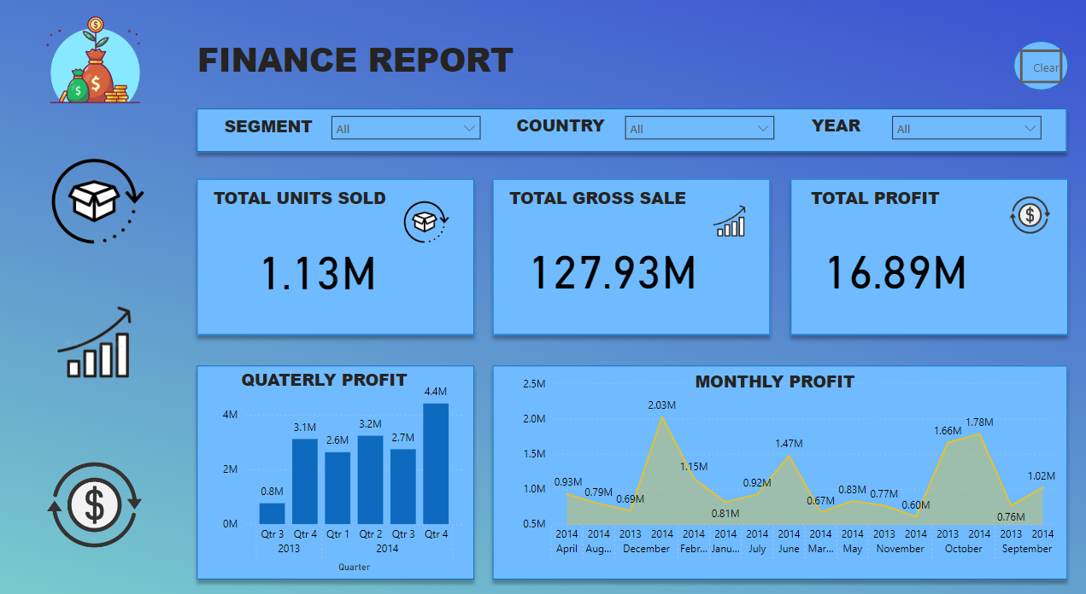
Visuals:
  - KPI Cards: Total Sales, Total Profit, Average Sales, Profit Margin.
  - Bar Chart: Sales by Category.
  - Line Chart: Monthly Sales Trend.
  - Slicer: Region and Year.
Insights:
  - Sales exceeded $5M in the last fiscal year, with 10% year-over-year growth.
  - Electronics contributes 45% of revenue.
  - Seasonal peaks occur in Q4.
Interactivity:
  - Slicers adjust data by region/year.
  - Cross-filtering enabled.

3.2 Page 2: Regional Analysis
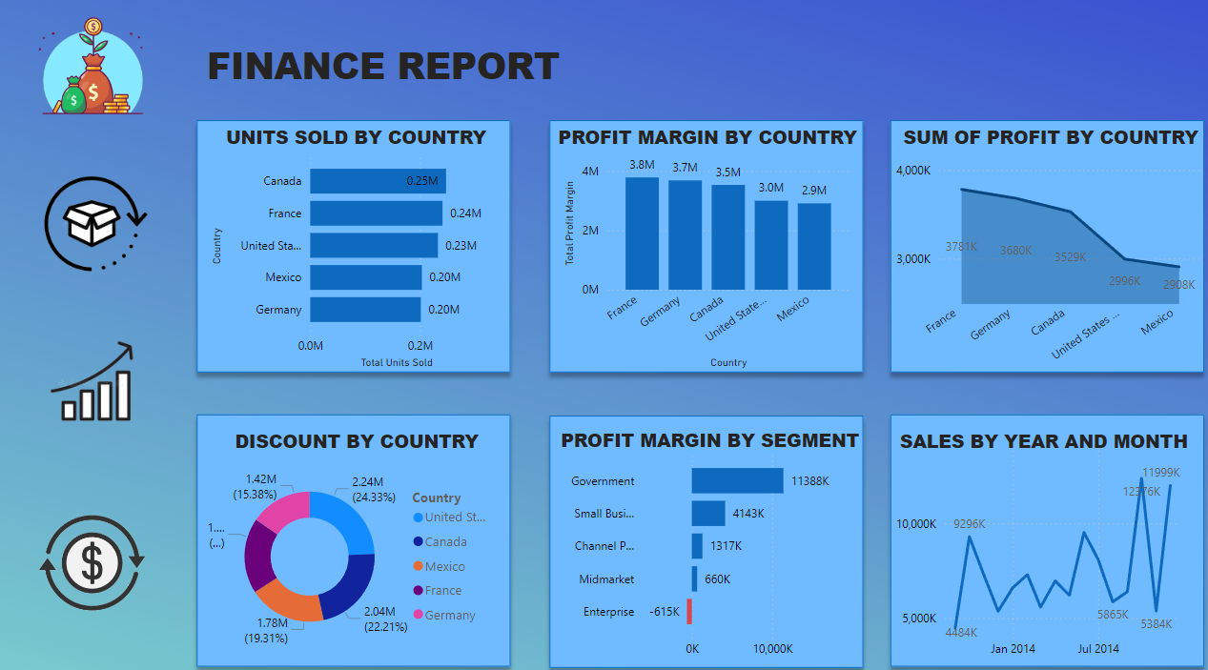
Visuals:
  - Map: Sales and profit by region.
  - Clustered Bar Chart: Profit by Region.
  - Pie Chart: Sales Contribution by Region.
Insights:
  - East region has high revenue but lower margins.
  - Central region underperforms.
  - South region shows growth potential.
Interactivity:
  - Filters based on map selection.

4. Conclusion
The Financial Dashboard offers executives a powerful tool to evaluate trends, compare regional performance, and optimize strategies. By leveraging its interactive features, businesses can drive informed decisions for growth and profitability.

