# Sustainable Supply Chain Performance Dashboard using Power BI – Week2

* Using Group by function in Transform tab in Power BI

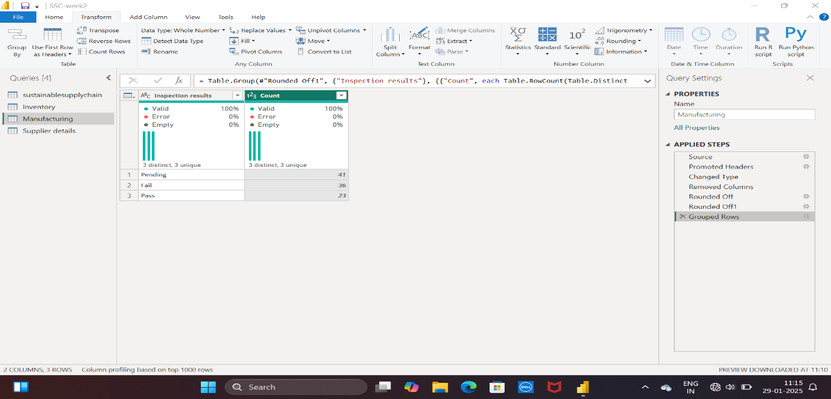

* Use of numerical operations- Calculating sum of Manufacturing Cost in Transform tab

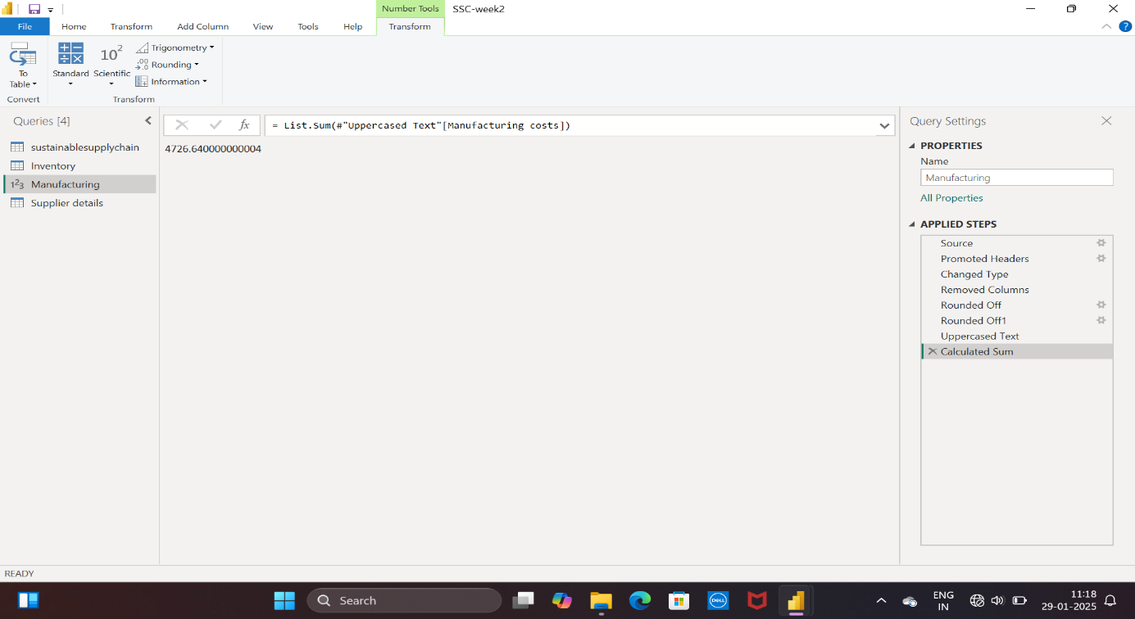

* Showcasing of relationships of tables in model view

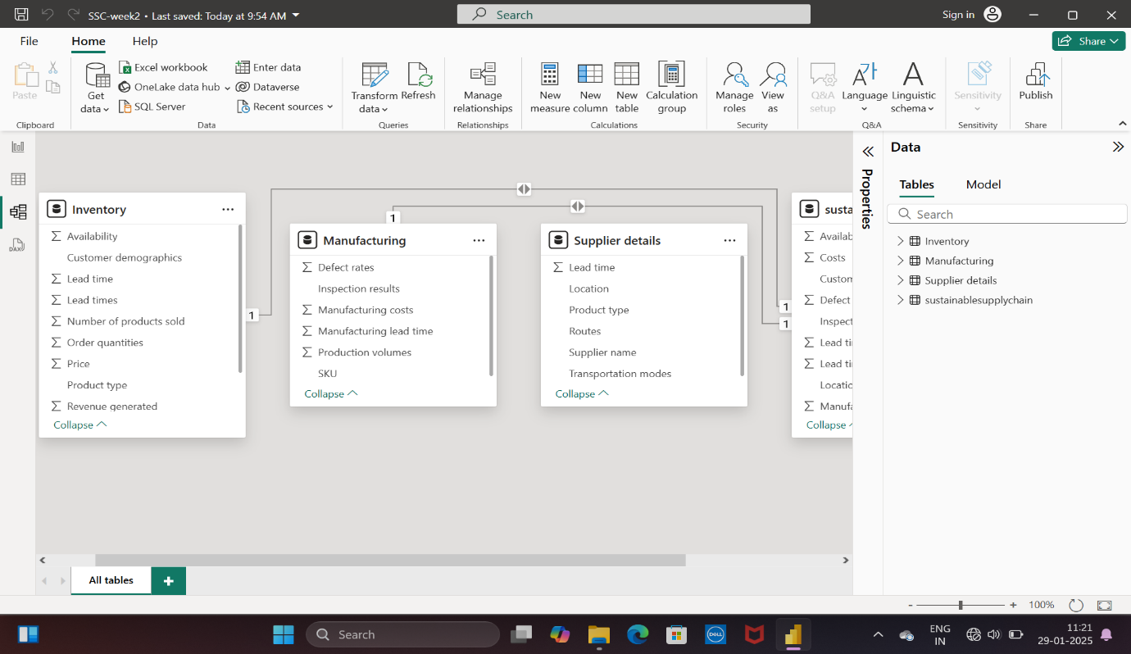

* Creating relation between two tables

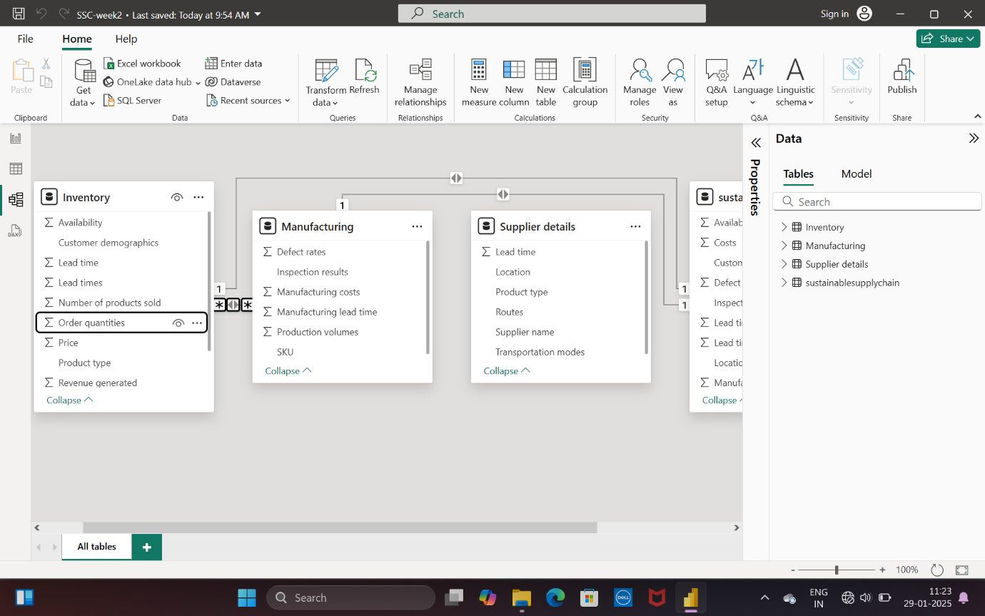

* Week2 – Completed Cleaning of data and Data modelling