Assignment Two - Scraping Twitter

Team #**67** - **'WORLD ENERGY'**

Group Participant- Only 1: Arpita Rai

GitHub: [***https://github.com/ArpitaRai/DMDD_Project_WorldEnergy****Links to an external site.*](https://github.com/ArpitaRai/DMDD_Project_WorldEnergy)

NUID: 002772720

ER Diagram:

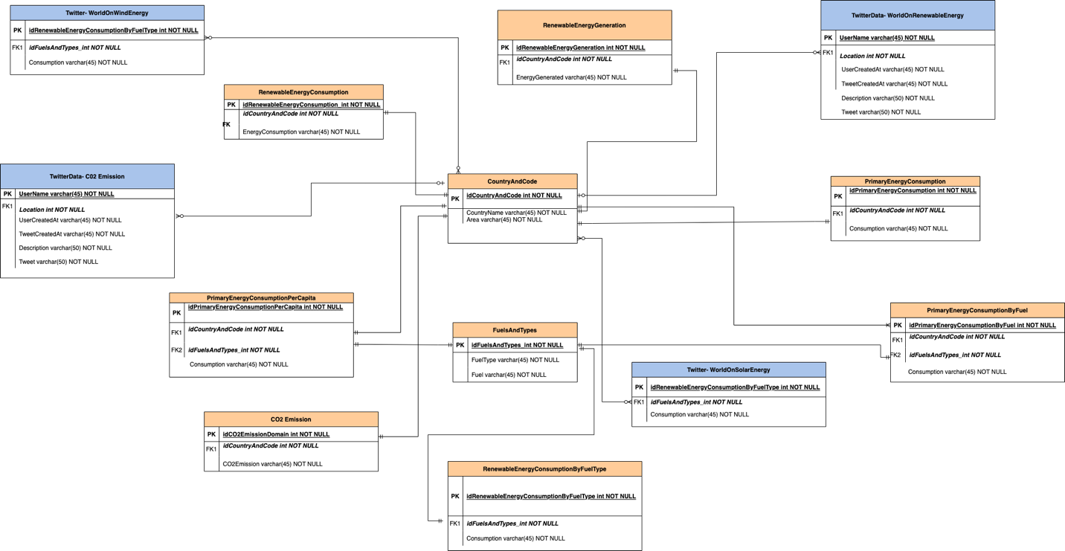

The ER Diagram above is a graphical representation of the database that has been implemented for the project- World Energy. This is a blueprint of how data has been stored in form of Relations between each table.

The data representation of Energy Consumption by Country and their geographical groupings focuses on types of Energy consumption along with the quantity of energy consumption and how it is changing over time. It also consists of CO2 emissions by developed and developing nations. The database also contains the data for renewable energies i.e., Solar and Wind Energies along with the consumption.

**Explanation of some of the design decisions:**

* CountryAndCode table has the Geographical location mapped with the countries and each country has a unique id associated with it, this acts as the primary key in this table and acts as a foreign key for others.
* The DB also consists of 4 tables which are extracted from Twitter. The data extracted from Twitter gives information about twitter tweets on Wind Energy, CO2 Emissions, Solar Energy and Renewable Energy.
* The extracted tweeter tables are further related to the main CountryAndCodeTable which has location as their foreign key. By the help of the foreign key, it’d be easier to extract hashtags and tweets related to the particular ‘Energy Table’.
* TwitterDataTables (WorldOnRenewableEnery, C02Emission) has information on the user posted, location, tweet created at what time, description, tweet, and the User Created Info. A user can come, and extract data based on keywords such as – ‘CO2Emission’, ‘GreenEnergy’, ‘RenewableEnergy’ etc.
* With the help of the foreign key ‘idCountryAndCode’ a user will be able to retrieve data from the ‘Primary Energy Consumption Per Capita’ of a country, the CO2 Emission of Geographical areas, and also Renewable Energy Consumption By Fuel Type. The Renewable Energy Generation and consumption of a particular area is also being retrieved by the same key.