SQL Analysis Report
Project: Olist E-commerce Business Performance Analysis
Purpose: Summarize the SQL analyses performed and provide space to insert SQL query outputs/screenshots and business insights.

1. Sales Performance

Objective
Evaluate revenue, orders and average order value over time.

Analysis Performed
Describe the SQL logic, joins, aggregations and calculations used.

Key Insights
• Total Revenue:

• Monthly Revenue Trend:
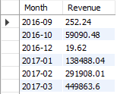
• Monthly Orders Trend:
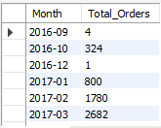
• Average Order Value Trend:
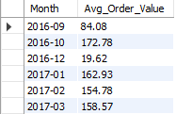

2. Product Performance

Objective
Identify the product categories contributing the highest revenue.

Analysis Performed
Describe the SQL logic, joins, aggregations and calculations used.

Key Insights
• Revenue by Product Category (Top 5):
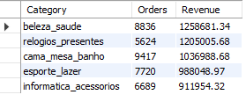
• Orders by Product Category (Top 5):
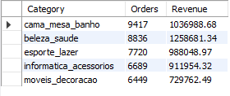

3. Customer Analysis

Objective
Understand customer purchasing behavior and identify valuable customer segments.

Analysis Performed
Describe the SQL logic, joins, aggregations and calculations used.

Key Insights
• Top Customers by Spending:
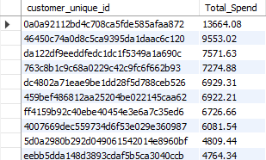

• Purchase Frequency:
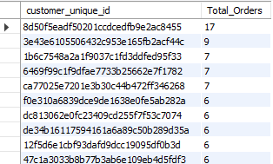

• Customer Distribution by State:
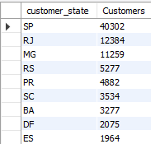

• Top Customer:

4. Seller Performance

Objective
Evaluate seller contribution and operational performance.

Analysis Performed
Describe the SQL logic, joins, aggregations and calculations used.

Key Insights
• Revenue, Orders, Avg. Reviews and Avg. Delivery Days by Seller according to Revenue (Top 5):
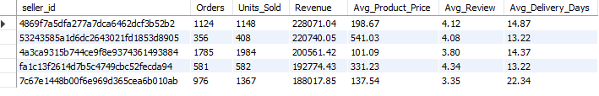

5. Customer Review Analysis

Objective
Investigate factors influencing customer review scores.

Analysis Performed
Describe the SQL logic, joins, aggregations and calculations used.

Key Insights
• Review Score by Category (Top 5):
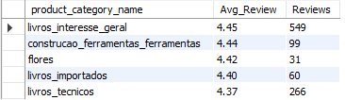

• Review Score by Seller:
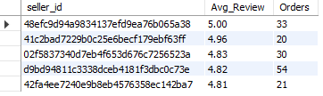

• Late Delivery vs Review Score:
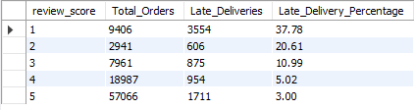

6. Delivery Performance

Objective
Analyze logistics performance and its relationship with customer satisfaction.

Analysis Performed
Describe the SQL logic, joins, aggregations and calculations used.

Key Insights
• Average Delivery Days:


• Late Delivery Percentage:
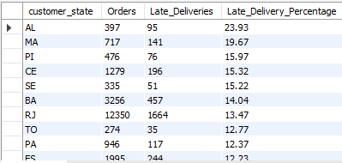

• Delivery Performance by State:
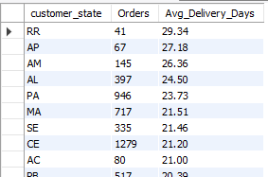

• Delivery Status vs Review Score:


