**Amrapali Institute of Applied Sciences,**

**Haldwani**



A

Synopsis

On

Online Shopping Software

Guide: Submitted by:

(Dr. Nitin Pandey) (Arpita Ginti)

Roll No. - 180945330003

**ABSTRACT**

The Online Shopping Software is a GUI based application intended for online retailers. The main objective of this application is to make it interactive and its ease of use. It would make searching, viewing and selection of a product easier. It contains a sophisticated search for user's to search for products specific to their needs. The search engine provides an easy and convenient way to search for products where a user can Search for a product interactively and the search engine would refine the products available based on the user’s input. The user can then view the complete specification of each product.

**INTRODUCTION**

In day to day life, we will need to buy lots of good or product from the shop. It may be food items, electronic items, household items etc. Now a days it is really hard to get some time to go out and get the by ourselves due to busy life style or lots of works.

The existing system of buying goods has several disadvantages. It requires lots of time to travel to the particular shop to buy the goods. Since everyone is leading busy life now a days, time means a lot to everyone. Also there are expenses for travelling from house to shop. More over the shop from where we would like to buy something may not be open 24*7*365. Hence we have to adjust our time with the shopkeeper’s time or vendor’s time.

# Manual Process

🚺

Customer physically visits the Retail outlet of his choice

**Bill clerk raises the Bill**

**The sales person precedes the products as per demand**

States a glance of the products and selects the required products

Cross-verifies the items from bill

Customer’s leaves

Computer plays an important role in our daily life. Anything we want we can get only in one mouse click. Speed, reliability and accuracy of the computer make it a powerful tool for different purposes. A very important and basic need of today’s modern business world is the quick availability and processing of information using computer. One can easily get the type of required information within a fraction of a second. The project that I have taken is also in this category which is used in our daily life whenever we want to purchase some items we can easily get them at our home.

**Why the New system**

* The system at any point of time can provide the information related to all the existing retail outlets and their operations.
* The system at any point of time can provide the list of items and their availability stock.
* The system at any point of time can help the customers in raising their orders.
* The system a specifically can instruct related to the status of the delivery process of the products.

**Explanation of the project**

Online Shopping System is the simple shopping solution. It’s a full-featured GUI system that bends over backwards to give you the flexibility you need to run your online store. This project is a GUI based shopping system for an existing shop.

The basic concept of the application is to allow the customer to buy the items from the store. The information pertaining to the products are store on an RDBMS at the server side (store).

Online shopping is the process whereby consumers directly buy goods or services from a seller .It is a form of electronic commerce. The process is called business-to-consumer (B2C) online shopping.

The Project is a GUI application developed in Python LANGUAGE using PySimpleGUI as front end and MYSQL as backend.

The main aim is to improve the services of Customers and vendors.

The primary features of the project are high accuracy, design Flexibility and easy availability. Application was designed into two modules first for the customers(USER) who wish to Buy the Product. Second is for the storekeepers(ADMIN) who maintains and updates the Information pertaining to the Product.

**SYSTEM REQUIREMENT & SPECIFICATION**

To be used efficiently, all computer software needs certain hardware components or other software resources to be present on a computer. These prerequisites are known as (computer) system requirements and are often used as a guideline as opposed to an absolute rule. Most software defines two sets of system requirements: minimum and recommended. Software requirements specification establishes the basis for an agreement between customers and contractors or suppliers on how the software product should function.

.

**HARDWARE REQUIREMENTS**

* Premium 200 MHz of processor
* 1 GB RAM or higher
* 512 GB Hard drive or higher
* Processor – i3

**SOFTWARE REQUIREMENTS**

* Platform: Windows
* Operating System: Windows XP or any other
* Front-End tool: PYTHON
* Back-End tool: MySQL

**Advantages:**

• Customers can get their goods delivered instead of actually going and buying the goods. They can make payment online itself.

• Managing of inventory in the shop for shopkeeper becomes easier as customers are not visiting and ordering online.

• This system saves both time and travelling cost of customers.

• User can get to know different kinds of goods that they were unaware of by just searching in the system using keywords.

**PROPOSED WORK**

**CONCEPT OF Pysimplegui**

It is easy to use with simple yet HIGHLY customizable features of GUI for Python. It is based solely on [Tkinter](https://www.geeksforgeeks.org/python-gui-tkinter/). It is a Python GUI For Humans that Transforms Tkinter, PyQt, Remi, WxPython into portable user-friendly Pythonic interfaces.

**How can we use PySimpleGUI?**

The Steps for using the GUI package PySimpleGUI are:-

* Install PySimpleGUI

*pip install PySimpleGUI*

* Find a GUI that looks a lot similar to which you want to design and create.
* Copy code from Cookbook.
* Paste into your IDE and run.

**ADVANTAGE**

* No callback functions needed
* It leverages Python constructs to shorten the amount of code. For example, a widget is configured in place, not at a distance of several lines of code.
* Single package dependency — Wraps Tkinter and does not require any other packages to be installed.
* The same GUI program can be executed on multiple GUI platforms — including a web browser — without changing the source code (only except the import statement).
* Able to create GUI for multiple OS platforms — Windows, Linux, Raspberry Pi, and Android (PyDroid3) — with very minor changes

**Limitations:**

* Should really only be used for simple GUI development
* Lacks a forms designer

**CONCEPT OF MYSQL**

**What is MySQL?**

MySQL is a Relational Database Management System (RDBMS) that runs as a server providing multi-user access to a number of databases.

MySQL was designed for three principles, which are performance, reliability and usability. A cheap, distinctive, fast and efficient RDBMS was created by following those principles. MySQL becomes a perfect tool for developers and administrators to establish maintain and configure complex applications.

It has the following main features:

**Performance**

In the RDBMS, the speed of executing a query and returning the results to the searchers is very important. MySQL is very fast, sometimes the implementation of major orders is even

Faster than its competitors. The benchmark on the MySQL official website shows that it is superior to almost all other databases such as Microsoft SQL Server 2000 and IBM DB2.

**Open Source**

The developer of MySQL is a strong supporter of open source, and MySQL software could be used smoothly under General Public License (GPL). Users can download and modify the source code to meet their needs of application, and are free to use it to enhance their applications.

**Reliability**

In most cases, the higher the performance of the database is, the more it will reduce the reliability.

However, MySQL is not the case as it provides maximum reliability and uptime, and a large number of demanding applications has been tested and certified. MySQL’s huge user base will help to quickly find and resolve the existent defects, and can test software in a variety of environments; this approach has created almost no defects in the software.

**Portability**

MySQL can be run on UNIX and non-UNIX operating systems, including Linux, Solaris, FreeBSD, OS/2, MacOS, and Windows, it can run on a range of architecture, including Intel x86, PowerPC and IA64, it also supports the 386 series from low to high-end Pentium machines and IBM series mainframes.

**Development Strategy: -**

Online Collaboration System is designed using ‘The waterfall model’. The waterfall model was the first structured approach to systems development. The waterfall model is just a time-ordered list of activities to be performed to obtain an IT system.

**Waterfall model:**

This model is called as the waterfall model, because in this model the more emphasizes is on the complete phase development before proceeding with the next phase of the development. With the combination with some kinds phase completions, establishment of the baseline is done which freezes the development products at such point. If the current requirement is identified in order to change these products, then the process of formal change is followed in order make the change. Such kind of phase’s graphic representation during the software development resembling the waterfall model downward flow.

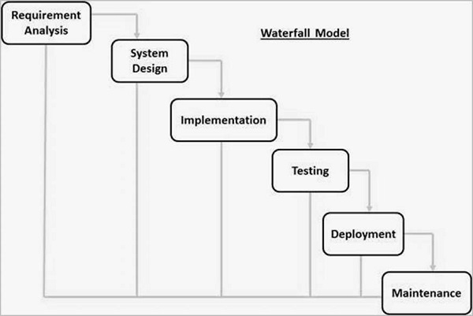

The activities in waterfall model are: -

**System Analysis**: The step refers to the gathering of system requirements, with the goal of determining how this requirement will be integrated in the system. Extensive communication between the customer and the development team is essential. During System Analysis Feasibility Studies are also carried.

**System Design**: Once the requirements have been collected and analyzed, it is necessary to identify in detail how the system will be constructed to perform the necessary tasks. More specifically, the system design phase is focused on the data requirement (what is processed by the system), the software construction (how will the Application be constructed) and the interface design and coding (what will the system look like?)

**Coding**: Also known as programming, this step involves the system software. Requirement and system specification are translated into computer code. Computer programs are written using a conventional programming language or an application generator. Programming tools like Compilers, Interpreter, Debuggers are used to generate the code. Different high level programming language like C, C++, Pascal, Java, C# are used for coding. With respect to the type of application, the right programming language is chosen.

**Testing**: As the software is created and added to the developing system, testing is performed to ensure that it is working correctly and efficiently. Testing is generally focused on two areas, internal efficiency and external effectiveness. The goal of external effectiveness testing is to verify that the software is functioning according to system design, and that it is performing all the required functions. The goal of internal testing is to make sure that the computer code is efficient, standardized, and well documented.

**Implementation:** After the code is tested, if it meets all the system requirements, it is handed over to the customer.

**Maintenance:** Inevitably the system will need maintenance. Software will definitely undergo change once it is delivered to the customer. Change could happen because of some unexpected input values into the system. The change in the system could directly affect the software operations. The software should be developed to accommodate changes that could happen during the post implementation period.

**PROCEDURE**

**STRUCTURE OF PROJECT**

* After Administrator Login
  + Update Stock
  + Add Items
  + Add new admin
  + Check detail of customer
  + Logout
* After User Login
  + Buy Products
    - Categories
  + My Cart
  + Returns
  + Checkout
  + Logout
  + Exit

**FUNCTIONAL REQUIREMENTS**

Functional requirements define the fundamental actions that must take place in the software in accepting the inputs and in processing and generating the outputs. These are listed as “shall” statements starting with “The system shall….

**Login Module** – This module is provided for both Administrator as well as user such as seller as well as buyer have registered themselves in the system. These login are provided according to the need of the systems.

* **Input –** User id and password
* **Process** – After entering user id and password by user process of validation occur to identify whether user id and password is available in FILE or not.
* **Output** – Registered user can access software and can use the services.

**Administrator Module** – The administrator is provided with password and login-id with which he/she can access the system. Administrator is provided right of maintaining the database.

* **Input** – Login id and password.
* **Process** – Process of validation will occur.
* **Output** – Administrator will maintain the database and will perform Product seller process.

**Search Module –** In this module we are going to provide facility for Product buyer to search for Products according to their specified categories so that users can search for Products easily.

* **Input-** Initial letter of Product, with the help of keywords and with the help of Brand name.
* **Output-** Information about Products.

**User Module –** As users are the main visitor of application, the following   facilities are available through this module.

* Firstly user need to Login the account to order the product from the software if he/she is not register then he/she cannot login firstly need to register the user
* Can search the Products according to their need.
* Can get information about Products.

**Purchase module** -In this module user select the ADD TO CART option for purchasing the desired product. This module is very important because its main aim to purchase the product or item by the user.

**New user-** This module is for the users who do not have their account. Here user is allowed to create an account to login. The account creation is done by filling the registration form with user details such as name, and create password

**Product:** This module has information regarding the mobiles such as its name, model, color, price information, its features etc. TheADMINhas the authority to Add, Delete, Update etc. The USER can only view the Mobile, add to cart only those in the stock etc.

.

**Non-Functional Requirements:**

* Security
* Reliability
* Maintainability
* Portability
* Extensibility
* Reusability
* Compatibility
* Resource Utilization

**ER diagram:**

ID

Password

Login

Password

Secure question

User id

Secure answer

Admin

Mobile no.

Customer

E-mail

Delivers

Reserve product in

Manage

Address

Product id

Product id

Product name

Quantity

Company

Products

Total

carts

Selling price

Stock

Purchase

To buy

Selling price

Product name

Bill

ATM pin

ATM number

**DFD DIAGRAM:**

A data flow diagram (DFD) is a graphical representation of the "flow" of data through an information system. DFDS can be used for the visualization of data processing (structured design). On a DFD, data items flow from an external data source or an internal data store to an internal data store or an external data sink, via an internal process. A DFD provides no information about the timing or ordering of processes, or about whether processes will operate in sequence or in parallel. It is therefore 10 quite different from a flowchart, which shows the flow of control through an algorithm, allowing a reader to determine what operations will be performed, in what order, and under what circumstances, but not what kinds of data will be input to and output from the system, nor where the data will come from and go to, nor where the data will be stored. The data flow diagram of the "Anti-Theft Department" is given on the next following page.

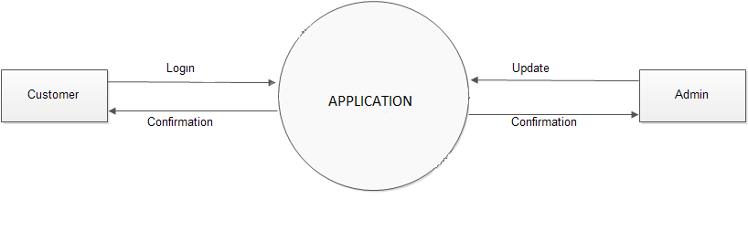

**LEVEL 0 DFD**

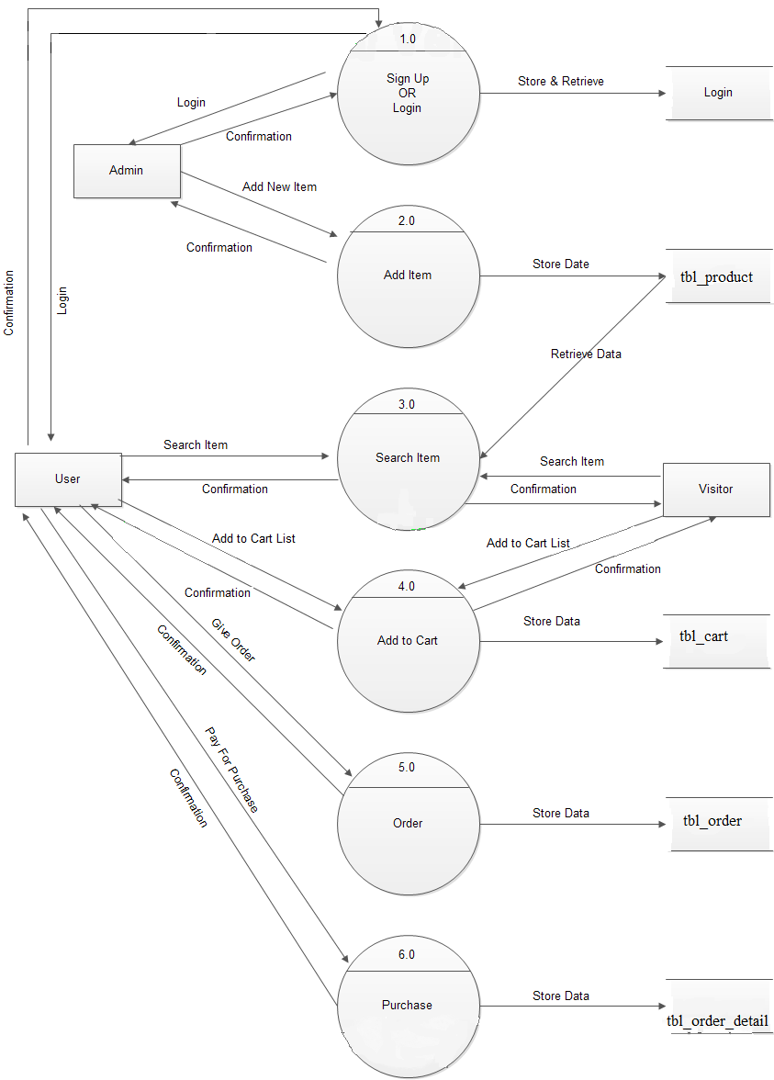

**LEVEL 1 DFD**

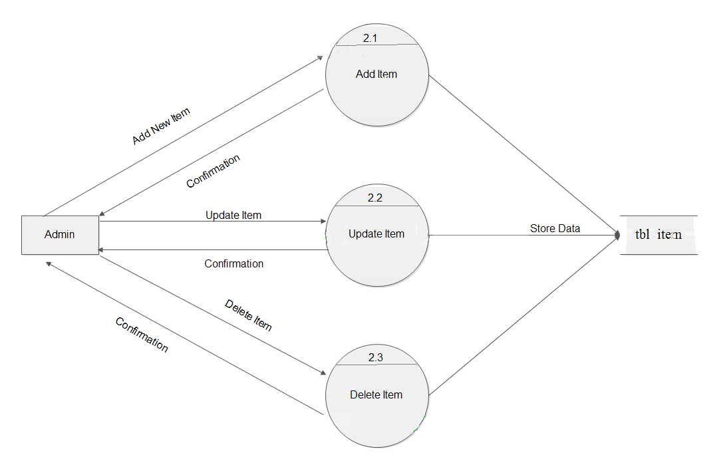

**LEVEL 2 DFD**

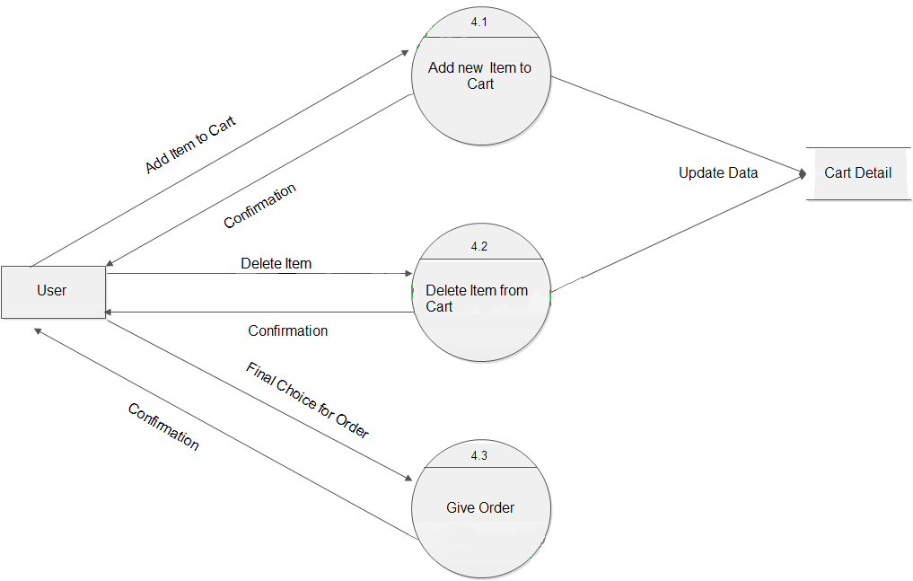

**LEVEL 2 DFD**

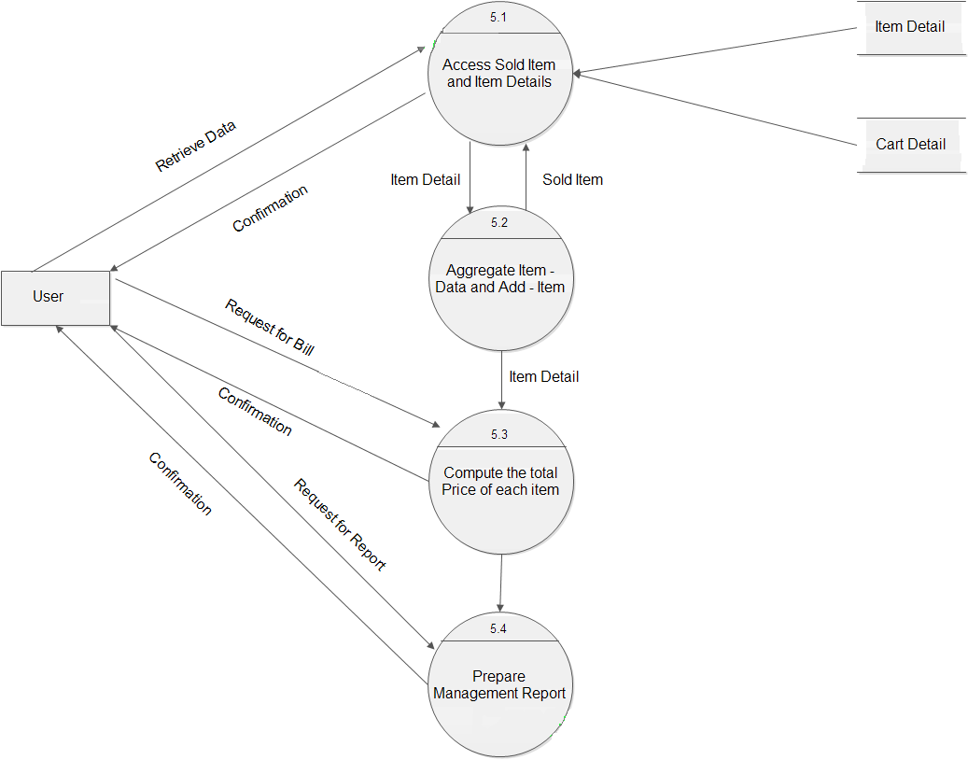

**LEVEL 2 DFD**

**CONCLUSION:**

The central concept of the application is to allow the customer to buy the items from the store. The information pertaining to the products are stores on an RDBMS at the server side (store). The application was designed into two modules first is for the customers who wish to buy the articles. Second is for the storekeepers who maintains and updates the information .The end user of this product is a departmental store where the application is on GUI and the administrator maintains the database. The application which is deployed at the customer database, the details of the items are brought forward from the database for the customer view based on the selection through the Search and the database of all the products are updated at the end of each transaction.