1. Create account with chef from manage.chef.io website.
2. Create a organization in chef-server
3. Create two instances workstation and node on AWS account
4. Enable rootlogin and password authentication on /etc/ssh/sshd_config file.
5. Download chef starter kit from Administration 🡪 starter kit
6. Copy starter kit into workstation and unzip in /root directory. It generates chef-repo
7. Download and install chef software with below command

curl -L https://www.opscode.com/chef/install.sh | bash

1. As of now we have configured chef-server and Chef workstation. Authentication files between chef server and chef workstation copied through starter ket. Now we should copies these authentication files from chef workstation to chef node. It helps chef node to communicate with chef-server. It should run from /root/chef-repo path.

knife bootstrap <server IP/ Hostname> -x root -P ravis829 -N <Tag>

1. Login to chef node and edit /etc/chef/client.rb file add below line

log_level :info

creating apache cookbook

1. Knife cookbook create apache
2. Go inside directory cookbooks/apache/recipes

cd cookbooks/apache/recipes

1. Edit default.rb file add below code to install httpd package.

package "httpd" do

action :install

end

1. Upload this new code to your chef server by using below command

Knife cookbook upload apache

1. Now go to node and run chef-client to get latest cookbooks from servers.

Chef-client

Note: even though our code is currect.. it cant install apache. Because we haven’t set this node to run recipe. To do that we should run below command.

knife node run_list add valaxynode “recipe[apache]”

1. Now if you run chef-client it is going to install httpd service in your system. But server status would be inactive. We can achive both by adding some more code to our chef-repo/cookbooks/apache/recipes/default.rb file.

service "httpd" do

action [:enable, :start]

end

1. Run chef-client on node it starts httpd server and also add servers to up after a reboot.

Writing another cookbook to remove validation.pem file from /etc/chef on node.

1. Go to chef workstation
2. Knife cookbook create security
3. Go to /chef-repo/cookbook/security/recipes and add below lince to default.rb

file "/etc/chef/validation.pem" do

action :delete

end

1. now we should add this to runlist to get it executed at node level. But we have already added httpd recipe to runlist. So we must take care of that too while adding new recipes to runlist. For this we can use below command.

knife node run_list add valaxynode -b “recipe[apache]” “recipe[security]”

Here -b means before httpd cookbook

We have given cookbook name instead of recipe in above command. Because we have added our code to default.rb file. So if we give cookbook name by default it search for default.rb, if your recipe name is something else please specify recipe name.

1. now upload cookbook to chef server

knife cookbook upload security

1. now goto node and run chef-client. It removes file as per our instructions.

chef-client

in workstation :

knife cookbooks create motd

go to cd cookbooks/motd/recipes

chef scripts written in ruby language

vi default.rb

template "/etc/motd" do

source "motd.erb"

mode "0644"

end

now go to templates/default directory and create motd.erb file

this is my MOTD created by <%= node["motd"]["author"] %>

cd atributes/default.rb

default["motd"]["author"] = "Ravi"

knife cookbook upload motd - this uploades our data on to chef

organization

then we should add chef clients at check workstation

knife node run_list add valaxynode "recipe[motd]"

then run chef-client on valaxynode

it copies data from chef organization to client.

Note: old file is stored in /var/chef/backup directory

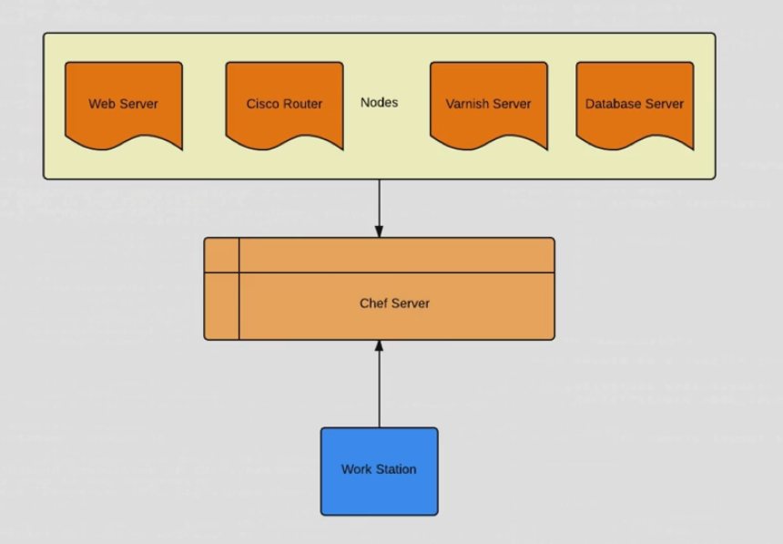

Chef Terminology

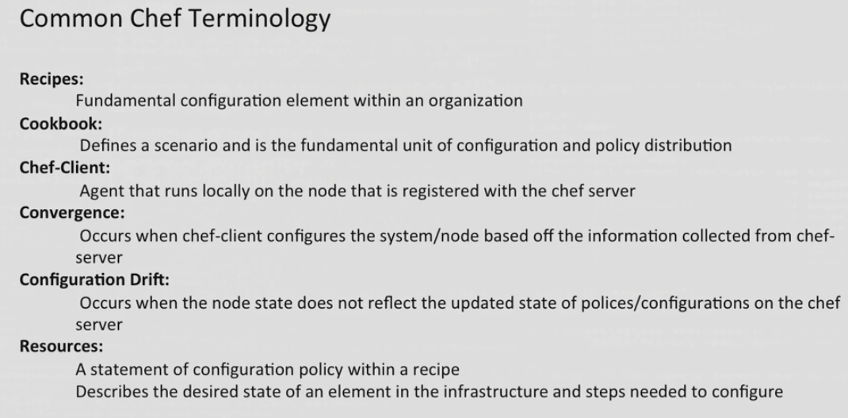

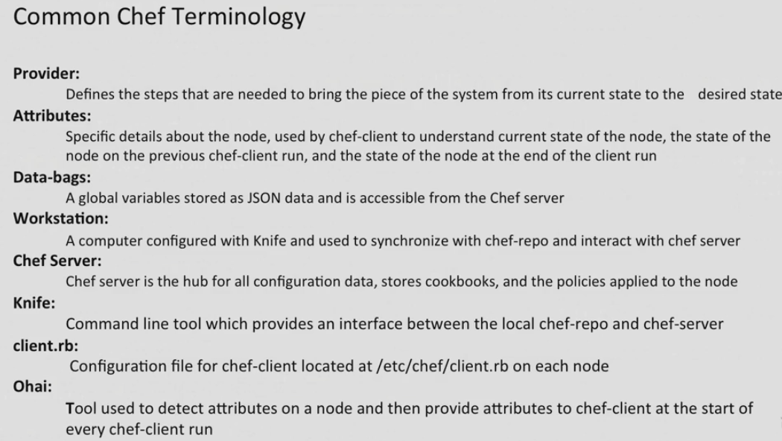

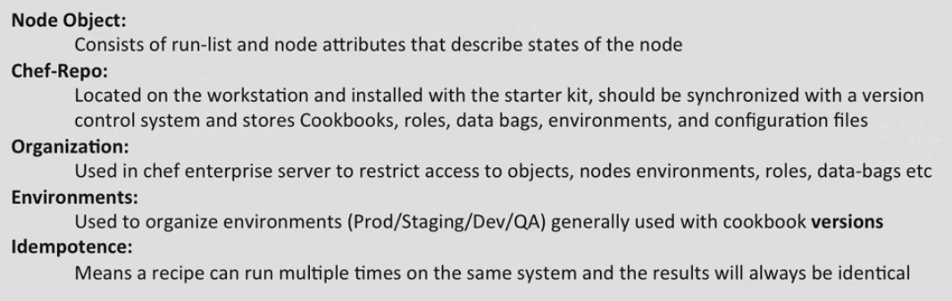

Chef server

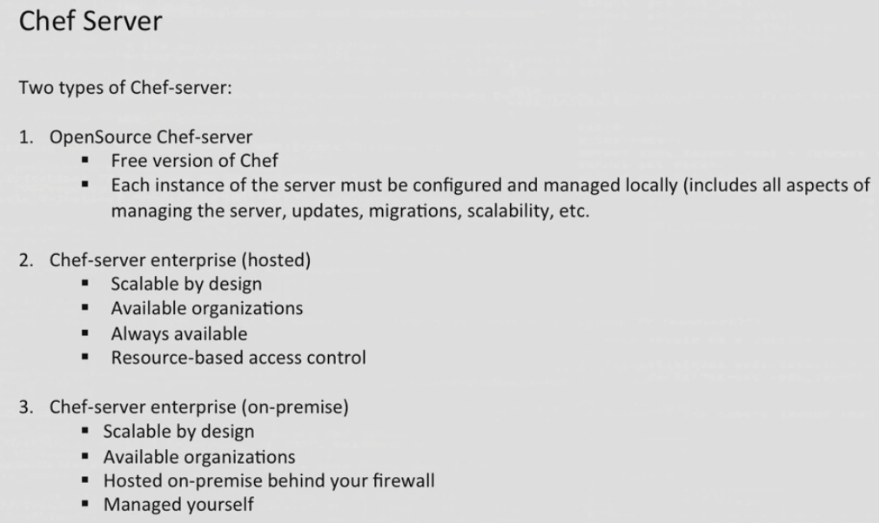

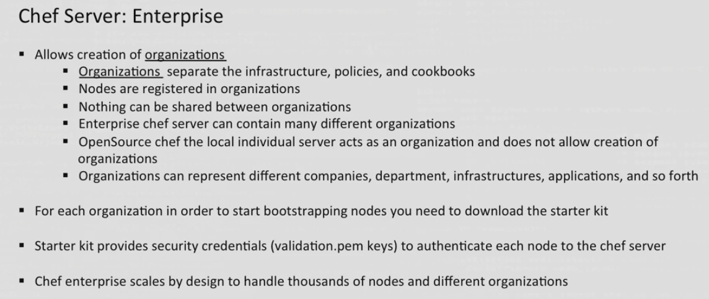

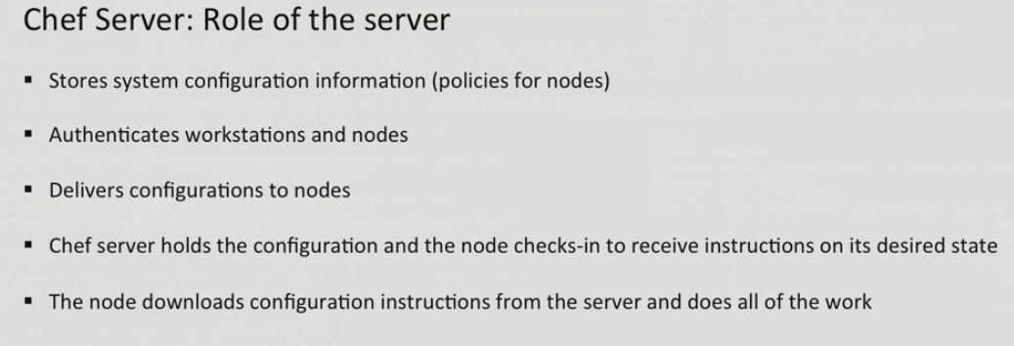

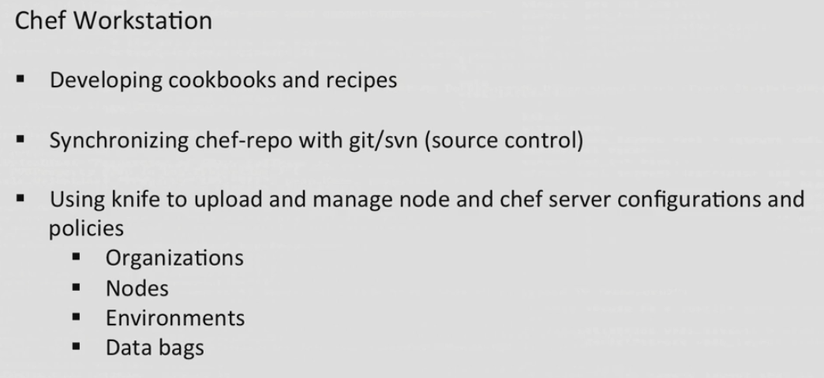

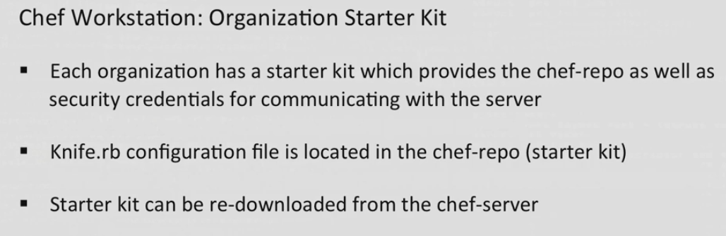

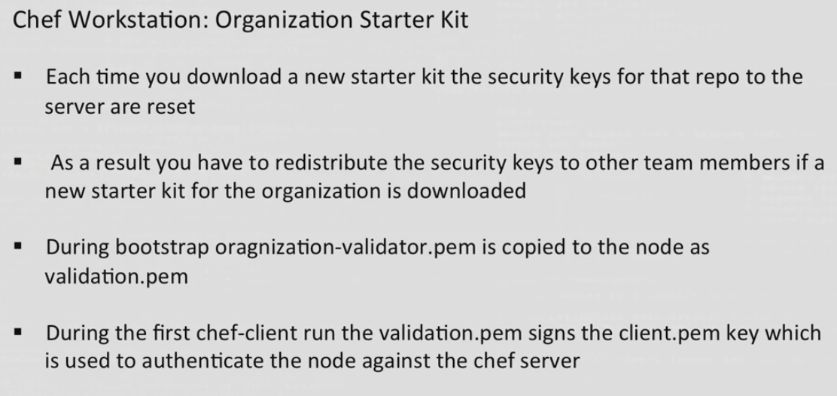

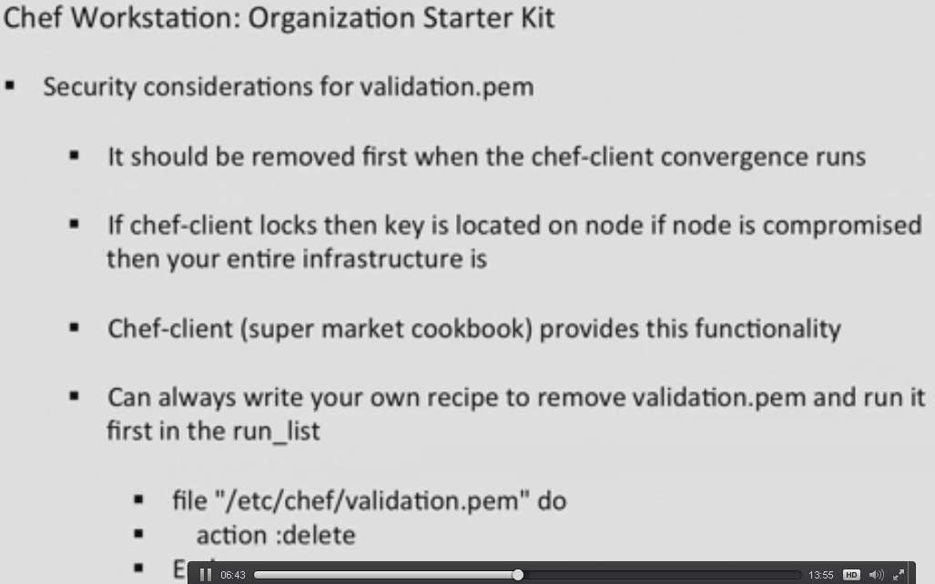

File “/etc/chef/validation.pem” do

Action :delete

End

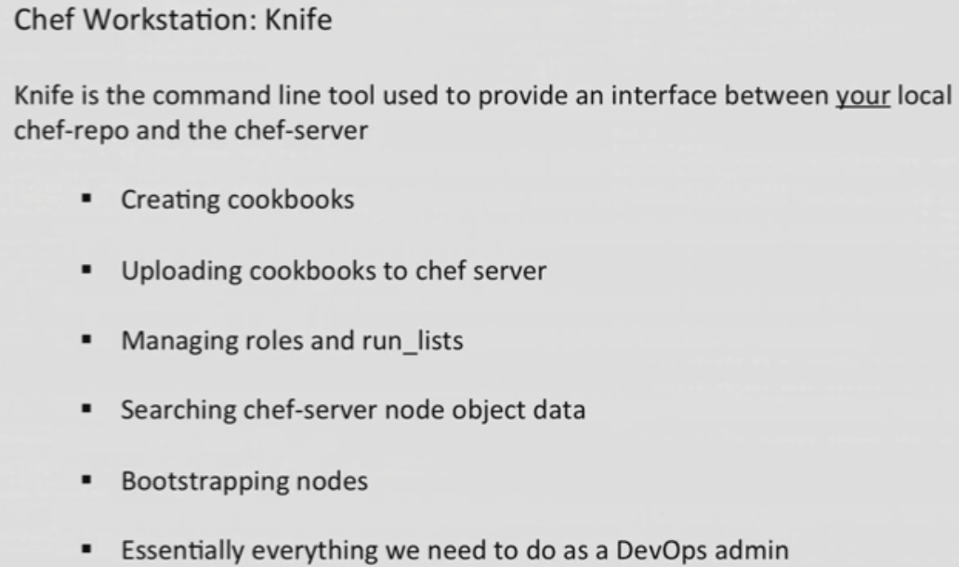

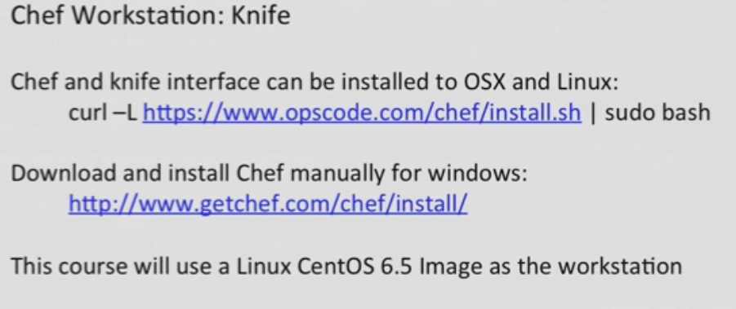

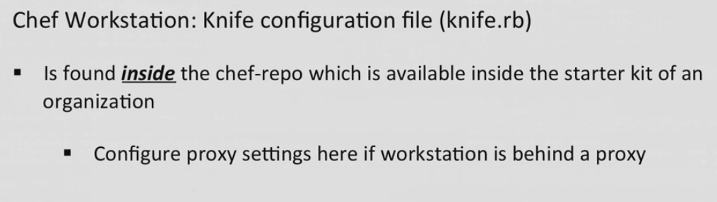

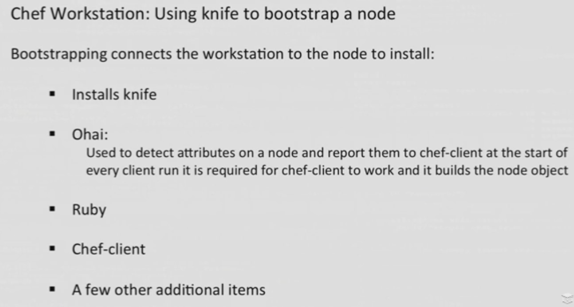

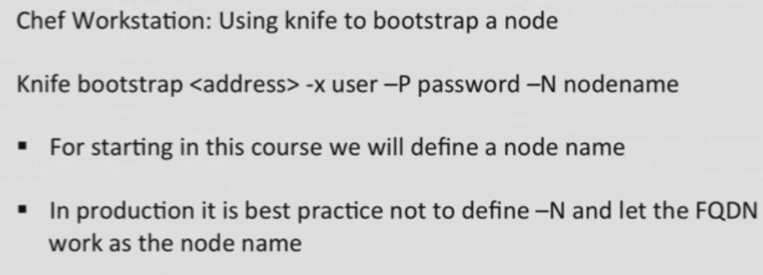

Add below line to clinet.rb in /etc/chef directory to make conversance automation.

log_level :info

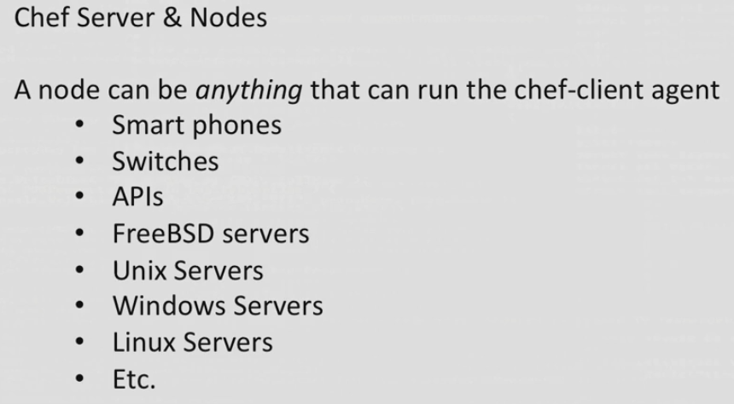

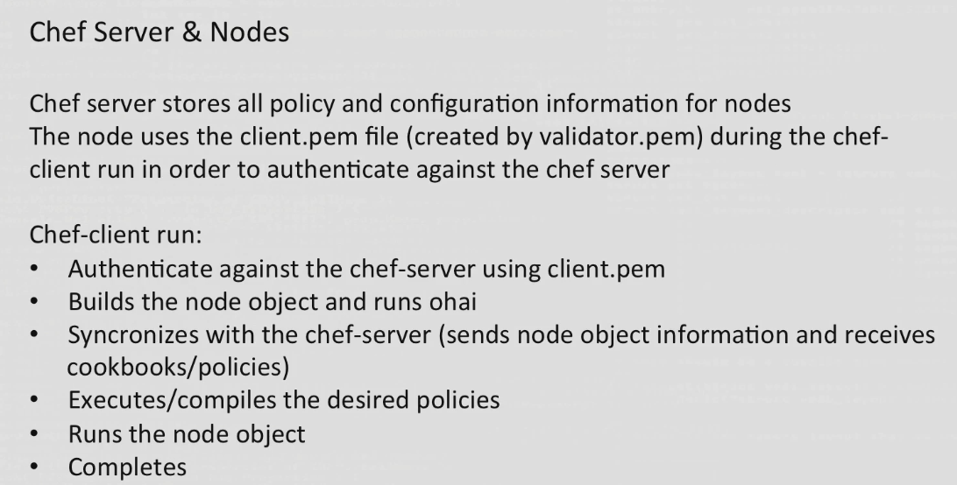

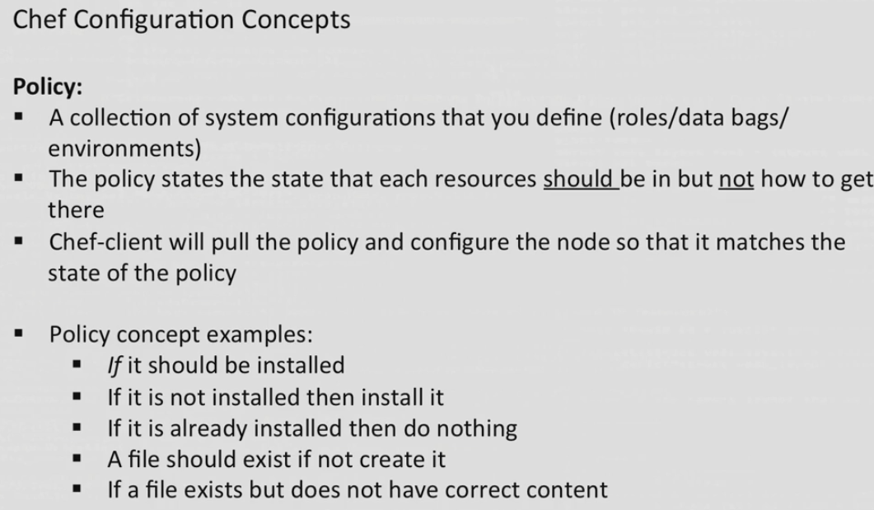

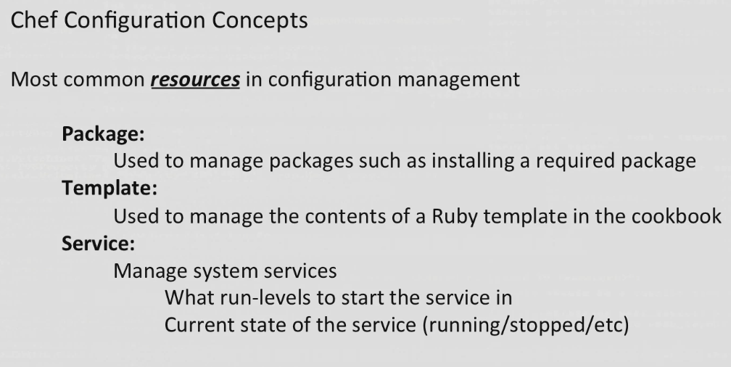

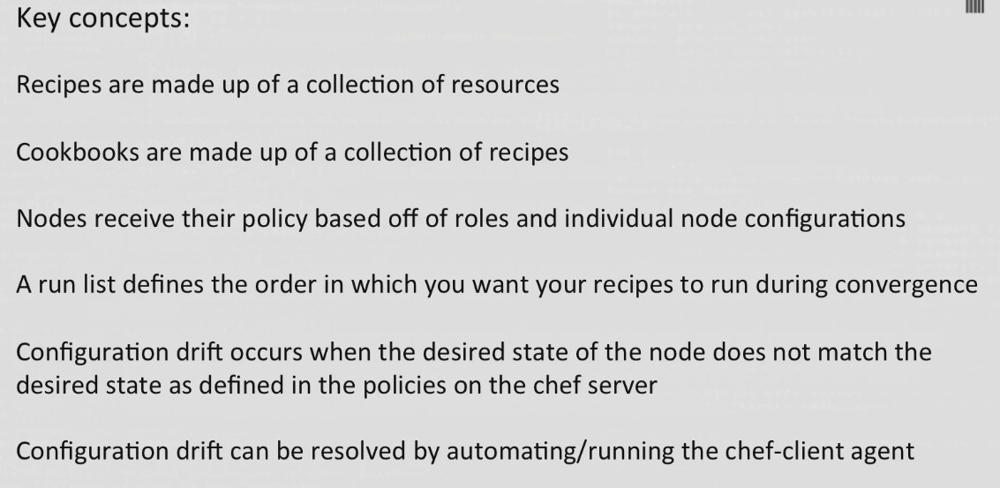

Knife configuration location

Chef-repo/.chef/knife.rb