1. First Create a repository on github
2. 
3. 
4. 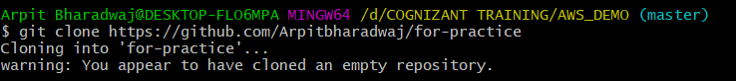
5. 
6. 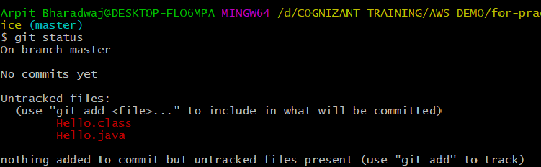
7. 
8. 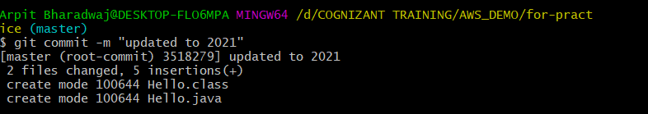
9. 
10. Then do login to github