
SUBJECT: DATABASE MANAGEMENT SYSTEMS
TOPIC: ONLINE EXAMINATION SYSTEM

UNDER THE GUIDANCE OF

DR. S MANIMALA
ASSOCIATE PROFESSOR,
Department of Computer Science &
Engineering JSS STU, MYSORE.

TEAM NO. 12

SUBMITTED BY
SL No. | Roll  No. | NAME | USN
1. | 21 | ShaikMisbah Shahzeen | 01JCE21CS089
2. | 39 | Arpitha S | 01JST21CS021
3. | 51 | Shifali S Shetty | 01JST21CS135
4. | 58 | Theekshna J | 01JST21CS162

CONTENTS

SL.No. | Title | Page No.
1 | Introduction | 3-6
2 | System Requirements | 7-8
3 | System Design | 9-10
4 | Scope | 11
5 | References | 11

INTRODUCTION
The ONLINE EXAMINATION SYSTEM is a technological solution designed to revolutionize the traditional examination process. In the modern digital age, the need for more efficient, accessible, and secure methods of conducting assessments has led to the development of online examination systems. These systems are web-based platforms that facilitate the creation, administration, and evaluation of exams over the internet.
The ONLINE EXAMINATION SYSTEM offers numerous advantages over traditional paper-based or in-person testing methods. It provides a scalable and adaptable solution for educational institutions, corporations, and other organizations looking to streamline their assessment processes.

1.1 OBJECTIVES

1. Accessibility and Convenience:
Online exams are accessible to a wider audience, allowing candidates to participate from virtually anywhere with an internet connection.
Examinees can choose the time and location that suits them, reducing the need for physical test canters and eliminating travel constraints.
2. Cost-Efficiency:
The system eliminates the need for printing and distributing paper exams, reducing both costs and environmental impact.
There is no need for manual grading, as most online examination systems offer automated grading, saving time and resources.
3. Security and Integrity:
Online examination systems can incorporate various security measures, such as randomized question orders, timed exams, and plagiarism detection, to maintain the integrity of the assessment process.
Biometric authentication and identity verification can be implemented to ensure the right person is taking the exam.
4. Customization and Flexibility:
Instructors and exam creators can easily design and customize exams, incorporating various question types, including multiple-choice, true/false, open-ended, and more.
The system allows for adaptive testing, where questions get progressively more challenging based on the candidate's previous responses.
5. Analytics and Reporting:
Online examination systems provide detailed analytics and reporting, offering insights into individual and group performance.
These insights can inform instructional decisions and help in the continuous improvement of assessment methods.
6. Real-Time Results:
Candidates receive immediate results after completing the exam, eliminating the anxiety associated with waiting for scores. Quick feedback can aid in the prompt identification of strengths and weaknesses, facilitating better learning and preparation.
7. Scalability:
Online examination systems can handle a large number of examinees simultaneously, making them suitable for both small-scale assessments and high-stakes examinations involving thousands of participants.
In conclusion, the Online Examination System represents a modern and efficient approach to conducting assessments and examinations. It leverages technology to provide a convenient, cost-effective, secure, and customizable solution for educators, employers, and organizations seeking to evaluate knowledge and skills in an increasingly digital world. As technology continues to advance, online examination systems will play an essential role in shaping the future of education and assessment.

1.2 FEATURES

User Management:
- User registration and authentication.
- Role-based access control for administrators, teachers, and students.

Exam Creation and Management:
- Intuitive exam creation tools with support for various question types (multiple-choice, true/false, essay, etc.).
- Ability to set exam parameters, including time limits, randomization, and question weighting.

Candidate Registration and Enrolment:
- Candidate registration for exams.
- Batch enrollment for multiple candidates.

Security Measures:
- IP tracking and monitoring to prevent unauthorized access.
- Anti-cheating features, such as randomized question orders and identity verification.
Scalability:
- Ability to handle a large number of concurrent exam takers.
- Support for both small-scale and large-scale assessments.

Adaptive Testing:
- Dynamic question difficulty adjustment based on candidate performance.
- Personalized exams tailored to individual abilities.

Auto-Grading:
- Automated grading for multiple-choice and other objective question types.
- Immediate feedback for candidates.

Analytics and Reporting:
- Detailed performance analytics for individuals and groups.
- Customizable reports for teachers and administrators.

Feedback and Review:
- Post-exam review options to view correct answers and explanations.
- Feedback submission and discussion forums for clarification.

Accessibility and Mobile-Friendly:
- Support for various devices and screen sizes.
- Usability features for candidates with disabilities.

Notifications and Reminders:
- Automated email or SMS notifications for exam schedules and updates.
- Reminders for candidates to start or complete exams.

Time Management:
- Timed exams with automatic submission.
- Display of remaining time to candidates.

Certification and Grading Scales:
- Support for custom grading scales and certification criteria.

SYSTEM AND SOFTWARE REQUIREMENTS
The program works on Desktop PC and is executed using a PHP 5 interface which interacts with a MySQL database running on localhost.
2.1 FUNCTIONAL REQUIREMENTS
A description of the facility or feature required. Functional requirements deal with what the system should do or provide for users. They include description of the required functions, outlines of associated reports or online queries, and details of data to be held in the system.
Interface Requirements:
- The system shall provide an option to add/delete quizzes with questions.
- The system shall provide an option to see and attend the quizzes.
- The system should give an option to login for staff and students.
- The system shall provide an option to see scores.

2.2 NON-FUNCTIONAL REQUIREMENTS
Non-functional requirements define the overall qualities or attributes of the resulting system.
Usability
- Usability is the ease with which a user can learn to operate the online examination system and get results.

Security
- Security requirements are included in a system to ensure:
- All questions and users are well secured.
- SQL injection is prevented.

Reliability
- Reliability is the ability of a system to perform its required functions under stated conditions for a specific period. Constraints on the run-time behaviour of the system can be considered under two separate headings:
- Availability: Is the system available for service when requested by end-users?
- Failure rate: how often does the system fail to deliver the service as expected by end- users.
2.3 SOFTWARE REQUIREMENTS
  - Programming language: PHP, MYSQL
  - Operating system: ANY OS (Recommended: Windows8, Windows Vista, Windows XP)
  - Application required: Standalone desktop application &
  - XAMPP Coding language: PHP, HTML, CSS, JavaScript.

2.4 HARDWARE REQUIREMENTS
- CPU: Pentium IV 2.4 GHz or above Memory
- (Primary): 512 MB, 1 GB or above
- Hard Disk: 40 GB, 80 GB, 160 GB or above
- Monitor: 15 VGA color

ER Diagram – high level data modelling

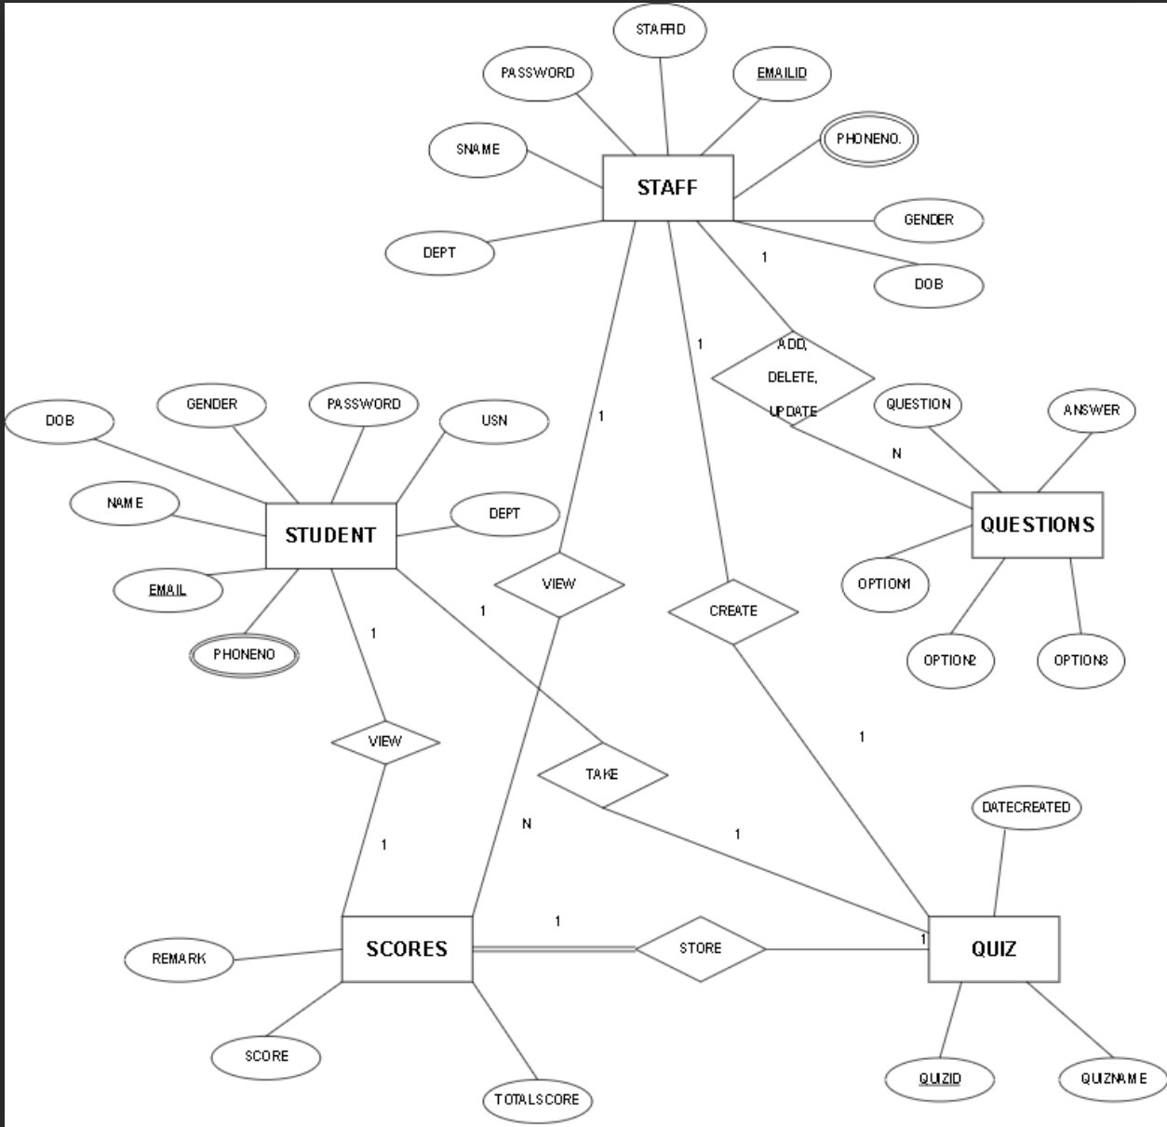

Schema Diagram – conceptual data modelling
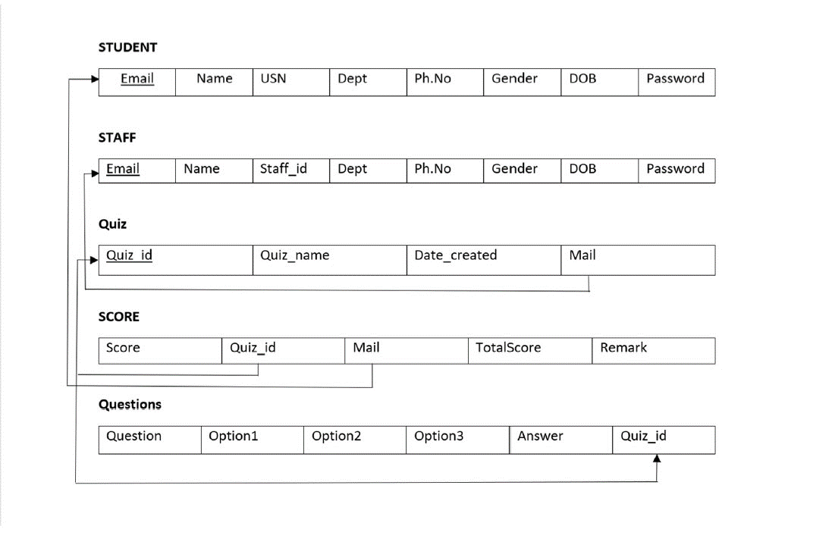

SQL Code

-- phpMyAdmin SQL Dump
-- version 4.1.14
-- http://www.phpmyadmin.net
--
-- Host: 127.0.0.1
-- Generation Time: Nov 20, 2023 at 04:29 PM
-- Server version: 5.6.17
-- PHP Version: 5.5.12

SET SQL_MODE = "NO_AUTO_VALUE_ON_ZERO";
SET time_zone = "+00:00";

/*!40101 SET @OLD_CHARACTER_SET_CLIENT=@@CHARACTER_SET_CLIENT */;
/*!40101 SET @OLD_CHARACTER_SET_RESULTS=@@CHARACTER_SET_RESULTS */;
/*!40101 SET @OLD_COLLATION_CONNECTION=@@COLLATION_CONNECTION */;
/*!40101 SET NAMES utf8 */;

--
-- Database: `projet`
--

DELIMITER $$
--
-- Procedures
--
CREATE DEFINER=`root`@`localhost` PROCEDURE `leaderboard`()
NO SQL
select q.quizname,s.score,s.totalscore,st.name,s.mail from score s,student st,quiz q where s.mail=st.mail and q.quizid=s.quizid order by score DESC$$

DELIMITER ;

-- --------------------------------------------------------

--
-- Table structure for table `dept`
--

CREATE TABLE IF NOT EXISTS `dept` (
`dept_id` int(11) NOT NULL,
`dept_name` varchar(3) DEFAULT NULL,
PRIMARY KEY (`dept_id`)
) ENGINE=InnoDB DEFAULT CHARSET=latin1;

--
-- Dumping data for table `dept`
--

INSERT INTO `dept` (`dept_id`, `dept_name`) VALUES
(1, 'CSE'),
(2, 'ISE'),
(3, 'ECE'),
(4, 'EEE');

-- --------------------------------------------------------

--
-- Table structure for table `questions`
--

CREATE TABLE IF NOT EXISTS `questions` (
`qs` varchar(200) NOT NULL,
`op1` varchar(30) NOT NULL,
`op2` varchar(30) NOT NULL,
`op3` varchar(30) NOT NULL,
`answer` varchar(30) NOT NULL,
`quizid` int(11) NOT NULL,
UNIQUE KEY `qs` (`qs`),
KEY `quizid` (`quizid`),
KEY `quizid_2` (`quizid`),
KEY `quizid_3` (`quizid`)
) ENGINE=InnoDB DEFAULT CHARSET=latin1;

--
-- Dumping data for table `questions`
--

INSERT INTO `questions` (`qs`, `op1`, `op2`, `op3`, `answer`, `quizid`) VALUES
('/ Assume that integers take 4 bytes.<br> #include<iostream> <br> using namespace std; <br> class Test { <br> static int i;<br> int j;<br> }; <br> int Test::i; <br> int main() { ', '1', '2', '3', '4', 5),
('C primiarily developed as..', 'General purpose language', 'Data processing language D.', 'None of the above.', 'System programming language ', 4),
('C programs converted into machine language with the help of..', 'An Editor ', 'An operating system', ' None of these.', 'A compiler ', 4),
('No. of consonant in english language is..', '20', '22', '28', '21', 6),
('No. of vowels in english language is..', '3', '4', '7', '5', 6),
('Total no of letters in english language is..', '23', '24', '25', '26', 6),
('When a copy constructor may be called?', 'When an object of the class is', 'When an object of the class is', 'When an object is constructed ', 'All of the above', 5),
('Which of the following functions must use reference.', 'Assignment operator function', 'Destructor', 'Parameterized constructor', 'Copy Constructor', 5),
('Which of the following is FALSE about references in C++', 'References cannot be NULL', 'A reference must be initialize', 'Once a reference is created, i', 'References cannot refer to con', 5),
('Which of the following operators cannot be overloaded', '. (Member Access or Dot operat', '?: (Ternary or Conditional Ope', ':: (Scope Resolution Operator)', 'All of the above', 5),
('Which of the followings is/are automatically added to every class, if we do not write our own.', 'Copy Constructor', 'Assignment Operator', 'A constructor without any para', 'All of the above', 5),
('Who is the father of C language?', 'Bjarne Stroustrup', 'James A. Gosling ', 'Dr. E.F. Codd', 'Dennis Ritchie ', 4);

-- --------------------------------------------------------

--
-- Table structure for table `quiz`
--

CREATE TABLE IF NOT EXISTS `quiz` (
`quizid` int(11) NOT NULL AUTO_INCREMENT,
`quizname` varchar(20) NOT NULL,
`date_created` timestamp NOT NULL DEFAULT CURRENT_TIMESTAMP,
`mail` varchar(30) DEFAULT NULL,
PRIMARY KEY (`quizid`),
KEY `mail` (`mail`)
) ENGINE=InnoDB DEFAULT CHARSET=latin1 AUTO_INCREMENT=7 ;

--
-- Dumping data for table `quiz`
--

INSERT INTO `quiz` (`quizid`, `quizname`, `date_created`, `mail`) VALUES
(4, 'c quiz', '2019-11-18 16:13:50', 'BHATVINAYAK94@GMAIL.COM'),
(5, 'c++ quiz', '2019-11-18 16:17:13', 'rakeshmr723@gmail.com'),
(6, 'english', '2019-11-18 17:04:12', 'BHATVINAYAK94@GMAIL.COM');

--
-- Triggers `quiz`
--
DROP TRIGGER IF EXISTS `ondeleteqs`;
DELIMITER //
CREATE TRIGGER `ondeleteqs` AFTER DELETE ON `quiz`
FOR EACH ROW delete from questions where questions.quizid=old.quizid
//
DELIMITER ;

-- --------------------------------------------------------

--
-- Table structure for table `score`
--

CREATE TABLE IF NOT EXISTS `score` (
`slno` int(11) NOT NULL AUTO_INCREMENT,
`score` int(11) NOT NULL,
`quizid` int(11) NOT NULL,
`mail` varchar(30) DEFAULT NULL,
`totalscore` int(11) DEFAULT NULL,
`remark` varchar(20) DEFAULT NULL,
PRIMARY KEY (`slno`),
KEY `quizid` (`quizid`),
KEY `mail` (`mail`)
) ENGINE=InnoDB DEFAULT CHARSET=latin1 AUTO_INCREMENT=15 ;

--
-- Dumping data for table `score`
--

INSERT INTO `score` (`slno`, `score`, `quizid`, `mail`, `totalscore`, `remark`) VALUES
(13, 6, 5, 'rakeshmariyaplar1@gmail.com', 6, 'good'),
(14, 2, 4, 'rakeshmariyaplar1@gmail.com', 3, 'good');

--
-- Triggers `score`
--
DROP TRIGGER IF EXISTS `remarks`;
DELIMITER //
CREATE TRIGGER `remarks` BEFORE INSERT ON `score`
FOR EACH ROW set NEW.remark = if(NEW.score = 0, 'bad', 'good')
//
DELIMITER ;

-- --------------------------------------------------------

--
-- Table structure for table `staff`
--

CREATE TABLE IF NOT EXISTS `staff` (
`staffid` varchar(10) NOT NULL,
`name` varchar(20) NOT NULL,
`mail` varchar(30) NOT NULL,
`phno` varchar(10) NOT NULL,
`gender` varchar(1) NOT NULL,
`DOB` varchar(10) NOT NULL,
`pw` varchar(200) NOT NULL,
`dept` varchar(3) DEFAULT NULL,
PRIMARY KEY (`mail`),
UNIQUE KEY `mail` (`mail`,`phno`),
UNIQUE KEY `staffid` (`staffid`)
) ENGINE=InnoDB DEFAULT CHARSET=latin1;

--
-- Dumping data for table `staff`
--

INSERT INTO `staff` (`staffid`, `name`, `mail`, `phno`, `gender`, `DOB`, `pw`, `dept`) VALUES
('svit1', 'B G VINAYAK', 'BHATVINAYAK94@GMAIL.COM', '9740834260', 'M', '1999-09-23', 'ral7gku4rfhLk', 'CSE'),
('123', 'Rakesh M R', 'rakeshmr723@gmail.com', '9901735897', 'M', '1999-10-07', 'rajJYeVNCiGD2', 'ISE');

-- --------------------------------------------------------

--
-- Table structure for table `student`
--

CREATE TABLE IF NOT EXISTS `student` (
`usn` varchar(10) NOT NULL,
`name` varchar(20) NOT NULL,
`mail` varchar(30) NOT NULL,
`phno` varchar(10) NOT NULL,
`gender` varchar(1) NOT NULL,
`DOB` varchar(10) NOT NULL,
`pw` varchar(200) NOT NULL,
`dept` varchar(3) DEFAULT NULL,
PRIMARY KEY (`mail`),
UNIQUE KEY `mail` (`mail`),
UNIQUE KEY `phno` (`phno`),
UNIQUE KEY `usn` (`usn`),
KEY `dept` (`dept`)
) ENGINE=InnoDB DEFAULT CHARSET=latin1;

--
-- Dumping data for table `student`
--

INSERT INTO `student` (`usn`, `name`, `mail`, `phno`, `gender`, `DOB`, `pw`, `dept`) VALUES
('1va17cs010', 'B G VINAYAK', 'BHATVINAYAK94@GMAIL.COM', '9740834260', 'M', '1999-09-23', 'ral7gku4rfhLk', 'CSE'),
('1va17cs140', 'Rakesh Mariyaplar', 'rakeshmariyaplar1@gmail.com', '6360300095', 'M', '1999-10-07', 'rajJYeVNCiGD2', 'CSE'),
('1va17cs040', 'Rakesh M R', 'rakeshmr723@gmail.com', '9901735897', 'M', '2000-10-07', 'rajJYeVNCiGD2', 'CSE'),
('1va17cs051', 'Siddhanth Sipoliya', 'siddhanthsipoliya@saividya.ac.', '7619360459', 'M', '1999-11-15', 'ray.whoA8HjCQ', 'CSE');

--
-- Constraints for dumped tables
--

--
-- Constraints for table `quiz`
--
ALTER TABLE `quiz`
ADD CONSTRAINT `quiz_ibfk_1` FOREIGN KEY (`mail`) REFERENCES `staff` (`mail`) ON DELETE CASCADE;

--
-- Constraints for table `score`
--
ALTER TABLE `score`
ADD CONSTRAINT `score_ibfk_1` FOREIGN KEY (`quizid`) REFERENCES `quiz` (`quizid`) ON DELETE CASCADE,
ADD CONSTRAINT `score_ibfk_2` FOREIGN KEY (`mail`) REFERENCES `student` (`mail`) ON DELETE CASCADE ON UPDATE CASCADE;

/*!40101 SET CHARACTER_SET_CLIENT=@OLD_CHARACTER_SET_CLIENT */;
/*!40101 SET CHARACTER_SET_RESULTS=@OLD_CHARACTER_SET_RESULTS */;
/*!40101 SET COLLATION_CONNECTION=@OLD_COLLATION_CONNECTION */;

Main php code
Index.php

<?php session_start(); ?>
<html>

<head>
<title>Online Examination System</title>
<meta name="viewport" content="width=device-width, initial-scale=1.0">
<link rel="stylesheet" href="https://www.w3schools.com/w3css/4/w3.css">
</head><?php
if (isset($_POST['login'])) {
if (isset($_POST['usertype']) && isset($_POST['username']) && isset($_POST['pass'])) { require_once 'sql.php';
$conn = mysqli_connect($host, $user, $ps, $project);if (!$conn) {
echo "<script>alert(\"Database error retry after some time !\")</script>";
}
$type = mysqli_real_escape_string($conn, $_POST['usertype']);
$username = mysqli_real_escape_string($conn, $_POST['username']);
$password = mysqli_real_escape_string($conn, $_POST['pass']);
$password = crypt($password, 'rakeshmariyaplarrakesh');
$sql = "select * from " . $type . " where mail='{$username}'";
$res = mysqli_query($conn, $sql);
if ($res == true) {
global $dbmail, $dbpw;
while ($row = mysqli_fetch_array($res)) {
$dbpw = $row['pw'];
$dbmail = $row['mail'];
$_SESSION["name"] = $row['name'];
$_SESSION["type"] = $type;
$_SESSION["username"] = $dbmail;
}
if ($dbpw === $password) {
if ($type === 'student') {
header("location:homestud.php");
} elseif ($type === 'staff') {
header("Location: homestaff.php");
}
} elseif ($dbpw !== $password && $dbmail === $username) {
echo "<script>alert('password is wrong');</script>";
} elseif ($dbpw !== $password && $dbmail !== $username) {
echo "<script>alert('username name not found sing up');</script>";
}
}
}
}
?>
<style>
@media screen and (max-width: 620px) {
input {
height: 6vw !important;
}

.seluser {
display: grid;
}

.sub {
width: 20vw !important;
}
}

.inp {
box-sizing: content-box !important;
width: 30vw;
height: 3vw;
border-radius: 10px;
border: 2px solid black;
padding-left: 2vw;
font-weight: bolder;
outline: none;
}

::placeholder {
font-weight: bold;
font-family: 'Courier New', Courier, monospace;
}

label {
font-weight: bolder;
font-size: 1.5vw;
}

form {
font-size: 1.5vw;
margin: 0;
}

button:hover {
background-color: #fff !important;
}

.bg {
background-size: 100%;
}

a {
color: #042A38;
}
.login{
max-height: 70vh;
}
</style>

<body style="margin:0;height: 100%;ouline:none;color: #042A38f !important;padding-botton:5vw;">
<div class="bg" style="font-weight: bolder;background-image: url(./images/rakesh.png);background-repeat: no-repeat;padding: 0;margin: 0;background-size: cover;font-family: 'Courier New', Courier, monospace;opacity: 0.9;height: 100%;">
<center>
<h1 class="w3-container" style=" color:#042A38;text-transform: uppercase;width: auto;background:#fff;padding: 1vw;">ONLINE
Examination System</h1>
</center>
<center>
<div class="w3-card" class="login" style="color: #042A38;width: 40vw;background-color: #ffffffab;border: 2px solid black;padding: 2vw;font-weight: bolder;margin-top: 10vh;border-radius: 10px;">
<form method="POST">
<div class="seluser">
<input type="radio" name="usertype" value="student" required>STUDENT
<input type="radio" name="usertype" value="staff" required>STAFF
</div><br><br>
<div class="signin">

<label for="username" style="text-transform: uppercase;">Username</label><br><br>
<input type="email" name="username" placeholder=" Email" class="inp" required>
<br><br>
<label for="password" style="text-transform: uppercase;">Password</label><br><br>
<input type="password" name="pass" placeholder="******" class="inp" required>
<br><br>
<input name="login" class="sub" type="submit" value="Login" style="height: 3vw;width: 10vw;font-family: 'Courier New', Courier, monospace;font-weight: bolder;border-radius: 10px;border: 2px solid black;background-color:lightblue"><br>

</form><br>
<a href="reset.php">Forgot password?</a> &nbsp; New user! <a href="signup.php">SIGN UP</a>
</div>
</div>
</center>
</div>
<?php require("footer.php"); ?>
</body>
</html>

SNAPSHOTS
Databases
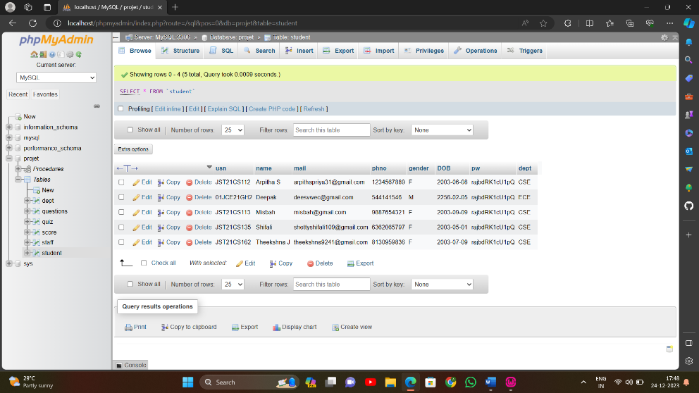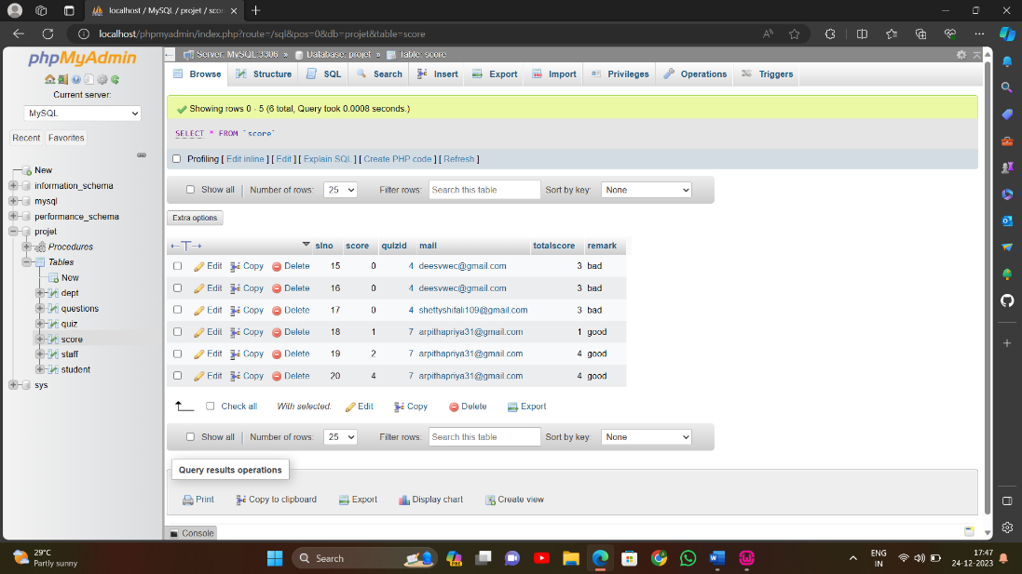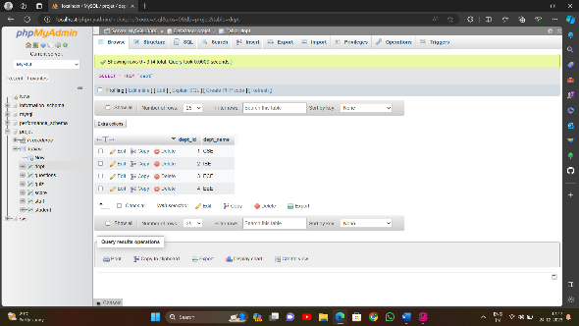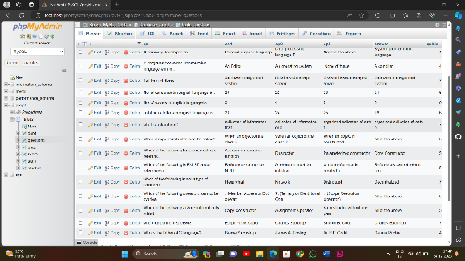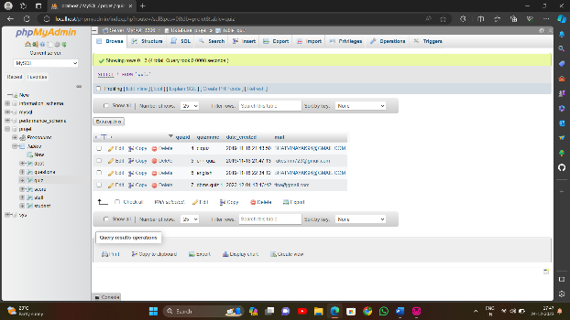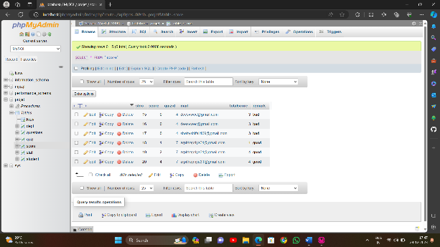
Start page of the project
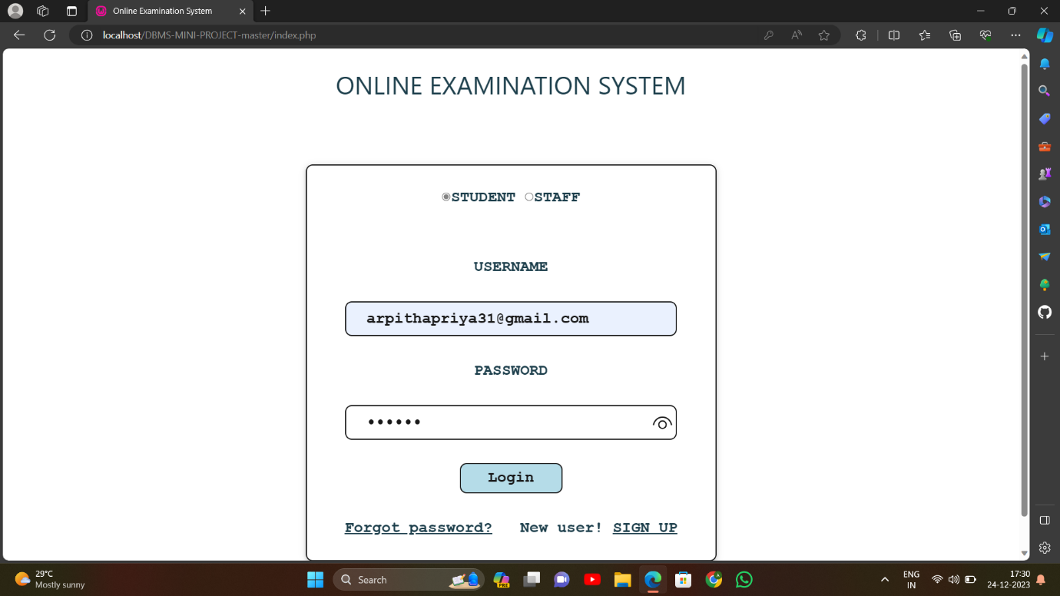
Sign Up Page
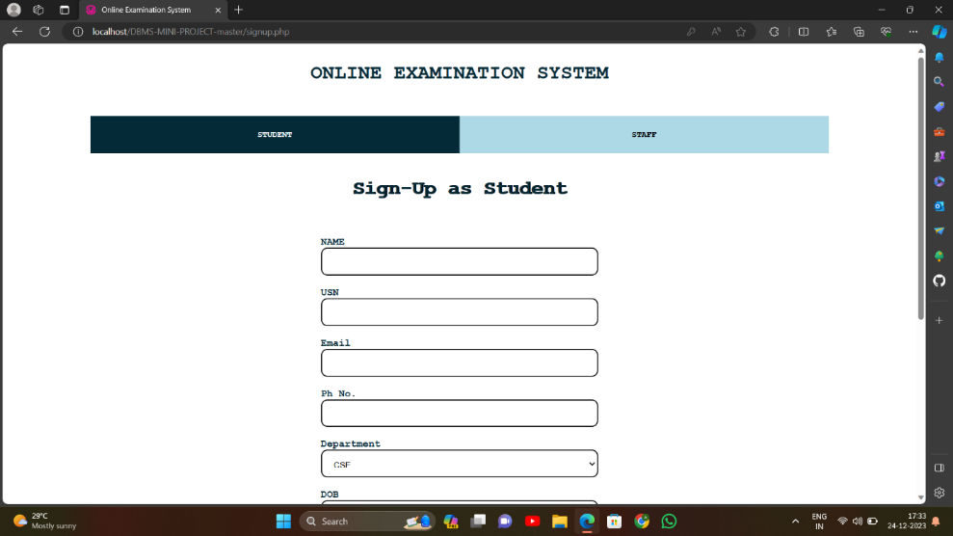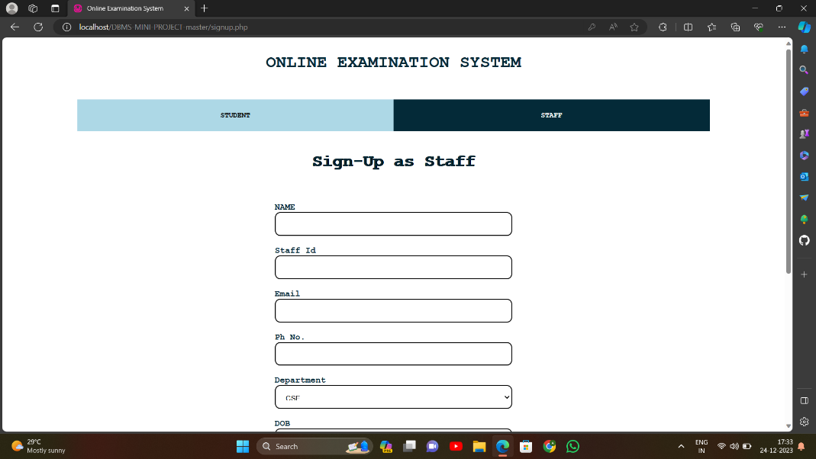
Student
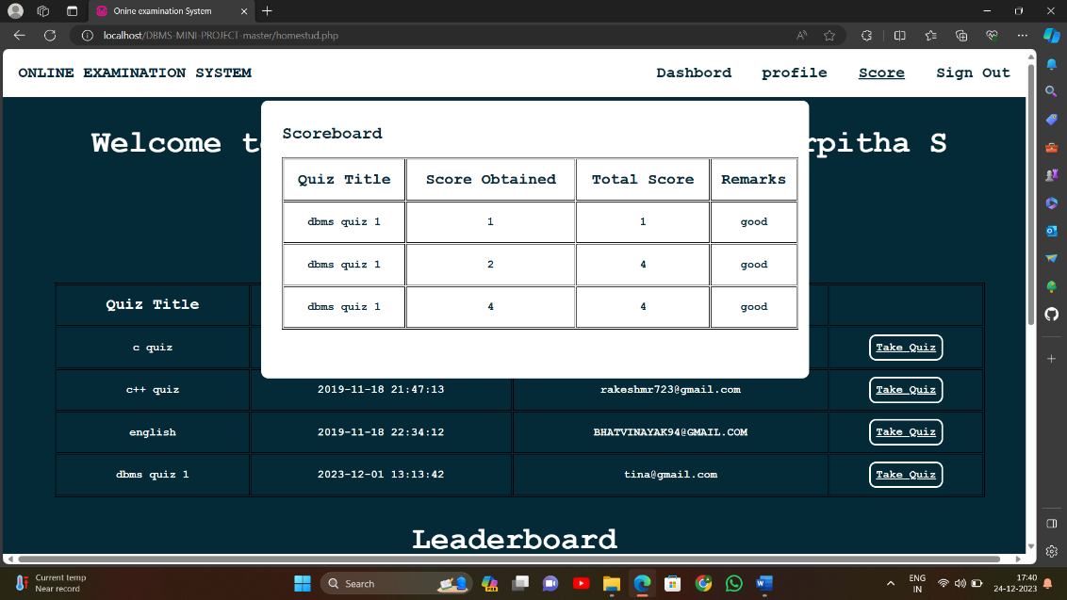
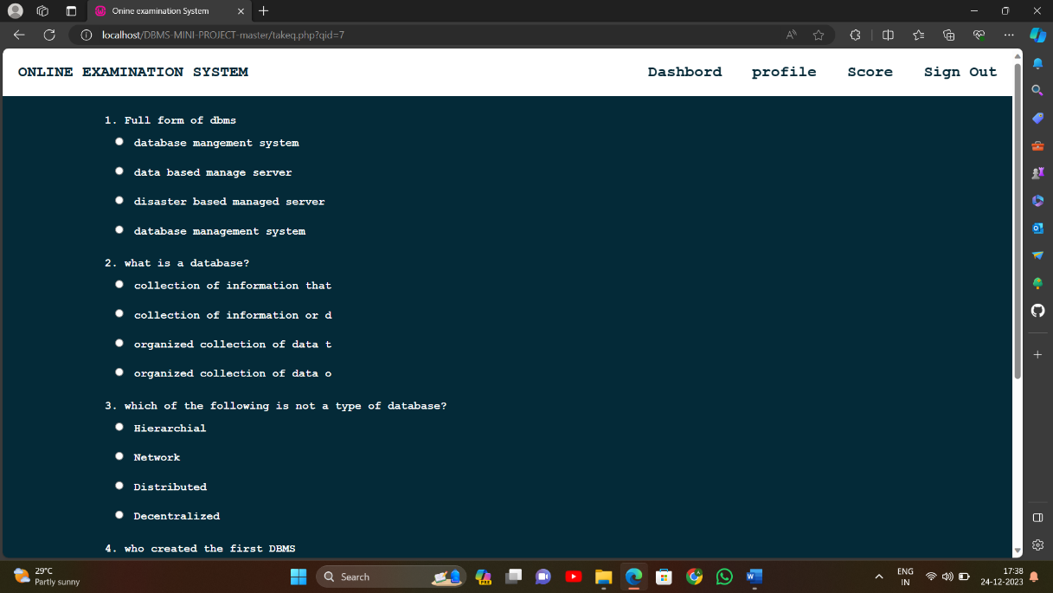
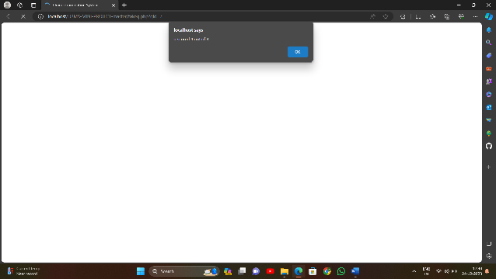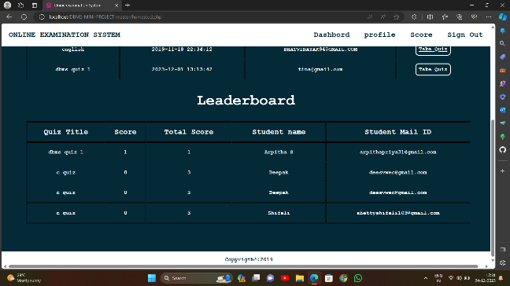
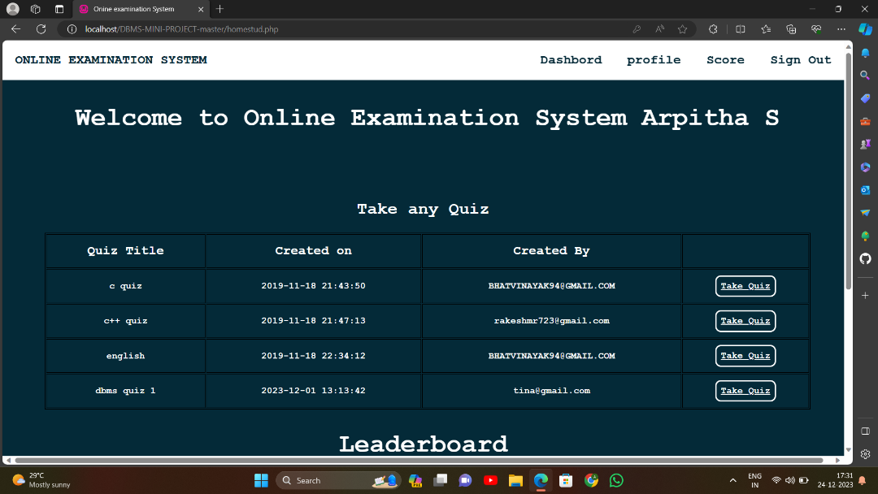

Staff
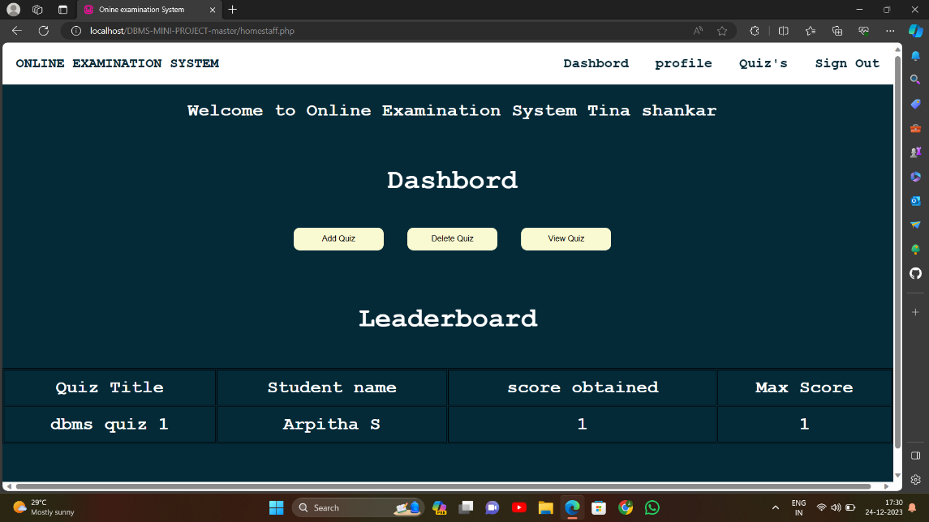
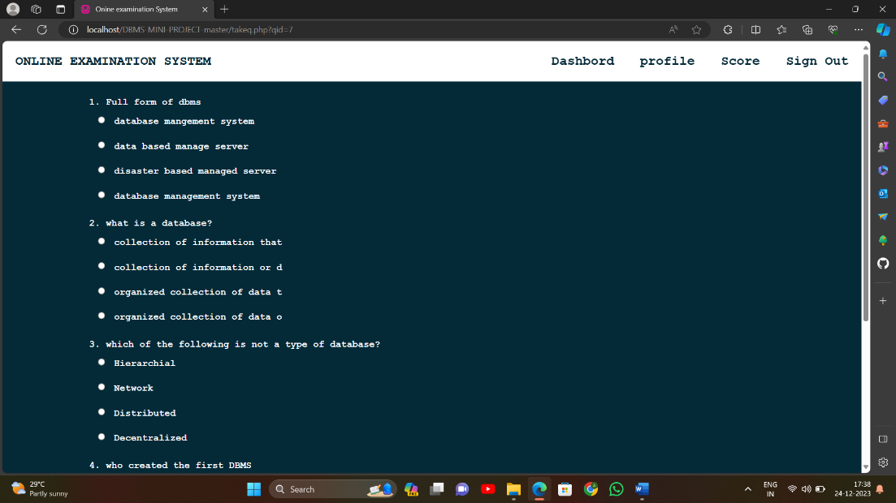
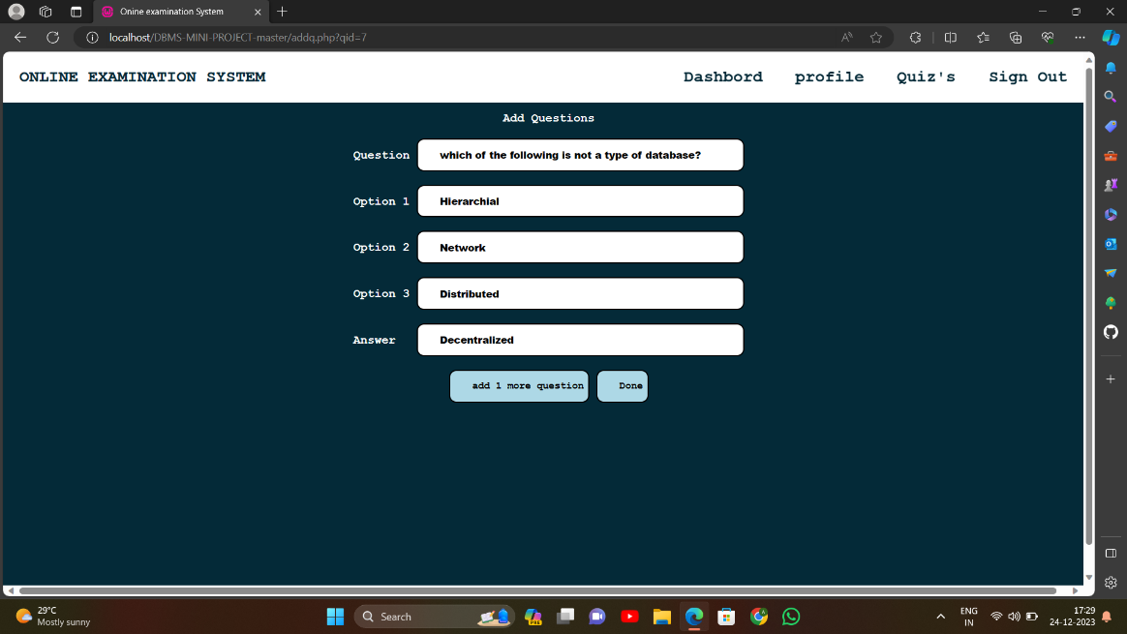

Reset password
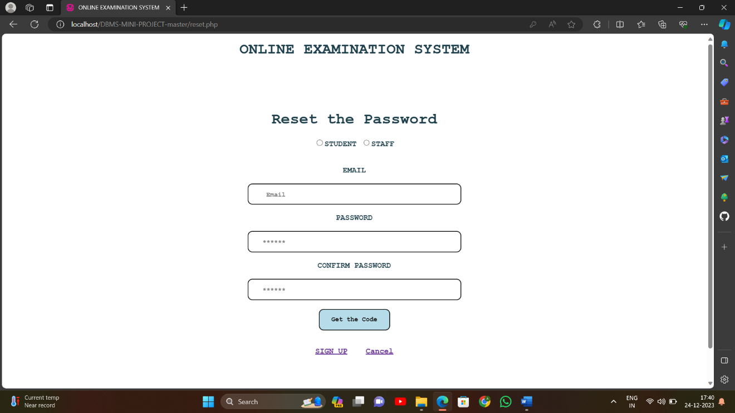

SCOPE
The essential framework of this report would be to elaborate the design of E.R-diagram, Schema Diagram and to display how the modules of the program work in order to achieve the automation.

CONCLUSION

The online examination system provides better functionality for an
examination to be more efficient and reduce manual paperwork in order to
automate all possible tasks. For implementing this system, PHP, HTML,
CSS, JavaScript and MySql are used. The system comprises following
features: Management of quiz, Automated grading ,Adding/deleting quizzes
and questions.

The project is trying to make teachers assess students in online education. As
we've seen in covid period it was very difficult to conduct classes and take
tests. We primarily used google forms which used to be cumbersome, like
creating tests and then sharing the links. But in this project we can share all
the tests using only one link and students don't need to find different links for
different tests. Their credentials will show which kind of tests they can
assess. and then they can just attempt the test, they may also get the results
thereafter.

For teachers it is very easy to create test questions and exams as per format.
And we can also see the ranking of all students in a given test. We can also
get their feedback as well so as to use it in future .
The online examination system provides better functionality for an examination to be more efficient and reduce manual paperwork in order to automate all possible tasks. For implementing this system, PHP, HTML, CSS, JavaScript and MySql are used. The system comprises following features: Management of quiz, Automated grading, Adding/deleting quizzes and questions.
The project is trying to make teachers assess students in online education. As we've seen in covid period it was very difficult to conduct classes and take tests. We primarily used google forms which used to be cumbersome, like creating tests and then sharing the links. But in this project we can share all the tests using only one link and students don't need to find different links for different tests. Their credentials will show which kind of tests they can assess. and then they can just attempt the test, they may . also get the results thereafter.
For teachers it is very easy to create test questions and exams as per format. And we can also see the ranking of all students in a given test. We can also get their feedback as well so as to use it in future.
We know the project is not the best in the market but we know we were able to solve some of the problems, the rest we can always upgrade in future.
The online examination system provides better functionality for an examination to be more efficient and reduce manual paperwork in order to automate all possible tasks. For implementing this system, PHP, HTML, CSS, JavaScript and MySql are used. The system comprises following features: Management of quiz, Automated grading, Adding/deleting quizzes and questions.
The project is trying to make teachers assess students in online education. As we've seen in covid period it was very difficult to conduct classes and take tests. We primarily used google forms which used to be cumbersome, like creating tests and then sharing the links. But in this project we can share all the tests using only one link and students don't need to find different links for different tests. Their credentials will show which kind of tests they can assess. and then they can just attempt the test, they may .
also get the results thereafter.
For teachers it is very easy to create test questions and exams as per format. And we can also see the ranking of all students in a given test. We can also get their feedback as well so as to use it in future.
We know the project is not the best in the market but we know we were able to solve some of the problems, the rest we can always upgrade in future.

REFERENCES

- https://1000projects.org/design-development-of-online-examination-management-system-project.html
- https://www.eklavvya.com/blog/online-examination-system/

