Node.js Student API Project
GeekWick Internship Tasks (1 – 9)
Name: Deekshith N
Technology Used: Node.js, Express.js
Tool Used: Postman
Date: 09-03-2026

Task 1 – Create an API that returns student details
A basic Express server was created. A route /students was added that returns a list of student objects.
const getAllStudents = (req, res) => {
res.json([
{ id:1, name:'John Doe', age:20, branch:'Computer Science', college:'ATME' },
{ id:2, name:'Jane Smith', age:22, branch:'Mathematics', college:'ATME' },
{ id:3, name:'Alice Johnson', age:19, branch:'Physics', college:'ATME' }
]);
};
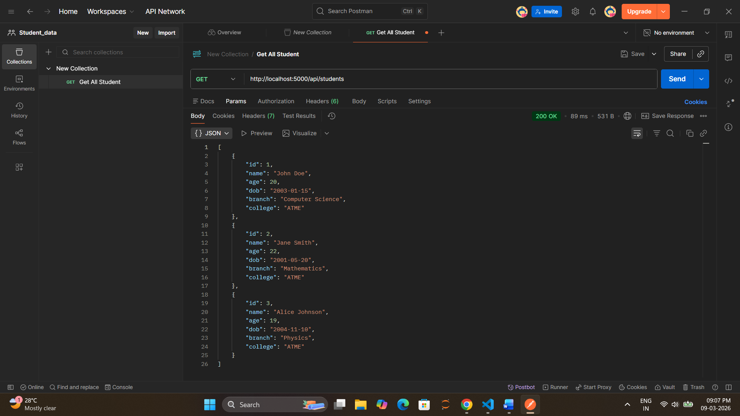

Task 2 – Create Multiple Routes
Routes Created
GET /students
GET /courses
GET /colleges

Task 3 – Implement Folder Structure Organize project files using a proper folder structure.
09032026
│
controllers
studentController.js
routes
studentRoutes.js
app.js

Task 4 – Build Student CRUD API (Create, Read, Update, Delete)

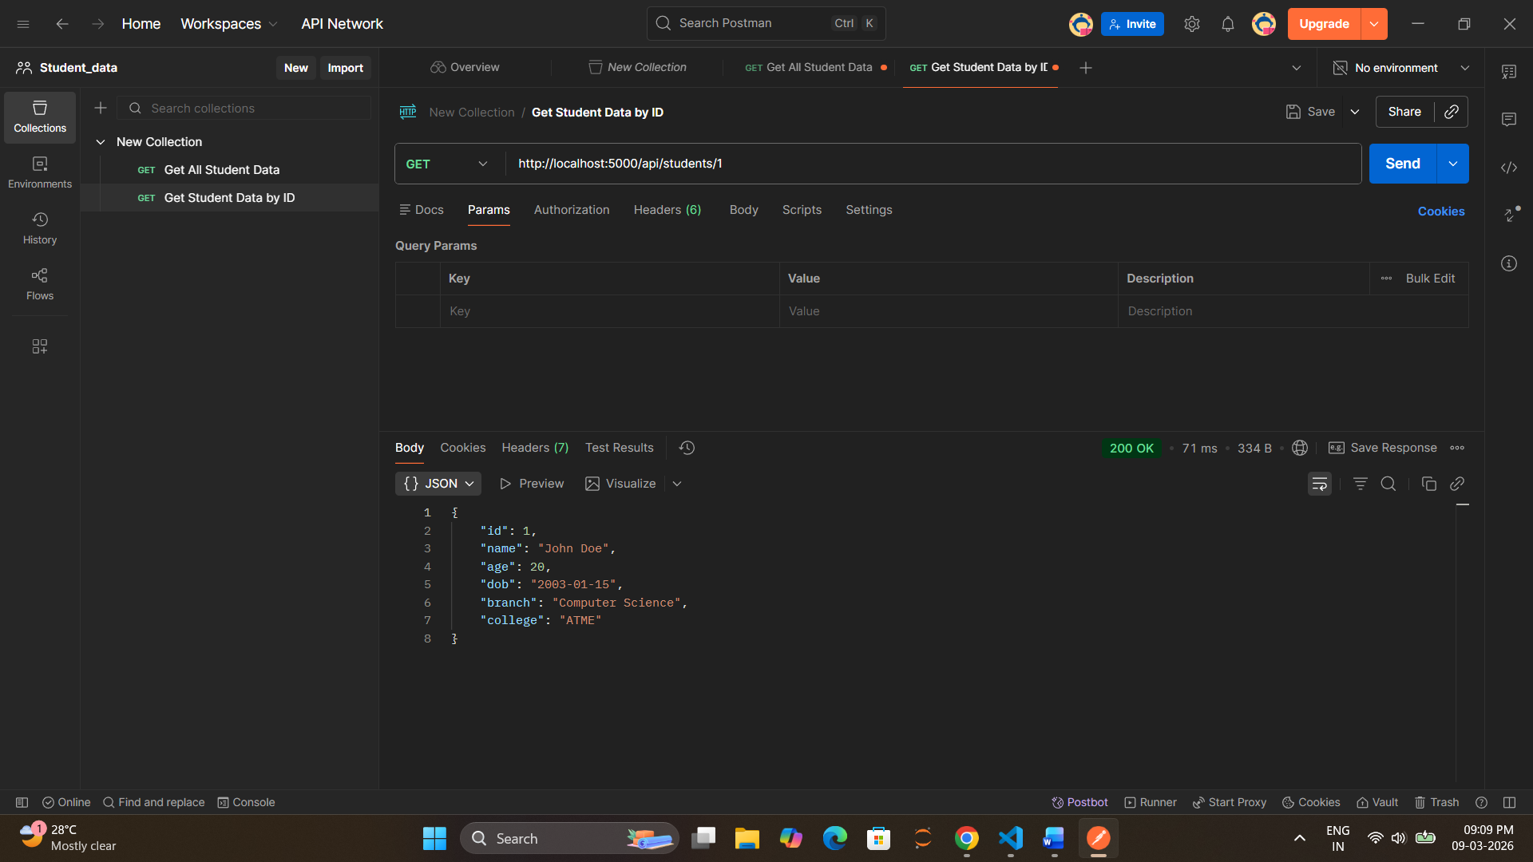
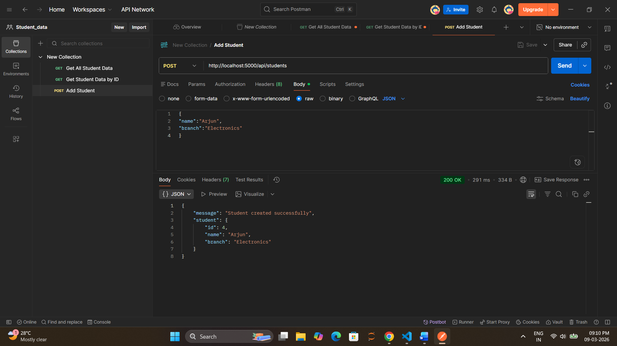
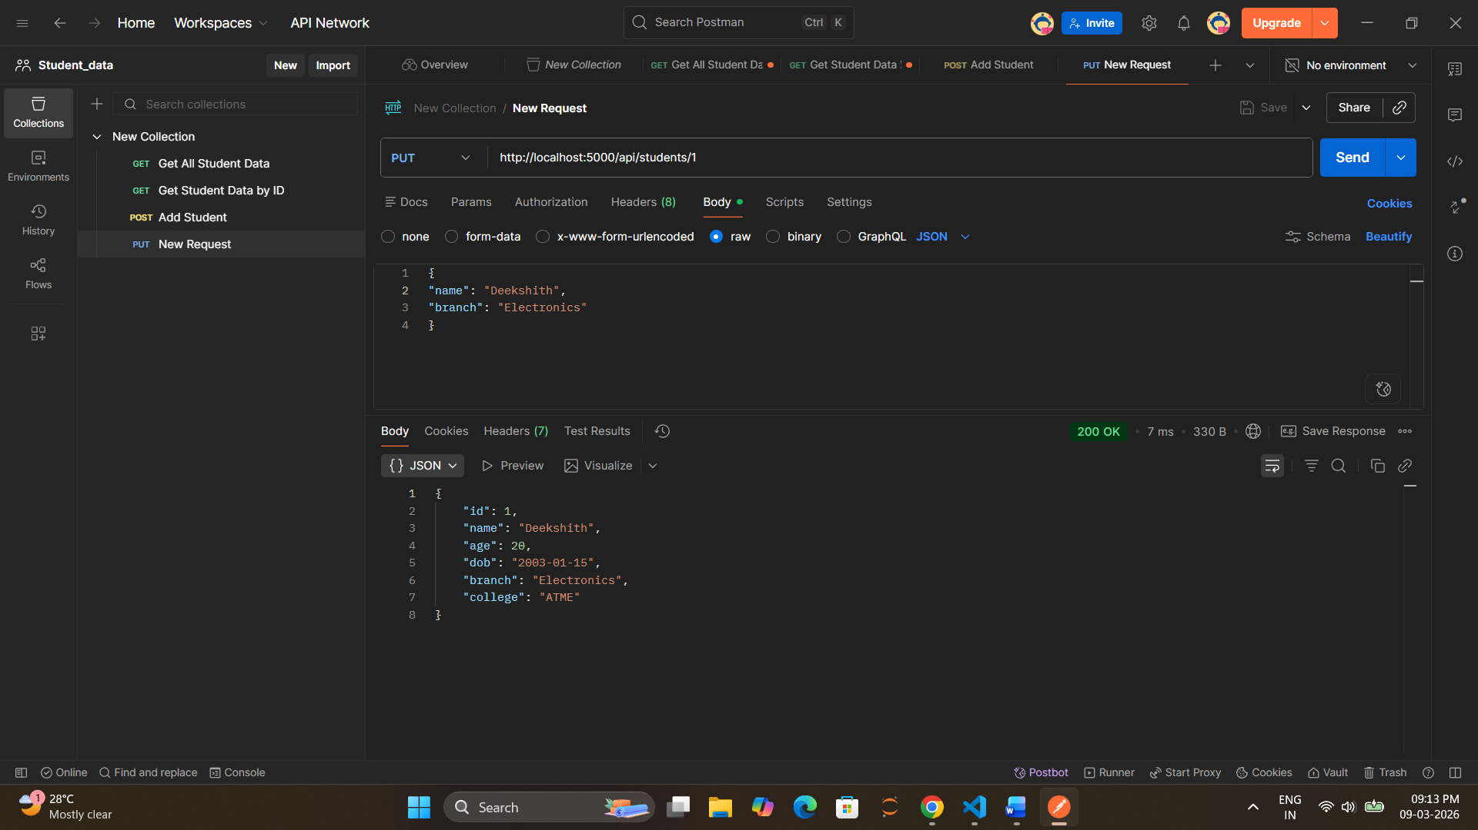
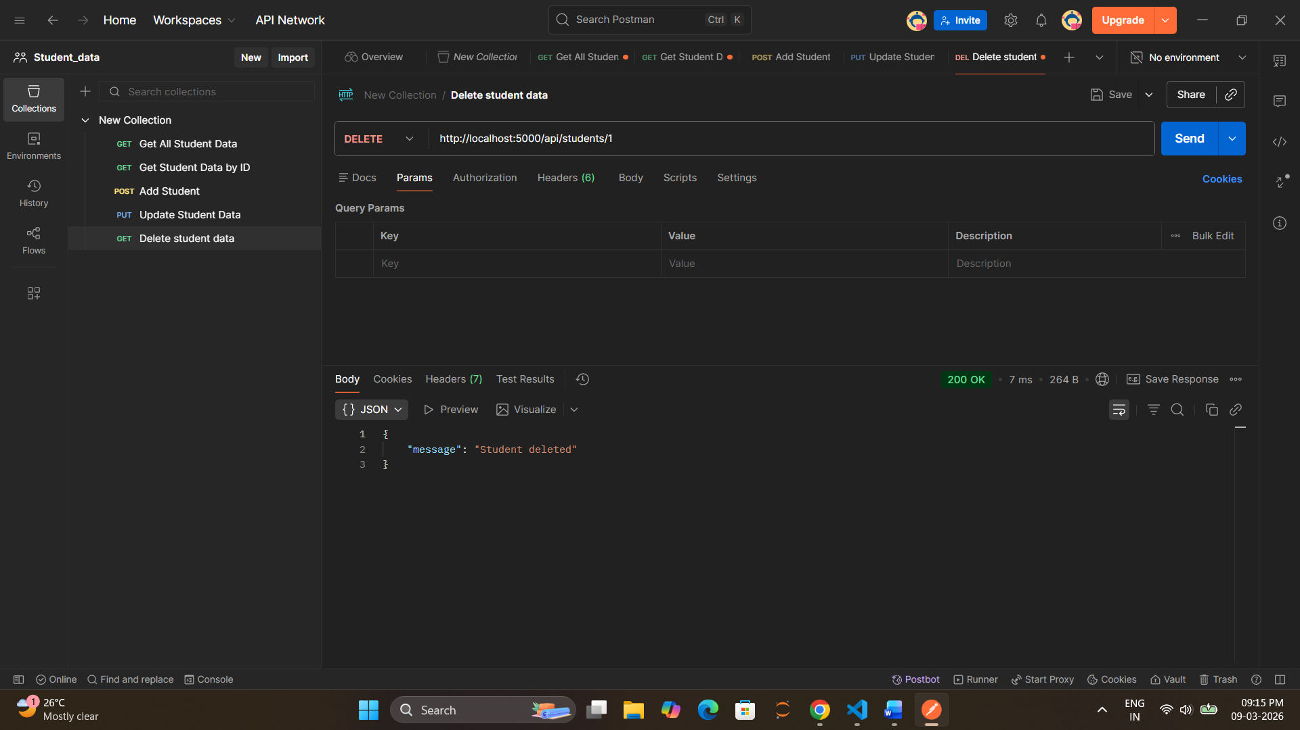

Task 5 – Follow Naming Conventions Done
Task 6 - Add API to get student by ID

Task 7 – Add New Entity (Courses) Done
Task 8 – Error Handling Done
if(!student){
return res.json({
message:"Student not found"
})
}

Response :

{
"message": "Student not found"
}

Task 9 – Create Multiple Services
Services Created
Service | Port
Student Service | 3001
Course Service | 3002
College Service | 3003
http://localhost:3001/students
http://localhost:3002/courses
http://localhost:3003/colleges
